Autolyse vs. Fermentolyse
A Professional Baker’s Guide
Techniques, Timing, Temperature, When to Use Each Method — and Baking with Ancient Grains
Version 23 · Updated 2026-06-10 · Now including grain blends, baker’s ratios, an expanded modern and ancient grain library, a grain encyclopedia of taste, usage & nutrition, low-temperature fermentolyse from 5–26 °C, a research roadmap, and deep sections on the bake, starter & preferment management, and crumb-reading & troubleshooting, plus deep sections on water chemistry, salt & hydration, and a prioritised roadmap with impact ratings, and deep sections on mixing & gluten development and shaping & scoring, and the final four roadmap topics — commercial yeast, enriched & laminated doughs, flours beyond the grain, and equipment — completing the roadmap, and a second roadmap of future topics, and the second roadmap developed in full (flavour, nutrition, specialty breads, rheology, finishing), and a comprehensive tour of the breads of France (Section 35), now illustrated, with a photograph-sourcing reference (Section 35.10), and comprehensive tours of the breads of Germany (Section 36) and Italy (Section 37), now with per-bread-type preparation, baking and troubleshooting methods, and ten new chapters on the world’s most historically influential bread cultures — from the Fertile Crescent and ancient Egypt through Greece and Rome, Vienna, the Jewish diaspora, the northern rye world, the Middle Eastern and Indian flatbreads, Mesoamerican maize, Ethiopian injera and the British Isles (Sections 38–47) — each with influence, method boxes, troubleshooting, illustrations, graphs and references, and two operational chapters on scaling and the baker’s calculators with ready-to-port app logic (Section 48) and on food safety, spoilage and shelf life (Section 49), and two chapters on equipping a home bakery — core kit of oven, steam and mixing (Section 50) and measuring, proofing and finishing kit with a tiered buying guide and buy-versus-skip guidance (Section 51), and three chapters on the steamed and milk-bread world — steamed breads such as mantou and baozi (Section 52), Asian milk breads like shokupan (Section 53) and the tangzhong and yudane water-roux methods with ready-to-port app logic (Section 54). This edition also adds front matter: a note on the companion application (built separately with Claude Code and JetBrains Rider, using this guide as its specification) and a full table of contents, plus back matter consolidating the whole guide: a glossary (Appendix A) and a unified, thematically grouped bibliography (Appendix B)

About the Companion Application
This guide has a companion application: a tool for capturing, measuring and visualising the timing and measurement data of the baking process — the rests, bulk and proof windows, dough temperatures, hydrations and formulas described throughout these chapters. It is referenced wherever the text gives “ready-to-port” logic, notably the baker’s-percentage, desired-dough-temperature, hydration, levain and cost calculators of Section 48 and the water-roux arithmetic of Section 54.
The application is developed in a separate environment from this document. It is built with Claude Code (Anthropic’s agentic coding tool) and JetBrains Rider (the .NET IDE), and this guide serves as its functional input and specification — the domain model, the formulas and the process logic are taken directly from these chapters. The two artefacts are kept deliberately in step: the guide is the source of truth for the baking science, and the application implements it.
Method box | Detail
Built in | A separate development environment (not this document workspace)
Tooling | Claude Code (agentic coding) + JetBrains Rider (.NET IDE)
Stack | ASP.NET Core · Razor / C# · Entity Framework Core
Specification | This guide — domain model, formulas (§48, §54) and process logic
Purpose | Capture, measure and visualise baking timing & measurement data
Because the two are maintained separately, the formulas in this guide are written in a form a developer (or Claude Code) can port directly: each calculator gives the formula, a worked example, and compact C# logic that mirrors the baker’s-percentage conventions used throughout.

Table of Contents
The guide’s fifty-four sections, in order. Page numbers refer to the start of each section.
1. Introduction 5
2. The Science Behind the Rest 6
3. Autolyse 7
4. Fermentolyse 7
5. Side-by-Side Comparison 9
6. Pros and Cons 9
7. Time & Temperature Reference Tables 11
8. Full Bread-Making Timelines 13
9. Baking with Ancient Grains 15
10. Baking with Grain Blends 24
11. An Expanded Grain Library — Modern & Ancient 28
12. When to Use Which Method 32
13. Professional Baker’s Tips 32
14. Quick Reference Summary 34
15. Grain Encyclopedia — Characteristics, Taste & Usage 35
16. Fermentolyse at Low Temperatures 42
17. Roadmap — Topics for Future Editions 48
18. The Bake — How Dough Becomes Bread 51
19. Sourdough Starter & Preferment Management 56
20. Reading the Crumb & Troubleshooting 60
21. Water Chemistry 64
22. Salt 67
23. Hydration as a Variable 70
24. Mixing & Gluten Development 73
25. Shaping & Scoring Craft 78
26. Commercial Yeast in Depth 82
27. Enriched & Laminated Doughs 86
28. Flours Beyond the Grain 90
29. Equipment 94
30. Flavour & Aroma Chemistry 97
31. Nutrition, Digestibility & Health 100
32. Specialty Bread Families 102
33. Dough Rheology & Flour Testing 105
34. Finishing, Glazing & Crust Design 107
35. The Breads of France 110
36. The Breads of Germany 130
37. The Breads of Italy 143
38. The Cradle of Bread — the Fertile Crescent & Ancient Egypt 155
39. Ancient Greece & Rome — Refinement and Spread 158
40. Austria & Vienna — the Vector into Modern French Baking 160
41. The Jewish Diaspora — a Cross-Border Bread Culture 162
42. The Nordic, Baltic & Russian Rye World 164
43. The Middle Eastern & Levantine Flatbread World 166
44. The Indian Subcontinent — Tandoor and Tawa 168
45. Mexico & Mesoamerica — Nixtamalised Maize 170
46. Ethiopia & the Horn of Africa — Teff Injera 172
47. The British Isles — from the Cottage Loaf to Chorleywood 174
48. Scaling & the Baker’s Calculators 177
49. Food Safety, Spoilage & Shelf Life 183
50. The Home Bakery — Core Kit (Oven, Steam & Mixing) 187
51. The Home Bakery — Measuring, Proofing & Finishing Kit 191
52. Steamed Breads — Bread Without a Crust 195
53. Asian Milk Breads — the Cloud-Soft Enriched Loaf 199
54. The Water-Roux Methods — Tangzhong & Yudane 202
Appendices
A. Glossary 205
B. References & Bibliography 209

1. Introduction
Both autolyse and fermentolyse are rest periods applied to flour and water — sometimes with starter — before the main mixing and kneading begins. The shared goal is to allow enzymes and hydration time to do work passively, before mechanical energy is applied. The result in both cases: reduced mixing time, better gluten development, improved extensibility, superior flavour, and a more open crumb. The critical difference is what you include during that rest.
“Autolyse for control. Fermentolyse for flavour.” — this baker’s rule of thumb captures the essential trade-off between the two methods.
This second edition extends the guide to ancient grains. Six grains — Emmer, Spelt, Einkorn, Teff, Sorghum and Kamut — behave very differently from modern bread wheat, and the resting techniques covered here must be adapted accordingly. Section 9 explains why these grains differ and how to handle and bake with each of them. This third edition goes further: Section 10 investigates how blends of different grains behave through every stage of the process, from the rest to the bake, and Section 11 expands the grain library with the common modern bread grains alongside further ancient and gluten-free grains. This fourth edition adds Section 15, a grain encyclopedia detailing the taste, culinary usage, nutrition, history and practical character of every grain in the guide. This fifth edition adds Section 16, an investigation of how fermentolyse behaves at low temperatures, from a 5 °C refrigerator up to a warm 26 °C room, and what cold does to flavour, acidity, dough structure and timing. This sixth edition adds a research roadmap (Section 17) charting where the guide will grow next, followed by three deep new chapters: the bake and how dough becomes bread (Section 18), sourdough starter and preferment management (Section 19), and reading the crumb and troubleshooting (Section 20). This seventh edition works further down that roadmap with three more deep chapters on the core formula variables: water chemistry (Section 21), salt (Section 22), and hydration as a variable (Section 23). This eighth edition revisits the roadmap in Section 17, validating which topics are now fully developed and adding Priority and Impact columns that rank the remaining topics by their logical order and their potential to improve bread quality. This ninth edition develops the two highest-impact roadmap topics in full: mixing and gluten development (Section 24) and shaping and scoring craft (Section 25). This tenth edition completes the roadmap, adding the final four topics as deep sections: commercial yeast (Section 26), enriched and laminated doughs (Section 27), flours beyond the grain (Section 28), and equipment (Section 29). This eleventh edition extends the roadmap itself, recording in Section 17.3 a second wave of researched topics — flavour and aroma chemistry, nutrition and digestibility, specialty bread families, dough rheology, and finishing and glazing — to guide where the reference grows next. This twelfth edition develops that second roadmap in full, adding deep sections on flavour and aroma chemistry (Section 30), nutrition, digestibility and health (Section 31), specialty bread families (Section 32), dough rheology and flour testing (Section 33), and finishing, glazing and crust design (Section 34). This thirteenth edition turns from technique to tradition with a comprehensive tour of the breads of France (Section 35): the flour “T” system, the French baker’s vocabulary, the 1993 Décret Pain and the 2022 UNESCO recognition of the baguette, and overview profiles of more than twenty breads across four families. This fourteenth edition illustrates every French and ancient-grain bread with an original line drawing and adds a reference (Section 35.10) for sourcing openly-licensed photographs. This fifteenth edition adds two further national surveys — the breads of Germany (Section 36), built on rye, sourdough and the Type-flour system, and the breads of Italy (Section 37), from durum DOP loaves to ciabatta, focaccia and the festive panettone — each with fuller recipes and baker’s percentages. This sixteenth edition deepens both into method: how the doughs are built and baked per bread type — Teigausbeute and the Detmold sour, rye acidification, biga/poolish/lievito-madre building, the durum DOP workflows and the multi-day panettone process — with step methods, baker’s-percentage formulas, troubleshooting tables, illustrations, graphs and web references (Sections 36.10–36.16 and 37.7–37.13). This seventeenth edition corrects Figure 38 (the rye:wheat naming ladder), where Weizenbrot was mistakenly drawn rye-dominant; it now correctly shows ≥90% wheat.

2. The Science Behind the Rest
During any hydration rest, two enzyme families activate within the flour:
- Proteases — partially break down proteins, loosening the gluten network and making the dough more extensible and easier to shape.
- Amylases — begin converting damaged starches into fermentable sugars, which become food for yeast and bacteria later.

Simultaneously, water molecules fully penetrate flour particles and spontaneous gluten bonds begin forming without any mechanical work. This is the magic of letting time do the labour.

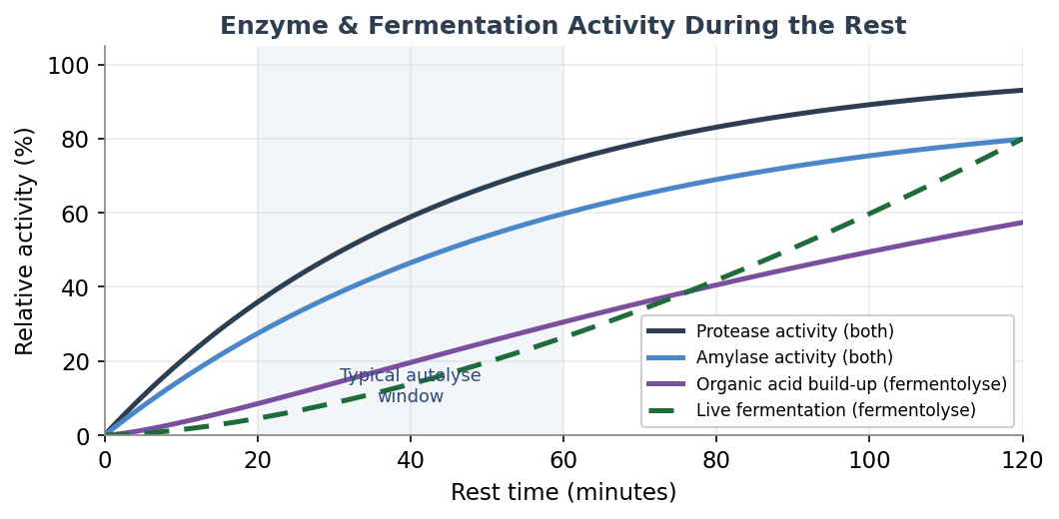
Figure 1 — Relative enzyme activity and fermentation during rest phases. Fermentolyse uniquely adds organic acid build-up (purple) and live fermentation activity (green dashes).

3. Autolyse

3.1 What Is It?
Autolyse was developed by French bread scientist Professor Raymond Calvel in the 1970s. The technique is deceptively simple: combine only flour and water — no salt, no yeast, no starter — and let the mixture rest for 20 to 60 minutes (up to 2 hours for very high-hydration doughs). Nothing else. Then continue with the rest of the recipe.

3.2 What Happens?
- Full hydration of flour particles — even without mixing.
- Protease enzymes begin softening gluten proteins, improving extensibility.
- Amylase enzymes begin converting starches to sugars.
- Gluten bonds form spontaneously — the dough becomes noticeably smoother.
- No fermentation occurs — the process is purely enzymatic and physical.

4. Fermentolyse

4.1 What Is It?
Fermentolyse is a modern variation popularised in the artisan sourdough community. You mix flour, water, AND your sourdough starter during the rest — essentially allowing a low-level fermentation to begin during the hydration phase. Rest times range from 30 minutes to 2 hours, with kitchen temperature playing a much larger role than in autolyse.

4.2 What Happens?
- Everything that happens during autolyse (hydration, protease and amylase activity).
- In addition: lactic acid bacteria (LAB) in the starter begin producing organic acids.
- Wild yeasts begin producing CO₂ and ethanol — fermentation has started.
- Moderate acid levels strengthen the gluten network; high acid levels weaken it.
- Flavour compounds begin developing earlier in the process.

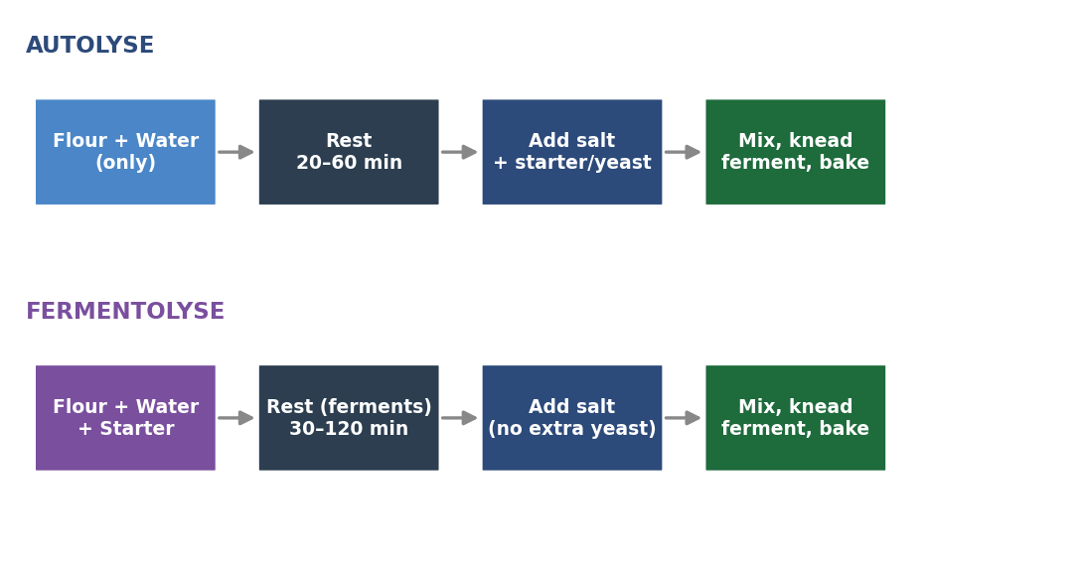
Figure 2 — Process flow for Autolyse (top) vs. Fermentolyse (bottom). Note that salt and commercial yeast are always added after the rest phase in both methods.

5. Side-by-Side Comparison

Feature | Autolyse | Fermentolyse
Ingredients in rest | Flour + Water only | Flour + Water + Starter
Salt included? | No | No
Commercial yeast included? | No | No
Fermentation activity | None | Low-level begins
Gluten development | Hydration + enzymes | Hydration + enzymes + acid
Flavour development | Minimal during rest | Begins during rest
Over-fermentation risk | None | Present in warm kitchens
Control | High | Moderate — temp-dependent
Complexity | Simple | Slightly more involved
Best suited to | All bread types | Sourdough only

6. Pros and Cons

6.1 Autolyse

Pros — Autolyse | Cons — Autolyse
✓ Very safe and predictable — no fermentation risk | ✗ Does not contribute to flavour development
✓ Reduces mixing and kneading time by 30–50% | ✗ Dough can feel slightly slack before salt is added
✓ Improves extensibility — dough is easier to shape | ✗ Less benefit for low-hydration doughs (≤65%)
✓ Better oven spring and open crumb potential | ✗ Minimal benefit for enriched doughs (fat, eggs, sugar)
✓ Works for any bread type — commercial yeast or sourdough | ✗ Adds time to the process without flavour return
✓ Easy to time around your schedule | ✗ Requires separate incorporation of starter later
✓ Ideal for beginners and new recipes

6.2 Fermentolyse

Pros — Fermentolyse | Cons — Fermentolyse
✓ Jumpstarts flavour development — acids build early | ✗ Risk of over-fermentation in warm kitchens
✓ Can improve extensibility/strength balance | ✗ Less predictable — temperature-sensitive
✓ Useful for complex, tangy sourdough flavour profiles | ✗ Extended rest can weaken gluten through over-acidification
✓ Reduces total bulk fermentation time slightly | ✗ Not suitable for commercial yeast bread
✓ Integrates starter evenly before salt is added | ✗ Harder to plan around a rigid schedule
✓ Particularly useful in cool kitchen conditions | ✗ Requires an active, well-fed starter

7. Time & Temperature Reference Tables
Kitchen temperature is the single most important variable in both methods. Warmer temperatures accelerate enzyme activity and — in fermentolyse — fermentation. Use these tables as a starting point and adjust based on your flour, starter activity, and dough hydration.

7.1 Autolyse — Rest Duration by Temperature

Kitchen temp | Minimum rest | Maximum rest | Sweet spot
16°C / 61°F | 55 min | 90 min | 70 min
18°C / 64°F | 50 min | 80 min | 60 min
20°C / 68°F | 40 min | 65 min | 50 min
22°C / 72°F | 35 min | 55 min | 45 min
24°C / 75°F | 28 min | 45 min | 35 min
26°C / 79°F | 22 min | 38 min | 30 min

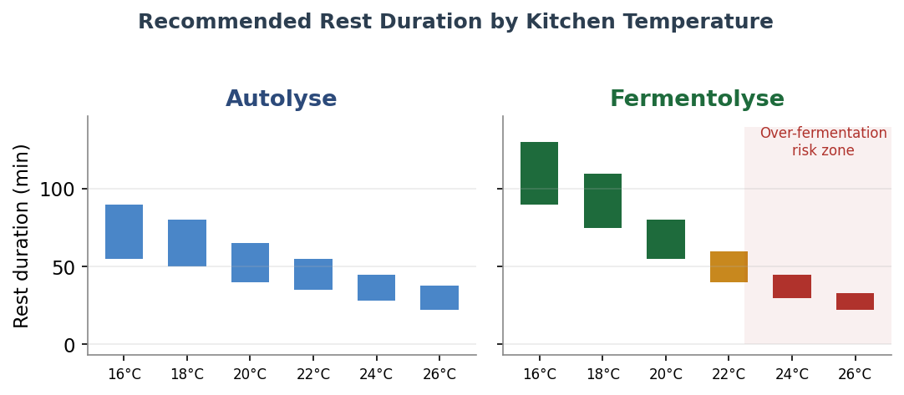
Figure 3 — Recommended rest duration ranges for Autolyse (left) and Fermentolyse (right) at different kitchen temperatures. Note the over-fermentation warning zone for Fermentolyse above 24°C.

7.2 Fermentolyse — Rest Duration by Temperature

Kitchen temp | Minimum rest | Maximum rest | Sweet spot | Risk level
16°C / 61°F | 90 min | 130 min | 110 min | Low
18°C / 64°F | 75 min | 110 min | 90 min | Low
20°C / 68°F | 55 min | 80 min | 65 min | Low
22°C / 72°F | 40 min | 60 min | 50 min | Moderate
24°C / 75°F | 30 min | 45 min | 38 min | High
26°C / 79°F | 22 min | 33 min | 28 min | High

8. Full Bread-Making Timelines
The following timelines show where autolyse and fermentolyse fit within the full baking process for sourdough and commercial yeast bread. Note that sourdough timelines are significantly longer due to the slower fermentation speed of natural leaven.

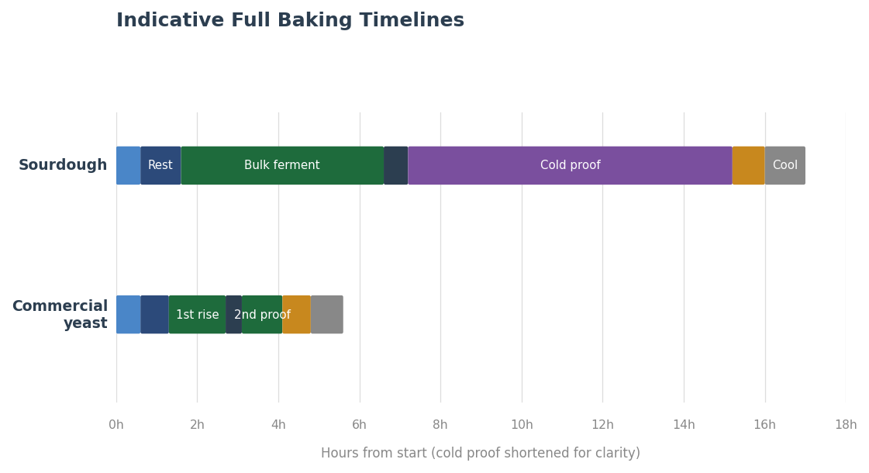
Figure 4 — Indicative timelines for Sourdough (top) and Commercial Yeast bread (bottom). Sourdough typically spans 12–18 hours total including cold proof; commercial yeast 4–6 hours.

8.1 Sourdough Timeline (Fermentolyse)

Phase | Duration | Temperature | Notes
Mix flour + water + starter | 5–10 min | 24–26°C | Rough mix only
Fermentolyse rest | 30–90 min | 24–26°C | Cover; watch in warm kitchens
Add salt, knead / fold | 5–10 min | Ambient | Slap-and-fold or coil folds
Bulk fermentation | 4–6 hours | 24–26°C | Stretch & fold every 30–45 min
Pre-shape | 5 min | Ambient | Gentle, build tension
Bench rest | 20–30 min | Ambient | Covered, let gluten relax
Final shape | 5–10 min | Ambient | Shape to banneton
Cold proof | 8–16 hours | 4°C / 39°F | Develops flavour & structure
Preheat oven + Dutch oven | 45–60 min | 250°C / 480°F | Stone or cast iron
Bake covered | 20 min | 230°C / 450°F | Steam trapped for oven spring
Bake uncovered | 20–25 min | 220°C / 430°F | Until deep crust, hollow sound

8.2 Commercial Yeast Timeline (Autolyse)

Phase | Duration | Temperature | Notes
Mix flour + water (no salt/yeast) | 5–10 min | 20–24°C | Rough mix only
Autolyse rest | 20–45 min | 20–24°C | Cover, do not disturb
Add salt + instant yeast, knead | 8–12 min | Ambient | Window-pane test for gluten
First rise (bulk) | 1–1.5 hours | 24°C / 75°F | Until doubled in volume
Punch down, pre-shape | 5 min | Ambient | Gentle handling
Bench rest | 15–20 min | Ambient | Covered, let gluten relax
Final shape | 5–10 min | Ambient | Shape to tin or free-form
Second proof | 45–60 min | 24–26°C | Until 1.5× original volume
Preheat oven | 20–30 min | 230°C / 450°F | With baking stone if available
Bake with steam | 10–15 min | 230°C / 450°F | Steam pan or spray for crust
Bake without steam | 20–25 min | 210°C / 410°F | Until deep golden, hollow sound
Cool on wire rack | 30–60 min | Room temp | Crumb finishes setting

9. Baking with Ancient Grains
Ancient grains are cereal species that have remained largely unchanged by modern selective breeding. This guide covers six of them. Four are members of the wheat family and contain gluten in varying amounts — Einkorn, Emmer, Spelt and Kamut — while two are unrelated grasses that contain no gluten at all — Teff and Sorghum. Because gluten is the protein network that traps gas and gives bread its rise and chew, this single distinction governs almost everything about how each grain is handled, rested and baked.

9.1 Why Ancient Grains Behave Differently
Within the wheat family, baking behaviour is driven largely by the ratio of two gluten proteins: gliadin (which gives extensibility, i.e. stretch) and glutenin (which gives elasticity, i.e. strength and gas retention). Modern bread wheat has a relatively low gliadin-to-glutenin ratio, so its dough is strong and elastic. The ancient wheats have a much higher proportion of gliadin — in einkorn the ratio can be several times that of modern wheat — which makes their doughs extensible and sticky but weak, slack and prone to tearing. They also ferment and proof faster, and their gluten degrades more quickly if over-mixed or over-acidified.
Teff and Sorghum are not wheat at all. They contain no gluten, so there is no network to develop and the autolyse / fermentolyse concept does not apply in the usual sense. Instead they are worked as batters or blended flours, and structure has to be supplied by a binder (psyllium husk, xanthan gum, or egg) and by starch gelatinisation during baking.

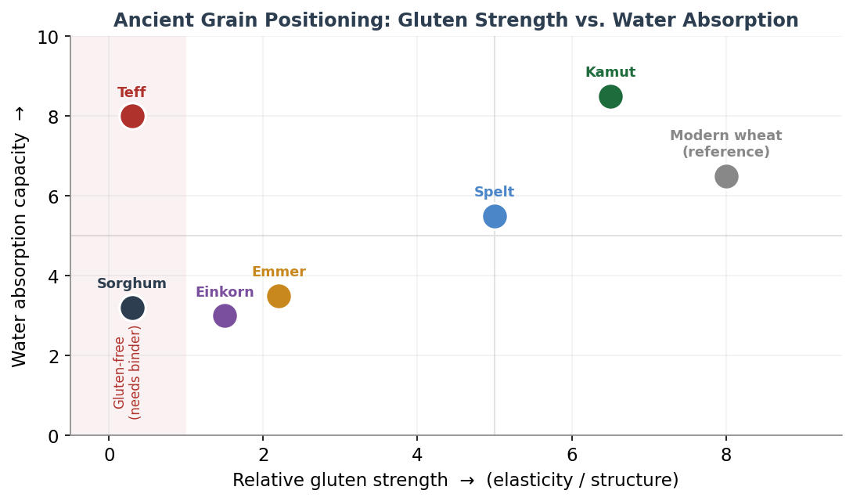
Figure 5 — Where each grain sits on two axes that matter most to the baker: gluten strength (horizontal) and water-absorption capacity (vertical). Grains in the shaded band on the left are gluten-free and require a binder.

9.2 The Six Grains at a Glance

Grain | Botanical / ploidy | Gluten | Flavour | Handling headline
Einkorn | T. monococcum (diploid) | Very weak | Nutty, sweet, golden | Sticky & slack — least water, gentlest hands
Emmer | T. dicoccum (tetraploid) | Weak | Earthy, rustic | Sticky, low elasticity — keep hydration modest
Spelt | T. aestivum ssp. spelta (hexaploid) | Moderate (fragile) | Sweet, wheaty, mellow | Easiest entry; do not overmix or overproof
Kamut | T. turgidum ssp. turanicum (tetraploid) | Strong | Buttery, rich | Thirsty & easy to handle; builds good strength
Teff | Eragrostis tef (grass) | None | Malty, nutty | Gluten-free; whole-grain, needs a binder
Sorghum | Sorghum bicolor (grass) | None | Mild, neutral | Gluten-free; gritty & dry — blend + bind

9.3 Grain-by-Grain Profiles
Einkorn (Triticum monococcum)

Einkorn — original illustration (indicative).
The oldest cultivated wheat and the genetic ancestor of the others — a diploid grain with the most delicate gluten of all. Einkorn dough is markedly sticky, wet and slack, with very little elasticity. It absorbs less water than modern wheat, so hydration should be reduced substantially. It also ferments and proofs quickly. Handle it as little as possible: a brief rest is fine, but a long autolyse only worsens the slackness. Despite the weak gluten, einkorn can rise surprisingly well and bakes into a dense, tender, golden, nutty crumb.
- Hydration: reduce by roughly 10–20% versus your usual wheat recipe.
- Mixing: minimal — mix just to combine, then a few gentle folds; never knead aggressively.
- Rest: skip the autolyse, or keep it to 15 minutes at most.
- Proof: shorter than wheat — watch closely, it over-proofs fast.
Emmer (Triticum dicoccum / farro)
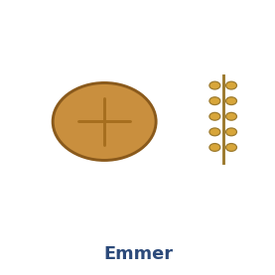
Emmer — original illustration (indicative).
A tetraploid grain, one step up from einkorn in complexity but still weak-gluten. Emmer doughs are sticky and slack with low elasticity, and they tend to lose what little structure they have after long fermentation or cold proofing. The flour can feel slightly gritty depending on milling. Emmer rewards a confident but gentle touch and modest hydration; it carries a deep, earthy, rustic flavour and is excellent blended with a stronger wheat.
- Hydration: reduce by roughly 5–15% versus modern wheat.
- Mixing: gentle folds rather than kneading; stop as soon as the dough comes together.
- Rest: a short autolyse of up to 20 minutes is helpful for bran hydration.
- Blending: 30–50% emmer with bread wheat gives flavour while keeping structure.
Spelt (Triticum aestivum ssp. spelta)
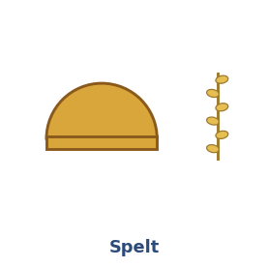
Spelt — original illustration (indicative).
A hexaploid wheat closely related to modern bread wheat, and therefore the easiest ancient grain to start with — it can often substitute for wheat at a 1:1 ratio. Its gluten is present and reasonably strong but fragile: it hydrates and builds strength quickly, then breaks down just as quickly if you keep going. The classic spelt mistakes are over-mixing and over-proofing. Reduce water slightly, mix to just-developed, and proof a little short. The reward is a high rise, a crisp crust and a sweet, mellow, wheaty flavour.
- Hydration: similar to wheat or 5% lower; spelt absorbs water fast, so add it gradually.
- Mixing: short — stop the moment the dough is smooth; over-mixing destroys the gluten.
- Rest: a 20–30 minute autolyse works well; fermentolyse suits whole spelt sourdough.
- Proof: err slightly on the short side to avoid a dense, collapsed crumb.
Kamut (Khorasan wheat, Triticum turgidum ssp. turanicum)
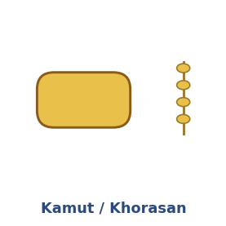
Kamut / Khorasan — original illustration (indicative).
A large-kernelled tetraploid ancestor of durum wheat with high protein and, unusually for an ancient grain, strong and forgiving gluten. Bakers often describe Kamut as a dream to work with: it builds excellent strength and is very thirsty, readily taking extra water without becoming unmanageable. The flour is golden and the flavour rich and buttery. Treat it much like a strong modern wheat, but be ready to add more water than usual and to watch the proof, as it can be slightly under-sprung if rushed.
- Hydration: increase by roughly 5–15%; add water progressively until the dough is supple.
- Mixing: normal kneading is fine — Kamut tolerates and benefits from gluten development.
- Rest: a full autolyse of 30–45 minutes improves extensibility.
- Proof: give it adequate time; under-proofed Kamut bakes a little tight.
Teff (Eragrostis tef) — gluten-free
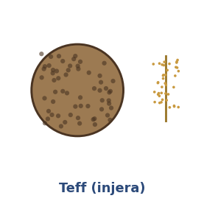
Teff (injera) — original illustration (indicative).
A tiny East-African grass seed, the traditional grain of Ethiopian injera. It is always used whole-grain (the seed is too small to refine), is rich in iron, calcium and fibre, and has a malty, lightly nutty flavour. Teff contains no gluten, so it cannot form a kneadable dough; it is worked as a batter. For the traditional flatbread it is fermented as a thin batter for one to three days and baked on a hot griddle. For raised loaves it must be blended with other gluten-free flours and a binder.
- Form: batter, not dough — hydration is effectively 90–120% or more.
- Binder: psyllium husk, xanthan gum or egg is essential for any raised loaf.
- Rest: allow a 20–60 minute hydration rest (a “soaker”) so the flour fully absorbs liquid.
- Mixing: whisk to combine; do not over-work, which can make the crumb gummy.
- Use: injera and other flatbreads, or 20–30% of a gluten-free flour blend for flavour and nutrition.
Sorghum (Sorghum bicolor) — gluten-free
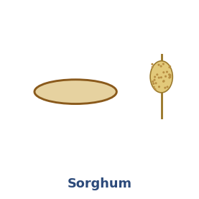
Sorghum — original illustration (indicative).
A mild, neutral-flavoured, pale gluten-free grain that is a workhorse base flour in gluten-free blends. Its drawback is a high starch-gelatinisation temperature and low water-holding capacity, which tend to give a dry, gritty, crumbly texture when used alone. It is therefore almost always blended (with rice, teff or starches) and combined with a binder and extra moisture. Waxy (high-amylopectin) sorghum varieties hold water better and stale more slowly, and are preferable where available.
- Form: batter or blended flour; never a stand-alone kneaded dough.
- Binder: required — psyllium or xanthan plus added moisture to offset its dryness.
- Blending: typically 30–50% of a gluten-free mix; pair with teff or rice for texture.
- Rest: a 30–60 minute soaker improves hydration and reduces grittiness.
- Tip: choose waxy sorghum for softer, longer-keeping results.

9.4 Adapting Autolyse & Fermentolyse for Ancient Grains
The resting techniques in this guide were designed around modern bread wheat. They still apply to ancient grains — but only after adjustment, and only to the gluten-bearing ones. The figure below summarises the two distinct workflows.

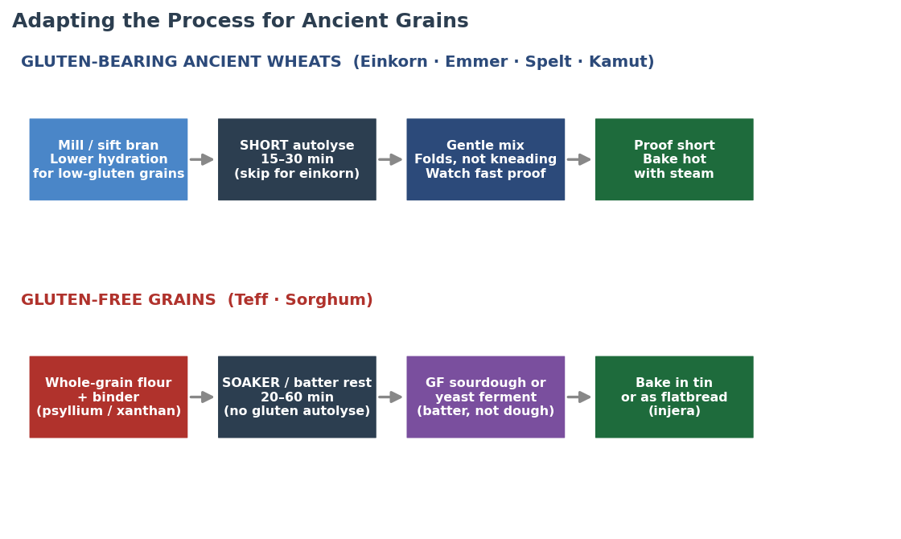
Figure 6 — Two workflows. Gluten-bearing ancient wheats (top) use a shortened, gentler version of the standard process; gluten-free grains (bottom) replace autolyse with a soaker and are fermented and baked as batters.

Gluten-bearing ancient wheats (Einkorn, Emmer, Spelt, Kamut)
- Shorten the rest. Because gliadin-rich gluten is already extensible and degrades quickly, a long autolyse is counter-productive for the weakest grains. Skip it for einkorn, keep it brief (≤20 min) for emmer, 20–30 min for spelt, and a full 30–45 min only for strong, thirsty Kamut.
- Adjust hydration grain by grain. Lower it for einkorn and emmer, hold or slightly lower for spelt, raise it for Kamut. Add water gradually — these flours respond fast.
- Use fermentolyse with care. It still benefits whole-grain spelt and Kamut sourdough, where the acids help manage bran cutting into gluten, but it accelerates an already-fast fermentation. For einkorn and emmer in a warm kitchen, prefer a plain short autolyse or no rest at all.
- Replace kneading with folding. Gentle stretch-and-folds build what structure these grains can hold without tearing the fragile network; aggressive kneading breaks it down.
- Proof short and bake hot. All four proof faster than modern wheat — watch the dough, not the clock — and bake with steam for good oven spring.
Gluten-free grains (Teff, Sorghum)
- There is no gluten autolyse. With no gluten to develop, the autolyse / fermentolyse logic does not apply. Use a soaker instead: rest the flour in its liquid for 20–60 minutes so it fully hydrates and the crumb is less gritty.
- Build structure with a binder. Psyllium husk or xanthan gum (or egg) replaces the role of gluten, holding gas and giving the loaf its shape.
- Ferment as a batter. Gluten-free sourdough or yeast fermentation happens in a pourable batter, not a shapeable dough — exactly as in traditional teff injera, which is fermented one to three days.
- Blend for best results. Both grains shine in blends — teff for flavour and iron, sorghum as a mild base — often with rice flour or starch for lightness.
- Bake in a tin or as flatbread. A batter needs the support of a tin for loaves, or is poured thin and griddled for injera and similar flatbreads.

9.5 Hydration, Rest & Handling Reference
A quick reference for adapting your process to each grain. Treat the hydration figures as starting adjustments relative to your usual modern-wheat recipe, then fine-tune to the dough.

Grain | Hydration vs. wheat | Rest / autolyse | Mixing | Over-proof risk
Einkorn | −10 to −20% | Skip or ≤15 min | Minimal — folds only | High
Emmer | −5 to −15% | ≤20 min | Gentle folds | High
Spelt | Same to −5% | 20–30 min | Short; stop early | Moderate
Kamut | +5 to +15% | 30–45 min | Normal — takes work | Moderate
Teff | Batter (90–120%) | Soaker 20–60 min | Whisk; do not knead | None (no gluten)
Sorghum | Batter (+ extra water) | Soaker 30–60 min | Whisk; needs binder | None (no gluten)

9.6 Troubleshooting Ancient Grain Doughs
- Dough is soup-like and will not hold shape (einkorn/emmer): hydration is too high and/or the rest was too long. Reduce water by 10–15% and skip the autolyse.
- Spelt loaf collapsed or is dense: over-proofed or over-mixed. Shorten both the mix and the final proof next time.
- Kamut dough feels tight and dry: it is thirsty — add more water gradually until supple.
- Gluten-free loaf is gummy inside: under-baked or too little binder — bake longer to a higher internal temperature and check the psyllium/xanthan quantity.
- Sorghum bread is gritty and crumbly: add a soaker, increase moisture, blend with finer flour, and prefer waxy sorghum.
- Ancient-grain sourdough turns sour and slack too fast: fermentation is running ahead — cut the bulk and proof times and lower the dough temperature.

10. Baking with Grain Blends
Few bakers work with a single ancient grain at 100%. In practice the most reliable, best-tasting loaves come from blends — combining the flavour and nutrition of ancient or specialty grains with enough strong wheat (or a binder, for gluten-free mixes) to carry structure. This section explains how blending changes every stage of the process, from the rest through to the bake, and gives quantitative starting points for the four blend families you are most likely to use.

10.1 The Gluten Budget — the One Idea Behind Every Blend
Bread structure depends far more on glutenin (which gives elasticity and traps gas) than on total protein. This is the key to understanding blends, and it explains an apparent paradox: ancient wheats are often higher in total protein than modern bread wheat, yet they make weaker dough. The reason is the ratio of the two gluten proteins. Modern wheat has a low gliadin-to-glutenin ratio (roughly 1.5 to 3.8), so its dough is strong and elastic. Ancient wheats are gliadin-heavy — the ratio climbs through spelt and emmer up to around 12 for einkorn — so their dough is extensible, sticky, slack and fragile.
Think of every recipe as having a gluten budget. Strong modern wheat deposits into it; low-gluten ancient grains, and especially gluten-free flours, draw it down. The art of blending is keeping the budget high enough to hold structure while letting the flavour grain dominate. Once the low-gluten fraction climbs past roughly 40%, you compensate — by adding water for the thirstier grains, switching from kneading to gentle folds, supporting the dough in a banneton or tin, shortening the rest and the proof, and accepting a denser crumb. Above about 60% you usually add a structure aid (vital wheat gluten for wheat blends, psyllium or xanthan for gluten-free).

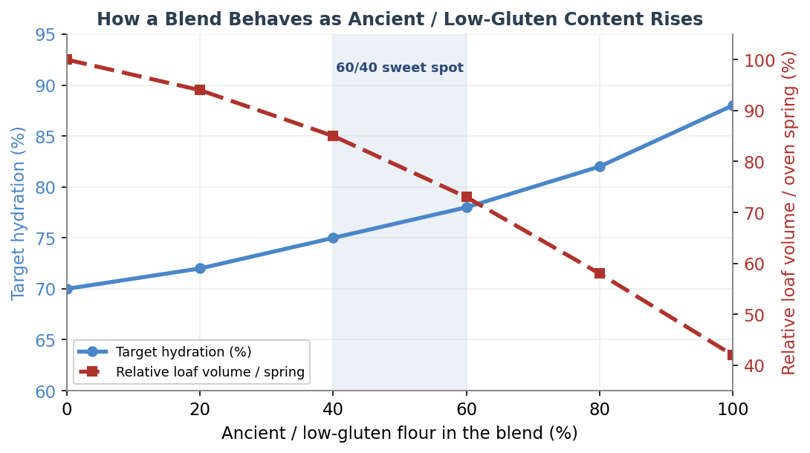
Figure 7 — As the ancient or low-gluten fraction of a blend rises, target hydration climbs (thirstier bran and starch) while loaf volume and oven spring fall. The 40–60% band is the practical sweet spot where flavour dominates but structure still holds.

10.2 Why 60/40 Is the Classic Ratio
The most widely recommended starting point for an ancient-grain loaf is roughly 60% ancient grain to 40% strong white wheat. The 40% high-protein wheat supplies just enough glutenin backbone for a buoyant, sliceable crumb, while 60% ancient flour lets its flavour, colour and aroma lead. Bakers who have trialled the same recipe at 20%, 40% and 100% whole ancient grain consistently land on around 40% whole grain as the best balance of an open, fluffy crumb and whole-grain character — the 20% version is barely distinguishable from white, while a 100% loaf can be so slack it almost pours into the basket. If your only wheat flour is weak (around 10% protein), top up the budget with vital wheat gluten (see Section 11).

10.3 Four Families of Blend
(a) Ancient grain + white wheat — the structure-retaining classic
This is the 60/40 approach and its neighbours. The white wheat carries the loaf, so the process stays close to a normal wheat bake: a standard 30–45 minute autolyse works, hydration sits around 70–78% for a sourdough, and you can shape free-form. Expect good oven spring, with slightly faster crust browning from carotenoid-rich grains like einkorn and Kamut. This family is the most forgiving and the best place to start.
(b) Ancient grain + wholegrain wheat — maximum flavour and nutrition
Replacing the white wheat with wholemeal pushes everything toward the whole-grain end: more flavour and fibre, a thirstier dough, faster fermentation and a denser crumb. A useful rule of thumb is to add roughly 3–4% water for every 25% wholegrain flour you introduce. A long autolyse (one to two hours) or a separate soaker of the wholegrain fraction helps the bran hydrate and stop it cutting the gluten. Drop the desired dough temperature to around 23°C / 75°F, because wholegrain ferments vigorously and over-proofs readily.
(c) Ancient + ancient — stacking the weaknesses
Combining two ancient grains (emmer with spelt, einkorn with Kamut, spelt with Kamut) gives wonderful flavour but no strong-wheat backbone, so structure is the challenge. Let the thirstiest partner set the hydration — a spelt-and-Kamut dough can climb well above 80% because Kamut is so absorbent. Handle gently, support the loaf in a banneton or tin, and consider a small dose of vital wheat gluten (around 1%, with a matching increase in water) or a scald of part of the flour to firm things up. Of the ancient grains, Kamut behaves best and makes the most dependable structural partner.
(d) Ancient or wheat + gluten-free — two different worlds
There are two cases here. A small amount of a gluten-free grain (up to roughly 20–25% teff or sorghum) added to a wheat or ancient dough lends flavour, colour and nutrition while the wheat still carries structure — sorghum in particular is best capped around 25% before the crumb turns dry and tight. But a fully gluten-free blend (for example teff with sorghum and rice, or buckwheat with quinoa and millet) has no gluten budget at all. It is not kneaded dough but a batter, and structure must be rebuilt from a base flour, a starch and a binder. See Section 11.4 for the gluten-free architecture.

10.4 Blend Reference Table — Process Adjustments by Ratio
The table below gives indicative starting points for how the process shifts as the low-gluten or gluten-free fraction of the blend rises. Treat hydration as an adjustment relative to your usual modern-wheat recipe, then fine-tune to the dough in your hands.

Blend (low-gluten %) | Hydration vs. wheat | Autolyse / rest | Mixing | Bulk & proof | Expected volume
0% (all strong wheat) | Baseline | 30–45 min | Full kneading | Standard | Full
20% | +0 to +3% | 30–45 min | Knead, light folds | Slightly faster | Near full
40% | +3 to +6% | 20–40 min | Folds preferred | Faster | Good
60% (sweet spot) | +5 to +10% | 15–30 min | Gentle folds | Watch closely | Moderate
80% | +8 to +15% | 0–20 min | Minimal; folds only | Fast; over-proofs | Reduced
100% ancient | Grain-specific | Skip or ≤15 min | Just combine | Very fast | Low / dense
Gluten-free blend | Batter (90%+) | Soaker only | Whisk; needs binder | Single batter rise | Tin / flatbread

10.5 Stage-by-Stage: What Changes in a Blend
- Autolyse / fermentolyse: white-dominant blends take a normal 30–45 minute rest; high-wholegrain blends benefit from a longer 1–2 hour autolyse or a soaker; above roughly 30% rye, einkorn or sprouted flour, shorten or skip the rest because the gluten is fragile and enzyme activity is high.
- Hydration: raise it for thirsty grains (wholegrain wheat, Kamut, rye, sorghum) and lower it for slack einkorn; add water gradually, as blends respond quickly.
- Mixing: the more low-gluten flour, the more you favour stretch-and-folds over kneading — aggressive kneading tears the weak network rather than building it.
- Bulk fermentation: bran and germ feed the yeast, so blends ferment faster than white dough; reduce the desired dough temperature and watch the dough, not the clock.
- Proofing: more ancient or wholegrain flour means a shorter proof and a higher over-proof risk; under-proof slightly rather than over-proof.
- Shaping: expect stickier, slacker dough as the low-gluten fraction rises; use wet hands, a bench knife and banneton or tin support.
- Baking: bake wholegrain and ancient blends a little cooler (around 190–220°C / 375–425°F) and tent with foil if the crust browns before the crumb sets; steam the first 15–20 minutes for spring and crust. Expect less oven spring and a tighter crumb than a white loaf.

10.6 A Worked Example — 60% Emmer / 40% White Wheat Sourdough
To make the principles concrete, here is how the 60/40 emmer blend from the brief would run through the full process. Quantities are in baker's percentages (flour totals 100%).
- Flour: 60% wholegrain emmer, 40% strong white bread flour. Water: start at 75% (emmer is moderately thirsty but its weak gluten will not hold the very highest hydrations). Starter: 20% ripe levain. Salt: 2%.
- Rest: a short 20-minute autolyse of the flours and water only — long enough to hydrate the emmer bran, short enough not to slacken the dough further.
- Mix & bulk: add levain and salt, then 3–4 sets of gentle coil folds in the first 2 hours. Bulk about 4–5 hours at 24–26°C — noticeably faster than an all-white dough.
- Shape & proof: shape with a light touch into a banneton for support; cold proof 10–14 hours at 4°C rather than a long warm proof, to limit over-proofing and firm the dough for scoring.
- Bake: 250°C / 480°F in a covered Dutch oven, 20 minutes covered, then 20–25 minutes uncovered at 225°C / 435°F. Expect a rustic, earthy loaf with a moderately open crumb and a faster-browning crust.

11. An Expanded Grain Library — Modern & Ancient
Blending is only as good as your knowledge of the grains you reach for. This section adds the common modern bread grains and several further ancient and gluten-free grains to the six profiled in Section 9, so you can choose blend partners with confidence. Each grain is described by its gluten status, flavour, behaviour and typical role in a blend. Protein figures are indicative and vary widely with cultivar, growing conditions and milling extraction.

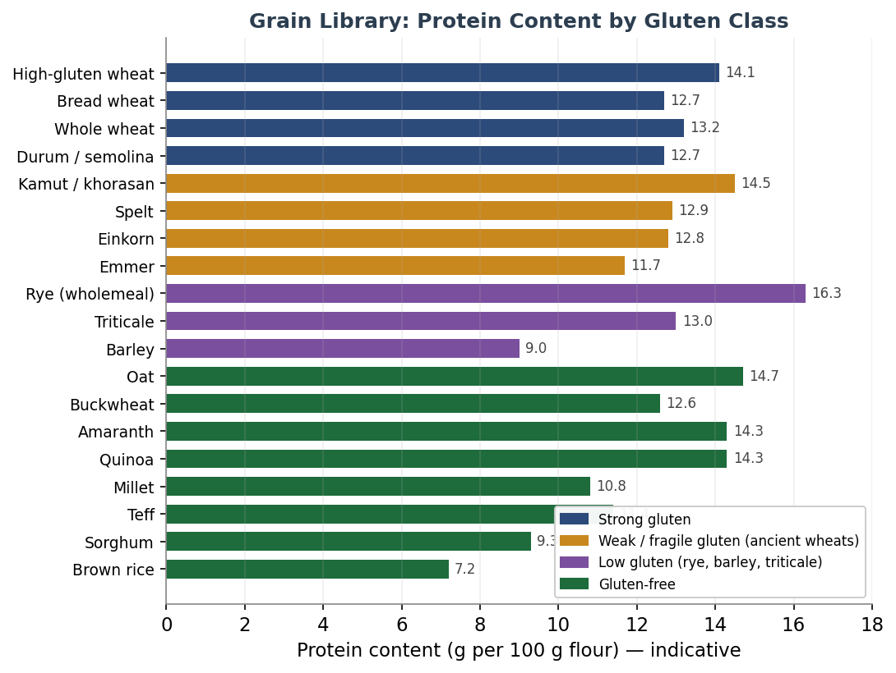
Figure 8 — Indicative protein content of the grain library, coloured by gluten class. Note that protein content alone does not predict structure: rye and the ancient wheats can be high in protein yet weak in dough, because structure depends on glutenin quality, not total protein.

11.1 Gluten-Strong Grains (the structural backbone)
Modern bread wheat (Triticum aestivum)
The reference baseline and the strongest, most reliable structure-builder. Its balanced gliadin-to-glutenin ratio (roughly 1.5–3.1) makes it the dependable carrier in almost every blend. Bread flour runs about 12.7% protein, all-purpose about 11.7%, and high-gluten flour 14% or more. It is the wheat that deposits most into the gluten budget.
Whole wheat / wholemeal
The whole grain of common wheat, around 13.2% protein, but the bran physically cuts gluten strands so its effective strength is lower than the protein figure suggests. It is thirstier and ferments faster than white flour. Commonly used up to 50% with no other change; for higher proportions, add water and lengthen the autolyse.
Durum / semolina (Triticum durum)
Pasta wheat, also the basis of southern Italian breads such as the protected Pane di Altamura. High in protein (semolina about 12.7%, the grain around 14%) with a deep golden colour and sweet, nutty flavour, but its gluten is strong-yet-inextensible, so it needs gentle, slightly longer mixing and a 30–60 minute autolyse to hydrate fully. Often used at 80% durum with 20% bread flour, or blended to lend colour and chew.

11.2 Low-Gluten & Specialty Grains
Rye (Secale cereale)
Rye is the great exception. Its gluten is weak, and structure instead comes from pentosans (arabinoxylans) — gums that absorb a great deal of water and give rye dough its characteristic sticky, paste-like body. Rye is thirsty (a 100% rye dough can need 90–100% hydration or more), ferments fast, and is high in enzymes, so it is almost always worked as a sourdough to keep the crumb from turning gummy. Kneading does nothing useful — mix only until combined. As a blend partner, 20–30% rye adds flavour and keeping quality while wheat still carries structure; add about 3% extra water per 10% rye, and shorten the rest.
Barley (Hordeum vulgare)
Low in functional gluten (about 7–10% protein) but rich in beta-glucan, a soluble fibre that boosts water absorption and dough viscosity while reducing loaf volume. Mild and slightly sweet; best as a minority flour (up to roughly 10–25%) for flavour and nutrition rather than structure.
Triticale (×Triticosecale)
A wheat-rye hybrid with moderate but lower-quality gluten (often above 13% protein) and more lysine than either parent. It is more workable than rye but less so than wheat, and it is high in alpha-amylase, so ferment and proof a little cooler and shorter. Common blends are 50:50 or 70:30 with wheat.

11.3 Gluten-Free Grains & Pseudocereals
None of these forms a gluten network. They are used in gluten-free blends or, in small amounts, as flavour and nutrition boosters in wheat doughs. The three pseudocereals (buckwheat, amaranth, quinoa) are botanically not grasses at all.
Oat (Avena sativa)
Gluten-free in pure form (though often cross-contaminated), about 14.7% protein and rich in beta-glucan. Adds moisture, softness and a gentle sweetness; used at 5–25% in wheat blends to increase water absorption and stability, or as part of a gluten-free mix.
Buckwheat (Fagopyrum esculentum)
An assertive, earthy pseudocereal (about 12.6% protein) high in lysine. Can anchor a gluten-free batter loaf with psyllium, or add depth at 10–30% of a blend. Its strong flavour is divisive — use it deliberately.
Amaranth (Amaranthus spp.)
A tiny, mineral-rich pseudocereal with a complete protein profile and almost no prolamin, so it cannot leaven alone. Nutty and slightly peppery; best as a minority component (up to about 25%) of a gluten-free blend for nutrition.
Quinoa (Chenopodium quinoa)
A complete-protein pseudocereal (about 14% protein) with an assertive, slightly bitter flavour that mellows on baking. Pairs with millet and buckwheat in gluten-free loaves; rinse or toast to tame the saponin bitterness.
Millet (Panicum miliaceum)
Mild, slightly sweet and pale (about 10.8% protein), millet is a friendly, neutral base for gluten-free blends and adds a tender crumb and gentle corn-like note. Needs soaking and a binder.
Rice, corn & fonio
Rice flour (brown about 7.2%, white about 6% protein) is the neutral workhorse base of most gluten-free blends, often around 60% of the mix. Corn/maize adds colour and a sweet note in flatbreads. Fonio, a fine West African ancient grain, is gluten-free but forms unusually strong gels, making it a promising structural element in gluten-free baking.

11.4 Building Structure Without Gluten
Gluten-free blends abandon the gluten budget entirely and rebuild structure from three parts: a base flour for body and flavour, a starch for lightness, and a binder to trap gas and hold the crumb together. A reliable framework is roughly 70% base flour, 25% starch and 5% protein or binder. Psyllium husk is the standout binder — research on gluten-free bread found it cut crumb firmness by 65–75% over three days of storage and substantially slowed staling, working as a gel that mimics gluten's gas-trapping role. A typical dose is about 5 g of blond psyllium husk per 100 g of flour, hydrated in roughly ten times its weight of water. Xanthan gum and eggs play a similar structural role.

Component | Role | Typical share | Examples
Base flour | Body, flavour, nutrition | ~70% | Rice, sorghum, teff, buckwheat, millet
Starch | Lightness, soft crumb | ~25% | Tapioca, potato, corn starch
Binder / protein | Traps gas, holds structure | ~5% | Psyllium, xanthan, egg

11.5 Vital Wheat Gluten — Topping Up the Budget
For wheat and ancient blends that fall short on structure, vital wheat gluten (VWG) is the simplest fix. It is wheat protein isolated to about 80% gluten, and it raises the dough's elasticity and gas-holding directly. (It is not an option for gluten-free baking — it is pure gluten.)
- Dosage: roughly 1–4% of flour weight for most breads; up to higher levels in very high-fibre or high-ancient blends.
- The math: VWG is about 80% protein, so adding roughly 1.5 g per 100 g of flour raises the flour's protein by about one percentage point. To take a 10% flour to 13%, add about 5 g per 100 g.
- Always add a matching amount of water — VWG is thirsty, and it will tighten the dough if you do not.
- Best used in rye, oat, teff, spelt, einkorn, emmer and buckwheat blends, where it lightens an otherwise dense crumb and improves rise.

A blend is a negotiation: flavour grain for character, strong wheat or a binder for structure. Know each grain's gluten budget, and you can blend with intent rather than by guesswork.

12. When to Use Which Method
Use this decision guide to choose the right method for your bake. The key variables are bread type, kitchen temperature, hydration level, flour type, and your flavour goals. The final rows cover the ancient grains added in this edition.

Situation | Recommendation | Notes
Commercial yeast, hydration ≥65% | Autolyse 20–45 min | Reduces kneading time
Commercial yeast, hydration <65% | Skip — not needed | Gluten forms easily
Enriched dough (brioche, milk bread) | Skip both | Fat interferes with gluten
Whole grain or rye-heavy dough | Autolyse 45–60 min | Bran needs longer hydration
Sourdough — beginner / new starter | Autolyse | Safe, predictable
Sourdough — high hydration ≥75% | Either method | Both work well
Sourdough — cool kitchen <20°C | Fermentolyse | Lower fermentation risk
Sourdough — warm kitchen >24°C | Autolyse | Avoid over-fermentation
Sourdough — complex tangy flavour | Fermentolyse | Acids build earlier
Sourdough — mild open crumb | Autolyse | Cleaner gluten development
Sourdough — whole wheat / spelt | Fermentolyse | Acids manage bran cutting
Stiff sourdough ≤68% hydration | Autolyse | Fermentolyse risk higher
Spelt or Kamut sourdough | Short autolyse 20–30 min | Strong-ish gluten; do not overdo
Einkorn or Emmer (low gluten) | Skip or ≤15 min autolyse | Long rest worsens slack dough
Teff / Sorghum (gluten-free) | Soaker + GF ferment | Autolyse concept does not apply

13. Professional Baker’s Tips
Golden Rules
- Never include salt in either rest period — salt tightens gluten and competes with hydration.
- Always cover the dough during the rest to prevent skin formation.
- Use your dough temperature as your primary guide, not your clock.
- For fermentolyse, use a starter at peak activity — not freshly fed and not past peak.
- When in doubt, go shorter rather than longer — you can add time, but you cannot reverse over-fermentation.

Working with Ancient Grains
- Match the technique to the grain: shorten or skip the rest for low-gluten wheats, lengthen for Kamut, and use a soaker for gluten-free grains.
- Add water gradually — einkorn and emmer want less, Kamut wants more, and all of them respond quickly.
- Favour gentle folds over kneading for the fragile-gluten grains; reserve full kneading for Kamut.
- Blend ancient flour with strong bread wheat (a 50–60% ancient to 40–50% wheat ratio is a reliable starting point) for flavour with dependable structure.
- For teff and sorghum, never skip the binder — it does the structural job gluten cannot.

Temperature Control
- If your kitchen is above 25°C, use cold water to control dough temperature.
- The ideal dough temperature for sourdough is 24–26°C — a probe thermometer is a worthwhile investment.
- In winter kitchens below 18°C, extend rest times and consider slightly warm water.

Troubleshooting (general)
- Dough feels weak after fermentolyse: starter was too active or rest too long. Reduce rest by 20–30%.
- Dough still stiff after autolyse: hydration may be low for the flour. Extend rest or add a little water.
- Bread lacks flavour despite fermentolyse: starter may have been underfed. Ensure peak activity before use.
- Over-proofed dough during fermentolyse: kitchen too warm. Switch to autolyse or move to a cooler spot.

14. Quick Reference Summary

 | Autolyse | Fermentolyse
Best for | All bread types | Sourdough only
Includes starter? | No | Yes
Typical duration | 20–60 min | 30–120 min
Key benefit | Control & extensibility | Flavour complexity
Temperature sensitivity | Low | High
Beginner-friendly? | Yes | Once experienced
Ancient low-gluten grains | Shorten or skip | Use with care
Gluten-free grains | Use a soaker instead | GF sourdough (batter)
Risk | Very low | Moderate

“Autolyse for control. Fermentolyse for flavour. For ancient grains — know your grain first.”
If you are new to a recipe, working in a warm environment, or using a very active starter, autolyse is your safe harbour. Once you know your dough, your starter and your kitchen, fermentolyse becomes a powerful tool for early flavour. And whenever you reach for an ancient grain, let its gluten — weak, moderate, strong, or absent — decide how you handle it. Both rest techniques reward patience: the real work happens while you step away from the dough.

15. Grain Encyclopedia — Characteristics, Taste & Usage
The earlier sections explain how each grain behaves in the dough. This closing reference is about the grains themselves — what they taste like, where they come from, how they nourish, and what they are traditionally baked into. It gathers the deeper findings on flavour, culinary usage, nutrition, history and practical handling for every grain in the guide, so you can choose not just by gluten budget but by character. Nutritional figures are indicative per 100 g and vary with variety, growing conditions and milling; flavour notes are drawn from baking and food-science sources and from how each grain is used in its home cuisine.

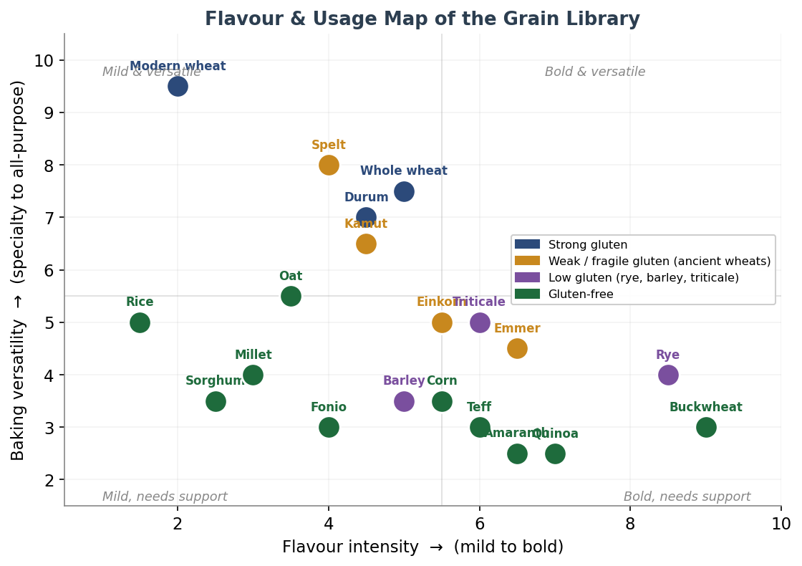
Figure 9 — A flavour-and-usage map of the whole library. The horizontal axis runs from mild to bold; the vertical axis from specialty grains (used in small proportions or needing support) to all-purpose flours that can carry a loaf alone. Modern wheat sits top-left — mild and endlessly versatile; rye and buckwheat sit far right — bold and best used with intent.

15.1 The Ancient Wheats
Einkorn (Triticum monococcum)
The first wheat humanity ever cultivated, domesticated roughly 10,000 years ago in the Karacadağ mountains of south-eastern Turkey. Every modern wheat traces its lineage back to einkorn or its wild ancestor; eating it is about as close as you can get to the bread of the Neolithic. It is a diploid grain (two sets of chromosomes rather than modern wheat’s six), and it has never been hybridised.
- Taste: rich, buttery and subtly sweet, with an almost egg-like warmth that comes from its carotenoids — a world away from the neutral-to-bitter note of modern whole wheat. Bakers consistently rank it among the best-tasting of all grains.
- Appearance: a distinctive golden-yellow flour and crumb, from three to eight times the lutein and zeaxanthin of modern wheat. Small kernels and small flour particle size.
- Nutrition: high in protein (often 16% or more), rich in lutein (an eye-health antioxidant), and notably higher in zinc, iron and manganese than modern wheat. Many with non-coeliac wheat sensitivity tolerate it better, though it is NOT gluten-free or coeliac-safe.
- Usage: best in tender, flavour-forward bakes — pasta, pancakes, cakes, cookies and enriched doughs — and blended into sourdough for colour and flavour. Its weak, sticky gluten makes 100% loaves dense, so many bakers blend it with stronger wheat.
- Practical: absorbs less water than modern wheat; ferments and proofs fast; the flour is best milled fresh and used promptly. Grows well in poor soils and resists fungal disease, suiting low-input organic farming.
Emmer (Triticum dicoccum / farro)
A tetraploid hulled wheat, one of the founder crops of the Fertile Crescent and the staple grain of Pharaonic Egypt — it is widely thought the word “farro” descends from the same root as “pharaoh.” In Italy it is farro medio, the “true” farro, distinct from einkorn (farro piccolo) and spelt (farro grande).
- Taste: deep, earthy, nutty and robust, with a satisfying chew when the whole berries are cooked. Its rustic flavour shines when charred over high heat.
- Nutrition: high in protein and fibre — often cited at nearly twice the fibre of common wheat — and a good source of magnesium, iron, zinc, copper, vitamin B1 and niacin, plus carotenoids and polyphenols.
- Usage: excellent in whole-berry form for soups and grain salads (a Tuscan and Umbrian tradition), as pasta (it is an ancestor of durum), and in flatbreads such as pita and naan where its low gluten is no handicap. Blended at 30–50% it lends flavour to sourdough.
- Practical: low, fragile gluten of poor baking strength, so 100% loaves are dense; the flour can feel slightly gritty; absorbs a little less water than modern wheat; a dream for home milling.
Spelt (Triticum spelta / dinkel)
A hexaploid ancient wheat closely related to modern bread wheat, cultivated in Europe since at least the fifth millennium BC and known in German as Dinkel. The easiest ancient grain to bake with, and the usual gateway for newcomers.
- Taste: gently sweet and distinctly nutty, with a honeyed, toasted-nut quality — more nuanced and less one-dimensional than ordinary whole wheat, which some find slightly bitter by comparison.
- Nutrition: a good source of protein, fibre, iron, magnesium, zinc, calcium and vitamin E. Its gluten is more water-soluble and fragile than modern wheat’s, which is part of why many people report it sits more easily on the stomach (though, again, it is not gluten-free).
- Usage: remarkably versatile — bread, sourdough, muffins, cookies, pancakes, pasta and pie crust. Often substituted 1:1 for wheat flour; whole spelt rises better and lighter than ordinary wholemeal.
- Practical: absorbs slightly more water than white flour but less than whole wheat; its fragile gluten breaks down quickly, so mix gently and don’t over-prove. Whole spelt spoils faster owing to oils in the bran.
Kamut / Khorasan (Triticum turanicum)
A large-kernelled tetraploid wheat closely related to durum, sold under the trademark KAMUT® (a guaranteed-organic, never-hybridised brand of khorasan wheat grown chiefly in Montana and the Canadian prairies). Its kernels are about twice the size of modern wheat, with a golden amber colour and a colourful “Egyptian tomb” origin legend.
- Taste: smooth, rich, buttery and naturally sweet with a nutty depth — the sweetness offsets the slight bitterness sometimes found in modern wheat, and loaves stay sweet even after a long cold prove.
- Nutrition: one of the highest-protein wheats (about 14–15%, sometimes over 16%), with a notably high lipid content (its “high-energy” reputation) and an exceptional selenium content — a single cooked cup can supply most of a day’s selenium — plus zinc, magnesium and a diverse polyphenol profile.
- Usage: versatile in both sweet and savoury baking — bread, pretzels, cookies, muffins, crepes and waffles — and excellent as whole berries in salads and bowls, or even brewed into beer.
- Practical: the best-behaved ancient wheat for structure: strong, forgiving gluten, but very “thirsty”, so add more water than usual. Its gluten differs from modern wheat’s and is often tolerated by the wheat-sensitive.

15.2 Modern Wheat & Close Relatives
Modern bread wheat (Triticum aestivum)
The hexaploid grain behind the overwhelming majority of the world’s bread — the product of a century of breeding for yield, disease resistance and dependable, strong gluten. It is the baseline every other grain in this guide is measured against.
- Taste: mild and neutral, which is exactly why it is so versatile: it carries other flavours rather than competing with them. Whole-wheat versions are nuttier but can read slightly bitter.
- Nutrition: bread flour is about 12.7% protein, all-purpose about 11.7%; a balanced gliadin-to-glutenin ratio gives the strongest, most reliable structure. Refined flour loses much of the bran and germ; enriched flours add back B vitamins and iron.
- Usage: everything — lean breads, enriched doughs, cakes, pastry. Higher-protein bread and high-gluten flours for chewy, lofty loaves; lower-protein cake and pastry flours for tenderness.
Whole wheat / wholemeal
The whole grain of common wheat, milled with the bran and germ intact.
- Taste: nutty, wheaty and fuller than white flour, with a faint bitterness from the bran; “white whole wheat” (from a paler wheat) is milder and sweeter.
- Nutrition: about 13.2% protein and far higher in fibre, B vitamins, iron, magnesium and antioxidants than white flour; the bran, however, physically cuts gluten strands so loaves are denser.
- Usage: hearty sandwich loaves, sourdough, rolls and quick breads; commonly used up to 50% with white flour for a lighter result. Thirsty and faster-fermenting; benefits from a long autolyse or a soaker.
Durum / semolina (Triticum durum)
The hardest of all wheats and the second most cultivated wheat species, durum is the grain of pasta and of southern-Italian bread. Coarsely milled it is semolina; finely milled, durum flour (semola rimacinata). It is the heart of Pane di Altamura, the first bread in Europe to receive PDO protected status.
- Taste: nutty and slightly sweet, with a pronounced golden colour from its carotenoids and a pleasant chew.
- Nutrition: high protein (semolina about 12.7%, the grain around 14%), with carotenoids and polyphenols. Its gluten is strong but inextensible — plastic and shape-holding rather than stretchy — ideal for pasta.
- Usage: nearly all dried pasta; couscous; golden rustic breads, focaccia and pizza; Mediterranean and Indian flatbreads (atta/chapati is a related hard wheat). Often blended 80:20 with bread flour for loaves.
- Practical: even fine semolina feels slightly sandy; slow to hydrate, so it benefits from a 30–60 minute autolyse; semolina is also the baker’s favourite dusting flour for peels because it resists burning.
Triticale (×Triticosecale)
A deliberate hybrid of wheat (Triticum) and rye (Secale), first bred in the 19th century to marry wheat’s baking quality with rye’s hardiness and nutrition.
- Taste: nutty and mildly rye-like, milder and sweeter than pure rye.
- Nutrition: moderate but lower-quality gluten, often above 13% protein, with more lysine than wheat or rye — a better amino-acid balance.
- Usage: blended 30–50% with wheat for rustic loaves and rolls; handles more easily than rye but less reliably than wheat.
- Practical: very high in alpha-amylase, so ferment and prove cooler and shorter to avoid a sticky, gummy crumb.

15.3 Rye & Barley
Rye (Secale cereale)
The defining bread grain of northern and eastern Europe and Scandinavia, prized in cold climates where wheat struggles. Its proteins cannot form a true gluten network; structure instead comes from pentosans (arabinoxylans), gums that absorb great quantities of water.
- Taste: robust, earthy and tangy, with a characteristic sourness that deepens through sourdough fermentation; dark rye is intensely aromatic, and long low baking (as in pumpernickel) develops deep malty, almost chocolate-coffee Maillard notes.
- Nutrition: high in fibre (especially soluble fibre), with whole/dark rye around 16% protein; linked to better gut health, lower cholesterol and improved insulin response. Rich in the micronutrients that feed a sourdough culture.
- Usage: from a 5–10% addition that quietly deepens a pain de campagne, through deli and Jewish sour ryes (up to ~40%), to dense 100% Northern European breads and Westphalian pumpernickel. The go-to flour for starting and reviving a sourdough culture, as it ferments fast and vigorously.
- Practical: sticky, paste-like dough; kneading is pointless — mix only to combine, and lean on acidity to control its high enzyme activity. Pumpernickel and dark rye flours contain the oily germ and spoil quickly — buy fresh and freeze.
Barley (Hordeum vulgare)
One of the oldest domesticated cereals and historically a everyday bread grain before wheat displaced it; today mostly malted (for beer and whisky) or used as a minority bread flour.
- Taste: mild, sweet and malty, with a gentle nutty earthiness.
- Nutrition: a standout source of beta-glucan, a soluble fibre (around 4–8% in hull-less “naked” barley) carrying an approved heart-health claim for lowering cholesterol and blunting blood-sugar spikes; also a source of lysine.
- Usage: best as 10–25% of a wheat blend for flavour, softness and fibre; used in flatbreads, and as malt (barley malt syrup or diastatic malt) to feed yeast and brown crusts. Beta-glucan boosts water absorption but lowers loaf volume, so keep the proportion modest.

15.4 Gluten-Free Grains & Pseudocereals
Teff (Eragrostis tef)
The smallest cultivated grain in the world — no bigger than a poppy seed — and the soul of Ethiopian and Eritrean cuisine, where it makes injera, the spongy, slightly sour fermented flatbread that doubles as plate and utensil. Teff is so central to Ethiopia that export of the whole grain has been restricted to protect domestic supply.
- Taste: malty, lightly nutty and mildly sweet; the long fermentation of injera (typically one to three days) adds its signature pleasant sourness.
- Nutrition: exceptionally high in iron and calcium for a grain, plus protein, fibre, magnesium, zinc, thiamine and vitamin K; naturally gluten-free and always whole-grain (too small to refine).
- Usage: injera and other flatbreads, porridge, and as 20–30% of a gluten-free blend for flavour and nutrition; comes in ivory, brown and red types. Restaurant injera is often cut with wheat or barley for economy, so it is not reliably gluten-free unless stated.
- Practical: worked as a batter, not a dough; benefits from a binder in raised loaves; relatively expensive owing to its tiny size and limited supply.
Sorghum (Sorghum bicolor)
A drought-tolerant African cereal and one of the world’s most important staple crops, now a workhorse base flour in gluten-free baking.
- Taste: mild, neutral and faintly sweet, with a pale colour — exactly the bland, unobtrusive profile that makes it a good base for blends, letting other flavours lead.
- Nutrition: gluten-free, with a low glycaemic index, useful fibre and antioxidants; comparable protein to other cereals.
- Usage: the backbone of many gluten-free flour blends and a common partner for teff in injera; capped around 25% in composite wheat breads before texture suffers.
- Practical: a high starch-gelatinisation temperature and low water-holding give a drier, grittier, firmer crumb on its own, so blend it, add moisture and use a binder; waxy (high-amylopectin) types hold water better and stale more slowly.
Oat (Avena sativa)
A soft, comforting grain, gluten-free in its pure form but very often cross-contaminated with wheat in handling — so coeliacs need certified oats.
- Taste: mild, gently sweet and lightly nutty, contributing a soft, tender crumb and natural moisture.
- Nutrition: rich in beta-glucan (the soluble fibre behind oats’ cholesterol-lowering, blood-sugar-steadying reputation), with relatively high protein (~14%) and good iron and magnesium.
- Usage: pancakes, muffins, cookies, quick breads and soft sandwich loaves; substitute up to about 20–25% of wheat flour, or use in gluten-free blends. Rolled oats also top and enrich many loaves.
- Practical: no gluten of its own, so it needs wheat or a binder for a raised loaf; holds moisture and fat well, helping keeping quality.
Buckwheat (Fagopyrum esculentum)
Not a wheat at all but a pseudocereal related to rhubarb and sorrel, long grown in cool climates from Brittany to Russia to Japan.
- Taste: bold, earthy and assertively nutty — the most strongly flavoured grain in the library, and divisive; use it deliberately.
- Nutrition: gluten-free, a complete protein high in lysine, and the richest of the pseudocereals in antioxidant polyphenols (notably rutin); good fibre and minerals.
- Usage: French galettes (savoury crepes), Japanese soba noodles, Russian blini, Breton bread, and gluten-free batters; superb at 10–30% of a blend for flavour, or 100% with psyllium for an earthy GF loaf.
Amaranth (Amaranthus spp.)
A tiny seed that was sacred to the Aztecs, who used it in ritual foods; revered then and rediscovered now as a nutrient-dense pseudocereal.
- Taste: mild, nutty and earthy with a slightly peppery, grassy note; toasting deepens it. Popped, it becomes the basis of the Mexican sweet alegría.
- Nutrition: gluten-free, a complete protein exceptionally high in lysine, and a strong source of calcium, magnesium and iron — nutritionally one of the richest grains here.
- Usage: best as a minority flour (up to about 25%) in gluten-free blends, in flatbreads, crackers and porridge; it cannot leaven on its own as it has almost no prolamin.
Quinoa (Chenopodium quinoa)
The celebrated Andean “mother grain” of the Inca, a pseudocereal now grown worldwide.
- Taste: nutty and faintly grassy with a characteristic mild bitterness from saponins in the seed coat (rinsing or toasting tames it); the bitterness mellows on baking.
- Nutrition: gluten-free, a complete protein (~14%) with all essential amino acids, plus fibre, iron, magnesium and the highest antioxidant activity of the pseudocereals in some bread studies.
- Usage: whole seeds in salads and bowls; the flour at 15–30% of a gluten-free blend for protein and flavour, paired with milder millet or rice. Strong flavour means a light hand.
Millet (Panicum miliaceum)
An ancient, drought-hardy small grain that has fed Asia and Africa for millennia and predates rice in parts of China.
- Taste: mild, mellow and slightly sweet with a gentle corn-like, buttery note — one of the friendliest gluten-free flavours, and a good neutral base.
- Nutrition: gluten-free, high in fibre and a source of niacin, beta-carotene, vitamins A and B, potassium, iron, calcium and antioxidants; lends a pleasant buttery-yellow colour.
- Usage: Indian rotis and flatbreads, porridge, and gluten-free blends (often with quinoa, buckwheat or rice); whole millet adds a tender crunch to multigrain loaves.
- Practical: benefits from soaking and a binder; mild enough to carry a blend without dominating.
Rice, corn & fonio
Three more gluten-free staples that round out the GF baker’s palette:
- Rice flour: the neutral workhorse base of most gluten-free blends (often around 60%). Brown rice (~7% protein) is nuttier and more nutritious; white rice (~6%) is the lightest and most neutral. A fine grind is essential to avoid grittiness; widely available and inexpensive.
- Corn / maize (Zea mays): sweet, sunny and slightly gritty, in cornbread, tortillas, arepas and polenta; masa harina (nixtamalised corn) carries the distinctive flavour of tortillas. Gluten-free, with a golden colour, but no dough-forming protein.
- Fonio (Digitaria exilis): a fine, fast-growing West African ancient grain with a delicate nutty, couscous-like taste. Gluten-free, yet it forms unusually strong gels, which makes it a promising structural element in gluten-free baking as well as a quick-cooking whole grain.

Structure tells you how to handle a grain; flavour tells you why to reach for it. The best loaves come from knowing both.
Used together, the gluten budget of Sections 10 and 11 and the flavour and usage notes here let you blend with real intent — choosing each grain not only for the structure it can carry, but for the taste, colour, nutrition and heritage it brings to the crumb.

16. Fermentolyse at Low Temperatures
The fermentolyse temperatures in Section 7.2 stop at 16 °C, the cool end of a normal kitchen. But the rest can be taken much colder — all the way down to a domestic refrigerator at about 5 °C. Because fermentolyse mixes the starter in from the very start, cooling the rest is not merely a way to slow things down: it is a deliberate tool that changes the flavour, the acidity, the dough’s handling and the timing of the whole bake. This section investigates how fermentolyse behaves from 5 °C up to 26 °C, in one-degree steps, and explains what each part of the process is doing along the way.
A caution on precision before the numbers: the published science gives us firm anchor points — the minimum growth temperatures of the sourdough microbes, and measured acid ratios at 4 °C, 10 °C and 18 °C — but nobody has measured fermentation at every single degree. The per-degree figures in the tables and graphs below are therefore modelled by interpolation between those anchors, using the well-established Q10 temperature rule (see 16.1). They are indicative starting points for planning, not laboratory guarantees; your flour, starter and refrigerator will all shift them.

16.1 Why Cold Slows Everything — the Q10 Rule
Fermentation is driven by living microbes and by enzymes, and both slow down predictably as they cool. The relationship is captured by the Q10 temperature coefficient: the factor by which the rate changes for every 10 °C of temperature change. For dough fermentation the Q10 is roughly 2 to 2.5, which is the scientific way of stating the baker’s rule of thumb that fermentation time roughly doubles for every 8–10 °C the dough cools. The slowdown is geometric, not linear — which is exactly why the cold end of the range stretches the timings so dramatically, and why a rest that takes one hour at 26 °C can take five or more hours near 5 °C.
Two biological facts set the floor. The classic sourdough bacterium Lactobacillus sanfranciscensis has a minimum growth temperature of about 3–4 °C, while the partnering sourdough yeast does not grow below about 8 °C. So at a 5 °C fridge you sit just above the bacteria’s floor but below the yeast’s working range: the yeast becomes largely dormant (it is not killed — it revives on warming), gas production nearly stops, yet the acid-producing bacteria and the flour’s own enzymes keep ticking over slowly. That split is the key to everything that follows.

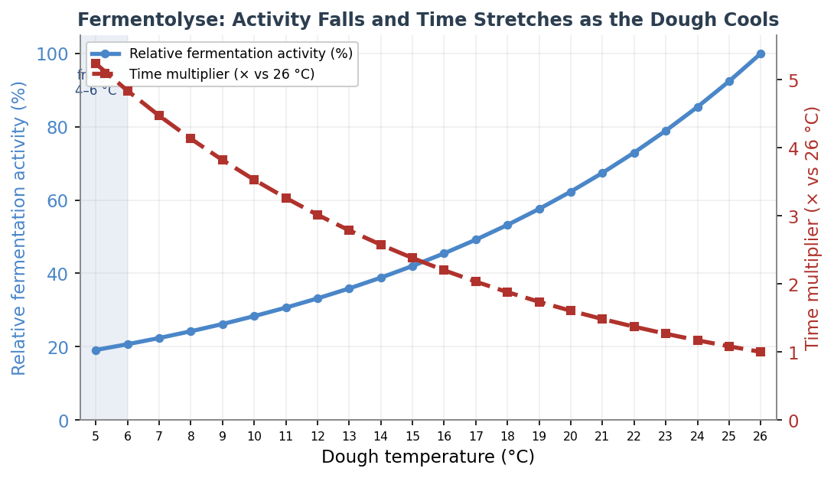
Figure 10 — Modelled relative fermentation activity (blue, left axis) and the resulting time multiplier (red, right axis) across 5–26 °C, built on a Q10 of about 2.2. Activity at the fridge floor is roughly a fifth of its room-temperature value, so the same degree of rise takes around five times as long. Values are indicative.

16.2 Flavour: Why Cold Builds Depth
Long, cold fermentation is prized because it develops flavour that a fast warm rise cannot. The reason is the split described above. While the yeast sleeps, the flour’s enzymes — proteases and amylases — keep working, slowly breaking proteins into aromatic amino acids and starch into sugars. Over a long cold rest these accumulate into a larger stockpile of flavour precursors than a quick warm ferment ever builds. Those amino acids and sugars then drive the Maillard browning reactions in the oven, giving cold-fermented loaves a darker, more complex crust and a deeper, more rounded flavour. In short: cold turns off the gas but leaves the flavour factory running.

16.3 Acidity: Cold Makes It Sharp, Warmth Makes It Mild
Sourdough’s tang comes from two acids in different proportions. Lactic acid is mild, smooth and yogurt-like; acetic acid is sharp, vinegary and aromatic. The bacteria produce more acetic acid in cool, stiff conditions and more lactic acid in warm, wet ones. The effect is large and measurable: published work records the acetic-to-lactic ratio at roughly 4:1 at 4 °C, falling to about 1:1 at 10 °C, and to roughly 1:4 (lactic-dominant) by 18 °C. This is precisely why a refrigerated rest produces a noticeably sharper, tangier loaf, and why King Arthur’s “extra-tangy” method relies on refrigeration.
One important subtlety: cold sharpens the character of the sourness but lowers the total amount of acid produced, because the microbes are so much less active. If you want the most intense total sourness, ferment warm and long; if you want a sharp, complex, acetic edge, ferment cold. Note too that the pH falls much more slowly in the cold, so the dough’s structure is protected for longer (see 16.4).

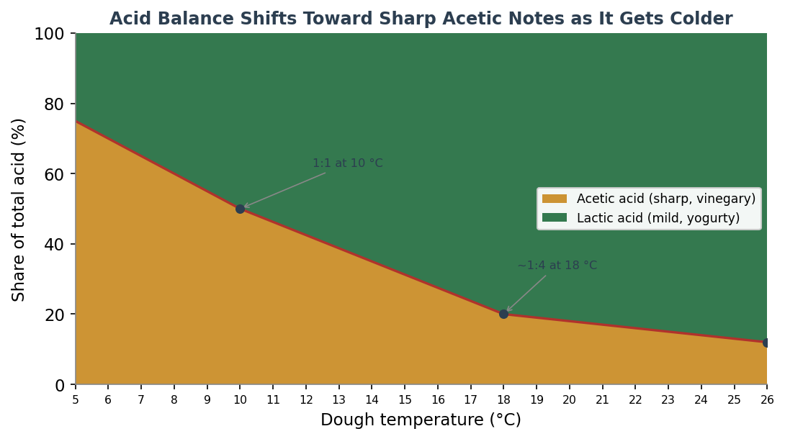
Figure 11 — The modelled balance between sharp acetic acid (amber) and mild lactic acid (green) as a share of total acid, anchored to measured ratios at 10 °C (1:1) and 18 °C (~1:4) and extrapolated across the range. Colder rests skew strongly acetic; warmer rests skew lactic. Values are indicative.

16.4 Dough Structure and Handling in the Cold
Cold does good things to the dough itself. A chilled fermentolyse firms up, becoming far easier to handle, shape and — especially — score, and it gives better, more controlled oven spring. The slow pH drop matters here: the flour’s gluten-degrading proteases switch on as acidity rises (they are most active at low pH), so by keeping acid build-up slow, cold also keeps gluten breakdown slow. That is why a cold rest can safely run for many hours where a warm one would turn the dough slack and sticky. The protection is not unlimited — held too long (typically beyond three to five days at fridge temperature, and sooner for wholegrain or rye-rich doughs, which carry more protease and buffer the pH) the gluten weakens and the dough eventually slackens.

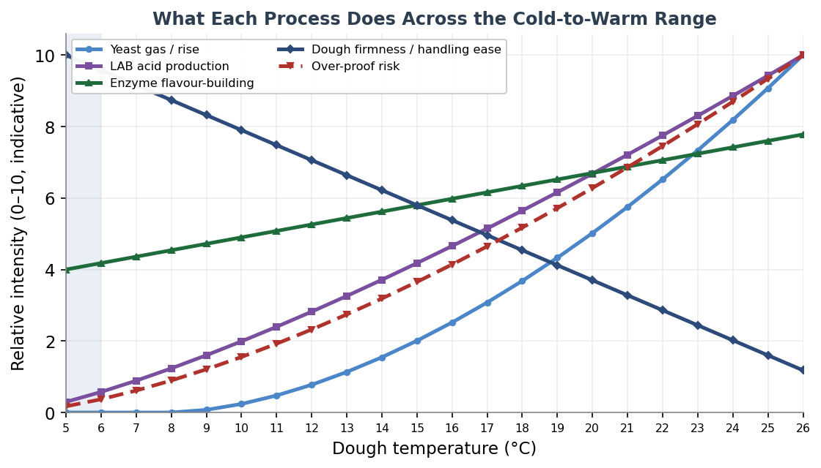
Figure 12 — A qualitative map of what each process contributes across the range. Yeast gas (blue) collapses below about 8 °C; acid production (purple) and over-proof risk (red) fall with cooling; enzyme flavour-building (green) stays comparatively high even in the cold; and dough firmness and handling ease (navy) rise as the dough chills. Indicative intensities.

16.5 Per-Degree Reference: Activity, Time & Acidity (5–26 °C)
The table below gives the modelled behaviour of a fermentolyse rest at each degree from 5 °C to 26 °C. “Activity” is fermentation rate relative to a 26 °C baseline; “time multiplier” is how much longer a given amount of fermentation takes versus that baseline; “acetic share” is the proportion of the acid that is sharp acetic rather than mild lactic. Read it as a planning guide, and remember the figures are interpolated between firm scientific anchors rather than measured at every degree.

Dough temp | Activity | Time × | Acetic share | Acid character | Yeast gas
5 °C | 19% | 5.2× | 75% | Sharp, vinegary | Near-dormant
6 °C | 21% | 4.8× | 70% | Sharp, vinegary | Near-dormant
7 °C | 22% | 4.5× | 65% | Sharp, vinegary | Near-dormant
8 °C | 24% | 4.1× | 60% | Balanced, tangy | Near-dormant
9 °C | 26% | 3.8× | 55% | Balanced, tangy | Slow
10 °C | 28% | 3.5× | 50% | Balanced, tangy | Slow
11 °C | 31% | 3.3× | 46% | Balanced, tangy | Slow
12 °C | 33% | 3.0× | 42% | Mild-tangy | Slow
13 °C | 36% | 2.8× | 39% | Mild-tangy | Slow
14 °C | 39% | 2.6× | 35% | Mild-tangy | Slow
15 °C | 42% | 2.4× | 31% | Mild-tangy | Slow
16 °C | 45% | 2.2× | 28% | Mild-tangy | Moderate
17 °C | 49% | 2.0× | 24% | Mild, yogurty | Moderate
18 °C | 53% | 1.9× | 20% | Mild, yogurty | Moderate
19 °C | 58% | 1.7× | 19% | Mild, yogurty | Moderate
20 °C | 62% | 1.6× | 18% | Mild, yogurty | Moderate
21 °C | 67% | 1.5× | 17% | Mild, yogurty | Moderate
22 °C | 73% | 1.4× | 16% | Mild, yogurty | Brisk
23 °C | 79% | 1.3× | 15% | Mild, yogurty | Brisk
24 °C | 85% | 1.2× | 14% | Mild, yogurty | Brisk
25 °C | 92% | 1.1× | 13% | Mild, yogurty | Brisk
26 °C | 100% | 1.0× | 12% | Mild, yogurty | Brisk

16.6 Practical Bands: How to Use Each Temperature Range
The continuous range falls naturally into four working bands, each suited to a different purpose.
Band | What is happening | Flavour & acidity | How to use it
5–7 °C (fridge) | Yeast dormant; bacteria and enzymes barely tick over | Sharpest, most acetic; deep flavour from enzymes; lowest total acid | Long retard of 12–48 h+; extends a fermentolyse safely; firm dough, easy to score
8–12 °C (cold cellar) | Yeast just creeping in; slow bacterial acid build | Still acetic-leaning and tangy; complex | Overnight to 24 h rests; a balance of keeping-quality and developing sourness
13–18 °C (cool room) | Steady, moderate fermentation | Shifting toward mild lactic; well-rounded | Several-hour fermentolyse or bulk; predictable and forgiving
19–26 °C (warm room) | Brisk fermentation; gas builds fast | Mild, lactic, yogurty; highest total acid if run long | Short fermentolyse only (≈20–30 min); watch closely for over-proof

16.7 Risks, Limits and Practical Tips
- The fridge floor (~5 °C): this is the practical minimum. Below it the bacteria stop too and nothing useful happens; the dough simply chills. Yeast is dormant, not dead, and revives on warming.
- Over-proofing still happens, slowly: cold greatly reduces but does not eliminate the risk. A dough already well along in bulk before chilling, or a fridge running warm (a 2–6 °C swing is common), can still over-proof over a long retard. Documented collapse occurs after roughly five days.
- Most cold fermentation happens during cool-down: a dough takes hours to actually reach fridge temperature, and most of the fermentation occurs while it is still cooling. This is why you cannot reliably rescue an under-fermented dough by simply leaving it in the fridge longer.
- Wholegrain and rye need shorter colds rests: they carry more enzymes and buffer the pH, so their gluten degrades faster — shorten the retard accordingly.
- Let it warm before judging: a cold dough must come back toward room temperature before the microbes resume meaningful activity, so plan a warming period before shaping and baking.
- Sharp tang vs. total sourness: use cold for a sharp, acetic, complex character; use warmth and time for maximum overall sourness. They are different goals.

Cold does not pause a fermentolyse so much as change its character: the yeast sleeps, the enzymes keep building flavour, and the sourness turns from mild and milky to sharp and bright. Used deliberately, the refrigerator is one of the baker’s most precise flavour controls.

17. Roadmap — Topics for Future Editions
This guide has grown from a single comparison of two resting techniques into a broad reference on grains, blends, fermentation and temperature. To keep that growth deliberate rather than haphazard, this chapter records the full landscape of bread-making topics worth covering, marks what has been done, and sets out what comes next. It serves two purposes: a map for the reader of where the guide is heading, and a working plan so that no worthwhile topic is forgotten.
The topics below are grouped by priority. The three highest-priority topics were judged to most strengthen the guide as a coherent whole, because each completes something the existing material only implies: the bake completes the timeline the guide already draws up to the oven door; starter and preferment management gives the fermentolyse chapters their living foundation; and crumb-reading turns the whole guide diagnostic. All three are developed in full immediately after this chapter, as Sections 18, 19 and 20. The remaining topics are recorded as placeholders for future editions.

17.1 Priority Topics — Developed in This Edition
These three are written up in depth in the sections that follow. Their Priority is shown as Done and their Impact on bread quality as High.

# | Topic | Why it earns priority | Status | Priority | Impact
1 | The Bake: oven transformation | Completes the process timeline the guide draws up to the oven door — oven spring, the setting of crumb and crust, steam, and doneness | Section 18 | Done | High
2 | Sourdough starter & preferment management | Gives the fermentolyse and low-temperature chapters their living foundation: the culture itself, and the preferments built from it | Section 19 | Done | High
3 | Reading the crumb & troubleshooting | Ties the whole guide together diagnostically — working backwards from a finished loaf to what helped or hurt it | Section 20 | Done | High

17.2 Future Topics — Placeholders for Later Editions
The following topics are not yet written, but are recorded here so they are not lost. They are arranged roughly in the order they would most naturally extend the guide. Each entry notes the core of what a future section would cover. The table now also carries a Priority and an Impact column: Impact rates each topic’s potential to improve bread quality, and Priority (P1 onward) sets the suggested writing order, combining that impact with the most logical teaching sequence. Topics already completed since this roadmap was first drafted are marked Done.

# | Topic | Scope a future section would cover | Priority | Impact
4 | Water chemistry | Hardness, pH, chlorine and mineral content; how each affects gluten and fermentation; adjusting hard or soft water → Now developed in Section 21. | Done
5 | Salt | Its role in tightening gluten, controlling fermentation rate and flavour; salt percentages in baker's math; salt types and timing → Now developed in Section 22. | Done
6 | Hydration as a variable | The full spectrum from stiff bagel dough to very wet ciabatta; what each hydration level demands of mixing, handling and baking → Now developed in Section 23. | Done
11 | Mixing & gluten development | Hand vs. machine mixing; the windowpane test; intensive, improved and short mixes; no-knead and stretch-and-fold approaches → Now developed in Section 24. | Done | High
7 | Shaping & scoring craft | Building surface tension; pre-shape and final shape for boule, bâtard and pan loaves; the hand skills, with step diagrams → Now developed in Section 25. | Done | High
9 | Commercial yeast in depth | Fresh, active-dry and instant yeast; conversions and dosing; osmotolerant yeast for sweet doughs; yeast vs. sourdough trade-offs → Now developed in Section 26. | Done | Med–High
8 | Enriched & laminated doughs | How fat, sugar, eggs and dairy rewrite the rules — brioche, challah, croissant and laminated doughs; the science of enrichment → Now developed in Section 27. | Done | Medium
12 | Flours beyond the grain | Malted and diastatic flours, flour treatments and additives, ageing and oxidation, protein and ash specifications → Now developed in Section 28. | Done | Medium
10 | Equipment | Dutch ovens, baking stones and steels, bannetons, mixers, thermometers and proofing boxes; thermal mass and how kit shapes results → Now developed in Section 29. | Done | Med–Low

17.3 Roadmap, Part Two — Topics Beyond the First Roadmap
With the twelve topics above now all developed, the guide has finished the roadmap it first set itself. But a good reference is never truly done, and a fresh survey of where baking knowledge runs deepest turned up a second wave of topics worth covering — chosen because they extend the guide in directions the existing chapters only imply. Three of them go deeper into the science of the loaf the guide already makes: the chemistry of its flavour and aroma, its nutrition and digestibility, and the measurement science that predicts how a flour will behave. Two widen the guide's reach: a set of specialty bread families that follow different rules from the wheat loaf, and the finishing and glazing craft that sits just past scoring. As before, each carries a Priority (P1 onward, the suggested order to write them) and an Impact rating for its potential to improve bread quality and understanding. None is yet written; they are recorded here so the guide remembers its next phase of unfinished business.

# | Topic | Scope a future section would cover | Priority | Impact
13 | Flavour & aroma chemistry | The 500-plus volatile compounds of bread; fermentation-derived crumb aromas (esters, alcohols, aldehydes, diacetyl) versus Maillard and Strecker crust aromas (notably 2-acetyl-1-pyrroline); how flour, fermentation and the bake steer flavour; a tasting vocabulary → Now developed in Section 30. | Done | High
14 | Nutrition, digestibility & health | How fermentation lowers the glycaemic index, degrades phytic acid for mineral bioavailability, reduces FODMAPs and breaks down gluten and ATIs; what the clinical evidence does and does not yet support → Now developed in Section 31. | Done | High
15 | Specialty bread families | Breads that break the wheat rules: rye and its pentosan-driven structure and acidification; pizza and flatbreads; and the alkaline or boiled breads (bagels, pretzels) whose lye or soda bath drives crust browning → Now developed in Section 32. | Done | Med–High
16 | Dough rheology & flour testing | Reading a flour by measurement — the farinograph, extensograph and alveograph (W and P/L values), falling number and amylograph — and connecting those lab numbers to the feel the craft chapters teach → Now developed in Section 33. | Done | Medium
17 | Finishing, glazing & crust design | Washes (egg, milk, starch), seeding and dusting, alkaline crust treatments, and how each interacts with steam and the Maillard chemistry of the crust → Now developed in Section 34. | Done | Med–Low

A good reference is never finished — it is only up to date. This roadmap is the guide's memory of its own unfinished business.

18. The Bake — How Dough Becomes Bread
Every chapter so far has taken the dough up to the oven door and stopped. This one walks through the door. The bake is not simply the application of heat to a finished product; it is the most dramatic transformation in the whole process, where a soft, living, gas-filled mass becomes a firm, browned, aromatic loaf in the space of half an hour. Understanding what happens — and at which temperatures — is what lets a baker control oven spring, crust and crumb rather than leaving them to chance.

18.1 The Temperature Timeline
The transformation is best understood as a sequence of events triggered at rising internal temperatures. As the loaf heats from the outside in, each zone of the dough passes through these stages in turn, which is why a finished loaf has a set, browned crust and a soft, open crumb that never exceeds the boiling point of water. The canonical reference for this sequence is the chart in Jeffrey Hamelman's Bread; the version below combines it with data from Modernist Cuisine and food-science sources.

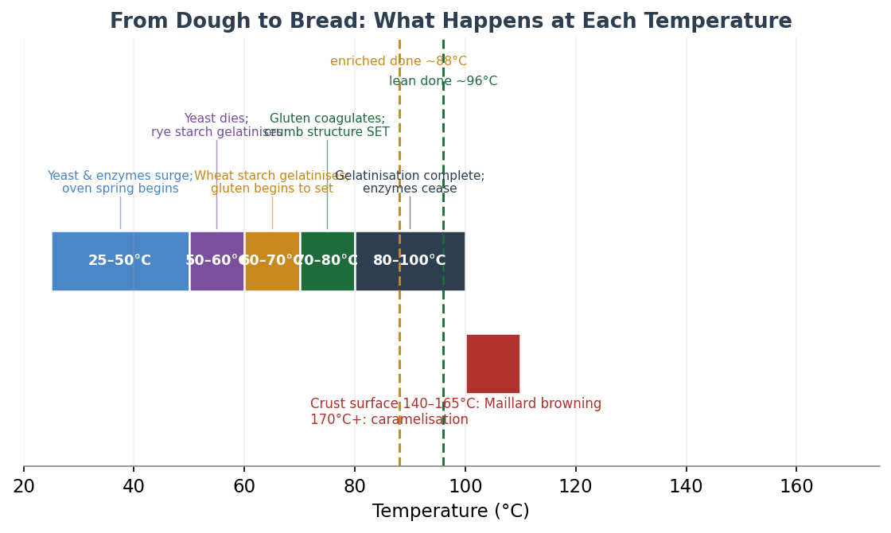
Figure 13 — The dough-to-bread temperature timeline. As the interior climbs, gas-driven oven spring gives way to the setting of structure (starch gelatinisation then gluten coagulation), while the crust surface, free of the cooling effect of internal moisture, races far ahead into the browning reactions. Lean loaves are done around 96 °C internal, enriched around 88 °C.
The single most important idea in this figure is that the crumb interior cannot exceed about 100 °C (212 °F) while moisture remains, which is why the inside never browns and tops out near boiling, while the dry crust surface climbs to 140–170 °C and beyond, where browning happens.

Internal temperature | What happens
25–50 °C (77–122 °F) | Yeast fermentation and enzyme activity surge; gas production accelerates; starch begins to swell — oven spring begins
50–60 °C (122–140 °F) | Yeast reaches its thermal death point; bacteria die; rye starch begins to gelatinise
60–70 °C (140–158 °F) | Wheat starch gelatinises; amylase activity peaks then ceases; expansion slows; gluten begins to coagulate
70–80 °C (158–176 °F) | Gluten coagulation completes — the crumb structure is set; oven spring ends
80–100 °C (176–212 °F) | Starch gelatinisation completes; enzyme activity ceases; interior approaches its maximum temperature
140–165 °C (crust surface) | Maillard reaction develops crust colour and hundreds of aroma compounds
170 °C+ (crust surface) | Caramelisation of sugars adds deeper colour and sweetness

18.2 Oven Spring — the Final Rise
Oven spring is the rapid expansion of the loaf in roughly the first ten minutes of baking, often the most dramatic rise of the entire process. It is driven by several mechanisms acting at once: gas already trapped in the dough expands as it heats (Charles's law); dissolved carbon dioxide comes out of solution as the dough warms; water turns to vapour inside the dough; and ethanol from fermentation vaporises. A final burst of yeast activity contributes only a percent or two before the yeast dies.
It is worth being honest that the relative size of these contributions is genuinely disputed in the scientific literature, and a good baker should know the debate rather than a false single figure. One school, associated with Hoseney and with Pyler's Baking Science and Technology, attributes about half of the spring to ethanol vaporising near 70 °C. Another, associated with Bloksma and supported by the later modelling of Fan, Mitchell and Blanshard, holds that water vapour contributes more than half and that dilute ethanol has no independent effect because it boils near 100 °C in a watery dough. Both camps agree on two things: thermal expansion of trapped gas alone accounts for only about 17–20%, and the final yeast burst for only 1–2%.

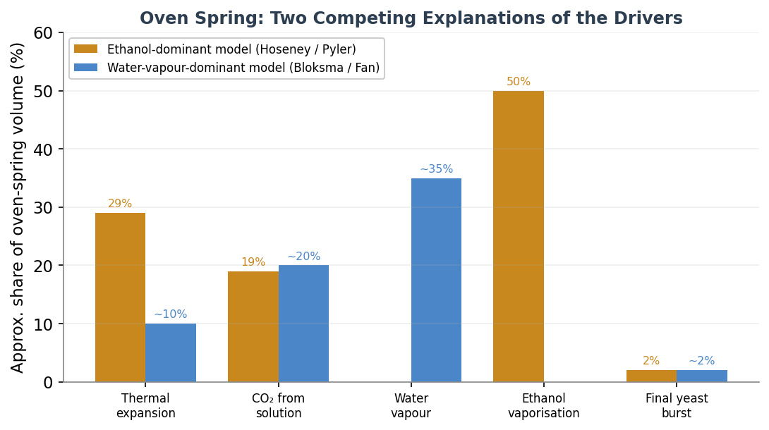
Figure 14 — The two competing explanations of what drives oven spring, shown side by side. The ethanol-dominant model (Hoseney / Pyler) and the water-vapour-dominant model (Bloksma / Fan) disagree most about the roles of ethanol and water vapour, but agree that thermal expansion is modest and the final yeast burst negligible. Figures are approximate.
Whatever the exact split, the practical lesson is the same: oven spring stops once the structure sets. As starch gelatinises and gluten coagulates between about 60 and 80 °C, the bubble walls turn rigid and the loaf can no longer expand. Everything a baker does to encourage spring — a hot oven, steam, a slightly under-proofed loaf, a confident score — works by maximising expansion in the brief window before that structure locks in.

18.3 Setting the Structure: Starch and Gluten
Two simultaneous changes convert the expanded foam into a solid crumb. Starch gelatinisation is the first: starch granules absorb water, swell and lose their crystalline order, forming a gel that gives the crumb its body. For wheat this happens at roughly 60–70 °C (140–158 °F); rye gelatinises lower, around 51–60 °C, which is one reason rye behaves so differently. The second change is gluten coagulation: the gluten proteins denature and firm up from about 70 °C, essentially complete by 80 °C, at which point the structure is set. As the gluten gives up its water to the gelatinising starch, it dehydrates and stiffens, locking the crumb in place.
Because gelatinised starch is what sets the loaf, anything that delays gelatinisation extends oven spring — which is precisely why steam, fat and sugar (all of which slow the surface setting or raise the gelatinisation temperature) affect the final volume and crust.

18.4 The Crust: Maillard and Caramelisation
The crust is where the flavour and colour of bread are born, through two distinct browning reactions. The Maillard reaction is a cascade between amino acids and reducing sugars that produces brown melanoidin pigments and hundreds of aroma compounds — the nutty, toasted, savoury notes of good crust. It proceeds rapidly from about 140–165 °C (280–330 °F). Caramelisation is the thermal breakdown of sugars alone, with no amino acid required, and begins higher, around 170 °C (338 °F); it contributes deeper colour and a rounded sweetness, and is especially prominent in enriched and sugared doughs.
Neither reaction can occur while the surface is wet and near 100 °C — which is the deep reason steam delays browning, and why the crumb, full of moisture, never browns at all. The most common home-baker error is pulling the loaf too pale; a deep mahogany crust is not over-baking but fully developed flavour.

18.5 The Crucial Role of Steam
Steam in the first part of the bake is the single biggest lever a home baker has over oven spring and crust quality. It does four things at once. It keeps the surface moist and flexible, delaying crust set so the loaf can expand fully and the scores can open into a clean ear. It gelatinises the surface starch into a thin, glossy, crackling shell. It extends the window in which surface enzymes liberate sugars, improving later browning. And it yields a thinner, crisper, longer-lasting crust.
The timing is straightforward: apply steam for the first 15–20 minutes, then vent or remove it so the crust can dry, brown and crisp. Leaving steam in for the whole bake gives a pale, leathery crust; too little steam gives a thick, dull crust that sets before the loaf has finished rising.
- Dutch oven or covered vessel: the best home method — the loaf's own moisture is trapped under the lid. Preheat thoroughly, bake covered for about 20 minutes, then uncovered for 15–25 minutes to colour the crust.
- Steam pan or ice cubes: a preheated metal pan on the bottom of the oven, into which boiling water or a handful of ice cubes is added at loading, then removed after about 20 minutes.
- Spray or spritz: the easiest method but the least effective, as the steam dissipates quickly and opening the door bleeds heat.
- Deck and rack ovens: professional ovens inject steam to fill the chamber for the first part of the bake, then vent it.
- Enriched doughs: skip steam for brioche and challah — their fat, sugar and eggs already brown the crust, and steam would only soften it.

18.6 Doneness, Oven Temperatures and Equipment
Lean breads are done at an internal temperature of about 200–210 °F (93–99 °C), with around 205 °F (96 °C) a reliable target and dense rye pushed to the top of that range to drive off moisture. Enriched breads are done cooler, around 185–195 °F (85–90 °C), to keep them tender. A useful caveat from careful testers is that internal temperature is a secondary cue: the crumb is usually fine across a wide window, and it is the crust colour that should lead the decision, with the thermometer as a backstop — most valuable for sugar-rich loaves that brown deceptively fast.
Lean loaves are typically baked at 450–500 °F (232–260 °C), often dropping after loading; enriched loaves at 350–375 °F (175–190 °C). A baking stone or steel stores heat and delivers it to the base of the loaf for a strong initial spring; steel conducts far faster than stone and recovers more quickly between bakes, though it is heavier and more expensive. Whatever the surface, it must be preheated long enough to saturate with heat — typically 45–60 minutes, well beyond the oven's own preheat signal, which only reports the air temperature.

18.7 Cooling — Finishing the Bake
Bread continues to change as it cools, and cutting too soon spoils it. As the loaf drops below about 60 °C, starch retrogradation begins and the crumb finishes setting; moisture redistributes from the wet interior outward. Cutting a hot loaf releases that steam prematurely and leaves a gummy, sticky crumb and a wet knife. Lean loaves should cool on a rack with airflow for at least one to two hours before slicing; dense and rye loaves benefit from far longer, ideally a day. A thin, porous crust lets internal steam escape and stays crisp; a thick crust traps it, and the vapour condenses and softens the crust to leather.

19. Sourdough Starter & Preferment Management
The fermentolyse and low-temperature chapters all assume a living culture is on hand. This section is about that culture itself: how to create a sourdough starter from nothing, how to keep it healthy, the microbiology that makes it work, and the family of preferments — sourdough and commercial-yeast alike — that bakers build from it. A starter is not an ingredient so much as a small managed ecosystem, and understanding it is what turns sourdough from luck into craft.

19.1 Creating a Starter — the Microbial Succession
A new starter is not made by catching yeast from the air on day one. It is a relay race, driven by a steadily falling pH, in which one community of microbes hands off to the next. The clearest account is the microbiologist Debra Wink's, and it has since been corroborated by sequencing studies of starters grown from many flours. The crucial insight is that the gassy bubbling many beginners see around day three or four is usually not yeast at all but an early bacterium, Leuconostoc, and that the wild yeast which finally leavens the bread only wakes once the pH has fallen far enough — which is why a new starter so often surges, then stalls, then comes to life.

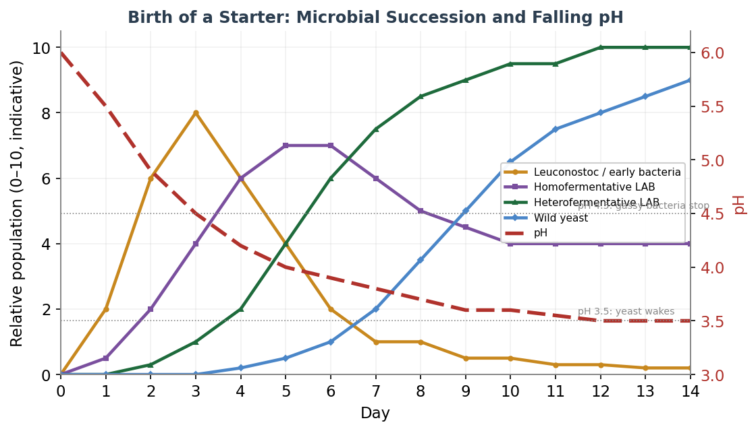
Figure 15 — The birth of a starter as a succession driven by falling pH. An early bloom of Leuconostoc and other bacteria (amber) gives way to homofermentative then heterofermentative lactic acid bacteria (purple, green), and only once the pH falls toward 3.5 does wild yeast (blue) populate and the starter become a reliable leaven. Curves are indicative.

Phase | Days (typical) | What is happening | Outward signs
First | ~1 (sometimes 2) | First-wave bacteria waking; nothing detectable yet | No bubbles or tang; slight colour change
Second | 1–3+ | Early bacteria (Leuconostoc), then homofermentative lactobacilli grow | Tangy taste; may bubble and rise; can smell bad; most likely to stall here
Third | 1–2 | Heterofermentative lactobacilli take over | Very tart, lemon-like; gluten may soften; tiny bubbles
Fourth | — | Wild yeast activates (tied to low pH ~3.5) and populates quickly | Expands with gas; yeasty, beery smell

Two pH thresholds explain the whole pattern: the gas-producing early bacteria stop growing once the pH falls to about 4.5, and the wild yeast does not begin until about pH 3.5. The gap between them is the stall. Three practical lessons follow: use whole-grain flour at first, because it carries far more microbes; do not overfeed before the yeast is active, as that dilutes the acid and slows the necessary pH drop; and be patient, as a healthy culture usually takes one to two weeks. Adding a little acid on day one — the well-known pineapple-juice trick — lowers the pH past the troublesome early bacteria and gives a faster, more predictable result without changing the final culture.

19.2 Maintaining a Starter
A mature starter is kept alive by regular feeding, and the single most useful idea is that feeding ratio, temperature and hydration together set how fast it ripens and how it tastes. The ratio is written as starter : flour : water by weight; when flour and water are equal, the result is a 100% hydration starter.

Ratio (starter:flour:water) | Peak at ~22 °C | Flavour | Best use
1:1:1 | 4–6 hours | Tangier, more acidic | Daily bakers, cool kitchens, same-day baking
1:2:2 | 6–8 hours | Balanced | The most versatile maintenance ratio
1:3:3 to 1:4:4 | Longer | Milder | Warm kitchens
1:5:5 | 10–14 hours | Mildest | Overnight builds, hot summer kitchens

A lower ratio means less food, so the culture ripens faster and turns more acidic; a higher ratio means more food, so it ripens slowly and stays mild. A warm kitchen shortens these times by an hour or two, a cool one lengthens them, so many bakers rotate ratios with the seasons. Use the starter at its peak — just after it domes and before it falls — for the strongest leavening. A stiffer starter (around 50–60% hydration) ferments more slowly, holds its dome longer and shifts the flavour toward sharper acetic notes, while a liquid starter ferments faster and milder. For storage, feed the starter and refrigerate it promptly; it can survive months between feeds, the cold simply slowing it almost to a halt.
Reviving a neglected starter
A starter that has been ignored for weeks is usually not dead. Warm it to room temperature, pour off or stir in any dark liquid (the alcohol byproduct known as hooch), and rescue a small seed — ten to twenty grams of the best-looking interior. Feed it generously, at a ratio of 1:5:5 or even 1:10:10 to dilute the accumulated acid, keep it warm at 24–28 °C, and feed every twelve hours. Recovery usually takes two to seven days, and it is ready when it doubles reliably in four to eight hours. The mistake to avoid is overfeeding many times a day at the start, which strips the colony before it can rebuild.
Signs of health and of trouble
- Hooch (grey or brown liquid): the starter is hungry; stir it in or pour it off and feed. Harmless.
- Sharp vinegar or acetone smell: starvation; feed more often. Harmless.
- Yeasty, bready, mildly sour smell: a healthy starter.
- Pink or orange streaks: harmful bacteria — discard the whole starter.
- Fuzzy mould of any colour: contamination — discard the whole starter.

19.3 The Microbiology
A mature starter is dominated by lactic acid bacteria, which outnumber the yeast by roughly a hundred to one (measured ratios range more widely, from about 100:1 to 10:1, with rare extremes well beyond). The bacteria come in two kinds: homofermentative species, which produce essentially only lactic acid and no gas, and heterofermentative species, which produce lactic acid plus acetic acid, carbon dioxide and ethanol. The classic sourdough bacterium, Fructilactobacillus sanfranciscensis, is heterofermentative, which is why true sourdough develops both a mild lactic tang and a sharper acetic edge.
The relationship between the bacteria and the yeast is a genuine symbiosis. In the famous San Francisco pairing, the yeast cannot use maltose, which the bacterium thrives on, while the bacterium excretes glucose that the yeast can use — so the two do not compete for the same sugar, and the yeasts in turn supply amino acids the bacterium needs. Temperature tilts the balance: a warm dough favours more total acid and a rounder lactic character, while a cool one yields less total acid but a sharper acetic profile — the same lever explored in depth in Section 16.

19.4 Preferments — the Wider Family
A preferment is a portion of the final dough's flour and water fermented ahead of time, then mixed into the dough. Fermentolyse and the levain are the sourdough members of this family; the others use commercial yeast or old dough. All of them do the same essential job — pre-building flavour, acidity, strength and extensibility — and differ mainly in hydration, the leavening they carry, and how long they ferment.

Preferment | Hydration | Leavening | Time | Contributes
Poolish | 100% (liquid) | Tiny commercial yeast | 12–16 h | Extensibility; mild, nutty flavour; open crumb
Biga | 45–60% (stiff) | Small commercial yeast | 12–24 h | Strength and elasticity; more pungent; forgiving
Pâte fermentée | ~60–65% | Yeast + salt (old dough) | 6–18 h | Mature flavour and acidity; dough strength
Sponge | 60–100% | Most of the recipe's yeast | 45 min–2 h | A fast jump-start; suits enriched doughs
Levain | Varies | Sourdough starter | 4–12 h+ | Wild-yeast leavening; lactic and acetic flavour

Pâte fermentée is the only preferment that contains salt, because it is simply a piece of a previous day's dough; poolish and biga are left unsalted so the yeast can work vigorously. When formula and process are held constant, the three yeasted preferments produce surprisingly similar loaves, but tradition assigns each a speciality: poolish for extensibility, prized in baguettes, and biga for strength, prized in ciabatta and other high-hydration breads. Swapping one for another means adjusting the dough water to account for the preferment's hydration.

A starter is the baker's only ingredient that is alive, and the only one that can be ruined by neglect or improved by care. Tend it well and everything downstream becomes easier.

20. Reading the Crumb & Troubleshooting
A finished loaf is a record of everything that happened to it. Learning to read that record — the crumb structure, the crust, the way the loaf opened — lets a baker work backwards from a result to its cause, and turn a disappointing bake into the next improvement. This closing diagnostic chapter gathers the most useful patterns: how to read a crumb, how to tell under-proofing from over-proofing, a broad troubleshooting matrix, and the science of why bread goes stale.

20.1 Reading the Crumb
An ideal lean-bread crumb is open but even, with glossy, translucent cell walls and a springy, custardy feel — the sign of full fermentation, good gluten development, even gas distribution and an adequate bake. Departures from that ideal each tell a story. A tight, dense crumb usually means under-fermentation, a weak or immature starter, too little hydration, or under-proofing. Large irregular holes surrounded by dense crumb — as opposed to an evenly open crumb — point to under-fermentation, over-tight or careless shaping that trapped pockets of air, or too much bench flour preventing the dough sealing to itself.
Three particular faults are worth naming. A gum line, a dense moist streak near the base, comes from under-baking, cutting the loaf too soon, or insufficient bottom heat. A flying crust — a large cavity just under the top crust — comes from under-proofing, a skin forming during proof, or an uneven dough temperature after a cold retard. And bursting in the wrong place comes from under-proofing or from inadequate scoring, which leaves the loaf to find its own weak point.

20.2 Under-proofing versus Over-proofing
The most common single question in bread-making is whether a loaf was proofed correctly, and the most reliable test is the simplest: press a floured finger about a centimetre into the dough and watch. An under-proofed dough springs back immediately and feels tight; a properly proofed dough springs back slowly and only halfway, leaving a slight dent; an over-proofed dough does not spring back at all, and the dent stays. The two errors produce opposite faults in the oven, which is what makes them easy to tell apart once you know the signs.

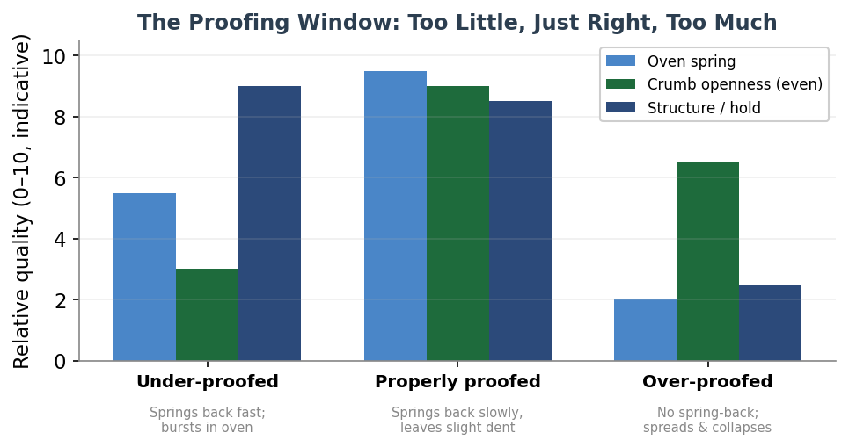
Figure 16 — The proofing window. An under-proofed loaf keeps good structure but bursts and stays tight inside; a properly proofed loaf springs strongly and opens into an even crumb; an over-proofed loaf spreads, collapses and loses its rise. The poke-test behaviour beneath each is the quickest way to judge readiness. Intensities are indicative.

Cue | Under-proofed | Properly proofed | Over-proofed
Poke test | Springs back at once; tight | Springs back slowly, halfway | No spring-back; dent stays
Feel | Dense, firm, tight | Aerated, jiggly, holds shape | Slack, sticky, fragile
In the oven | Bursts; big random holes | Strong even spring and ear | Spreads sideways; flat
Baked crumb | Dense, tight, sporadic holes | Open, even, glossy | Loose or collapsed; dense base

Timings depend entirely on temperature, so the dough should be watched rather than the clock: a bulk ferment that takes four to eight hours at 21–24 °C can over-run in three to four at 27–29 °C, or stretch past twelve in a cool room. A slight under-proof at the moment the loaf enters the oven is desirable, because it leaves the most energy for oven spring.

20.3 The Troubleshooting Matrix
The table below maps the faults bakers most often meet to their usual causes and fixes. Two patterns recur so often they are worth stating outright: a dense or gummy crumb is almost always under-fermentation or under-baking, and most crust problems trace back to steam and oven temperature.

Symptom | Most likely cause(s) | Fix
Dense or gummy crumb | Under-fermentation; weak or young starter; under-baked; cut too soon | Extend bulk; use a peak-active starter; bake to 205–210 °F; cool fully
Gummy, sticky interior | Under-baked; cut while hot; rye starch issues | Bake longer and hotter; cool one to two hours or more
Too sour | Long or warm ferment; low feed ratio | Shorter, cooler ferment; higher feed ratio; bake sooner
Not sour enough | Ferment too short or too warm-fast | Longer, cooler bulk; add a cold retard; stiffer starter
Pale crust | No steam; oven too cool; over-fermented (sugars depleted) | Steam first 15–20 min then vent; raise temperature; bake darker
Crust too thick or hard | Too little steam; over-baked; oven hotter than the dial | Robust early steam; pull at target temp; check true oven temp
Poor oven spring | Over- or under-proofed; weak gluten; no steam; dull blade | Diagnose the proof; develop gluten; steam; use a sharp lame
Flat, spreading loaf | Over-proofed; dough too slack; weak gluten or shaping | Shorten proof; lower hydration; build gluten and shaping tension
Large holes under top crust | Under-proofing; poor shaping; trapped gas; uneven temp | Proof fully; shape with even tension; even out dough temperature
Bursting in the wrong spot | Under-fermented; shallow or absent score | Ferment fully; one confident, deep score
Collapse during baking | Over-proofed; structure weakened | Shorten proof; bake sooner; handle gently

20.4 Scoring
Scoring is functional, not merely decorative: the cut becomes the path of least resistance, directing where the loaf opens instead of leaving it to burst at random. The angle controls the result — a shallow blade held at about thirty to forty-five degrees creates a flap that lifts into an ear as the loaf springs, while a vertical cut gives an even split with no ear. Depth matters too, around a quarter to half a centimetre: too shallow and the crust seals before the loaf can expand, too deep and it degasses and spreads. Use a sharp blade, replaced often, with one fast confident stroke on cold, firm dough just before loading, and remember that scores only bloom when there is steam to keep the crust open.

20.5 Staling and Storage
Bread goes stale mainly through starch retrogradation, not simply through drying out. After baking, the gelatinised starch slowly recrystallises, expelling water and firming the crumb, while moisture migrates from crumb to crust and softens it. This is why refrigerated bread can still feel moist yet taste stale — the change is structural, not a loss of water.

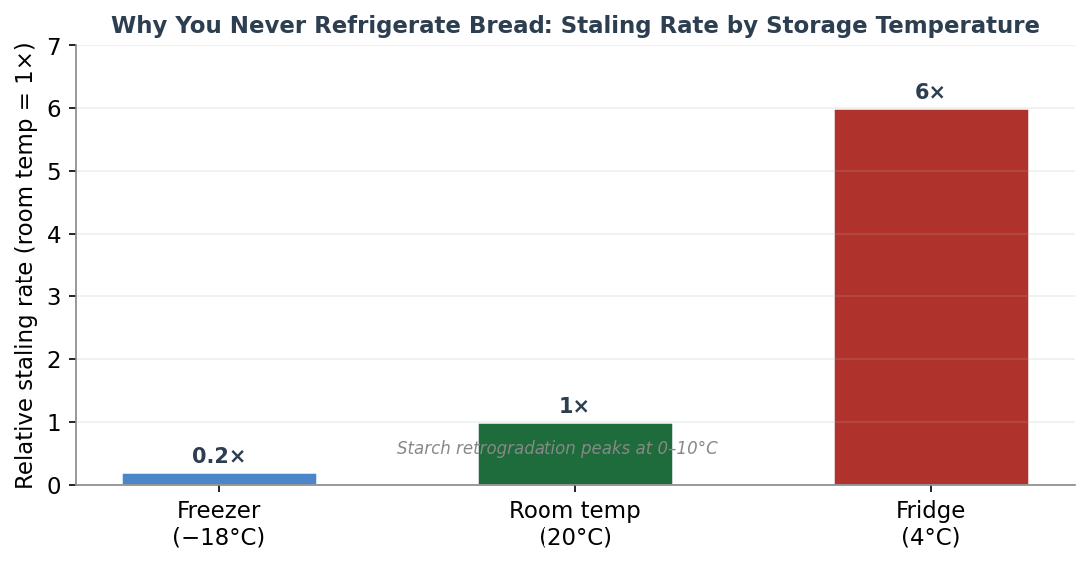
Figure 17 — Why bread is never refrigerated. Starch retrogradation peaks at fridge temperatures (0–10 °C), so bread stales there roughly six times faster than at room temperature, while freezing nearly halts it. Rates are relative to room-temperature storage.
The counterintuitive consequence is that the refrigerator is the worst place to keep bread: retrogradation runs fastest between 0 and 10 °C, so a fridge stales bread about six times faster than the counter. Freezing, by contrast, nearly stops it. The practical rules follow directly: keep a crusty lean loaf at room temperature, cut-side down or wrapped in paper or cloth, for a day or two; freeze anything you will not eat within that window, sliced and tightly wrapped; and never refrigerate crusty bread. Reheating or toasting temporarily reverses staling by re-gelatinising the starch, but the loaf then stales again faster once cool — a short-term rescue, not a cure.

Every loaf is feedback. Read the crumb, name the cause, change one thing — and the next bake is better. That is the whole of the craft, repeated.

21. Water Chemistry
Water is the most overlooked ingredient in bread, yet it makes up roughly two-fifths of the dough by weight, so even small variations in its mineral content and acidity have measurable effects. The good news first: most drinkable tap water makes perfectly good bread, and water chemistry matters far less than flour, fermentation or technique. Where it does matter most is in two places — a sourdough starter, whose fragile young microbes are sensitive to disinfectants, and very wet, lean, flour-and-water doughs, where there is little else to mask the effect. This section explains what to look for and when it is worth acting.

21.1 Hardness — the Mineral Content
Water hardness is the amount of dissolved calcium and magnesium, measured in parts per million (ppm, equivalent to milligrams per litre) of calcium carbonate. These minerals are not impurities to be feared: in the right amount they are quietly helpful, because calcium and magnesium ions reinforce the bonds of the gluten network — acting a little like a natural dough conditioner — and serve as mineral nutrients for the yeast. The consensus ideal is moderately hard water, around 50 to 150 ppm, which is firm enough to strengthen gluten and feed the culture without going too far.

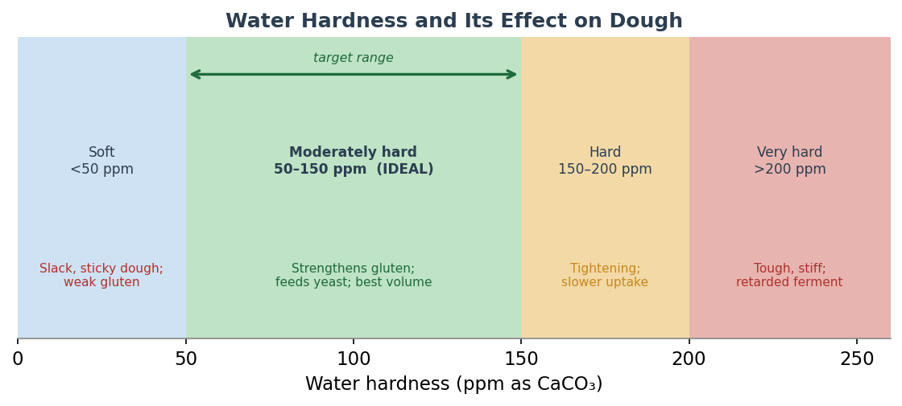
Figure 18 — Water hardness and its effect on dough. Below about 50 ppm the dough turns slack and sticky; above about 200 ppm the gluten over-tightens and fermentation slows. The moderately hard band of roughly 50–150 ppm is the target, where minerals strengthen gluten and feed the yeast without going too far. Boundary values vary between sources.
The two extremes cause opposite problems. Very soft water (below about 50 ppm) lacks the minerals that firm up gluten, so the dough becomes slack, sticky and overly extensible, and it can be hard to push hydration high without the dough going to pieces. Very hard water (above about 200 ppm) does the reverse: the excess minerals make the dough tight, stiff and inextensible, gas cells struggle to expand, and fermentation slows, reducing loaf volume. Note that sources disagree slightly on the boundaries and even on direction at the margins — some report that very high mineral levels can briefly speed fermentation even as they limit volume — so treat the numbers below as typical ranges rather than fixed thresholds.

Class | Hardness (ppm CaCO₃) | Effect on dough
Soft | below ~50 | Slack, sticky dough; weak gluten; structure hard to build
Moderately hard (ideal) | ~50–150 | Strengthens gluten without over-tightening; feeds yeast; best volume
Hard | ~150–200 | Gluten begins to tighten; water uptake slows
Very hard | above ~200 | Tough, stiff, inextensible dough; fermentation retarded; less volume

21.2 pH — How Acidic or Alkaline
Bread chemistry prefers water that is slightly acidic, with a pH just below neutral — broadly in the 5 to 6.5 range. This suits both the yeast, whose enzymes work best in mildly acidic conditions, and the gluten, which swells best at low pH. Strongly alkaline water (pH above about 7.5 to 8) is the one to watch: it neutralises the acidity that fermentation is trying to build, pushes the dough above the enzymes' comfort zone, slows yeast activity, lengthens the bake and can leave the bread duller in flavour. Most municipal supplies are treated to sit near neutral, so dangerously acidic water is rare for the home baker; alkaline well water is the more common real-world problem, and a little food-grade acid will bring it back into range.

21.3 Chlorine and Chloramine — the Real Debate
Municipal water is disinfected, usually with chlorine or the more stable chloramine, and whether these harm bread is genuinely contested among reputable bakers. On one side, Jeffrey Hamelman warns that heavily chlorinated water can inhibit the metabolism of the developing microorganisms during the fragile beginnings of a culture, and several test kitchens report that it can weaken or even kill a young starter. On the other, experienced bakers point out that they have raised and fed starters on chlorinated tap water in many cities without trouble, and that if the water is good enough to drink it is generally good enough for the microbes. The sensible middle ground: the effect is real but modest for ordinary yeasted dough, more of a concern for a delicate young starter, and chloramine is the bigger troublemaker than plain chlorine.
The practical distinction matters because the two are removed differently. Free chlorine is volatile: letting water stand uncovered overnight, or simply leaving it in a wide pan for an hour or two, lets it dissipate, and boiling drives it off quickly. Chloramine does none of this — it does not evaporate off by standing or boiling, and slips through basic carbon filters at speed. To remove chloramine you need a Campden tablet (a pinch of potassium or sodium metabisulfite, about a quarter tablet per five litres, acting within minutes), reverse osmosis, or a high-contact carbon block rated for it. If your starter is sluggish for no obvious reason and your utility uses chloramine, this is worth ruling out.

21.4 Water Sources and Practical Fixes
- Softened water: ion-exchange softeners swap calcium and magnesium for sodium, which leaves the gluten-firming minerals gone and can make dough slack and sticky. Use an unsoftened tap line or bottled water for baking.
- Distilled or reverse-osmosis water: stripped of all minerals, so it gives slack dough and starves a starter of mineral nutrition — though some bakers use it deliberately to start a culture precisely because it carries no chlorine.
- Well water: often hard and sometimes alkaline; usable, but may need a touch of acid, and can carry iron or sodium depending on treatment.
- Bottled spring or filtered water: the reliable default for starters, sidestepping both chlorine and pH surprises.
- To firm up soft water: add a little more salt, or a small dose of gypsum (calcium sulfate, around a quarter percent of flour), and consider lowering hydration slightly.
- To loosen the effect of hard or alkaline water: increase the yeast a little, add a mild acid to bring the pH just below neutral, or switch to softened or filtered water.

21.5 Water Temperature and Desired Dough Temperature
The one property of water that every baker should actively control is its temperature, because it is the easiest lever for hitting a target final dough temperature — and dough temperature, as the fermentation and low-temperature chapters showed, governs how fast everything proceeds. Most wheat breads aim for a desired dough temperature (DDT) of about 24 to 26 °C (75 to 78 °F). Bakers hit it with a simple formula: multiply the target by the number of temperature factors, then subtract the ones you can measure.
Without a preferment there are three factors, so the water temperature equals three times the DDT, minus the flour temperature, minus the room temperature, minus a friction factor for the heat that mixing adds. With a preferment or levain there are four factors, and you also subtract the preferment's temperature. The friction factor is the slippery part: gentle hand mixing adds only a few degrees, while a stand mixer can add twelve or thirteen °C and a high-speed commercial mixer far more. The formula is an approximation — it weights each factor equally and can be off by a few degrees — so the real advice is to measure your finished dough temperature once, work out your own friction factor, and reuse it.

Good water is mostly a non-problem: if you can drink it, you can usually bake with it. Save your attention for the starter, for very wet doughs, and for the water's temperature.

22. Salt
Salt is the ingredient bakers treat as almost fixed. Where flour, water and fermentation invite endless variation, salt sits stubbornly at around two percent of the flour weight in nearly every bread on earth. That consistency hides how much work it does: salt is not merely seasoning but a structural and biological tool, shaping flavour, fermentation speed, gluten strength, crust colour and keeping quality all at once. This section explains each of those roles, how much to use, which salt to reach for, and when to add it.

22.1 The Five Jobs Salt Does
- Flavour. the obvious one, but subtler than it looks. Beyond making bread taste seasoned rather than flat and insipid, sodium ions suppress bitterness — a documented effect in taste science — which lets the wheat's own sweetness and nutty, grainy notes come forward. Salt-free bread does not just taste under-salted; it tastes dull and one-dimensional.
- Controlling fermentation. salt is hygroscopic and draws water osmotically from the yeast, slowing its reproduction and gas output and so evening out and regulating the proof. The effect at normal doses is gentler than bakers often assume — measured gas production falls only modestly at one-and-a-half percent salt — but without any salt the yeast runs wild and the dough over-ferments fast.
- Strengthening gluten. this is the big structural role. The gluten proteins gliadin and glutenin carry electric charges that make them repel one another; the dissolved ions from salt screen those charges, so the proteins can pack together into a tighter, stronger, more elastic and less sticky network. You can feel it happen — a slack, tacky dough firms up within a minute or two of the salt dissolving in.
- Crust colour. by slowing the yeast's consumption of sugars, salt leaves more residual sugar in the dough at baking time, feeding the Maillard browning that colours the crust. Salt-free loaves bake noticeably pale.
- Keeping quality. salt's same water-grabbing, osmotic nature inhibits spoilage organisms and slows staling, so a properly salted loaf keeps a little longer.

Function | Mechanism | Without salt
Flavour | Sodium suppresses bitterness, unmasks sweetness and wheatiness | Flat, insipid, one-dimensional
Fermentation control | Osmotic draw on yeast slows gas production | Fast, uncontrolled over-proofing
Gluten strength | Ions screen protein charges so gluten packs tighter | Slack, sticky, poor volume
Crust colour | Spares residual sugar for Maillard browning | Pale, dull crust
Keeping quality | Hygroscopic and mildly antimicrobial | Stales and spoils faster

22.2 How Much — the Two Percent Rule
The standard dose is 1.8 to 2.2 percent of the flour weight, and most bakers simply use two percent and rarely stray. The figure below shows why this band is the sweet spot: as salt rises, fermentation slows steadily while gluten strength climbs and then plateaus, and the two curves cross right around the standard range. Below about 1.5 percent the bread tastes bland and the dough ferments fast and turns slack; above about 2.5 percent the dough tightens, fermentation drags and the salt becomes obtrusive. A few traditional breads break the rule deliberately — Tuscan bread is famously saltless — but they are the exceptions that prove it.

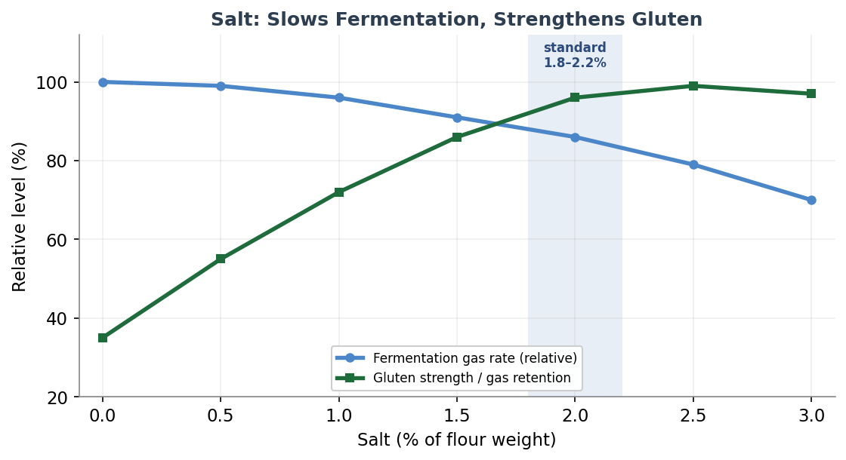
Figure 19 — Salt's twin effects. As salt rises, fermentation gas production falls steadily while gluten strength and gas retention climb then plateau; the two cross near the standard 1.8–2.2% band. Note that at two percent the visible slowing of the rise owes more to tighter gluten holding gas than to true suppression of the yeast. Curves are indicative.
Salt (% of flour) | Effect on dough and bread
0% | Slack, sticky, hard to shape; fast uncontrolled fermentation; pale crust; bland (e.g. Tuscan bread)
1.0–1.5% | Softer, faster dough; mild flavour; watch for over-proofing
1.8–2.2% (standard) | Balanced gluten strength, controlled fermentation, good colour and flavour
2.5% | Tighter dough, slower fermentation, distinctly salty
3% and above | Strongly suppressed fermentation; very tight dough; unpalatably salty

22.3 Which Salt — and Why You Must Weigh It
Any pure salt does the same chemical job, but salts differ enormously in crystal size, and that wrecks volume measurement. A teaspoon of dense fine table salt carries roughly twice as much actual salt as a teaspoon of the airy, hollow flakes of one popular kosher brand, with another kosher brand sitting in between. The widely used rule of thumb is that one part table salt equals about one-and-a-half parts of the denser kosher salt equals about two parts of the flakier kosher salt, by volume. This is exactly why bread bakers weigh salt rather than spooning it: at a two-percent dose, a twofold volume error is the difference between balanced and either bland or inedibly salty.
Beyond density, fine sea salt and fine table salt dissolve quickly and are the easiest to disperse evenly; coarse and flaky salts need time or a little extra water to dissolve fully, or they leave sharp salty pockets. Table salt is often iodised and carries anti-caking agents, which a few palates detect as a faint metallic note; plain fine sea salt avoids the question. Whichever you choose, the discipline is the same: measure it by weight in grams.

Salt type | Approx. per teaspoon | Notes
Table salt (fine) | ~6.0 g | Densest; often iodised with anti-caking agents; dissolves slowly
Fine sea salt | ~5–6 g | Good all-purpose baking salt; dissolves readily
Kosher salt (denser brand) | ~4.8 g | Rolled flakes; about 1.5× the volume of table salt for the same weight
Kosher salt (flakier brand) | ~2.8 g | Hollow flakes; about 2× the volume of table salt for the same weight

22.4 When to Add It — the Autolyse Question
Timing is the one genuinely debated point, and it connects directly to the autolyse material at the start of this guide. The classic autolyse is flour and water only, with salt held back and added after the rest, precisely because salt tightens gluten and slows the enzyme and hydration activity that the autolyse is meant to encourage. Withholding salt lets the flour hydrate freely and the gluten relax into extensibility; the dough then tightens noticeably the moment the salt goes in, which is exactly the intended effect. With whole-grain and bran-heavy doughs the case is stronger still, because keeping salt out leaves more water free to soften the bran.
Against that, some authorities — Hamelman among them — prefer to add salt at the very start, because salt also slows the oxidation of the dough and so helps preserve the flour's carotenoid pigments and flavour, which a late addition can let escape. And mixing salt in with the starter from the beginning, the fermentolyse approach, works perfectly well for many bakers. The honest summary is that for high-protein or whole-grain sourdough, a saltless autolyse of twenty to sixty minutes measurably improves extensibility and bran hydration, while for straight commercial-yeast doughs and short processes, adding salt at the start is fine. Many experienced bakers cannot reliably tell the finished loaves apart, so treat this as fine-tuning, not a make-or-break rule. One older caution still worth heeding: keep undissolved salt from sitting in direct, concentrated contact with fresh or instant yeast, and keep heavy salt away from a levain, where it can harm the bacteria.

Two percent, by weight, is the baker's anchor. Everything else about salt — when to add it, which crystals to buy — is refinement around that fixed point.

23. Hydration as a Variable
Hydration is a single number that tells you more about how a dough will behave than almost any other figure — how open the crumb will be, how crisp the crust, how sticky the dough, how long the loaf will keep. It is the percentage of water relative to flour, and learning to think in it is what lets a baker read a recipe at a glance and adjust with intent. But a warning runs through this whole section: hydration alone does not create an open crumb. It raises the ceiling for one, while also raising the difficulty; fermentation and gluten development decide whether you actually reach it.

23.1 What Hydration Means
Hydration is a baker's percentage: the total water weight divided by the total flour weight, multiplied by a hundred. It is not the fraction of water in the dough as a whole, only the ratio of water to flour, and it counts every source of each — including the water and flour hidden inside a levain or preferment. A thousand grams of flour with seven hundred grams of water is a seventy-percent dough; the same ratio holds whether you scale up or down. When a recipe includes a hundred-percent-hydration starter at twenty percent of the flour, you fold that starter's flour and water into the totals before working out the figure, which usually nudges the real hydration a few points above what the main mix suggests.

23.2 The Hydration Spectrum
Breads arrange themselves along a spectrum from stiff to nearly pourable, and each band suits different breads and demands different handling. The figure and table below lay out that range. The trend is consistent: as hydration rises, the crumb opens up with larger, more irregular holes, the crust grows thinner and crisper, and the loaf keeps better — but the dough grows slacker, stickier and harder to handle, until past about eighty-five percent it behaves more like a batter than a dough and needs strong flour and real skill to hold any structure at all.

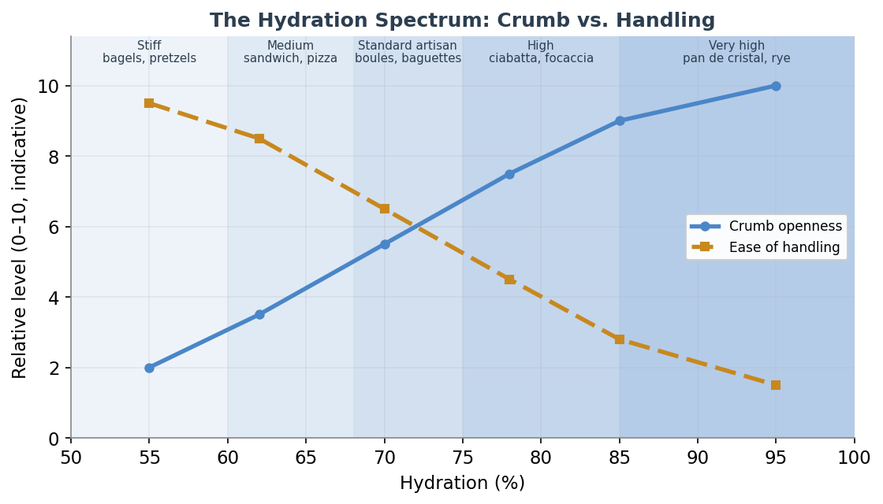
Figure 20 — The hydration spectrum. As hydration climbs from stiff bagel dough toward pourable cristal dough, the potential for an open crumb rises while the ease of handling falls. The bands are approximate and overlap; whole-grain and rye breads sit higher because bran and pentosans drink so much water. Values are indicative.
Band | Hydration | Representative breads | Handling
Stiff / low | ~50–60% | Bagels, pretzels, some pasta | Very stiff; often needs a mixer; hard to knead by hand
Medium | ~60–68% | Sandwich loaves, many enriched doughs, pizza | Easy to shape; the beginner-friendly starting point
Standard artisan | ~68–75% | Pain de campagne, sourdough boules, baguettes | Tacky but workable; folds plus some kneading
High | ~75–85% | Ciabatta, focaccia, rustic open-crumb loaves | Slack, sticky; coil folds, wet hands, bench scraper
Very high | ~85–100%+ | Pan de cristal, wet focaccia, rye breads | Batter-like; no traditional shaping; strong flour essential

23.3 How Much Water a Flour Can Take
Two flours at the same hydration can feel completely different, because flours vary in how much water they can absorb. Three things drive that capacity. The first is protein: the gluten-forming proteins absorb around twice their own weight in water, so higher-protein bread flour drinks more than a soft all-purpose flour. The second, and often the largest single factor, is damaged starch — intact starch granules absorb only a little water, but granules cracked during milling absorb several times their weight, which is why harder wheats and finer milling raise absorption. The third is bran and whole grain: the pentosan gums in bran absorb up to fifteen times their weight, so whole wheat and rye drink far more water and need longer to take it up. Freshly milled and ancient grains, covered in the earlier grain chapters, behave differently again and reward a longer rest.
This is why the same recipe needs adjusting as you change flour. As rough starting points relative to a standard bread flour: all-purpose flour wants perhaps five to ten percent less water, very high-protein flour a few percent more, whole wheat roughly five to ten percent more (a useful rule is about two percent more hydration for every ten percent of whole wheat), and rye more still. Warm water, incidentally, makes a dough feel stickier without actually changing its hydration — a common source of confusion.

23.4 Working with Hydration in Practice
- Build up gradually. start a new bread at the low end of its band and raise the water by a few percent per bake. You can always add water; you cannot easily take it out. A seventy-five-percent dough is markedly harder to handle than a sixty-five-percent one, so earn the increase.
- Change technique as you climb. below about sixty-eight percent, conventional kneading and hand-shaping work fine. Above roughly seventy-five percent, switch from kneading to gentle stretch-and-folds or coil folds during the bulk, wet your hands, use a bench scraper, and lean on a longer, cooler fermentation to firm the dough for shaping.
- Use bassinage for the wettest doughs. mix the dough at a lower, more workable hydration to develop the gluten efficiently, then add the reserved water slowly during late mixing or the first fold. The held-back water acts as a lubricant between gluten strands already formed, letting you reach a high final hydration that would be unmanageable if all the water went in at once. Hamelman recommends the approach above about seventy percent.
- Remember what actually makes an open crumb. higher hydration only raises the potential. Bakers regularly produce beautifully open crumbs at sixty-eight percent and tight ones at eighty. Fermentation, gentle shaping, oven heat and steam are decisive; water is necessary but never sufficient. For most ovens, flours and skill levels, a loaf at sixty-five to seventy-two percent will beat an over-ambitious eighty-five-percent attempt.

23.5 How the Three Variables Interact
Water chemistry, salt and hydration are not independent dials. Soft water makes any given hydration feel slacker, because the mineral reinforcement of the gluten is missing, which effectively lowers the hydration you can handle — bakers on very soft water often struggle past eighty-five percent. Hard water tightens the gluten and lets you push hydration a little higher, at the risk of inextensibility. Salt pulls in the helpful direction here: because it tightens gluten and cuts stickiness, an adequately salted dough is easier to handle at high hydration, while a reduced-salt dough at the same hydration is both slacker and faster to ferment, so it pays to drop the water a touch when you cut the salt. And withholding salt during the autolyse, from the previous section, deliberately frees water to hydrate the flour and bran — which is precisely what a high-hydration or whole-grain dough needs. Read together, the three sections describe one system: the water you use, what you dissolve in it, and how much of it you add.

Hydration sets the ambition of a loaf; fermentation and the hands decide whether it is reached. Raise the water only as fast as your technique can follow.

24. Mixing & Gluten Development
Everything the earlier chapters describe — the rest of an autolyse, the slow work of fermentation, the rise in the oven — depends on a structure that mixing creates: the gluten network. This section looks at how that network forms, what mixing actually accomplishes beyond the obvious blending of ingredients, and the choices a baker makes between developing dough with muscle and machine or with time and fermentation. It is the most foundational of the craft skills, because a loaf can only be as good as the structure built into it before the first fold.

24.1 The Science of Gluten
Wheat flour carries two families of proteins that together make gluten. Glutenin is the source of strength and elasticity — long polymer chains, some among the largest molecules in nature, held together by sulfur-to-sulfur bonds between chains. Gliadin is the source of extensibility and flow — smaller, compact, single molecules folded by sulfur bonds within each chain. When water meets flour the two hydrate and begin bonding almost at once, but forming them into an organised, strong network takes time and work. This is the key idea: hydration is instant, but structure is earned.
Mixing and kneading do their work by reorganising those sulfur bonds. The mechanical action breaks some of the bonds in the largest, most tangled glutenin chains, letting them relax, hydrate fully and re-link into an elastic web, with the gliadin woven through as a softening, lubricating filler. This is why a shaggy, rough mass gradually becomes smooth, stretchy and cohesive under the hands. And it is also why the network keeps maturing even in the oven: the same bonds continue to interchange as the dough heats, which is part of how the crumb sets during the bake described earlier.
It is worth separating two terms bakers often blur. Gluten development is the chemical building and strengthening of the protein network. Dough development is the broader state of the whole dough — how well it is hydrated, how many gas cells it holds, and whether its elasticity and extensibility are in balance. You can create gluten simply by mixing flour and water; you strengthen it by kneading or folding; and you build it into layers by folding repeatedly. But, crucially, gluten also develops on its own over time, through enzyme action and fermentation, with no mechanical work at all — the principle behind both the autolyse and the no-knead loaf.

24.2 What Mixing Actually Does
Mixing is easy to think of as just kneading, but it performs four distinct jobs at once, and understanding them clarifies every later choice.
- Hydration. it wets the starch and proteins evenly, which both builds gluten and switches on the enzymes that feed fermentation and browning.
- Distribution. it spreads water, salt, leaven and any inclusions uniformly through the mass, so the dough ferments and bakes evenly.
- Air incorporation. this one is easy to miss but vital. Mixing beats tiny air bubbles into the dough, and these become the nucleation sites — the seeds — into which fermentation carbon dioxide diffuses. Yeast cannot create a bubble from nothing; it can only inflate one that mixing already put there. Studies put the gas cells at roughly nine to twenty percent of the dough’s volume at the end of mixing, swelling to seventy to seventy-five percent by the end of proof. The crumb you finally cut into was, in a real sense, mapped out during mixing.
- Gluten development. and finally the organising of the network itself, as described above.
There is a hidden cost to mixing, though, and it explains much of what follows: oxidation. The air worked into the dough strengthens the network, but its oxygen also bleaches the carotenoid pigments that give good bread its creamy colour and much of its flavour and aroma. Fast industrial white bread exploits this; artisan baking, following Raymond Calvel, treats it as damage to be minimised. This is the deep reason that the most flavourful breads are mixed gently, kept cool, and given their strength by time and folding rather than by a long, hot, intensive machine mix. It is also why salt, an antioxidant, is sometimes held back: a saltless mix bleaches faster.

24.3 Two Roads to Development: Work and Time
A baker can build the same gluten network two ways: by mechanical work, or by time and fermentation. The figure contrasts them. Mechanical development is fast and rises steeply, but in a machine it can be pushed past its peak into breakdown, where the gluten “blows out” and the dough turns slack and soupy. Development through time — autolyse, long fermentation, periodic folds, the no-knead method — climbs more slowly but plateaus gently and is very hard to overdo. Most artisan practice blends the two: a brief mix to bring the dough together, then folds and fermentation to finish the job, capturing strength and flavour while avoiding both under-development and over-oxidation.

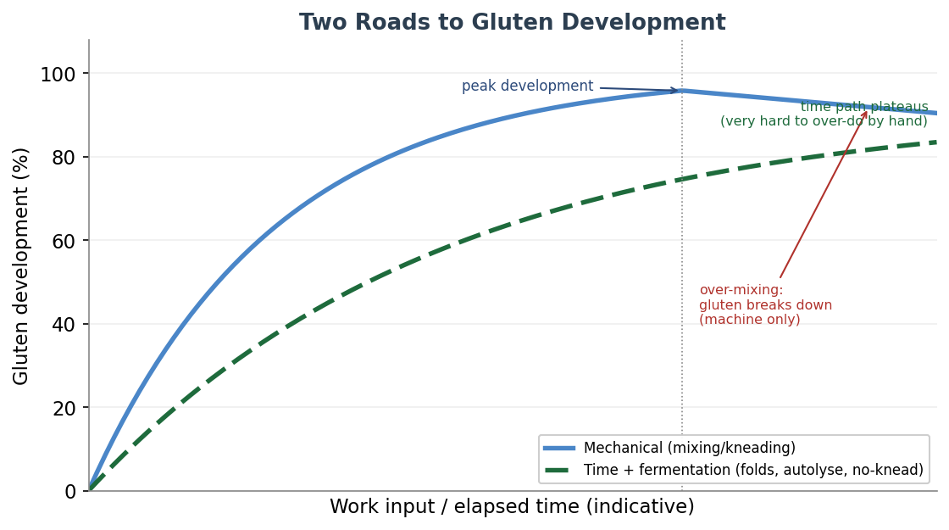
Figure 21 — The two roads to gluten development. Mechanical work (solid) develops the network quickly but, by machine, can be driven past its peak into breakdown; the time-and-fermentation path (dashed) is slower but plateaus safely and is almost impossible to overdo by hand. Skilled practice combines a short mix with folds and fermentation. Curves are indicative.

24.4 Mixing Intensity: Short, Improved and Intensive
French practice, codified by Calvel and taught widely through Michel Suas’s work, recognises three levels of mechanical mixing, and the choice among them is one of the most consequential a baker makes. A short mix barely develops the gluten, leaning on long fermentation and several folds to finish it; it gives the most open, creamy, flavourful crumb but the least volume. An intensive mix develops the gluten fully in the machine, giving high volume and a fine, white, uniform crumb — but the blandest flavour and the most bleaching. The improved mix sits in between, the balanced middle ground for much artisan bread. As a single anchoring figure, Suas puts the improved mix at roughly a thousand revolutions in second speed; the short and intensive figures around it are reasonable approximations rather than fixed constants.

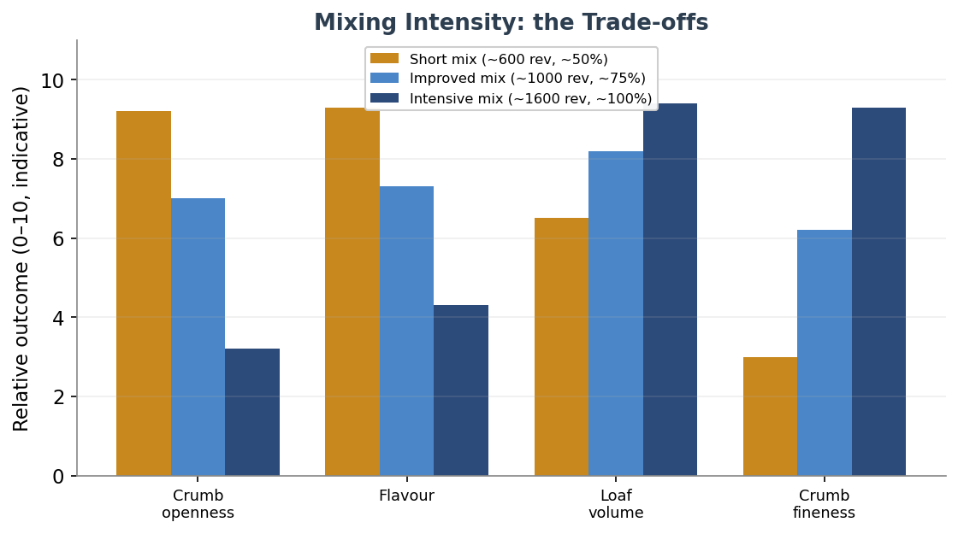
Figure 22 — The trade-offs of mixing intensity. A short mix favours crumb openness and flavour; an intensive mix favours volume and a fine, uniform crumb; the improved mix balances them. The revolution and percentage figures are indicative and vary with flour, batch and mixer type.
Attribute | Short mix | Improved mix | Intensive mix | Notes
Development | ~50% (~600 rev) | ~75% (~1000 rev) | ~100% (~1600 rev) | approx.
Folds in bulk | 3 sets | 1 set | none | —
Bulk ferment | ~3 hours | ~1.5 hours | ~15–20 min | temp-dependent
Crumb | open, creamy | balanced | tight, fine, white | —
Flavour / volume | best / smaller | balanced | blandest / largest | the core trade-off

The intensive mix earns its place with enriched doughs — brioche and the like — where butter, eggs and sugar interfere with gluten and demand fuller development, and where a fine, soft, uniform crumb is the goal. The short mix is the choice for the most open, rustic, deeply flavoured lean breads. Sources disagree on the exact minute counts (they depend on mixer type, batch size, and whether the initial incorporation is counted), so treat the scheme as a map of trade-offs rather than a timetable.

24.5 Developing Gluten by Hand
For the home baker and the artisan, the hand is often better than the machine — gentler, cooler, and almost impossible to overdo. Several named techniques have grown up, each suited to a different dough, and most sourdough is built not by kneading at all but by a short initial mix followed by folds spread through the bulk fermentation. Each fold organises the gluten into new layers and ratchets up the strength while the dough quietly ferments.

Technique | Associated with | Best for | Effect
Rubaud method | Gérard Rubaud | very high hydration, loose dough | builds strength up front, gentle in-bowl lift
Slap-and-fold | Richard Bertinet | hydration above ~78% | fast strength and aeration
Stretch-and-fold | Chad Robertson (Tartine) | most sourdough; replaces kneading | strengthens; ~4 layers per set
Coil fold | Full Proof Baking | mid-to-late bulk, high hydration | gentle; ~8 layers; preserves gas
Lamination | open-crumb bakers | inclusions; one-time boost | dramatic structure in a single step

Stretch-and-folds, the workhorse of sourdough, are typically done in four to six rounds at roughly half-hour intervals during bulk, more assertively early and gently later to protect the gas building inside. Slap-and-fold develops a wet dough astonishingly fast. Coil folds are the gentle late-stage option. Lamination — stretching the dough to a thin translucent sheet and folding it up — gives the biggest one-step boost and is the cleanest way to fold in seeds, nuts or cheese.

24.6 Judging Development: the Windowpane Test
The classic check is the windowpane test: pinch off a small piece, let it relax for a minute, then stretch it gently. Fully developed gluten stretches into a thin, translucent membrane you can almost see through without it tearing; under-developed gluten tears quickly and looks opaque and ragged. It is a genuinely useful gauge for short-fermentation doughs, enriched doughs and for beginners learning the feel of the dough. But it has a real limitation worth stating plainly: it is largely irrelevant for long-fermented and very high-hydration doughs, where the gluten develops biochemically over hours and a test piece may tear well before showing a windowpane, yet the loaf bakes beautifully. Whole-grain and freshly milled doughs, with their sharp bran particles, often never reach a textbook windowpane at all. Read the test as one signal among several, not a verdict.

24.7 No-Knead, Over-Mixing, and the Fermentation Trade-off
The no-knead method, popularised by Jim Lahey, is the purest demonstration that time can replace work: a wet dough — around seventy-five percent hydration, with a tiny amount of yeast — is left twelve to eighteen hours, during which the mobile proteins bond and enzymes do the developing, with only a few folds at the end. It trades a little structure and control for near-zero effort, and it reframes the whole topic: mixing is not sacred, it is simply one way to spend the energy that builds gluten.
The two failure modes sit at opposite ends. Under-mixing leaves the dough shaggy and unevenly hydrated, with poor gas retention and a dense, low, coarse crumb. Over-mixing — almost exclusively a machine fault — drives the gluten past its peak until it breaks down: the dough goes slack and soupy, loses all surface tension, and bakes flat, dense and crumbly, with the bleaching that intensive oxygen brings. The reassuring news for the hand baker is that over-mixing by hand is nearly impossible; you will tire long before the dough does. The practical risk at the bench is almost always under-development, not over.

Cue | Under-mixed | Over-mixed (machine)
Feel | sticky, shaggy, lumpy | slack, soupy, no tension
Windowpane | tears at once | passes, then degrades
Surface | rough, ragged | shiny then “blown out,” tears easily
Baked loaf | dense, low, coarse | flat, dense, dry, pale
Fixable? | keep mixing or folding | essentially not (a long cold rest may rescue a levain dough)

Underlying all of this is one elegant trade-off: the more a dough is mixed, the less fermentation it needs, and the more it ferments, the less mixing it needs. A heavily prefermented or long, slowly fermented dough arrives at full development with only a brief mix, which is exactly why the flavour-first traditions favour time over intensity. And it connects directly back to the autolyse chapter: by letting flour hydrate and gluten begin forming on its own, an autolyse can cut the required machine mixing to as little as a minute or two of second-speed work — Hamelman notes such dough “develops miraculously well during the autolyse” and will, in fact, break down quickly if overmixed afterwards. How much autolyse reduces mixing is debated in degree, but that it does is well established.

Gluten is built, not bought. Whether you build it with your hands, a machine, or the patient work of time, the goal is the same: a network strong enough to trap gas, supple enough to flow into shape, and never pushed so hard it breaks.

25. Shaping & Scoring Craft
After the dough is mixed, fermented and folded, two craft skills stand between it and a finished loaf: shaping and scoring. Both are often underestimated by new bakers, yet together they decide whether a loaf rises tall and opens cleanly or spreads into a flat, lopsided disc. Shaping builds the tension that holds the loaf’s form and traps its gas; scoring directs where and how that trapped gas escapes. This section covers both, form by form and cut by cut, and ties them back to the proofing and oven-spring ideas from the bake chapter.

25.1 Why Shaping Matters
Shaping builds surface tension — a taut, smooth outer skin of gluten that does three things. It traps the fermentation gas inside the loaf rather than letting it escape; it gives the loaf height and a defined form instead of a puddle; and it sets up the loaf to spring upward in the oven rather than spreading outward. A well-shaped loaf, slashed and baked, springs up because its taut skin resists sideways flow and channels the expansion vertically. How firmly you handle the dough also tunes the crumb: gentle shaping that preserves the large bubbles gives an open, irregular crumb, while firmer, more thorough degassing gives the even, uniform crumb wanted in a sandwich loaf.

25.2 Pre-Shaping and the Bench Rest
With more than one loaf, or with slack dough, shaping happens in two stages. Pre-shaping gathers each divided piece into a loose, lightly tensioned round, organising a ragged mass into a uniform starting point and making the final shape far more predictable. The motion is simple: with a bench knife held at a shallow angle, the dough is dragged and tucked under itself until the top is smooth and gently domed — using almost no flour, so the seam underneath grips and holds. The dough should be tensioned but not so tight that the skin tears.
Then comes the bench rest, usually twenty to thirty minutes, occasionally as little as ten or as long as forty-five. Its purpose is to let the tensioned gluten relax enough to be shaped again without tearing. The dough is read by its state, not the clock: it should have relaxed and spread a little, but not collapsed into a flat pancake. If it still springs back tight and resists, it needs longer; if it has gone slack and flat, the pre-shape was too loose or the rest too long. A tighter pre-shape needs a longer rest; a gentle one, less.

25.3 Final Shaping, Form by Form
Each classic form has a repeatable sequence that builds tension while preserving as much gas as the desired crumb allows. The descriptions below give the essential motions; all of them finish by tightening the skin against the work surface and placing the loaf to proof.
- Boule (round): flip the rested round, fold the edges into the centre like an envelope to build a taut underside, then flip it seam-down and drag it in small circles across an unfloured patch of bench, cupping it with both hands, until the surface is tight and evenly domed. The friction of the bare bench is what tightens the skin. Proof seam-up in a floured round banneton.
- Bâtard (oval): flip and gently stretch to a rough rectangle without punching out the gas, fold the sides in, then either roll it up from the top toward you, sealing the seam, or “stitch” the sides together across the middle before rolling. Rock it gently to tension the skin and taper the ends. Proof seam-up in an oval banneton. The stitch builds the most tension and best resists spreading for wet doughs.
- Baguette: pre-shape into a short cylinder and rest, then pat to a rectangle, make two letter folds, fold in half along its length sealing with the heel of the hand, and roll out from the centre to the full length, tapering the ends — a target of around sixteen inches for a fifteen-inch loaf, allowing for shrinkage. The whole roll-out should take seconds, not minutes. Proof seam-up in a floured couche and flip seam-down to bake.
- Pan loaf: degas more deliberately for an even crumb, pat to a rectangle about the length of the tin, fold the sides in, then roll into a tight log and pinch the seam closed. Set it seam-down in a greased tin, long enough to reach the short ends so the rise is supported — roughly nine hundred grams of dough for a standard two-pound tin.

Form | Final shaping | Bench rest | Proof vessel / orientation
Boule | envelope fold, then drag to tension | 20–30 min | round banneton, seam-up
Bâtard | rectangle → letter-fold → roll-up or stitch | 20–30 min | oval banneton, seam-up
Baguette | letter folds → fold in half → roll out & taper | 10–30 min | couche, seam-up; bake seam-down
Pan loaf | rectangle → tuck-and-roll into a tight log | 15–30 min | greased tin, seam-down

25.4 Bench, Hands and Proofing Baskets
A recurring beginner mistake is flouring the bench under the dough while shaping. The dragging surface needs friction to build tension, so the bench should be bare where the dough grips it; flour goes only on the top of the dough, to keep it off the hands. For very wet dough, damp hands and a bench scraper do the work instead. Proofing baskets — bannetons or brotforms — support the shaped loaf so it holds its form and rises up rather than out, and are dusted with rice flour, or a rice-and-wheat blend, which releases far more cleanly than wheat flour alone. Seam orientation links directly to scoring: place the loaf seam-up in the basket when you intend to score it (so you flip it to a smooth top and cut that), and seam-down when you do not, letting the seams open as natural cracks.

25.5 Scoring — the Functional Cut
Scoring is not decoration first and function second; it is the reverse. The cut creates a deliberate line of weakness in the taut skin, so that when the loaf surges in the oven’s first minutes the expansion is directed there, in a clean controlled opening, rather than bursting at random on the side or base where the skin happens to be weakest. An unscored lean loaf will usually tear itself open somewhere ugly and bake lopsided. Scoring takes that control back.
The angle of the blade is the master variable. Held shallow, at roughly thirty to forty-five degrees to the surface — shaving rather than stabbing — the cut lifts a thin flap that the expanding loaf raises into the prized “ear,” the crisp ridge known as the grigne. Held vertical, at ninety degrees, the cut simply opens evenly on both sides, giving a rounder cross-section and no ear. Depth matters too: about half a centimetre to a centimetre and a half, with the shallower cut paradoxically lifting a better ear, because a too-deep cut collapses under its own weight. The figure shows the contrast.

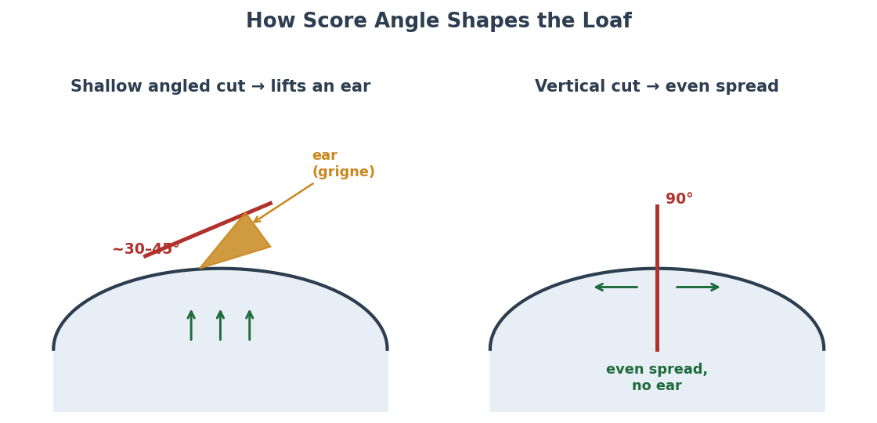
Figure 23 — How score angle shapes the loaf. A shallow cut of roughly 30–45° lifts a flap that springs into an “ear” (grigne); a vertical 90° cut opens evenly with no ear, giving a rounder cross-section. The same loaf can be steered toward height or width by the blade angle alone.
Variable | Setting | Effect
Angle | shallow ~30–45° | lifts a flap → ear / grigne; slower side-spread
Angle | vertical ~90° | even, rapid spread; rounder section; no ear
Depth | ~½ cm (¼") | classic ear; the shallow cut lifts best
Depth | ~1–1.5 cm (½") | oven-spring cut for boule or bâtard
Too shallow | — | score seals over and will not open
Too deep | — | flap collapses; loaf may spread and flatten
Pattern | single axial cut | widens the cross-section (oval)
Pattern | cross or multiple parallel | directs expansion upward or sideways

A few practical points complete the picture. Use a lame — a thin razor on a handle — rather than a knife, which drags and tears; a curved blade favours an ear, a straight one favours clean decorative lines. Cut with one swift, confident pass; hesitation tears. And score cold: dough taken straight from a cold retard has a firm surface that cuts cleanly, where warm, slack dough drags. The pattern itself steers the loaf — a single long cut along a bâtard widens its section, a cross or pair of parallel cuts on a boule pushes the expansion upward.

25.6 The Ear, the Proof, and Common Faults
The ear is the visible proof that everything came together, and it is worth understanding that it cannot be created by the cut alone. It is the product of four things acting together: a well-shaped loaf with real surface tension, the correct shallow-angled score, steam to keep the crust soft long enough to lift, and — decisively — the right level of proof. An under-proofed loaf has so much elastic tension that it springs hard and can burst dramatically, sometimes tearing past the score; an over-proofed loaf has exhausted its gluten and lacks the internal push to open the score at all, so it barely blooms and spreads flat. The ear, in other words, is earned across the whole process, not in the last second with the blade.
This makes the poke test, introduced for proofing in the bake chapter, the natural companion to shaping and scoring. A floured finger pressed lightly into the shaped loaf tells the tale: spring back at once means under-proofed, spring back slowly and only part-way means ready to bake, and no spring back at all means over-proofed. Cold dough rebounds faster and can read as under-proofed when it is not, so judge a retarded loaf by how much it grew during bulk as well. Most bakers agree it is safer to err slightly under-proofed, preserving the oven spring and the chance of a good ear, than to over-proof, which rarely recovers. The faults below gather the common shaping and scoring problems and tie back to the troubleshooting chapter.

Fault | Likely cause | Fix
Flat loaf, spreads out | loose shaping; weak skin; over-proof | tighten shaping; build the skin; shorten proof
Skin tears while shaping | too little bench rest; over-tight; over-fermented | rest and reshape gently; shorten bulk
Dough sticks to basket | under-floured or new basket; too wet | rice-flour blend; season basket; flour the top
Score will not open | too shallow; over-proofed; no steam | cut deeper and angled; proof less; add steam
Blade drags and tears | dull blade; warm dough; hesitation | sharp lame; score cold; one confident pass
Bursts on side or base | unscored or too shallow; under-proofed | score adequately and angled; proof a little more
Dense, heavy crumb | over-degassed in shaping; under-proof | shape more gently; confirm proof by poke test

Shaping decides how high a loaf can rise; scoring decides where it opens to get there. Build the skin tight, cut it cold and shallow, give it steam — and let a slightly young proof keep the spring alive.

26. Commercial Yeast in Depth
This guide is built around the wild fermentation of sourdough, but no professional reference is complete without a thorough account of its faster, more predictable cousin: commercial baker's yeast. Where a sourdough culture is a living community of wild yeasts and bacteria, commercial yeast is a single organism grown in purity and sold in a form that leavens reliably in hours rather than the half-day or more a levain needs. Understanding it — its forms, how to convert between them, how much to use, and where it struggles — lets a baker move fluently between the two worlds and choose the right tool for each loaf.

26.1 What Baker's Yeast Is
Commercial baker's yeast is a single species, Saccharomyces cerevisiae, the same organism behind beer and wine, selected over generations of cultivation for vigorous, consistent gas production. It leavens dough by consuming the simple sugars released as flour's starches are broken down, and converting them into carbon dioxide and ethanol — the gas inflates the dough, the alcohol bakes off and contributes to flavour and aroma. This is the same fundamental fermentation that drives a sourdough, but with a crucial difference: commercial yeast is a pure, dense population of one fast organism, so it ferments quickly and predictably, while a sourdough's mixed wild population works more slowly and brings the sour, complex flavour and keeping quality that the bacteria contribute. Commercial yeast trades that flavour and character for speed and reliability.

26.2 The Three Forms
Commercial yeast is sold in three main forms that differ chiefly in how much water they contain, which in turn governs how they are stored, how they are used, and how potent each gram is. The figure shows the trade-off at a glance: as moisture falls from fresh to instant, shelf stability and per-gram potency both rise.

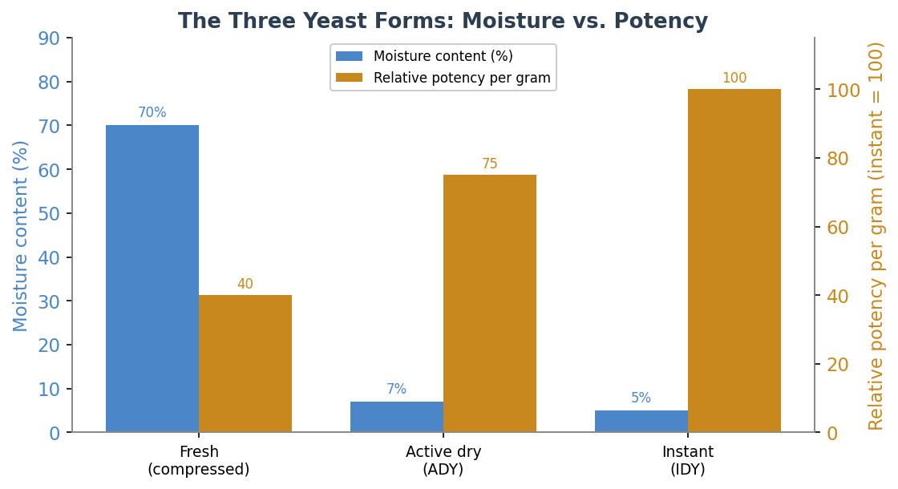
Figure 24 — The three yeast forms. Fresh yeast is about 70% water, active dry around 7%, and instant around 5%. As moisture falls, the yeast keeps longer and each gram becomes more potent — which is why instant is dosed most sparingly. Potency figures are indicative and relative.
- Fresh (compressed or cake) yeast. the original commercial form — a moist, crumbly block about 70% water. It is favoured by some professionals for its clean performance and is crumbled straight into the dough, but it is highly perishable, keeping only two to three weeks refrigerated. The least potent per gram because most of its weight is water.
- Active dry yeast (ADY). dried into comparatively large granules at about 7% moisture, with a protective coating of dormant and dead cells around the live core. Traditionally it is rehydrated first — dissolved in warm water at roughly 105–115°F (40–46°C) for five to ten minutes — to dissolve that coating, though many modern active dry yeasts can be mixed straight into the flour. Stores for months.
- Instant dry yeast (IDY). dried faster into finer particles at about 5% moisture, with no protective coating, so it needs no proofing and is added directly to the dry ingredients. It is the most potent and convenient form, and shortens rising time by roughly a quarter to a third compared with active dry. Rapid-rise and bread-machine yeasts are variants of instant. Stores for months, even years sealed.

Form | Moisture | Storage | Use
Fresh / compressed | ~70% | 2–3 weeks refrigerated | crumble into dough; perishable
Active dry (ADY) | ~7% | months; cool, dry | traditionally proof in warm water; modern can mix dry
Instant (IDY) | ~5% | months–years sealed | add directly to flour; no proofing; most potent

26.3 Converting Between the Forms
Because the three forms differ in moisture and live-cell concentration, a recipe written for one must be rescaled for another. The widely used industry ratio by weight is fresh : active dry : instant of about 3 : 1.2 : 1 — so 100 grams of fresh yeast is roughly 40 grams of active dry or 33 grams of instant. Put the other way: instant is the most concentrated, active dry is about a third more than the same effect in instant, and fresh is about two and a half times the weight of active dry. The handy bench rules are that instant is about 75% of the weight of active dry for the same lift, and fresh is about two and a half times active dry. Sources vary slightly — some quote fresh at 2.5× and others nearer 3× active dry — so treat these as close approximations and adjust to how your dough actually behaves.

To convert | Multiply by | Example
Instant → active dry | × 1.33 | 3 g instant ≈ 4 g ADY
Active dry → instant | × 0.75 | 4 g ADY ≈ 3 g instant
Fresh → instant | ÷ 3 | 30 g fresh ≈ 10 g instant
Fresh → active dry | ÷ 2.5 | 30 g fresh ≈ 12 g ADY
Instant → fresh | × 3 | 5 g instant ≈ 15 g fresh

26.4 How Much to Use
Yeast is dosed as a baker's percentage of the flour weight, and the workable range for instant yeast runs from about 0.5% to 2%, with most same-day breads sitting around 1% to 1.4%. The amount is not fixed but traded against time and temperature: more yeast or a warmer dough ferments faster, less yeast or a cooler dough ferments slower. This is the single most useful lever in yeasted baking. A long, cool or overnight ferment uses very little yeast — sometimes a small fraction of a percent — precisely so that flavour can develop without the dough racing ahead; a fast pizza or rapid bake uses more. One natural ceiling: a distinct yeasty taste begins to show in the finished bread once added yeast climbs above about 2.5% of the flour, so flavour as well as speed argues for restraint.

Instant yeast | Speed | Typical use
~0.5% | slow | long or cold/overnight fermentation; more flavour
~1% | standard | everyday same-day loaves
~1.5% | quick | faster same-day bakes; many pizza doughs
~2% | rapid | quick rolls, time-pressed bakes
above ~2.5% | very fast | yeasty taste becomes noticeable — avoid

A single 7-gram sachet of instant or active dry yeast — about two and a quarter teaspoons — is calibrated for a typical 500-to-1000-gram dough, a useful sanity check against any recipe. To test whether older yeast is still alive, dissolve a little in warm water with a pinch of sugar; healthy yeast foams within about ten minutes.

26.5 Temperature, Salt and Sugar
Yeast is an organism with clear preferences. Its growth is fastest in a warm range of roughly 75–95°F (24–35°C); below about 80°F metabolism slows markedly, which is the whole basis of the cold retard covered earlier in the guide, and at around 130–140°F the cells die irreversibly — which is why rehydrating water must be warm, never hot. Salt and sugar both affect it through osmosis, as the salt and hydration chapters described: salt in normal doses gently restrains the yeast, while sugar is more complicated and important enough to need its own treatment, below and in the next section.

26.6 Osmotolerant Yeast for Sweet Doughs
Here is a problem every baker of sweet bread meets. In small amounts sugar feeds the yeast and speeds fermentation, but once it exceeds about 5% of the flour weight it begins to work against the yeast: dissolved sugar draws water osmotically out of the yeast cells, leaving them stressed, sluggish and slow to rise. In a rich brioche or panettone this can stall fermentation badly, and the old workaround was to pile in extra ordinary yeast, well above 2%.
The modern answer is osmotolerant yeast, sold most familiarly as SAF Gold. It is a special strain of instant yeast bred to need less water, so it ferments happily in sweet, low-water doughs where regular yeast struggles — lifting a sweet dough in a normal hour or so. It is used at about 1–3% of the flour, mixed straight into the dry ingredients, and kept away from ice-cold water; in rich doughs it provides on the order of 10–20% more activity than ordinary yeast and gives a more uniform, reliable rise. For doughs below the roughly 5% sugar threshold there is no need for it; for anything sweeter, it is the professional's choice and the natural partner to the enriched doughs of the next section.

Commercial yeast is a single fast organism sold in three moistures; sourdough is a slow wild community. Choose speed and reliability or flavour and keeping — and dose by the clock and the thermometer, not habit.

27. Enriched & Laminated Doughs
Everything so far has concerned lean dough — flour, water, salt and leaven. Add fat, sugar, eggs or dairy and you enter a different country: the soft, rich, tender world of brioche, challah, milk bread and the laminated pastries. These enrichments do not merely flavour the bread; they rewrite the rules of gluten, fermentation and structure. This section explains how each ingredient changes the dough, surveys the major enriched breads and their formulas, and then turns to lamination — the architecture of butter and dough layers behind the croissant.

27.1 What Enrichment Does
Enrichment means adding fat (butter or oil), sugar, eggs or dairy to a lean dough, and each ingredient pulls the dough toward softness and tenderness while pulling against the gluten structure that gives lean bread its chew and rise. The central theme is a trade-off: richness versus structure. The richer and more tender the crumb, the harder the baker must work to build enough gluten strength to support it.
- Fat (butter, oil). coats and shortens the gluten strands, physically getting in the way of the network and so tenderizing the crumb, softening the crust, and improving keeping quality by slowing staling. It also slows yeast a little by coating, and lubricates the dough for a more billowy texture. Too much makes a greasy, dense, hard-to-shape dough; the classic fix for high-butter dough like brioche is to develop the gluten first and add the soft (room-temperature) butter at the end of mixing.
- Sugar. tenderizes, attracts and holds water (keeping bread moist), and browns the crust through caramelization and the Maillard reaction. But, as the yeast section noted, above about 5% of flour weight it competes with the yeast for water and slows fermentation through osmotic stress — the reason sweet doughs ferment slowly and reward osmotolerant yeast.
- Eggs. do several jobs at once: the yolk brings fat and the emulsifier lecithin (which gives a finer, more uniform crumb and helps fat and water combine), the white brings protein and water that add structure, and both bring colour and richness.
- Dairy (milk). adds fat, the sugar lactose (which aids browning), and softness; milk often replaces some or all of the water in enriched dough. Many recipes scald milk first, a tradition that also denatures a whey protein that can otherwise slacken dough.
Because fat coats the gluten and sugar steals water, enriched doughs ferment more slowly and generally need more yeast (or osmotolerant yeast) and longer, gentler handling than lean dough. Their hydration is also reckoned differently, since eggs and milk are only partly water — a point the hydration chapter flagged.

27.2 The Major Enriched Breads
Enriched breads form a spectrum from barely enriched to extravagantly rich, and thinking in baker's percentages makes the family legible. At the rich end sits brioche; modestly enriched pan loaves sit near the lean end; the Japanese milk breads achieve their softness as much through a starch trick as through enrichment.

Bread | Typical enrichment (baker's %) | Character
Brioche | butter ~30–100% (often 50–60%), eggs 50%+, sugar 10–20%, milk | very rich, tender, cake-like
Challah | eggs and oil; no dairy | rich, glossy, braided
Pain de mie | butter ~12%, milk ~22%, a little honey | soft sandwich loaf, modest enrichment
Milk bread / shokupan | milk, modest butter, plus tangzhong or yudane | cottony, light, long-keeping
Panettone | very high butter, eggs, sugar, candied fruit | extreme, complex, long ferment
Cinnamon rolls / babka | butter, sugar, eggs, milk | soft, sweet, filled

Brioche is the type specimen, extreme in every direction: bakers have made it with as much as 100% butter (in baker's percentage), though 50–60% is more common, alongside eggs at half the flour weight or more and sugar at 10–20%. One well-known naturally leavened version runs 42% butter, 42% egg, 21% sugar and 16% milk — a useful anchor. The defining technique is to build strong gluten before adding the butter, so the network can survive the fat that is about to coat it.

27.3 Tangzhong and Yudane: the Starch Trick
The Japanese and Chinese milk breads owe their famous cottony softness less to enrichment than to a clever pre-treatment of starch. By pre-cooking a small portion of the flour with liquid, the starch gelatinizes — it absorbs and locks in water, swelling into a paste — and that pre-bound water makes the finished bread softer, fluffier and far slower to stale, because the water cannot easily escape. The trick lets a baker push hydration higher (often around 75%) without the dough becoming unmanageably slack.
There are two versions of the method. Tangzhong (the Chinese name) cooks a portion of flour and liquid together on the stove in roughly a 1:5 ratio by weight, stirring to a pudding-like paste at about 150°F (65°C), the temperature at which wheat starch gelatinizes. Yudane (the Japanese name) instead pours boiling liquid over flour in about a 1:1 ratio and rests it, usually overnight, reaching the same end by a different road. Both typically use 5–10% of the total flour, are cooled before being mixed into the dough, and have their flour and liquid deducted from the main formula. They are not freely interchangeable: tangzhong carries far more water (up to four times as much as yudane), so swapping one for the other means re-balancing the recipe.

Method | Flour : liquid | How | Result
Tangzhong | ~1 : 5 by weight | cook to ~150°F/65°C paste, cool | smooth paste; brioche-like softness
Yudane | ~1 : 1 by weight | pour boiling liquid over flour, rest 8h+ | firmer gel; lighter, chewy crumb

27.4 Lamination: Building Layers of Butter and Dough
Lamination is the architecture behind croissants, Danish pastries and puff pastry: alternating layers of dough and butter, built by repeatedly rolling and folding, so that in the oven the water in each thin butter layer flashes to steam and pushes the dough layers apart into flaky, open leaves. The dough component is called the détrempe and the butter block the beurrage. After the butter is locked inside the dough, each fold multiplies the layers.
The fold maths is the heart of it. A single (letter) fold into thirds triples the layers each time, so the butter layers go as roughly three to the power of the number of folds. The figure shows how quickly this escalates: three letter folds give 27 butter layers, the classic croissant count; six folds reach 729, the traditional puff-pastry figure. Croissants are often made with about three folds (sometimes mixing single and double, or book, folds — two double folds give 16 layers, three singles give 27); puff pastry uses more. Beyond a point, too many folds compress and blur the layers rather than multiplying useful ones, so the count is chosen, not maximised.

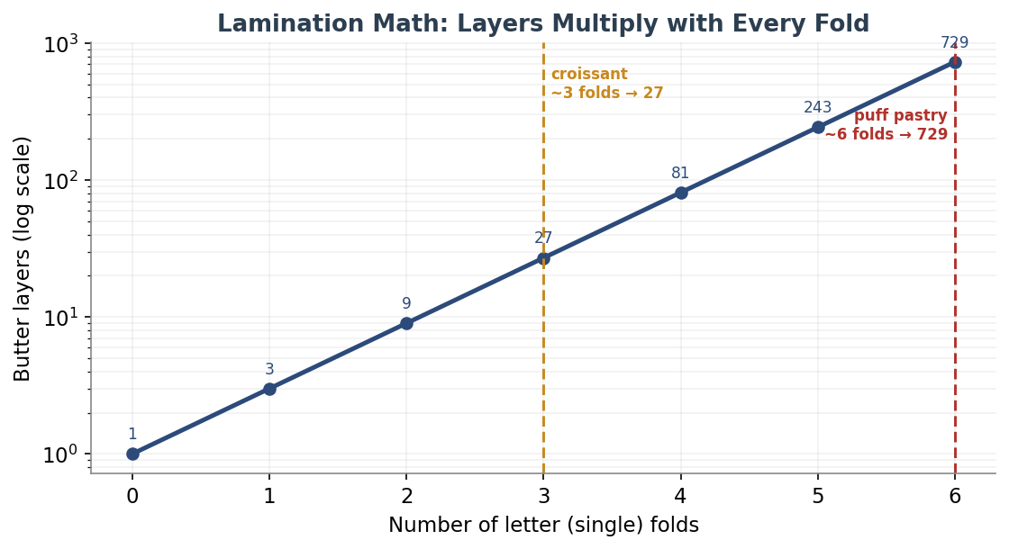
Figure 25 — Lamination maths. Each letter (single) fold triples the butter layers, so layers rise as 3 to the power of the number of folds; the count climbs exponentially (note the log scale). Croissants land near 27 layers, classic puff pastry near 729. Exact schemes and counts vary by recipe and tradition.
Pastry | Folds / layers | Notes
Croissant | ~3 folds → ~27 butter layers | yeasted; lamination plus a gentle rise
Danish | ~3 single folds → ~27 layers | yeasted; often a book fold; enriched with egg
Puff pastry | ~6 folds → up to ~729 layers | unyeasted; all rise from steam

Temperature control is everything in lamination. The butter must stay plastic — pliable but not soft — at around 55°F (13°C), ideally a couple of degrees cooler than the dough. Too cold and the butter shatters into shards that tear the layers; too warm and it smears into the dough and the leaves merge. European-style butter, at roughly 82–84% fat (so less water than ordinary butter), is preferred for its plasticity and clean layers. The dough is rested and chilled, typically 30 to 45 minutes, between folds, both to relax the gluten and to firm the butter. Butter is generally around 30–40% of the flour weight for croissants and 45–55% (sometimes equal weight) for puff pastry.
The yeasted laminates — croissants and Danish — get a gentle lift from yeast in addition to the steam-driven flaking, while puff pastry is unleavened and rises entirely from steam. In all of them the same physics applies: water in dough and butter turns to steam, inflates the gaps between layers, and the heat then sets those layers in their blown, flaky shape. It is the most demanding craft in this guide, and the most spectacular when it works.

Enrichment trades structure for tenderness; lamination turns that tension into architecture. In both, fat is the protagonist — coating gluten to soften a crumb, or layered into dough to blow it open with steam.

28. Flours Beyond the Grain
The grain chapters earlier in this guide surveyed wheats and ancient grains by their botany and flavour. This section looks at flour from the other side: not the grain it came from but how it was milled, classified, aged and treated — the extraction rate and ash content behind the European type numbers, the protein specifications bakers actually read, the malt and enzymes that quietly shape almost every loaf, and the additives and dough improvers of industrial baking. It completes the flour story and lets a baker read a flour by its specification, not just its name.

28.1 Extraction Rate and Ash Content
When wheat is milled, the bran and germ are progressively sifted away from the white endosperm. The extraction rate is the percentage of the whole grain that ends up in the flour: a white flour is around 72–75% extraction (the bran and germ removed), a wholemeal flour is 100% (everything retained). Because the bran and germ are rich in minerals, the simplest way to measure how much of them remain is to burn a sample and weigh the mineral residue — the ash content. More bran means more ash, so ash content stands in for extraction rate and is the basis of the European flour-type numbers. One subtlety worth holding onto: the relationship is not linear, because the very first material removed in milling is the mineral-rich bran, so ash falls steeply at first and then levels off.

28.2 Reading the Type Numbers
Continental flours are labelled by ash, and the systems map onto one another once you know the unit. The French T-number is milligrams of ash per 10 grams of flour, so T55 is about 0.55% ash; the German number is milligrams per 100 grams, ten times larger, so German 550 is the same flour as French T55. The Italian system (00, 0, 1, 2) instead describes fineness of grind and refinement rather than ash directly, with 00 the finest and most refined. The table gathers the common types.

French | German | Italian | Typical use
T45 | 405 | 00 (pastry) | pastry, viennoiserie; soft, fine
T55 | 550 | 0 | standard white; baguettes, croissants, general baking
T65 | 812 | 0–1 | rustic breads, artisan baguettes
T80 | 1050 | 1 | light wholemeal, pain de campagne
T110 | 1370 | 2 | darker breads
T150 | 1600–1700 | integrale | wholemeal / wholegrain

Two cautions matter. First, a T-number is an ash measure, not a protein or strength measure — two T55 flours can have quite different protein contents, so the protein line on the bag still has to be read separately. Second, US ash figures are not directly comparable, because they are measured at a different reference moisture and the milling streams differ; there is no exact US equivalent of a T55, only approximations.

28.3 Protein by Use
Where Europe classifies flour by ash, the US and UK classify it largely by use, which tracks protein content — the gluten-forming potential the mixing chapter described. The ladder runs from soft, low-protein cake flour up to high-gluten flour, with bread flour and all-purpose in the middle. As a rough orientation, King Arthur's Sir Galahad artisan flour at about 11.7% protein behaves much like a French T55 or T65.

Flour (US) | Protein | Use
Cake | ~7–9% | tender cakes; very soft
Pastry | ~8–9% | pastry, cookies
All-purpose | ~10–12% | general baking; some breads
Bread | ~12.5–13% | most yeast breads; higher hydration
High-gluten | ~14%+ | bagels, pizza, chewy breads
Durum / semolina | ~13% | pasta, some breads; yellow, high extensibility

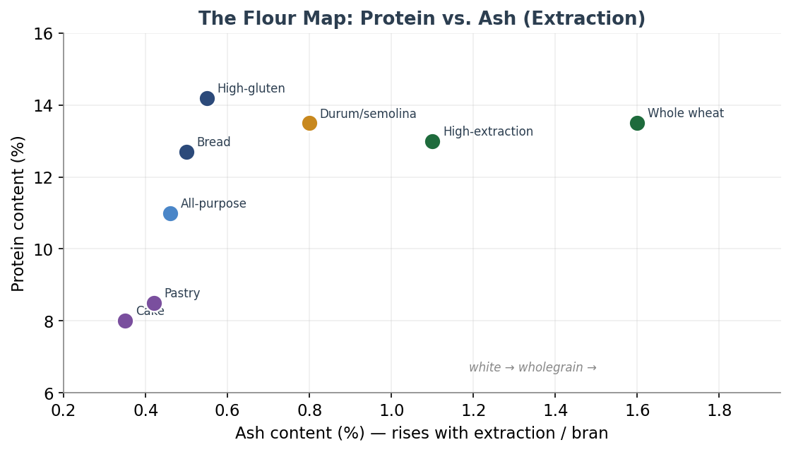
Figure 26 — The flour map. Plotting protein against ash separates the families: low-protein, low-ash cake and pastry flours at the bottom left; bread and high-gluten flours up the protein axis; high-extraction and wholemeal flours out along the ash axis as more bran is retained. Positions are indicative.

28.4 Ageing, Bleaching and Maturing
Freshly milled flour is not at its best for bread. Straight from the mill it is slack and sticky — bakers call it green — and it improves over a few weeks as atmospheric oxygen matures it, strengthening the gluten through oxidation. Traditionally flour was simply aged in storage; industrially the same effect is achieved chemically and faster, and it is worth distinguishing two different chemical jobs that are often confused.
- Bleaching whitens the pigment of the flour. Agents include benzoyl peroxide (whitening only) and chlorine gas, the latter used for cake flour because it also modifies the starch to take more liquid and sugar. Unbleached flour is simply allowed to whiten naturally with age.
- Maturing / oxidizing strengthens the gluten for better volume and structure. Ascorbic acid (vitamin C) is the common, benign strengthener, generally recognised as safe and widely used even in artisan flour. More aggressive oxidants carry regulatory baggage: azodicarbonamide (ADA) is banned in the EU and UK and capped at 45 ppm in the US; potassium bromate is banned in many countries and capped at 50 ppm where allowed; potassium iodate is similarly restricted. These belong to industrial baking, not the craft bakery.

28.5 Malt: the Hidden Enzyme
One of the most consequential flour additives is nearly invisible: malt. Diastatic malt is made from sprouted grain and carries active amylase enzymes that break the flour's damaged starch down into sugars the yeast can eat — feeding fermentation, improving rise, and browning the crust. Most US bread and all-purpose flours already contain a little added malted barley flour for exactly this reason; many organic, whole-wheat and home-milled flours do not, and benefit from a small addition. The dose is critical and small: at or below about 0.5% of the flour (King Arthur suggests roughly half a teaspoon to a teaspoon per three cups), because too much amylase over-degrades the starch and leaves a gummy, sticky crumb. Non-diastatic malt, by contrast, has had its enzymes deactivated and is used purely for flavour, sweetness and colour — the malty note and shiny crust of a bagel, for instance. The laboratory measure of a flour's own amylase activity is the falling number; a very high falling number signals low enzyme activity and may call for diastatic malt, a very low one signals excess (sprout-damaged grain) and a slack, sticky dough.

28.6 Dough Improvers and Other Additives
Commercial baking leans on a toolkit of dough improvers, typically dosed at 0.5–4% of flour, that the craft baker rarely needs but should recognise. They fall into families by function: enzymes (amylases, proteases, lipases, xylanases) that adjust starch, protein and dough handling; oxidants (ascorbic acid and the restricted bromate, ADA and iodate) that strengthen gluten; emulsifiers (DATEM, SSL, CSL, mono- and diglycerides, lecithin) that consolidate the gluten and give a finer, more uniform crumb with better machinability; reducing agents (L-cysteine) that do the opposite, relaxing dough for extensibility; anti-staling enzymes (maltogenic amylases such as the Novamyl family) that keep industrial bread soft for days; and preservatives (calcium propionate) that hold off mould. Two consumer flour categories also belong here: self-rising flour, which has baking powder and salt already blended in, and enriched flour, which has had nutrients — niacin, thiamine, riboflavin, folic acid and iron — added back after milling to replace what refining removed.

Family | Examples | What it does
Enzymes | amylase, protease, lipase, xylanase | adjust starch, protein, handling; feed yeast
Oxidants | ascorbic acid; bromate, ADA, iodate (restricted) | strengthen gluten; more volume
Emulsifiers | DATEM, SSL, CSL, mono/diglycerides, lecithin | finer, uniform crumb; machinability
Reducing agents | L-cysteine | relax dough for extensibility
Anti-staling | maltogenic amylases (e.g. Novamyl) | keeps crumb soft longer
Preservatives | calcium propionate | delays mould

For the craft baker the practical message is simple: choose a flour by its protein for structure, its ash or extraction for flavour and character, and its falling number or malt status for enzyme balance, and let long fermentation do the work that industrial improvers do by chemistry.

A flour's name tells you the grain; its specification tells you the bread. Read the protein for strength, the ash for character, and the malt for how hungry the yeast will be.

29. Equipment
Bread needs remarkably little equipment, and no tool will rescue poor fermentation or shaping. But the right kit removes friction and unlocks results a home kitchen otherwise cannot reach — chiefly the fierce, even base heat and the trapped steam that the bake chapter showed are decisive for oven spring and crust. This closing section surveys the equipment that matters, from the surfaces you bake on to the tools you measure and shape with, with cross-references to the chapters where each does its real work. It completes the guide's roadmap.

29.1 The Oven and What You Bake On
Home ovens top out around 500–550°F and rarely hold the temperature they claim, so the first and cheapest upgrade is an oven thermometer to learn the truth of your oven. Beyond that, what you bake on matters more than the oven itself, because a preheated mass of stone or steel gives the loaf the sudden base heat that drives oven spring.
The choice between a baking stone and a baking steel comes down to two properties: thermal mass (how much heat the slab stores) and conductivity (how fast it delivers that heat). Steel's great advantage is conductivity — it transfers heat to the dough far faster than stone, often quoted at around eighteen times faster — so it gives a stronger, faster base heat, better oven spring, a quicker preheat, and a fast recovery between loaves. Its costs are weight, price and the need to keep it from rusting. Stone is cheaper, lighter and gives a gentle, even heat with no rust worry, but it is thermally sluggish, slow to preheat, and prone to cracking from thermal shock. A useful caution from the physics: thick mass without conductivity just creates lag, so a very thick stone can preheat for ninety minutes and still deliver less to the dough than a thinner steel. Typical thicknesses are about a quarter to a half inch for steel and a half to three-quarters of an inch for stone; preheat steel around 45–60 minutes and a thick stone longer.

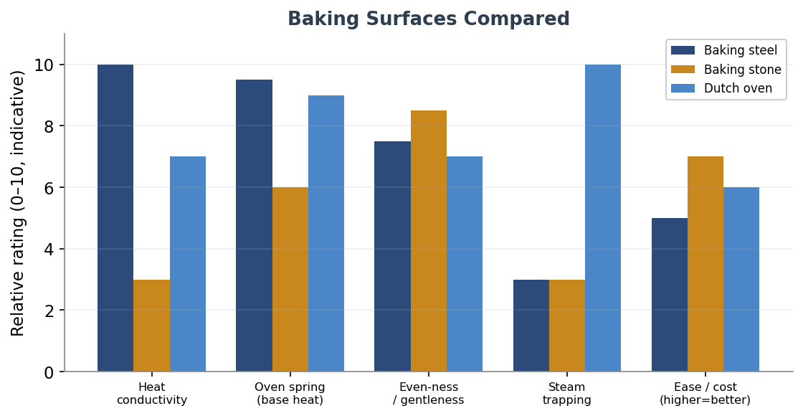
Figure 27 — Baking surfaces compared. Steel leads on conductivity and base-heat oven spring; stone is gentler, cheaper and rust-free but thermally slow; the Dutch oven wins decisively on trapping steam, the home baker's hardest problem. Ratings are indicative and relative.

29.2 Steam: the Dutch Oven and the Alternatives
As the bake chapter argued, steam in the first ten to fifteen minutes is what lets a loaf expand and develop a glossy, crisp, well-coloured crust before the surface sets. The home baker's difficulty is that domestic ovens vent steam, and the single best solution is also the simplest: a Dutch oven, combo cooker or cloche. A preheated cast-iron or enamelled vessel traps the loaf's own escaping moisture into a humid micro-oven, mimicking a bakery's steam injection with no fuss. Lid on for the first part of the bake, then off to colour and crisp. The main limit is that it bakes one loaf at a time.
The alternatives, in rough order of effectiveness: a covered vessel (best); a preheated steam pan or a tray of lava rocks with boiling water or ice added as the loaf goes in (remove after about 20 minutes); and spritzing the oven, which is the least effective. A baking shell or cloche set over a preheated steel combines fierce base heat with trapped steam and lets you open-bake several loaves with a water pan below. One firm rule from the surface section: never put parchment under a loaf or pizza on a steel if you want maximum base heat, because it insulates.

Steam method | Effectiveness | Notes
Dutch oven / cloche | best | traps the loaf's own moisture; one loaf at a time
Steam pan / lava rocks | good | add boiling water or ice at load; remove after ~20 min
Cast-iron tray + ice | good | simple; protect oven glass from splashes
Spritzing | least effective | brief surface moisture only

29.3 Measuring and Monitoring
If only one tool is bought, it should be a digital scale. Weighing every ingredient is the foundation of the baker's-percentage thinking used throughout this guide, and is far more accurate and repeatable than measuring by volume — the salt and yeast chapters showed how badly volume betrays dense and fluffy ingredients alike. A probe thermometer is the close second: an instant-read probe lets you hit a desired dough temperature (the mixing and water chapters' DDT) and confirm doneness — about 96°C for a lean loaf, a little lower, around 88°C, for an enriched one. Add an oven thermometer to calibrate the oven, and for sourdough a pH meter can track culture and dough acidity. Timers and a hygrometer round out the kit.

29.4 Mixing, Shaping, Proofing and Cooling Tools
The remaining equipment supports the techniques of earlier chapters, and most of it is inexpensive. For mixing, a spiral mixer develops dough gently with little friction heat and excels at high hydration, while a planetary stand mixer is more versatile but warmer and weaker on wet dough, as the mixing chapter detailed; hand methods need no machine at all.
- Shaping and handling: a bench knife (scraper) for dividing and pre-shaping, a flexible bowl scraper, and a lame or razor for scoring — all as covered in the shaping and scoring chapter — plus a couche for baguettes and a peel and transfer peel for loading the oven.
- Proofing: bannetons or brotforms to support shaped loaves (floured with a rice-and-wheat blend, per the shaping chapter), a couche for baguettes, and for temperature control a proofing box or a simple improvised one — an oven with the light on, or a cooler with a bowl of warm water.
- Fermentation tracking: a straight-sided, clear container lets you read the percentage rise during bulk fermentation at a glance — one of the most useful cheap upgrades for sourdough.
- Cooling: a wire rack, so air circulates underneath and the crust does not turn soggy with trapped steam as the loaf cools.
- For lamination and enriched work: a good rolling pin, a ruler, and a cool marble or steel surface help keep butter in temperature, as the previous section's lamination notes require.

Essential | Very useful | Nice to have
Digital scale | Dutch oven / combo cooker | pH meter (sourdough)
Probe thermometer | Baking steel or stone | proofing box / proofer
Bench knife & bowl scraper | Banneton(s) | transfer peel
Lame / razor | Oven thermometer | couche
Mixing bowls | Straight-sided dough tub | hygrometer
Wire cooling rack | Peel | stand or spiral mixer

With this, the guide's roadmap is complete: from the science of the rest through grains, fermentation, the bake, the core formula variables, the craft of mixing, shaping and scoring, and now yeast, enrichment, flour specification and equipment. The tools are only ever in service of the dough — but the right ones, well understood, let everything the earlier chapters teach finally reach the loaf.

No tool bakes the bread for you, but the right surface, a trapped cloud of steam, a scale and a thermometer turn a home oven into a bakery. Buy the scale first; earn the rest as the dough demands them.

30. Flavour & Aroma Chemistry
Every chapter so far has worked toward a good-tasting loaf without ever pausing to ask what good taste is made of. This one does. The flavour of bread is one of the most studied in food science, and the picture that emerges is both complex and beautifully ordered: more than five hundred volatile compounds have been identified in bread, yet only a few dozen are present in high enough concentration to actually register as aroma. Better still, those few dozen sort themselves along exactly the line the bake chapter already drew — the cool, moist crumb and the hot, dry crust — because each is built by a different chemistry. Understanding that division turns flavour from a mystery into something a baker can steer.

30.1 Two Sources, One Loaf
Bread aroma comes from two distinct engines. The crumb's flavour is built by fermentation, at temperatures that never exceed the boiling point of water, so it is a biological chemistry: yeasts and bacteria converting sugars and amino acids into aromatic molecules over hours. The crust's flavour is built by heat, at surface temperatures of 140–180 °C, so it is a thermal chemistry: the Maillard reaction and caramelisation forging hundreds of new compounds in minutes. The same loaf therefore carries two flavour systems, and the figure shows the leading players in each.

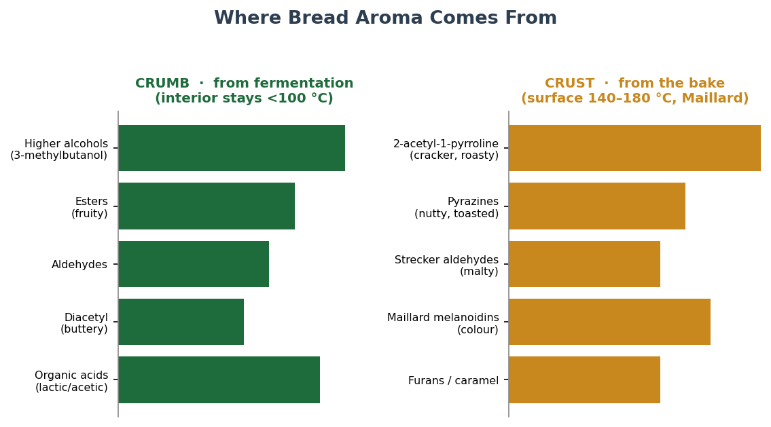
Figure 28 — Where bread aroma comes from. The crumb's aromas are fermentation-derived and survive only because the interior never exceeds about 100 °C; the crust's are forged by the Maillard reaction on a surface that climbs to 140–180 °C. Relative intensities are indicative.

30.2 The Crumb: Flavour from Fermentation
The aromatic compounds of the crumb are the work of the starter and yeast, and they fall into a few families. Alcohols are the most abundant, led by ethanol but including the higher alcohols such as 3-methyl-1-butanol, which the yeast makes from the amino acid leucine through what is called the Ehrlich pathway — a route that turns the proteins broken down during fermentation into fragrant molecules. Esters, formed when those alcohols meet organic acids, bring fruity and floral notes. Aldehydes contribute green, malty and grassy tones. Diacetyl provides the buttery note prized in some breads. And the organic acids themselves — mild, yogurt-like lactic acid and sharp, vinegary acetic acid, in the balance set by fermentation temperature as the low-temperature chapter described — give sourdough its defining tang. This is why a long, cool fermentation builds more flavour: it gives the enzymes and microbes time to accumulate a deeper stock of these aromatic precursors and acids than a fast warm rise ever can.

30.3 The Crust: Flavour from Heat
The crust is where the most intense aromas are born, and almost none of them existed before the loaf entered the oven. The Maillard reaction — the cascade between amino acids and reducing sugars described in the bake chapter — produces, alongside the brown melanoidin pigments, a vast family of aroma compounds. The single most important is 2-acetyl-1-pyrroline, the roasty, cracker-like, popcorn note that defines the smell of fresh crust (and, remarkably, also gives jasmine rice and popcorn their scent). Pyrazines add nutty and toasted notes; the Strecker degradation of amino acids yields malty aldehydes such as methylbutanal; and caramelisation of sugars adds furans and a sweet, caramel depth. Because every one of these depends on heat and a dry surface, the crust's flavour is a direct dividend of how dark you are willing to bake — the deep mahogany crust the bake chapter argued for is, chemically, simply more flavour.

Family | Where | Notes / leading compounds
Higher alcohols | crumb | fermentation (Ehrlich pathway); 3-methyl-1-butanol; warming, solvent-fruity
Esters | crumb | fruity, floral; from alcohols + acids
Aldehydes | crumb | green, malty, grassy
Diacetyl | crumb | buttery
Organic acids | crumb | lactic (mild) and acetic (sharp); the sourdough tang
2-acetyl-1-pyrroline | crust | roasty, cracker, popcorn — the signature crust note
Pyrazines | crust | nutty, toasted (Maillard)
Strecker aldehydes | crust | malty (e.g. methylbutanal)
Furans / caramel | crust | sweet, caramel (caramelisation)

30.4 Steering Flavour, and a Tasting Vocabulary
Because the two engines respond to different controls, a baker can steer flavour deliberately. To build crumb flavour, lengthen and cool the fermentation, raise the proportion of pre-ferment or whole and ancient grains (which bring their own aromatic compounds and more enzyme substrate), and choose the acid balance through temperature. To build crust flavour, bake darker, use steam to extend the window for browning, and remember that residual sugar — spared by adequate salt, or supplied by a touch of diastatic malt — feeds the Maillard reaction. The two are somewhat independent: a pale loaf with a long ferment is all crumb-flavour and no crust depth, while a fast dough baked dark has crust but little fermentation complexity. The best loaves earn both.
To talk about the result, it helps to taste in a fixed order, the way a professional does. Look first (crust colour, crumb structure), then smell (the roasty crust against the tangy, fermented crumb), then taste for the basic dimensions — sweetness from residual sugars, sourness from the acids, salt, and any bitterness from very dark crust or whole-grain bran — and finally judge the texture and the finish, the flavour that lingers. Naming what you taste against the families above turns vague impressions into feedback you can act on, closing the same diagnostic loop the crumb-reading chapter opened.
One honest caveat: of those five hundred-plus volatiles, only a fraction are odour-active, and which ones matter is judged by their concentration relative to the threshold at which a nose can detect them — the odour activity value. Flavour perception is also genuinely individual, shaped by genetics and culture, so treat the compound names here as a map of what is present and steerable, not a verdict on what any one person will taste.

Bread carries two flavour systems in one loaf: a fermented crumb built slowly by microbes below the boil, and a roasted crust forged in minutes by heat above it. Lengthen the ferment for one; bake darker for the other; earn both.

31. Nutrition, Digestibility & Health
Bread is one of the oldest staple foods, and the way it is fermented turns out to change not just its flavour but its nutrition and how the body handles it. This is the dimension eaters ask about most and the guide has so far said least about. The honest summary is that long, slow fermentation — especially sourdough — makes bread measurably better on several health measures, through mechanisms that are well understood, while the clinical evidence for how much this matters in practice is genuinely mixed. This section explains the mechanisms and is candid about where the science is firm and where it is still emerging. It is not medical advice, and one boundary is absolute: none of these effects makes bread safe for someone with coeliac disease.

31.1 What Fermentation Changes
Four well-documented effects sit behind sourdough's nutritional reputation, and the figure summarises their direction and rough scale. Each follows from the same root cause: the long action of acids, enzymes and microbes on the dough before baking.

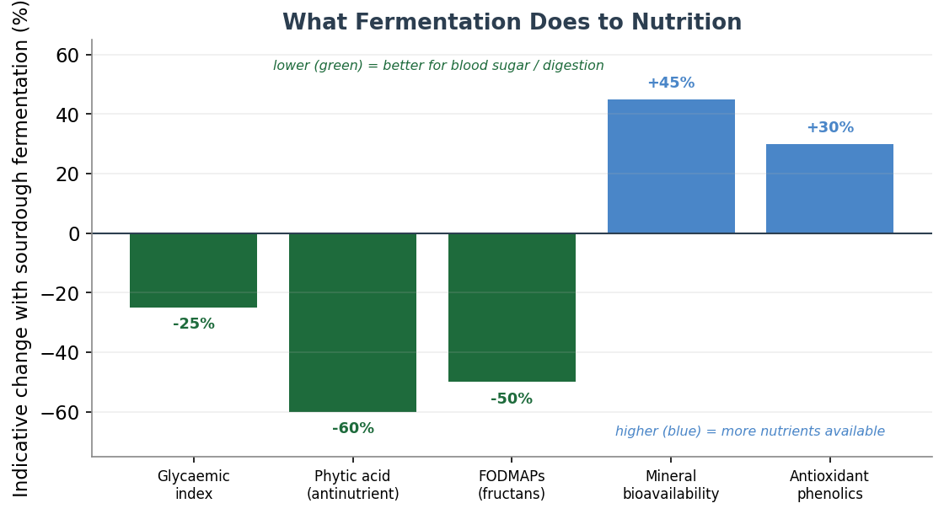
Figure 29 — What fermentation does to nutrition. Sourdough fermentation tends to lower the glycaemic index, phytic acid and FODMAPs (green, generally beneficial) while raising mineral bioavailability and antioxidant phenolics (blue). Values are indicative ranges, not guarantees, and vary widely with fermentation time, acidity and flour.
- A lower glycaemic index. sourdough bread raises blood sugar more slowly than ordinary white bread — often cited around a glycaemic index of 53 against markedly higher figures for standard white — because the organic acids slow both gastric emptying and the enzymatic digestion of starch. A gentler blood-sugar rise is the best-supported of these benefits.
- Degraded phytic acid. whole grains carry phytic acid, an antinutrient that binds minerals so the body cannot absorb them. The acidic sourdough environment activates the enzyme phytase, which breaks phytic acid down, freeing zinc, iron, magnesium and calcium to be absorbed — raising the bread's effective mineral nutrition substantially over unfermented or fast-yeasted equivalents.
- Reduced FODMAPs. wheat contains fructans, one of the fermentable carbohydrates (FODMAPs) that trigger bloating and discomfort in people with irritable bowel syndrome. A long fermentation lets the microbes consume much of the fructan content, which is why many people who find ordinary bread uncomfortable tolerate long-fermented sourdough better.
- Partially broken-down gluten and ATIs. extended fermentation proteolyses some of the gluten proteins and reduces amylase-trypsin inhibitors (ATIs), compounds implicated in non-coeliac wheat sensitivity. This can make the bread sit more easily for the wheat-sensitive — but, to be unambiguous, it does not make it gluten-free or safe for coeliacs.

31.2 Where the Evidence Is Firm, and Where It Is Not
The mechanisms above are well established in the laboratory. What is less settled is how reliably they translate into a difference an eater notices, because the size of each effect depends heavily on the length and acidity of the fermentation, the flour, and the individual. The glycaemic and phytic-acid effects are on firm ground. The FODMAP and wheat-sensitivity benefits are more variable: at least one controlled study found a sourdough bread was not better tolerated than ordinary bread for FODMAP-sensitive people, and a regular rye sourdough showed no significant symptom improvement in another — results that caution against treating sourdough as a guaranteed remedy. The sensible reading is that long fermentation reliably improves bread on average, and may help an individual considerably or barely, which is exactly the kind of honest uncertainty a good reference should state plainly.
Two further points round out the picture. Whole and ancient grains add fibre and a higher load of antioxidant phenolic compounds, more of which become bioavailable through fermentation, so the grain choice of the earlier chapters compounds these effects. And the bake itself has a nutritional footnote: very dark crust develops acrylamide through the same Maillard chemistry that gives it flavour, so an extremely dark bake trades a little against that. As with everything in this guide, the levers interact, and the long, cool, whole-grain fermentation that builds flavour is broadly the same one that improves nutrition.

Slow fermentation improves bread's nutrition by the same patient chemistry that builds its flavour: acids lower the glycaemic rise, enzymes free the minerals, microbes ease digestion. The mechanisms are real; the size of the benefit varies; coeliac safety it is not.

32. Specialty Bread Families
The guide has so far treated the wheat loaf as the default, with ancient grains and gluten-free flours as variations on it. But several whole families of bread follow rules different enough to deserve their own treatment: rye, which builds structure without relying on gluten at all; pizza and flatbreads, governed by an inverse trade between water and heat; and the alkaline or boiled breads, whose defining step happens in a bath before the oven. This section gathers the three, each a distinct logic the earlier chapters only hinted at. The figure places them by the two variables that most separate them — hydration and bake temperature.

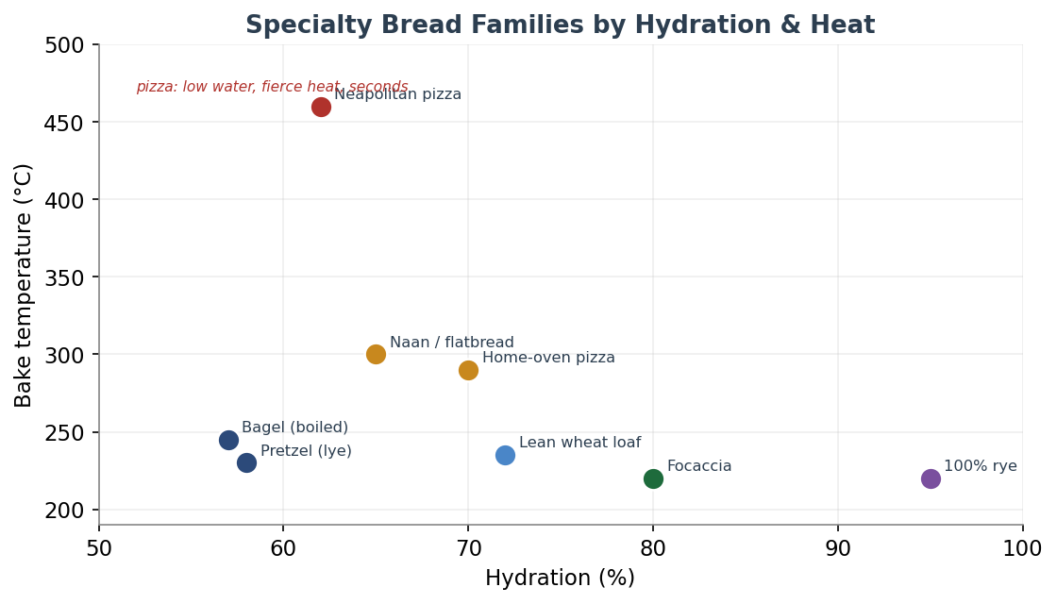
Figure 30 — Specialty bread families by hydration and heat. Pizza occupies the fierce-heat, lower-water corner (a Neapolitan bakes in seconds at around 460 °C); rye and focaccia sit wet and cooler; the boiled breads (bagel, pretzel) are stiff and baked moderately. Positions are indicative.

32.1 Rye: Structure Without Gluten
Rye is the great exception among the common bread grains, and the grain library touched on why; here is the fuller picture. Rye's proteins cannot form a proper gluten network, so its structure comes instead from pentosans — arabinoxylan gums that absorb up to fifteen times their own weight in water and give rye dough its characteristic sticky, paste-like body. The ratio that matters is roughly one part pentosans to sixteen parts starch for a well-structured rye. Two consequences follow. First, rye is extremely thirsty and its dough behaves like a stiff batter, not a kneadable mass — kneading does nothing useful, so it is simply mixed until combined. Second, rye carries high levels of the starch-degrading enzyme amylase, which would leave the crumb gummy if left unchecked, so rye is almost always fermented as a sourdough: the acidity restrains the enzyme and sets the crumb. This is why a true 100% rye is a sour, dense, intensely flavoured loaf, often helped by a scald of part of the flour (pre-gelatinising starch to bind water, much like the tangzhong of the enriched chapter) and baked long and low. As a blending partner, 20–30% rye adds flavour and keeping quality while wheat still carries the structure.

32.2 Pizza and Flatbreads: the Heat–Water Trade
Pizza and the flatbreads are governed by one elegant principle: the higher the oven temperature, the lower the dough hydration, and vice versa. A true Neapolitan pizza is engineered for a roughly 460–480 °C wood-fired oven, where it bakes in sixty to ninety seconds; its dough is therefore a comparatively stiff 60–65% hydration of finely milled Tipo 00 flour, with nothing but water, salt and a little yeast, given a long, cold fermentation of one to three days for flavour and digestibility, and stretched (never rolled) to leave the puffy rim called the cornicione. Move that same dough to a home oven that tops out near 260 °C and it underperforms, because the bake now takes minutes, not seconds; the fix is to raise hydration to around 70–72% and switch to a stronger bread flour, baking on a preheated steel for the fiercest base heat the oven can give. The flatbreads — naan, pita, focaccia and the rest — are variations on the same theme of relatively quick, hot bakes, with focaccia sitting at the high-hydration, oil-rich end.

Style | Hydration | Flour | Bake
Neapolitan | 60–65% | Tipo 00 | ~460–480 °C, 60–90 s; long cold ferment
Home-oven pizza | 70–72% | strong bread | ~500–550 °F on a steel, minutes
New York | ~58% | bread flour | ~500–550 °F; larger, foldable
Focaccia | ~80%+ | bread flour | oil-rich, in a pan, moderate heat

32.3 Alkaline and Boiled Breads: the Bath Before the Oven
Bagels and pretzels share a defining step found nowhere else in the guide: a dip in hot liquid before baking. For the bagel, it is a brief boil in water, often with a little malt or baking soda, which gelatinises the surface starch into the dense, chewy, shiny skin and sets the crumb before baking, giving the characteristic tight, chewy interior. For the true pretzel, it is a dip in an alkaline bath — traditionally a 3–4% food-grade lye (sodium hydroxide) solution, or baking soda as a milder home substitute. The chemistry is the point: a high surface pH dramatically accelerates the Maillard reaction, so the crust browns to a deep mahogany and develops the distinctive, almost savoury pretzel flavour and glossy skin that no ordinary bake produces. The same principle — raise the surface pH to supercharge browning — reappears in the finishing chapter that follows. These breads show that crust can be engineered chemically, not just thermally.

Bread | Pre-bake step | Result
Bagel | brief boil (water + malt or soda) | gelatinised, chewy, shiny skin; tight crumb
Pretzel | dip in 3–4% lye (or soda) bath | high-pH surface → deep Maillard; mahogany, glossy, savoury

Some breads break the wheat rules: rye builds its body from gums and acid, pizza trades water against heat, and the boiled breads earn their crust in a bath before the oven. Know the rule each one follows, and none is mysterious.

33. Dough Rheology & Flour Testing
Throughout this guide a baker judges dough by feel — the slackness of a high-hydration dough, the resistance of a well-developed gluten, the point at which a windowpane forms. The milling industry judges the same properties by instrument, and its measurements are what fill the specification sheet behind every sack of flour. This section explains those instruments and the numbers they produce, not because the craft baker needs a laboratory, but because understanding them lets you read a flour before you ever mix it, and because each instrument is really just a machine measuring something the hands already know.

33.1 The Four Instruments
Four classic instruments dominate flour testing, each isolating a different aspect of how dough behaves.
- The farinograph measures a dough as it is mixed, tracing a curve that reports water absorption (how much water the flour takes to reach a standard consistency), the dough development time, and its stability and tolerance to over-mixing — the instrument reading of the mixing chapter's central concerns.
- The extensograph stretches a rested piece of dough until it breaks, plotting resistance to extension against extensibility — the same elasticity-versus-stretch balance the gluten chapter described, expressed as a ratio.
- The alveograph (the Chopin alveograph, dominant in France and for Tipo 00 flours) inflates a disc of dough into a bubble until it bursts, which yields the three figures bakers most often see on a spec sheet, shown in the figure: P, L and W.
- The amylograph and the falling number measure enzyme activity rather than gluten — specifically how much amylase is at work breaking down starch, which connects directly to the malt discussion of the flour chapter.

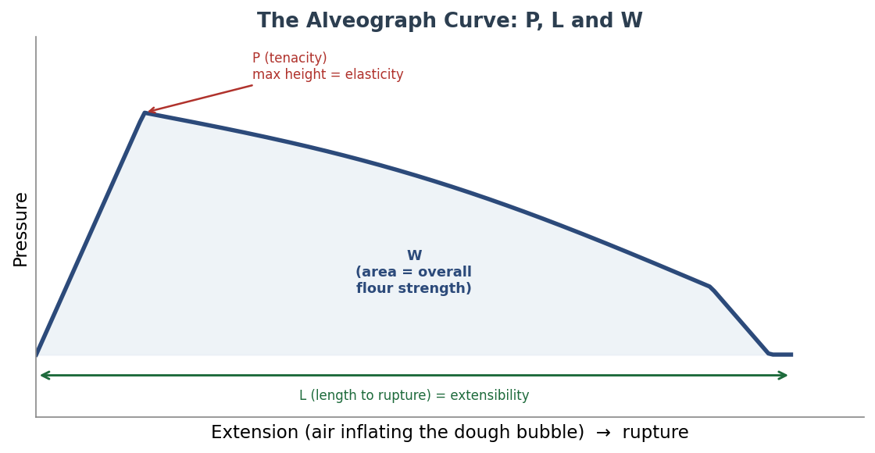
Figure 31 — The alveograph curve. A disc of dough is inflated into a bubble until it ruptures. The peak height P measures tenacity (elasticity); the length L measures extensibility; and the area under the curve, W, measures the dough's overall strength — the energy needed to blow the bubble apart. Stylised; not to scale.

33.2 Reading the Numbers
The alveograph figures are worth knowing because they appear on flour bags and recipes, especially for Italian and French flours. P is tenacity — the dough's resistance and elasticity. L is extensibility — how far it stretches before breaking. Their ratio, P/L, captures the same elasticity-versus-extensibility balance the mixing and gluten chapters taught by feel: a low P/L is slack and extensible, a high P/L is strong and tight, and most bread flour sits in a balanced band around 0.5 to 0.7. W, the area under the curve, is the flour's overall strength — its capacity to hold up through a long fermentation. Strong bread flours run a W around 250–350, while soft biscuit and pastry flours sit far lower, near 100–130. The falling number, meanwhile, reports amylase activity as a time in seconds: a high number (above about 300) means low enzyme activity and a flour that may benefit from a little diastatic malt, while a low number (below about 250) signals excess amylase — often from sprout-damaged grain — and a tendency to a sticky, gummy crumb. A figure around 250–300 is generally ideal.

Measure | What it captures | Typical / reading
Water absorption | water to standard consistency | higher for strong, whole, or damaged-starch flours
P (tenacity) | elasticity / resistance | higher = stronger, tighter dough
L (extensibility) | stretch before rupture | higher = more extensible
P/L ratio | elasticity vs. extensibility | bread flour balanced ~0.5–0.7
W (strength) | overall dough strength | bread ~250–350; biscuit ~100–130
Falling number | amylase activity (seconds) | ~250–300 ideal; high needs malt; low = sticky

The practical value of all this for the craft baker is not to buy the instruments — almost no one outside a mill or large bakery has them — but to read their output. When a flour is sold as W260, P/L 0.55, you now know it is a balanced, strong bread flour suited to a long fermentation; when a recipe calls for a high-W flour for panettone, you know why. These numbers are simply the precise, repeatable language for the qualities the rest of the guide teaches you to feel, and the bridge between the artisan's hands and the miller's bench.

The miller's instruments measure what the baker's hands already know: how much water a flour drinks, how it balances stretch against strength, and how busy its enzymes are. You need not own them to read what they report.

34. Finishing, Glazing & Crust Design
The last craft between a shaped loaf and the table is finishing — the washes, seeds and surface treatments applied just before (and sometimes just after) baking. It is the layer that sits past scoring, part decoration and part function, and it is where a loaf earns its colour, its shine and its final character. This closing technique section gathers the washes and what each does, the seeding and dusting that ride on them, the alkaline crust treatments that the specialty-breads chapter introduced, and how all of it interacts with the steam and Maillard chemistry of the bake.

34.1 The Washes
A wash is a liquid brushed onto the surface of the dough, and the choice among them is really a choice between two effects: browning and shine. The two do not always go together, and understanding why lets a baker pick deliberately. Plain water promotes a little browning by dissolving surface starch into glucose that then feeds the Maillard reaction, but gives almost no shine. Milk browns better, because its lactose sugars and proteins both join the Maillard reaction, and leaves a soft, satiny, faintly sweet finish. Egg is the workhorse: the proteins drive browning while any yolk brings fat and colour, and it is egg that supplies real gloss — a whole egg gives a balanced golden, moderately shiny crust, an egg white the highest gloss with a lighter colour, and an egg yolk (often loosened with cream) the deepest amber and an almost shellacked shine, which is why it crowns brioche and challah. The figure plots them along the two axes.

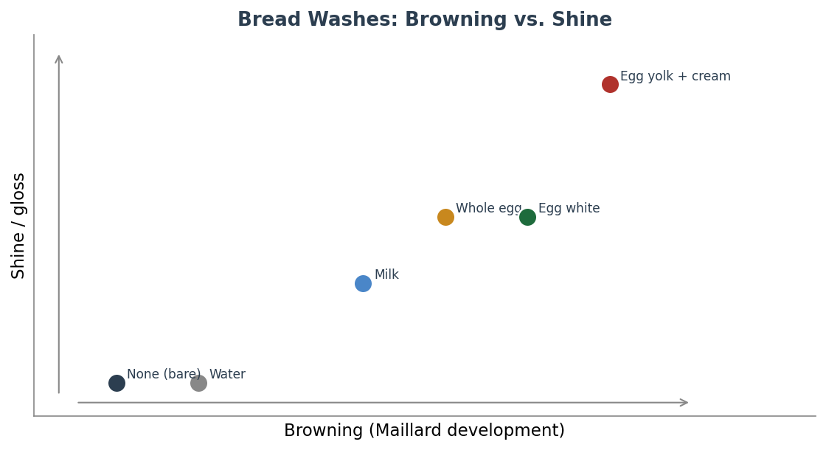
Figure 32 — Bread washes by browning and shine. Water and milk brown gently with little gloss; whole egg balances colour and shine; egg yolk with cream gives the deepest colour and the highest, near-shellacked shine. Shine comes chiefly from egg; browning from sugars and proteins. Indicative positions.
Wash | Browning | Shine | Best for
Water | decent | very little | lean, crusty breads; gluing seeds
Milk | good | soft, satiny | sandwich loaves, dinner rolls; tender crust
Whole egg | good | moderate | most enriched breads, rolls, pastry; all-purpose
Egg white | very good | high | decorative work; crisp finish; gluing seeds
Egg yolk + cream | deepest | very high | brioche, challah — the professional's choice
Butter (after bake) | — | temporary | soft, rich crust; brush on hot from the oven

One timing rule matters: a butter wash goes on after baking, not before, brushed onto the hot crust so it melts in and softens it — applied before the bake it simply burns. The plainer washes suit lean and everyday breads, while the egg washes are reserved for the enriched breads whose richness they complement.

34.2 Seeding, Dusting and Alkaline Crusts
A wash is also the glue for a seed or grain topping. Brushing the loaf with egg or water before pressing on sesame, poppy, sunflower or a mixed seed coat makes them adhere through the bake; the same works for rolled oats on a soft loaf or a dusting of cracked grain. At the other extreme of effort, a simple dusting of flour — white, or rice flour through a stencil — gives the rustic, matte, floured top of a country loaf and a crisp contrast where the scores break through, with no wash at all. These are the visual vocabulary that finishing adds to the structural scoring of the shaping chapter.
The most dramatic surface treatment is the alkaline one introduced with the pretzel: brushing or dipping the surface in a high-pH solution — food-grade lye, or a baking-soda wash as a gentler version — before baking. Because the Maillard reaction runs faster at high pH, an alkaline surface browns to a deep mahogany and develops a distinctive flavour and sheen that an ordinary wash cannot reach. It is the same chemistry the boiled breads exploit, applied as a finish, and it closes the circle between this chapter and the last.

34.3 Finishing, Steam and the Whole Guide
Finishing cannot be separated from the steam and heat of the bake. As the bake chapter showed, steam in the first minutes keeps the surface moist and delays the crust setting, which is what lets scores open and washes brown evenly rather than scorching; a glaze applied under steam develops a more even, glossy colour. The washes feed the very Maillard reaction the flavour chapter anatomised, so finishing is not a cosmetic afterthought but the last adjustment to the crust's colour, flavour and texture all at once. With it, the guide arrives where it began — at a loaf — having followed the dough from the first rest of an autolyse through grains, fermentation, the bake, the core variables, the craft of the hands, and now the science of flavour, nutrition, the specialty breads, the miller's measurements, and the final brush of glaze across the crust. The reference is, for now, complete; and a good reference, as its roadmap says, is never finished but only up to date.

Finishing is the last word the baker gives the crust: water and milk for a gentle colour, egg for gloss, an alkaline bath for mahogany depth, butter for softness after the bake. The brush is small; the difference it makes is not.

35. The Breads of France
No other country has woven bread so tightly into its law, its daily ritual and its identity as France. This closing tour gathers the breads of France into four working families — the lean wheat breads (pain), the regional and shaped breads, the enriched and viennoiserie-adjacent breads, and the laminated doughs (viennoiserie) — and profiles more than twenty of them. Each profile is an overview rather than a full recipe: enough to place the bread, name its flour, hydration and method, and describe how it is shaped and baked. Three things bind the whole family together and so come first: the French flour grading system, the technical vocabulary of the French bakery, and the law and heritage that protect the names.
A note on figures and disputes, in keeping with this guide. Recipe numbers — hydration, butter percentages, fold counts, oven temperatures — vary widely between houses and authorities (Calvel, Hamelman, Suas, the INBP, King Arthur). Where they are contested this section gives ranges and names the source; where folklore has crept in (the baguette-origin legends in particular) it is flagged as legend, not fact. All figures are indicative starting points.
Throughout this section — and the ancient-grain profiles of Section 9 — each bread now carries a small original line illustration of its characteristic form (schematic and indicative, drawn for this guide). To add real photographs in their place, Section 35.10 lists how to source openly-licensed images, with verified examples.

35.1 The French Flour “T” (Type) System
French flour is graded not by protein but by ash — the mineral residue left when a sample is burned, which is concentrated in the bran. The “T” number (T for Type) is the ash content per 100 g of flour: the lower the number, the whiter and more refined the flour. T45 is the whitest, used for viennoiserie and pastry; T55 is the white baguette and all-purpose workhorse; T65 is the staple of country breads and the baguette de tradition; T80 (“bise”), T110 and T150 climb toward wholemeal. Rye uses a parallel scale (T85, T130, T170). Critically, the T-number says nothing about gluten strength — a T55 can be 11% or 13% protein — so it is not interchangeable with the protein-led grading of British and American flour.

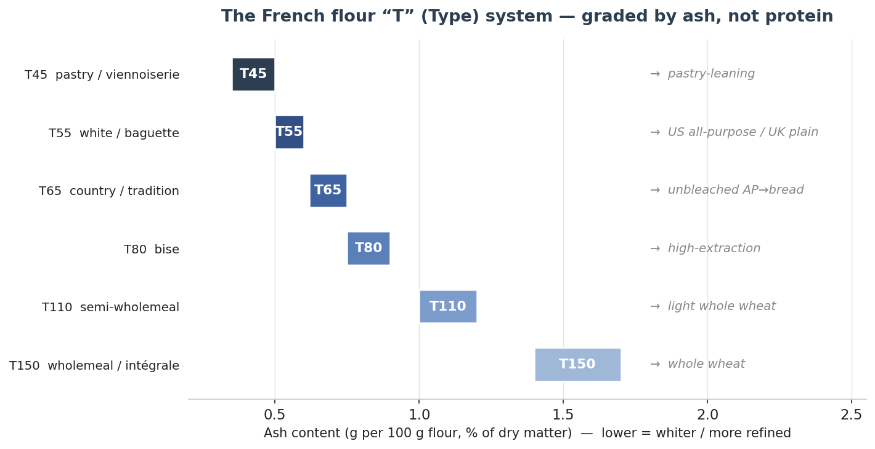
Figure 33 — The French flour “T” system, graded by ash content rather than protein. Lower numbers are whiter and more refined; the rough US/UK equivalents on the right are approximate, since the T-number does not fix protein. Values indicative.
Type | Ash (%) | Typical use | Rough US / UK equivalent
T45 | < 0.50 | Viennoiserie, pastry, brioche | Pastry-leaning flour
T55 | 0.50–0.60 | White baguette, all-purpose | US all-purpose / UK plain (~11%)
T65 | 0.62–0.75 | Tradition baguette, country bread | Unbleached AP → bread
T80 | 0.75–0.90 | Semi-wholemeal (“bise”) | High-extraction
T110 | 1.00–1.20 | Semi-wholemeal breads | Light whole wheat
T150 | > 1.40 | Wholemeal (intégrale) | Whole wheat

35.2 A Baker’s Glossary of French Terms
French bakery vocabulary is precise, and the same words recur on every formula and in every profile below. The core sequence of a lean-bread day runs frasage → pétrissage → pointage → division → détente → façonnage → apprêt → grignage → the bake → ressuage.
French term | What it means
Frasage | The initial mixing that brings the ingredients into a rough, shaggy mass.
Autolyse | A rest of flour and water only (Calvel’s technique) to hydrate and build extensibility before full mixing.
Pétrissage | Kneading / mixing. Bassinage is the addition of reserved water late in the mix.
Pointage | First or bulk fermentation, from the end of the mix to division — it can be direct (warm) or retardé (cold, ~4–6 °C).
Pâton | A divided piece of dough.
Détente | The intermediate bench rest between pre-shape and final shaping, letting the gluten relax.
Façonnage | Final shaping — boule, bâtard, baguette and the regional shapes.
Apprêt | Final proof, from shaping to the oven (also deuxième fermentation).
Lame / grignage | The blade, and the act of scoring the loaf.
Grigne / oreille | The opened cut (grigne) and its raised lip or “ear” (oreille) — the mark of good scoring and spring.
Buée | Injected oven steam, essential for crust and spring.
Ressuage | The post-bake cooling and moisture loss as the loaf finishes setting.

35.3 The Law and the Heritage
Two pillars protect French bread. The first is the Décret Pain of 13 September 1993 (Decree No. 93-1074), the “décret Balladur,” which gives three names legal force. Pain maison must be entirely kneaded, shaped and baked at the point of sale. Pain de tradition française may never be frozen at any stage, may contain no additives, and must be made only from panifiable wheat flour, water and salt, leavened by baker’s yeast and/or levain — with just a few permitted minor additions (up to 2% bean flour, 0.5% soya flour, 0.3% wheat-malt flour). Pain au levain must be raised by a natural levain and, per the decree, present a maximum pH of 4.3 and at least 900 ppm of endogenous acetic acid in the crumb, with any added baker’s yeast capped at 0.2% of the flour.
Designation | What the law requires
Pain maison | Kneaded, shaped and baked entirely at the point of sale to the consumer.
Pain de tradition française | No freezing at any stage; no additives; wheat flour, water and salt only; yeast and/or levain. Minor permitted additions only (fève ≤ 2%, soya ≤ 0.5%, malt ≤ 0.3%).
Pain au levain | Raised by natural levain; crumb pH ≤ 4.3 and ≥ 900 ppm endogenous acetic acid; added baker’s yeast ≤ 0.2% of flour.
The second pillar is cultural. On 30 November 2022 UNESCO inscribed the “artisanal know-how and culture of baguette bread” on the Representative List of the Intangible Cultural Heritage of Humanity — honouring the craft and the daily ritual rather than a fixed recipe, and noting the baguette’s four ingredients of flour, water, salt and leaven. President Macron, who backed the nomination, called the baguette “250 grams of magic and perfection in our daily lives,” and the inscription came against a real decline: France has lost roughly 400 artisanal bakeries a year since 1970, from about 55,000 then to roughly 35,000 today.
Quarantined legend. The popular tales — that Napoleon ordered long thin loaves for his soldiers’ pockets, or that the baguette was invented so Paris Métro workers need not carry knives — are charming but unverified, with no period documentation. The better-supported history is duller: the word “baguette” for a loaf is first recorded in a 1920 Seine prefecture regulation that fixed an 80 g minimum weight and 40 cm maximum length, and the modern thin loaf owes much to a 1919 law (effective 1920) banning bakery work between 10 p.m. and 4 a.m., which favoured faster-fermenting shapes.

35.4 Family One — Lean Wheat Breads (pain)
The lean breads are the heart of the French bakery: flour, water, salt and leaven, and nothing else. They differ in shape, in flour extraction and in the leaven — commercial yeast (often via a poolish), natural levain, or both — far more than in ingredients. The figure places the main lean breads (with their neighbours) on a hydration spectrum.

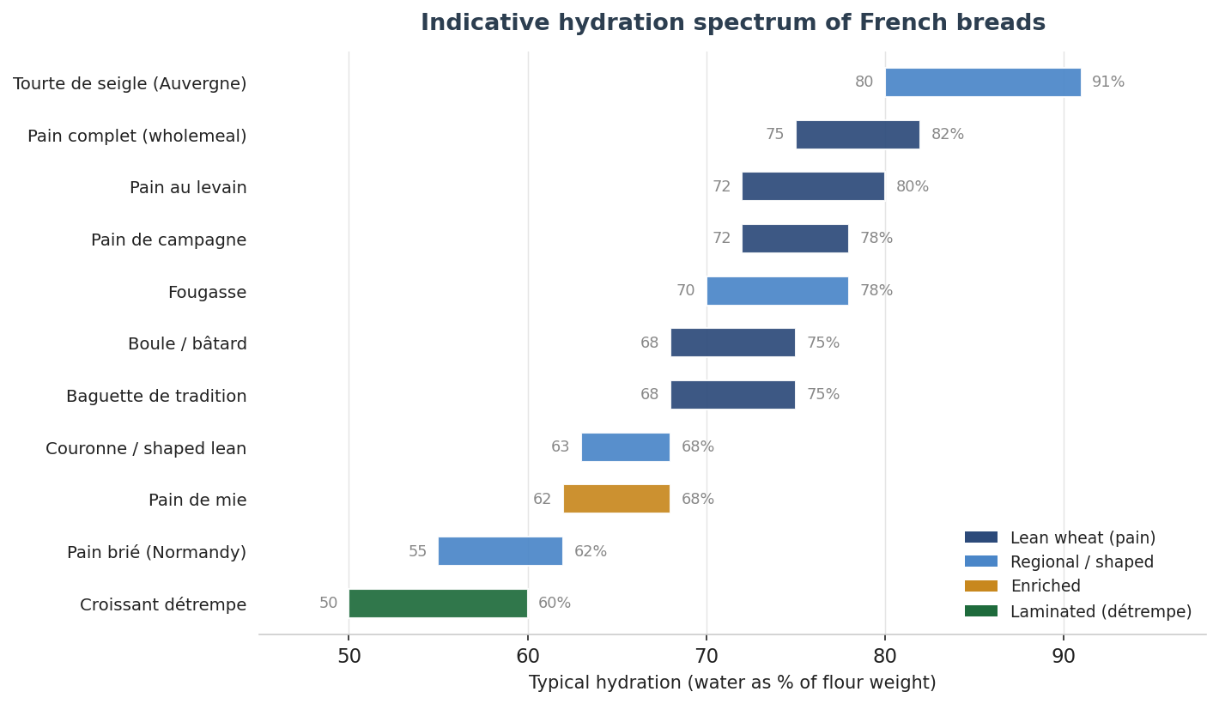
Figure 34 — Indicative hydration spectrum across the French families, from the tight, beaten pain brié to the near-pourable rye tourte de seigle. Colour denotes family. Hydration depends on flour, milling and house style; treat as ranges.
Baguette de tradition française. The flagship. Flour is typically T65 (sometimes T55); ingredients are limited by the décret to flour, water, salt and yeast and/or levain. Hydration commonly runs 68–75% (Hamelman’s poolish baguette is a deliberately stiffer ~66%; very wet styles reach 75–80%). It is built by three main routes — direct, poolish (the classic French preference, an equal-weight flour-and-water preferment fermented 12–16 h for a nutty flavour and open, irregular alveolar crumb), or levain. After a gentle mix to preserve the carotenoids, the dough takes a pointage with a fold, is divided, rested, and hand-shaped into a ~55–65 cm baton, proofed on a floured couche, scored with several overlapping diagonal grignes, and baked with steam at 240–260 °C to a crackling crust. A standard loaf is ~250 g.
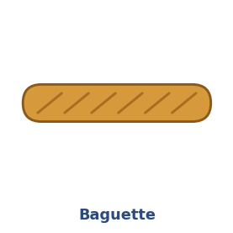
Baguette de tradition — original illustration (indicative).

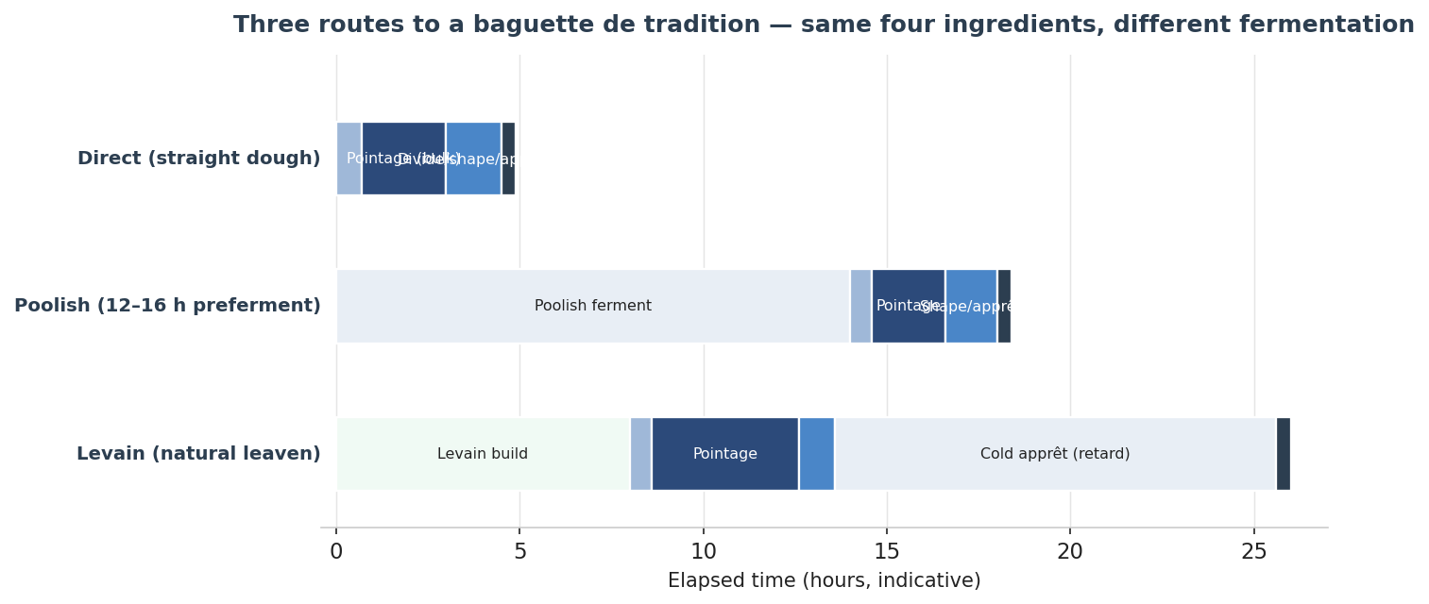
Figure 35 — Three routes to the same baguette: a quick direct dough, the classic poolish (a long preferment then a normal day), and a levain build often finished with a cold apprêt. The four ingredients are identical; only the fermentation differs. Timings indicative.
Ficelle. The “string” — a thinner, lighter baguette, often about half the dough weight, giving far more crust per crumb; the same dough, frequently seeded, baked quicker.
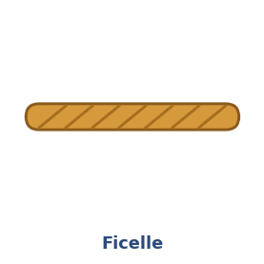
Ficelle — original illustration (indicative).
Bâtard. The “in-between”: shorter and fatter than a baguette, typically ~400 g, with fewer, longer scores and more crumb relative to crust. The same lean dough.
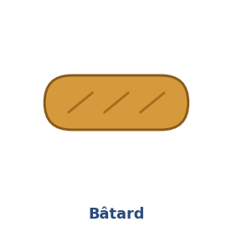
Bâtard — original illustration (indicative).
Boule. The round loaf that gives boulanger and boulangerie their name. Any lean dough, proofed in a round banneton and scored in a cross, square or single arc.
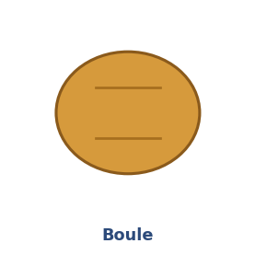
Boule — original illustration (indicative).
Pain de campagne. “Country bread”: mostly white wheat (T65/T80) with a minority of wholemeal and/or rye (often 10–20%), raised on levain, sometimes with a yeast boost. Hydration ~72–78%. Shaped as a boule or bâtard, often proofed in a banneton and sometimes left fendu (split) rather than scored. Thick crust, creamy crumb, mild tang, long keeping; baked ~230–250 °C with steam.
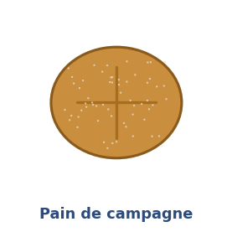
Pain de campagne — original illustration (indicative).
Pain au levain. Naturally leavened bread meeting the décret’s acidity thresholds (pH ≤ 4.3, ≥ 900 ppm acetic acid). Its character ranges from mild to assertively sour depending on the levain, hydration and schedule; it takes a long pointage and is often finished with a cold retard for flavour and a firmer, scoreable dough.
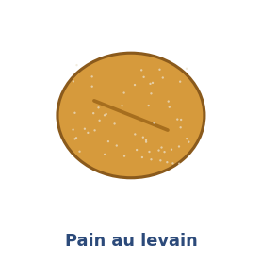
Pain au levain — original illustration (indicative).
Pain complet. Wholemeal bread from T110/T150 (or intégrale). It absorbs more water, ferments faster, has weaker gluten and a denser crumb; often pan-baked or formed as a dense boule, and it benefits from a long autolyse or a soaker to hydrate the bran.
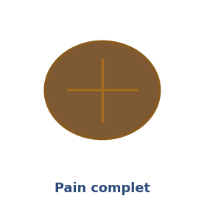
Pain complet — original illustration (indicative).
Pain de seigle vs. pain au seigle. A legal distinction worth knowing: pain de seigle must contain at least 65% rye (the balance wheat), while pain au seigle has 10–65% rye; roughly equal wheat and rye is pain de méteil. Rye is low in gluten and high in water-binding pentosans, so the dough is sticky and paste-like, the crumb dense and moist, and staling slow. Mix only to combine, keep pointage and apprêt short, and bake to the core without scorching.
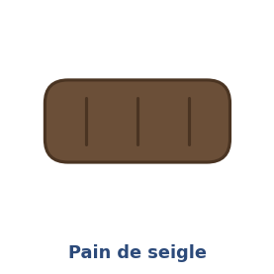
Pain de seigle — original illustration (indicative).
Pain de mie. The soft, fine-crumbed French sandwich or Pullman loaf — mie means the crumb. Built on a T55-type flour and lightly enriched with butter (~15%), a little sugar (~6%) and milk, at ~66% total hydration. It is baked in a lidded Pullman pan for a flat top and square, close-grained slices, with no steam, at ~175–180 °C. The everyday bread for toast, sandwiches and canapés.
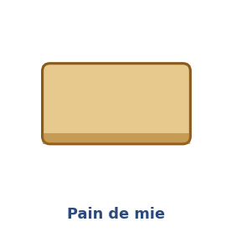
Pain de mie — original illustration (indicative).

35.5 Family Two — Regional and Shaped Breads
Beyond the everyday loaves lies a wealth of regional and shaped breads — the same lean doughs, often, but cut, folded and proofed into forms that maximise crust, signal a region, or solve an old problem of keeping or transport.
Fougasse. The Provençal ladder- or leaf-shaped flatbread, cousin to focaccia. A lean wheat dough (often poolish-based) enriched with olive oil and studded with olives, herbes de Provence, anchovy or lardons; flattened, cut and stretched open so the slashes stay open, brushed with oil and baked hot (~220–250 °C) to a chewy interior and crisp crust.
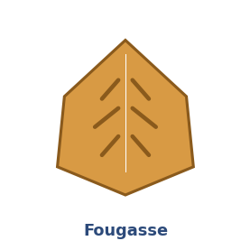
Fougasse — original illustration (indicative).
Épi (épi de blé). A “wheat-stalk” baguette: the proofed baton is cut along its length with scissors and the segments laid alternately left and right to mimic an ear of wheat, maximising crust. Segments pull apart as individual rolls. Same dough, steam and temperature as a baguette.
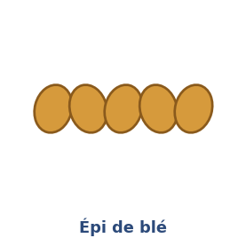
Épi de blé — original illustration (indicative).
Couronne. The “crown” or ring loaf. The Bordeaux couronne bordelaise is a flat central disc ringed by six to eight dough balls, the disc slit into triangular flaps draped over each ball, proofed in a special couronne banneton and baked inverted at ~230–245 °C. A medium-hydration lean dough (~65%).
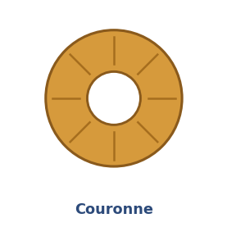
Couronne — original illustration (indicative).
Traditional shapes — fendu, tabatière, tordu. A family of façonnage rather than recipes. The fendu is split deeply down the middle and proofed split-side down, opening into two lobes (and the original source of the word grigne). The tabatière (“snuffbox”) has a flap rolled out from a boule and folded over the top to bake as a hinged lid. The tordu is a twisted loaf. All use ordinary lean dough; the interest is in the hand skill.
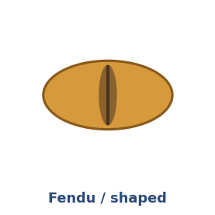
Fendu / traditional shapes — original illustration (indicative).
Pain brié. A dense, tight-crumbed, long-keeping loaf from Normandy, its name from the Old Norman brier, to pound. Low hydration (~55–62%), the dough beaten hard to tighten it (historically with a brie roller), sometimes with a little butter and a poolish or pâte fermentée, on T55/T65. A striped blonde crust scored lengthwise, a short proof and brief steam. Historically a sailors’ and fishermen’s bread for its keeping.
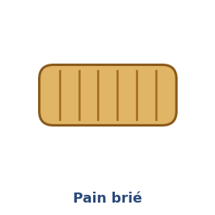
Pain brié — original illustration (indicative).
Pain de Beaucaire. A free-form, low-hydration bread from south-east France, built on levain and made by stacking two layers of dough and cutting strips that bake side by side, giving an open, ciabatta-like interior with a bran vein. Described in Suas’s Advanced Bread and Pastry.
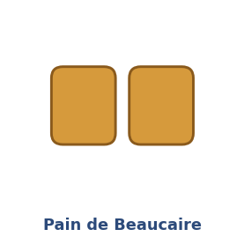
Pain de Beaucaire — original illustration (indicative).
Tourte de seigle (Auvergne). A large rye levain loaf, classically near-100% rye (sometimes 70–90% rye with wheat) on a sour rye sponge, at very high hydration (~80–91% on the rye). The slack dough is barely shaped — eased into a banneton, its surface left to crack naturally, no scoring needed — and baked high then descending (e.g. 260 → 220 → 200 °C), often about an hour for a large loaf. Thick crust, dense moist crumb, a sweet-then-sour profile and exceptional keeping.
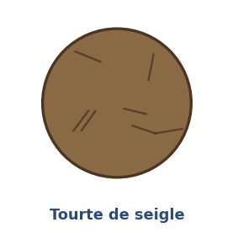
Tourte de seigle — original illustration (indicative).
Pain bouillie and fouée. Two regional curiosities worth a line: pain bouillie, a long-keeping Breton bread built on a scalded rye dough, and the fouée (Anjou/Touraine), a small puffed wood-oven flatbread related etymologically to fouace and fougasse.

35.6 Family Three — Enriched and Viennoiserie-adjacent Breads
Enriched breads add fat, eggs, sugar and milk to the lean foundation, trading open crumb and crackling crust for tenderness, richness and a soft, golden finish. The defining variable for brioche is butter as a percentage of flour, which spans a whole spectrum of richness:
- Brioche pauvre (poor): ~20–25% butter — sturdier, for buns and bases.
- Brioche moyenne: ~40–50% butter — the common braided and shaped standard (flour:butter ≈ 2:1).
- Brioche riche: ~70–100% butter — luxurious and delicate, and the base for laminated brioche.
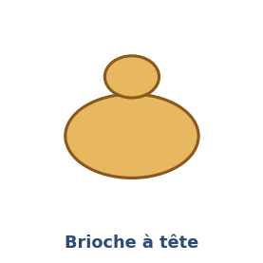
Brioche à tête — original illustration (indicative).
The method is an emulsion: cold butter is worked into a developed dough kept cool (dough temperature ~24–27 °C so the butter never melts), given a long first ferment usually with an overnight cold retard to firm it for shaping, then egg-washed and baked from ~180 to 230 °C to an internal ~90 °C or above. The regional and shaped variants are legion:
- Brioche parisienne / à tête: a fluted mould with a large body and a small “head” (tête).
- Brioche Nanterre: a loaf-pan brioche of two rows of balls that fuse and pull apart.
- Brioche vendéenne and gâche: the vendéenne braided and oval with a fine springy crumb (often Label Rouge/IGP); the gâche oval, slit lengthwise and made with crème fraîche for a denser, moist crumb.
- Pogne de Romans and Saint-Genix: the pogne a soft orange-blossom crown of the Drôme; the brioche de Saint-Genix studded with pink pralines, created around 1880 in Savoie.
- Brioche feuilletée / craquelin: brioche laminated for flaky layers, or sugared for crunch.
Pain viennois. “Viennese bread” — a soft, slightly sweet enriched loaf or baton, the direct lineage of August Zang’s Boulangerie Viennoise, which brought the Viennese steam oven to Paris around 1838–1839. Built on T55/T45 with milk, butter (~10%), sugar (~5%) and sometimes egg; a soft crumb, a thin shiny egg-washed crust and a characteristic close longitudinal scoring, often from an overnight cold dough.
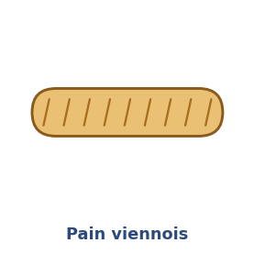
Pain viennois — original illustration (indicative).
Pain au lait. Milk-bread rolls: a soft enriched dough with milk as the main liquid, plus butter, sugar and egg, shaped as small rolls or batons, the tops scissor-snipped and often finished with pearl sugar, egg-washed and baked ~180–210 °C. A breakfast and goûter staple.
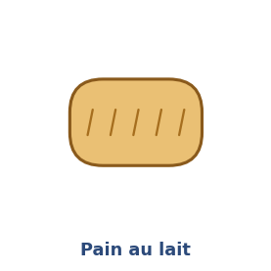
Pain au lait — original illustration (indicative).

35.7 Family Four — Laminated Doughs (viennoiserie)
Lamination folds a sheet of butter into a yeast-leavened dough and rolls it thin again and again, building dozens of alternating layers. In the oven the butter’s water turns to steam and lifts each leaf, giving the shattering, honeycombed interior of good viennoiserie.
Croissant. The laminated icon. The détrempe (base dough) of T45/T55 flour, milk and/or water, sugar, salt, yeast and a little butter is mixed only to partial gluten development; the beurrage (roll-in butter, ideally 82% “tourage” butter at ~16–19 °C) is enclosed and folded — the tourage. Roll-in butter is commonly ~25–30% of total dough weight for a bread-like croissant (around 50% of flour weight for a rich style). A documented professional formula (BAKERpedia, after Suas) sets the standard roll-in fat at 25% of total dough weight. The classic fold scheme is three single (letter) folds, giving 27 dough layers — though houses differ, and counting conventions vary. Proof at ~26 °C and 75–80% humidity, never above the butter’s melting point; bake at ~190–220 °C (Suas/BAKERpedia ~200 °C; an MOF source distinguishes ~170 °C convection from ~200 °C deck). By convention the straight, unrolled ends signal a croissant au beurre (pure butter) and the curved crescent an ordinaire (other fat).
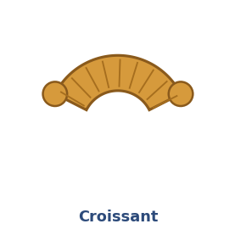
Croissant — original illustration (indicative).

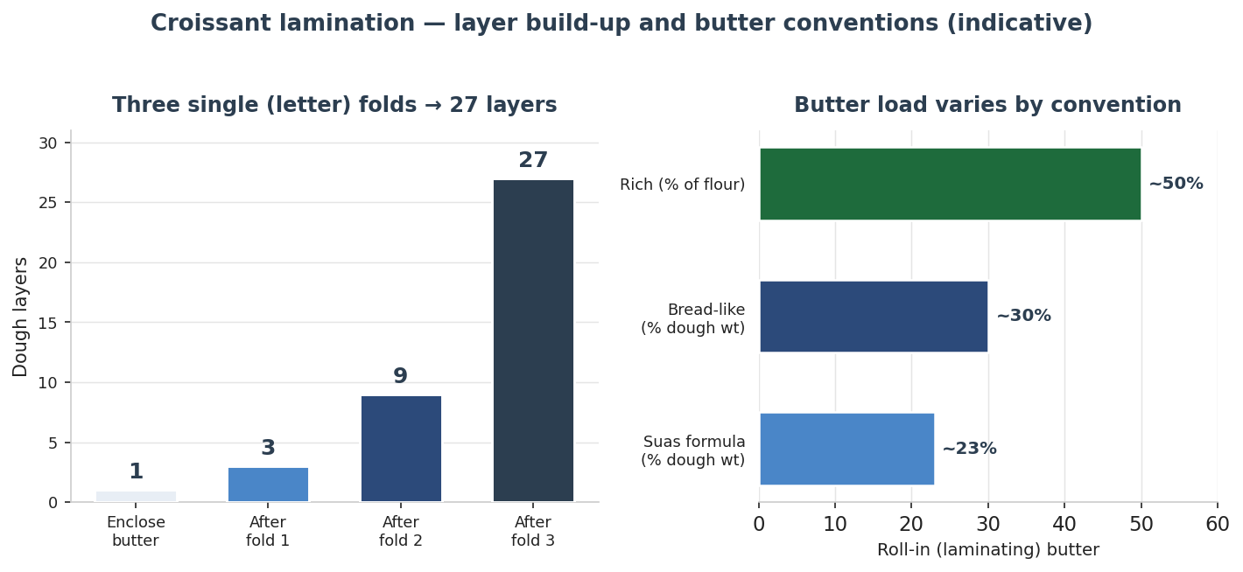
Figure 36 — Croissant lamination. Three single (letter) folds multiply one butter layer into 27 dough layers (left); the roll-in butter load varies by convention, from ~23% of dough weight in the Suas formula to ~50% of flour weight for a rich style (right). Layer-counting conventions differ between sources. Indicative.
Pain au chocolat / chocolatine. The same laminated dough, rolled rectangular around two batons of dark chocolate. Its name is a famous regional dispute: most of France says pain au chocolat, but the south-west (Bordeaux, Toulouse and the wider Occitanie/Nouvelle-Aquitaine) says chocolatine. A 2019 IFOP survey for the bakery federation found 84% of French people overall use “pain au chocolat,” while in Nouvelle-Aquitaine 63% say “chocolatine” (47% in Occitanie); outside the south-west “pain au chocolat” wins more than 90% of usage. A 2018 parliamentary attempt to recognise “chocolatine” failed.
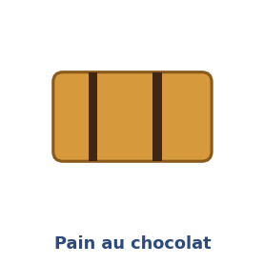
Pain au chocolat — original illustration (indicative).
Pain aux raisins. A spiralled viennoiserie of laminated or croissant dough rolled with crème pâtissière and (often rum-soaked) raisins, cut into pinwheels, proofed, baked and glazed.
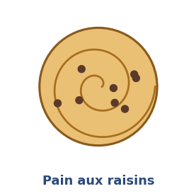
Pain aux raisins — original illustration (indicative).
Chausson aux pommes. An apple turnover — strictly a pâte feuilletée (puff) pastry rather than a yeast-laminated dough, but a fixture of the same counter, filled with apple compote.

35.8 Quick Reference — The Breads of France at a Glance
A consolidated reference to the breads profiled above. Hydration is indicative and house-dependent; flour types follow the French T system of 35.1.
Bread | Family | Flour | Hydration | Method & bake
Baguette de tradition | Lean | T65 (T55) | 68–75% | Direct / poolish / levain; steam, 240–260 °C
Ficelle | Lean | T65 | 68–75% | As baguette, thinner, quicker bake
Bâtard | Lean | T65 | 68–75% | As baguette, shorter & fatter (~400 g)
Boule | Lean | T65/T80 | 68–75% | Banneton, cross/arc score, steam
Pain de campagne | Lean | T65/T80 + rye | 72–78% | Levain; banneton; 230–250 °C, steam
Pain au levain | Lean | T65/T80 | 72–80% | Long pointage, often cold retard
Pain complet | Lean | T110/T150 | 75–82% | Long autolyse; pan or dense boule
Pain de seigle (≥65% rye) | Lean | Rye T130/T170 | 75–85% | Short ferment; bake to core
Pain de mie | Enriched | T55 | ~66% | Lidded Pullman pan, no steam, ~175–180 °C
Fougasse | Regional | T65 | 70–78% | Cut & stretched flat; oil; 220–250 °C
Épi de blé | Regional | T65 | 68–75% | Scissor-cut baguette; steam
Couronne bordelaise | Regional | T65 | ~65% | Ringed, baked inverted, ~230–245 °C
Pain brié | Regional | T55/T65 | 55–62% | Beaten tight; short proof; brief steam
Tourte de seigle | Regional | Rye | 80–91% | Rye levain; minimal shape; 260→200 °C
Brioche | Enriched | T45/T55 | egg+butter | Cold-retarded emulsion; egg wash; 180–230 °C
Pain viennois | Enriched | T55/T45 | milk-based | Soft; egg wash; close longitudinal scoring
Pain au lait | Enriched | T55 | milk-based | Rolls; snipped tops; ~180–210 °C
Croissant | Laminated | T45/T55 | détrempe 50–60% | 3 letter folds (27 layers); ~190–220 °C
Pain au chocolat | Laminated | T45/T55 | as croissant | Croissant dough + 2 chocolate batons
Pain aux raisins | Laminated | T45/T55 | as croissant | Rolled with crème pâtissière & raisins; glazed

35.9 Further Breads Worth Knowing
A handful of breads sit just outside the profiles above but round out the French repertoire, and are flagged here for a future edition or a curious baker:
- Pain bis: the semi-wholemeal middle ground between white and complet (a T80/T110 loaf).
- Pain de méteil: built on a roughly equal mix of wheat and rye — the bridge between pain au seigle and pain de seigle.
- Flute: a loaf between the baguette and the bâtard in size, on the same lean dough.
- Pain d’épices: a rye honey-and-spice loaf — chemically leavened, not a yeast bread, but a French classic.
- Kouign-amann: the Breton laminated butter-and-sugar cake, a sweet cousin of the croissant family.
A bread is a country in miniature: its flour, its law, its region and its ritual baked into a single crust. Know the family, the flour and the leaven, and any French loaf becomes legible.

35.10 Photograph Reference — Sourcing Openly-Licensed Images
The inline pictures in this section and in Section 9 are original schematic illustrations, drawn for the guide and free of any copyright restriction. To replace them with real photographs, the safest route is openly-licensed images from Wikimedia Commons. Three licence classes are easy and safe to reuse: CC0 / public domain (no attribution required, though a courtesy credit is polite); CC BY (credit the author, name the licence, link to it); and CC BY-SA (the same, and any derivative must keep the same licence). Always open the individual file page and confirm the licence there — a search results page mixes licences — and copy the author’s name for the caption.
A reliable way to browse is the Wikimedia Commons Media Search, which can be filtered to freely-licensed images. The search terms below open results for each bread; the three verified examples show the exact file, licence and credit you would use.
Verified examples. Each of these is a real Commons file with the licence confirmed on its file page.
Bread | Wikimedia Commons file | Licence | Credit to use
Baguette | File:Baguette-246424.jpg | CC0 / public domain | None required (Pixabay); courtesy credit optional
Croissant | File:Croissant.jpg | CC BY-SA 3.0 | Author per file page + licence link
Teff (injera) | File:Injera, Ethiopian bread made from teff a cereal native to Ethiopia.JPG | CC BY-SA 4.0 | “Visio” (Wikimedia) + licence link
Search terms for the remaining breads. Open Commons Media Search (https://commons.wikimedia.org/w/index.php?title=Special:MediaSearch&type=image&search=) and enter the term, then filter to free licences and pick an image whose file page shows CC0, CC BY or CC BY-SA. Confirm the author before use.
Bread | Commons Media Search term
Ficelle | ficelle bread baguette
Bâtard | batard bread loaf
Boule | boule bread pain
Pain de campagne | pain de campagne
Pain au levain | pain au levain sourdough
Pain complet | pain complet wholemeal bread
Pain de seigle | pain de seigle rye bread
Pain de mie | pain de mie pullman loaf
Fougasse | fougasse
Épi de blé | epi bread pain
Couronne | couronne bordelaise bread
Fendu / shapes | pain fendu
Pain brié | pain brie normandy
Pain de Beaucaire | pain de beaucaire
Tourte de seigle | tourte de seigle auvergne
Brioche | brioche a tete
Pain viennois | pain viennois
Pain au lait | pain au lait
Pain au chocolat | pain au chocolat
Pain aux raisins | pain aux raisins
Einkorn | einkorn bread
Emmer | emmer bread farro
Spelt | spelt bread
Kamut / Khorasan | kamut khorasan bread
Sorghum | sorghum bread flatbread
Once you have downloaded the images you want, upload them here and I will embed each one in place of its illustration, with a proper attribution caption (author, licence and link) drawn from its Commons file page.

36. The Breads of Germany
If France is the country of the lean wheat loaf, Germany is the country of rye and of sheer variety. The Deutsches Brotinstitut maintains a Brotregister — the first archive of its kind — into which guild bakers enter their breads; it listed 3,023 registered specialities in 2024, and German Brotkultur was added to Germany’s national inventory of intangible cultural heritage in 2014. Behind that variety sit three organising ideas, which come first: the flour Type system, the technical vocabulary of the German bakery, and the biochemistry that makes rye demand sourdough. Then follow the families — the rye and mixed-rye breads that are the heart of the tradition, the wheat and specialty breads, the roll family, the lye breads, and the festive Hefegebäck.
On figures, in keeping with this guide. Baker’s percentages, hydrations and bake parameters vary by house and source; where they are documented (Hamelman, Ginsberg, the Detmold institute, the Dresdner Christstollen PGI specification) they are given with the source named, and treated as indicative starting points. Folklore is flagged as legend, not fact.

36.1 The German Flour Type System (DIN 10355)
The German Type number is simply the ash content in milligrams per 100 g of flour — the mineral residue (concentrated in the bran) left when a sample is incinerated. Type 405 carries about 0.41% ash; Type 1740 about 1.74%. The higher the number, the darker, more mineral- and enzyme-rich the flour. The same numbers run across grains (Weizen = wheat, Roggen = rye, Dinkel = spelt), and as in France the number says nothing about protein. Switzerland uses the same system; Austria uses a W/R/D letter scale (W700 ≈ Type 550).

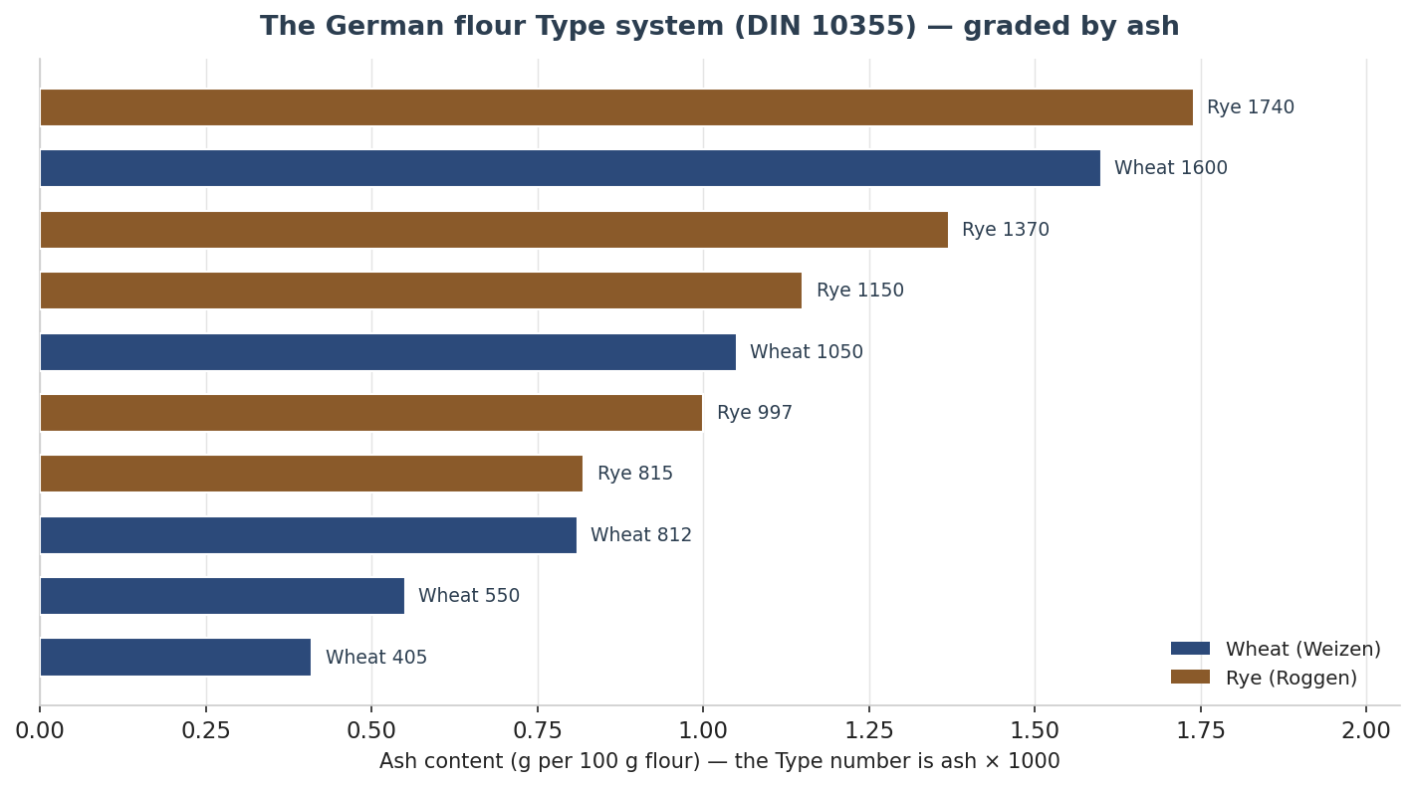
Figure 37 — The German flour Type system: the Type number is ash content × 1000. Wheat (slate) and rye (brown) share the scale; rye breads use the higher-ash rye flours 997–1370. Values indicative.
Flour | Ash (approx.) | Character & typical use | Rough US/UK equivalent
Wheat 405 | ~0.41% | Fine, soft; cakes & fine pastry | Cake / pastry flour
Wheat 550 | ~0.55% | The bread & roll workhorse | US all-purpose / strong AP
Wheat 812 / 1050 | 0.81–1.05% | Darker, higher-gluten; hearty & mixed breads | First clear / high-extraction
Rye 997 / 1150 | 1.00–1.15% | The everyday light–medium rye flours | (no direct equivalent)
Rye 1370 / 1740 | 1.37–1.74% | Medium-dark & dark rye breads | Dark / whole rye
Vollkornmehl / Schrot | whole | Whole-grain flour / coarse meal | Whole grain / chops

36.2 A Baker’s Glossary of German Terms
German bakery vocabulary is precise, and three ideas recur throughout: the sourdough that leavens and acidifies, the family of pre-doughs that manage water and texture, and the steam and spice of the bake.
German term | What it means
Sauerteig / Anstellgut | Sourdough; and the perpetuated “mother” held back to seed the next build.
Vorteig | A preferment (yeasted or soured).
Quellstück (cold soaker) | Seeds/grains swelled in cool water (10–30 °C); preserves aroma, binds moisture.
Brühstück (scald) | Coarse meal/seeds scalded with hot water (70–100 °C); softens hulls, aids digestibility.
Kochstück / Mehlkochstück | Flour cooked with ~5× its weight of water into a gel (the German tangzhong/water-roux) for a moist, long-keeping crumb.
Backferment | A honey/legume/grain natural leaven — an alternative to classic sourdough.
Schwaden / Ausbund | Oven steam; and the natural bursting of the crust (rye is often left to crack rather than scored).
Brotgewürz | Bread spice — caraway, coriander, fennel, anise. Note: caraway is a choice, not the taste of rye itself.
Versäuerung | The acidification of rye dough — the key to controlling its enzymes (see 36.3).

36.3 Why Rye Needs Sourdough
Rye is not simply wheat with more bran; it behaves differently for hard biochemical reasons, and understanding them explains almost every German rye technique. Rye’s gluten proteins (secalins) cannot form a strong network, so structure instead comes from pentosans (arabinoxylans), gums that bind great quantities of water, and from gelatinised starch. The problem is that rye is rich in alpha-amylase that stays active to high temperatures: left unchecked it breaks down starch during baking, giving a gummy crumb and a hollow “flying roof” under the crust. The fix is acid. Lowering the dough pH with sourdough holds the amylase in check; the working window is about pH 4.5–4.0 (below ~3.5 the structure-building pentosans themselves degrade). This is why rye breads above roughly 20% rye are almost always soured — not for flavour alone, but for structure.
The Detmolder three-stage method. Developed at the Detmold institute and described by Hamelman, this builds a rye culture in three temperature- and hydration-staged phases, each favouring one quality: a warm, loose fresh sour (Anfrischsauer) to grow yeast for lift; a stiff, cool, long basic sour (Grundsauer, ~60–65% hydration, 15–24 h) to build sharp acetic acid; and a warm, liquid full sour (Vollsauer, 100% hydration, ~29 °C, 3–4 h) to build mellow lactic acid. Simpler one- and two-stage Detmold builds exist for production speed.

36.4 Rye & Mixed-Rye Breads — the Heart of German Baking
German bread names are tied by law (the Leitsätze für Brot) to the rye-to-wheat ratio. The ladder runs from pure rye to pure wheat, and the name tells you what to expect of crumb, flavour and keeping.

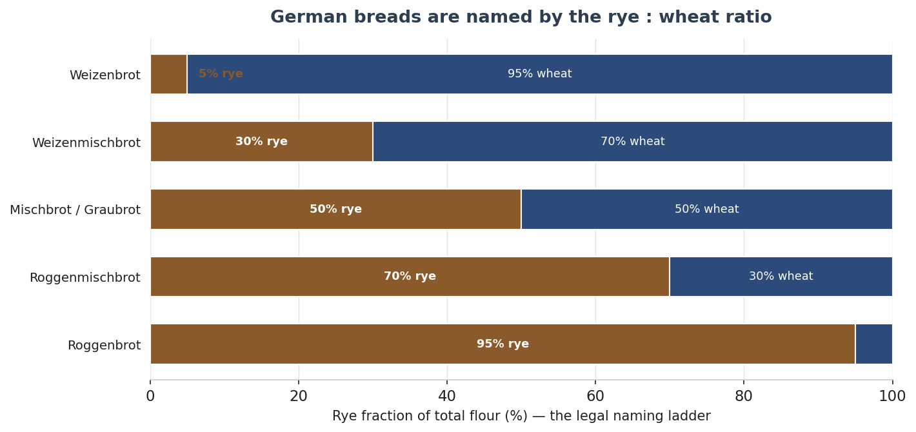
Figure 38 — The legal naming ladder: a bread’s name is set by the rye fraction of its flour. Rye-dominant breads are darker, denser, more sour and longer-keeping; wheat-dominant ones lighter and milder. Values indicative.
Name | Rye fraction | Character
Roggenbrot | ≥ 90% rye | Dense, moist, malty-sour; thick crust; long keeping
Roggenmischbrot | > 50–89% rye | Rye-forward but more open; the everyday dark loaf
Mischbrot / Graubrot | ~50 / 50 | Germany’s commonest bread; balanced, mild
Weizenmischbrot | > 50–89% wheat | Light, even crumb; US “deli rye” sits here
Weizenbrot / Weißbrot | ≥ 90% wheat | Soft, open white bread
Roggenbrot (≥ 90% rye). The benchmark. Taste: deep, earthy, malty-sour with real tang; aroma of toasted grain. Crumb close, moist, elastic; crust thick and chewy. Flour: rye 1150/1370 or rye meal. Leavening: 100% sourdough (a little yeast optional). Hydration high — rye drinks far more water than wheat. Salt ~1.8–2.0%. Shaped in pans or free-standing; the crust is usually left to crack (Ausbund) rather than scored. Bake with steam, a hot start (~250 °C) falling to ~210 °C.
Roggenmischbrot. The rye-dominant everyday loaf (Berliner Landbrot, Paderborner). Milder and more open than pure rye but still rye-led and tangy; the wheat fraction (550/1050) lightens the structure while the rye still needs souring.
Mischbrot / Graubrot. “Mixed / grey bread,” about half and half — the most common German bread. Milder, looser-crumbed, a perfect base for cold cuts and spreads. Sourdough plus, often, a little yeast.
Weizenmischbrot & Bauernbrot. Wheat-dominant mixed breads with a light, even crumb. Bauernbrot (“farmer’s bread”) is the rustic archetype — commonly ~50–70% rye / 30–50% wheat (no single canonical formula), hydration ~70–78%, salt ~1.8–2%, sourdough often with a touch of yeast; a thick crackly crust and a full, tangy-malty flavour.
Vollkornbrot (whole-grain rye). Dense, dark, intensely grainy and nutty-sour, very moist, with superb keeping; ≥ 90% whole grain by law, the acid at least two-thirds from sourdough. A documented formula (after Hamelman) shows the shape of the bread:
Component | Baker’s % | Notes
Whole rye meal | ~68% | 60% of it prefermented as a stiff rye sour
Cracked rye (chops) | ~32% | Hydrated in a 100% cold soaker
Sunflower seeds | ~5–6% | Optional; soaked
Salt | ~2% | —
Overall hydration | ~82% | Rye binds far more water than wheat
Baked in a lidded Pullman pan with steam, ~15 min at ~250 °C then ~60–75 min at ~210 °C, and rested wrapped in linen for 24–48 hours before slicing so the crumb sets and the flavour rounds out.
Pumpernickel (Westphalian). The legendary near-black loaf, and the clearest case of the bake itself making the bread. Coarse rye meal or whole rye berries are baked in a lidded pan in a steam-filled oven at low temperature (around 120 °C, some sources lower) for 16–24 hours. The colour and the deep malty sweetness — notes of dark chocolate and coffee, a mild tang, a whisper of bitterness — come entirely from Maillard browning and the caramelisation of rye sugars over that long bake; the authentic product uses no colourings (industrial imitations add molasses or caramel). The crumb is moist, dense and almost crustless. Westphalian Pumpernickel carries an EU protected geographical indication.

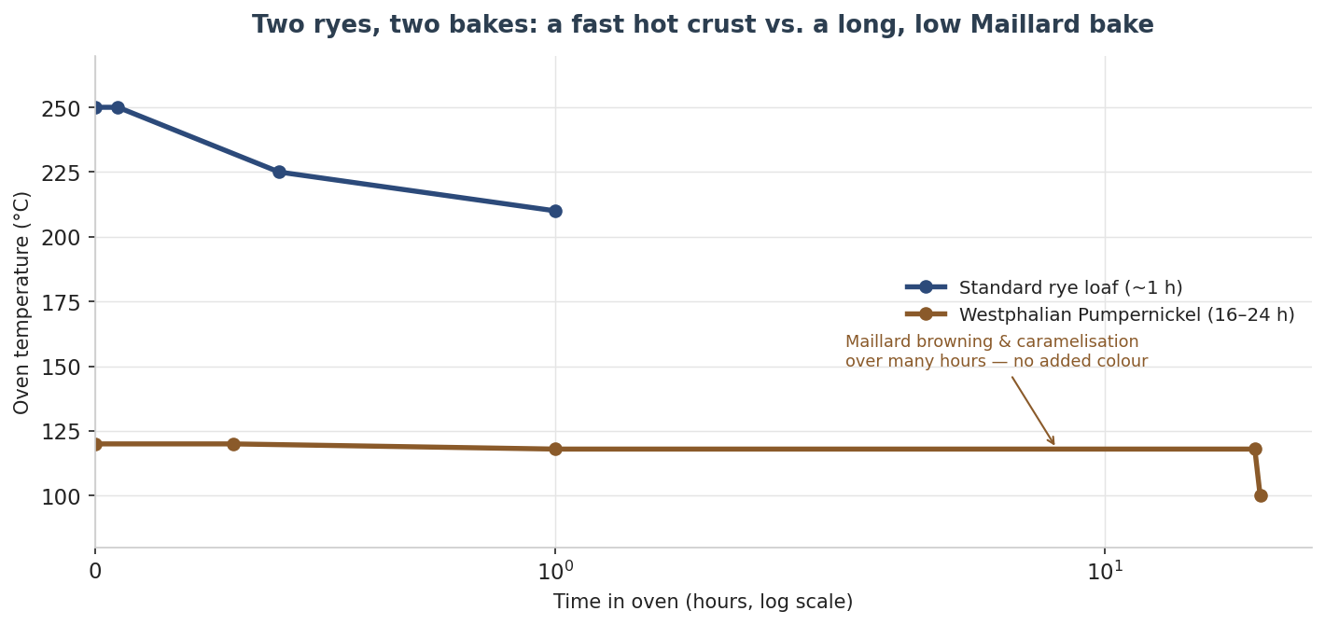
Figure 39 — Two ryes, two bakes. A standard rye takes a fast, hot bake (~1 h, 250 → 210 °C) for crust and spring; Pumpernickel takes a long, low bake (16–24 h, ~120 °C) in which Maillard and caramelisation alone build colour and sweetness. Note the log time axis. Indicative.
Roggenschrotbrot & Kommissbrot. Schrotbrot is built on cracked rye (Schrot), usually with a Brühstück to soften the meal — coarse, hearty, very moist and long-keeping. Kommissbrot is the historic dark rye army bread: dense, sour and built for ration durability.

36.5 Wheat & Specialty Breads
Weizenbrot / Weißbrot. Wheat / white bread — mild, soft, open; yeasted, sometimes on a Vorteig.
Seeded & multigrain breads. By naming convention a Sonnenblumenkernbrot (sunflower) or Kürbiskernbrot (pumpkin-seed) must carry at least ~8% of the seed; Dreikorn-, Fünfkorn- and Mehrkornbrot at least ~5% of each named grain. Seeds are pre-soaked in a Quellstück or Brühstück for a nutty, moist crumb, usually on a rye or mixed base. Leinsamenbrot (flax) relies on a soaker for the mucilaginous seed.
Dinkelbrot (spelt). Nutty and gently sweet; spelt’s gluten is extensible but fragile, so a Mehlkochstück is often used to add water and softness without over-mixing.
Specialty enrichments. Kartoffelbrot (potato) is moist and tender with long keeping; Zwiebelbrot (onion) savoury; Walnussbrot nutty on a mixed base; Haferbrot (oat) soft. Toastbrot is the German sandwich loaf — soft, fine, milk- and fat-enriched, pan-baked with a thin crust, often built on a Kochstück for shelf life.

36.6 Rolls (Brötchen / Semmel / Schrippe)
The basic crusty wheat roll carries strongly regional names — Brötchen (north/standard), Semmel (Bavaria/Austria), Schrippe (Berlin), Wecken/Weckle (south-west), Rundstück (Hamburg). All share a crisp, shattering crust and a soft open crumb, eaten ultra-fresh at breakfast; Type 550 wheat, yeasted, steam-baked hot. The Kaisersemmel (Kaiser roll) is the star — a Viennese creation named for the emperor, with a five-segment rosette made either by a hand-knotted fold or a stamped cutter. Mohn- (poppy), Sesam- (sesame), Milch- (soft, milk-enriched) and Roggenbrötchen round out the basket.

36.7 Laugengebäck — Lye Pastry
The defining step is a brief dip in food-grade lye (sodium hydroxide, NaOH) — typically a ~4% solution, three to four seconds — before salting and baking. The high pH drives an intense Maillard reaction, giving the mahogany gloss and the unmistakable flavour and aroma; the lye is rendered harmless in the oven. The Brezel / Breze (pretzel) is the icon: thick belly, thin crossed arms, coarse salt. The Bavarian Breze is fatter and softer-armed, not scored (it bursts naturally); the Swabian Brezel is higher in fat with distinctly thin crisp arms against a fat fluffy belly, and is scored across the belly before baking. The bite is a crackly, glossy crust over a chewy interior. Laugenstange (stick), Laugenbrötchen and Laugenkringel are the same dough in other shapes.

36.8 Sweet & Festive Breads (Hefegebäck)
Stollen / Dresdner Christstollen (PGI). A dense, rich, fruit-laden yeasted loaf — firm and cake-like rather than fluffy, folded into its lopsided shape, brushed in butter and heavily dusted with icing sugar to symbolise the Christ child in swaddling clothes. Dresdner Christstollen carries EU PGI status and may be made only in and around Dresden by certified bakers. The taste is buttery and warmly spiced (cardamom, cinnamon, nutmeg) with boozy fruit; sweetness comes mostly from the fruit and the sugar coat. The PGI specification sets ingredient ratios relative to flour:
Ingredient (Dresdner Christstollen) | Minimum per 100 kg flour
Butter | ≥ 50 kg (or equivalent)
Raisins / sultanas | ≥ 65 kg
Candied orange & lemon peel | ≥ 20 kg
Sweet almonds | ≥ 15 kg
Flour | Wheat Type 405 or 550 only
Hefezopf, Stuten & friends. Hefezopf / Zopf is the braided milk-and-butter bread — soft, tender, lightly sweet, glossy with egg wash. Rosinenstuten / Stuten is the milk-enriched raisin loaf; Mohn- and Nussstriezel are poppy- and nut-filled braids. The Hamburg Franzbrötchen is a buttery, caramelised cinnamon pastry, and the Berliner / Krapfen is the jam-filled fried doughnut of Carnival and New Year.
Quarantined legend. Pumpernickel’s “bon pour Nicol” (fit only for a horse named Nicol) and Soest-siege origin tales, and Stollen’s supposed 1329 baking-competition birth, are folk etymology and legend rather than documented history. The 1490 papal “Butterbrief” that lifted the Advent butter ban for Saxony, by contrast, is real.

36.9 Quick Reference — The Breads of Germany
Bread | Type | Flour | Leaven | Bake / notes
Roggenbrot | ≥90% rye | Rye 1150/1370 | Sourdough | Steam, 250→210 °C; crust cracks
Roggenmischbrot | >50% rye | Rye + wheat | Sour (+yeast) | Everyday dark loaf
Mischbrot | ~50/50 | Rye + wheat | Sour + yeast | Mild, looser crumb
Vollkornbrot | ≥90% whole | Whole rye + chops | Stiff rye sour | Lidded pan; rest 24–48 h
Pumpernickel | rye meal | Whole rye | Sour | Lidded, ~120 °C, 16–24 h
Bauernbrot | mixed | Rye + wheat | Sour (+yeast) | Thick crackly crust
Brötchen / Semmel | wheat | Wheat 550 | Yeast | Crisp, steam-baked, fresh
Brezel | wheat | Wheat 550 | Yeast | Lye dip; coarse salt
Dresdner Stollen | wheat | Wheat 405/550 | Yeast | Butter+fruit; PGI; rest weeks
Hefezopf | wheat | Wheat 550 | Yeast | Braided, milk+butter, egg wash

36.10 Method — Reading a German Formula (TA & Acidity)
German formulas are written in their own dialect, and two metrics unlock them. The first is Teigausbeute (TA), dough yield: TA = (flour + water) / flour × 100, so the hydration percentage is simply TA minus 100. A TA of 178 is a 78% dough. Rye and wholegrain doughs run high (TA 175–195) because pentosans and bran bind far more water than gluten; rolls and Brezel run low (TA ~150–160) for dry, shapeable doughs. The second is the Säuregrad (degree of acidity) — the millilitres of 0.1 M NaOH needed to neutralise 10 g of dough — which measures how much acid is present. The baker’s adage captures the division of labour: der Säuregrad schmeckt und der pH-Wert bäckt — acidity quantity drives flavour, pH drives bakeability.

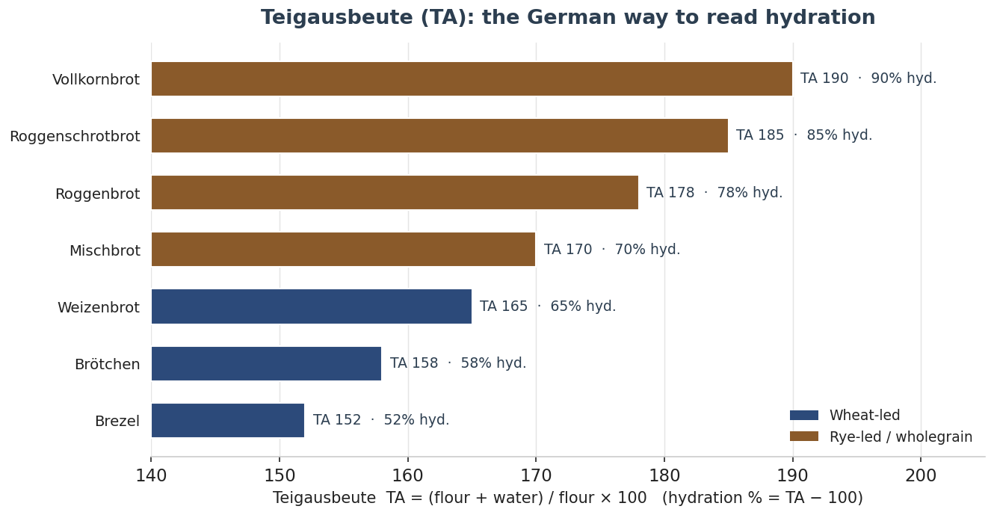
Figure 43 — Teigausbeute (TA) is hydration expressed as dough yield: hydration % = TA − 100. Rye and wholegrain breads sit high; rolls and Brezel low. Values indicative.

36.11 Building the Rye Sour — the Detmold Method
The rye sour does two jobs at once: it leavens, and it acidifies. The Detmold (Detmolder) family of builds, codified at the German cereal-research institute, lets the baker choose how much labour to trade for aroma balance and rise. A one-stage build is simplest and most tolerant; the three-stage build is the traditional gold standard, deliberately varying dough yield, temperature and time so each stage favours one set of organisms.

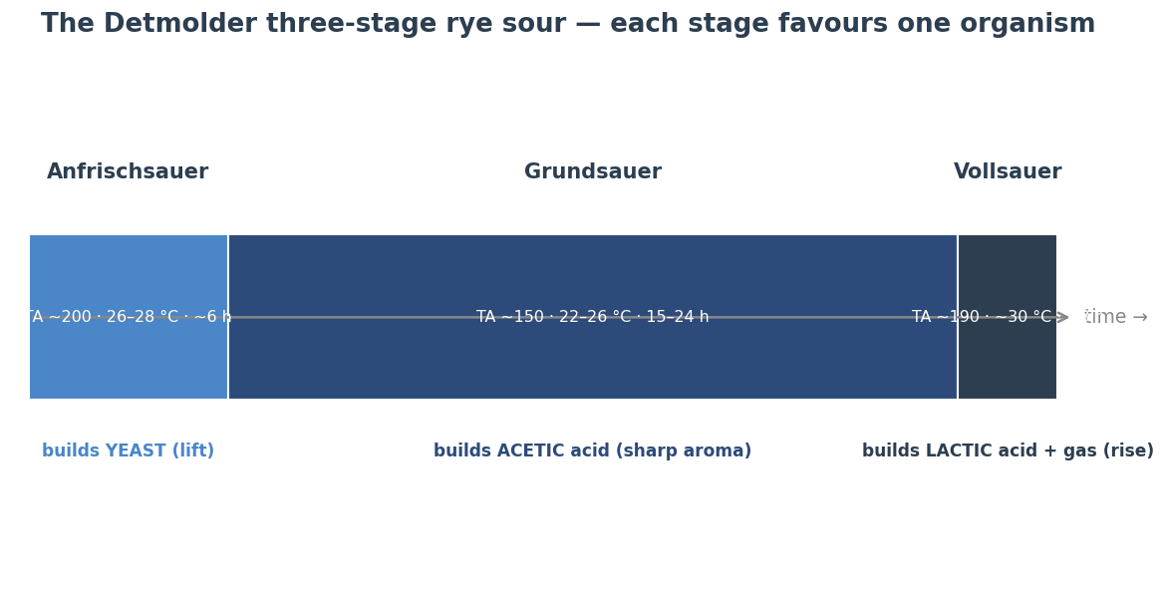
Figure 44 — The Detmolder three-stage sour. Warm and wet favours yeast (lift); cool and firm favours acetic acid (sharp aroma); warm and wet again favours lactic acid and gas (rise). Parameters vary by source; values indicative.
Build | Outline | Best for
One-stage (Einstufen) | ~10% ripe starter on the sour flour; TA ~200; 15–20 h at 18–26 °C | Production; high tolerance, mild-balanced
Two-stage | Grundsauer then Vollsauer | A practical compromise
Three-stage (Detmolder) | Anfrischsauer (yeast) → Grundsauer (acetic, 15–24 h) → Vollsauer (lactic, ~3 h, ~30 °C) | Maximum aroma control; the classic
Why rye must be soured. Rye is rich in alpha-amylase whose activity peaks near pH 5.0–5.5 and whose temperature optimum overlaps the gelatinisation temperature of rye starch (~55–70 °C). Left unchecked, the enzyme degrades starch during baking — the result is a damp, gummy crumb and a hollow “flying roof” where the crust separates. Lowering the dough pH below about 4.5 holds the amylase in check so the pentosan-and-starch matrix sets into a sliceable crumb. This is chemistry, not tradition: it is why any dough above roughly 20% rye is soured.

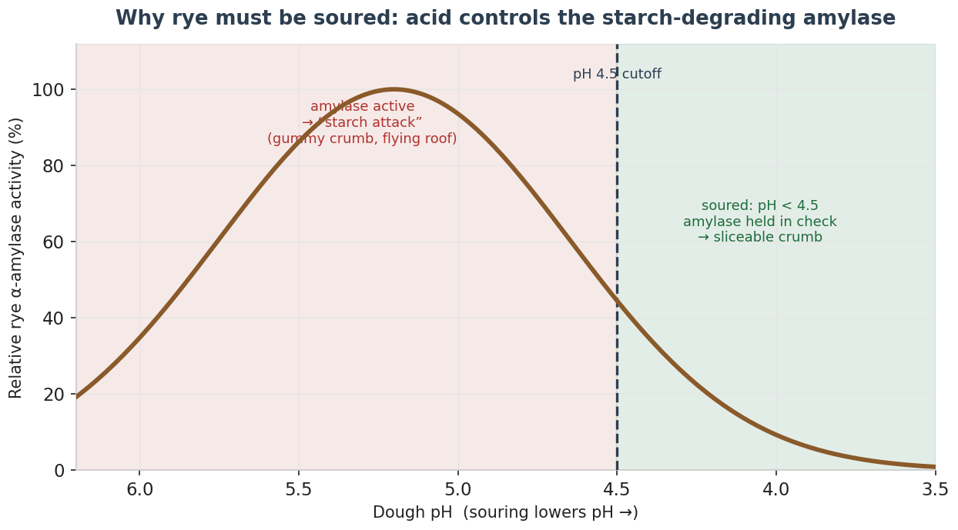
Figure 45 — Rye alpha-amylase activity against dough pH. Above ~4.5 the enzyme runs loose (the “starch attack”); souring below 4.5 brings it under control. Curve indicative; the practical cutoff is cited between pH 4.5 (Hammes/Gänzle) and 4.1 (Plötzblog).

36.12 Method by Type — Rye & Mixed Breads
A representative working method for a rye or rye-mixed bread, assuming a ripe three-stage (or one-stage) sour:
- Acidify the right fraction. Sour ~35–50% of the total rye (more for pure rye, less for rye-mixed). Target a ripe sour at pH ~3.8–4.0.
- Mix only to combine. There is no gluten window to chase — over-mixing tears the pentosan structure. Use warm water to hit a dough temperature of 28–30 °C. Salt 1.8–2%.
- Short or no bulk. Rye needs little floor time (Kesselgare ~20–30 min). Shape wet-handed or with the help of water.
- Proof to the crack. Proof in a banneton or pan ~50–75 min until the surface shows 2–3 mm fissures — the natural Ausbund; pure rye is not scored.
- Hot start, falling oven, bake to core. Load with steam at ~250 °C, fall to 200–220 °C; bake to an internal 96–98 °C.
- Rest before cutting. Wrap and rest 24–48 h so the crumb sets and moisture equalises — cutting warm gives a gummy slice.
Baker’s percentages — 70/30 Roggenmischbrot (after IREKS/Detmold logic). Total flour 100% (rye 70 / wheat 30):
Component | Baker’s % | Notes
Rye in the sour | ~35% of total flour | i.e. ~50% of the rye, at TA ~180
Remaining rye + wheat | 65% | added in the final mix
Water | to TA ~178–185 | warm, to reach 28–30 °C dough
Salt | 2% | —
Yeast (optional spike) | 0.5–1% | to restore lift if the sour is run for acidity

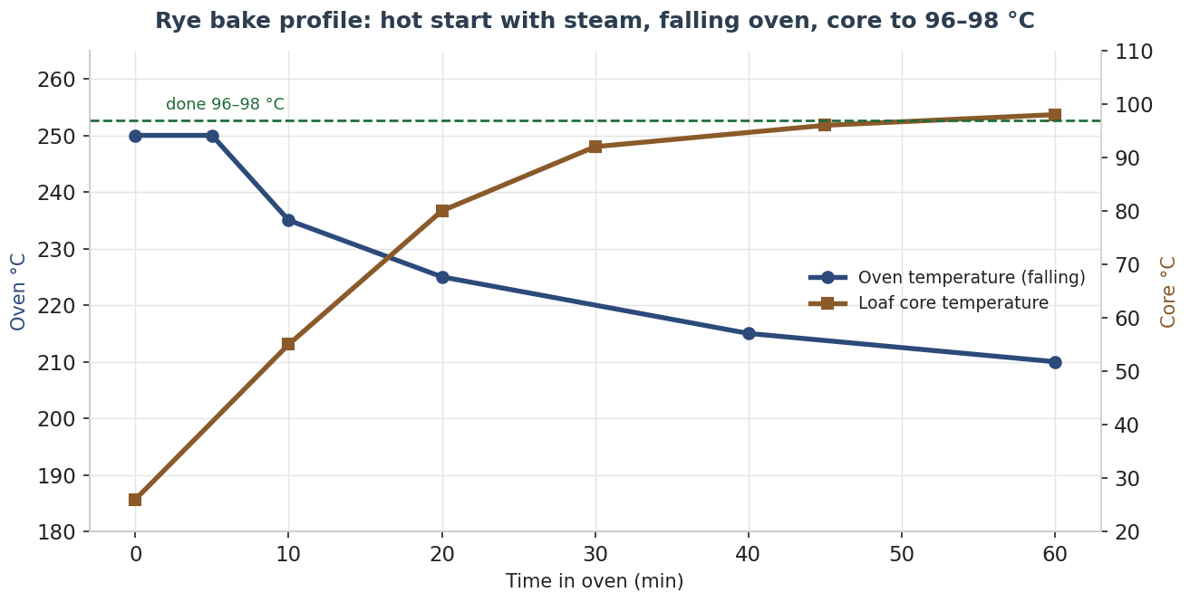
Figure 46 — A rye bake profile: a hot, steamed start with a falling oven temperature, while the loaf core climbs to the 96–98 °C doneness window. Indicative.
Troubleshooting — rye.
Fault | Likely cause | Fix
Gummy crumb / flying roof | Under-acidified (amylase loose) or under-baked / cut warm | Acidify more rye; hit pH < 4.5; bake to 96–98 °C; rest 24 h
Too sharp / sour | Grundsauer too cool-long or too much acidified flour | Warmer, shorter sour; reduce acidified fraction
Weak lift, dense | Vollsauer immature or too cold | Ensure ~30 °C, ~3 h; spike with a little yeast
Dry crust, no bloom | Over-proofed or no early steam | Load at first cracking, with steam

36.13 Method by Type — Wholegrain, Schrot & Pumpernickel
Wholegrain and coarse-meal breads are built on pre-soaking stages that bind water and protect structure. Choose the soaker by what it must do:
Soaker | Water & temp | Job
Brühstück (scald) | ~100% water at 70–100 °C | Softens hard Schrot/hulls & old bread; binds water
Quellstück (cold soaker) | ~50–100% cold water | Hydrates seeds/grains; roughly water-neutral
Mehlkochstück (water roux) | flour cooked with ~5× water | Gelatinised paste; big moisture & shelf-life boost (≤5–15% of flour)
Altbrot soaker | old bread, toasted, scalded | Flavour & moisture (≤5–10% of flour)
Vollkornbrot & Schrotbrot. Hydration is very high (TA 185–195). Combine the soaker(s) with a stiff rye sour, mix only to combine, dough temp ~30–31 °C, proof in a pan to the first cracking, and give a long pan bake — load ~240–250 °C with brief steam, drop to 180–220 °C, 45–75 min, to 96–98 °C core. Rest 24–48 h.
Pumpernickel. The method is the bread. Coarse rye meal and whole rye berries go into lidded pans in a steam-filled oven and bake ~16–24 h at ~120 °C. The near-black colour and malty-sweet, chocolate-and-coffee notes come entirely from Maillard browning and starch caramelisation over that marathon — the authentic loaf uses no colourings. Hamelman’s celebrated Horst Bandel formula adds soaked rye berries, rye chops, a little high-gluten wheat, an old-bread soaker and molasses, and bakes covered for ~12 h on a descending profile to an internal ~98–99 °C; bakers’ replications run roughly 1 h at 175 °C, then 90 min each at 150 °C and 120 °C, finishing in a cooling oven. Rest 24–72 h.
Troubleshooting — wholegrain & pumpernickel.
Fault | Likely cause | Fix
Soggy centre | Too much free water; Schrot not pre-soaked | Use Brüh-/Kochstück; bake longer/lower; rest 24–48 h
Crumbly, dry | Insufficient soaker water | Add a Kochstück or Quellstück
Pumpernickel not dark | Bake too short/hot | Longer & lower — colour is from the long bake, not additives
Breaks into chunks | Over-hydrated / under-baked | Cut water; bake fully to core; rest

36.14 Method by Type — Brötchen & Brezel
Brötchen / Kaisersemmel. Use a matured Vorteig (poolish, pâte fermentée or biga, 12–48 h at 5 °C) for the splittery crust and mild aroma. Mix to full gluten (windowpane); dough temp 24–26 °C. Divide ~70–90 g, round, rest 15–25 min, then shape the Kaiser rosette by the hand-struck fold (handgeschlagen) or a stamp. Proof face-down to about three-quarters, then load at 250 °C with hard steam, vent after ~10 min, fall to 230 °C, ~18–20 min; spray for gloss. A representative hand-struck Kaisersemmel: flour T550 100%, pre-ferment ~16%, water ~45%, milk ~17%, butter ~3%, salt ~2.2%, yeast ~1%, inactive malt ~1.5%, dough 25–26 °C.
Brezel. A firm, low-hydration dough (TA ~150–160) with a little fat. Shape a long strand with a thick belly and thin arms, cross and twist the arms and press them onto the belly, then chill or briefly freeze the shaped pieces 20–30 min so the surface skins and firms for dipping.

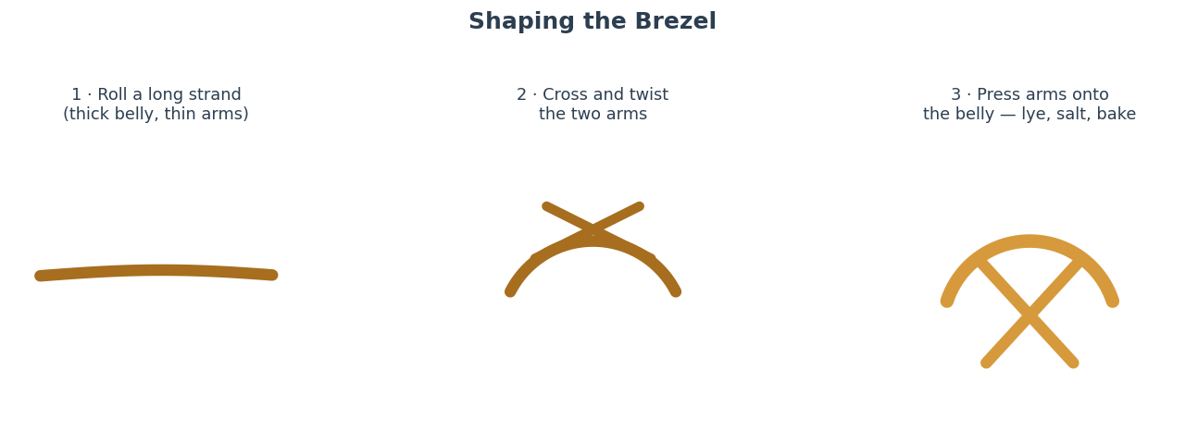
Figure 47 — Shaping the Brezel: roll a tapered strand, cross and twist the arms, then press them onto the belly before the lye dip. Indicative.
The lye, handled safely. Dip in food-grade sodium hydroxide (NaOH) at ~3–4% (40 g pearls per litre of cold water). Always add the pearls to cold water, never the reverse; wear chemical gloves and goggles; use plastic or stainless, never aluminium. Dip ~5 s, salt with coarse pretzel salt, score the belly (Swabian) or leave it to burst (Bavarian), and bake ~220–240 °C for 12–20 min. The lye is rendered harmless in the oven. Household natron (baking soda) is a weaker, safer substitute that gives colour but not the true crust or flavour.
Troubleshooting — rolls & Brezel.
Fault | Likely cause | Fix
Pale rolls, no shine | No steam / no spray | Steam hard at load; spray before & after
Kaiser pattern bakes out | Over-proofed face-down or shallow stamp | Reduce proof; stamp deeper; load at ¾ proof
Ugly cracks from lye | Pieces frozen-through when dipped | Thaw 20–30 min so the surface is skinned, not solid
Brezel loses shape in lye | Not skin-dried/chilled | Rest uncovered cold until the surface skins

36.15 Method by Type — Stollen & Enriched Breads
Dresdner Christstollen. Macerate the sultanas in rum a day ahead; add candied peel and almonds. Build a yeast pre-dough, then knead the rich dough (often kept cool so it stays firm) — it is low-yeast and will not double, so give it a long, slow prove. Shape the traditional offset fold (the Umschlag); the PGI permits no baking tins. Bake with a brief hot start (~230–240 °C) then finish at 180–190 °C, ~50–60 min for a 2 kg loaf. Finish while hot: brush generously with melted clarified butter and dust in layers of caster then icing sugar — this seals the loaf. Mature wrapped, cool, for 2–6 weeks before cutting. The PGI ingredient minima (butter 50%, raisins 65%, candied peel 20%, almonds 15% of flour) are tabled in 36.8.

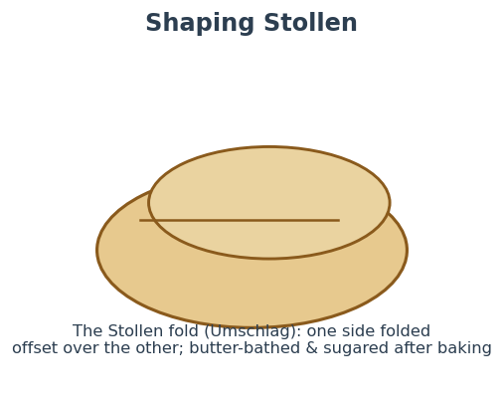
Figure 48 — The Stollen fold (Umschlag): one side folded offset over the other, then butter-bathed and sugared after baking. Indicative.
Hefezopf & sweet breads. Develop full gluten in the enriched dough, keep it cool-ish (~24–26 °C), bulk to near-double, braid (three, four or six strands), proof, egg-wash for gloss and bake ~180 °C to a ~88–90 °C core. Common faults: a split crust (under-proofed or braided too tight), pale colour (no egg wash), a dense crumb (under-proofed or too much butter added too early).

36.16 German Method — Key References
Authoritative sources for the German methods above (verify protected-product figures against the current specification before relying on them commercially):
- IREKS Compendium — why rye sourdough must be acidified — ireks-kompendium.com/en/rye-sourdoughs/basics-of-acidification
- Plötzblog (Lutz Geißler) — Dreistufige Sauerteigführung — ploetzblog.de/baeckerlatein/dreistufige-sauerteigfuehrung
- Plötzblog — pH-Wert & amylase cutoff — ploetzblog.de/baeckerlatein/ph-wert
- Stanley Ginsberg — Baking with Rye: the chemistry (BBGA) — theryebaker.com/wp-content/Ginsberg_BreadLines-2016.24.02.pdf
- Jeffrey Hamelman, Bread — Horst Bandel Black Pumpernickel (replication) — thefreshloaf.com/node/16348
- Teigausbeute (TA) explained — brooot.de/lexikon/was-ist-die-sogenannte-teigausbeute-ta-beim-brotbacken
- Wiener Kaisersemmel (Plötzblog) — ploetzblog.de/2011/12/08/wiener-kaisersemmel
- Laugenbrezel & lye handling — brooot.de/broetchen/brezeln-selber-backen-bayerische-und-schwaebische
- Dresdner Christstollen PGI (European Commission) — agriculture.ec.europa.eu/.../dresdner-christsollen-pgi_en
- Deutsche UNESCO-Kommission — Deutsche Brotkultur — unesco.de/.../deutsche-brotkultur
- Deutsches Brotinstitut — Brotkultur — brotinstitut.de/brotkultur

37. The Breads of Italy
Italy has no single bread tradition but hundreds — nearly every region, and many a town, has its own. Two forces organise that variety. The first is grain geography: soft wheat (grano tenero) in the north and centre, durum (grano duro, milled to golden semola) in the south. The second is the protected-designation system, DOP and IGP, which has formalised a roster of historic breads — Pane di Altamura was the first bread in the EU to win PDO, in 2003. As with the other countries, three foundations come first: the flour grading system, the vocabulary of preferments and natural leaven, and the regional families that follow.
On figures and disputes. Italian recipes vary widely by house; hydrations, strengths and bake parameters are given as ranges with sources named where documented (Carol Field’s The Italian Baker, the DOP/IGP disciplinari, the festive-bread decree). Folklore is flagged as legend.

37.1 The Italian Flour System — tipo, forza & P/L
Italian soft-wheat flour is graded by ash / refinement, from the highly refined tipo 00 (“doppio zero”) through 0, 1 and 2 to integrale (wholemeal). As in France and Germany, the number is about extraction, not protein — a tipo 00 can be anywhere from 9% to 14% protein. Strength is read separately through two numbers every Italian baker watches: the W index (“forza”), the flour’s overall strength, and the P/L ratio, its tenacity against its extensibility. Durum is graded on its own track as semola and, for bread, semola rimacinata (re-milled, finer) — amber-gold, sweet and nutty. A terminology trap: Italian “grano duro” is durum, while what Americans call “hard wheat” is high-protein grano tenero.

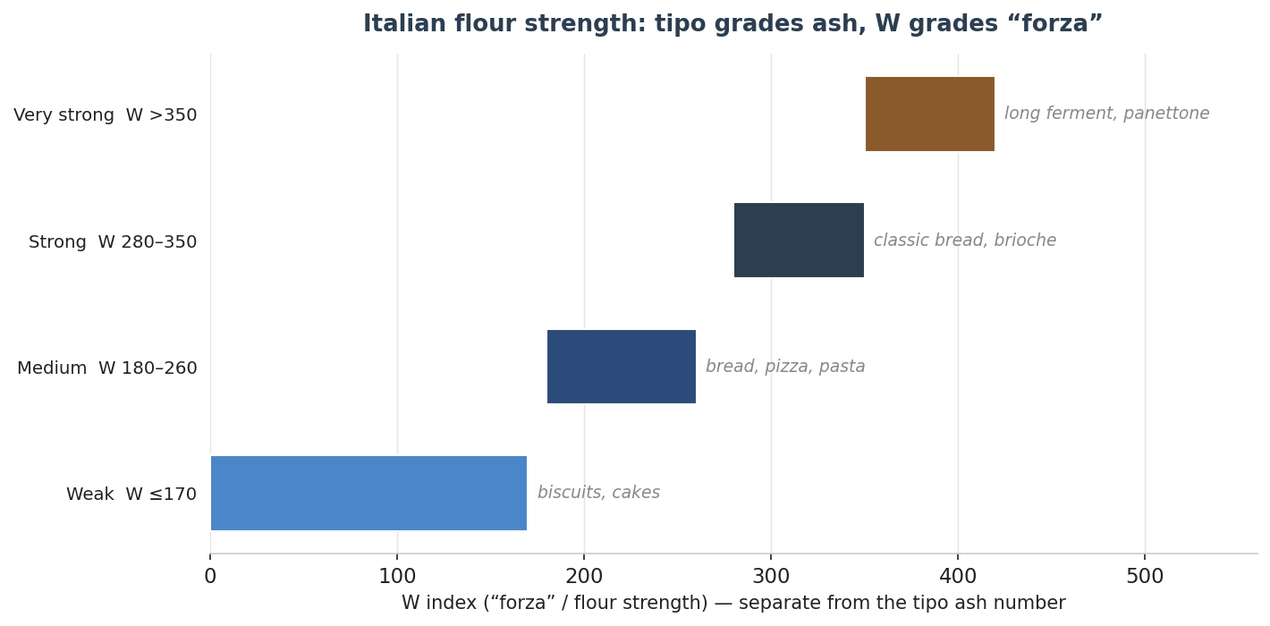
Figure 40 — Italian flour is read on two axes: the tipo number grades ash/refinement, while the W index (“forza”) grades strength. Longer fermentations and richer doughs demand higher W. Values indicative.
Grade | Ash (max) | Typical use | Rough US/UK equivalent
Tipo 00 | < 0.55% | Pizza, fresh pasta, fine breads, enriched doughs | Low-ash; protein varies 9–14%
Tipo 0 | ~0.65% | Everyday bread & pizza | All-purpose / strong AP
Tipo 1 | ~0.80% | Flavourful rustic breads (thirstier) | High-extraction
Tipo 2 / integrale | 0.95% / whole | Semi-wholemeal / wholemeal | Whole wheat
Semola rimacinata | durum | Southern durum breads (Altamura, Matera) | Fine durum / semolina

37.2 A Baker’s Glossary of Italian Terms
Italian term | What it means
Biga | A stiff preferment (flour, water ~45–50%, a little yeast), 16–48 h; builds strength, aroma, open crumb.
Poolish | A liquid preferment, equal flour and water, yeast dosed inversely to time; builds extensibility and crust colour.
Lievito madre / pasta madre | Natural sourdough — solido (stiff, ~45–50%) like a firm starter, or liquido / LiCoLi (100% hydration).
Lievito di birra | Commercial (brewer’s) yeast.
Autolisi | An autolyse — flour-and-water rest before salt and leaven.
Incordatura | Bringing dough fully “on the cord” to complete gluten development — critical for panettone.
Pirlatura | The rounding/tightening shaping motion (e.g. for panettone).
Forza (W) / P/L | Flour strength, and the tenacity-to-extensibility ratio.
Biga or poolish? Italian practice splits by goal. A stiff biga builds strength, chew and a bold open crumb — the preferment of ciabatta and rustic loaves. A liquid poolish builds extensibility, crust colour and a milder, nutty flavour, and turns around faster. Natural lievito madre brings both leavening and a gentle lactic-acetic complexity, and is mandatory for the great festive breads.

37.3 Lean Regional Breads
The lean breads are where Italy’s regionalism is most vivid — the same handful of ingredients, transformed by local grain, leaven and oven into dozens of distinct loaves. The figure places the main ones on a hydration spectrum, from the tight, lard-enriched Coppia Ferrarese to the near-pourable doughs of ciabatta and Roman pizza bianca.

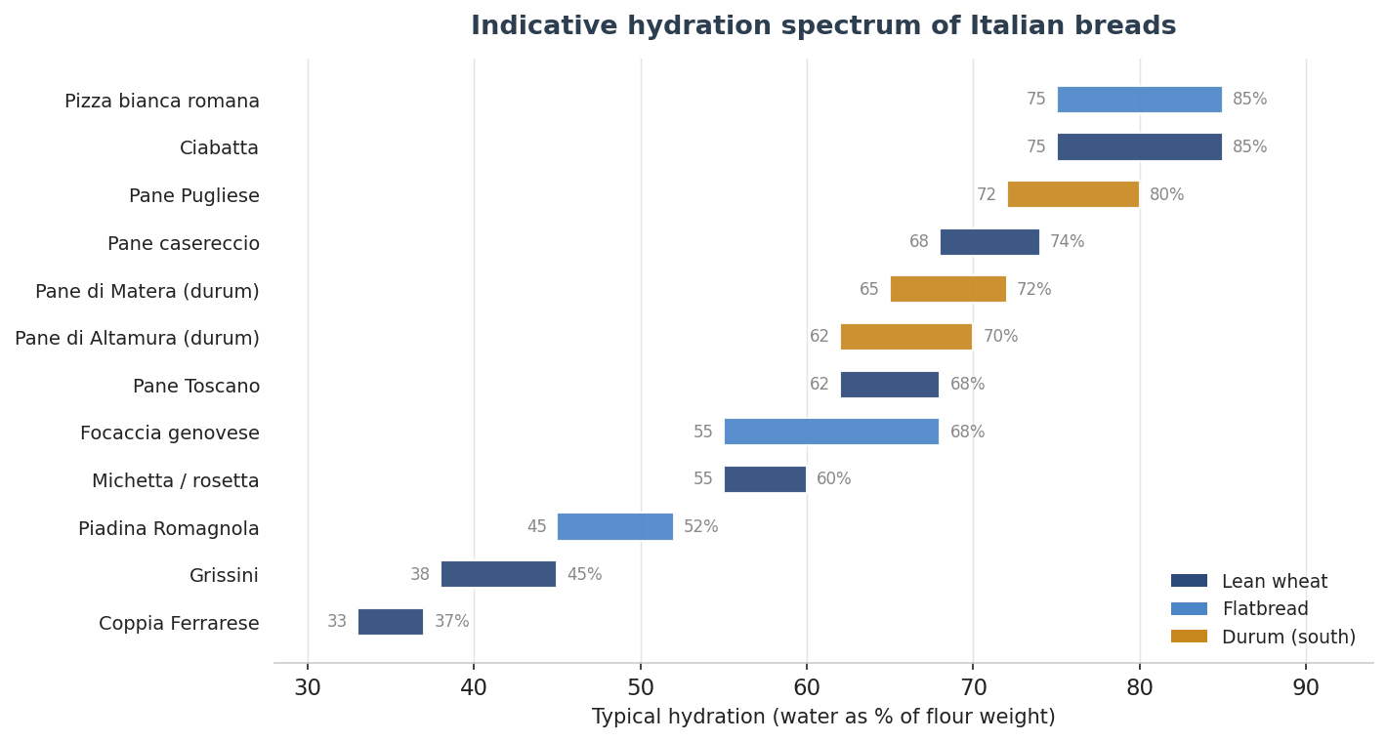
Figure 41 — Indicative hydration spectrum of Italian breads. Colour denotes family; southern durum breads sit in the middle, the high-hydration wheat breads at the top. Hydration depends on flour and house style; treat as ranges.
Ciabatta. Not ancient at all: invented in 1982 by the miller-baker Arnaldo Cavallari in the Veneto as a deliberate Italian answer to the spreading French baguette, and named “slipper” for its flat oblong shape. It is biga-based and very wet — Cavallari’s own recipe ran ~70% final hydration from a stiff biga; modern versions reach 75–85% and beyond on strong flour. The reward is a crisp, chewy crust over an open, irregular, glossy alveolar crumb with a mild, sweet, wheaty flavour. Variants include ciabatta integrale and al latte. Handle wet, fold rather than knead, and bake hot with steam.
Pane di Altamura DOP. Puglia’s pride and the first EU bread to gain PDO (registered 18 July 2003). Made from re-milled durum semola of local cultivars (Appulo, Arcangelo, Duilio, Simeto; Senatore Cappelli also used), raised on lievito madre, with salt and water, through five defined phases and a wood- or stone-fired bake. The crust must be at least 3 mm thick; the form is the tall “u’ sckuanète.” Taste: aromatic and faintly acidic, with a deep-yellow chewy crumb and a brittle crust, and it keeps up to two weeks.
Pane di Matera IGP. Basilicata’s durum loaf, close cousin to Altamura but shaped as a high, twisted cone (the cornetto/horn). Re-milled durum semola of local cultivars, natural leaven traditionally begun from macerated fruit, three leavening phases, wood-fired. Crust ≥ 3 mm and dark; straw-yellow crumb with large irregular pores; sensory notes of grass and hay with a fruity finish; keeps 7–9 days.
Pane Toscano DOP. The famous saltless bread of Tuscany (“pane sciocco”). Soft-wheat flour, natural leaven, water — and no salt. Taste: neutral, almost bland, with a faintly sour ivory crumb and a thick reddish crust, and an aroma of toasted hazelnut. The point is balance: it is the perfect foil for salty Tuscan companions — pecorino, prosciutto, finocchiona, ribollita.
Pane casereccio di Genzano IGP. From the Castelli Romani south of Rome, the first Italian bread to win IGP (1997). A bran-dusted, dark, thick crust over a soft, spongy, ivory alveolate crumb, with an intense aroma from long fermentation and a chestnut- or oak-fired bake. Tipo 0/00 with cruschello (bran), natural leaven, salt; built on a biga.
Coppia Ferrarese IGP. Emilia’s curiosity (IGP since 2001): two ribbons of dough crossed and each twisted into horned ends. Enriched with lard (~6%) and olive oil (~3%) at a notably low hydration (~35%), tipo 0, natural leaven and malt. The result is crisp and savoury with scarce crumb — “a grissino with a soft heart” — and keeps for days.
Michetta / Rosetta. The hollow, rose-stamped crusty roll of Milan (michetta) and Rome (rosetta), adapted from the Austrian Kaisersemmel under Habsburg rule and lightened by Milanese bakers to a near-empty interior with a hard, thin, crisp crust. Highly leavened, stamped while raw; best eaten the same day.
Pane Pugliese, Cafone, Filone & Biova. Pane Pugliese is the broad Puglian durum loaf — thick-crusted, open, golden, robustly nutty. Pane Cafone is the blistered Neapolitan table bread on natural leaven. Filone and sfilatino are the Italian baguette-like long loaves. Biova and biovetta are the soft, thin-crusted white rolls of Piedmont.

37.4 Flatbreads
Focaccia. The master category, and intensely regional. Focaccia genovese (fugàssa) is thin and oil-rich, its dimples finished with a salamoia brine that bakes to a golden, crisp-topped, soft-crumbed, savoury sheet. Focaccia barese is thicker, with boiled mashed potato and durum semola worked into the dough for an extra-soft, long-keeping crumb, topped with cherry tomatoes, olives and oregano. Focaccia di Recco col formaggio (IGP) is unleavened: two paper-thin sheets enclosing molten stracchino, baked hot and blistered.
Schiacciata, Piadina & Carasau. Schiacciata is the Tuscan focaccia (the autumn schiacciata all’uva is studded with wine grapes). Piadina Romagnola (IGP) is the Emilian griddle flatbread of soft wheat with lard or oil and little or no leaven, cooked on a hot testo in under four minutes — the thicker classic and the thin, soft Riminese being its two styles. Pane carasau (“carta da musica”) is the Sardinian shepherd’s bread: re-milled durum rolled paper-thin, baked until it balloons, split into two sheets and re-baked crisp — so thin you could read music through it, and keeping for months (brushed with oil and salt it becomes pane guttiau).
Pizza bianca romana & Grissini. Pizza bianca romana is the high-hydration, long-fermented Roman bakery flatbread, blistered and airy under oil and salt, sold by weight. Grissini are the Turin breadsticks — all crust, no crumb — in two forms: the hand-rolled knotty rubatà and the hand-pulled, thinner, brittle stirato.

37.5 Enriched & Festive Breads
These are the summit of the Italian baker’s art — multi-day doughs built on lievito madre, brought fully on the cord, and governed by law: the Decreto Ministeriale of 22 July 2005 (amended 2017) sets the minimum richness of panettone, pandoro and colomba.

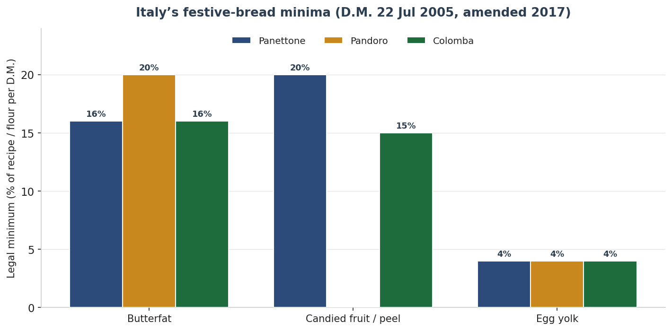
Figure 42 — Italy’s festive breads have legal minima for butterfat, candied fruit/peel and egg yolk (D.M. 22 July 2005, amended 2017). Pandoro is the richest in butter; panettone the fruitiest. Values are the legal floors.
Panettone (Milan). Tall, domed, with an airy, cottony, almost gravity-defying crumb and a buttery-citrus-vanilla aroma carrying a gentle natural-leaven tang. Lievito madre is mandatory; the process spans 36–48 hours across a refreshed mother, a first dough (primo impasto) and a second (secondo impasto) enriched with yolks, butter, sugar, candied citrus and raisins, shaped by pirlatura into a paper pirottino, proofed, scored with a cross and a knob of butter, baked, and — crucially — cooled hung upside-down for 12–24 hours so the delicate crumb sets. By law it must contain at least 16% butterfat, 20% raisins-plus-candied-peel, and 4% egg yolk.
Pandoro (Verona). Tall, fruitless, baked in a star-shaped frustum mould and finished with vanilla-scented icing sugar to resemble snowy peaks. Deeply buttery and vanilla-scented, its silky sheeted crumb comes from a sfogliatura — a butter emulsion folded in lamination-like stages, the dough kept below 26 °C. The law sets its butterfat floor higher than panettone’s, at 20%.
Colomba Pasquale. The Easter dove: a panettone-like enriched dough with candied orange peel but no raisins, topped before baking with an almond-and-sugar glaze and pearl sugar, and cooled upside-down. The law requires at least 16% butterfat, 15% candied peel and 4% egg yolk, plus the mandatory almond glaze.
Maritozzo, Pangiallo & Panmarino. The maritozzo is the soft Roman sweet bun split and filled with whipped cream; pangiallo romano an ancient dense honey-nut-and-fruit solstice bread; panmarino a modern rosemary-and-sea-salt loaf, star-scored and aromatic.
Quarantined legend. The romantic “pan di Toni” origin of panettone (a love-struck baker’s apprentice in the Sforza court) and the tale that grissini were invented in 1679 to cure a sickly Savoy prince are charming but unverified — widely repeated, thinly documented. Ciabatta’s 1982 invention, by contrast, is firmly recorded.

37.6 Quick Reference — The Breads of Italy
Bread | Region | Flour | Hydration | Method & bake
Ciabatta | Veneto | Strong 0 | 75–85% | Biga; fold; hot + steam
Pane di Altamura DOP | Puglia | Durum rimacinata | 62–70% | Lievito madre; wood-fired; crust ≥3 mm
Pane di Matera IGP | Basilicata | Durum rimacinata | 65–72% | Madre; wood-fired; horn form
Pane Toscano DOP | Tuscany | Soft 0 | 62–68% | No salt; natural leaven
Pane di Genzano IGP | Lazio | 0 + bran | 68–74% | Biga; bran-dusted; wood-fired
Coppia Ferrarese IGP | Emilia | Tipo 0 | ~35% | Lard+oil; twisted horns; crisp
Michetta / rosetta | Lombardy/Lazio | Soft 0 | 55–60% | Stamped; hollow; same-day
Focaccia genovese | Liguria | 0 | 55–68% | Oil + salamoia brine; dimpled
Piadina Romagnola IGP | Emilia | 00 (+lard/oil) | 45–52% | Griddle/testo; <4 min; no leaven
Pane carasau | Sardinia | Durum | low | Twice-baked, paper-thin
Grissini | Piedmont | 0 | 38–45% | Rolled/pulled; all crust
Panettone | Milan | Strong 00 | soft | Lievito madre; 36–48 h; cool inverted
Pandoro | Verona | Strong 00 | soft | Sfogliatura; star mould; 20% butter
Colomba | Milan | Strong 00 | soft | Dove form; almond glaze; inverted
From a saltless Tuscan loaf to a Milanese panettone cooled upside-down on skewers, Italy proves that bread is geography made edible — know the grain, the leaven and the region, and every loaf explains itself.

37.7 Method — Preferments & Dough Building
Italian method is organised less by acidity than by the choice of preferment and by how water is brought into the dough. Three preferments cover most of the repertoire, and the choice is made by goal, not habit.

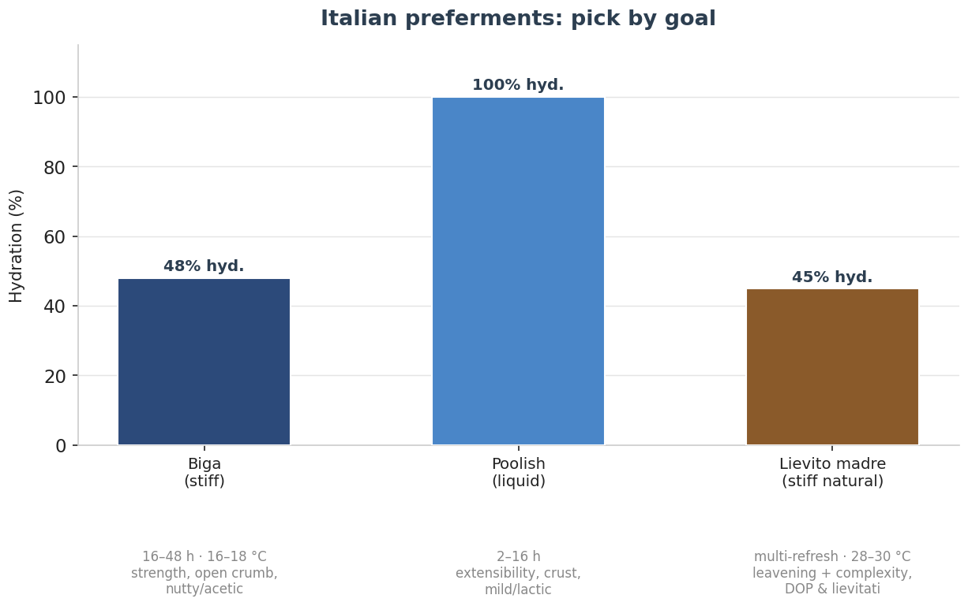
Figure 49 — Italian preferments by goal: a stiff biga for strength and an open, nutty crumb; a liquid poolish for extensibility and crust colour; a stiff lievito madre for leavening plus complexity in DOP breads and the festive lievitati. Indicative.
Biga is stiff (flour, ~44–50% water, ~1% yeast), fermented 16–48 h at 16–18 °C; it builds strength, a mellow nutty-acetic flavour and tolerance. Poolish is liquid (equal flour and water, no salt), with the yeast dosed inversely to time; it builds extensibility and crust colour and ferments faster. Lievito madre (stiff natural leaven, ~45% hydration) is refreshed several times before use and brings both leavening and a gentle yogurt-and-lemon complexity.

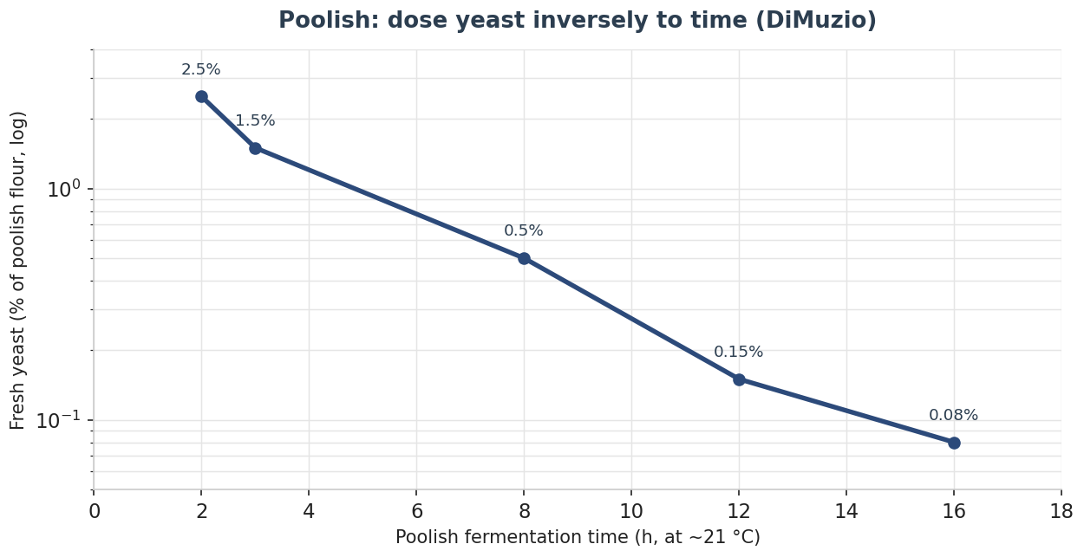
Figure 50 — Dosing a poolish: less yeast for a longer ferment (after DiMuzio). At ~21 °C a 2-hour poolish takes ~2.5% fresh yeast; a 16-hour poolish only ~0.08%. Indicative.
Bassinage. For high-hydration doughs (ciabatta above all) the technique is to build strong gluten first on a firmer dough, then add the remaining water in stages — bassinage — so the gluten can carry 75–85%+ hydration without turning to soup. Dough temperature is held to 24–28 °C with cold biga and cold water, because wet doughs build a lot of frictional heat in the mixer.

37.8 Method by Type — Ciabatta & Biga Breads
Ciabatta is the archetypal biga-and-bassinage bread, and its open crumb is as much about handling as formula:
- Build the biga. 35–45% of the total flour at ~50% hydration with ~1% yeast; 16–18 h at 16–18 °C, kept cool.
- Develop, then bassinage. Mix biga, flour, salt, yeast and part of the water to strong gluten (incordatura), then add the rest of the water in stages to 75–85%. Use strong flour (≥ 12.7% protein).
- Fold, don’t knock back. Bulk with gentle stretch-and-folds; the crumb depends on preserving the gas.
- Cut the slipper. Turn out onto a heavily floured bench, cut into slippers and load with minimal degassing.
- Bake hot with steam. ~230–250 °C to a thin, crisp crust and a glossy, irregular crumb.

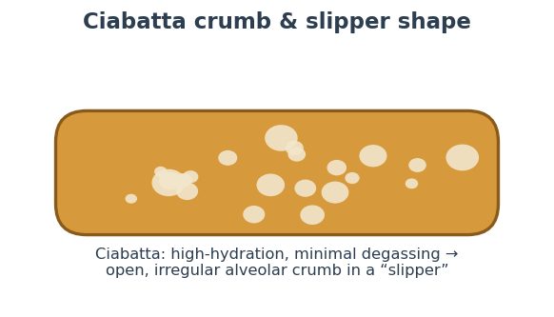
Figure 51 — Ciabatta: high hydration plus minimal degassing gives the open, irregular alveolar crumb in the flat “slipper”. Indicative.
Troubleshooting — ciabatta.
Fault | Likely cause | Fix
Soupy, no structure | Flour too weak; water added before gluten built | Use ≥ 12.7% protein; bassinage only after strong gluten; fold
Tight, closed crumb | Over-degassed in shaping or under-hydrated | Handle gently; raise hydration
Flat, spreading | Over-proofed or weak gluten | Shorter proof; stronger flour

37.9 Method by Type — Durum DOP/IGP Breads
Pane di Altamura DOP. The disciplinare fixes the method. Refresh a lievito madre at least three times with water and re-milled durum semola; use it at 20% of the semolina. Per 100 kg semola: 20 kg natural leaven, 2 kg sea salt, ~60 L water at 18 °C, mixed ~20 min in a plunging-arm mixer. Then: a first rest (≥ 90 min, covered with thick cotton for even temperature) → weigh and hand-shape in two steps with rests of 30 and 15 min → invert the loaves → load a wood- or stone-fired oven at 250 °C, the first ~15 min with the door open, then ~45 min closed → wait ≥ 5 min with the door open before drawing so the crust crisps. Crust ≥ 3 mm; the tall accavallata (“u’ sckuanète”) or low cappello-di-prete form.
Pane di Matera IGP. Re-milled durum semola of old varieties, on a lievito madre traditionally begun from macerated fruit; five phases (impastamento, formatura, lievitazione, modellatura, cottura). Pre-form ~20% heavier than the finished loaf, rest, hand-shape the cornetto (horn), stamp with “MT,” and bake in a wood (oak/olive) oven, ~2 h for a 1 kg loaf. Crust ≥ 3 mm; pale-straw crumb with large irregular alveoli; moisture ≤ 33%.
Troubleshooting — durum breads.
Fault | Likely cause | Fix
Burnt base, pale top (home oven) | Thin tray; base too hot | Bake on a stone; start 240 °C then 200–220 °C; raise the loaf
Crust thinner than 3 mm | Too little initial heat / short bake | Load very hot; keep a long bake to build the crust
Dense crumb | Weak leaven or under-proof | Triple-refresh the madre; prove fully

37.10 Method by Type — Pane Toscano & Genzano
Pane Toscano DOP (saltless). Build on a first impasto (e.g. 200 g first dough + 1 kg flour + ~550 mL water), mix, rest ≥ 20 min, divide, rest ≥ 15 min, shape and final-prove the panetti ≥ 2.5 h, then bake on a falling profile from 220 °C down to 180 °C for the mandated pale, hazelnut-toned crust. The absence of salt is the method’s defining variable: the dough ferments faster and handles slacker and stickier, with a weaker gluten film — so the baker works quickly, and the reward is the characteristic irregular open crumb and a bread that keeps 6–7 days and is built to partner salty Tuscan food.
Pane Casareccio di Genzano IGP. A biga matured several hours feeds a Type 0+00 dough; mix ~20 min (traditionally a fork mixer), bulk ~1 h, shape pagnotte or filoni, lay them in canvas-lined wooden boxes and dust with crusca (bran) — the source of the dark crust — and prove ~40 min. Bake on refractory brick in a wood oven at 300–320 °C, 35 min to an hour by size, to a crust ≥ 3 mm over an ivory, well-holed crumb. Home replication: load ~275 °C with steam, dropping 20 °C after 10 min and again after 30 min.

37.11 Method by Type — Focaccia, Piadina, Carasau & Grissini
Focaccia genovese. A soft Type 0 dough with olive oil and a little malt. Bulk 30–45 min, stretch into a well-oiled pan, rest ~30 min, then press the fossette (dimples) right down to the pan with three fingers and flood them with salamoia — an emulsion of roughly equal water and oil with salt. Prove uncovered 40–60 min until the brine is half absorbed, and bake hot, 220–230 °C, ~15 min, turning out onto a rack so the base stays crisp. Use little yeast (~7 g fresh per kg flour) for a slow, flavourful rise. Barese folds boiled potato and durum semola into the dough for a taller, softer crumb under tomato and olives.
Piadina Romagnola IGP. Soft-wheat flour with lard or olive oil and little or no leaven (a touch of bicarbonate is permitted). Mix to a smooth dough, ball, rest, roll thin, and cook on a hot testo or griddle at 200–250 °C for under four minutes total — about two minutes a side — turning once. The thicker classic and the thin, flexible Riminese are the two registered styles.
Pane Carasau. The twice-baked shepherd’s bread. Mix a firm durum dough, bulk, divide and rest, then roll paper-thin discs and rest again. A very hot first bake balloons each disc; while it is still hot it is split with a knife into two thin sheets (this must be done fast, before it cools) and flattened to cool. A second bake (the carasatura) at ~180–240 °C crisps the sheets — this is what gives the months-long keeping and the “carta da musica” snap.
Grissini. A Type 00 dough with oil or lard and malt. Rubatà are hand-rolled under the palms — knobbly and irregular; stirato are hand-pulled from a strip — smoother and more regular, the form that suited mechanisation. Bake ~180–210 °C, 12–25 min by thickness, to an all-crust, no-crumb stick.

37.12 Method by Type — Panettone, Pandoro & Colomba
The festive lievitati are the summit of the craft: multi-day doughs built on a triple-refreshed lievito madre, brought fully on the cord, with the dough temperature never allowed past 26–27 °C. The timeline below is indicative for panettone.

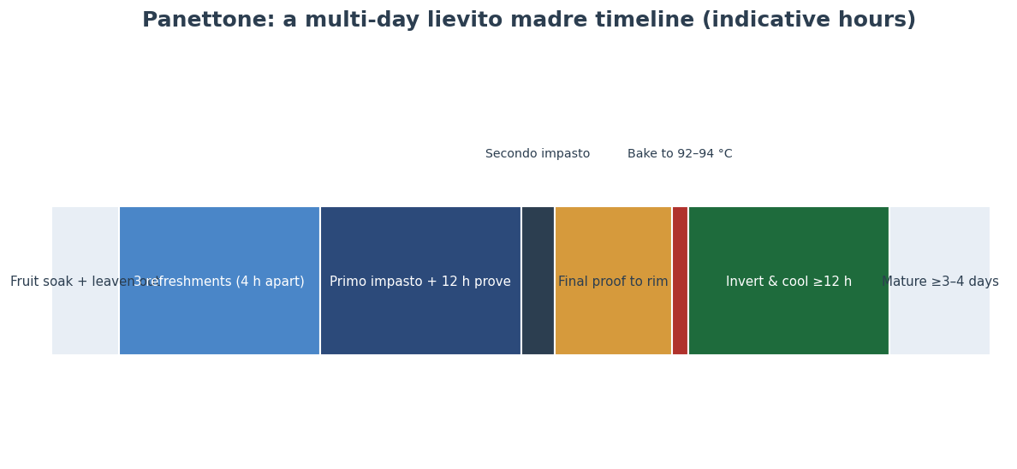
Figure 52 — A representative panettone timeline: refresh the leaven, build the primo impasto and prove ~12 h, add the secondo impasto, prove to the rim, bake to 92–94 °C, then hang inverted ≥ 12 h and mature several days. Indicative hours.
- Refresh the leaven. Three refreshments ~3–4 h apart at 28–30 °C (often after an 18 °C water bath) until the madre triples in 3–4 h and tastes of yogurt and lemon, not vinegar.
- Primo impasto (evening). Strong flour (W 330–380), water, sugar, yolk, butter and leaven built to strong gluten; ferment ~12 h at 22–26 °C until it triples. Keep the dough ≤ 26 °C.
- Secondo impasto (morning). Add flour, then yolks, sugar, salt, the aromatic mass (honey, citrus zest, vanilla), butter and finally the candied fruit and raisins; mix to a smooth, incordato dough at 26–27 °C.
- Pirlatura & proof. Round with buttered hands into a taut sphere, drop into the paper mould, and prove at ~28 °C (never above 30 °C) for many hours until the dough reaches the rim.
- Scarpatura & bake. Cut a cross and add a knob of butter (pandoro is not scored — it is baked in its star mould); bake ~160–180 °C to an internal 92–94 °C.
- Invert and mature. Skewer through the base and hang upside-down ≥ 12 h so the structure cannot collapse, then mature wrapped ≥ 3–4 days.

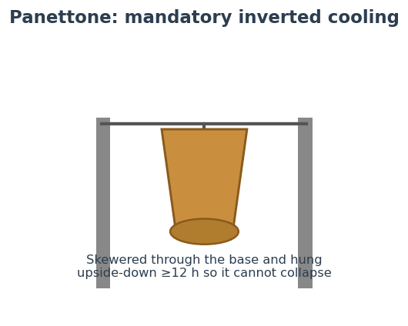
Figure 53 — The mandatory inverted cooling: skewered through the base and hung upside-down for at least 12 hours so the tall, fragile crumb cannot collapse under its own weight. Indicative.
Representative baker’s % (panettone, Giorilli-type). Flour 100%; lievito madre ~10–16%; sugar ~25–30%; butter ~25–30%; egg yolk ~25–30%; candied fruit + raisins ~50–80% on flour; honey and aromas small. The 2005/2017 decree sets the legal floors: butterfat ≥ 16% and egg yolk ≥ 4% for panettone and colomba (≥ 20% butterfat for pandoro), with candied fruit + peel ≥ 20% for panettone and candied peel ≥ 15% for colomba.
Troubleshooting — panettone & pandoro.
Fault | Likely cause | Fix
Collapses / shrinks after bake | Skipped inverted cooling or over-proofed | Always hang inverted ≥ 12 h; respect the proof
Dense, won’t triple | Leaven too weak or dough > 30 °C (inhibitory lactic acid) | Triple-refresh; keep dough ≤ 26–27 °C, prove ≤ 28–30 °C
Greasy / butter weeps, loses cord | Butter added too fast or dough too warm | Add butter in stages; chill between impasti; ≤ 26–27 °C
Closed / uneven crumb | Poor incordatura or rushed proof | Develop full gluten; let it fully reach the rim

37.13 Italian Method — Key References
Authoritative sources for the Italian methods above (the disciplinari and the festive-bread decree are the binding specifications for protected products):
- Pane di Altamura DOP — fasi della lavorazione — panealtamuradop.it/pane-dop/fasi-della-lavorazione
- Pane di Matera IGP (Qualigeo) — qualigeo.eu/prodotto-qualigeo/pane-di-matera-igp
- Pane Toscano DOP — il pane senza sale (AIFB) — aifb.it/arte-bianca/pane-toscano-sciocco-storia-ed-usi-del-pane-senza-sale
- Pane Casareccio di Genzano IGP (Qualigeo) — qualigeo.eu/prodotto-qualigeo/pane-casareccio-di-genzano-igp
- Piadina Romagnola IGP (Qualigeo) — qualigeo.eu/prodotto-qualigeo/piadina-romagnola-igp
- Festive-bread decree D.M. 22 July 2005 (full text) — ambientediritto.it/Legislazione/consumatori/2005/dm 22lug2005.htm
- Carol Field, The Italian Baker — biga — leitesculinaria.com/79243/recipes-biga.html
- Ciabatta with biga & bassinage — dawghousebakery.com/2021/06/16/ciabatta-with-biga
- Focaccia genovese & salamoia (VivaLaFocaccia) — vivalafocaccia.com/ricetta/video-ricetta-della-focaccia-genovese
- Pane Carasau — twice-baked method — panificiobattacone.it/preparazione-del-pane-carasau
- Grissini rubatà / stirato (Turismo Chieri) — turismochieri.it/en/i-grissini-rubata
- Panettone — primo/secondo impasto (Agrodolce) — agrodolce.it/come-si-prepara-un-panettone
- Andrew Janjigian (Wordloaf) — panettone lessons — newsletter.wordloaf.org/eight-lessons-from-my-panettone-saga
Method is where a bread’s character is decided: the same flour becomes a sour Roggenbrot or a buttery panettone according to temperature, acid, water and time. Read the metric, build the leaven, control the dough — and the loaf follows.

38. The Cradle of Bread — the Fertile Crescent & Ancient Egypt
The previous chapters surveyed three great national traditions. The next ten step back to ask a larger question: which bread cultures shaped the craft itself, sending techniques and loaves across borders to become the breads we know today? The story begins where bread begins — in the Fertile Crescent, the arc of land from the Levant through Mesopotamia where wild emmer, einkorn and barley were first gathered and farmed, and in ancient Egypt, the likely birthplace of leavened bread and of baking as a profession.
The oldest bread predates farming. At Shubayqa 1, a Natufian site in the Black Desert of north-eastern Jordan, archaeologists recovered charred crumbs of a flatbread radiocarbon-dated to about 14,400 years ago — roughly four thousand years before cereals were domesticated (Arranz-Otaegui & Richter et al., PNAS, 2018). It was unleavened, made from wild einkorn-type wheat and club-rush tubers, and baked occasionally rather than daily. The find overturned the old assumption that bread followed farming; if anything, the desire for bread may have helped drive cultivation.

38.1 Egypt — the Birthplace of Leavened Bread
By around 3000 BCE the Egyptians had turned bread into the centre of an economy. The grain was emmer wheat and barley — both hulled, low-gluten grains that had to be parched and pounded to free the kernel, then ground on saddle querns. Workers, including the pyramid builders, were paid in bread, beer and grain; the combined signs for bread and beer stood for “food” itself. Egypt’s dry climate preserved actual loaves and tomb models of bakeries, giving us an unusually clear picture of the first professional baking.
How many breads? The figures depend on the period: Old Kingdom documents list at least 14 types of bread, rising to about 40 breads and cakes by the New Kingdom (Darby, Ghalioungui & Grivetti, Food: The Gift of Osiris, 1977). Leavening was real, not accidental: Cambridge archaeobotanist Delwen Samuel examined desiccated New Kingdom loaves under the electron microscope and identified yeast cells and enzyme-pitted starch, confirming genuine yeast fermentation (Science, 1996).

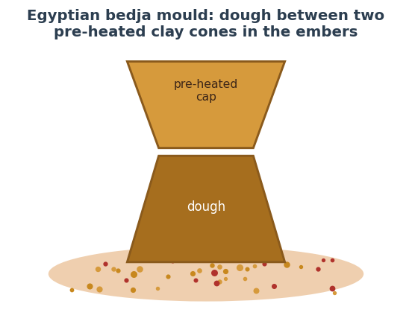
Figure 54 — The Egyptian bedja mould: dough baked between two pre-heated conical clay moulds buried in embers — in effect, an individual oven. Indicative reconstruction.

38.2 Method — the Bedja Mould Bake
A characteristic Old Kingdom method used heavy bell- or cone-shaped ceramic moulds (bedja). The reconstruction below follows Mark Lehner’s Giza bakery excavation (Ancient Egypt Research Associates) and Ed Wood’s 1993 experimental bake with captured wild Giza yeast.
Method box | Detail
Grain / flour | Emmer (and barley); stone-ground wholemeal, sieved
Leaven | Wild sourdough — a sour, dense crumb; some breads malted
Mould | Bedja cones pre-heated upside-down over fire (largest ~12 kg)
Bake | Dough in the hot cone, capped with a second hot cone, surrounded by embers
Result | Heavy, conical, tangy loaf over a foot long; gritty from quern stone
Troubleshooting — ancient-grain wholemeal (modern kitchen).
Fault | Likely cause | Fix
Dense, heavy crumb | Low-gluten emmer + wild leaven | Blend with strong wheat; give a longer, warm proof
Gritty texture | Coarse wholemeal | Sieve the flour; hydrate longer (a soaker)
Sour and flat | Over-long wild ferment | Shorten the proof; build a livelier starter
Lines of influence. Egyptian leavening and professional baking passed to Greece (Greek traders are repeatedly credited with carrying Egyptian flour and methods home) and thence to Rome. The modern Egyptian aish baladi — a puffed wholemeal flatbread — is a living descendant. From this single hearth flow both great lineages of bread.

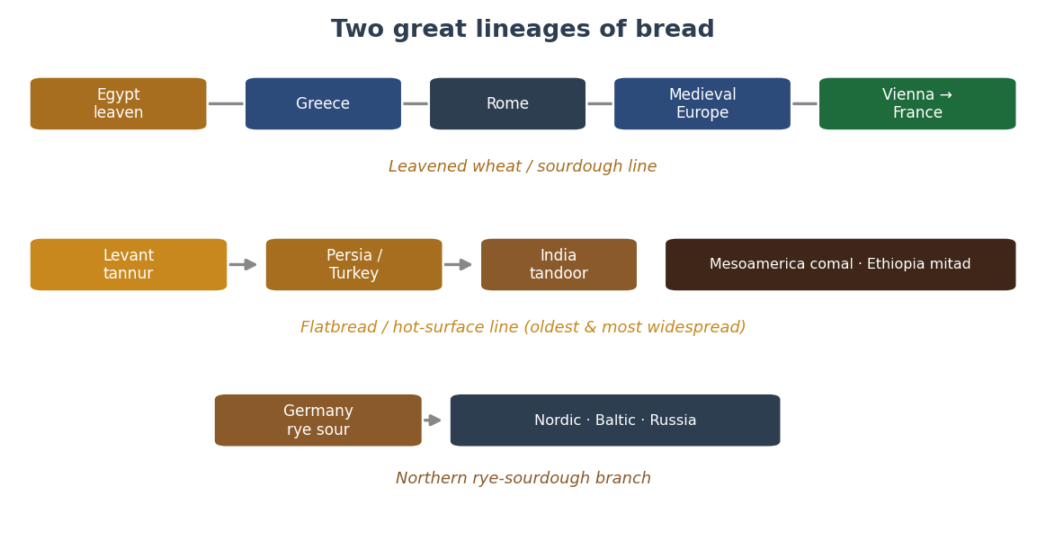
Figure 55 — The two great lineages of bread, with the northern rye branch. The leavened-wheat line runs Egypt → Greece → Rome → medieval Europe → Vienna → France; the flatbread line spreads from the Levantine tannur; the rye-sourdough branch is the northern speciality. Schematic.

39. Ancient Greece & Rome — Refinement and Spread
If Egypt invented professional baking, Greece refined it and Rome industrialised and spread it across a continent. Together they are the bridge between the first bakeries and the breads of medieval and modern Europe.

39.1 Greece — the First Gourmet Bakers
The Greeks turned bread into a craft of variety. Athenaeus, in the Deipnosophistae, catalogues more than seventy named breads, distinguished by grain, shape and method. The early staple was maza (a barley-meal preparation, often unbaked); wheaten bread was a luxury. Greek bakers introduced enrichments — olive oil, honey, cheese, milk, sesame — and revered Demeter as goddess of grain. When Greek bakers reached Rome they were soon permitted to form a guild.

39.2 Rome — the Great Industrialiser
Rome’s genius was scale. Commercial bakeries (pistrina, run by pistores) proliferated — some forty have been identified at Pompeii alone — and bakers organised into the powerful Collegium Pistorum. Milling advanced from hand querns to animal-driven “Pompeian” mills and then to water power: the Barbegal complex near Arles, sixteen overshot wheels in two rows, is described as the greatest concentration of mechanical power in the ancient world, perhaps milling enough flour for tens of thousands daily. The grain supply was managed by the state through the cura annonae, the dole that fed around 200,000 citizens and, under Aurelian, shifted from grain to baked bread.

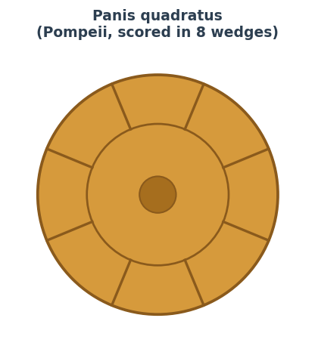
Figure 56 — Panis quadratus, the Roman wheel loaf scored into eight wedges for breaking and sharing, often string-tied at the equator and stamped with the baker’s mark. Eighty-one carbonised examples survived at Pompeii. Indicative.

39.3 Method — Panis Quadratus
The iconic Roman loaf is known from frescoes and from carbonised loaves preserved by Vesuvius in 79 CE. Food archaeologist Farrell Monaco reconstructs it as below.
Method box | Detail
Flour | Common wheat (T. aestivum), often with some spelt; sieved
Leaven | Sourdough (Pliny: leaven kept from yesterday’s dough, or a must-soured cake)
Weight | ~1.3 kg (about 4 Roman librae)
Shaping | Press a rod down into the dough to mark 8 wedges; tie a string around the equator; stamp the top
Proof / bake | Proof inverted; bake in a hot wood oven with the wedges set
Troubleshooting — wedge-scored sourdough wheel.
Fault | Likely cause | Fix
Wedges bake out / merge | Marks too shallow or over-proofed | Press the rod deeper; load slightly under-proofed
No equatorial groove | String omitted | Tie damp string around the dough before proofing
Pale, soft crust | Oven too cool / no early heat | Load very hot; the Roman oven ran fierce
Lines of influence. Rome carried wheat agriculture, the rotary quern, water-milling and professional baking from Iberia to Britain to the Rhine. Every later European tradition — French, German, Italian — is downstream of this diffusion.

40. Austria & Vienna — the Vector into Modern French Baking
Vienna’s importance is that it reshaped French baking, the tradition usually treated as the gold standard. The mechanism was one man: August Zang, a Viennese former artillery officer who opened the Boulangerie Viennoise in Paris in 1838–39. It was a sensation, and within two years a dozen Vienna-style bakeries had sprung up in imitation.
Two transmissions changed France (per food historian Jim Chevallier). First, the Viennese steam oven, which became standard and is the oven behind the modern baguette’s thin, glossy, crackling crust — though Chevallier cautions that the claim Zang “introduced the baguette” is not supported by period sources; the technique he brought made it possible. Second, the Austrian crescent roll, the Kipferl, which French bakers renamed for its shape — croissant. The laminated butter croissant we know is a later French transformation: yeast-leavened puff dough (pâte feuilletée levée) only appears in the first decade of the 20th century. The croissant is therefore a Franco-Austrian hybrid: Austrian form, French lamination.

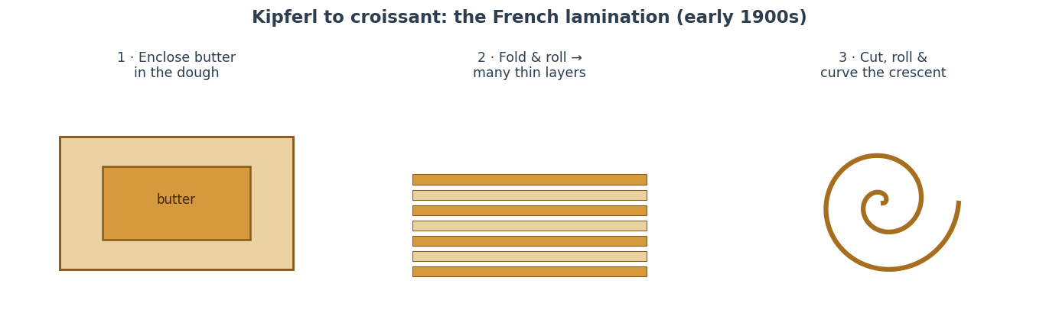
Figure 57 — From Kipferl to croissant: the French contribution was lamination — enclosing butter, folding to many thin layers, then rolling and curving the crescent. Indicative.
Quarantined legend. The story that the Kipferl/croissant was created to celebrate the lifting of the 1683 Ottoman Siege of Vienna (its crescent mocking the Ottoman flag), and the tale that Marie-Antoinette introduced the croissant to France in 1770, are folklore unsupported by contemporary sources. The Kipferl itself is genuinely old — crescent rolls are recorded in Central Europe well before then — but the siege and queen stories are later inventions. The kaiser roll’s “named for Emperor Franz Joseph” origin is likewise folk etymology; the term predates his reign.

40.1 Method — the Croissant (laminated yeast dough)
Method box | Detail
Flour | Strong-ish white wheat (T45/T55-style), ~12–13% protein
Detrempe | Flour 100%, water+milk ~55%, sugar ~10%, butter ~5%, yeast ~4% fresh, salt ~2%
Lamination | Lock in a butter block ~25–30% of dough weight; 3 single folds (or 1 double + 1 single)
Keep cool | Butter must stay plastic — rest chilled between folds; dough below ~16 °C
Proof | Shaped crescents proofed warm (24–26 °C) until jiggly — butter must not weep
Bake | Egg-washed; ~190–210 °C with a little early steam, until deep gold
Troubleshooting — viennoiserie.
Fault | Likely cause | Fix
Butter weeps out in oven | Proof too warm or butter melted in lamination | Proof ≤ 26 °C; keep dough cold while folding
No layers / bready crumb | Butter too cold (shattered) or over-proofed | Plastic (not hard) butter; correct proof
Dense, no rise | Under-proofed or weak yeast | Proof fully until visibly jiggly
Lines of influence. Vienna → Paris → the modern baguette and croissant, and from France, viennoiserie spread worldwide. Vienna also seeded the kaiser roll across Central Europe and influenced the Italian michetta during Austrian rule of Lombardy.

41. The Jewish Diaspora — a Cross-Border Bread Culture
Unusually, this tradition is defined by migration rather than territory — and it profoundly shaped the baking of the United States, and through it the world. Its breads travelled from Poland and the wider Ashkenazi world to the delicatessens of New York and London and then everywhere.

41.1 The Bagel — Boiled, then Baked
The bagel is first documented in 1610, in the community ordinances of Kraków, where bagels were named as gifts for women in childbirth; the Yiddish beygl derives from a Middle High German word for “ring.” It likely descends from the Polish obwarzanek. The defining step is boiling before baking: a brief bath (traditionally in malt- or honey-sweetened water) gelatinises the surface starch, giving the chewy interior and glossy, crisp crust. Jewish immigration carried it to New York and Montreal, producing the two classic styles.

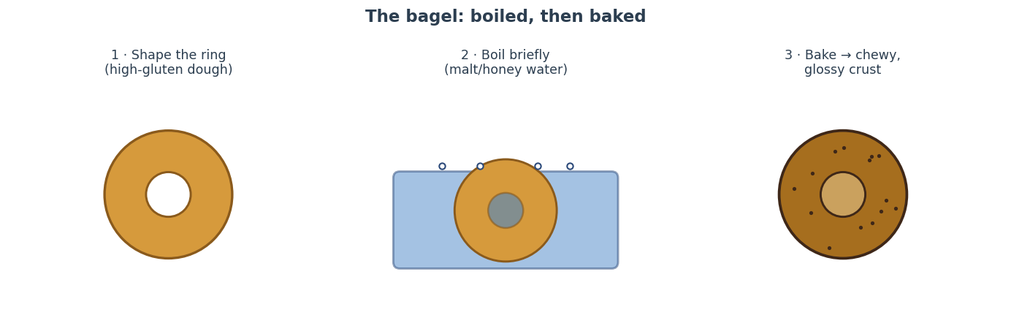
Figure 58 — The bagel: shape the high-gluten ring, boil briefly in malt- or honey-sweetened water, then bake to a chewy crumb and glossy crust. Indicative.
Method box | Detail
Flour | High-gluten wheat (~13–14% protein) for chew
Dough | Flour 100%, water ~52–56%, malt ~2–4%, yeast ~1%, salt ~2% — a stiff dough
Shape | Roll a rope and seal into a ring (or poke-and-stretch); retard cold overnight
Boil | 30–60 s in water with barley-malt syrup (NY) or honey (Montreal)
Bake | NY: ~230–245 °C oven; Montreal: hotter wood-fired, denser, sweeter
Troubleshooting — bagels.
Fault | Likely cause | Fix
Wrinkled / shrivelled crust | Over-proofed before boil, or boil too long | Retard cold; boil only 30–60 s
Dense, no chew | Flour too weak or under-boiled | Use high-gluten flour; ensure a proper boil
Flat, spreads in boil | Under-proofed gluten or too slack | Develop gluten fully; stiffen the dough

41.2 Challah, Bialys, Deli Rye & Matzo
Challah is the rich, braided, dairy-free (pareve) Shabbat loaf; the name refers to the mitzvah of separating a portion of dough. Braiding began in 15th-century Austria and southern Germany, Jewish bakers adopting local plaited Sunday loaves. Two loaves honour the double portion of manna; round loaves at Rosh Hashanah symbolise continuity. American challah grew sweeter and larger than its European parent.

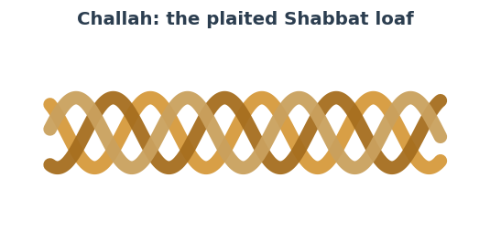
Figure 59 — Challah, the plaited Shabbat loaf: an enriched, pareve dough (flour, egg, oil, a little sugar, yeast, salt), braided and egg-washed. Indicative.
Bialys (from Białystok) are baked rolls with an onion-filled central depression, not a hole. Jewish / deli rye is a wheat-rye blend on a rye sourdough, seasoned with caraway and often cornmeal-dusted — the bread of the American pastrami sandwich; Hamelman’s entry-level Deli Rye runs about 15% pre-fermented rye in an 80%-hydration sour, ~66% overall hydration, ~1.75% caraway, baked on a stone with steam. Matzo is unleavened flour-and-water flatbread baked within 18 minutes start to finish so no leavening can begin.
Lines of influence. Late-19th and early-20th-century emigration transplanted these breads to the US and UK; the American deli made rye and the bagel mainstream, and the bagel is now a global breakfast bread.

42. The Nordic, Baltic & Russian Rye World
Across the “rye belt” — Scandinavia, the Baltics, Poland and Russia — rye thrives where wheat struggles, in cold, short summers and poor soils. The result is a deep sourdough-rye tradition that parallels and reinforces the German one (Sections 36, 16). It is technically distinct from wheat baking because rye’s enzymes must be controlled by acid: sourdough is essential, since commercial yeast alone cannot properly leaven a high-rye dough.

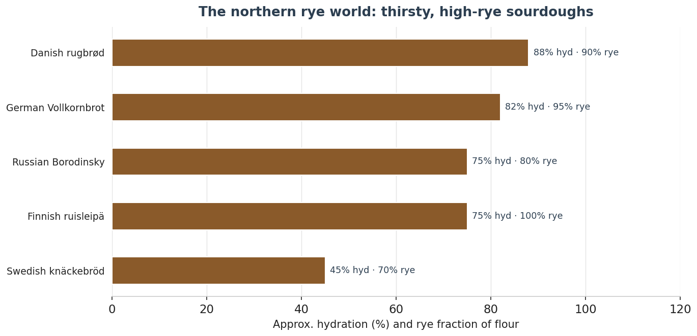
Figure 60 — The northern rye world: thirsty, high-rye sourdoughs. Whole rye binds great quantities of water, so hydration runs high; crispbread is the dry exception. Values indicative.

42.1 The Signature Breads
Danish rugbrød is a dense rectangular pan loaf of mostly whole rye with cracked kernels and seeds, sourdough-leavened, the base of smørrebrød. Finnish ruisleipä / reikäleipä is a 100% dark-rye sourdough, the western form a flat disc with a central hole for pole-storage, leavened with leivän juuri (“the root of the bread”), starters sometimes kept for generations. Swedish knäckebröd (crispbread) is rolled thin with a centre hole and dried to 5–7% moisture for near-indefinite keeping. Russian Borodinsky is a dark rye-and-wheat sourdough flavoured with red rye malt, molasses and coriander.
Quarantined legend. The romantic origin of Borodinsky — that it was created by a widow (Margarita Tuchkova) to commemorate the 1812 Battle of Borodino, or alternatively by the composer-chemist Alexander Borodin — is folklore. The standardised recipe was in fact fixed by Soviet GOST specification in the 20th century.

42.2 Method — a Northern Rye (Detmold-style sour)
Method box | Detail
Flour | Whole and medium rye; 40–90%+ rye with the balance wheat (Hamelman)
Sour | Whole-rye sour ~80% hydration, 14–16 h; or a Detmold 3-stage build (see 36.11)
Scald (option) | A Brühstück of rye scalded with near-boiling water sweetens the crumb & improves keeping
Dough | Overall hydration ~65–84% (whole rye is thirsty); salt ~2%; mix only to combine
Proof / bake | Short proof; bake with steam, hot then falling; core 96–98 °C
Rest | 24 h before slicing so the crumb sets
Troubleshooting — high-rye sourdough.
Fault | Likely cause | Fix
Gummy / sticky crumb | Under-acidified or under-baked / cut warm | Riper sour (pH < 4.5); bake to 96–98 °C; rest 24 h
Dense, no lift | Sour not active enough | Build a livelier rye sour; warm the final dough
Crispbread not crisp | Too thick or too moist | Roll thinner; dry longer at low heat
Lines of influence. This northern rye-sourdough tradition is intertwined with the German one, and — via Polish, Lithuanian and Russian Jewish bakers — fed the American deli rye. Crispbread became a global product.

43. The Middle Eastern & Levantine Flatbread World
Flatbread is the oldest and most widespread form of bread, and the Middle East is its heartland. The defining technology is the tannur — the clay oven (Arabic tannūr, the root of “tandoor”) against whose fierce hot walls dough is slapped. This lineage radiates from the Levant and Mesopotamia through Persia, the Caucasus, Central Asia and into India.

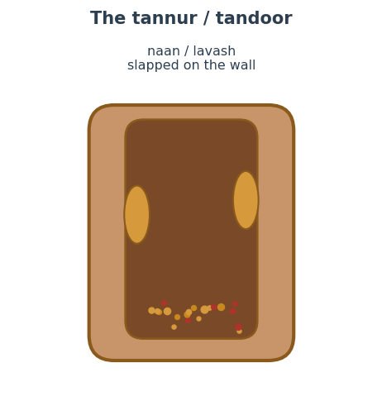
Figure 61 — The tannur / tandoor: a clay cylinder fired at the base, against whose walls leavened flatbreads are slapped to bake in minutes. The shared ancestor of Persian, Central Asian and Indian oven breads. Indicative.

43.1 The Flatbread Family
Pita / khubz is the round, lightly yeasted wheat flatbread baked so hot that steam puffs it into a pocket. Turkish simit is a sesame ring dipped in dilute grape molasses (pekmez) then baked — not boiled like a bagel — giving a caramelised, nutty crust, documented in Istanbul from 1525. Persian breads (nan) are a world of their own: sangak, a thin leavened wholemeal baked on a bed of hot pebbles; barbari, thick, long and grooved with a glazed top; taftoon, thin and tender; and lavash, paper-thin and flexible (a UNESCO-listed heritage bread).

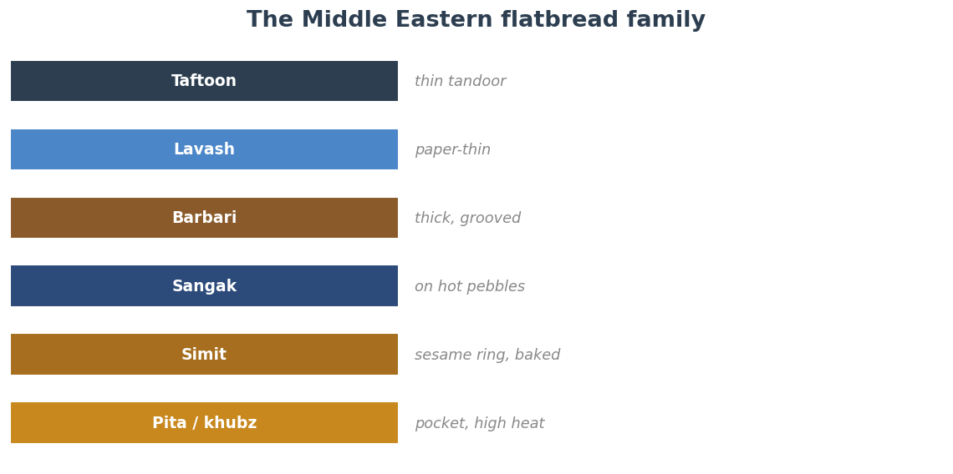
Figure 62 — The Middle Eastern flatbread family at a glance. Indicative.

43.2 Method — Pita (the pocket mechanism)
Method box | Detail
Flour | White or whole-wheat (~11–12.5% protein)
Dough | Flour 100%, water ~60–65%, yeast ~1%, salt ~2%, a little oil
Proof | Bulk ~1 h; divide, ball, rest 15–20 min; roll ~5 mm
Bake | Very hot stone/oven 250–290 °C, ~2–4 min — steam flashes inside and splits the layers into a pocket
Cool | Wrap in cloth so the pocket stays soft
Troubleshooting — pocket flatbreads.
Fault | Likely cause | Fix
No pocket | Oven not hot enough or dough too thin/dry | Maximise heat (stone); roll even ~5 mm; rest before baking
Hard / cracker-like | Over-baked | Pull at first puff (2–4 min); cover when cooling
Uneven puff | Uneven rolling or dough skinned | Roll evenly; keep pieces covered before baking
Lines of influence. The tannur and the leavened flatbread spread east into India (naan) and Central Asia, while the simit-type ring connects to the Greek koulouri, the Jerusalem ka’ak and the wider boiled-or-baked ring family.

44. The Indian Subcontinent — Tandoor and Tawa
South Asia developed a distinct, ancient and widely exported bread culture split between two surfaces: the tandoor (clay oven, shared with the Persian tannur) for leavened breads, and the tawa (flat iron griddle) for everyday unleavened ones. Wheat here goes back to the Indus Valley Civilisation, and the griddle tradition is far older than the tandoor-baked one.
The key distinction is the flour: atta, finely stone-ground wholemeal wheat, the nutty base of roti and chapati; and maida, refined white flour, the soft, pillowy base of naan, kulcha and bhatura.

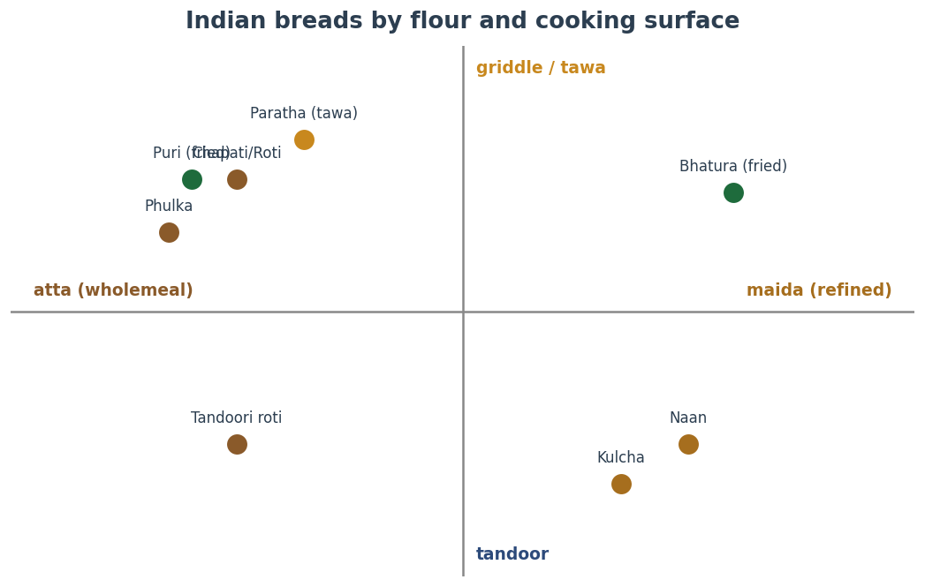
Figure 63 — Indian breads mapped by flour (wholemeal atta vs refined maida) and cooking surface (griddle/tawa vs tandoor vs deep-frying). Indicative.

44.1 The Signature Breads
Roti / chapati is unleavened atta-and-water dough, rolled thin and cooked on a tawa; a finish over the flame puffs it into a phulka. Naan is a leavened maida dough (yeast and/or yogurt) slapped onto the tandoor wall and baked in minutes — historically a “royal/restaurant” bread, mentioned by Amir Khusrau around 1300. Paratha is layered and pan-fried with ghee, often stuffed; bhatura and puri are deep-fried and puffed. Regional grains give makki di roti (corn, Punjab), bhakri (millet), akki roti (rice) and missi roti (chickpea).

44.2 Method — Naan (tandoor) and Chapati (tawa)
Method box | Detail
Naan flour | Maida (refined wheat)
Naan dough | Flour 100%, water ~50% + yogurt ~20%, yeast ~1% (or baking powder), sugar ~3%, oil ~5%, salt ~1.5%
Naan bake | Slap onto tandoor wall (~450–480 °C); ~60–90 s; blisters and chars on one side, soft within
Chapati flour | Atta (wholemeal); dough is just flour + water + salt
Chapati cook | Roll thin; tawa ~2 min turning; finish over open flame to puff (phulka)
Troubleshooting — tandoor & tawa breads.
Fault | Likely cause | Fix
Naan falls off the wall | Surface too dry or wall not hot enough | Dampen the back of the dough; get the tandoor screaming hot
Chapati won’t puff | Dough too dry / rolled unevenly / pan too cool | Soften dough; roll even; finish over direct flame
Tough roti | Over-worked or too little rest | Rest the dough 20–30 min; handle gently
Lines of influence. Indian breads travelled with 19th-century indentured labourers and traders to East Africa (chapati), the Caribbean (roti, dhalpuri), Mauritius (farata) and Fiji; today naan is on Indian-restaurant menus worldwide.

45. Mexico & Mesoamerica — Nixtamalised Maize
Mesoamerica’s contribution is a wholly independent grain-bread technology built not on wheat but on maize, made edible and nutritious by nixtamalisation — an alkaline cooking process and one of the most consequential food technologies in human history.
Dried maize is simmered and steeped in an alkaline solution — cal (slaked lime, calcium hydroxide), or historically wood-ash lye — which dissolves the hull, gelatinises the starch and, crucially, frees the niacin (vitamin B3) and amino acids so they can be absorbed, preventing pellagra. The washed, hulled kernels (nixtamal) are ground into masa. The earliest evidence dates to roughly 1500–1200 BCE on the Pacific coast of Guatemala.

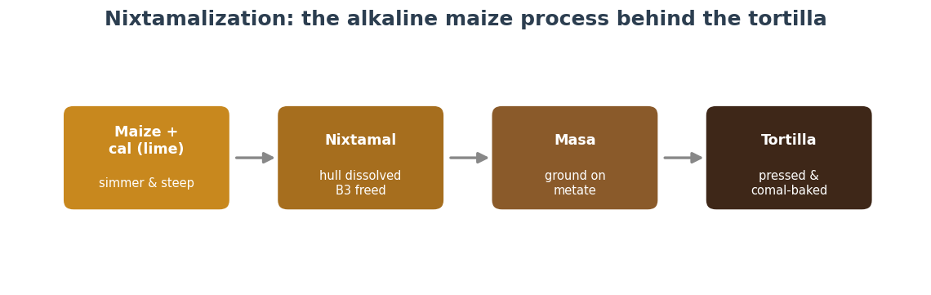
Figure 64 — Nixtamalisation: maize cooked and steeped with cal becomes nixtamal (hull dissolved, B3 freed), ground to masa, then pressed and baked on a comal into the tortilla. Indicative.

45.1 Method — the Corn Tortilla
Method box | Detail
Maize | Field corn (dent), whole dried kernels
Nixtamal | Simmer ~1% cal (by weight of corn) ~15 min; steep 8–12 h; rinse & hull
Masa | Grind nixtamal to a smooth, just-tacky dough; add water as needed
Shape | Press ~25–30 g balls flat between plastic in a tortilla press
Bake | Comal ~190–230 °C; ~30–45 s, flip, then a final flip puffs it
Troubleshooting — masa & tortillas.
Fault | Likely cause | Fix
Masa cracks at the edges | Too dry, or over-ground | Add water a little at a time to a play-dough feel
Tortilla won’t puff | Comal too cool or masa too thick | Hotter comal; press thinner; flip on schedule
Gluey / sticky masa | Under-rinsed or too wet | Rinse nixtamal well; rest masa; adjust water
Spanish wheat & lines of influence. Spanish colonisers introduced wheat bread in the 16th century, giving northern Mexico the bolillo and telera (the base of the torta) and the flour tortilla. Nixtamalised maize spread into the American Southwest (as “hominy”) and is now a global technology; the tortilla and its derivatives are among the most-eaten breads on earth.

46. Ethiopia & the Horn of Africa — Teff Injera
Ethiopia sustains one of the oldest continuous indigenous bread cultures, built on teff — a tiny grain native to the Ethiopian highlands, cultivated for millennia, naturally gluten-free, and rich in iron, calcium, protein and fibre. The result, injera, is a large sourdough flatbread that serves as plate and utensil at once. It is a rare major sourdough tradition built on a gluten-free grain.

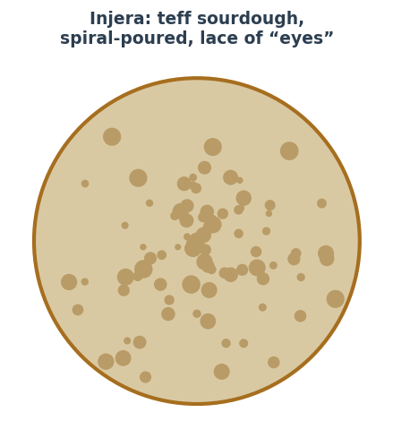
Figure 65 — Injera: a teff sourdough batter, fermented for days, spiral-poured onto a hot mitad and steamed under a lid — smooth below, a lace of “eyes” above. Indicative.

46.1 Method — Injera
Method box | Detail
Grain | Teff (brown = fuller flavour; ivory = milder); ideally 100%
Leaven | Wild sourdough; reserve the yellow liquid (ersho) to seed the next batch
Ferment | Thin batter, 2–3 days (up to ~5), until tangy and bubbling
Absit (option) | Cook a little batter to a paste, return it for a second ferment — improves texture
Bake | Spiral-pour onto a hot mitad (~180–230 °C); do not flip; cover to steam-set
Troubleshooting — injera.
Fault | Likely cause | Fix
No “eyes” (holes) | Under-fermented batter or mitad too cool | Ferment longer; get the griddle properly hot
Too sour / thin | Over-fermented | Shorten the ferment; refresh with a little fresh batter
Sticks / tears | Mitad not seasoned/hot, or lifted too soon | Season & pre-heat the surface; let it set before lifting
Lines of influence. Injera is the shared staple of Ethiopia and Eritrea; teff is now grown and exported from the US, and Ethiopian restaurants have carried injera worldwide — a model gluten-free sourdough.

47. The British Isles — from the Cottage Loaf to Chorleywood
Britain’s twofold significance is a distinctive repertoire of regional and griddle breads, and an outsized modern role in industrialising bread worldwide — alongside American baking — through the Chorleywood Bread Process.

47.1 The Regional Repertoire
The cottage loaf is the traditional English two-round stacked loaf, pinched at the centre. The crumpet is a yeast-(and baking-powder-)leavened batter cooked in rings, its honeycomb of holes the signature; the English muffin is its griddle cousin. Irish soda bread is leavened by bicarbonate of soda reacting with buttermilk — no yeast — using soft, low-gluten wheat; it became a staple after baking soda arrived around 1840 and during the Famine when yeast was scarce. Oatcakes and the bannock are the oldest breads of the Gaelic world, oat or barley griddle breads from a pre-wheat north.

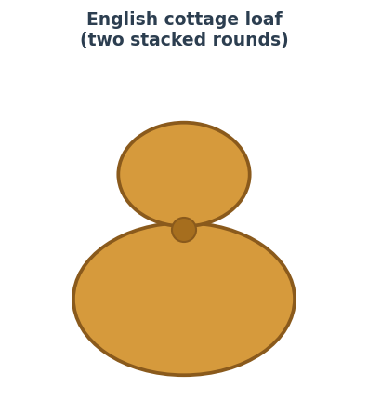
Figure 66 — The English cottage loaf: a smaller round stacked on a larger, pinched through the centre. Indicative.

47.2 Method — Irish Soda Bread (chemical leavening)
Method box | Detail
Flour | Soft, low-protein wheat (plain); wholemeal for “wheaten”
Leaven | Bicarbonate of soda ~1.5% reacting with the acid in buttermilk — no yeast, no proof
Dough | Flour 100%, buttermilk ~80–85%, soda ~1.5%, salt ~1.5%
Mix | Bring together quickly with a light hand — do not knead or the gas escapes
Bake | Cut a deep cross; ~200–220 °C, ~35–45 min, into the oven at once
Troubleshooting — soda bread.
Fault | Likely cause | Fix
Dense, heavy crumb | Over-mixed or batter stood before baking | Mix minimally; bake the instant it comes together
Soapy / bitter taste | Too much soda or under-acidic liquid | Cut the soda; use fresh buttermilk
Cracked, raw centre | Oven too hot / loaf too thick | Slightly lower heat; cut the cross deep to open the middle

47.3 The Chorleywood Bread Process — a Global Industrial Legacy
Developed in 1961 at the British Baking Industries Research Association in Chorleywood, the process replaces long bulk fermentation with intense high-speed mixing — a defined energy input of about 11 watt-hours per kilogram of dough delivered in roughly five minutes — plus oxidant, added fat, extra yeast, emulsifiers and more water. It cut the flour-to-loaf time to about three hours and, crucially, let bakers use lower-protein home-grown wheat. Within a decade it dominated; around 80% of UK bread is made this way, and the method has spread across the Commonwealth and beyond. It is the chief reason most of the industrialised world eats soft, uniform, long-life sliced bread — and precisely what the modern artisan and sourdough revival reacts against.

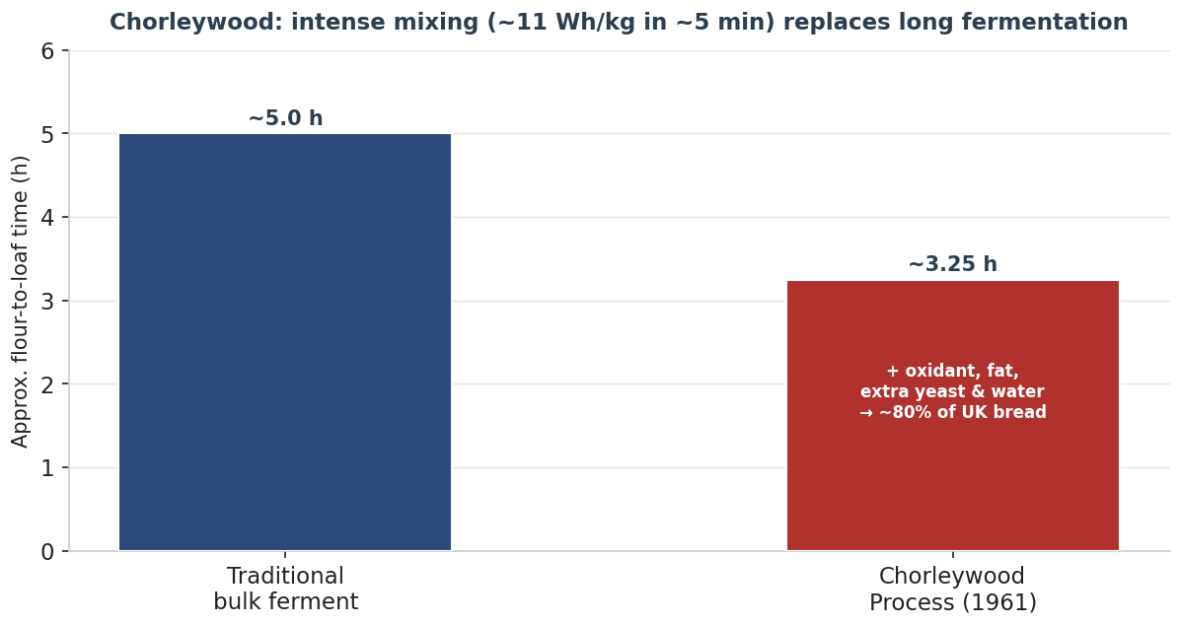
Figure 67 — The Chorleywood Bread Process trades long fermentation for intense mechanical mixing plus additives, collapsing the timeline and enabling weaker domestic wheat. Indicative.
Lines of influence. Through the British Empire and the Chorleywood Process, British (and parallel American) industrial baking spread the soft factory loaf across the globe; soda bread and oatcakes survive as emblems of the older, low-gluten northern world.

47.4 The Threads Drawn Together
Seen as a whole, these ten cultures are not a list but a web. One hearth in Egypt feeds the leavened-wheat line that runs through Greece and Rome into medieval Europe, is re-energised by Vienna and perfected in France. A separate and older flatbread line spreads from the Levantine tannur into Persia and India, while parallel inventions — Mesoamerican nixtamalised maize, Ethiopian teff injera — arrive at bread by entirely different roads. The northern rye-sourdough branch and the migrating Jewish tradition stitch regions together, and Britain’s Chorleywood Process closes the story by industrialising it for the world. To know these lineages is to understand why the breads in the earlier chapters look and taste as they do.

47.5 World Bread Cultures — Key References
Authoritative sources for the ten chapters above (scholarly and primary sources are the most reliable; popular and recipe sources are corroborative):
- Arranz-Otaegui & Richter et al., “Origins of bread 14,400 years ago,” PNAS (2018) — pnas.org/doi/10.1073/pnas.1801071115
- Darby, Ghalioungui & Grivetti, Food: The Gift of Osiris (1977) — archive.org/details/foodgiftofosiris0000darb
- Delwen Samuel, “Ancient Egyptian Baking & Brewing,” Science 273 (1996) — science.org/doi/10.1126/science.273.5274.488
- Ancient Egypt Research Associates (Mark Lehner) — Giza bakeries — aeraweb.org/lost-city-project/feeding-pyramid-workers/
- Farrell Monaco, “Baking Bread with the Romans — Panis Quadratus” — tavolamediterranea.com
- Cura annonae (Roman grain dole) — en.wikipedia.org/wiki/Cura_annonae
- Jim Chevallier, August Zang and the French Croissant — en.wikipedia.org/wiki/August_Zang
- Bagel — history (Kraków 1610) — en.wikipedia.org/wiki/Bagel
- “A Short History of Challah,” The Nosher / My Jewish Learning — myjewishlearning.com/the-nosher/a-short-history-of-challah-bread
- Jeffrey Hamelman, Bread — rye & deli-rye formulas — thefreshloaf.com/node/65849/hamelmans-deli-rye-bread
- Rugbrød & Nordic rye — en.wikipedia.org/wiki/Rugbr%C3%B8d
- Persian breads (sangak, barbari, lavash, taftoon) — irandoostan.com/top-persian-bread-of-iran/
- History of naan & roti — origin-trace.com/article/history-of-naan-and-roti/
- Nixtamalization — en.wikipedia.org/wiki/Nixtamalization
- Injera — en.wikipedia.org/wiki/Injera
- Chorleywood bread process — en.wikipedia.org/wiki/Chorleywood_bread_process
Bread is geography and history made edible. Follow any loaf back far enough and it joins one of a handful of streams — from a hearth in the desert, a Roman mill, a Vienna oven, a Polish ring, a clay tannur, a comal, a teff griddle — all still flowing through the bakery today.

48. Scaling & the Baker’s Calculators
The earlier chapters explain how dough behaves; this one is about the arithmetic that turns understanding into a repeatable, scalable bake. Every figure here is something a baker computes — how much of each ingredient to weigh, what temperature the water should be, how long a levain will take, what a loaf costs. Each calculator is given three ways: the formula, a worked example, and compact logic ready to port into the companion baking application. The notation matches the rest of the guide — baker’s percentages with flour always at 100%.

48.1 Baker’s Percentages — the Foundation
In baker’s math every ingredient is expressed as a percentage of the total flour weight, which is fixed at 100%. The percentages therefore sum to more than 100 — a useful number in its own right, because it is the bridge between a formula and a batch. Call it the total formula percentage (TFP).

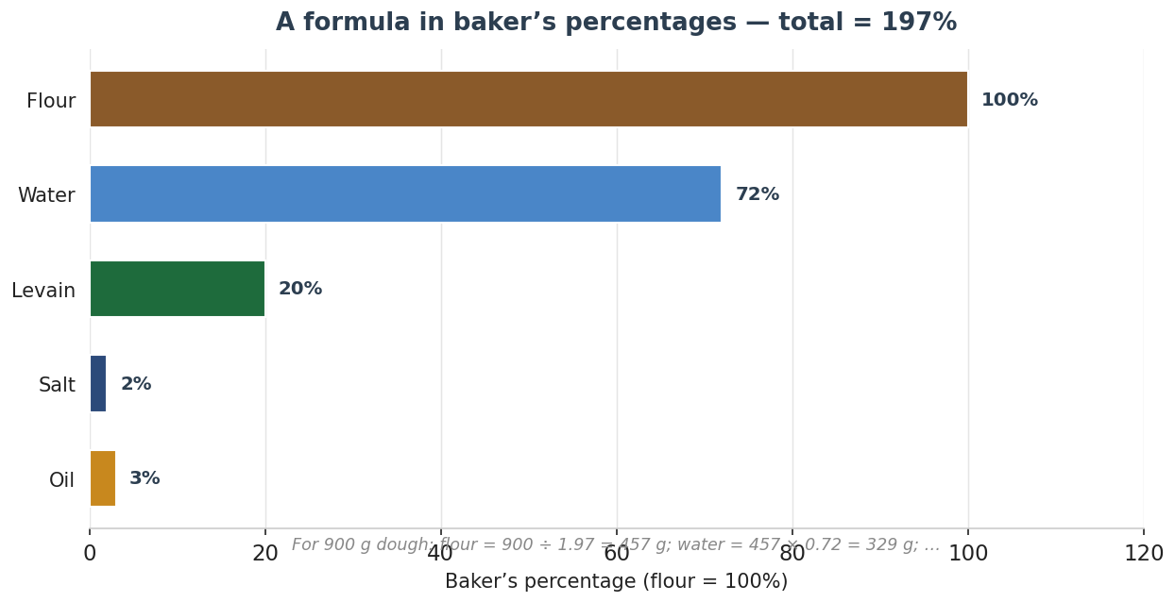
Figure 68 — A formula in baker’s percentages (flour = 100%). The percentages sum to the total formula percentage (here 197%), which converts any target dough weight into a flour weight. Indicative example.
The two core conversions:
- Ingredient → percentage: percentage = (ingredient weight ÷ total flour weight) × 100.
- Percentage → batch: flour = target dough weight ÷ (TFP ÷ 100); then each ingredient = flour × (its % ÷ 100).
Worked example. The formula in Figure 68 — flour 100, water 72, levain 20, salt 2, oil 3 — has TFP = 197%. For 900 g of dough: flour = 900 ÷ 1.97 = 457 g; water = 457 × 0.72 = 329 g; levain = 457 × 0.20 = 91 g; salt = 457 × 0.02 = 9 g; oil = 457 × 0.03 = 14 g. The five weights total 900 g, which is the check.
Ready-to-port — baker’s-percentage scaling (C#)
decimal TotalFormulaPct(IEnumerable<Ingredient> f)
=> f.Sum(i => i.Percent); // flour’s percent is 100

Dictionary<string,decimal> Scale(
IEnumerable<Ingredient> formula, decimal targetDoughGrams)
{
var tfp = TotalFormulaPct(formula) / 100m;
var flour = targetDoughGrams / tfp; // grams of flour
return formula.ToDictionary(
i => i.Name, i => Math.Round(flour * i.Percent / 100m, 1));
}

48.2 Scaling by Loaf Count, Yield & Loss
Production scaling starts from the other direction — a number of finished loaves of a target weight — and must account for the dough lost along the way. Two corrections matter: scaling loss (dough left on the bench, in the bowl, trimmed at divide) and baking loss (water driven off in the oven, typically 10–20% of dough weight). Work backwards from the loaf to the flour.

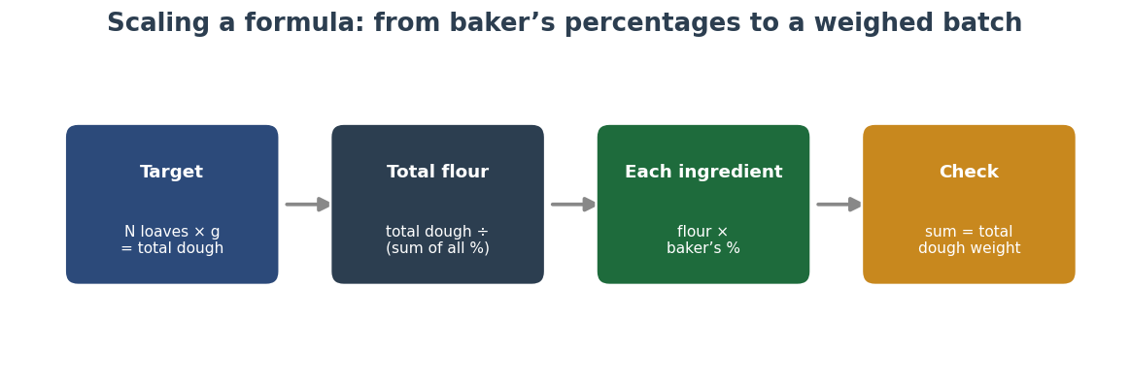
Figure 69 — Scaling a formula: target dough weight → total flour (via the total formula percentage) → each ingredient (flour × baker’s %) → reconciliation against the target. Indicative.
The chain.
- Dough per loaf = baked weight ÷ (1 − baking loss). A 500 g baked loaf at 12% bake loss needs 500 ÷ 0.88 = 568 g of dough.
- Batch dough = (loaves × dough per loaf) ÷ (1 − scaling loss). For 20 loaves at 2% scaling loss: (20 × 568) ÷ 0.98 = 11,592 g.
- Then apply 48.1 to convert that batch dough weight into flour and each ingredient.
Ready-to-port — loss-corrected batch (C#)
decimal DoughPerLoaf(decimal bakedG, decimal bakeLossPct)
=> bakedG / (1 - bakeLossPct/100m);

decimal BatchDough(int loaves, decimal doughPerLoafG,
decimal scaleLossPct)
=> loaves * doughPerLoafG / (1 - scaleLossPct/100m);

// then: Scale(formula, BatchDough(...)) // from 48.1

48.3 Desired Dough Temperature (DDT)
Dough temperature is the master variable of fermentation (Sections 7, 16). The baker controls it through the one ingredient whose temperature is adjustable on the day: the water. The desired dough temperature method sums the fixed temperature factors and solves for the water that hits the target.

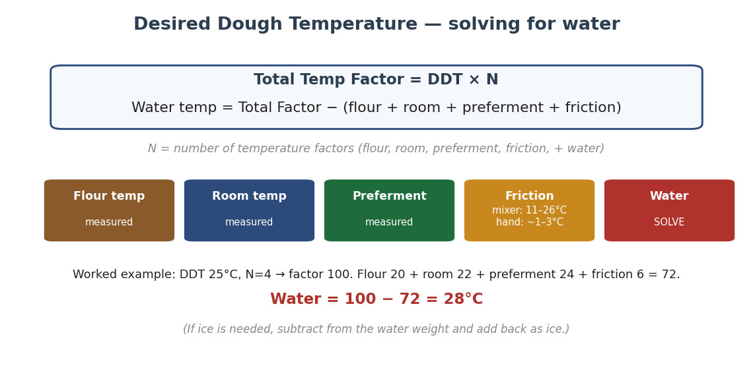
Figure 70 — The DDT calculation: a total temperature factor (DDT × number of factors) minus the measured factors (flour, room, preferment, friction) gives the required water temperature. Friction is the heat a mixer adds. Indicative worked values.
Method. Count the temperature factors N (typically flour, room, preferment, friction, and the water you are solving for — so N = 4 if there is no preferment, 5 if there is). Total factor = DDT × N. Subtract the measured factors; the remainder is the water temperature.
Worked example. DDT 25°C with flour, room, preferment, friction and water gives N = 5 — but the classic four-factor form (flour, room, friction, water) is shown in the figure with N = 4, total 100. With flour 20, room 22, preferment 24 and friction 6, the five-factor total is 25 × 5 = 125; 125 − (20 + 22 + 24 + 6) = 53°C would be too hot, so in practice the preferment is folded in and N chosen to match the factors you actually measure. The rule: N must equal the number of temperature terms on the right-hand side plus the water. Friction is ~1–3°C by hand, ~11–26°C for an intensive mixer — calibrate it once for your own mixer by back-solving from a test batch.
Ready-to-port — DDT water solver (C#)
decimal WaterTemp(decimal ddt, decimal flour, decimal room,
decimal friction, decimal? preferment = null)
{
var factors = new List<decimal>{ flour, room, friction };
if (preferment is decimal p) factors.Add(p);
int n = factors.Count + 1; // +1 for the water itself
return ddt * n - factors.Sum();
}

// Calibrate friction once: friction = doughTemp*n - (sum of others)

48.4 Hydration, Levain & Final-Dough Adjustments
A preferment carries its own flour and water, so the dough water must be adjusted so the whole formula hits the target hydration, not just the final mix. Treat the levain’s flour and water as part of the totals.
- Overall hydration = (total water including levain water) ÷ (total flour including levain flour) × 100.
- Levain at 100% hydration contributes equal flour and water — e.g. 100 g levain = 50 g flour + 50 g water — so subtract those from the dough’s flour and water when balancing.
- Stiff levain (50% hydration): 100 g = 67 g flour + 33 g water. Always split the preferment before computing dough water.

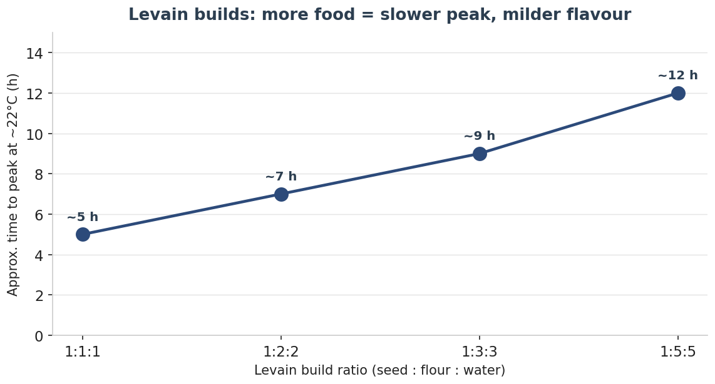
Figure 71 — Levain build ratios. A larger build (more flour and water per unit of seed) ripens more slowly and tastes milder; a tight 1:1:1 peaks fast and sharp. Times are indicative at ~22°C.
Ready-to-port — levain split & true hydration (C#)
record Levain(decimal grams, decimal hydrationPct);

(decimal flour, decimal water) Split(Levain l)
{
var flour = l.grams / (1 + l.hydrationPct/100m);
return (flour, l.grams - flour);
}

decimal OverallHydration(decimal doughFlour, decimal doughWater,
Levain l)
{
var (lf, lw) = Split(l);
return (doughWater + lw) / (doughFlour + lf) * 100m;
}

48.5 Cost per Loaf
Once the batch is scaled, costing is straightforward: price each ingredient per gram, add energy, labour, packaging and an overhead share, then divide by the number of saleable loaves. Ingredient cost is usually the small part; labour dominates an artisan loaf.

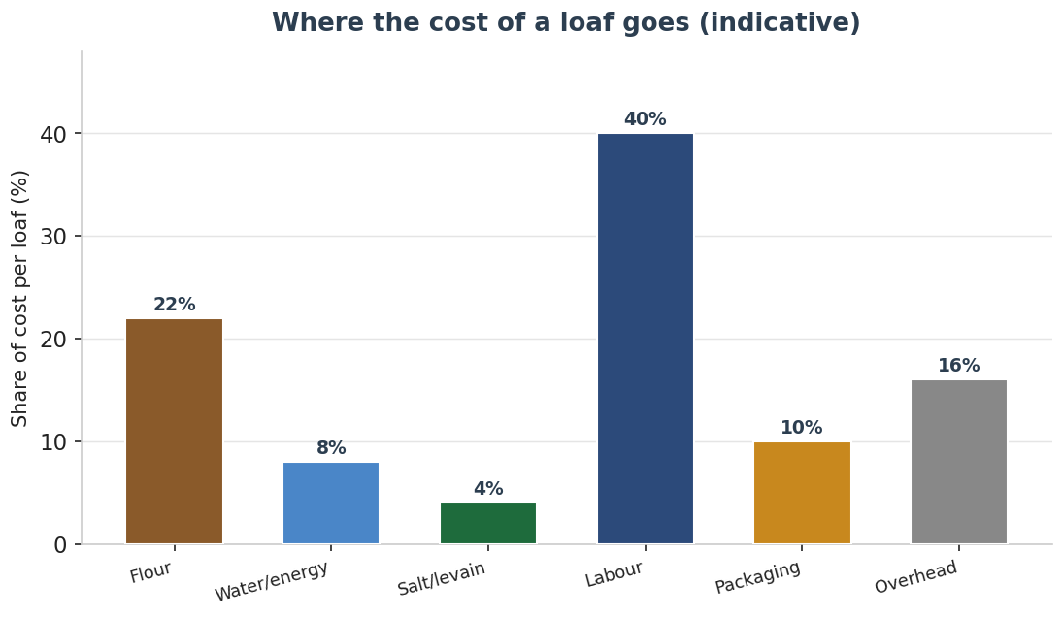
Figure 72 — Where the cost of an artisan loaf goes. Ingredients are a minority of the total; labour is typically the largest single share. Indicative split.
Ready-to-port — cost per loaf (C#)
decimal CostPerLoaf(
Dictionary<string,decimal> gramsByIngredient,
Dictionary<string,decimal> pricePerGram,
decimal energy, decimal labour, decimal packaging,
decimal overhead, int saleableLoaves)
{
var ingredients = gramsByIngredient
.Sum(kv => kv.Value * pricePerGram[kv.Key]);
var batch = ingredients + energy + labour
+ packaging + overhead;
return batch / saleableLoaves;
}

48.6 A Quick Reference of the Formulas
Calculator | Formula | Notes
Baker’s % | % = ingredient ÷ flour × 100 | Flour always 100%
Scale to batch | flour = dough ÷ (TFP÷100) | TFP = sum of all %
Dough per loaf | baked ÷ (1 − bake loss) | Bake loss ~10–20%
Batch dough | loaves × dough ÷ (1 − scale loss) | Scale loss ~1–3%
Water temp (DDT) | DDT×N − Σ(other factors) | N counts the water too
Overall hydration | total water ÷ total flour × 100 | Include levain flour+water
Cost per loaf | batch cost ÷ saleable loaves | Labour usually dominates
A formula is a ratio, not a recipe. Master the ratios and any quantity, any batch, any kitchen falls out of the same simple arithmetic.

49. Food Safety, Spoilage & Shelf Life
Bread is one of the safer foods — low in moisture at the crust, baked hot, and often acidified by fermentation — but it is not immune. A professional needs to know the few real hazards (rope, mould, and the handful of temperature rules that govern them), how fermentation itself is a safety tool, and how to keep a loaf at its best for as long as possible. This chapter gathers those into one reference.

49.1 The Baker’s Temperature Ladder
Almost every safety and quality rule in baking is really a temperature rule. The ladder below collects them: the cold zone where bread is safe but stales fastest; the danger zone (about 5–60°C) where spoilage and rope organisms multiply; the band where the crumb sets; and the core and crust temperatures that define doneness (Section 18).

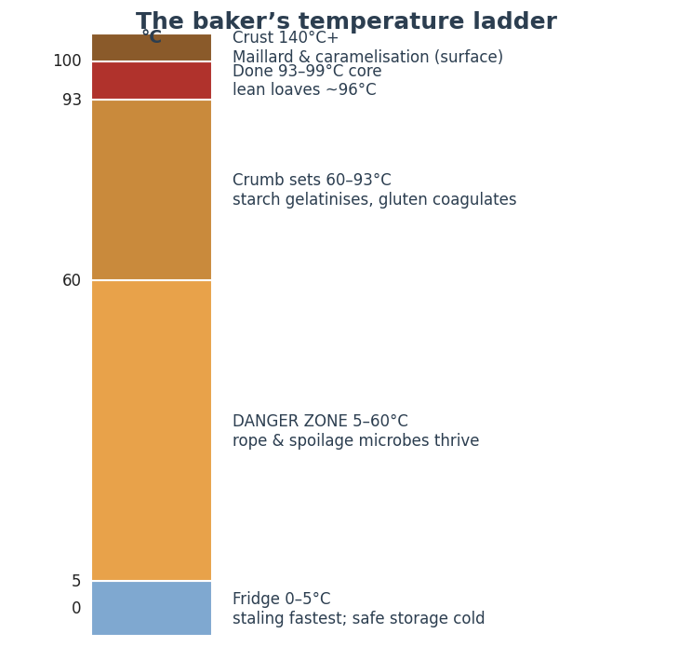
Figure 73 — The baker’s temperature ladder, from cold storage through the microbial danger zone to crumb-set, doneness and crust browning. Indicative.

49.2 Rope — the Hidden Bacterial Spoiler
Rope is the spoilage every baker should recognise. It is caused by Bacillus subtilis (and B. licheniformis), soil bacteria whose heat-resistant spores ride in on the flour and survive the bake. In a warm, moist, low-acid loaf they germinate and digest the crumb, producing a sticky, stringy, discoloured centre and a distinctive over-ripe melon or pineapple smell. It is most common in large, slow-cooling loaves in hot weather.

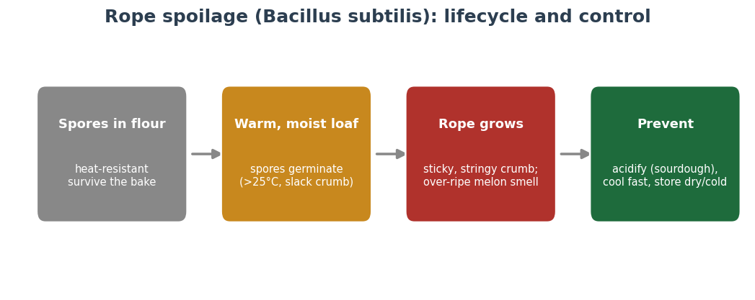
Figure 74 — Rope spoilage: spores survive the bake, germinate in a warm moist crumb, and grow into sticky strings. Acidity, fast cooling and dry/cold storage prevent it. Indicative.
Control.
- Acidify. Rope cannot establish below about pH 4.5 — which is exactly why sourdough breads almost never rope. A little vinegar, a preferment, or calcium/sodium propionate in commercial work all help.
- Cool fast and store cool/dry. Don’t stack hot loaves; get the crumb out of the danger zone quickly.
- Discard rope-affected bread and sanitise surfaces and tins — the spores spread; never bake around it.

49.3 Mould & Mycotoxins
Mould (Penicillium, Aspergillus, Rhizopus, the red “bread mould” Neurospora) is the commonest visible spoilage. It needs moisture, oxygen and time, and it lands on the loaf after baking — from the air, hands and surfaces during cooling and slicing — so hygiene at cooling and packaging is the main defence.
- Never “cut the mould off.” On soft, high-moisture bread the hyphae and any mycotoxins penetrate well beyond the visible spot — discard the loaf.
- Defences: lower surface moisture (proper bake and cool), clean cooling and packaging, acidity, and — for shelf-stable products — propionate or sorbate. Freezing stops mould; refrigeration slows it but stales the bread (49.5).
- Aflatoxin and ochratoxin come from mouldy grain, not the bake — sound, dry, well-stored flour is the upstream control.

49.4 Fermentation as a Safety Tool
Sourdough is not only a flavour and texture method — it is a preservation technology. The lactic and acetic acids that lower the pH (Section 16) suppress rope, mould and many pathogens; the organic acids and bacteriocins of the culture actively inhibit spoilage organisms; and the long fermentation degrades some anti-nutrients (phytic acid) and FODMAPs. The same acidity that protects gluten from over-active rye enzymes (Sections 36, 42) protects the finished loaf from spoilage. A well-acidified sourdough simply keeps better than a fast yeasted loaf of the same formula.

49.5 Staling & Storage
Staling is mostly starch retrogradation, not drying (Section 20.5): the gelatinised starch slowly recrystallises and firms the crumb, expelling water. The counter-intuitive consequence is that the refrigerator is the worst place for bread — retrogradation runs fastest between 0 and 10°C, so a fridge stales bread several times faster than the counter, while freezing nearly halts it.

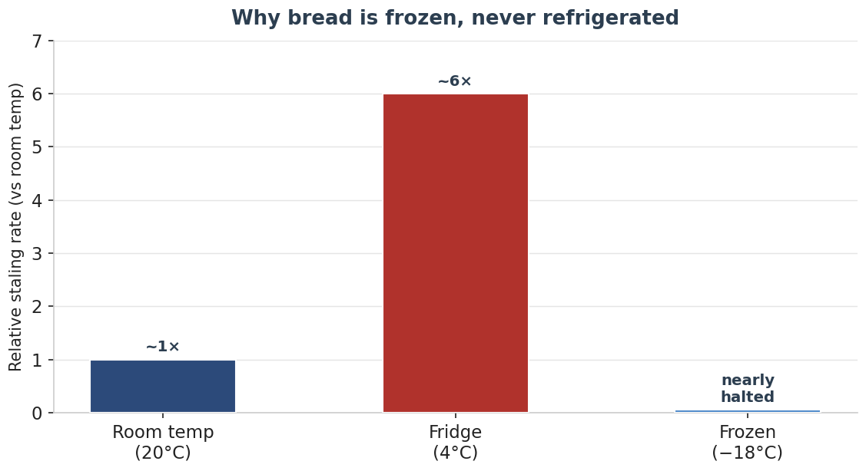
Figure 75 — Relative staling rate by storage: the fridge is worst (retrogradation peaks at 0–10°C), the counter is the everyday home, and the freezer nearly stops the clock. Indicative, relative to room temperature.
Practical storage rules.
- Crusty lean loaves: room temperature, cut-side down or in paper/cloth, 1–2 days; never refrigerate.
- Freeze early, not late: freeze what you won’t eat within the window, sliced and tightly wrapped; refresh straight from frozen.
- Refreshing works once: reheating to ~60°C+ re-gelatinises the starch and temporarily reverses staling, but the loaf then stales faster — a rescue, not a cure.
- Enriched and high-fat breads keep longer (fat slows retrogradation); high-rye and well-acidified sourdoughs keep longest of all.

49.6 A Spoilage & Storage Quick Reference
Fault | Likely cause | Fix
Sticky, stringy, sweet-rotten crumb | Rope (Bacillus) — warm, moist, low-acid loaf | Acidify (sourdough/propionate); cool fast; discard affected; sanitise
Fuzzy coloured spots on surface | Mould landed after baking | Discard whole loaf; improve cooling/packaging hygiene; freeze to store
Stale yet still moist | Starch retrogradation (often fridge-stored) | Store at room temp or freeze; never refrigerate; refresh with heat
Dry, hard, crumbling | Moisture loss (unwrapped, over-baked) | Wrap once cool; don’t over-bake; freeze for longer keeping
Off, yeasty-alcoholic smell, fresh | Over-fermented / under-baked | Correct ferment and bake; check core 96–99°C
Heat makes bread; temperature keeps it. Know the ladder — the danger zone, the set, the core, the crust, the fridge and the freezer — and both safety and shelf life follow.

50. The Home Bakery — Core Kit (Oven, Steam & Mixing)
Equipment cannot make a baker, but the right kit removes the obstacles between a good formula and a good loaf. This chapter and the next survey a home bakery from the baker’s point of view — not as a shopping list but as a set of decisions, each judged by one test: does it change the bread? Buy-versus-skip callouts mark the difference between kit that genuinely improves the loaf and kit that is pleasant but optional. This first section covers the three things that most shape the bake: the oven, the steam, and the mixer.

50.1 The Oven — and Its Limits
The domestic oven is the home baker’s biggest constraint. It is smaller, leakier and less steady than a deck oven, and — critically — its thermostat reports air temperature, not the temperature of the thermal mass that actually bakes the loaf. The “preheated” beep comes long before a stone or steel is saturated with heat (Section 18.6). The single most common home fault is loading too early into an oven whose air is hot but whose mass is cold.

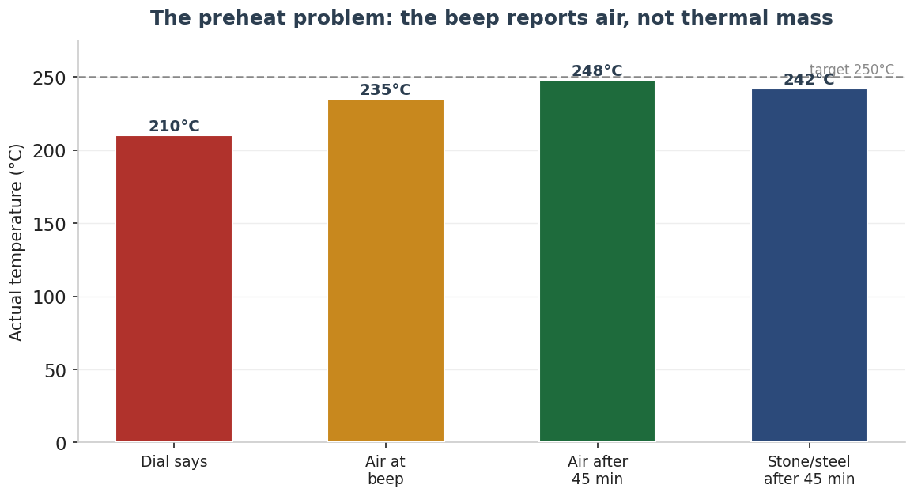
Figure 76 — The preheat problem: the oven’s beep reports the air, which heats quickly, while the stone or steel that bakes the base lags far behind — typically needing 45–60 minutes. Indicative.
Worth it — A long preheat (free): The cheapest upgrade of all — give the oven and its stone/steel 45–60 minutes, well past the beep. Nothing else improves oven spring as reliably at zero cost.
Convection (fan) ovens bake faster and more evenly but dry the crust and can deflect a delicate score; many bakers turn the fan off for the steam phase and on for the drying phase. Gas ovens vent more moisture (harder to keep steam in) than electric. Know your oven’s true behaviour with a separate thermometer before blaming a formula.

50.2 Baking Surfaces — Stone vs Steel
A heavy baking surface stores heat and delivers it to the base of the loaf, driving the initial spring. The choice is between stone and steel: steel conducts heat several times faster, so it recovers more quickly when a cool loaf is loaded and gives a stronger bottom and bigger spring; stone is gentler, cheaper and more forgiving of scorching on long bakes, but slower to recover.

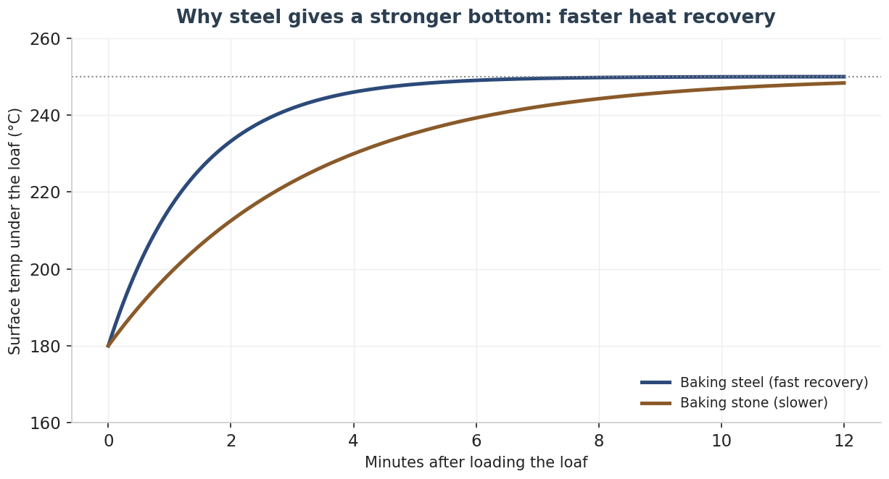
Figure 77 — When a cool loaf is loaded, the surface temperature dips; steel’s high conductivity recovers it far faster than stone, delivering more heat to the base in the critical first minutes. Indicative model.
Surface | Strengths | Trade-offs | Best for
Baking steel | Fast recovery; strong base & spring; durable | Heavy; pricier; can over-brown bases | Pizza, baguettes, max oven spring
Baking stone / cordierite | Gentle, even; cheaper; forgiving on long bakes | Slower recovery; can crack with thermal shock | Hearth loaves, longer bakes
Inverted heavy tray | Free stand-in | Little thermal mass; modest effect | Getting started
Worth it — A baking steel or stone: Real, repeatable improvement in oven spring and base crust — the first surface upgrade worth making once you have a Dutch oven (50.3).

50.3 Steam — the Biggest Lever a Home Baker Has
Steam in the first part of the bake keeps the crust soft so the loaf can expand and the score can open, gelatinises the surface for sheen, and yields a thin, crisp, long-lasting crust (Section 18.5). At home the contest is won decisively by the Dutch oven (or combo cooker): it traps the loaf’s own moisture under the lid, reproducing a steam-injected deck oven for the price of a pot.

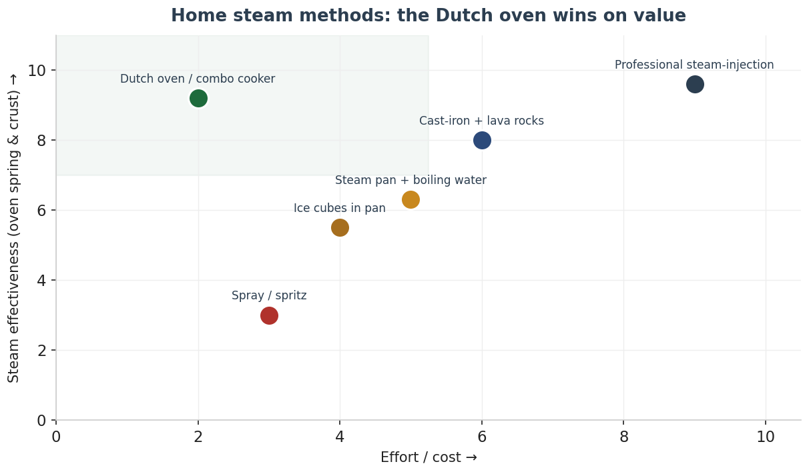
Figure 78 — Home steam methods plotted by effectiveness against effort. The Dutch oven sits in the high-value corner; spraying is the least effective. Professional steam injection is the ceiling. Indicative.
Method box | Detail
Dutch oven / combo cooker | Best home method; preheat hot; 20 min lid on, then 15–25 min lid off to colour
Cast-iron pan + lava rocks | Pour boiling water onto pre-heated rocks at load; remove after ~20 min
Steam pan + boiling water | A pre-heated metal tray on the floor; effective but bleeds heat when opened
Ice cubes in a pan | Convenient; gentler steam burst than boiling water
Spray / spritz | Easiest, least effective — steam dissipates and opening the door loses heat
Worth it — A Dutch oven / combo cooker: If you buy one thing for crust and spring, this is it. A plain cast-iron combo cooker (shallow base, deep lid) is easier to load than a tall pot.
Skip or wait — A countertop steam-injection oven: Lovely, but a Dutch oven gets you ~90% of the result for a fraction of the price and space. Defer unless you bake daily in volume.
Troubleshooting — oven, surface & steam.
Fault | Likely cause | Fix
Weak oven spring | Under-preheated mass; too little steam | Preheat stone/steel 45–60 min; bake lidded in a Dutch oven
Pale, leathery crust | Steam left in too long; oven too cool | Vent after ~20 min to dry; verify true temp with a thermometer
Score won’t open / no ear | Crust set before expansion (no steam) | Add steam for the first 15–20 min; load slightly under-proofed
Burnt base | Steel too hot on a long bake | Move up a shelf; switch to stone; lower heat for the dry phase

50.4 Mixing — and the Friction Factor
Mixing develops gluten, but for the home baker its hidden importance is heat: every mixer adds friction warmth to the dough, and that figure is the friction factor in the desired-dough-temperature calculation (Section 48.3). The more intensive the mixer, the more it heats — and the colder the water must be to compensate.

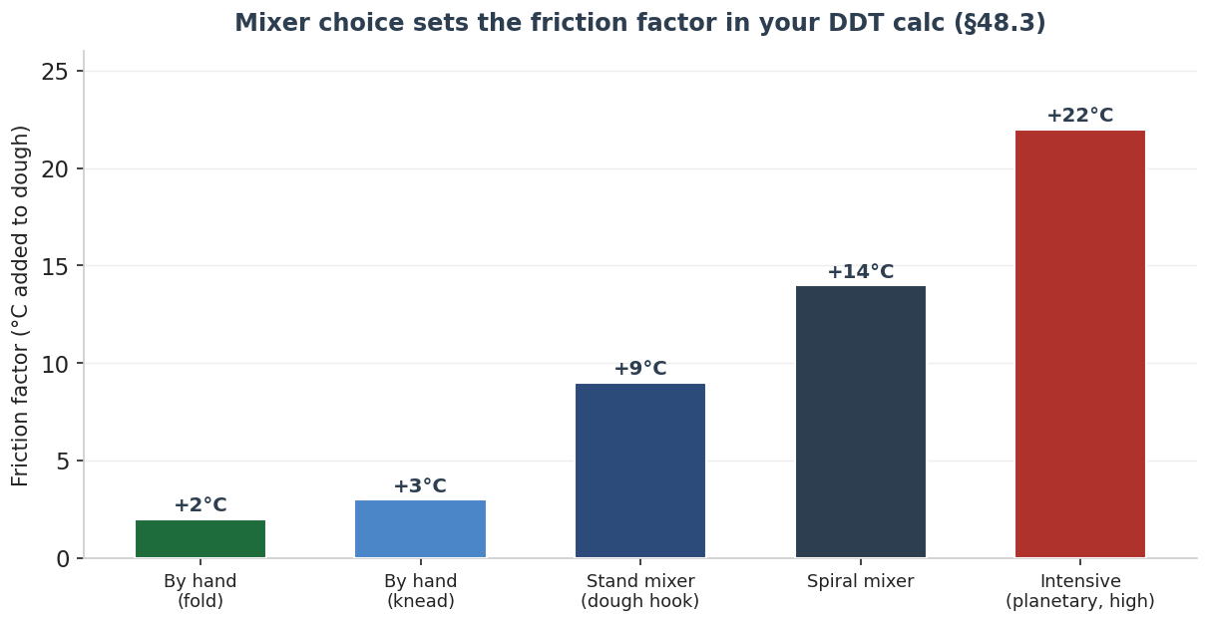
Figure 79 — Typical friction factors by mixing method — the heat each adds to the dough, and the value to plug into the DDT water solver of Section 48.3. Calibrate your own once by back-solving from a test batch. Indicative.
Method | Friction | Notes
Hand — folds | ~1–3°C | Gentlest; ideal for high-hydration and ancient grains
Hand — knead | ~2–4°C | Good control; tiring for stiff or large doughs
Stand mixer (hook) | ~8–12°C | Versatile; watch dough temp on long mixes
Spiral mixer | ~12–16°C | Gentle, efficient gluten; the artisan standard
Intensive (planetary, high) | up to ~22–26°C | Fast but heats fast; use cold water/ice
Skip or wait — A stand mixer (for lean dough): Hand-folding builds better structure in wet, rustic and ancient-grain doughs than a hook does. A mixer earns its place for stiff, enriched and large batches — not for everyday sourdough.
Worth it — A spiral mixer (if you bake in volume): For frequent or larger bakes a spiral mixer develops gluten gently with a predictable, modest friction factor — a genuine quality and consistency gain.
The oven, the steam and the heat of the mix decide more about a loaf than any gadget. Master those three and most “equipment problems” disappear.

51. The Home Bakery — Measuring, Proofing & Finishing Kit
If the previous section governs the bake, this one governs everything before and after it: measuring accurately, proofing under control, shaping and scoring, and cooling and storing. These tools are cheaper than an oven but, item for item, several of them change the bread as much as anything in the kitchen — the scale and the thermometer most of all.

51.1 Measuring — Weigh, Probe, Scan, Test
Baking is ratios (Section 48), and ratios demand weight, not volume. A digital scale is the single most important tool in the bakery — it turns every formula in this guide into a repeatable bake. A probe thermometer is second: it reads dough temperature (for the DDT method) and crumb temperature (for doneness, 96–99°C lean). Beyond those, an infrared gun reads stone and oven-surface temperature, and a pH meter quantifies sourdough acidity for those who want to.

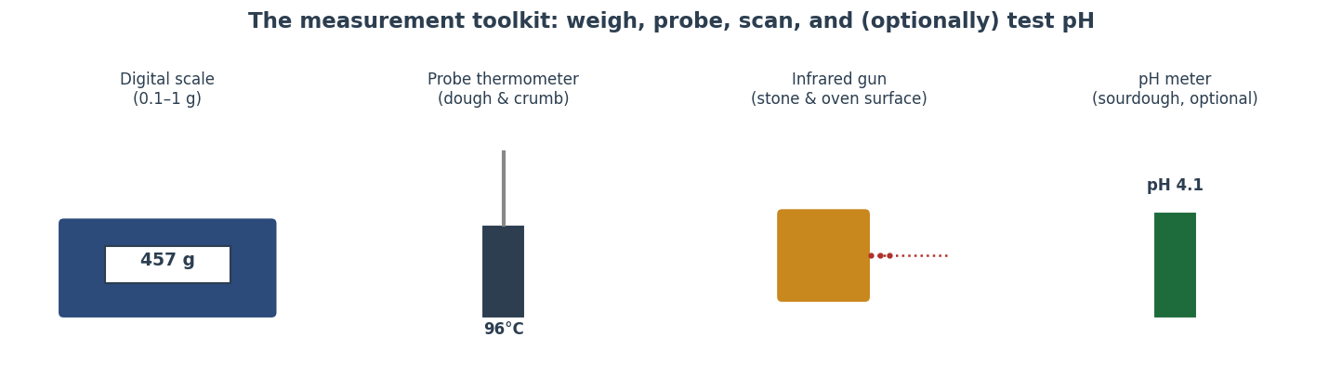
Figure 80 — The measurement toolkit: a digital scale (weigh to 0.1–1 g), a probe thermometer (dough and crumb), an infrared gun (surfaces), and an optional pH meter (sourdough acidity). Indicative.
Tool | What it measures | Priority
Digital scale (0.1–1 g) | Every ingredient by weight; baker’s % | Essential
Probe thermometer | Dough temp (DDT) & crumb doneness | Essential
Oven thermometer | True air temperature vs the dial | Highly useful
Infrared thermometer | Stone/steel & surface temperature | Useful
pH meter | Sourdough/levain acidity (pH 3.5–4.5) | Optional
Worth it — A digital scale and a probe thermometer: Together under the cost of a good pot, and they do more for consistency than any other purchase — they make the calculators in Section 48 usable and tell you when the loaf is actually done.
Skip or wait — A pH meter (for most home bakers): Instructive if you love the data, but the float/poke tests and taste already tell you what you need. Buy it for curiosity, not necessity.

51.2 Proofing — Support and a Controlled Environment
Proofing kit does two jobs: it supports slack dough so it holds shape, and it controls temperature so fermentation is predictable (Sections 7, 16). A banneton (rattan basket) wicks moisture and leaves the classic spiral; a couche (heavy linen) pleats to hold baguettes and batons; a proofing box or a repurposed fridge gives a steady warm proof or a cold retard.

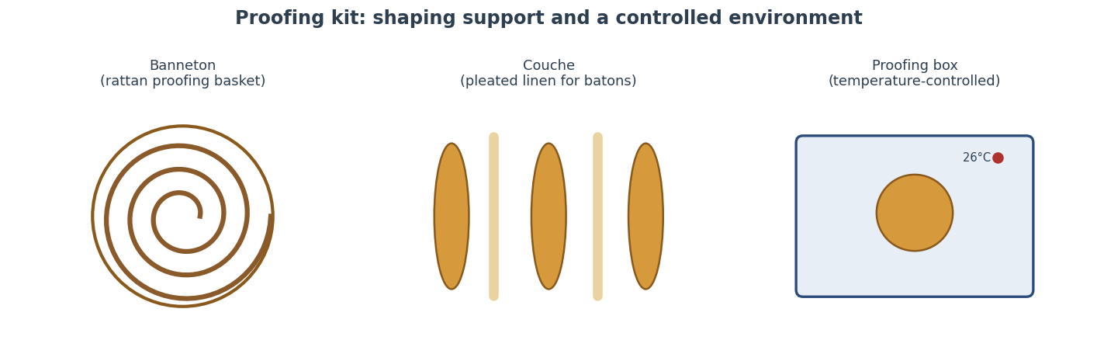
Figure 81 — Proofing kit: the banneton supports and patterns a round; the couche cradles batons; a temperature-controlled box (or the fridge, for retarding) makes fermentation predictable. Indicative.
Method box | Detail
Banneton / brotform | Supports high-hydration rounds; dust well or line; wicks moisture, leaves a spiral
Couche (baker’s linen) | Pleated to hold baguettes/batons in shape; flour heavily, never wash with soap
Proofing box | Holds a set warm temperature (e.g. 26°C) for repeatable bulk and final proof
Fridge / retarder | The cold-proof tool (Section 16): firms dough, builds flavour, fits your schedule
Bowl + tea towel | The zero-cost start — works, with less shape support and no temperature control
Worth it — A banneton and a bench knife: Cheap, durable, and they visibly improve shape and handling of wet doughs — the loaf holds taller and scores cleaner.
Skip or wait — A dedicated proofing box (at first): Your oven with the light on, a turned-off microwave, or the fridge for retarding cover most needs. Buy a box only when precise, repeatable proofing becomes a bottleneck.

51.3 Shaping & Scoring
Shaping tools are few and cheap but high-impact. A bench knife (dough scraper) divides, pre-shapes and builds surface tension; a bowl scraper empties a wet bowl cleanly; and a lame (a razor on a handle) scores far more cleanly than a knife. As Section 20.4 explains, the blade angle decides the bloom: shallow lifts an ear, vertical gives an even split.

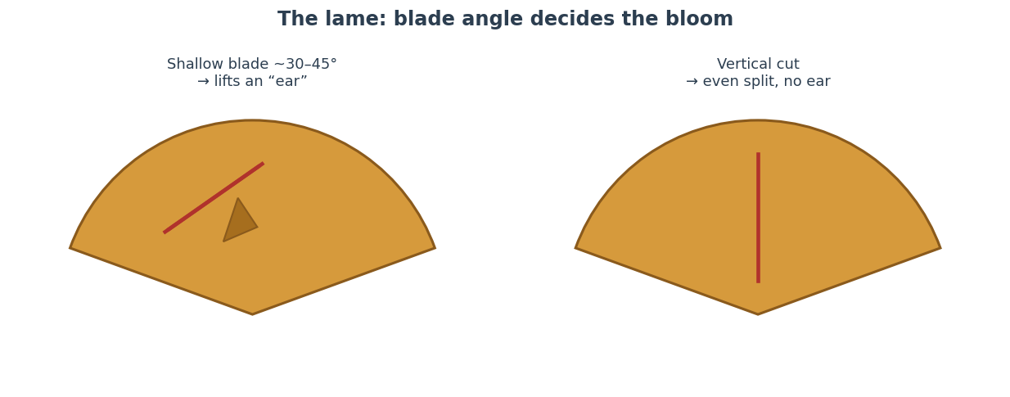
Figure 82 — The lame: a shallow blade (~30–45°) undercuts a flap that lifts into an ear; a vertical cut opens an even split. A sharp, replaceable razor beats any knife. Indicative.
Worth it — A lame and a bench knife: A few coins each and they transform shaping tension and score definition — the cheapest route to a professional-looking loaf.

51.4 Cooling & Storing
Finishing matters as much as starting. A wire rack lets air circulate so the crust stays crisp and the crumb finishes setting (cutting hot bread leaves it gummy, Section 20.5). For storage, the rules from Section 49.5 set the kit: a cloth bag or paper for a day or two at room temperature, and the freezer — sliced and tightly wrapped — for anything longer. Never the fridge.
Tool | Role | Priority
Wire cooling rack | Airflow; crisp crust; crumb sets | Essential
Linen/cloth bag or paper | Room-temp keeping 1–2 days | Useful
Freezer bags / wrap | Long keeping; halts staling | Useful
Bread box | Moderates humidity at room temp | Optional
Skip or wait — A bread box: Pleasant and tidy, but a cloth bag plus the freezer manage shelf life just as well. A nice-to-have, not a need.

51.5 The Home Bakery at a Glance — a Tiered Buying Guide
Pulling both chapters together, here is the kit in the order it earns its place — each tier assuming the one before it. Buy down the list, not up: the early items change the bread most per unit cost.

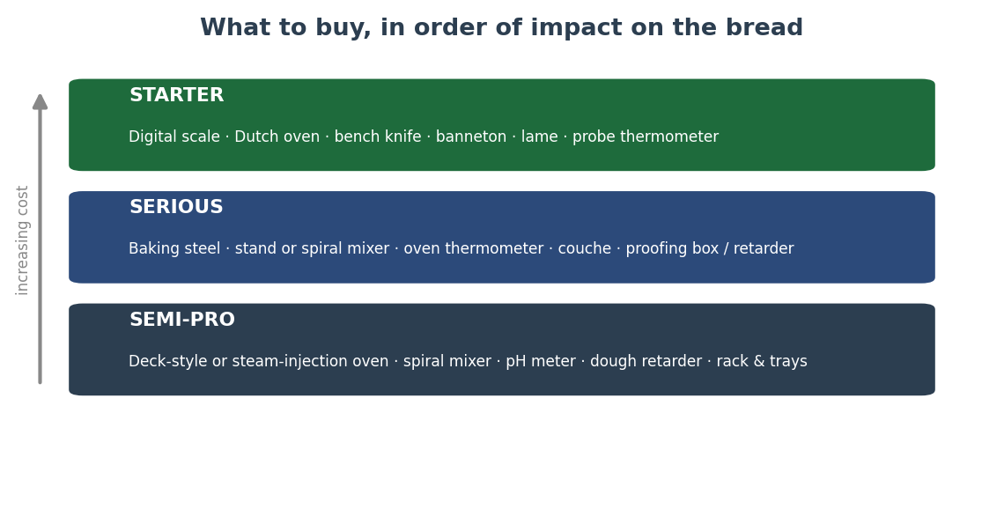
Figure 83 — The home bakery in three tiers. Start with the scale, Dutch oven and hand tools that change the bread most per pound spent; add thermal mass, controlled mixing and proofing as you bake more; reserve deck/steam ovens and spiral mixers for near-professional volume. Indicative.
Tier | Kit | What it buys you
Starter | Digital scale, Dutch oven, bench knife, banneton, lame, probe thermometer | Repeatable formulas, real steam, clean shaping & scoring, true doneness
Serious | Baking steel/stone, stand or spiral mixer, oven thermometer, couche, proofing box or retarder | Stronger spring, gentler gluten, predictable proofs, batons
Semi-pro | Deck-style or steam-injection oven, spiral mixer, pH meter, dedicated retarder, racks & trays | Volume, consistency and the closest home approach to a deck bake
Buy in the order the bread improves: weigh accurately, trap steam, control temperature, support the dough — then, and only then, chase the luxuries. The best loaf in the room is rarely the one made with the most kit.

52. Steamed Breads — Bread Without a Crust
Every bread in the guide so far has been baked in dry, radiant heat. This chapter steps outside the oven entirely. Across China and much of East Asia the staple leavened wheat bread is not baked but steamed — cooked in saturated water vapour at around 100°C. The result is a different food: snow-white, soft, springy and crustless, because the surface never reaches the temperature at which browning happens. Steamed bread is one of the great parallel traditions of the wheat world, and understanding it sharpens the whole picture of what heat does to dough.

52.1 The Steaming Heat Path — Why There Is No Crust
The defining fact of steaming is a temperature ceiling. In a dry oven the loaf’s dry surface races to 140–175°C and the Maillard and caramelisation reactions build a brown, flavourful crust (Section 18.4). In a steamer the surface is wet and surrounded by vapour, so it cannot exceed about 100°C — the boiling point of water. Browning never begins. The interior sets exactly as in baking (starch gelatinises, gluten coagulates between roughly 60 and 80°C, Section 18.3), so a steamed bun has the same cooked crumb as a baked loaf but a soft, pale, tender skin instead of a crust.

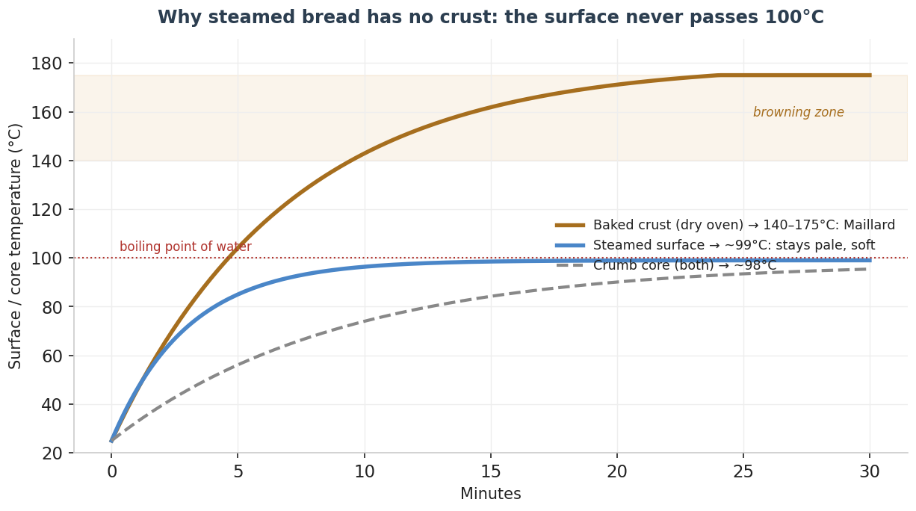
Figure 84 — Steaming holds the surface at ~100°C, below the 140°C+ browning zone, so steamed bread stays pale and crustless while its crumb sets just as a baked loaf’s does. Indicative model.

52.2 The Breads — Mantou & Baozi
The two pillars are mantou (馅头), the plain steamed bun or roll that is the northern-Chinese equivalent of a slice of bread, and baozi (包子), its filled cousin, pleated shut around savoury or sweet fillings. Both are made from a soft, low-protein wheat dough leavened with yeast (historically with a sourdough, 老面 lǎomiàn). Regional and related forms include the Cantonese char siu bao (often with a slightly opened, cracked top from added baking powder), the swirled hua juan (flower rolls), and the Japanese nikuman.

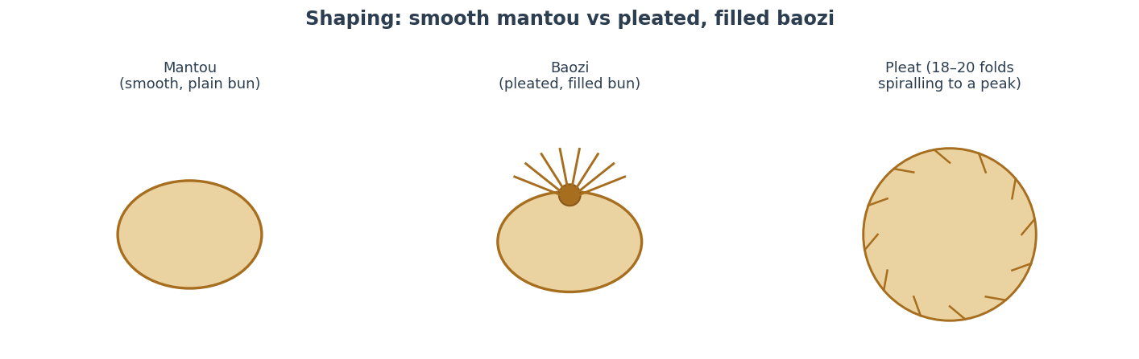
Figure 85 — Mantou is shaped smooth; baozi is pleated — typically 18–20 folds spiralling up to a sealed peak around the filling. Indicative.
A distinctive flour matters here. Chinese steamed-bread flour is a low-to-medium protein wheat (often ~9–11%), milled very white and fine; too strong a flour gives a tough, chewy bun rather than the prized soft, cottony, slightly fluffy texture. Some regional styles deliberately add a little baking powder alongside the yeast for extra lift and a whiter crumb.

52.3 Method — Mantou / Baozi
Method box | Detail
Flour | Low-protein white wheat (~9–11%); fine milled
Dough | Flour 100%, water ~46–50%, yeast ~1%, sugar ~5–10%, oil ~2–3%, sometimes baking powder ~0.5%
Mix | Knead to a smooth, stiff, satin dough — stiffer than Western bread; develop fully for a fine crumb
Bulk | Until doubled (~1 h at 28–30°C); knock back thoroughly to expel large bubbles for a smooth skin
Shape | Mantou: roll smooth. Baozi: roll thin discs, fill, pleat 18–20 folds to a peak
Final proof | 30–45 min until light and ~1.5×; the bun should feel airy before steaming
Steam | 12–18 min over vigorously simmering water; rest 2–3 min before lifting the lid

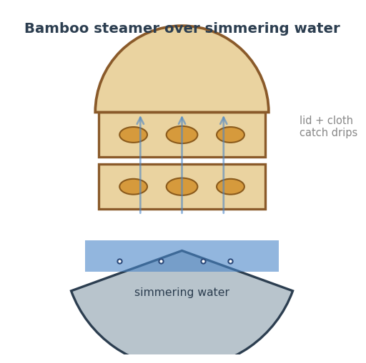
Figure 86 — A stacked bamboo steamer over simmering water; the lid (or a cloth under it) keeps condensation from dripping onto the buns. Indicative.
The lid discipline. Two rules separate good steamed buns from collapsed, wrinkled ones: line or cloth the lid so condensed water never drips onto the surface, and after steaming turn off the heat and wait two to three minutes before opening, so the sudden temperature drop does not shrink and wrinkle the skin.

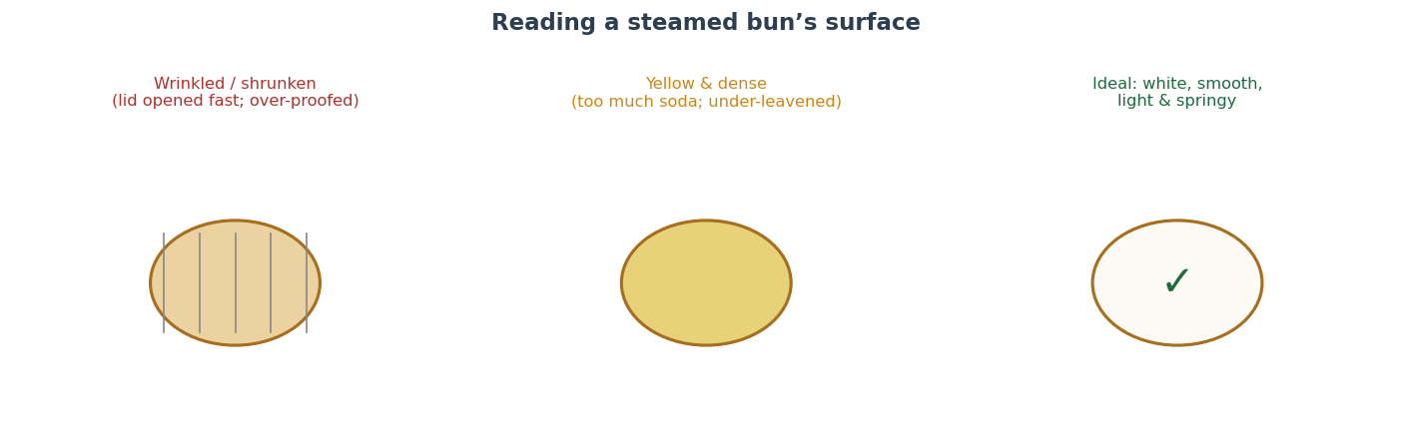
Figure 87 — Reading a steamed bun: wrinkling and shrinkage point to a fast lid-open or over-proofing; a yellow, dense bun to too much soda or under-leavening; the ideal is white, smooth, light and springy. Indicative.
Troubleshooting — steamed buns.
Fault | Likely cause | Fix
Wrinkled, shrunken surface | Lid opened too fast; over-proofed; dripping condensation | Rest 2–3 min before opening; proof a touch less; cloth the lid
Dense, heavy crumb | Under-proofed or flour too strong | Proof until airy & ~1.5×; use low-protein flour
Yellow tinge / soapy note | Too much baking powder/soda | Cut the chemical leavening; rely on yeast
Rough, lumpy skin | Under-kneaded; large bubbles left in | Knead smooth; knock back fully before shaping
Soggy bottoms | Too vigorous a boil / too much water contact | Moderate the simmer; use liners
Lines of influence. Steamed wheat bread radiated from northern China across East and Southeast Asia — the Japanese nikuman, the Filipino siopao, the Vietnamese bánh bao — and is now found worldwide through the Chinese diaspora and dim sum culture. It is the clearest reminder that “bread” need not mean “baked.”
Take away the crust and you see the crumb clearly: steamed bread is the same gelatinised, leavened wheat foam as a baked loaf — only the surface chemistry is different.

53. Asian Milk Breads — the Cloud-Soft Enriched Loaf
If steamed bread removes the crust, the Asian milk-bread tradition perfects the crumb. Japanese shokupan, the Chinese and Taiwanese milk breads, the Hong Kong and Korean enriched loaves and rolls share a goal: an exceptionally soft, fine, feathery, faintly sweet crumb that stays tender for days. The chapter that follows (54) covers the water-roux techniques that make this possible; this one profiles the breads themselves and how they are built.

53.1 Shokupan & the Milk-Bread Family
Shokupan (食パン, “eating bread”) is the Japanese soft white loaf, baked in a long pullman tin — square if lidded, gently domed if open. Its crumb is famously fine, even and cottony, and it tears in soft sheets. Close relatives include Hokkaido milk bread, the spiralled milk loaf, and a family of soft rolls and buns. What unites them is an enriched but restrained dough — milk, a little butter, sugar and sometimes egg — and, above all, a pre-gelatinised flour paste (the tangzhong or yudane of Section 54) that lets the dough carry far more water than a plain loaf.

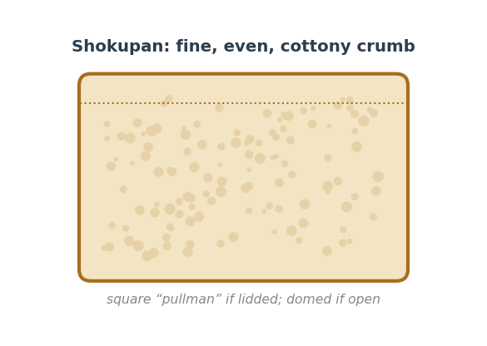
Figure 88 — Shokupan’s crumb: fine, even and cottony, baked square in a lidded pullman tin or domed if open. Indicative.
How it differs from brioche. A milk bread is far leaner in fat than a French brioche — it gets its softness from hydration and pre-gelatinised starch rather than from large amounts of butter and egg. The crumb is therefore lighter and more cottony than brioche’s rich, close, cake-like texture, and it toasts and slices for sandwiches beautifully.

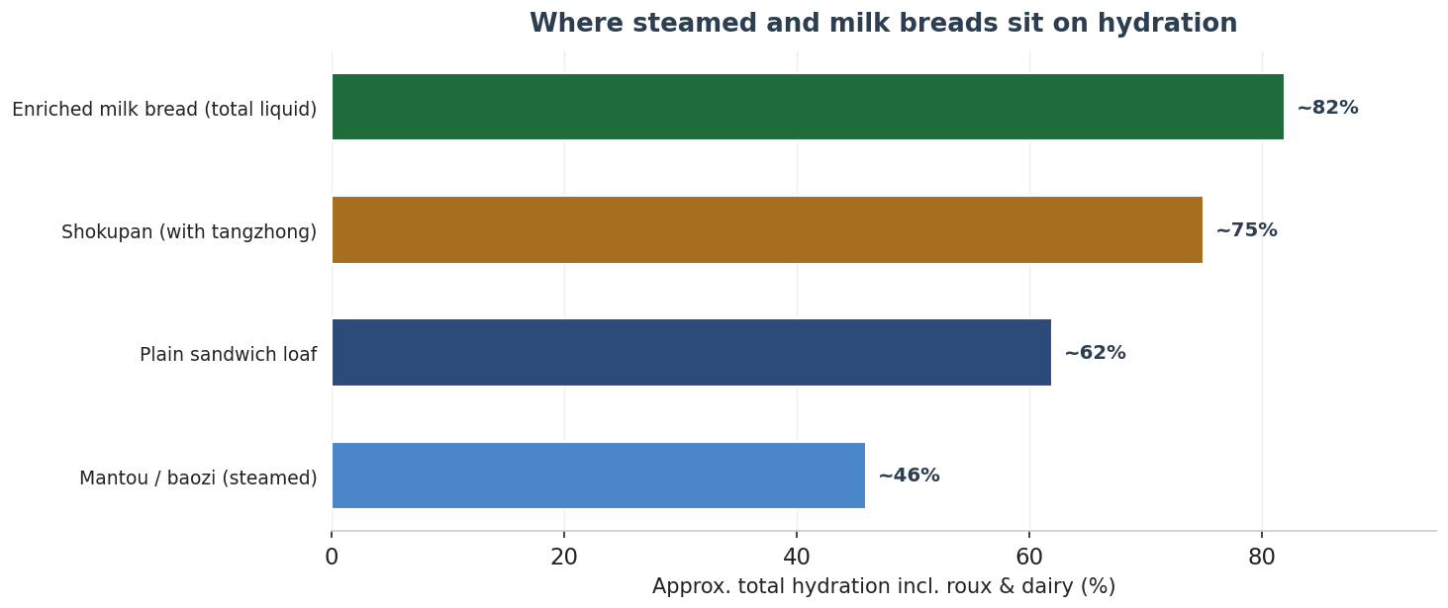
Figure 89 — Where these breads sit on hydration. Steamed buns are stiff and dry; a milk bread’s total liquid (counting the roux and dairy) can climb past 80%, which is the source of its softness. Indicative.

53.2 Method — Shokupan (tangzhong milk loaf)
Quantities in baker’s percentages (flour in the tangzhong is counted in the 100% flour total — see Section 54.3 for how to fold the roux into the math).
Method box | Detail
Flour | Strong white bread flour (~12–13%); the roux flour is part of this total
Tangzhong | ~5–7% of the flour, cooked with 5× its weight of milk/water (Section 54)
Dough | Flour 100%, milk ~60–65% (incl. roux liquid), butter ~8–10%, sugar ~8–12%, egg ~10%, yeast ~2%, salt ~2%, milk powder ~3% (optional)
Mix | Mix to a strong, elastic, slightly tacky dough; add softened butter after gluten forms; develop to a thin windowpane
Bulk | ~1 h at 26–28°C until doubled
Shape | Divide; roll out, fold and coil each piece; set 2–4 coils side by side in the pullman tin
Final proof | Until the dough reaches ~80–90% of tin height (lidded) or just over the rim (open)
Bake | Lidded for a square loaf or open for a dome; ~190–200°C, ~25–35 min; egg-wash if open
Worth it — A pullman (lidded) tin: For shokupan it genuinely changes the result — the lid gives the signature square shape and an ultra-fine, even crumb by constraining the rise. Worth it if you bake milk bread often.
Troubleshooting — milk breads.
Fault | Likely cause | Fix
Dense, not fluffy | Under-developed gluten or under-proofed | Mix to a thin windowpane; proof to ~80–90% tin height
Coarse or uneven crumb | Roux skipped or dough under-mixed | Use tangzhong/yudane; develop gluten fully
Greasy / split crust | Butter added too early or too much | Add butter after gluten forms; keep fat ≤10%
Stales within a day | No pre-gelatinised paste; under-hydrated | Add a roux (Section 54); raise total liquid
Collapses after baking | Over-proofed; tin too small for the dough | Proof slightly less; scale dough to tin volume
Lines of influence. The soft enriched loaf travelled Japan → Taiwan → China → Korea and through East-Asian bakeries worldwide, and the tangzhong method it popularised has since been adopted by Western bakers for softer sandwich loaves, burger buns and dinner rolls — a rare modern technique flowing from East to West.
Brioche is soft because of butter; milk bread is soft because of water — held in place by cooked starch. It is enrichment by hydration, not by fat.

54. The Water-Roux Methods — Tangzhong & Yudane
Behind every great milk bread is a small cooked or scalded paste of flour and liquid. The water-roux is a pre-ferment’s textural cousin: it changes not flavour but the crumb, letting a dough hold more water, rise higher, and stay soft for days. This short chapter explains the two methods, the science that makes them work, and the arithmetic to fold them into any formula — including ready-to-port logic for the baking application.

54.1 The Two Methods
Both methods pre-gelatinise a portion of the recipe’s flour — bursting the starch granules so they absorb several times their weight in water — before that flour ever reaches the main dough. They differ in how the heat is applied.

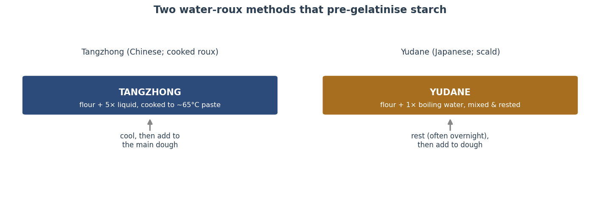
Figure 90 — The two water-roux methods. Tangzhong cooks flour with about five parts liquid to a paste at ~65°C; yudane scalds flour with an equal weight of boiling water and rests it. Both are cooled before mixing into the dough. Indicative.
Method | Flour : liquid | How | Character
Tangzhong | 1 : 5 | Cook flour + liquid to ~65°C, a smooth pudding-like paste; cool | Light, very soft; the popular modern method
Yudane | 1 : 1 | Scald flour with boiling water, mix to a stiff paste; rest (often overnight) | Chewier, slightly sweeter, more aromatic
The 65°C target is not arbitrary: it is the wheat-starch gelatinisation range (Section 18.3). Heating flour-and-water to that point swells and bursts the granules so they bind water as a gel, without cooking the mixture into a stiff, unworkable lump. Yudane reaches gelatinisation differently — the boiling water scalds the flour on contact — and the overnight rest lets hydration complete and adds a faint sweetness as amylases free some sugars.

54.2 Why It Works — Bound Water & Slower Staling
A milk bread is soft for two linked reasons. First, the gelatinised paste lets the whole dough carry more water without becoming slack — the gel holds it — so the baked crumb is moister and more tender. Second, that bound water slows starch retrogradation, the recrystallisation that stales bread (Section 49.5). A loaf made with a roux therefore not only starts softer but stays soft noticeably longer, as the curve below shows.

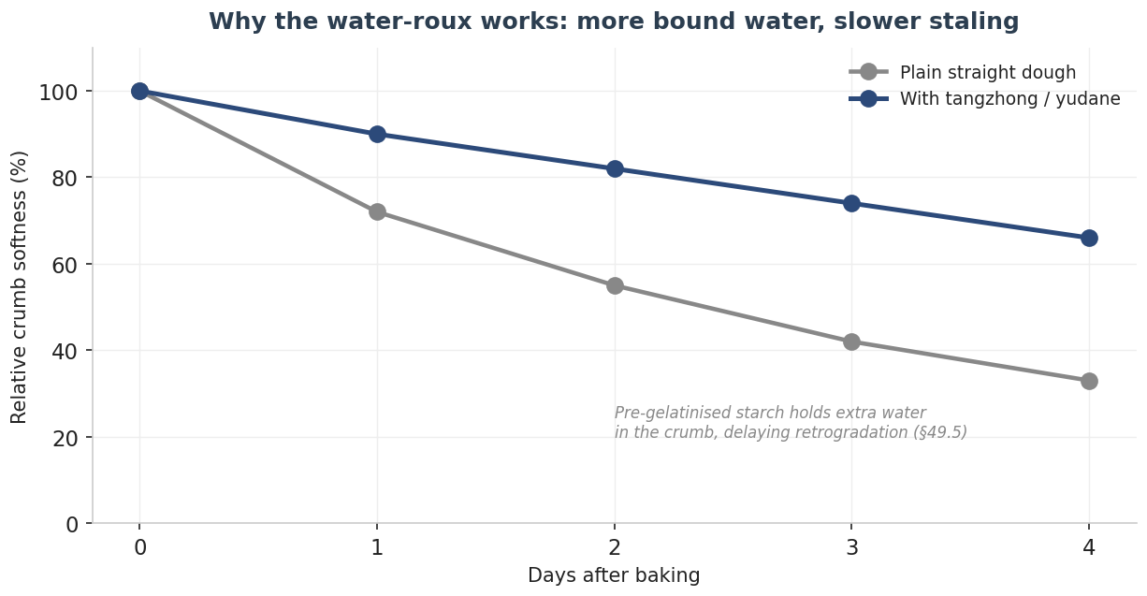
Figure 91 — Why the water-roux works: the pre-gelatinised starch binds extra water, so a roux loaf starts softer and stales more slowly than the same formula made straight. Indicative.

54.3 The Arithmetic — Folding a Roux into a Formula
The key rule for keeping baker’s math honest (Section 48): the flour and liquid in the roux are part of the formula totals, not extra. To add a tangzhong to a formula, decide what fraction of the total flour goes into the roux (commonly 5–7%), multiply by five for its liquid, and subtract both from the main dough so the overall flour, hydration and salt are unchanged.
Worked example. A loaf uses 500 g flour at 70% hydration (350 g liquid). Put 6% of the flour — 30 g — into a tangzhong with 5× = 150 g of the milk. The main dough then takes 470 g flour and 200 g milk; the roux brings the rest. Totals are still 500 g flour and 350 g liquid, so the formula’s hydration and percentages are intact — only the texture changes.
Ready-to-port — fold a water-roux into a formula (C#)
record Roux(decimal flourPct, decimal ratio); // e.g. 6%, 1:5

(decimal rouxFlour, decimal rouxLiquid,
decimal doughFlour, decimal doughLiquid)
FoldRoux(decimal totalFlour, decimal hydrationPct, Roux r)
{
var totalLiquid = totalFlour * hydrationPct/100m;
var rf = totalFlour * r.flourPct/100m; // roux flour
var rl = rf * r.ratio; // roux liquid
return (rf, rl, totalFlour - rf, totalLiquid - rl);
}
// Totals are preserved: rf+doughFlour = totalFlour,
// rl+doughLiquid = totalLiquid

Rules of thumb.
- Keep the roux flour to about 5–7% of total flour. Too much makes a gummy, dense crumb rather than a soft one.
- Cool the roux to room temperature before mixing — a warm paste will over-warm the dough (it feeds the friction/DDT budget of Section 48.3).
- Raise total hydration when you add a roux. The whole point is that the dough can now take more water; a roux added without extra liquid gives only a modest gain.
- Yudane suits chewier, more aromatic loaves; tangzhong suits the lightest, softest crumb. They are interchangeable in most milk-bread formulas.
Quick reference | Tangzhong | Yudane
Flour : liquid | 1 : 5 | 1 : 1
Heat | Cook to ~65°C | Boiling water, scald
Rest | Cool, use same day | Often overnight
Roux flour share | ~5–7% of total | ~5–10% of total
Crumb | Lightest, cottony | Chewier, sweeter
A spoonful of cooked flour is the quietest of all preferments: it adds no sourness and no rise of its own, only the soft, lasting moisture that defines a milk bread.

Appendix A — Glossary
A consolidated reference to the technical vocabulary used throughout this guide. Where a term is treated at length in the text, the relevant section is noted. Grain names profiled in the encyclopedia (Section 15) are not repeated here.
A
Absit — A portion of injera batter pre-cooked to a paste and returned to the ferment to improve texture (§46).
Acetic acid — The sharp, vinegary acid produced by heterofermentative bacteria, favoured in cool, stiff doughs (§16).
Amylase — A flour enzyme that converts damaged starch into fermentable sugars; very active in rye and malted flours.
Ash content — The mineral residue of flour after burning; a measure of extraction — higher ash means more bran and germ (the basis of French “T” and German “Type” grading).
Atta — Finely stone-ground Indian wholemeal wheat flour, the base of roti and chapati (§44).
Autolyse — A rest of flour and water only, before salt and leaven, to hydrate and build extensibility (§3).
B
Baker’s percentage — A formula notation in which every ingredient is expressed as a percentage of total flour weight, fixed at 100% (§48).
Bassinage — Adding part of the water late in mixing, after the gluten has formed, to reach a high final hydration (§37).
Bedja — The pre-heated conical clay mould used to bake bread in ancient Egypt (§38).
Beta-glucan — A soluble fibre rich in barley and oats that raises water absorption and viscosity but lowers loaf volume.
Biga — A stiff Italian commercial-yeast preferment (45–60% hydration) that builds strength and flavour (§19, §37).
Bran — The fibrous outer layers of the grain; nutritious but it physically cuts gluten strands, lowering volume.
Brühstück (scald) — Flour mixed with near-boiling water to gelatinise starch, sweeten the crumb and improve keeping; common in rye baking (§42).
Bulk fermentation — The first rise of the whole dough after mixing, before dividing and shaping.
C
Caramelisation — The browning of sugars alone above ~170°C, adding colour and sweetness to the crust (§18).
Chorleywood Bread Process — A 1961 British method replacing bulk fermentation with intense mechanical mixing plus additives; behind most UK industrial bread (§47).
Coil fold — A gentle strengthening fold for high-hydration dough, lifting the centre and tucking the ends under.
Crumb — The internal cellular structure of a baked loaf.
D
DDT (desired dough temperature) — The target dough temperature after mixing, reached by adjusting the water temperature (§48.3).
Detmold process — A multi-stage German rye sour build (fresh, basic and full sour) optimising yeast, lactic and acetic development (§36).
E
Ersho — The reserved liquid starter used to inoculate a new batch of Ethiopian injera (§46).
Extensibility — The dough’s willingness to stretch without tearing; governed by gliadin.
Extraction rate — The proportion of the grain retained in the flour after milling; wholemeal is ~100%, white flour much lower.
F
Fermentolyse — A rest of flour, water and starter together, allowing low-level fermentation during hydration (§4).
FODMAPs — Fermentable carbohydrates that long sourdough fermentation partly degrades, often improving digestibility.
Forza / W — The Italian measure of flour strength (W value); high-W flours hold long fermentations (§37).
Friction factor — The heat a mixing method adds to the dough — a term in the DDT calculation; ~1–3°C by hand, up to ~26°C for intensive mixers (§48, §50).
G
Gelatinisation — The swelling and bursting of starch granules as they absorb water and heat (~60–70°C for wheat), setting the crumb (§18).
Gliadin — The gluten protein giving extensibility (stretch); proportionally high in ancient wheats.
Gluten — The elastic protein network of gliadin and glutenin that traps gas and gives wheat bread its rise and chew.
Glutenin — The gluten protein giving elasticity and gas retention (strength); the key to structure.
H
Hooch — The grey-brown alcoholic liquid that forms on a hungry starter; harmless, stir in or pour off (§19).
Hydration — The water content of a dough as a baker’s percentage of flour weight.
K
Kipferl — The Austrian crescent roll that, taken to Paris by August Zang, became the croissant (§40).
L
Lactic acid bacteria (LAB) — The bacteria of sourdough that produce its acids; outnumber the yeast ~100:1 (§19).
Lame — A razor blade on a handle, used to score dough; blade angle sets the bloom (§20, §51).
Lamination — Folding butter into dough to build many thin layers, as in croissants (§40).
Levain — A sourdough preferment built from a portion of starter for a specific bake (§19).
M
Maida — Refined white Indian wheat flour, the base of naan and kulcha (§44).
Maillard reaction — The browning between amino acids and reducing sugars above ~140°C that builds crust colour and aroma (§18).
Mitad — The clay or electric griddle on which Ethiopian injera is baked (§46).
N
Nixtamalisation — The alkaline cooking of maize that frees its niacin and makes masa, the base of the tortilla (§45).
O
Oven spring — The rapid final expansion of the loaf in the first minutes of baking, before the structure sets (§18).
P
Pentosans (arabinoxylans) — Gums, abundant in rye, that absorb great quantities of water and give rye dough its paste-like body.
Phytic acid — A grain anti-nutrient that binds minerals; partly degraded by long sourdough fermentation.
Poolish — A liquid (100% hydration) commercial-yeast preferment prized for extensibility (§19).
Preferment — Any portion of flour and water fermented ahead of the final dough — poolish, biga, levain, sponge or old dough (§19).
Proofing — The final rise of the shaped loaf before baking.
Protease — A flour enzyme that loosens gluten, increasing extensibility; activated by acidity.
Pullman — A lidded rectangular tin giving a square-sided loaf with a fine, even crumb (§53).
Pâte fermentée — “Old dough” — a salted, yeasted preferment that is simply a piece of a previous batch (§19).
Q
Q10 — The factor by which reaction rate changes per 10°C; ~2–2.5 for fermentation, the basis of cold-retard timing (§16).
R
Retardation (retard) — Slowing fermentation by chilling, to develop flavour and fit a schedule (§16).
Retrogradation — The recrystallisation of gelatinised starch as bread cools and stales; fastest at fridge temperatures (§49).
Rope — A bacterial spoilage (Bacillus) giving a sticky, stringy, sweet-smelling crumb; prevented by acidity and fast cooling (§49).
S
Scoring — Cutting the dough surface before baking to control where it opens (§20, §51).
Sourdough — Bread leavened by a wild culture of yeast and lactic acid bacteria rather than commercial yeast.
Sponge — A fast, wet preferment carrying much of the recipe’s yeast; suits enriched doughs (§19).
Starter — The maintained mother culture of wild yeast and bacteria from which levains are built (§19).
Stretch and fold — A non-kneading strengthening technique of stretching the dough and folding it over during bulk.
T
Tangzhong — A Chinese water-roux: flour cooked with ~5 parts liquid to a paste (~65°C) for a softer, longer-keeping crumb (§54).
Teigausbeute (TA) — The German dough-yield figure: flour weight plus water, expressed as TA = 100 + hydration%, used in rye work (§36).
Tipo — The Italian flour grading scale (00, 0, 1, 2, integrale) by fineness and extraction (§37).
V
Vital wheat gluten (VWG) — Isolated wheat protein (~80% gluten) added to raise dough strength in weak or high-fibre blends (§11).
W
Windowpane test — Stretching a piece of dough thin enough to see light through it, a check of full gluten development.
Y
Yudane — A Japanese water-roux: flour scalded with an equal weight of boiling water and rested, for a chewier soft crumb (§54).

Appendix B — References & Bibliography
A consolidated, thematically grouped bibliography for the whole guide. In-chapter reference lists (for example §47.5) remain alongside their material; this appendix gathers the principal sources in one place. Books are listed by author and title; online sources give a locator.

Foundational science & technique
- Jeffrey Hamelman, Bread: A Baker’s Book of Techniques and Recipes — Wiley
- Raymond Calvel, The Taste of Bread (Le Goût du Pain) — Springer
- Nathan Myhrvold et al., Modernist Bread — The Cooking Lab
- Debra Wink, “Lactic Acid Fermentation in Sourdough” (starter succession) — thefreshloaf.com
- Emily Buehler, Bread Science — Two Blue Books

Grains, ancient wheats & gluten-free
- Stanley Ginsberg, The Rye Baker — W. W. Norton
- Psyllium husk in gluten-free bread — staling & crumb study — doi.org (food-science literature)
- Whole Grains Council — ancient grains references — wholegrainscouncil.org

France, Germany & Italy
- Le Décret Pain (French bread decree), 1993 — legifrance.gouv.fr
- UNESCO — the baguette / artisanal bread know-how (2022) — ich.unesco.org
- DIN 10355 — German flour type designations — din.de
- Carol Field, The Italian Baker — Ten Speed Press
- Pane di Altamura DOP; Pane Toscano DOP — EU PDO registers — ec.europa.eu/agriculture/eambrosia

World bread cultures (§38–47)
- Arranz-Otaegui & Richter et al., “Origins of bread 14,400 years ago,” PNAS (2018) — pnas.org/doi/10.1073/pnas.1801071115
- Darby, Ghalioungui & Grivetti, Food: The Gift of Osiris (1977) — archive.org/details/foodgiftofosiris0000darb
- Delwen Samuel, “Ancient Egyptian Baking & Brewing,” Science 273 (1996) — science.org/doi/10.1126/science.273.5274.488
- Ancient Egypt Research Associates (Mark Lehner) — Giza bakeries — aeraweb.org
- Sürmelihindi et al., the Barbegal Roman watermills, Science Advances (2018) — science.org
- Farrell Monaco, “Baking Bread with the Romans — Panis Quadratus” — tavolamediterranea.com
- Jim Chevallier, August Zang and the French Croissant — en.wikipedia.org/wiki/August_Zang
- Maggie Glezer, A Blessing of Bread (challah history) — myjewishlearning.com
- Chorleywood bread process — Real Bread Campaign / Sustain — sustainweb.org/realbread

The bake, the starter & the crumb
- Jeffrey Hamelman, Bread (oven, steam, doneness, rye sours) — Wiley
- Modernist Bread (oven-spring mechanisms; staling) — The Cooking Lab
- Chad Robertson, Tartine Bread — Chronicle Books

Steamed & milk breads (§52–54)
- Yvonne Chen / Andrew Janjigian — tangzhong & yudane method notes — kingarthurbaking.com
- Chinese steamed-bread (mantou) flour & technique references — seriouseats.com
A reference is only as honest as its sources. Where this guide states a figure or a history, it rests on the works above — and, where they disagree, says so.

