Abel Berhane

Extra Credit Project

Instructions

The following program was written and compiled in Java. The classes to include in the project folder is: ChessPiece.java, driver.java, StdDraw.java

The system will ask you to input the appropriate information. The x and y coordinates for a standard chess board are from 0 to 7. So for example, if you want to start in a5, then type 0 for the initial x coordinate and 4 for the y coordinate

Chess Piece with irregular relations of reachability

The irregular pieces relation of reachability is similar to the King piece, except it moves 2 spaces in all directions instead of 1.

Sample input for the element with irregular relations of reachability

Enter first type of piece (for the special piece, type the word special):

special

Enter second type of piece:

special

Irregular 6 X 6 board? (true or false):

false

Obstacles? (true or false):

false

Enter the initial x axis:

0

Enter the initial y axis:

0

Enter the destination x axis:

4

Enter the destination y axis:

4

Enter number of trajectories:

2

Sample output for the element with irregular relations of reachability:

**Coordinate of paths along the trajectories**

Paths for coordinate: 0,0. Number of trajectories: 2:

2, 2

Paths for coordinate: 2,2. Number of trajectories: 1:

4, 4

Paths for coordinate: 4,4. Number of trajectories: 0:

**Graph of trajectories**

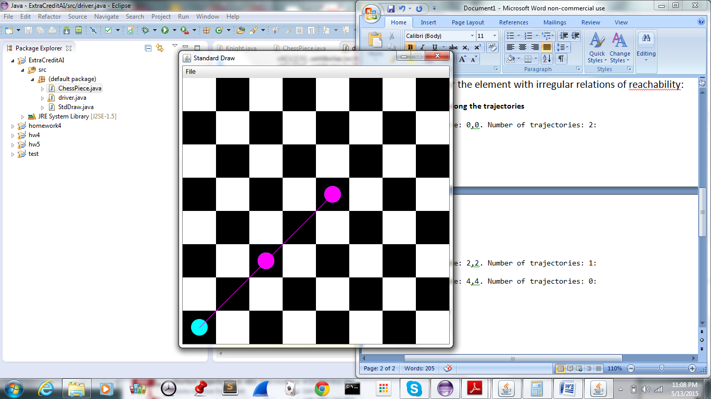

Sample input for trajectories of a King on an IRREGULAR sized board going from a1 to a5:

Enter first type of piece (for the special piece, type the word special):

king

Enter second type of piece:

king

Irregular 6 X 6 board? (true or false):

true

Obstacles? (true or false):

false

Enter the initial x axis:

0

Enter the initial y axis:

0

Enter the destination x axis:

0

Enter the destination y axis:

4

Enter number of trajectories:

4

Sample output for trajectories of a King on an IRREGULAR sized board going from a1 to a5:

**Coordinates of paths along the trajectory**

Paths for coordinate: 0,0. Number of trajectories: 4:

0, 1

1, 1

Paths for coordinate: 0,1. Number of trajectories: 3:

0, 2

1, 2

Paths for coordinate: 1,1. Number of trajectories: 3:

0, 2

1, 2

2, 2

Paths for coordinate: 0,2. Number of trajectories: 2:

0, 3

1, 3

Paths for coordinate: 1,2. Number of trajectories: 2:

0, 3

1, 3

Paths for coordinate: 0,2. Number of trajectories: 2:

0, 3

1, 3

Paths for coordinate: 1,2. Number of trajectories: 2:

0, 3

1, 3

Paths for coordinate: 2,2. Number of trajectories: 2:

1, 3

Paths for coordinate: 0,3. Number of trajectories: 1:

0, 4

Paths for coordinate: 1,3. Number of trajectories: 1:

0, 4

Paths for coordinate: 0,3. Number of trajectories: 1:

0, 4

Paths for coordinate: 1,3. Number of trajectories: 1:

0, 4

Paths for coordinate: 0,3. Number of trajectories: 1:

0, 4

Paths for coordinate: 1,3. Number of trajectories: 1:

0, 4

Paths for coordinate: 0,3. Number of trajectories: 1:

0, 4

Paths for coordinate: 1,3. Number of trajectories: 1:

0, 4

Paths for coordinate: 1,3. Number of trajectories: 1:

0, 4

Paths for coordinate: 0,4. Number of trajectories: 0:

Paths for coordinate: 0,4. Number of trajectories: 0:

Paths for coordinate: 0,4. Number of trajectories: 0:

Paths for coordinate: 0,4. Number of trajectories: 0:

Paths for coordinate: 0,4. Number of trajectories: 0:

Paths for coordinate: 0,4. Number of trajectories: 0:

Paths for coordinate: 0,4. Number of trajectories: 0:

Paths for coordinate: 0,4. Number of trajectories: 0:

Paths for coordinate: 0,4. Number of trajectories: 0:

**Graph of trajectories**

