Documentation

The documentation of BEAT will be displayed using this type of styling and formatting

You will need to click on the side Bar of the *“Documentation”* tab to Selected and get:

* **Relevant** data
* Software tutorials

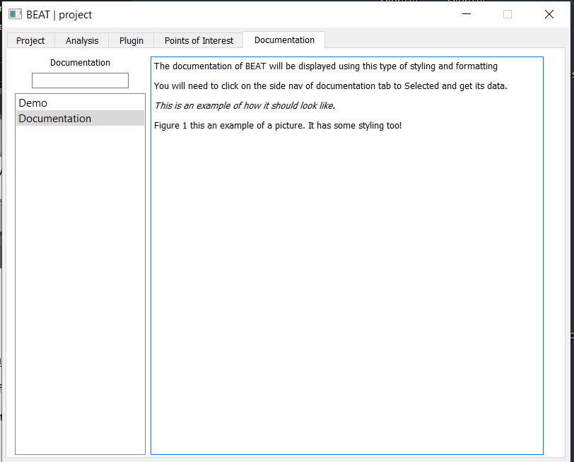

This is an example of how it should look like.