***This is the POI (Point of Interest) Tab***

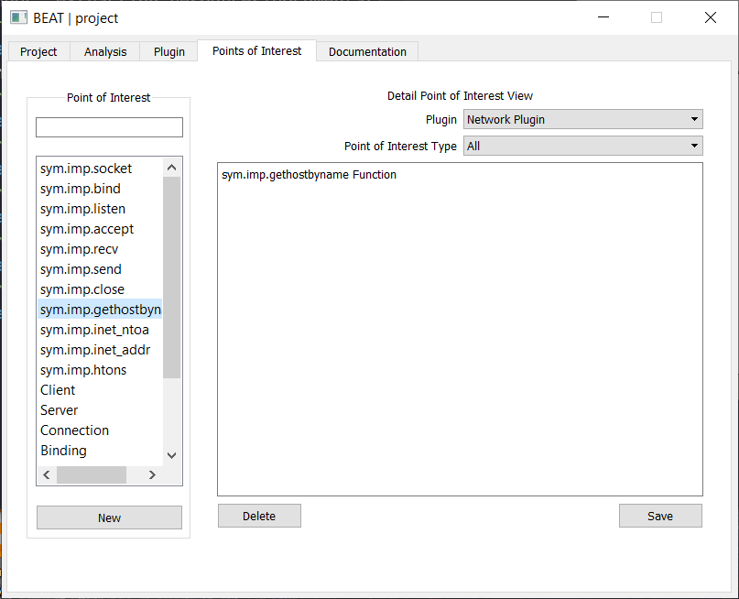

Figure