***This Is the Project Tab***

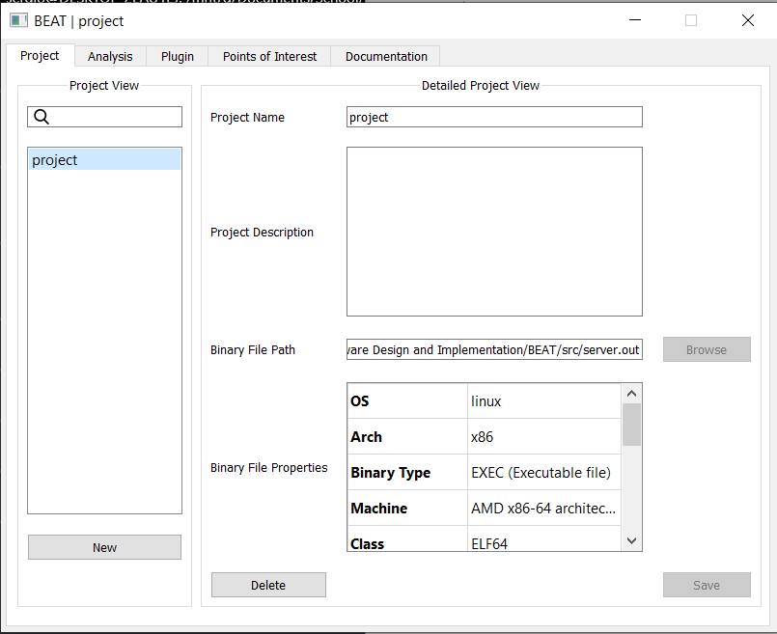

Figure