This guide is for users who wish to fit MRS data with LCModel using the specReg pipeline.   
You should have already installed and pre-processed your data with specReg. If not, refer to the *specReg-preproc-manual*.

Any issues can be addressed to [adam.berrington@nottingham.ac.uk](mailto:adam.berrington@nottingham.ac.uk)

The following GitHub packages are necessary to download and add to your Matlab path:

* <https://github.com/chenkonturek/MRS_MRI_libs>
* <https://github.com/CIC-methods/FID-A>

**Access to SPMIC computers for LCModel processing**

The LCModel program is available on an SPMIC computer called cador (as well as others).

1. Ensure that you have access* and a home directory on cador.  
   *You can check access by opening a terminal and running the following command followed by your password.

ssh [[your-uon-username]@cador.magres.nottingham.ac.uk](mailto:your-username@cador.magres.nottingham.ac.uk)

1. Once ssh’ed into cador, install LCModel in your home directory. Type

lcmodel2

If you do not have access, please contact [andrew.peters@nottingham.ac.uk](mailto:andrew.peters@nottingham.ac.uk) before proceeding.

1. **Choice of script**

During the processing, the code assumes you are working in a local computer and not on cador itself. Choose the script according to your MRS acquisition.

|  |  |
| --- | --- |
| **Acquisition** | **Script** |
| 7 T or 3 T MEGA | specreg_fit_MEGA |
| 7 T STEAM | specreg_fit_STEAM |
| 7 T SLASER | specreg_fit_SLASER |

Using these scripts, the files are generated, transferred to cador, analysed and then transferred back to your local machine.

1. **Setting up**
   1. Make sure the specReg folder and subfolders are added to your Matlab path.
   2. Navigate to the working directory with your data inside. SpecReg folder should be in there.
   3. 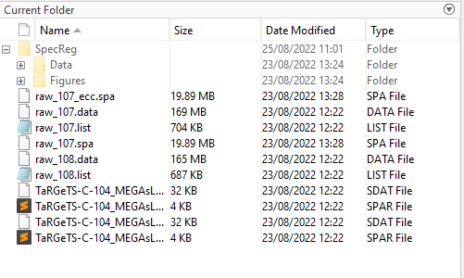

Figure : Data directory should have specReg folder already present with Data and Figures

1. **Run correct script from step (0)**

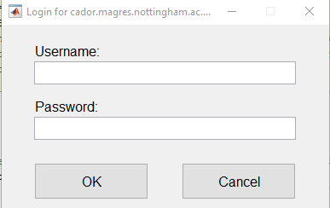

When you run the script, it will ask for your username and password to access cador SPMIC computer.

If you get the following error, please check again username and password and that you have access to cador.



Other errors can be because the cador LCModel isn’t set up correctly. See red box.

If the script runs successfully you should see something similar to the following output

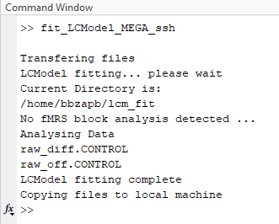

Figure : Successful run of LCModel

1. **Outputs**

After completing, you should have an ‘LCModel’ directory within your SpecReg/[SEQUENCE] folder.

Within LCModel directory, are the following file types:

|  |  |
| --- | --- |
| **File Type** | **Description** |
| .CONTROL | This is the file containing parameters that LCModel uses to fit the data. This is written using the fit_LCModel_MEGA script. In certain cricumstances, it is necessary to change fitting parameters – you can do this by changing the respective text file in specReg\control or making your own study-specific file and pointing to it from fit_LCModel_MEGA script. |
| .COORD | This contains the output from the LCModel fit. It contains the concentrations as well as vectors of the line fits for display. |
| .RAW | This is the metabolite data in a format for LCModel to process |
| .H20 | This is the water unsuppressed data for LCModel to process |
| .PRINT | Contains many fitting outputs |
| **.pdf** | **This is the visual summary of the fit** |

**Open the pdf files and check that the fitting has been carried out successfully.**

For MEGA there will be separate files for the difference spectrum (‘DIFF’) and the unedited (OFF) spectrum.   
  
**4. Estimated concentration values**

The values in .pdf or in .COORD are given relative to an internal reference as well as water. If estimated concentration values are desired, then corrections will need to be applied for partial volume (CSF/WM/GM) contribution and T2 relaxation times.

