This guide is for users wising to pre-process data (acquired using UoN scanners) using specReg pipeline. Once pre-processing has been carried out, data can then be fit with LCModel.

**Currently the pipeline is fully supported for MEGA-sLASER (MEGA) at 7 T and SLASER (30ms) + STEAM (14ms) at 7 T**

Any issues running specReg can be addressed to [adam.berrington@nottingham.ac.uk](mailto:adam.berrington@nottingham.ac.uk)

1. **Setting up specReg**
   1. The following MRS packages are necessary to download and add to your Matlab path
      1. <https://github.com/chenkonturek/MRS_MRI_libs>
      2. <https://github.com/CIC-methods/FID-A>
   2. Clone the latest specReg code from the Git Repository. Keep up to date with any updates or bug fixes this way. The latest version is at -

<https://github.com/aberrington/specReg>

* 1. Open Matlab. Make sure the specReg code folder and subfolders are added to your Matlab path.
  2. Navigate to the working directory with your data inside

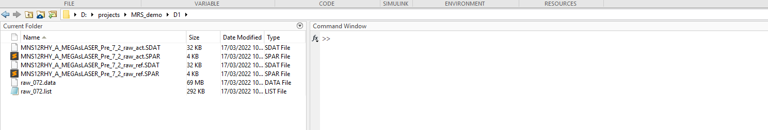

Figure : Navigate to Matlab directory with data stored inside

* 1. Check that you have the correct data type stored for the particular acquisition

|  |  |
| --- | --- |
| **Acquisition** | **Data Types Supported** |
| 7 T MEGA-sLASER | (.data/.list **and** .SDAT/.SPAR) **or** .SIN/.LAB/.RAW |
| 7 T STEAM | (.data/.list **and** .SDAT/.SPAR) **or** .SIN/.LAB/.RAW |
| 3 T MEGA-PRESS (Philips) | .data/.list **and** .SDAT/.SPAR |
| 3 T MEGA-PRESS (GE) | .p **or** .h5 |

The ‘specreg_proc_’ script runs the pre-processing on the raw MRS data. You need to tell it which files to look for:

* 1. Open the appropriate specreg_proc_ script for your data in a Matlab editor (See Step 2). At top of the file, comment out which data format you are working with. For example, here I am processing 7 T data/list format.

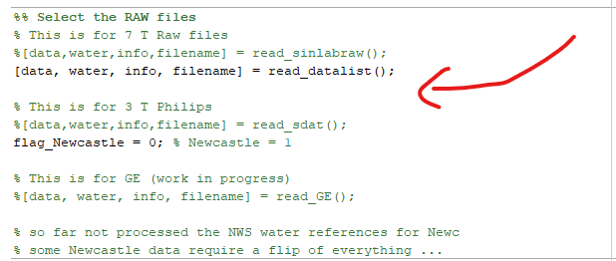

Figure : Modify the beginning of the ‘specreg_proc_’ code to select your data format

1. **Running specReg**

The specReg scripts depend on the MRS acquisition you are analysing. Please choose the correct file depending on your acquisition.

|  |  |
| --- | --- |
| **Acquisition** | **Script** |
| 7 T or 3 T MEGA | specreg_proc_MEGA |
| 7 T STEAM | specreg_proc_STEAM |
| 7 T sLASER | specreg_proc_SLASER |

*Info: During this step raw data are then read in, coil-combined and eddy current corrected. They are then split into ON and OFF spectra if processing MEGA data.*

* 1. Within the data folder, run the correct script listed above. The user will then be asked to select the raw data to analyse.

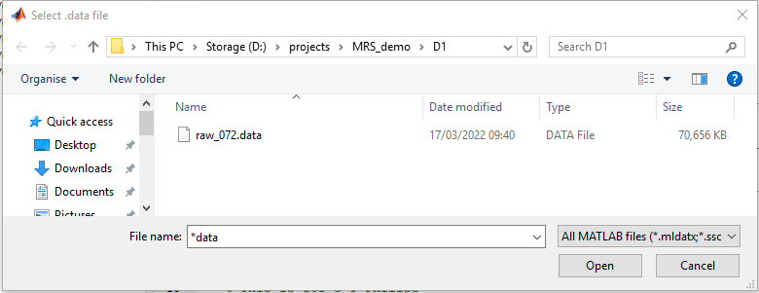

Figure : User should select appropriate file to be analysed

The following window appears. This is a plot of the mean spectrum for the whole experiment. The user can control the manual phase adjustment applied to the data. In general, **no manual adjustment is required**. However, sometimes the presence of large baseline artifacts/lipids or water is apparent. Therefore it is crucial to perform a visual inspection of the data.

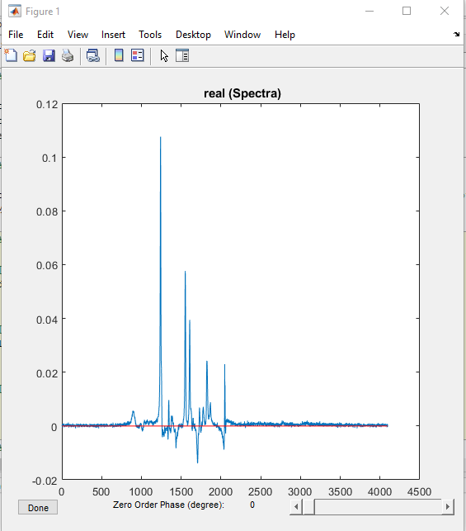

Figure : Example manual phasing window. Check for obvious artefacts in the data.

* 1. Click ‘Done’ to proceed
  2. Once the script is finished and all figures have been plot – this step is now complete. The user can then proceed to LCModel fitting.

1. **specReg outputs**

Several outputs will be created, including figures and folders, after running specReg. Here is a summary of the most important information. The figures will change depending if MEGA or STEAM has been selected.

* 1. **SNR and Linewidth**

In the Command Window, the SNR and estimated linewidth of the unsuppressed water are given. It is useful to record these values for each experiment for quality assessment.

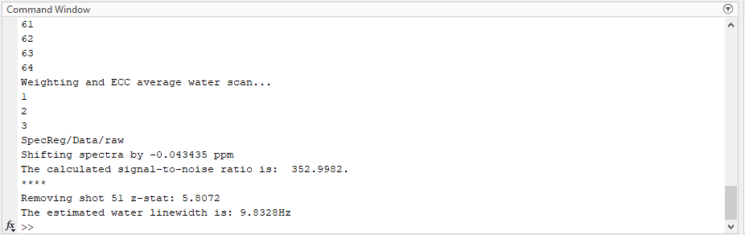

Figure : Example Command Window output with quality metrics (showing spectral SNR of 353 and linewidth of 9.83Hz)

* 1. **Alignments**

For MEGA, all the OFF and ON spectra are plotted in separate figures, before and after spectral registration correction.

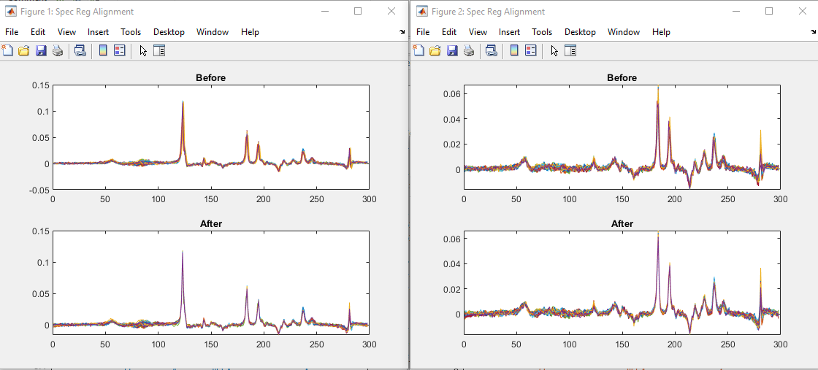

For each spectrum acquired during the experiment, the frequency and phase adjustment applied is plotted (below).

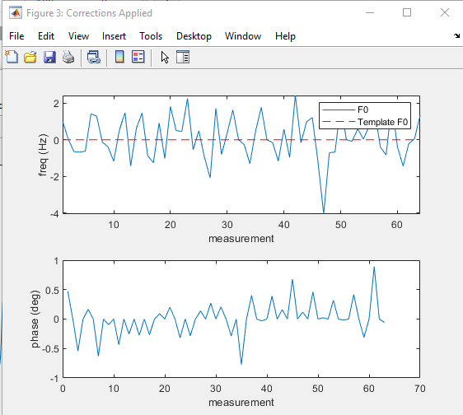

* 1. **Automatic Outlier Rejection**

Spectra are rejected as outliers, if the mean square error around the Choline peak is larger than +/- 3 standard deviations from the mean. The following plot shows which spectra are rejected (red-cross) and plots them against the mean (right panel).

The Command Window output also reports which spectra have been removed from the final analysis (along with their z-statistic).

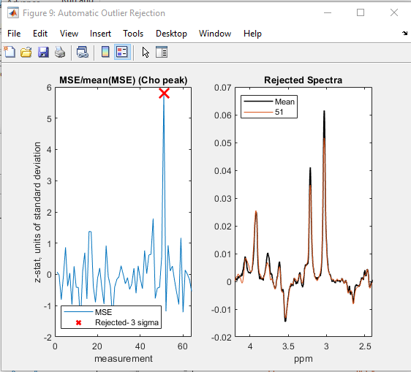

* 1. **Difference spectrum – for MEGA processing only**

The final aligned ON and OFF spectra are plotted before subtraction (to make difference spectrum)

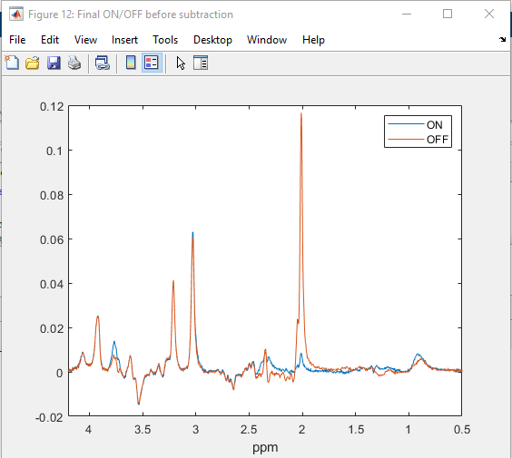

The mean GABA difference spectrum with corrections is plotted. The arrow indicates the GABA peak. Comparison is made between Spectral Registration and Spectral Registration + final alignment procedure (DAS). Either side of the GABA peak should be clean and free of subtraction artifacts.

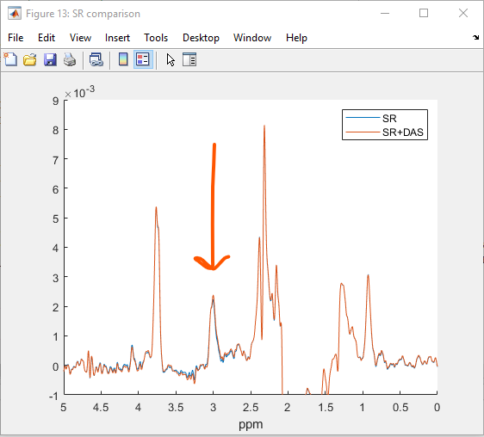

Figure : Example GABA difference spectrum

* 1. **Example subtraction artifact – for MEGA processing only**

Data processed using specReg should be free of subtraction artifacts. An example of a subtraction artifact is given below. Here the spectrum to the left of the GABA peak is not flat and contains some residual signal from the Choline peak. **This should be avoided.**

**Difference spectra should be visually checked after running specReg to make sure subtraction artifacts are not present!**

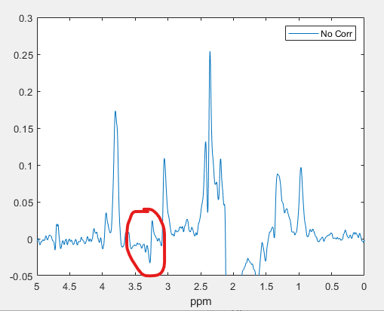

Figure : Example subtraction artifact, which happens when alignment doesn't work

1. **specReg directory**

After running specReg a new directory will be created in the current working directory. Within this folder, the outputs (figures) and processed data will be stored.

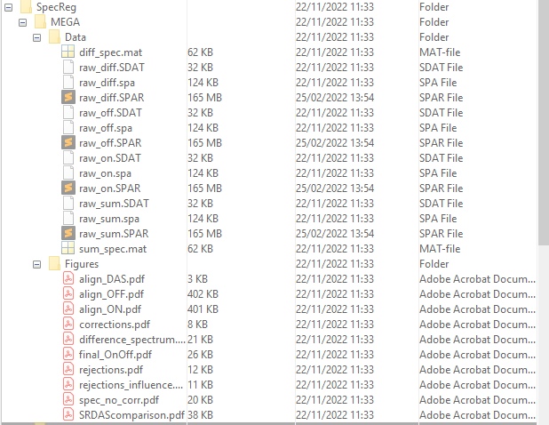

Figure 8: MEGA processing with specReg

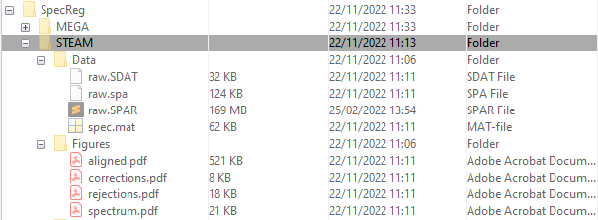

Figure 9: STEAM processing with specReg

The data contained in this folder is ready to be processed for LCModel.