**Introduction**

This guide is for users wising to pre-process data (acquired using UoN scanners) using the specReg pipeline. It covers tissue correction for data already fit with LCModel.

**Currently the pipeline supports MEGA-sLASER (MEGA) at 3T/7T and STEAM, sLASER at 7 T**

Any issues running specReg can be addressed to [adam.berrington@nottingham.ac.uk](mailto:adam.berrington@nottingham.ac.uk)

**A note on tissue correction**

There are many pieces of software which estimate grey, white matter and CSF for use in tissue fraction calculations. You are welcome to do this step manually and perform your own corrections. This guide will describe a semi-automated pipeline using fsl-mrs to get tissue fractions from the accompanying anatomical image and then feed those into a quantification script to output tissue corrected values. If you have your own tissue concentrations calculated from another program (i.e. Gannet/SPM) then you can skip to step 5.

1. **Required software**

FSL (with FSL-MRS) <https://fsl.fmrib.ox.ac.uk/fsl/fslwiki/FslInstallation>

spec2nii <https://github.com/wtclarke/spec2nii>

dcm2niix <https://github.com/rordenlab/dcm2niix>

1. **Convert spectroscopy from SDAT/SPAR to nifti (Running spec2nii)**

First the SDAT/SPAR Philips formats should be converted to nifti (.nii) imaging format.

This can be done using the spec2nii tool. Once downloaded and installed, it can be run from the command line as:

spec2nii philips SDAT_FILE SPAR_FILE

You need to point to the correct SDAT_FILE and SPAR_FILE which corresponds to the MEGA acquisition, such as:



You will then end up with a [SPECTRO].nii.gz in the file directory

1. **Convert T1w anatomical from PAR/REC to nifti (Running dcm2niix)**

To convert the anatomical image, you need to install the dcm2niix tool, available here  
<https://github.com/rordenlab/dcm2niix>

Run the command and point to the PAR file corresponding to the anatomical image.

For example:

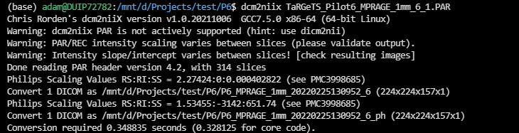

You will end up with a .nii.gz file in the directory.

1. **Check image outputs are correct**

Open an image viewer (such as [MRIcon](https://www.nitrc.org/projects/mricron) or [FSLeyes](https://fsl.fmrib.ox.ac.uk/fsl/fslwiki/FSLeyes)) to view the calculated nifti images and check the placement is correct.

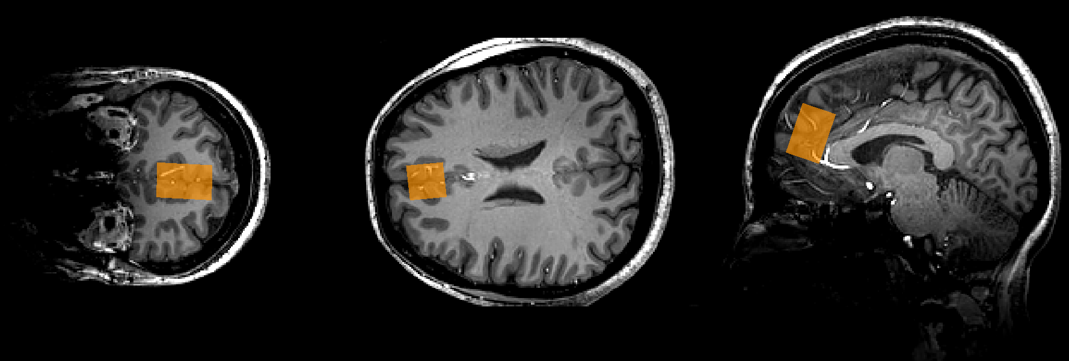

*MRS voxel in orange – overlaid onto anatomical scan*

1. **Run svs_segment to get segmented tissue fractions**

Tissue calculation will be run using FSL-MRS tools

<https://users.fmrib.ox.ac.uk/~saad/fsl_mrs/html/quantitation.html>

With FSL-MRS installed, run the following command (replacing [T1] with the filename of the T1 image, and [svs_data] as the spectroscopy filename)

svs_segment -t [T1].nii.gz -f tissue_frac [svs_data].nii.gz

This command takes some time (~40mins) to run since it is performing tissue estimates, registration and brain extraction in a single command.

After this, you should be left with a .json file containing the tissue fractions.   
  
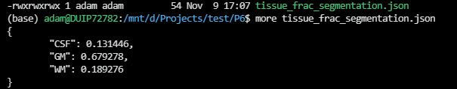

1. **Read and correct tissue fractions from LCModel**

Depending on your acquisition, select the appropriate script to run for tissue correction:

|  |  |
| --- | --- |
| **Acquisition** | **Script** |
| MEGA (sLASER or PRESS) | spec_reg_quant_MEGA |
| 7 T STEAM | spec_reg_quant_STEAM |
| 7 T sLASER | spec_reg_quant_sLASER |

Run the correct script above from the normal working directory level.

If you have your own tissue fractions calculated you can run any of the scripts with an argument specifying the GM, WM and CSF fractions.

For example

specreg_quant_MEGA([0.2, 0.7, 0.1])

otherwise you can leave the arguments blank and the script will read the outputs from steps 1-4 automatically, i.e.

specreg_quant_MEGA()

Once complete, a new folder will be created within SpecReg called Quant. Inside will be the concentrations and corrected values saved as a .csv file.

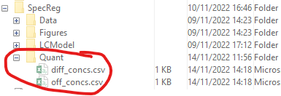

Figure : Result of specReg quantification for a MEGA acquisition

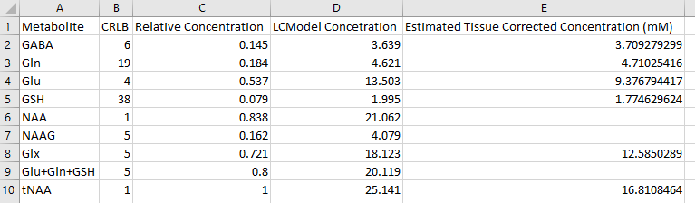

**CRLB**: Cramer-Rao Lower Bound from LCModel gives an estimate of uncertainty on each metabolite fit.

**Relative Concentration**: Taken from the LCModel ouput (could be /NAA or /tCr depending on acquisition and LCModel setup). If reporting relative concentrations for GABA, please use the LCModel Concentration (from raw_diff.csv) divided by the concentration from raw_off.csv. For example, GABA/tCr should be calculated by dividing the GABA from column D in above, by the corresponding value for tCr in the OFF data.

**LCModel Concentration**: Taken from LCModel – this is the uncorrected water referenced concentration

**Estimated Tissue Corrected Concentration (mM)** – Using the tissue fractions and relaxation constants to estimate a mM concentration.

**Important**

**For MEGA analysis, use the GABA values from the raw_diff.csv file. For all other metabolites use the values from raw_off.csv file.**

*A note on relaxation values –*

Relexation values for water and for the various metabolites are taken from literature. They are saved in the main specReg code under

D:\Packages\specReg\quant\RM_7T and RH2O_7T for 7 T acquisition.   
  
The literature values are taken from different sources outlined in T1T2Refs.xlsx.