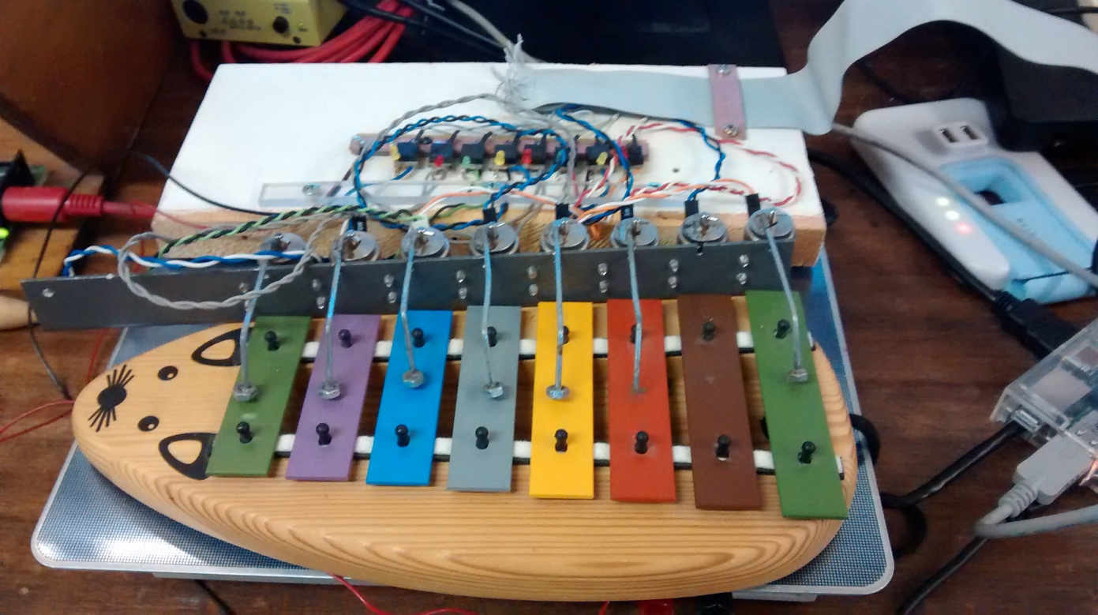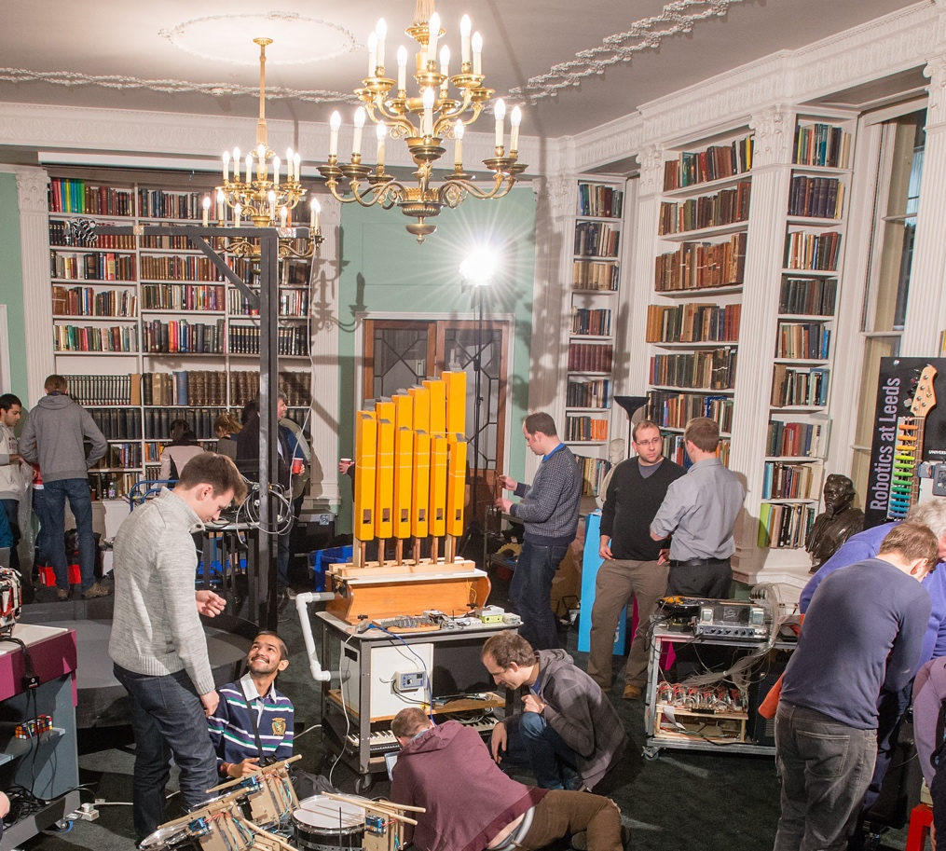

**What’s next?**

* Improve the control of existing instruments.
* Investigate the control of other styles of instrument.

Link to further info

**Why is it important?**

* It encourages us to understand how a human interacts with the instrument.
* It causes us to gain an understanding of why a device might struggle with a task that a human finds relatively intuitive.

**How is it done?**

* We construct a 'device' that imitates human behavior in controlling the instrument.
* MIDI music is sent to a small microcomputer which then activates the device controlling the instrument.
* We collaborate with other groups when opportunities arise.

Dave Price and Colleagues, Computer Science

**Introduction**

* Computer/robotic controlled production of music.
* Using (adapted) real instruments - not synthesizers.
* Distributed and extendable.

Photo: Paul Wilkinson, Royal Institution.



Towards a Robotic Orchestra