OpenSCAD
Workshop 1: Making a mast holder

Step 1: Download an install OpenSCAD.

Windows and Mac: http://www.openscad.org/downloads.html
Linux: There is probably a version in your distro’s repositories, if there is one, it is probably best to get it from there. On the page linked above for the Windows and Mac users there are instruction on how to install it for some common distros, as well as links to snaps and flatpacks.

Step 2: Open scad and click new.

It should take you to an empty project that looks something like this:

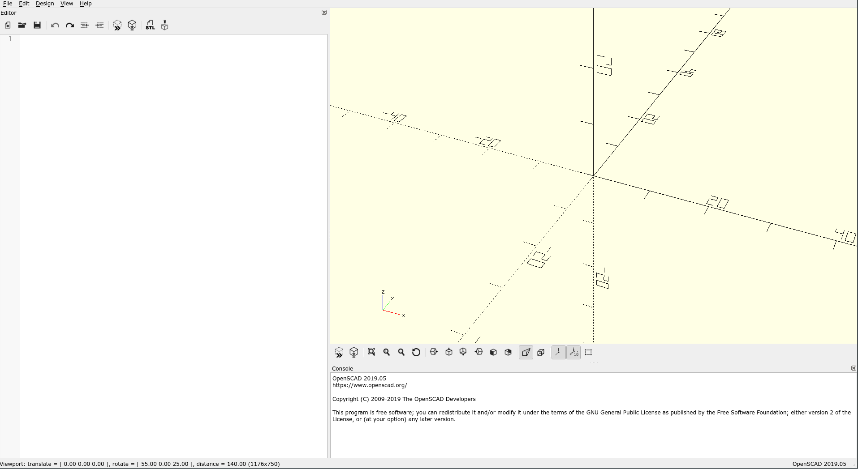

On the left is the editor. This is where you’ll be writing your code.
The window in the top right is the viewport. It will give a visual representation of what you are doing.
The bottom right is the console. Errors messages will be highlighted in yellow.

Take a moment to familiarize yourself with the viewport and it’s controls.

- Left click and drag is rotate.
- Right click and drag is pan.
- Scroll to zoom.
- You should also try out the buttons under it.

Step 3: Make a cuboid

In OpenScad the main way you make models is that you create primitives and then modify them. So in general the syntax looks like this:
...
modification2()
modification()
primitive();

The modifications are applied in reverse order, so in this example modification is applied before modification2.

Don’t worry if seems a little abstract for the moment, it probably will become clearer once you start using it.

Now back onto the cuboid. To make a cuboid type this into the editor:
cube([75, 75, 5]);

The numbers in the array correspond to the x side-length, the y side-length and z side-length (in that order) of the cuboid. The sizes are in millimeters (and can be non-integers). Most things in OpenSCAD are measured in millimeters (degrees for angles). Next, you need to tell OpenSCAD to preview your code.

Press F5 or the preview button, which is the box with two arrow heads in-front of it (there are two preview buttons, one above the editor and one below the viewport).

You should end up with something that looks like this:
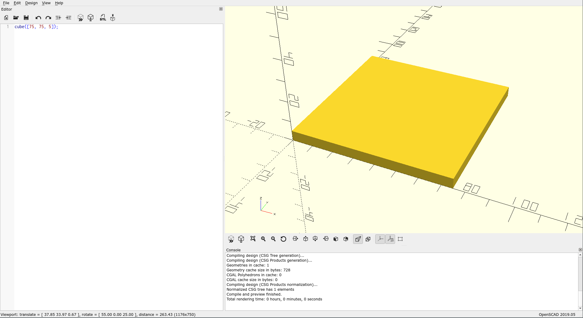
Step 4: Use variables.

You sometimes want to re-use a value multiple times. You could just type the value in every time you need it. But that can quickly get messy if you want to change the value later. You will end up having to change every single instance of that value, and that’s time consuming and error-prone. So instead we define variables.

Variables are defined like this:

my_variable_name = 34.5;

After you have done this you can now use the name you gave your variable instead of the value. You can only use the variable further down the file than where you declare it.

As we want to use the values for the size of the cuboid again later, we want to make variables out of them.

Make variables representing the values, and then replace the values with their variable names. You should end up with code that looks something like this:

base_width = 75;
base_thickness = 5;
cube([base_width, base_width, base_thickness]);

When you press preview nothing should change.

Step 6: Make the outside of the mast shaft.

We are going to make the mast shaft out of a cylinder. We are going to need the values defining the cylinder multiple times so we need to turn them into variables.

outer_shaft_length = 50;
outer_shaft_diameter = 20;

To create the cylinder itself the syntax is:

cylinder(d = outer_shaft_diameter, h = outer_shaft_length);

Once you have added these lines to the project, making sure that the variable definitions come before the their use, press the preview button and you should end up with something that looks like this:

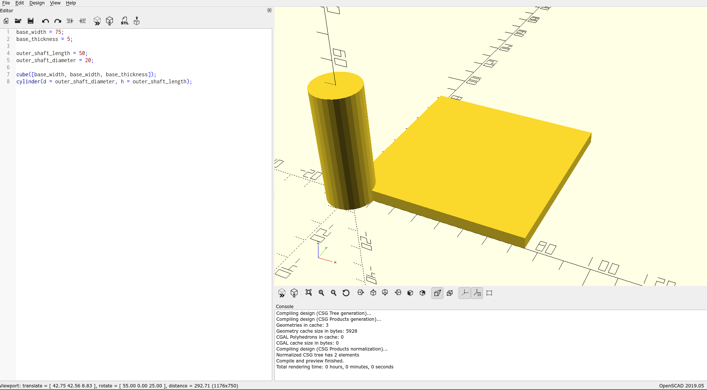

Step 7: Move the cylinder into place.

We are now going to use one of those modifiers I talked about earlier. We are going to use the translate modifier.

The syntax for translate looks like this:

translate([x, y, z])

If you remember from before the syntax looks like this:

modification()
primitive();

So we are going to apply this pattern to the cylinder:

translate([base_width/2, base_width/2, -outer_shaft_length])
cylinder(d = outer_shaft_diameter, h = outer_shaft_length);

Notice that the line with translate on it doesn’t have “;” at the end.

After you press preview you should end up with something that looks like this:
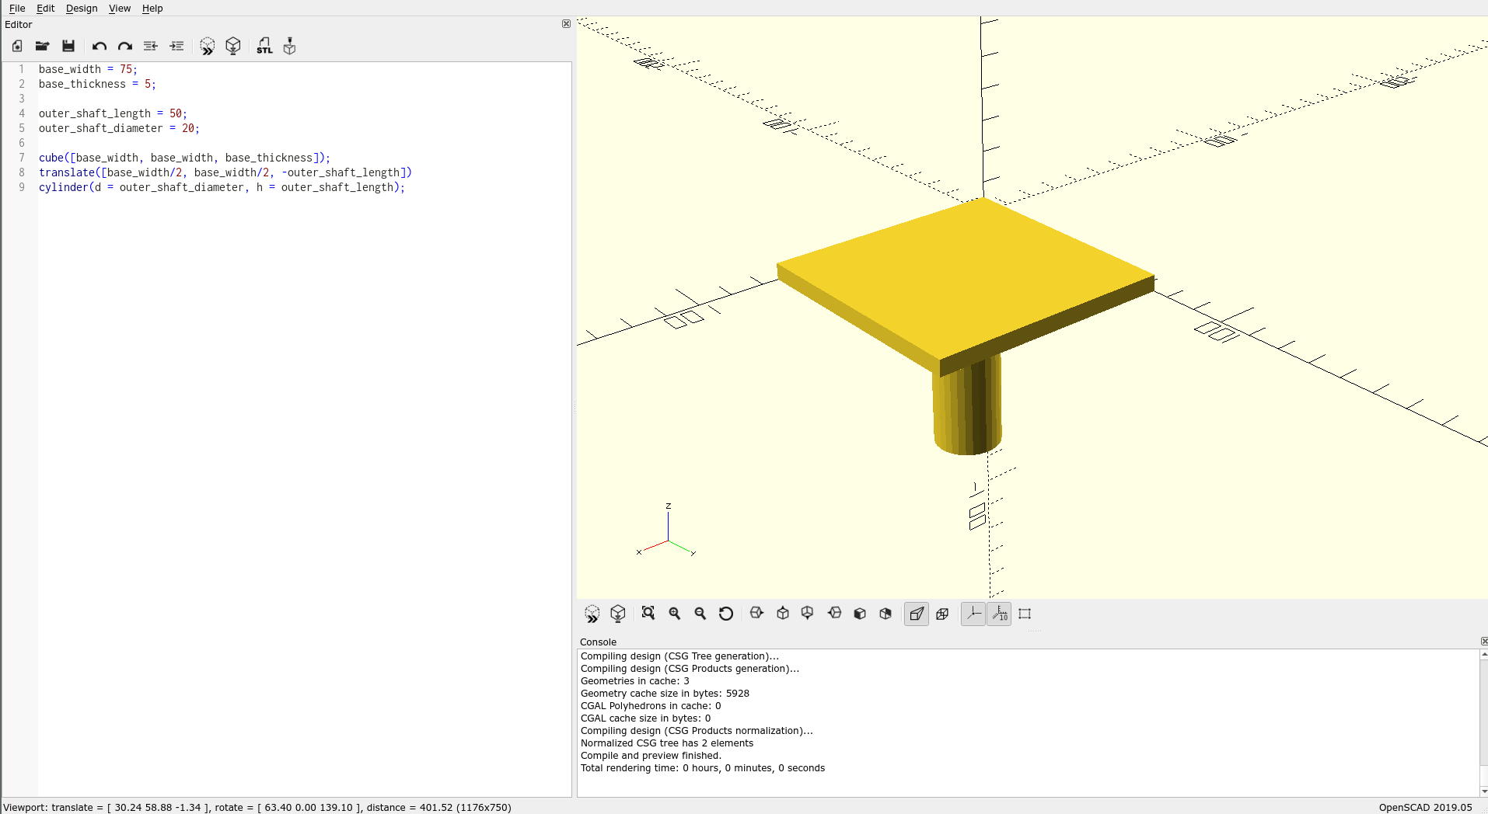

Step 8: Make the cylinder smoother.

You have probably noticed that the cylinder is not very smooth. This is in-fact one of OpenSCAD’s main limitations, it does not deal with curves. For the most part this can be gotten around by increasing the number of line segments OpenSCAD will use. We can do this by changing one of the system variables.

Add this line to the beginning of the file:

$fn = 100;

You should make changes to the system variables at the top of the file, as changing them can be very resource intensive.

Press preview again and the cylinder should become much smoother.

The performance effects can be best seen when you render the project. You can render the project by pressing F6 or the button with the cube with an hour-glass in-front (next to the preview buttons).

Try changing the value and then clicking rendering to see the results and how much time it takes. “$fn = 1000” takes a few seconds for my laptop to render. Don’t set the number too high (>5000ish) because this can cause OpenSCAD to hang.
Step 9: Cut a hole in the shaft.

When you want to cut a shape out of another shape you use a difference block. The syntax for this looks like this:

difference() {
shape();
shape2();
shape3();
...
}

When OpenSCAD encounters this, it will create “shape”, and then it will see where “shape” intersects with any of the shapes that come after. Anywhere they do intersect will be removed from “shape”.

But there is a problem for us. Our shape so far is made from two shapes. For it to fit with work in difference it needs to be one. Otherwise we would cut one out of the other. The way we make them one shape is using a union block. The syntax for this is:

union() {
shape();
shape2();
shape3();
...
}

This tells OpenSCAD we all of the shapes inside of the union to be treated as one.

Wrap the cuboid and cylinder in a union block and then difference block. You’re code should end up looking something like this:

difference() {
union() {
cube([base_width, base_width, base_thickness]);
translate([base_width/2, base_width/2, -outer_shaft_length])
cylinder(d = outer_shaft_diameter, h = outer_shaft_length);
}
}

When you press preview nothing should change.

Now we are going cut a cylinder out of the shaft. We are going to be using the same values several times, so we need to make two more variables defining the shape of the cylinder we want to cut out:
inner_shaft_diameter = 15;
inner_shaft_length = outer_shaft_length - 5;

Notice how “inner_shaft_length” is defined in terms of “outer_shaft_length”. This means that this definition needs to come after the definition for “outer_shaft_length” in the file.

To cut the cylinder out of the shaft we need to create it after the union but still inside of the difference. We are going to create the cylinder in the same way we did before. Firstly creating the correct size cylinder and the moving it to the correct location: The code should look something like this:

difference() {
union() {
...
}
translate([base_width/2, base_width/2, -inner_shaft_length])
cylinder(d = inner_shaft_diameter, h = inner_shaft_length + base_thickness);
}

Press preview. If this has gone correctly you may see some visual artifacts on the top of the model. When you move the viewport around they will shimmer. This is normal. When you use difference and a face of the base shape and a face of the cutouts are exactly on top of each other this happens. You can get rid of this by rendering instead.

What is should look like after pressing preview:
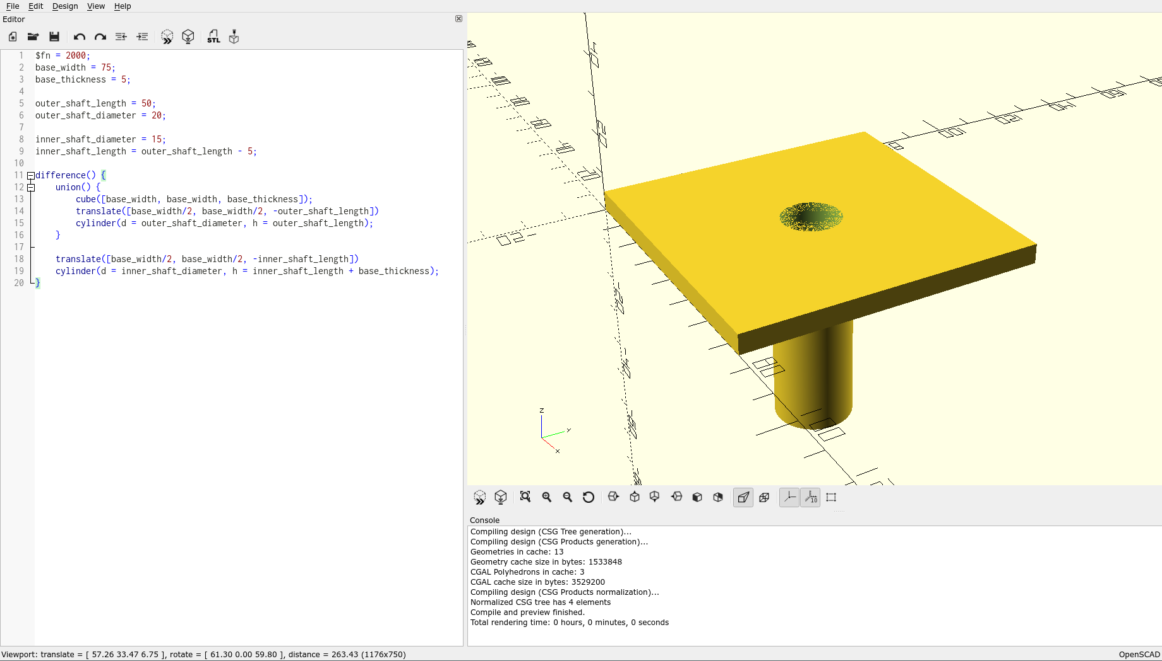
What it should look like after pressing render:
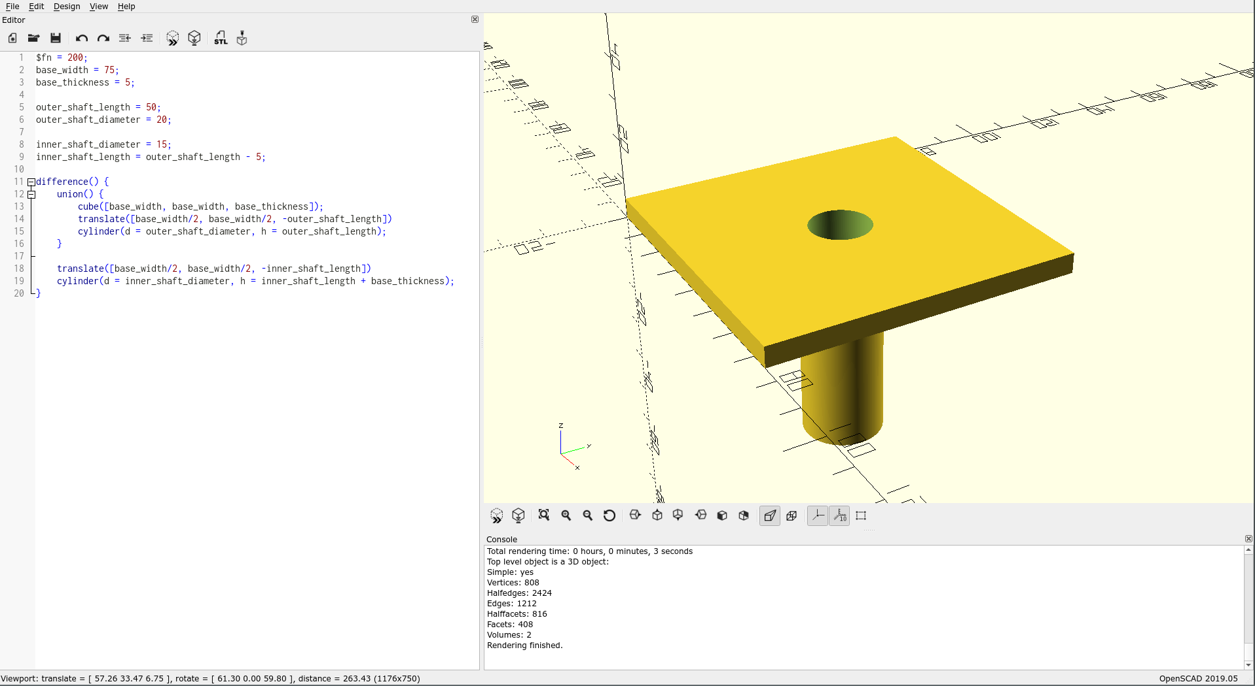

Step 10: Add mounting holes.

OpenSCAD has for loops that allow you to generate do the same thing multiple times but with changing values.

The syntax for a for loop looks like this:

for (i = [start:step:end]) {
...
}

What this will is that it will first run the code in the between the brackets with “i” set to the value of “start”. Then it will add “step” to “i”. And run the code between the brackets again. It will keep adding “step” to “i” and running the code between the brackets until “i” is greater than “end”.

While we are only going to use this to make four holes, and so this is a little overkill, this method is very useful for making a lots of the same object so it’s worth seeing.

First we need to use some values several times so we are going to need to make some variables.

mounting_hole_radius = 2.5;
distance_from_edge = 10;

First, we are going to make only two of the holes, so it’s a little easier to see what is happening.

Inside of the difference but after after the union, we are going to make a for loop that creates a cylinder of the correct size, then moves it to the correct place. The code should look like this:

difference() {
union() {
...
}

...

for(y = [distance_from_edge : base_width - 2 * distance_from_edge : base_width] ) {
translate([distance_from_edge, y, 0])
cylinder(r = mounting_hole_radius, h = base_thickness);
}
}

This might look a little bit complicated, it’s not helped by the fact that the for is going over two lines. You can expand you’re editor by dragging on the edge between it and the viewport to change it’s size.

Once you have pressed render you it should look something like this:
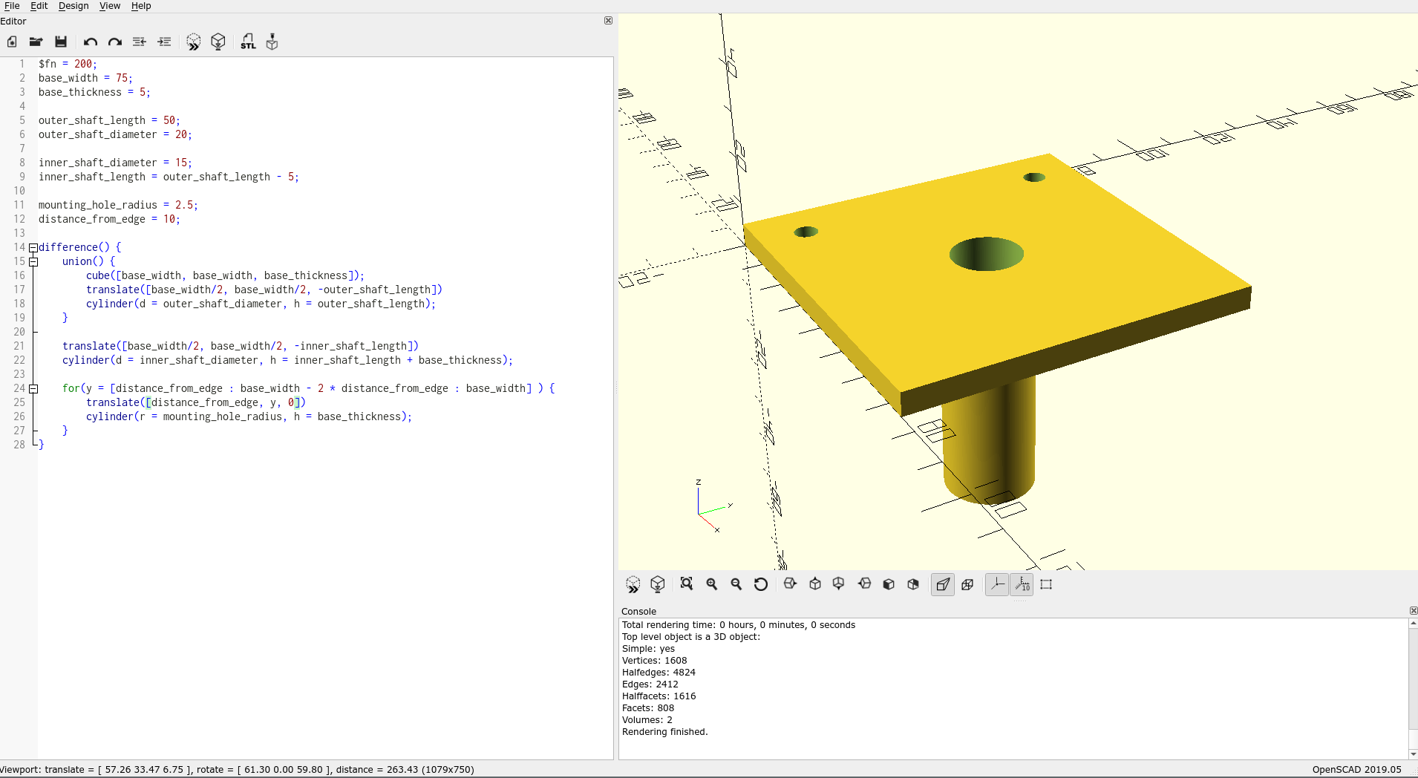
Now we’re going to surround this is another for loop that is going to change the values in the x direction in the same way:

difference() {
union() {
...
}
...
for(x = [distance_from_edge : base_width - 2 * distance_from_edge : base_width] ) {
for(y = [distance_from_edge : base_width - 2 * distance_from_edge : base_width] ) {
translate([x, y, 0])
cylinder(r = mounting_hole_radius, h = base_thickness);
}
}
}

Be careful not to miss that the “distance_from_edge” in the translate changes to an “x”.

Once you have rendered the project it should look like this:
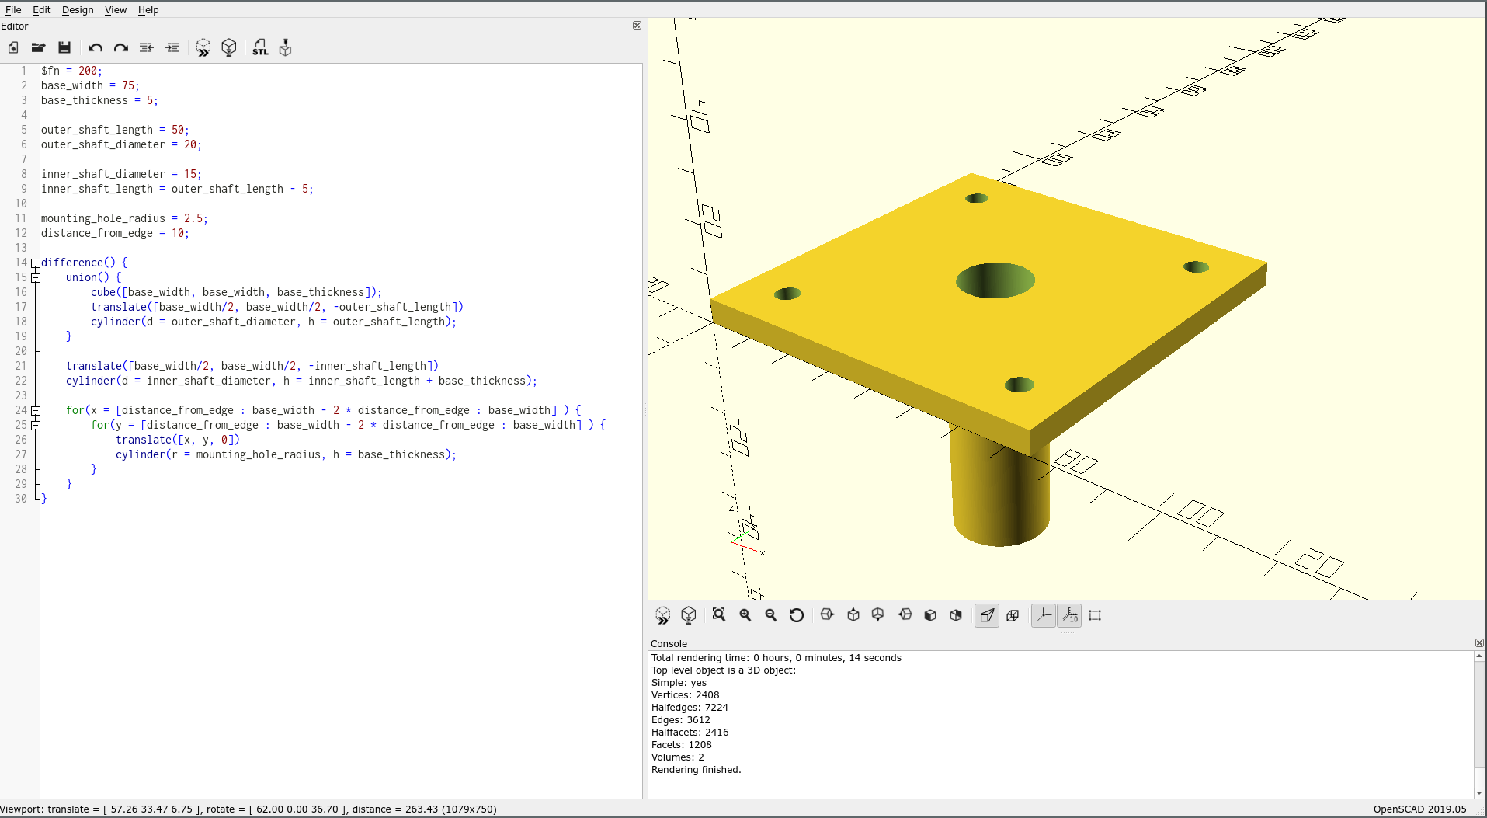

Step 11: Export

To export your model to a format that other programs can use, first you need to render the project. Then you need to press F7 or press the button with a piece of paper that is folded over and has “STL” written in-front of it (above the editor). Then you can save the file where you like.

