Project Report - 12/8/24
Team 1: Ali Beshir, K***, K***, J***

Introduction:
Electric vehicles (EVs) have emerged as a source of innovation in the fight against global warming. They offer a sustainable alternative to traditional gas-powered vehicles, significantly reducing greenhouse gas emissions. In recent years,there has been a steady growth in the adoption of EVs, due to advancements in technology, more environmental awareness, and supporting policies. In particular, Washington State has become a powerhouse for this transition, with a growing population of EVs supported by clear energy programs such as the Clean Alternative Fuel Vehicle (CAFV) program. This adoption inspired our team to create the Washington_EVs database, which contains insights into EV usage across the state.
When planning database ideas, we were drawn to the growing interest in clean energy and sustainable transportation. After considering different topics we chose EVs because of their impact on the environment and their increasing trendiness in the market. We began with a very broad scope, trying to include as much data on EVs in Washington as possible. Further on, it came to our understanding that we needed to narrow the focus of our project, which led us to refine the dataset by focusing on Battery Electric Vehicles (BEVs) and Plug-in Hybrid Electric Vehicles (PHEVs), and organizing the data into seven connected tables. These tables cover vehicle details and coordinates, geographic information, utility connections, and CAFV eligibility. This enables us to address the key trends accurately.
This database, as well as the queries we developed, could be insightful for researchers and prospective EV owners. By providing insights into consumer preferences and trends within the region, the Washington_EVs database contributes to advancing the adoption of sustainable transportation solutions.

Database Description:
Our database is constructed around electric vehicle (EV) adoption in Washington State. The database is designed to serve as a tool for researchers, policymakers, and prospective electric vehicle owners to analyze trends in EV usage and supporting utilities across the state. Our database consists of seven tables and holds detailed data on electric vehicles, their geographic locations, utility connections, and CAFV eligibility. Each table is carefully structured to provide insights into vehicle models, electric utility providers, and geographic information, such as counties, cities, and legislative districts. By organizing this information into a relational database, users can easily explore and analyze patterns in EV adoption, utility usage, and geographic distribution, making it a valuable resource for advancing sustainable transportation initiatives.

ERD: washingtonEVs
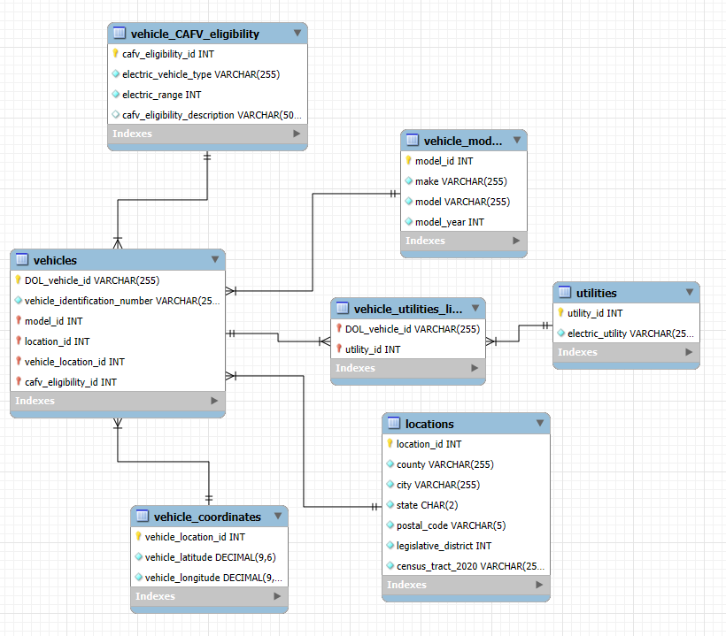
Logical Design:
One of our top priorities was to create a logical design that is clear, functional, and capable of answering detailed queries about electric vehicles (EVs) in Washington State. To achieve this, we structured the design with seven tables. This structure provides enough granularity for users to query specific details without overwhelming them. The vehicles table serves as the central hub of the database, containing key identifiers like the DOL_vehicle_id and foreign keys that link it to related tables. Foreign key relationships were intentionally incorporated to enhance the coherence and usability of the database. For example, the location_id foreign key connects the vehicles table to the locations table, which stores county, city, and legislative district details. We also incorporated a **many-to-many relationship** between vehicles and utilities using the vehicles_utilities_link table. This table connects the DOL_vehicle_id with the utility_id from the utilities table, which lists electric utility providers. This design allows users to query which vehicles are serviced by specific utilities efficiently. To ensure data integrity and functionality, we identified columns that should include non-null constraints. For example, columns such as DOL_vehicle_id, vehicle_identification_number, and electric_utility were marked as non-null, as these are critical for uniquely identifying vehicles and utilities. By carefully structuring the relationships and constraints, our logical design ensures a robust, efficient, and user-friendly database for analyzing EV trends, geographic data, and utility connections in Washington State.

Physical Design:
Our Washington_EV database is structured into seven interconnected tables that provide insights into electric vehicle usage in Washington State. Our seven tables include locations, vehicle_cafv_eligibility, vehicle_coordinates, utilities, vehicle_models, vehicles, and a linking table called vehicles_utilities_link. The vehicles table serves as the core table, containing details such as vehicle identification numbers, models, locations, and CAFV eligibility. It connects to the vehicle_models table, which includes information on the make, model, and year of each vehicle, and to the vehicle_CAFV_eligibility table, which provides eligibility descriptions and electric range data. Geographic data is stored in the locations table, containing the counties, cities, legislative districts, and census tract details, while exact vehicle coordinates are maintained in the vehicle_coordinates table. The utilities table holds information on electric utility providers, and the vehicle_utilities_link table establishes a many-to-many relationship between vehicles and utilities. This normalized structure ensures efficient data retrieval, minimizes redundancy, and allows for comprehensive analysis of electric vehicle trends across geographic and utility-based dimensions.

Sample Data:
Our sample data provides a clear representation of the information stored in the Washington_EV database. For instance, the locations table includes geographic details such as counties, cities, postal codes, and legislative districts, with entries like "Spokane", "King", and "Benton" counties. The vehicles table contains data on electric vehicles, including unique Department of Licensing (DOL) IDs, vehicle models, and their corresponding locations. Additionally, the utilities table captures various electric utility providers like "Puget Sound Energy INC", while the vehicle_utilities_link table maps the many-to-many relationship between vehicles and their associated utilities. There are other tables like the vehicle_CAFV_eligibility, vehicle_coordinates, and vehicle_models that include information about electric vehicle eligibility based on range and type, geographic coordinates (latitude and longitude) for vehicle locations, and specific details about the vehicle's make, model, and production year. This sample data highlights the interconnected nature of the database and provides a solid foundation for analyzing electric vehicle usage and trends across Washington State.
Example of Our Vehicles Table:

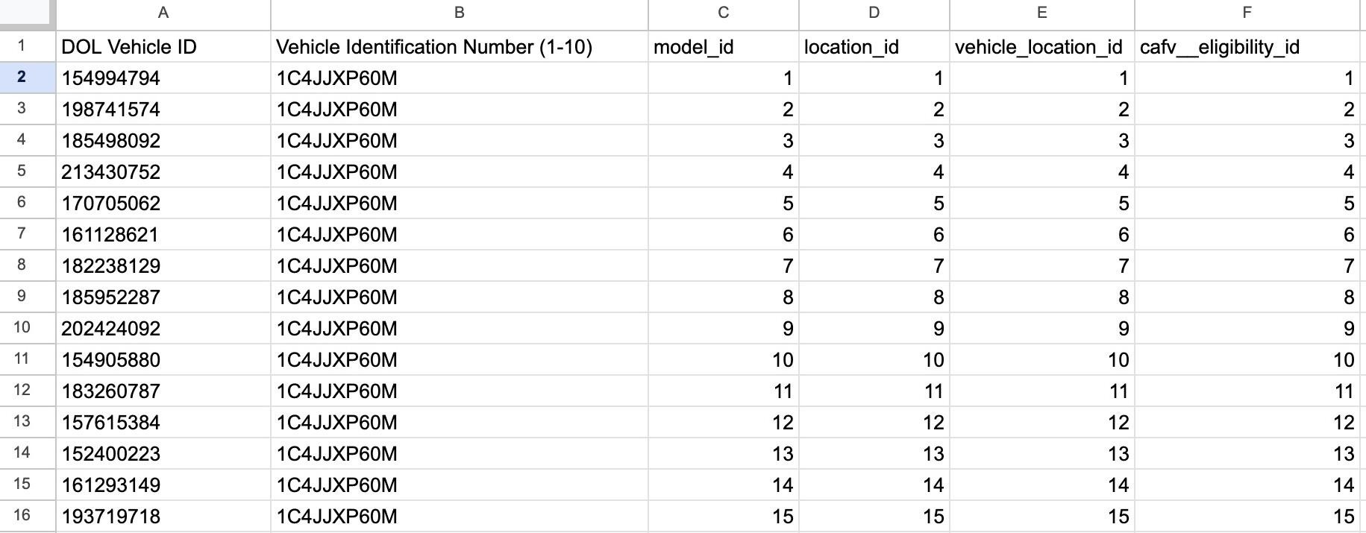

Views / Queries:
View Name | Requirement A | Requirement B | Requirement C | Requirement D | Requirement E
jeep_county | x | x | x
avg_electric_range | x | x | x
puget_users | x | x | x | x
county_vehicle_count | x | x | x |  | x
king_vehicle_count | x | x | x

We have created 5 queries and saved them as views for our database to make the data easily accessible for analysis. Each view answers specific questions about our dataset and displays relevant information. These views allow users to retrieve summarized and aggregated data with ease, without needing to write the underlying SQL code themselves. Below is a summary of the five views created:

Query 1: jeep_county
This view counts the number of Jeep Wranglers in each county. It joins the vehicles, vehicle_models, and locations tables, filters for the make "JEEP" and model "WRANGLER", and counts the total vehicles in each county. This provides a quick summary of Jeep Wrangler distribution across counties.
Query 2: avg_electric_range
This view calculates the average electric range of electric vehicles in each legislative district. By joining the vehicle_CAFV_eligibility, vehicles, and locations tables, it aggregates the data to show the average electric range for vehicles that are eligible for CAFV, grouped by legislative district.
Query 3: puget_users
This view counts the number of users of Puget Sound Energy electric vehicles in each legislative district. It joins the vehicle_utilities_link, utilities, vehicles, and locations tables to filter for electric vehicles using the "PUGET SOUND ENERGY INC" and "CITY OF TACOMA - (WA)" utilities and groups the count by legislative district.
Query 4: county_vehicle_count
This view counts the total number of vehicles in counties that have more than two vehicles. Using a subquery, it first identifies counties with more than two vehicles, then aggregates the count of vehicles by county. It helps identify counties with a significant number of vehicles.
Query 5: king_vehicle_count:
This view provides the number of vehicles across different cities within King County. By joining the locations, vehicles, and vehicle_models tables, it groups the data by city, county, and vehicle make, giving a detailed view of vehicle distribution in King County specifically.

Changes from Original Design:
Since our project proposal, we have made substantial changes to the database. We began with restructuring the database by expanding it into 7 distinct tables to ensure better clarity and organization. We also changed our relationship lines in our ERD from dotted lines that represent a non-identifying relationship to a solid line to highlight the relationships between the foreign and primary keys. This helped to clearly define the connections between tables and improve the overall structure of the database. Additionally, a major change from the original design was modifying the foreign key relationships in the ERD. We had to adjust which items were designated as foreign keys for the reverse engineering to work. However, we encountered an issue where we had to make a critical adjustment to the vehicle_utilities_link and utilities tables. Initially, the utilities table contained multiple pieces of utility information in one cell, which was not ideal. We revised this to ensure each utility had a unique primary key. The vehicle_utilities_link table was also updated to correctly match the Department of Licensing (DOL) IDs with the utility IDs they used, showing the many-to-many relationship between vehicles and utilities. We then successfully reverse engineered our database into an ERD and generated a creation script that includes all seven tables. Throughout every stage of the project, we collaborated to identify and revise any parts of our database that didn’t work, ensuring that the final design improved its efficiency, integrity, and usability, making it a solid tool for analyzing electric vehicle trends in Washington State.

Database Ethics Considerations:
Ethical considerations are critical for our Washington_EV database, especially when dealing with data privacy, fairness, and transparency. While the data is sourced from public records, combining geographic details with vehicle identifiers could accidentally expose sensitive information. To address this, the database should prioritize anonymizing or aggregating data, such as grouping location data by ZIP code or county instead of using exact coordinates. Transparency is equally important when dealing with sensitive information. Clear documentation of data sources, data cleaning methods, and disclaimers about dataset limitations ensures that users are fully informed and can use the data accurately and effectively. Prioritizing transparency and data privacy helps prevent misuse and fosters trust in the database.
In addition to privacy and transparency, data security and compliance are essential. Adhering to the Washington State Department of Licensing's data usage policies and properly attributing sources ensures compliance with copyright and fair use standards. By addressing these ethical considerations, the Washington_EV database can maintain its integrity, protect sensitive information, and provide a valuable tool for understanding EV trends. Ultimately, these measures not only strengthen the database's reliability but also contribute to equitable and ethical advancements in EV adoption.

Lesson Learned:
The main lesson we learned as a group this semester was the importance of communication and proactiveness. At the start of the year, we made sure to emphasize communication because we all knew that doing a semester-long project while also dealing with a relatively unfamiliar software would definitely bring challenges. We made sure to keep eachother on the same page constantly in order to do the best we could on the major assignments and as a result, we have had virtually no conflicts whatsoever which made the project much easier. Team proactiveness was also a very important lesson we learned. During our Project Logical Design assignment, we were very pressed on time and ended up turning in the assignment at the very last second. This was due to us making many last second changes. We all realized that if we had started earlier and had gotten help from someone on the teaching team, things would have been much less stressful. From then on, we made sure to start finishing parts very early in order to get advice and have confidence in our submissions. Other than those lessons, we also learned a lot about database design and how important the quality of sample data is. Cleaning up our data to fit the database design we were going for made things like normalizing and importing data much easier.

Potential Future Work:
One way we can enhance our electric vehicle database is by including more information about the vehicle’s performance. For example, this could include information about battery life, charging times, and even user feedback or reviews from EV users. This way people could use the database to assess the aspects of owning different electric vehicle models. Another potential improvement for our database would be to integrate the environmental impact data of the different vehicle models. This information could include the reduction of carbon emissions by area based on EV adoption to help policymakers and researchers better track progress toward sustainability. Lastly, by expanding the data collected about eclectic vehicles from not just the state of Washington but across the United States would be a huge improvement for future work on this database. This would provide a broader perspective on EV adoption because data from various regions would allow researchers, businesses, and policymakers to compare trends, assess policy effectiveness, and identify areas for infrastructure improvements and sustainable transportation strategies.

