Candice Fotheringham CV

Dancer/Model/Actress/Professional Stylist

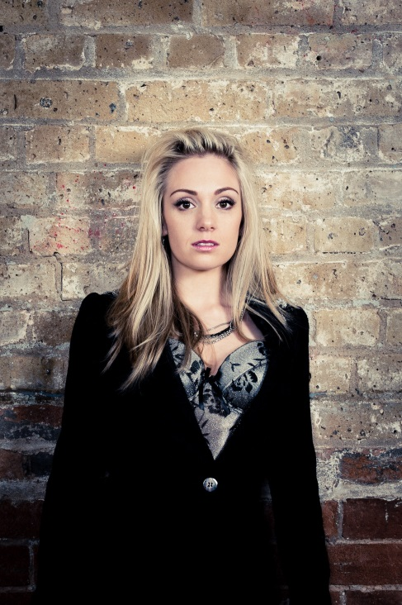

Email: [Candice@fotheringhamstyling.com](mailto:Candice@fotheringhamstyling.com)

Mobile: 07564218061

D.O.B: 05/01/1983

Hair colour: Blonde

Hair type: Long wavy

Eye colour: Dark brown

Dress size 6-8

Height 5ft 4inches

Weight: 47kg

Nationality: British

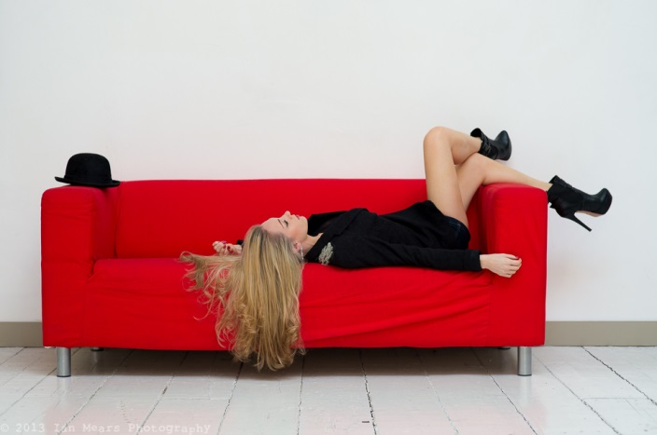

I am a passionate, determined, ambitious individual. I was a professional dancer with the Birmingham Royal Ballet company and am highly trained in most styles of dance.

**Experience**

Current: CEO and Professional stylist of Fotheringham Styling <http://www.fotheringhamstyling.com/>

2013: Designed/styled/created outfits (80% by hand) for girl group Monroe – Isle Of Wight Festival

2013: Designed/styled/created outfits for girl group Monroe – Malta Music Awards (same outfits used for music video)

2010 – 2013: Stylist at The Beckster Lifestyle

2012: Gary Go music video – Gulity Pleasures (acting)

2011: Pussy.co advert (actress/model – Maria) <http://www.youtube.com/watch?v=InZ2uf_AVJo>

2011: Gary Go music video – Through the walls (dancer/model, main girl) <http://www.youtube.com/watch?v=WBEjz_Jk8ZY>

2010: Potbelleez music video – From the music (acting/model/dancer) <http://www.youtube.com/watch?v=jOLbeclDaZ0>

2007 – 2010: Ballet, tap, modern and jazz teacher (ages 3-21 classes and private tuition)

2002 – 2007: Professional dancer with the Birmingham Royal Ballet company: Ballets include – Swan Lake (Cygnet), Sleeping Beauty (Songbird fairy solo, the little red riding hood), Beauty and the beast (the vixen), Solitaire (polka girl), Giselle, Elite Syncopations, The Nutcracker, Carmina Burrana (Pong tail girl), Romeo and Juliet (Juliet’s friend), La Fille Mal Gardee, Hobson’s choice and more.

1998 – 2002: Royal Ballet Upper School

 

 

Photography Ian Mears: Make-up/hair/stylist – Candice Fotheringham

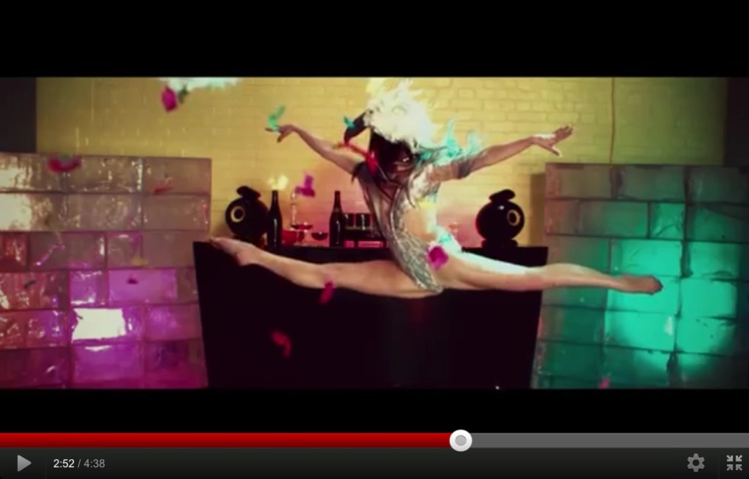

Action shot: Gary Go music video