SUMMITHUB: REAL ESTATE MANAGEMENT SYSTEM (RSMS)
PROJECT DOCUMENTATION

CHAPTER I: THE PROBLEM AND ITS BACKGROUND
I. Introduction
SummitHub is a comprehensive Real Estate Management System (RSMS) developed to modernize the property transaction process. In an era where digital presence is paramount, SummitHub serves as a bridge between property sellers and potential buyers, offering a streamlined platform for property listing, discovery, and communication. The system is built using the Laravel framework, leveraging its robust security features and MVC architecture to ensure a seamless experience for all users.
II. Purpose and Value Proposition
The primary purpose of SummitHub is to provide a centralized marketplace for real estate. It offers efficiency by reducing the time taken to list and discover properties, transparency through detailed specifications, and quality control via administrative moderation. The value proposition lies in its ability to connect diverse users in a secure and structured environment.
III. Target Audience
1. Buyers: Home seekers looking for verified property listings.
2. Sellers: Property owners and agents looking to manage their inventory and leads.
3. Staff/Moderators: Quality control team ensuring listing accuracy.
4. Admin: Platform managers overseeing users and system roles.

CHAPTER II: DESIGN AND ARCHITECTURE
VI. Wireframes and Visual Design
The SummitHub interface is designed for high usability and responsiveness. Below are the core wireframe components and their technical descriptions:
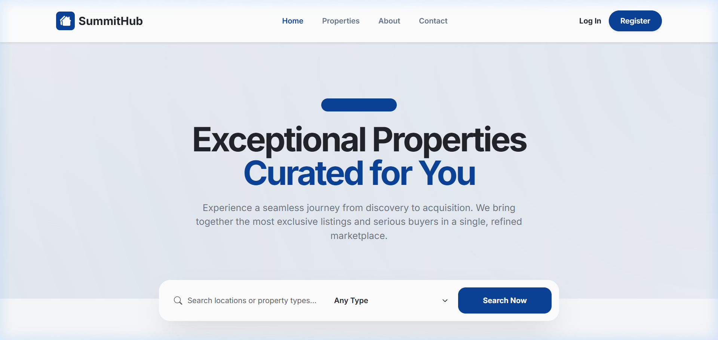
Figure 1: The SummitHub Homepage Wireframe
• Navigation Bar: A sticky header containing navigation links and dynamic Auth buttons. Managed via Laravel Blade components.
• Property Grid: Displays property cards dynamically fetched from the database via Eloquent ORM.
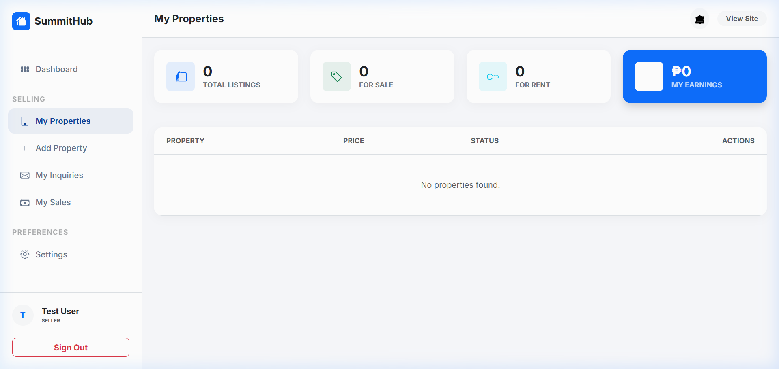
Figure 2: User Dashboard Architecture
• Sidebar Navigation: Features role-based links secured by Laravel Middleware (Admin, Seller, Buyer).
• Statistics Overview: Summarizes user activities such as pending inquiries and active listings.
VII. Task Analysis: Property Inquiry Process
1. Search: Buyer browses the Explore catalog and selects a property record.
2. Detail View: The system fetches full property details from the 'Properties' table.
3. Form Submission: Buyer fills out the inquiry form; Laravel performs Request Validation for data integrity.
4. Persistence: System saves the message to the 'Inquiries' table, linking the Buyer and Seller.
5. Response: The Seller receives a notification in their inbox and can reply through the dashboard.
IX. Entity Relationship Diagram (ERD) Explanation
• Users Table: Stores core identity and authentication data. Acts as the parent for Properties and Inquiries.
• Properties Table: Contains property attributes (price, location, features) with a Foreign Key to the User (Owner).
• Inquiries Table: Facilitates communication between Buyers and Sellers, tracking property-specific messages.
• Roles Table: Handles permission logic to ensure users only access their authorized features.

CHAPTER III: USER INTERFACE MANUAL
This manual provides comprehensive instructions for system navigation and feature usage across different roles.
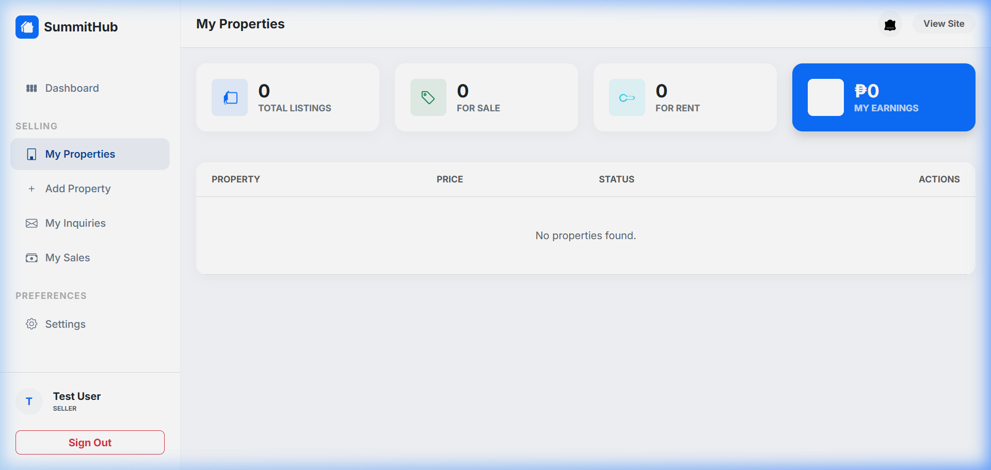
Figure 3: Property Management Interface
1. Listing Management: Sellers can add, edit, or delete listings. Each action undergoes role-based authorization checks.

