SUMMITHUB: REAL ESTATE MANAGEMENT SYSTEM (RSMS)
PROJECT DOCUMENTATION

CHAPTER I: THE PROBLEM AND ITS BACKGROUND
I. Introduction
SummitHub is a comprehensive Real Estate Management System (RSMS) developed to modernize the property transaction process. It serves as a bridge between property sellers and potential buyers, offering a streamlined platform for property listing, discovery, and communication. The system is built using the Laravel framework, leveraging its robust security features and MVC architecture to ensure a seamless experience for all users.
II. Purpose and Value Proposition
The primary purpose of SummitHub is to provide a centralized marketplace for real estate. It offers efficiency by reducing the time taken to list and discover properties, transparency through detailed specifications, and quality control via administrative moderation.
III. Target Audience
The system caters to Buyers looking for properties, Sellers/Agents managing listings, Staff/Moderators reviewing content, and Administrators overseeing the platform.

CHAPTER II: DESIGN AND ARCHITECTURE
VI. Wireframes and Visual Design
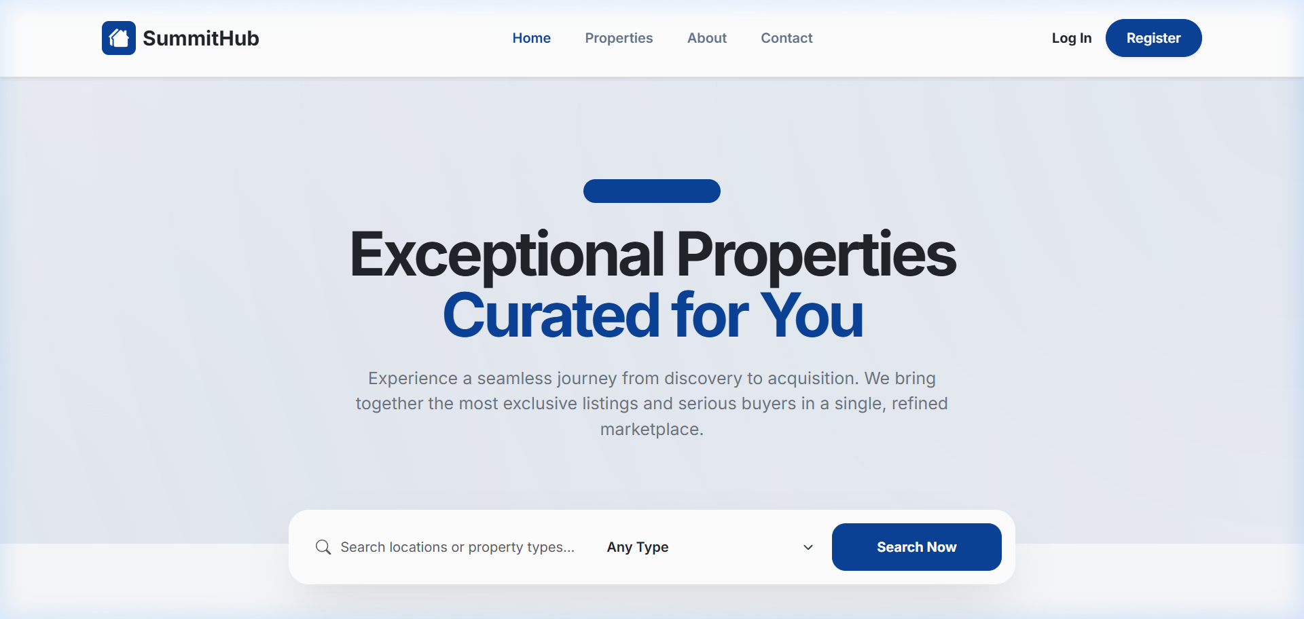
Figure 1: The SummitHub Homepage
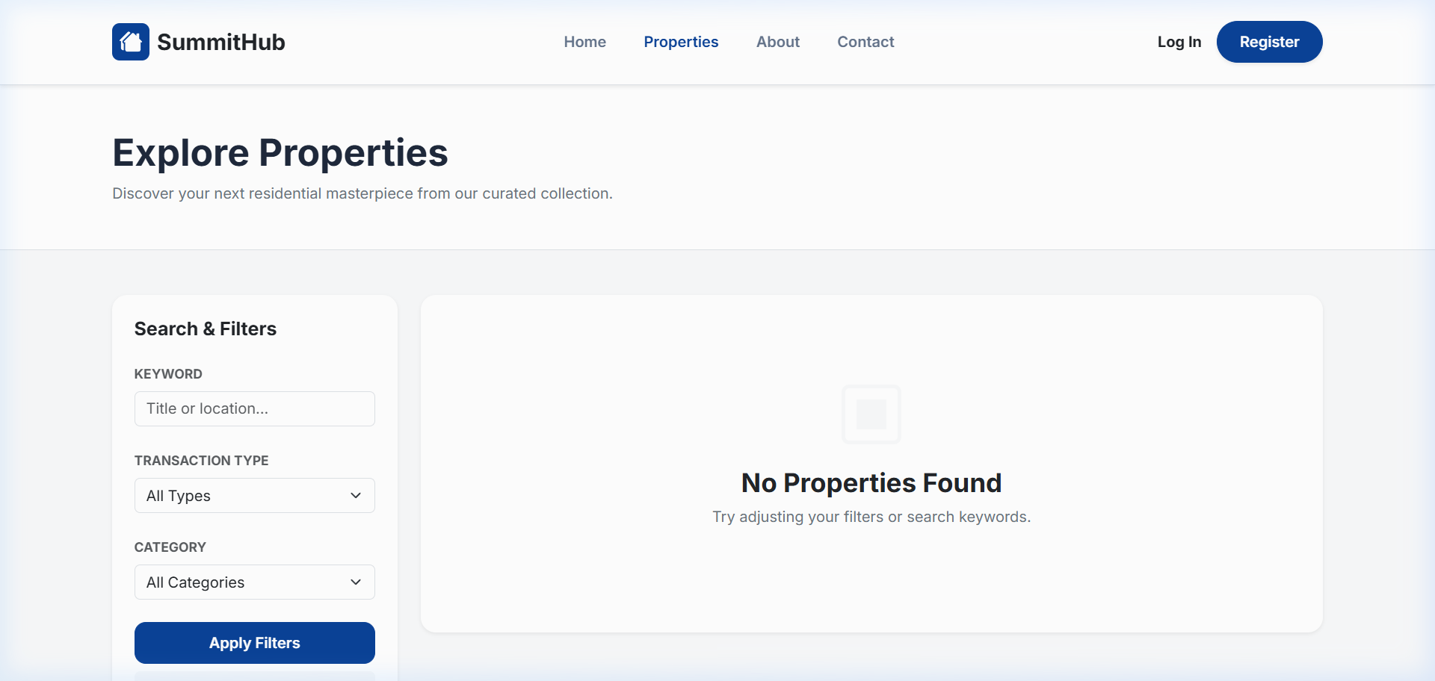
Figure 2: The Explore Page
VII. Task Analysis
The typical workflow involves User Registration, Property Listing by Seller, Moderation by Staff, Discovery by Buyer, and Inquiry/Engagement between parties.
IX. Entity Relationship Diagram (ERD)
[Insert ERD Image Here]

CHAPTER III: USER INTERFACE MANUAL
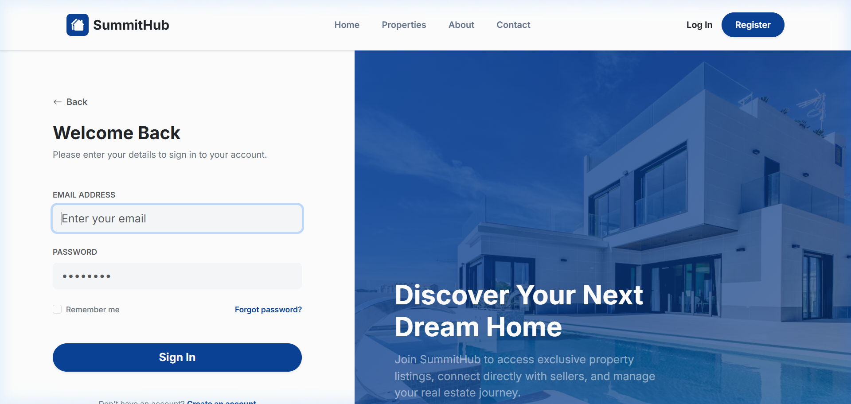
Figure 3: Secure Login Interface
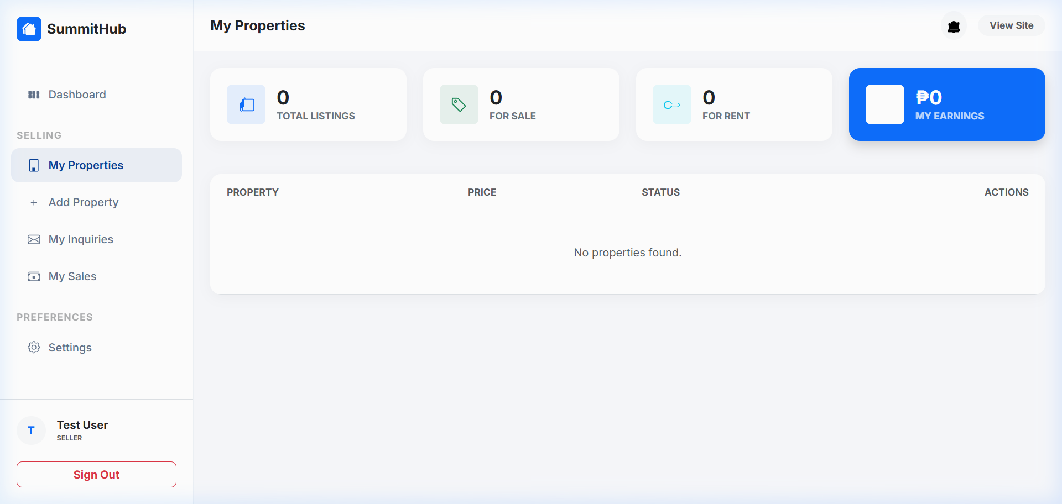
Figure 4: The Seller Dashboard
This manual provides a step-by-step guide on navigating the system, managing properties, and handling inquiries effectively using the role-based dashboards.

