**Documentation**

Rest API Using PHP and MySql

**Understanding code:-**

* I have used PDO(PHP Data Object) to connect to database.
* Database.php is setting database parameter and connecting to database.
* student.php is the class with all the read update delete function.
* read.php is code to use student.php and read whole database.
* read_single.php is code to use student.php and read one student data.
* create.php is code to use student.php and create one student data.
* update.php is code to use student.php and update one student data.
* delete.php is code to use student.php and delete one student data.
* All data are returned in Json format.

**Softwares needed:-**

* Xampp
* A Browser with Rested or Servistate Extension installed to test API

**Steps to Be followed to Run code:-**

* Open XAMPP and connect APACHE and MYSQL
* Go to PHPMYADMIN page
* Create a new database
* Import the sql file students.sql in it

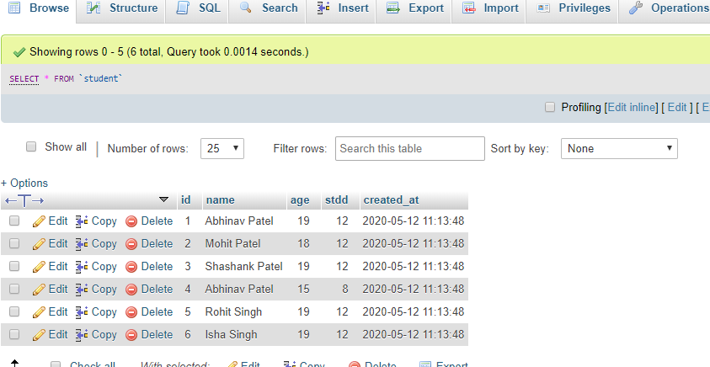

* Extract the zip file in htdocs folder inside xampp

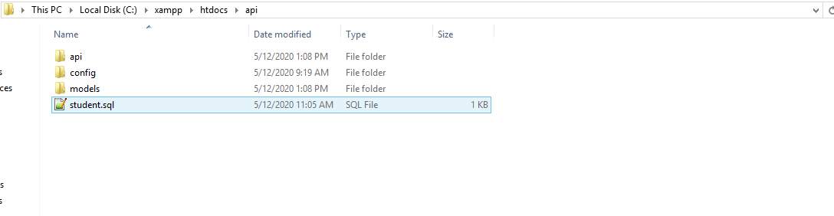

* To read full database just open url: <http://localhost/api/api/read.php>



* To read single data just open url with get variable id: [http://localhost/api/api/read_single.php?id=4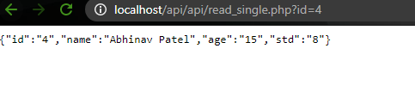](http://localhost/api/api/read_single.php?id=4#)
* To create a new student data open rested extension and do as follows:-

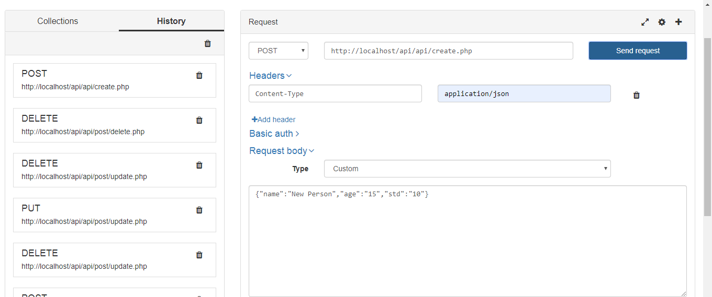

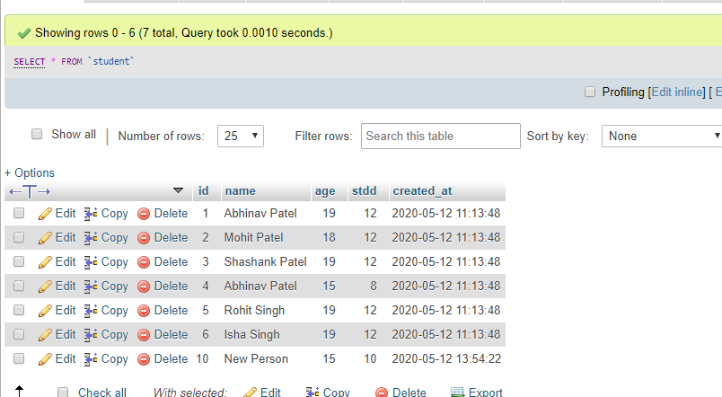

* To update student data do as follows:-

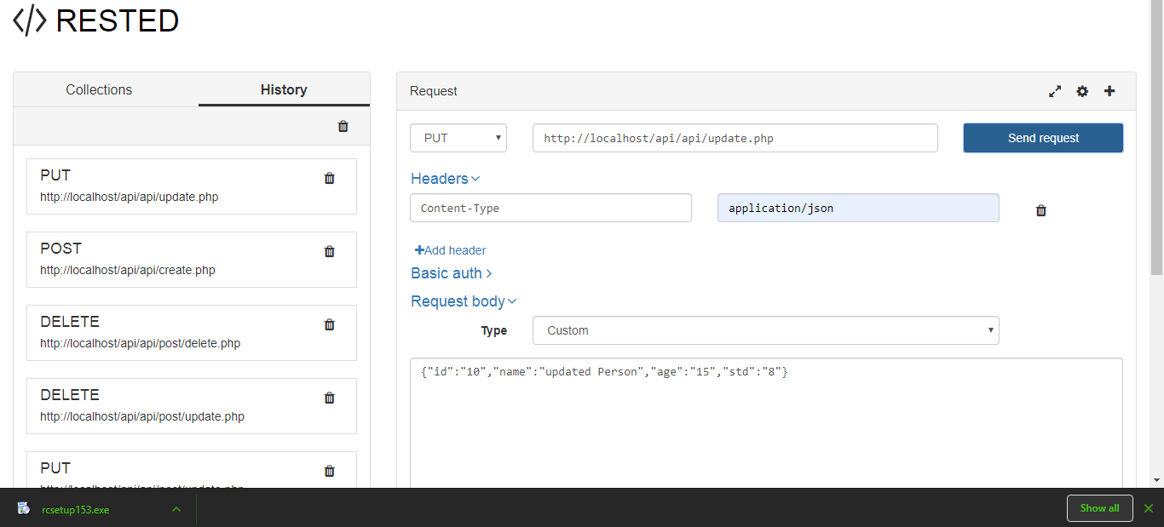

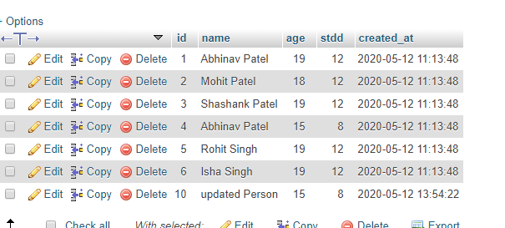

* To delete a students data do as follows:-

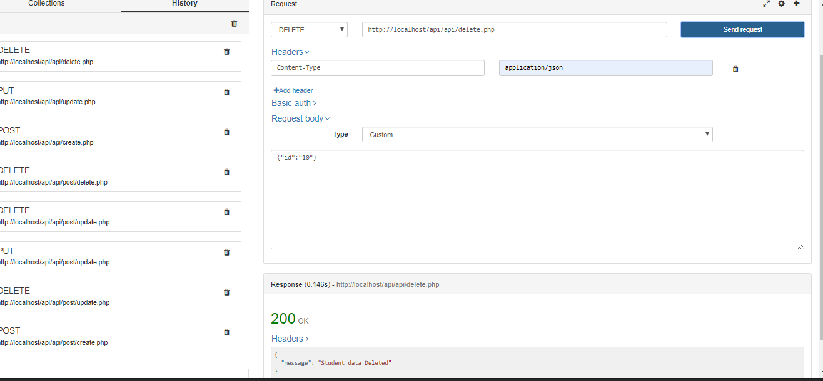



****Thank***You****