Project Planning for [DPP]
November 11 2015
Prepared by:
Brett Yeager, David Godi, James Bednarz

- Domain Model
This system or DPP provides services to manage patient appointments at local family physician’s office. DPP will use the services provide by a DBA. The DBA will provide services for managing and retrieving records. DPP has two separate interfaces, one for the patient and for the staff members that have secure logins. A staff member¹ can create³ a Patient account¹ which has⁶ the following information, name¹, address¹, phone number¹, mobile number¹, email address¹ . Each patient account¹ is uniquely identified by a patient id¹ number. Once a patient account has been created then a staff member¹ can edit³ the patient’s account¹. A staff member¹ can also schedule³ appointment¹ for a patient¹ with a specific doctor¹. A staff member¹ can also edit³ and view³ the patient’s appointment¹. Staff member¹ views³ the appointment schedule¹ which contains all⁷ appointments¹. Each scheduled appointment is identified by an appointment ID¹ that contains a patient ID¹, which doctor¹ is being seen at the recorded specific time¹ and date¹. The appointment¹ is then archived³ into the appropriate appointment schedule¹. A staff member¹ can create³ and edit³ a medical record¹ which has patient’s recent medical history known as doctors notes¹ history. Each Doctors note contains information on the patient’s last office visit. The patient¹ can view³ their appointments¹ and doctor notes¹. A patient can also view³ and edit³ their personal information¹. A patient ¹can also view³ and update³ their scheduled appointment¹. The scheduled appointment¹ can only use one⁵ time slot⁴ using a 30 min period. Patients¹ can schedule³ an appointment¹ by a web interface⁴ or by phone⁴. The system must display a message telling the patient or staff member that the date and time for the appointment is not available⁴. The patient or staff member will want to know such information when reserving an appointment. The appointment¹ cannot be voided⁴ The appointment¹ binds³ a patient¹ to the date¹ and time¹ if a patient does not change the appointment within a 24 hour period¹. The patient¹ can view³ their doctor notes¹

Brainstorming List | Classification Result | Rule
staff members¹ | (C) Staff Member | 1(a)
create³ | (AS) create(Staff Member, Patient) | 3
patient account¹ | (C) Patient | 1(a)
name¹ | (A) name | 1(a)
Address¹ | (A) address | 1(a)
phone number¹ | (A) phone number | 1(a)
mobile number¹ | (A) mobile number | 1(a)
e-mail address¹ | (A) e-mail | 1(a)
patient id | (A) patient ID | 1(a)
edit³ | (AS) edit(Staff Member, Patient) | 3
schedule³ | (AS) schedule(Staff Member, Appointment) | 3
Appointment¹ | (C) Appointment | 1(a)
specific doctor¹ | (A) staff ID | 1(a)
Appointment schedule¹ | (C) Appointment Schedule | 1(a)
edit³ | (AS) view(Staff Member, Appointment) | 3
view³ | (AS) view(Staff Member, Appointment) | 3
contains all⁷ | (AG) Part-of(Appointment Schedule, Appointment) | 7
appointment ID¹ | (A) appointment ID | 1(a)
time¹ | (A) time | 1(a)
date¹ | (A) date | 1(a)
archived | (AS) archive(Appointment, Appointment Schedule) | 3
create³ | (AS) create(Staff Member, Medical Record) | 3
edit³ | (AS) edit(Staff Member, Medical Record) | 3
medical record¹ | (C) Medical Record | 1(a)
doctor’s notes¹ | (A) doctor note | 1(a)
can view³ | (AS) view(Patient, Patient) | 3
edit³ | (AS) edit(Patient, Patient) | 3
can also view³ | (AS) view(Patient, Appointment) | 3
can also update³ | (AS) update(Patient, Appointment) | 3
one⁵ | 1 | 5
can schedule³ | (AS) schedule(Patient, Appointment) | 3
web interface⁴ | (V) web | 4
phone⁴ | (V) phone | 4
 | (A) appointment by | 1(a)
not available⁴ | (A) available: boolean | 4
voided⁴ | (A) void appointment: boolean | 1(a)
24 hour period | (A) time limit | 1(a)
can view³ | (AS) view(Patient, Doctors Note) | 3
 | (I)ISA(Staff, Person) | 9
 | (I)ISA(Patient, Person) | 9

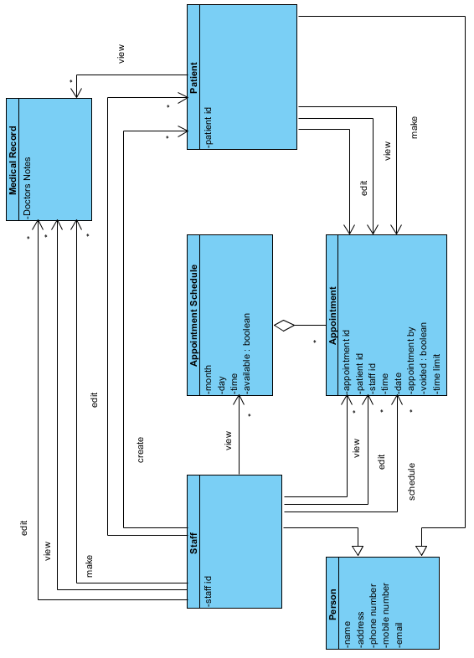

- Expanded use cases from your high level use cases.

Functional requirements:
R1 DPP must allow Staff to create patient accounts.
R2 DPP must allow users to login to a client side application and communicate to the central server.
R2.1 Secure login will be done with a username and password.
R2.2 Passwords will not be stored in plaintext.
R3 Patients can view their records.
R4 Patients can update parts of their account.
R4.1 Address, name, phone number, email address.
R4.2 Patients can’t update their medical records.
R5 Staff can update patients’ medical records.
R5.1 Records will be freeform, unstructured text.
R5.2 Patients will be notified when their records are updated.
R6 Automation of appointments.
R6.1 systematically organizes and manages appointments
R7 Staff can view patients’ records.
R8 Staff can make appointments for a patient
R9 Patients can schedule appointment.
R9.1 Shows patients available dates and times.
R9.2. Patients can submit a date and time for an appointment.
R9.3 Patients can cancel appointments.
R10 Staff can create medical record
R11 Staff and create patient account
R12 Staff can edit patient account
R13 Patient can make appointment
R14 Patient can view appointment
R15 Staff can view schedule
R16 Staff can view appointment
R17 Staff can delete patient account.

Nonfunctional requirements:
R18 System only supports desktop and android.
R19 System will have a user friendly interface.
R20 System must accept concurrent access for simultaneous requests by account users
R21 Security measures to prevent non users from using the system
R22 System will use a database
R22.1 The client side will use a TCP connection for communication between client and server.
R22.2 The server will communicate with the database to return data to the client using the
same TCP connection.

high level use cases :
- Login
- TUCBW user clicks the Login link on homepage
- TUCEW User sees landing page.

- Logout
- TUCBW user clicks the Logout button
- TUSEW User is redirected to login page and sees logout message.

- View Medical Record
- TUCBW a patient clicks the “View Doctors Note” button link
- TUSEW the patient is shown an accordion style module that display doctors notes

- Edit Contact Information
- TUCBW a patient clicks the “Edit Profile” button link
- TUSEW patient has change their information

- View Appointment
- TUCBW a patient clicks the “View Appointment” button link
- TUSEW a patient is shown the time and date of their appointment

- Edit Appointment
- TUCBW a patient clicks the “Edit Appointment” button link
- TUSEW a patient has rescheduled their appointment

- Create Appointment
- TUCBW a patient clicks the “Schedule Appointment” button link
- TUSEW a patient has rescheduled their appointment

- Create Medical Record
- TUCBW a staff member clicks the “Create Doctor Note” button link
- TUSEW a new doctors note has been creaeted

- Edit Medical Record
- TUCBW a staff member clicks the “Edit Doctor Note” button link
- TUSEW a doctor’s note has been changed

- View Patient Appoinmtent
- TUCBW a staff member clicks the “View Appointment” button link
- TUSEW a staff meber is shown the time and date of the patients appointment

- View Schedule
- TUCBW a staff member clicks the “View Schedule” button link
- TUSEW a staff member is shown all appointments in the schedule
- Edit Patient Appointment
- TUCBW a staff member clicks the “Edit Appointment” button link
- TUSEW a staff member has rescheduled a patient’s appointment

- Create Patient Account
- TUCBW Staff clicks create account button.
- TUSEW a new patient account has been created

- Edit Patient Account
- TUCBW a staff member clicks the “Edit Patient” button link
- TUSEW patient account has been changed

- Create Patient Appointment
- TUCBW a staff member clicks the “Schedule Appointment” button link
- TUCEW staff user sees appointment is successfully added.

Use Case diagrams
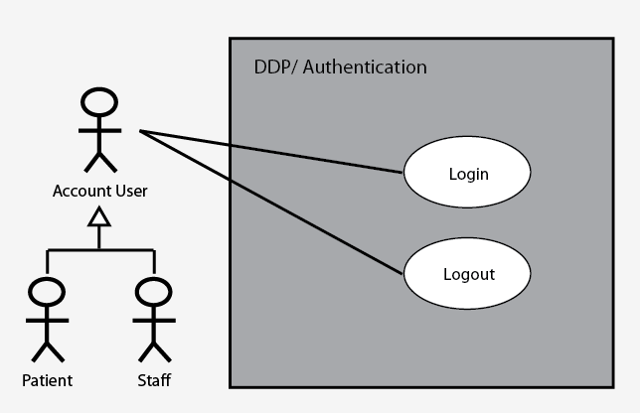

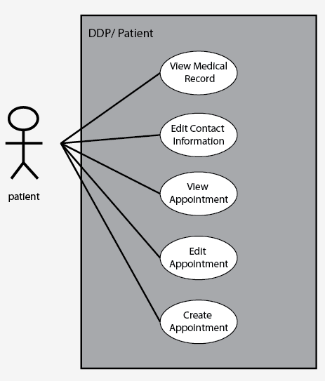

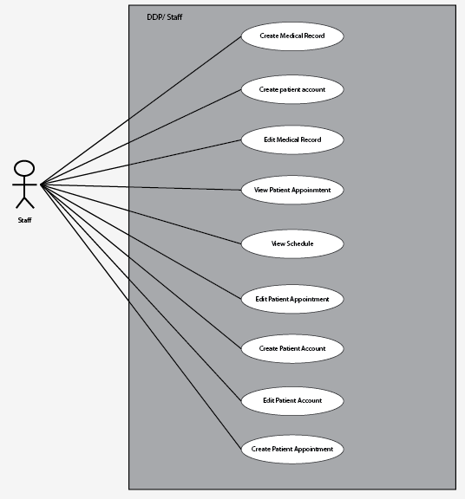

Use Case Traceability Matrix

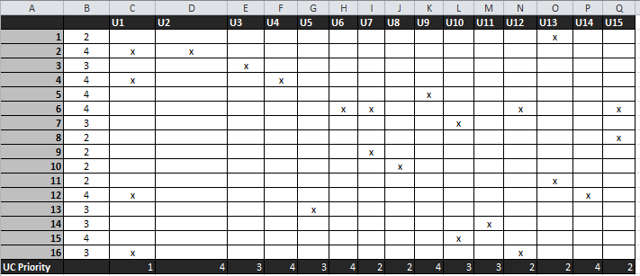

Iteration allocation matrix

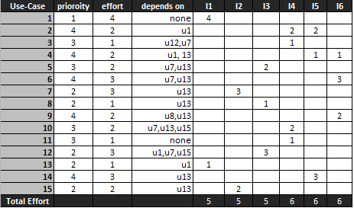

Expanded Use Case

Login
Actor: User | System:DPP
 | 0. System displays home page
1. TUCBW user clicks the Login link on homepage | 2. System displays login page
3. User enters username & password and clicks Login button. | 4a. If user login is not valid, diplay message
3. User enters username & password and clicks Login button. | 4b. Else App displays the landing page .
5. TUCEW User sees landing page.
Logout
Actor: User | System:DPP
 | 0. Logout button is displayed on all pages.
1. TUCBW user clicks logout button. | 2. System logs out user and returns them to the login page with goodbye message.
3. TUCEW user is redirected to login page and sees logout message.
Create Patient Account
Actor: Staff | System:DPP
 | 0. System displays a list of options under patient sub menu
1. TUCBW staff clicks add patient account button. | 2. System shows the Create Patient Form.
3. Staff fills out the form and clicks submit. | 4. System displays a patient account is succesfully added message
5. TUCEW staff user sees patient account successfully created.
Create Appointment
Actor: Staff | System:DPP
 | 0. System displays a list of options under patient sub menu
1. TUCBW staff clicks the “Schedule Appointment” button | 2. System displays list of doctors.
3. Staff clicks doctor from list. | 4. System displays accordian calender.
5. Staff clicks a day on the calender. | 6. System expands the day the calendar to show available time slots.
7. Staff clicks the time that they want. | 8. System displays appointment has been successfully created message
9. TUCEW staff user sees appointment is succesfully added.
View Medical Record
Actor: Patient | System:DPP
 | 0. System displays a list of main options
1. TUCBW patient clicks view medical records button. | 2. System displays accordian view of dated medical records.
3. Patient clicks on a day to see that date's medical record. | 4. System expands the day and displays the medical record
5. TUCEW patient sees the medical record

- Prototype
Login use case:
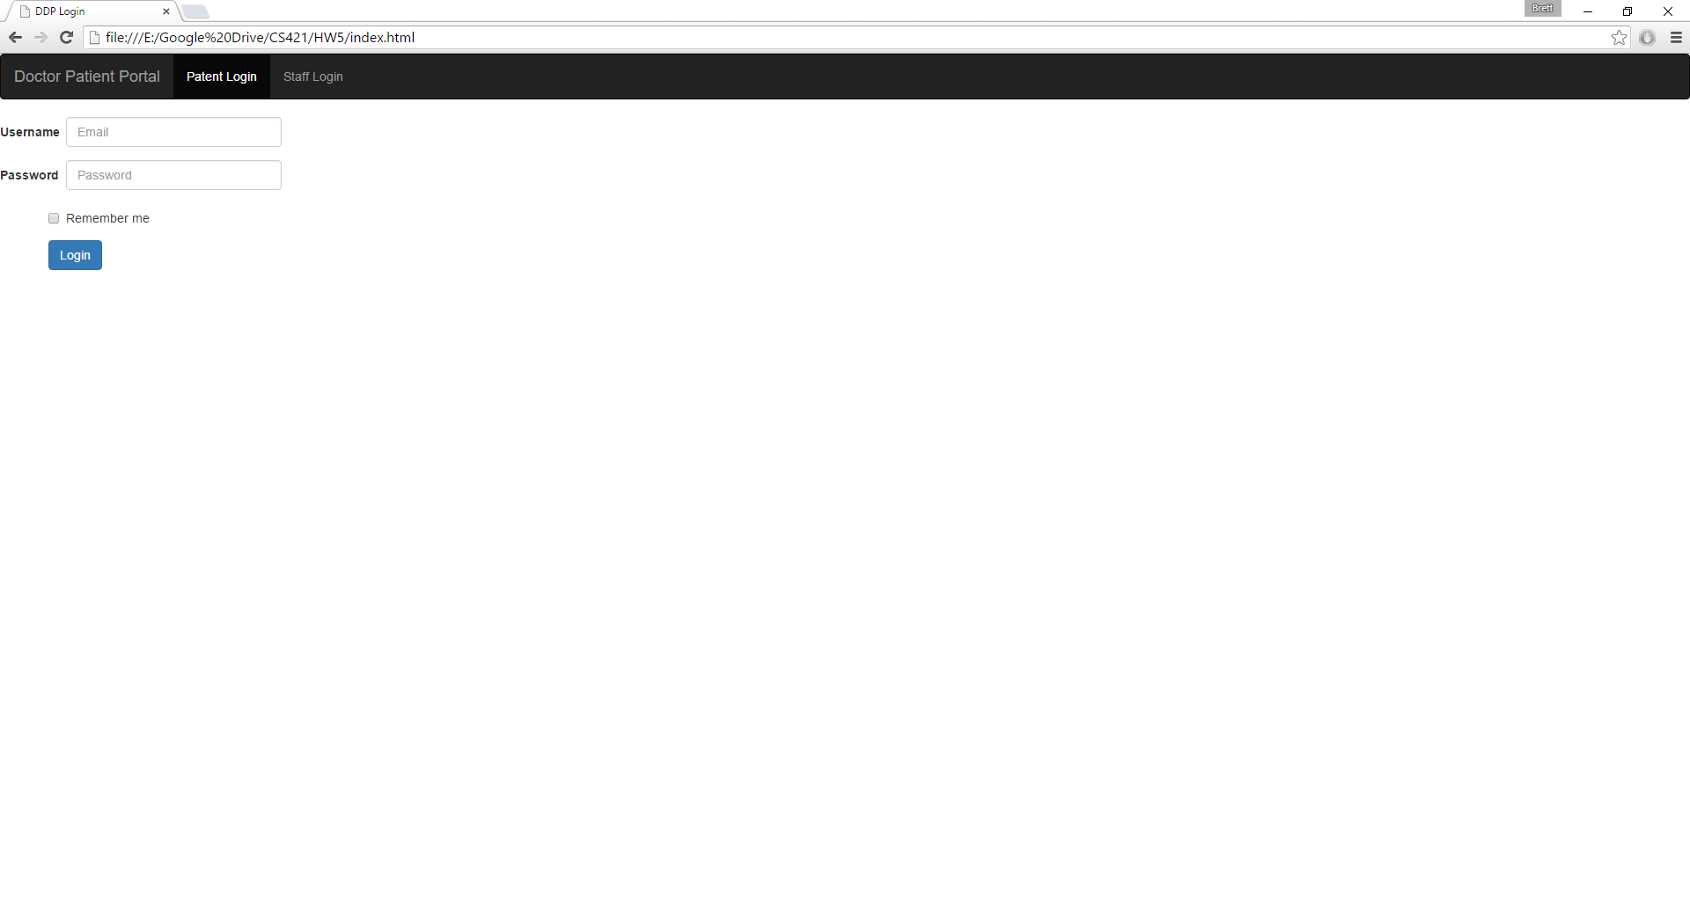

Login error message if incorrect information is entered
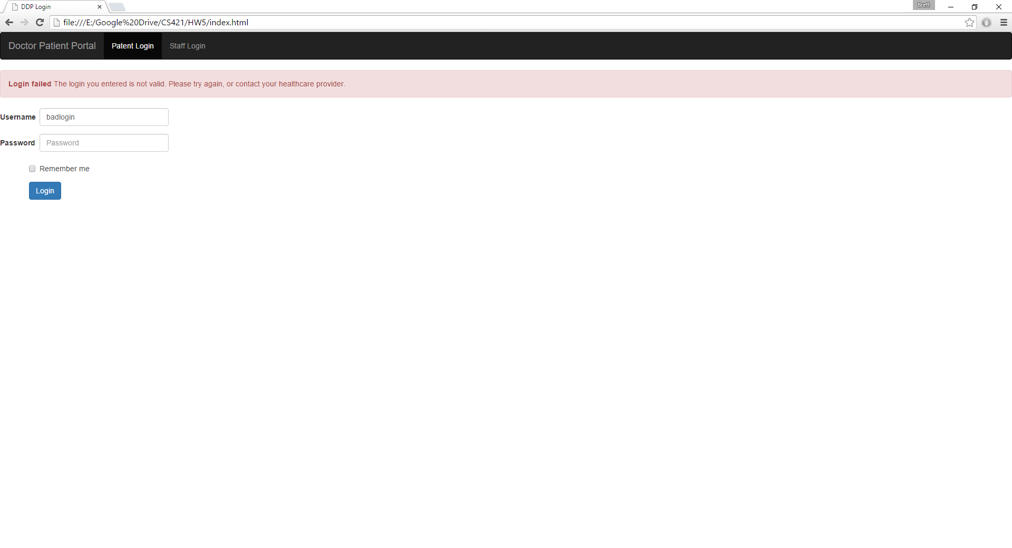

Patient landing page

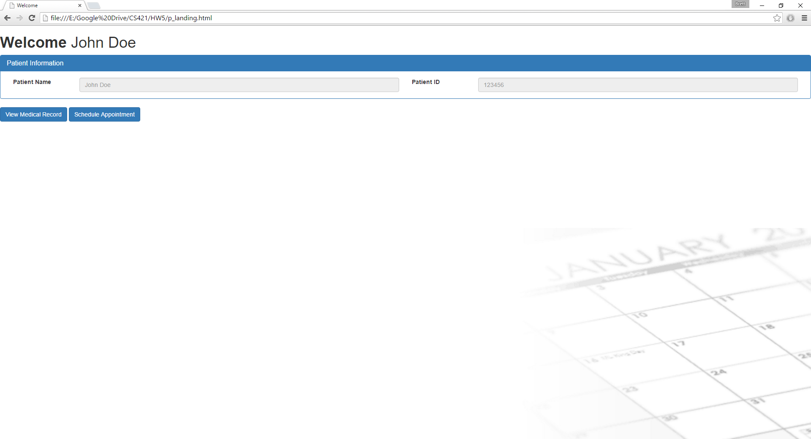

Patient Record Page

