Abram Fouts

Homework 1

ECE – 373

April 4, 2020

1. 1.  
   **BUGS**  
   Not possible to enable signal-driven I/O by specifying O_ASYNC when calling open()  
     
   Must check for two different error codes, EISDIR and ENOENT to see if the kernel supports O_TMPFILE  
     
   When both O_CREAT and O_DIRECTORY are specified are in flags and the file by pathname does not exist, open() will create a regular file  
     
   **What files need to be included**sys/types.h  
   sys/stat.h  
   fcntl.h  
     
   **Related**  
   chmod()  
   chown()  
   close()  
     
   **Choose one above**, close()  
   Bugs: no specified bugs, but errors exist: EBADF if fd isn’t a valid open file descriptor, EINTR if it was interrupted, EIO I/O error, ENOSPC & EDQUOT errors for subsequent writes if it exceeds available space.   
     
   unistd.h

2. **Kernel Version 5.6.3**  
A.  
include/linux/usb.h  
int devnum;

char devpath[16];

[**u32**](https://elixir.bootlin.com/linux/latest/ident/u32) route;

enum [**usb_device_state**](https://elixir.bootlin.com/linux/latest/ident/usb_device_state) state;

enum [**usb_device_speed**](https://elixir.bootlin.com/linux/latest/ident/usb_device_speed) [**speed**](https://elixir.bootlin.com/linux/latest/ident/speed);  
  
B.

[**include/uapi/linux/usb/ch9.h**](https://elixir.bootlin.com/linux/latest/source/include/uapi/linux/usb/ch9.h#L1139)

C.  
enum [**usb_device_speed**](https://elixir.bootlin.com/linux/latest/ident/usb_device_speed) {

[**USB_SPEED_UNKNOWN**](https://elixir.bootlin.com/linux/latest/ident/USB_SPEED_UNKNOWN) = 0, */* enumerating */*

[**USB_SPEED_LOW**](https://elixir.bootlin.com/linux/latest/ident/USB_SPEED_LOW), [**USB_SPEED_FULL**](https://elixir.bootlin.com/linux/latest/ident/USB_SPEED_FULL), */* usb 1.1 */*

[**USB_SPEED_HIGH**](https://elixir.bootlin.com/linux/latest/ident/USB_SPEED_HIGH), */* usb 2.0 */*

[**USB_SPEED_WIRELESS**](https://elixir.bootlin.com/linux/latest/ident/USB_SPEED_WIRELESS), */* wireless (usb 2.5) */*

[**USB_SPEED_SUPER**](https://elixir.bootlin.com/linux/latest/ident/USB_SPEED_SUPER), */* usb 3.0 */*

[**USB_SPEED_SUPER_PLUS**](https://elixir.bootlin.com/linux/latest/ident/USB_SPEED_SUPER_PLUS), */* usb 3.1 */*

};

B.  
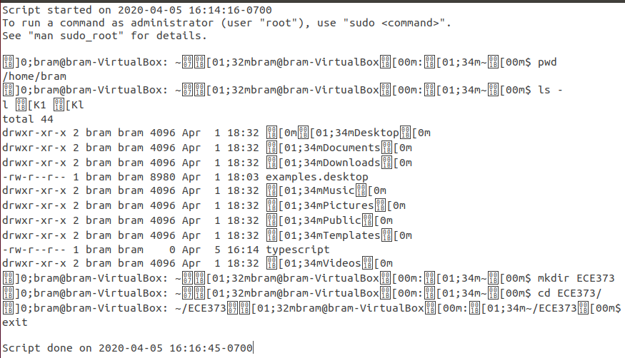

C.  
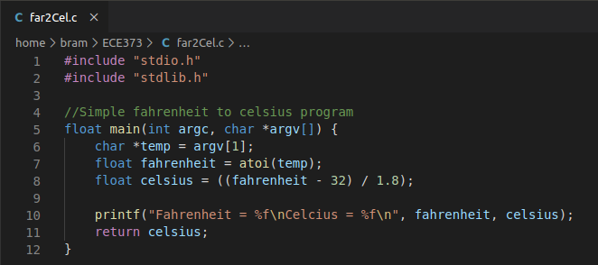  
  
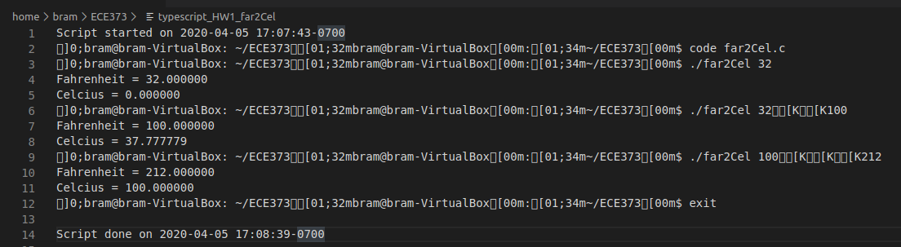  
  
D.  
  
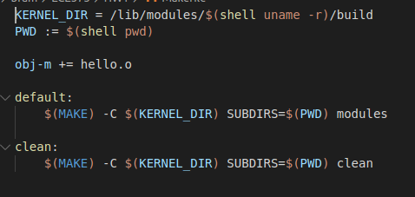

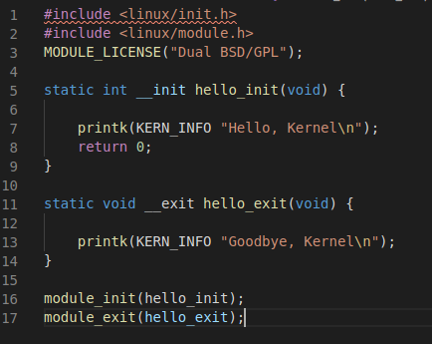  
  
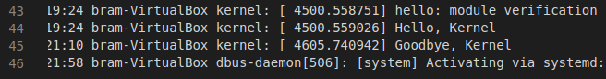  
  
(Will add typescript in zip)