|  |  |
| --- | --- |
| Player | |
| Initial HP: 1000 | Initial coins: 0 |
| Arms: Magic Dice  Number:  “1” increase 100HP  “2” receive 50 damage  “3” receive 100 damage  “4” attack 40 damage to monster  “5” attack 50 damage to monster  “6” attack 60 damage to monster | Item:  1. Potion: Increase 200HP 2. Antidote: Release the poisoned state 3. Insecticide: Expel the Baby Spider Other Number:  - Get 20 damage (65%)  - Increase 50HP (20%)  - Release the poisoned state (15%) |

|  |  |
| --- | --- |
| At choose direction | In battle |
| Other Input: Random direction | 1. Attack  2. Flee  3. Item  Other Number:  - Do nothing (50%)  - Flee (25%)  - Get lost (Randomly Teleport) (25%) |

|  |  |  |  |  |  |  |
| --- | --- | --- | --- | --- | --- | --- |
| Random Map (Different every time when start the game) | | | | | | |
| 0 | 1 | 3 | 9 | 4 | 0: Skeleton (4)  1: Bat (4)  2: Spider (3)  3: Zombies (3)  4: Rainbow Shop (3) | 5: Pit (1)  6: Land (2)  7: Q&A (2)  8: Treasure (1)  9: Poison Swamp (2) |
| 1 | 0 | 7 | 5 | 6 |
| 1 | 0 | 2 | 4 | 6 |
| 0 | 3 | 2 | 9 | 7 |
| 2 | 3 | 1 | 4 | 8 |
| Player start at upper left corner | | | | | | |

|  |  |
| --- | --- |
| **Treasure** | **Land** |
| 50% probability to get treasure immediacy  50% probability to wake up Boss | - Nothing (50%)  - Potion (25%)  - Antidote (15%)  - Armor (10%) (If you already owned armor, it would be Insecticide) |
| **Poison Swamp** | **Pit** |
| Add poisoned state to player with 4 round, 20 damage for each round. | You die, GAME OVER |

|  |  |
| --- | --- |
| **Skeleton** | **Bat** |
| HP: 50  Attack: 7-14  Drop coins: 7-17  Probability of Flee: 45% | HP: 60  Attack: 35-45  Skill 1: Dodge (60%) - dodge your attack  Skill 2: Chase - after your escape, it would follow you and bite you with 2 times  Drop coins: 25-50  Probability of Flee: 25% |
| **Spider** | **Zombies** |
| HP: 100  Attack: 0  Skill 1: Spew silk (35%) - stop player action  Skill 2: Call Baby Spider - 20 damage for first two round, 50 damage for after two round  Drop coins: 30-80  Probability of Flee: 40% | HP: 240  Attack: 120-160 (30% dodge Zombies attack)  Skill: Poison (70%) - add poisoned state to player with 4 round, 20 damage for each round, still exist after battle  Drop coins: 40-120  Probability of Flee: 75% |
| **Boss Zombies** (50% probability to wake up Boss) | |
| HP: 840  Attack: 180-240 (35% dodge Boss Zombies attack)  Skill 1: Poison (80%) - add poisoned state to player with 4 round, 20 damage for each round, still exist after battle  Skill 2: Call Baby Spider (50%) - 20 damage for first two round, 50 damage for after two round  Skill 3: Dodge (20%) - dodge your attack  Drop coins: 500-1000  Probability of Flee: 80% | |

|  |  |  |  |
| --- | --- | --- | --- |
| **Rainbow Shop** (Three form of color can be written: e.g. Red/red/RED)  Price: 10 – 40 coins for random | | | |
| Color | First time | After buy one times | Description |
| Red | Potion | | Increase 200HP |
| Orange | Fireball | Potion | Burning state to monster with 2 round, 20 damage for each round (80%) |
| Yellow | Magic Dice | Potion | Attack damage to monster increase 40 by extra (Attack: 80-100) |
| Green | Antidote | | Release the poisoned state |
| Blue | Insecticide | | Expel the Baby Spider |
| Indigo | (40%) Legend Dice; | Antidote | Number:  "4-6" attack 200 damage to monster every times; "1" increase 200HP;  "2" receive 25 damage;  "3" receive 50 damage. |
| (60%) Potion | | Increase 200HP |
| Violet | Armor | Potion | Decrease 40 damage from monster |

|  |  |
| --- | --- |
| **Q&A** (Three form of answer can be written: e.g. Lima/lima/LIMA)  Answer correct: get Potion  Answer wrong: get 100 damage | |
| What is the Capital of Peru?  Lima | What is the Capital of Japan?  Tokyo |
| What is the Capital of Sweden?  Stockholm | What is the Capital of United States?  Washington |
| What is the symbol of Lead?  Pb (Must be equal with Capital letter) | What is the symbol of Potassium?  K (Must be equal with Capital letter) |
| What color of the flame when you burn the Sodium(Na)?  Golden / Golden Yellow (Six form of answer can be written) | |
| What is the degree of absolute zero on the Celsius scale?  -273.15 / -273 / -273C / -273.15C / -273.15 C / -273 C (Five form of answer can be written) | |
| How many letters in the word "sup___li___rag___cexpi___ocious/"?  (supercalifragilisticexpialidocious)  A / a / 34 / A. 34 (Four form of answer can be written) | |

Game Title

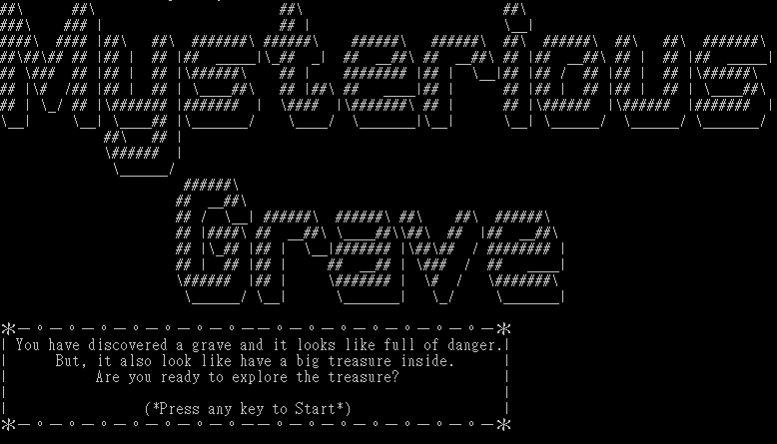

|  |  |  |  |
| --- | --- | --- | --- |
|  | | | Random direction  Random range 0-3.9,  - 0-0.9: go West  - 1-1.9: go East  - 2-2.9: go North  - 3-3.9: go South |
|  | | | Wrong Number Input  Random range 0-1.9,  - 0-0.9: Do nothing  - 1-1.9: Random range 0-1.9 inside,  + 0-0.9: Flee  + 1-1.9: Randomly Teleport |
|  | | Dodge your attack  Random range 0-1.9,  - Bat: 0.8-1.9  - Boss Zombies: 1.6-1.9 | |
|  | When x/y are 0 or 4,  and player want to go x/y -1 or 5  Block the way and do nothing | | |
|  | Probability of Flee  Random range 0-1.9,  - Skeleton: 0-0.8  - Bat: 0-0.4  - Spider: 0-0.7  - Zombies: 0-1.4  - Boss Zombies: 0-1.5 | | |
|  | Drop coins  - Skeleton: 7 + Random range 0-10  - Bat: 25 + Random range 0-25  - Spider: 30 + Random range 0-50  - Zombies: 40 + Random range 0-80  - Boss Zombies: 500 + Random range 0-500 | | |
|  | Random range 0-1.9  Poisoning by Zombies: 0-1.3 Poisoning by Boss Zombies: 0-1.5 | | |
|  | Random range 0-3.9  Dodge Zombies attack: 2.8-3.9  Dodge Boss Zombies attack: 2.6-3.9 | | |
|  | | Random range 0-1.9,  - 0-0.9: Boss Zombies call Baby Spider | |
|  | | Random range 0-1.9,  - 1.4-1.9: Stop player action | |
|  | | Land  Random range 0-1.9  - 0.0-0.9: Nothing  - 1.5-1.9: Potion  - 1.2-1.4: Antidote  - 1.0-1.1: Armor (Insecticide) | |
|  | | Random range 0-5.9  - 0-0.9: “1” increase 200HP  - 1-1.9: “2” receive 25 damage  - 2-2.9: “3” receive 50 damage  - 3-5.9: attack 200 damage to monster | |

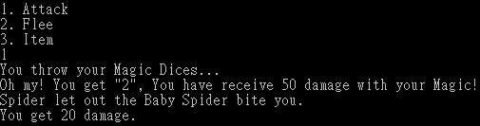

Random range 0-5.9

* 0-0.9: “1” increase 100HP
* 1-1.9: “2” receive 50 damage
* 2-2.9: “3” receive 100 damage
* 3-3.9: “4” attack 40 damage to monster
* 4-4.9: “5” attack 50 damage to monster
* 5-5.9: “6” attack 60 damage to monster

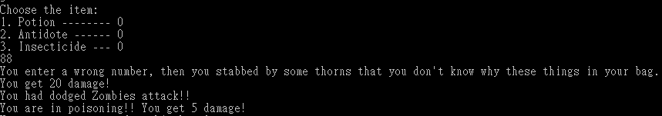

Random range 0-1.9

* 0-1.2: Get 20 damage
* 1.3-1.6: Increase 50HP
* 1.7-1.9: Release the poisoned state

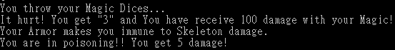

Armor can decrease 40 damage from monster,

when Skeleton just can inflict you 7-14 damage, you get 0 damage.

Attack

- Skeleton: 7 + Random range 0-7

- Bat: 35 + Random range 0-10

- Zombies: 120 + Random range 0-40

- Boss Zombies: 180 + Random range 0-60

|  |  |
| --- | --- |
|  | - Armor decrease 40 damage from monster  - Magic Dice(Yellow) increase 40 damage to monster for extra, e.g. “4”: 40+40=80 |
|  | If Baby Spider count more then 2,  It would be more Baby Spider bite you  (with different if, else if case) |

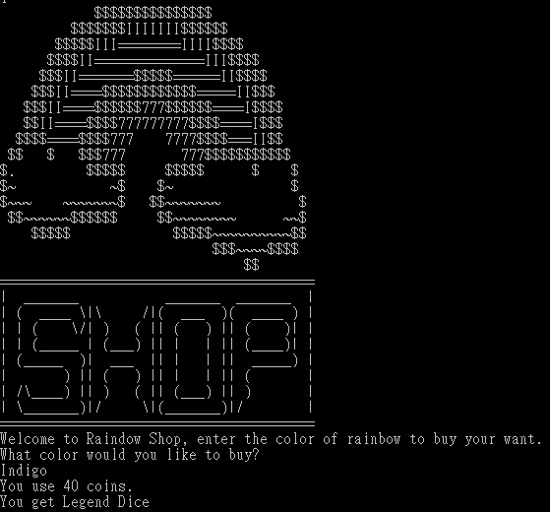

Indigo Random range 0-1.9

* 0.0-1.1: Potion
* 1.2-1.9: Legend Dice

Price: 10 + Random range 0-30

Random range 0-1.9, if 1-1.9: wake up Boss

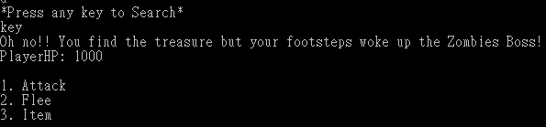

Random range 0-1.9, if 0-0.9: get treasure immediacy

