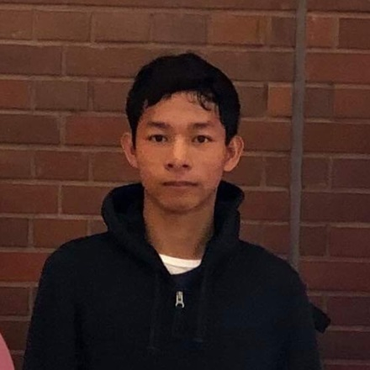**Ariel B. Ganzon**

Junior Software Engineer

Email: [arielganzon@gmail.com](mailto:arielganzon@gmail.com)

Skype: arielganzon

Phone: 09391935233

|  |  |
| --- | --- |
| **TECHNOLOGIES**   * Angular * Capacitor * Nodejs * Python * Ionic * PHP * Laravel * Code Igniter * Snowflake * Retool * OpenAI * AWS Amazon | **KNOWLEDGEABLE**   * Google API * Twillio API * SMSON API * One Signal API * Whisper API * Pinecone API * AWS Step Function * AWS Comprehend * AWS Lambda Function * AWS Roles and Policies * AWS S3 Bucket |

|  |  |  |
| --- | --- | --- |
| **EXPERIENCE** | |  |
| **Junior Software Engineer** — Ferret9 Creative Solutions | |  | |  |
|  |  |  | |  |
| January 12, 2020 – Present | |  |
|  |  |  | |  |
| **Responsibilities:** | |  | |  |
| •    Back-end programmer and Front-end Programmer. | |  | |  |
| • Transcribing audio to text .   * Create Chatgpt api prompt, embeddings, completion, chatcompletion. * Troubleshoot and debug to optimize performance. | |  | |  |

* Manage Snowflake Data Ingesting.
* Create/Update Retool Application base on client demand.
* Create AWS Lambda Function and Function URL.
* Manage AWS S3 Bucket CORS Policy, User Policies,
* Create Step Function and deploy with function url
* Deploy retool application to live.
* Create python code base on needs functionality

|  |
| --- |
| • Create and Manage Snowflake Pipe and Stages. |
|  |  |
|  |  |

**Sage Emergency Application**  — Sage Restoration K.C

March 06, 2021 – March 20, 2021

**Responsibilities:**

* Front-end and Back-end programmer
* Create web admin
* Create API’s
* Create Functions and Features
* Deploy application live
* Support the entire application lifecycle.
* Troubleshoot and debug to optimize performance.

**Technologies used:**  *Ionic, Capacitor, PHP, Twillio API, Laravel*

**Food Ecommerce Application** — Foreign & Local Investor

March 25, 2021 – July 20, 2021

**Responsibilities:**

* One of the Front-end and Back-end programmer
* Support the entire application lifecycle.
* Troubleshoot and debug to optimize performance.
* Create API’s
* Create Functions and Features
* Deploy application live

**Technologies used:** *Ionic, Angular, PHP, Twillio API, Google API, One Signal API*

**Medical Ecommerce Application** —Local Investor

August 28, 2021 – October 12, 2021

**Responsibilities:**

* One of the Front-end and Back-end programmer
* Create API’s
* Support the entire application lifecycle.
* Troubleshoot and debug to optimize performance.
* Create Functions and Features
* Deploy application live

**Technologies used:** *Ionic, Angular, Code Igniter, SMSON API, Google API, One Signal API*

**Grocery Ecommerce Application** —Local Investor

June 14, 2022 – Present

**Responsibilities:**

* One of the Front-end and Back-end programmer
* Create API’s
* Support the entire application lifecycle.
* Troubleshoot and debug to optimize performance.
* Create Functions and Features

**Technologies used:** *Ionic, Capacitor, PHP, SMSON SMS API, Google API, Firebase Messaging API*

**EDUCATION**

**Sergio Osmeña Elementary School** (2005 -2011)

Primary Education

**Zamboanga Del Norte National High School** (2011 -2015)

Secondary Education

**DMC College Foundation – De La Salle Supervised** (2015 -2019)

Bachelor of Science in Information Technology