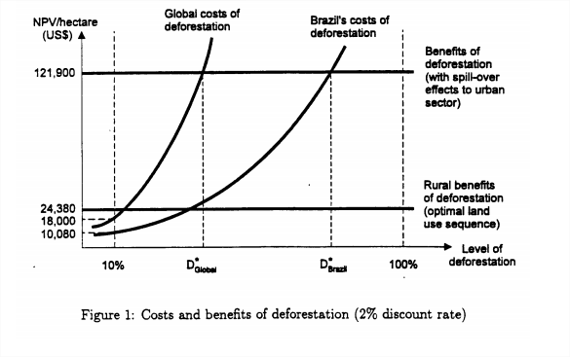

Page 30 of Destroying forest in Brazil article

<http://www.realinstitutoelcano.org/wps/portal/rielcano_eng/Content?WCM_GLOBAL_CONTEXT=/elcano/elcano_in/zonas_in/ari26-2012>

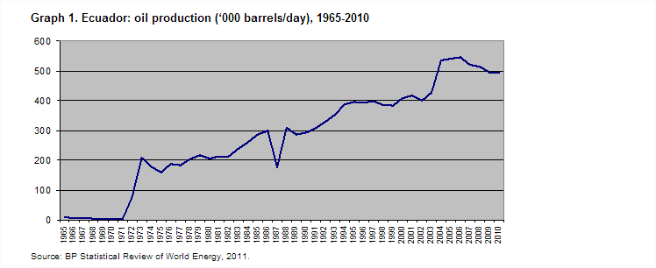900 million barrels of oil in Yasuni

Per cent of yasuni destroyed = hectares of yasuni destroyed / hectares of yasuni = 1,152,000 / 980,000 hectares = more than 100% will destroy all of the yasuni

Hectares of yasuni destroyed = hectares of oil destroyed per barrel of oil drilled * number of barrels drilled = .00128 * 900 million = 1,152,000

Hectacres of forest destroyed per barrel of oil drilled = hectares of forest destroyed since 1994 / barrels of oil drilled since 1994 = 4 million / (3.13 * 10^9) = .00128

Barrels of oil drilled since 1994 = days since 1994 * barrels drilled per day since 1980 = 7300 * 430,000 = 3.13*10^9

Alternative Analysis:

Per cent of yasuni destroyed = hectares of yasuni destroyed / hectares of yasuni = 550,440/ 980,000 hectares = 56 % of yasuni

Hectares of yasuni destroyed = hectares of oil destroyed per barrel of oil drilled * number of barrels drilled = 6.116*10^-4* 900 million = 550,440

Hectacres of forest destroyed per barrel of oil drilled = hectares of forest destroyed from drilling / barrels of oil drilled= 815000 / (133225000) = 6.116*10^-4

Barrels of oil drilled since in 1987: barrels per day * days in 50 years = 73000 * days in 50 years = 133225000

815,000 hectares of forest destroyed: http://totumasymaracas.files.wordpress.com/2010/01/forest-oil-and-indigenous-people_2002_tatiana.pdf