**How to Start with Texas Instruments TIDEP-01012:**

1. Contact ISG Phys ([isg@phys.ethz.ch](mailto:isg@phys.ethz.ch)) and request Administration rights for your ETH Desktop Computer (rights to install all software required).
2. Register on the Texas Instruments Website with your **<username>@ethz.ch** E-Mail Address: <https://www.ti.com/>
3. Download and install **MMWAVE Studio** for the first (Radar C) and second generation (**2G**, Radar A and B): <https://www.ti.com/tool/MMWAVE-STUDIO>
4. Download and install **MMWAVE-DFP** firmware packages for both generations: <https://www.ti.com/tool/MMWAVE-DFP>
5. Download and install **Tera Term** for serial connection to the boards: <https://ttssh2.osdn.jp/>
6. Download and install **WinSCP** for download of files/data acquired with the MIMO-SAR systems: <https://winscp.net/eng/download.php>
7. Download and install a **Matlab Runtime Engine R2015a SP1** (required for MMWAVE Studio): <https://in.mathworks.com/supportfiles/downloads/R2015a/deployment_files/R2015aSP1/installers/win32/MCR_R2015aSP1_win32_installer.exe>
8. Download and install **Microsoft Visual C++ 2013** (required for MMWAVE Studio), e.g. for Windows 10: <https://support.microsoft.com/en-us/topic/update-for-visual-c-2013-and-visual-c-redistributable-package-5b2ac5ab-4139-8acc-08e2-9578ec9b2cf1>
9. You can find the important manuals in the directories of the MMWAVE Studio:

C:\ti\mmwave_studio_03_00_00_14\docs\mmwave_studio_cascade_user_guide.pdf   
(How to setup, calibrate, and use MIMO-SAR/Beamforming modes)

C:\ti\mmwave_studio_03_00_00_14\docs\mmwave_studio_user_guide.pdf   
(Installation of MMWave Studio)

C:\ti\mmwave_studio_03_00_00_14\mmWaveStudio\Scripts\Cascade  
(Standard Configuration and Capture Scripts for the MIMO-SAR/Beamforming modes)

C:\ti\mmwave_studio_03_00_00_14\mmWaveStudio\MatlabExamples

(Standard Matlab Scripts for processing data acquired in MIMO-SAR/Beamforming modes)

C:\ti\mmwave_studio_03_00_00_14\mmWaveStudio\PostProc

(Folder where data are automatically copied in if you download them through MMWAVE Studio)

The following laptops have the required software installed [August 2022]:

**GSEG23** (Acer Aspire 5) and **GSEG24** (Dell Latitude 5520)

**How to connect with TIDEP-01012 and acquire data:**

1. Plug-in the power supply, USB and RJ45/LAN cables to the board and connect to a laptop/computer.
2. There will likely be a red light on the upper right corner of the (red) antenna board. This indicates an issue. For resolving it and avoiding general issues (i.e. not storing data while carrying out measurements) it is recommended to always reboot the boards once laptop and board are powered-up. For that click on the lower of the three buttons on the (green) data processing board.

|  |  |
| --- | --- |
|  |  |

1. If the board is connected for the first time to a new computer, the following setup must be carried out:
2. Open **Network Connections** and right-click on **Ethernet** and open **Properties**

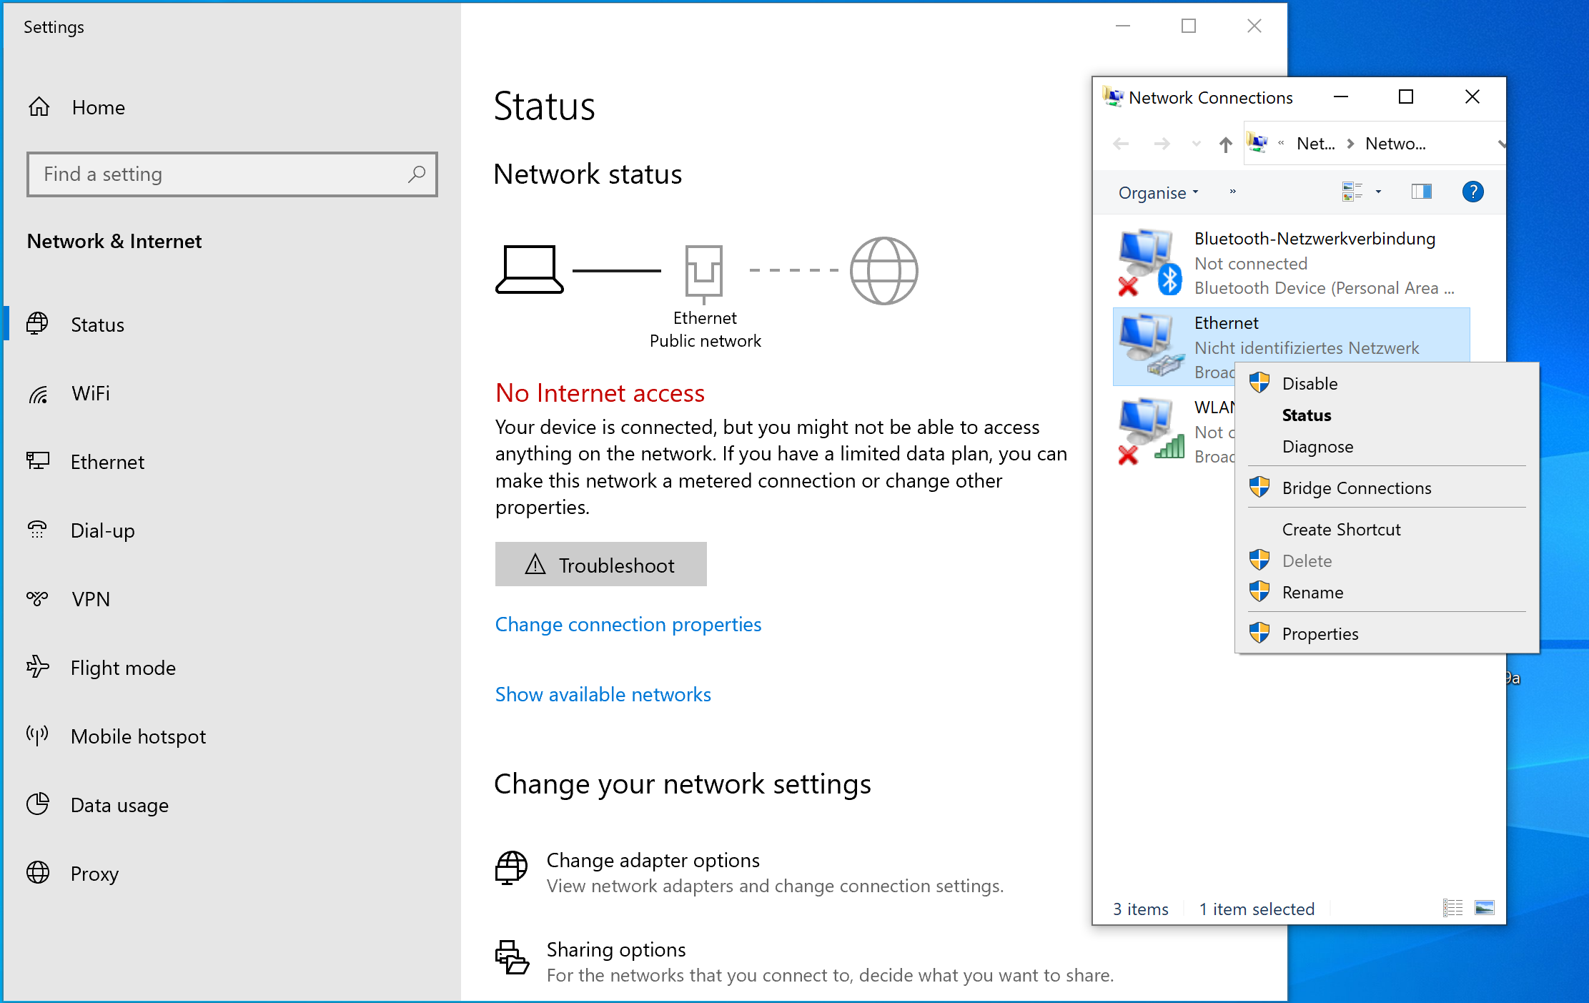

1. Scroll down to **Internetprotokoll;Version 4 (TCP/IPv4)**. Activate it and click on **Properties**. Add the below mentioned **IP-Address**es.

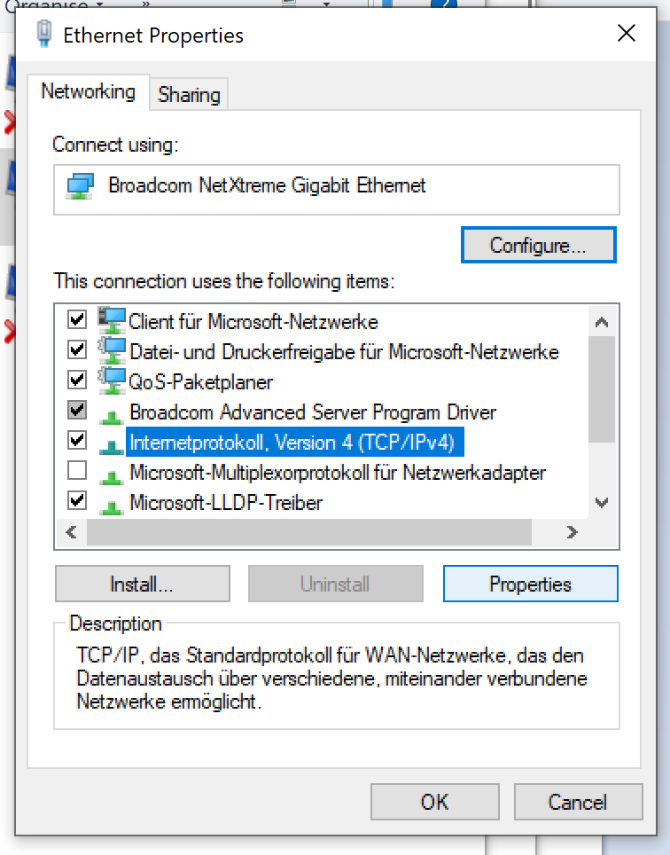 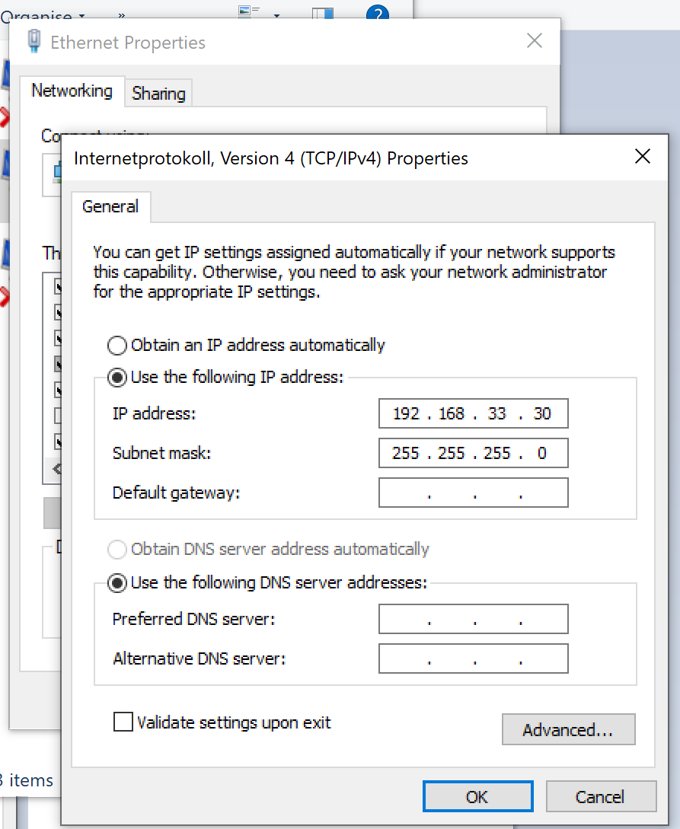

1. Establishing the connection to the board:
2. Open Tera Term and establish a serial connection. Usually there will be two ports open. Select the "lower" number.

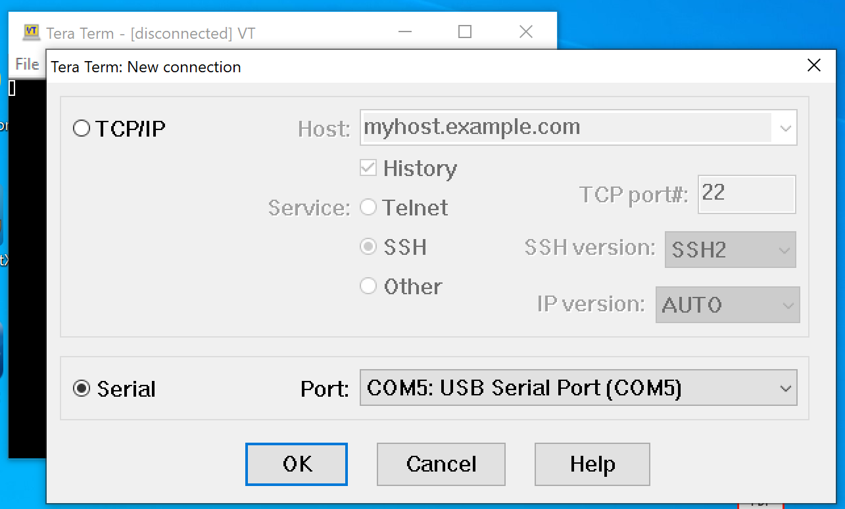

1. Afterward click on Setup 🡪 Serial port… and change the Speed to **115200** and add the "New setting".

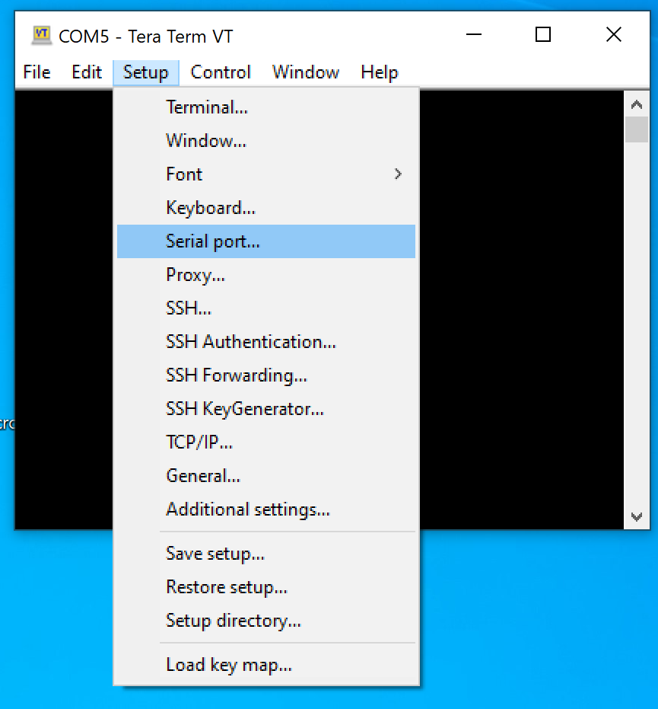 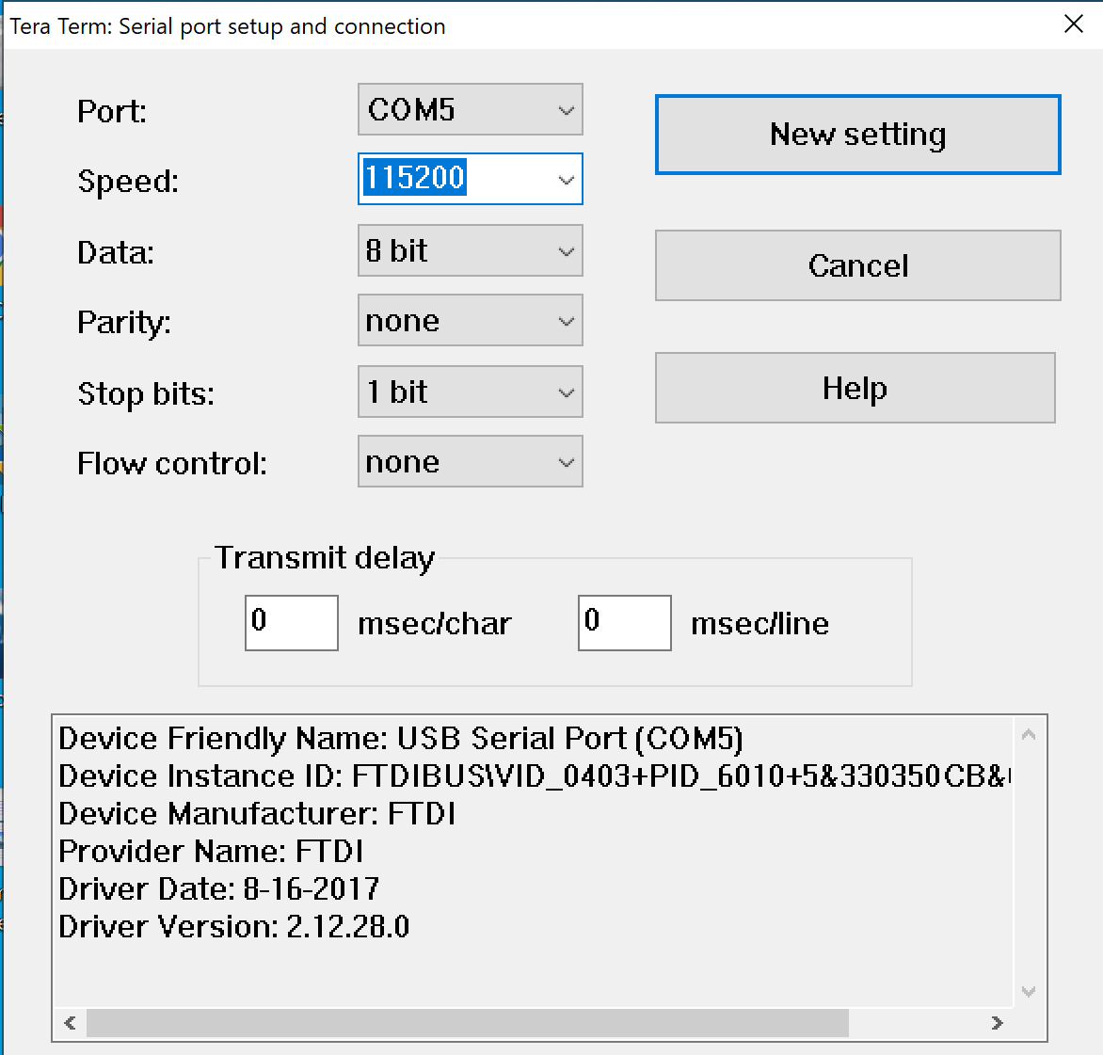

1. If everything works correctly and you enter in the Tera Term command window **root** [Enter] followed by **ifconfig** [Enter], then you should see a similar message as below:

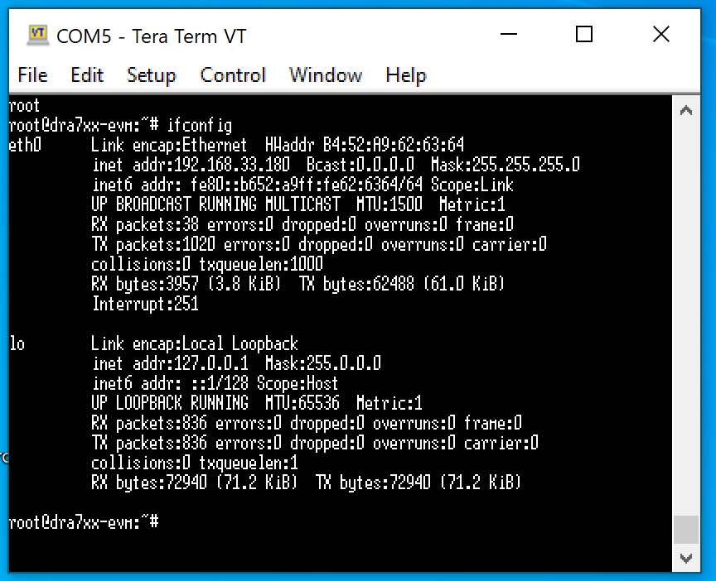

1. Configuration of Acquisition (Chirp Parameters, Acquisition Rate, etc.) and upload of Firmware
2. Start MMWAVE Studio. If everything was previously installed and the MIMO-SAR system is connected correctly then the Output-Window should not show any errors. There should be three different areas visible: The "RadarAPI", "Output", and "Lua Shell". If this is not the case, then they can be activated in "View".

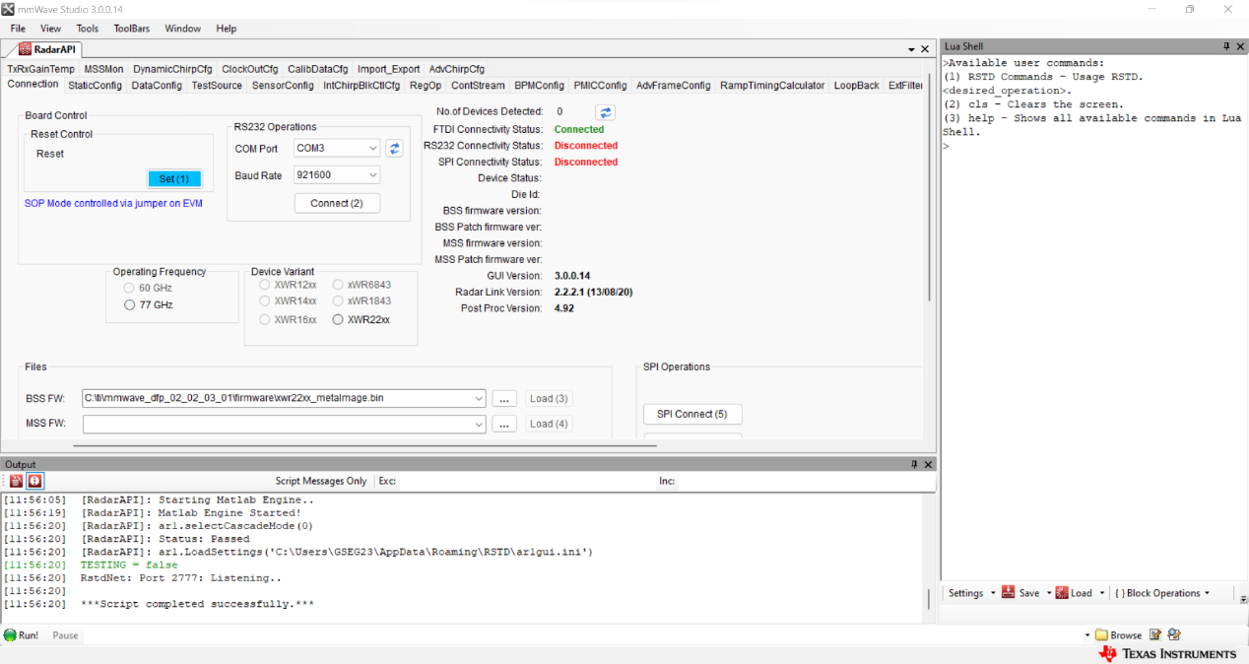

View

Lua Shell

Output

RadarAPI

RadarAPI

1. A first recommended step is to scroll (<->) the "RadarAPI" tab to the left to see some additional settings. Change then the Radar System from "Single Chip" to "Cascade". Optional: Change the view to the "SensorConfig" tab to see the chirp parameters.

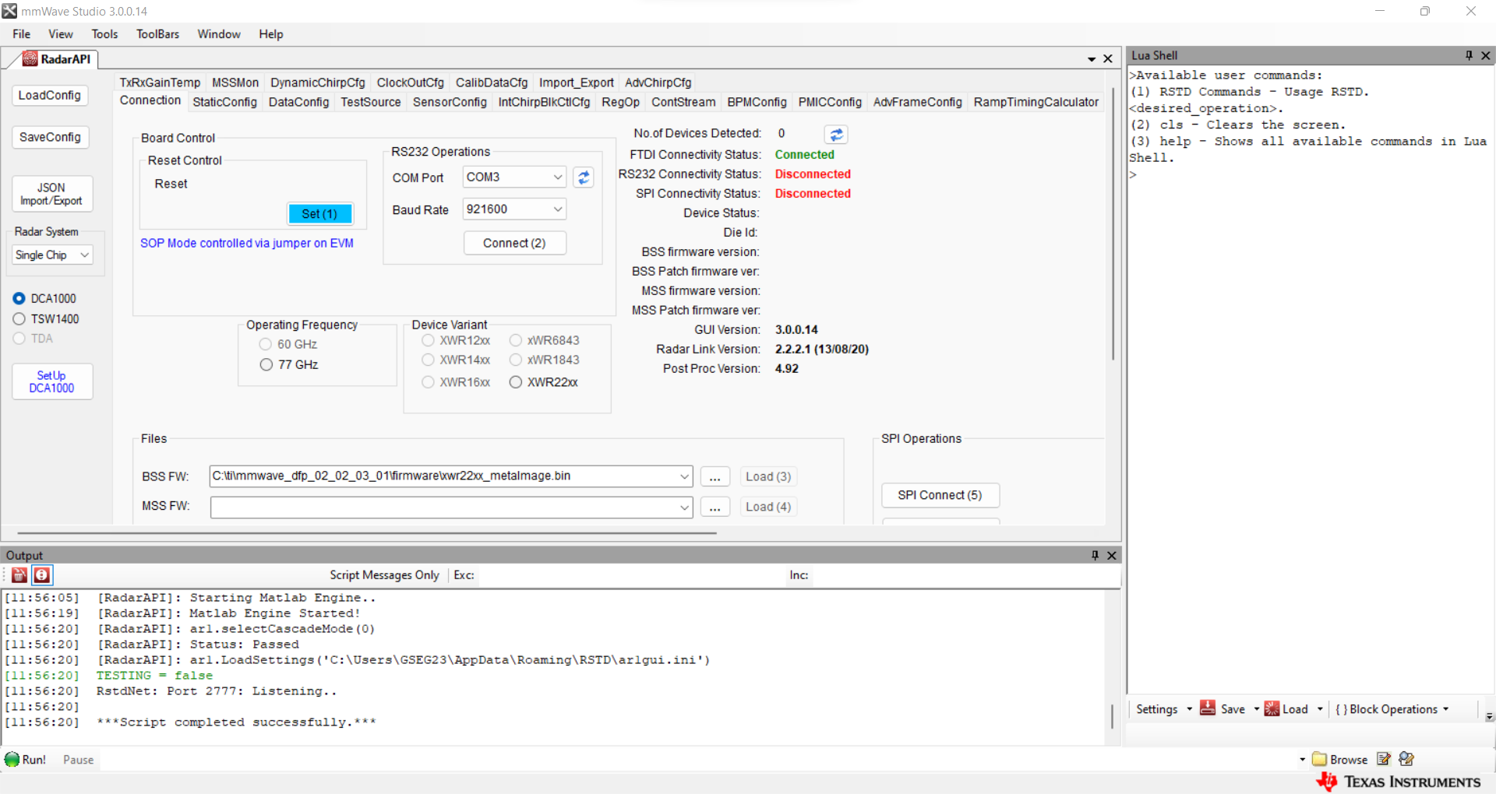

1. On the right side a lua script configurating the acquisition parameters can be loaded by clicking on Load 🡪 Load Lua Commands File. Further details on how to load and configurate the chirps are given in a separate document describing the procedures for MIMO-SAR and Beamforming mode. (***TIDEP-01012_02_Acquisition_...***)

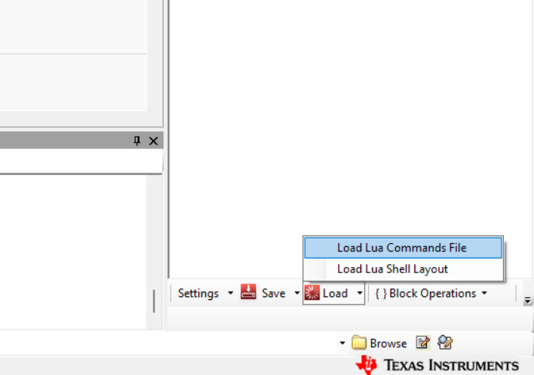

1. The data acquired are stored on the (green) board on an SSD. Downloading the data can happen in three ways:
2. Automatically, if programmed in the LUA-script. The files will be stored in the PostProc folder in the MMWAVE Studio installation directory.
3. Manually in MMWAVE Studio by clicking "Transfer Files" in the "SensorConfig" tab. The data will also be stored in the PostProc directory.
4. Manually through WinSCP and MMWAVE Studio:
5. Open WinSCP and start a session with the following settings:

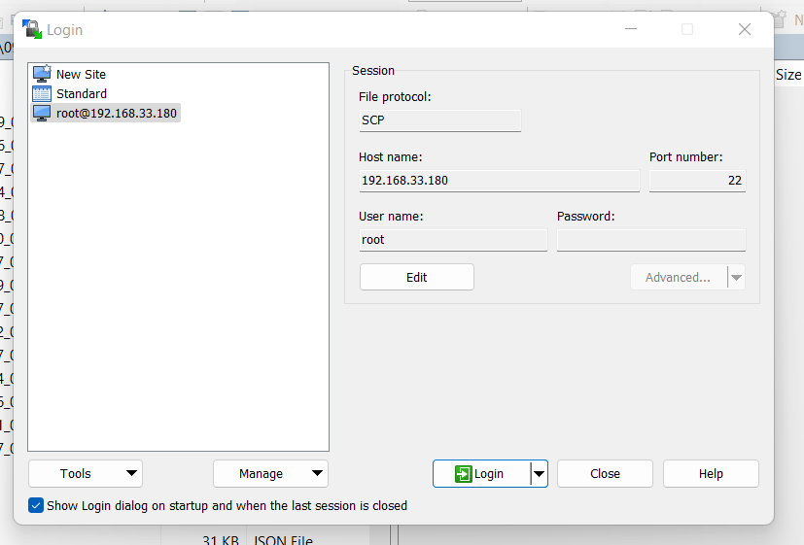

Furthermore, **remove** in Advanced… 🡪 Connection the tick next to **Optimize connection buffer size**. If this is activated, then a file transfer will fail after a few 100 MB.

Navigate to the top directory and go then to the data storage location in /mnt/ssd/. In this folder are all the acquisition stored. You can copy them to a local storage or directly to the server by drag and drop. Don’t forget to delete the data when you don't need them anymore as the storage is limited to about 450MB.

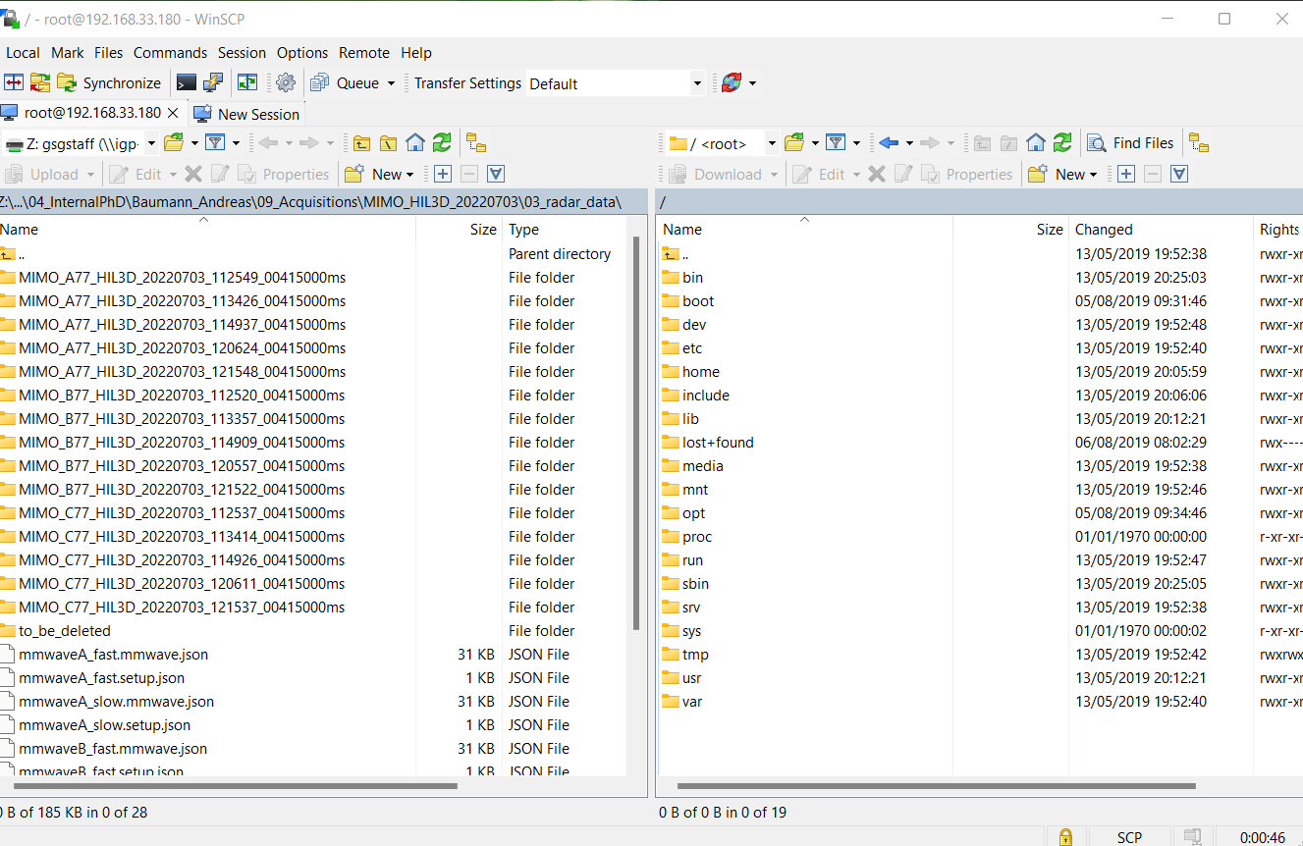

1. With the first two approaches, two JSON files have automatically been downloaded. Those files must be downloaded separately when using WinSCP. This can be done in MMWAVE Studio on the left side by clicking on JSON Import/Export. For post processing, the files should be stored in the acquisition directory together with the files and should contain at least eight *.bin files and the two *.json files.

If MMWAVE Studio has been closed in-between or other processing has been done, then load the respective lua script to MMWAVE Studio again (Configurating without acquisition!). Then download the JSON files as described above.

 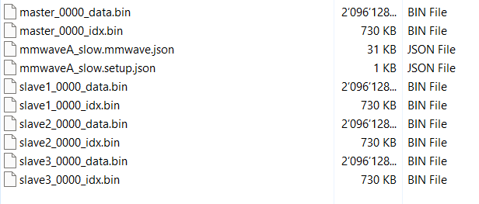

1. Those *.bin files are the raw acquisitions and can be processed using various MATLAB scripts. Detailed processing steps are described in the documents ***TIDEP-01012_03_Processing_...***.

**Whom to write from Texas Instruments, if there are technical problems?**

1. Engineer to Engineer-Forum (**e2e Forum**) of Texas Instruments: <https://e2e.ti.com/support/sensors-group/sensors/f/sensors-forum> [Attention: It is possible that you cannot post there directly because of restriction as ETH is an "University" not a "Company". Only "Staff of Companies" can ask questions on the forum]
2. Open a "new support request" on the **TI Customer Support Center** (if they don't know the answer, then they post your question on E2E-Forum): <https://support.ti.com/csm>