MINI PROJECT REPORT

on

HOTEL MANAGEMENT SYSTEM using Tkinter

Submitted by

KESHAV B.S (RA2311053010144)

ABHINANTH .M (RA2311053010148)

ADORN. B (RA2311053010149)

Semester – II

Academic Year: 2023-24 Even

Under the guidance of

Dr. Haroonhaider Homi Sidhwa
Assistant Professor, Department of ECE

In partial fulfilment for the Course

of

21CSS101J -PROGRAMMING FOR PROBLEM SOLVING



DEPARTMENT OF ELECTRONICS AND COMMUNICATION ENGINEERING

College of Engineering and Technology,

SRM Institute of Science and Technology
SRM Nagar, Kattankulathur – 603203, Kancheepuram District, Tamil Nadu.

April 2024

SRM INSTITUTE OF SCIENCE AND TECHNOLOGY

(Under Section 3 of UGC Act, 1956)

BONAFIDE CERTIFICATE

Certified that this activity report for the course 21CSS101J -PROGRAMMING FOR PROBLEM SOLVING is the bonafide work of ABHINANTH.M (RA2311053010148) ADORN.B (RA2311053010149) AND KESHAV.B S (RA2311053010144) who carried out the work under my supervision.

SIGNATURE SIGNATURE

Dr. B. Priyalakshmi Dr. Shanthi Prince
Assistant Professor Head of The Department
Department of ECE Department of ECE
SRMIST SRMIST
Kattankulathur Kattankulathur

TABLE OF CONTENTS

S.NO. | CONTENT | PAGE NO.
1 | ABSTRACT
2 | OBJECTIVE
3 | INTRODUCTION
4 | SYSTEM DESIGN AND SOURCE CODE
5 | RESULTS (SCREENSHOTS)
6 | REFERENCES

ABSTRACT

The project aims to develop a comprehensive hotel management system using the Tkinter library in Python. The system will provide a user-friendly interface for managing various aspects of hotel operations, including room booking, guest check-in/check-out, room service, billing, and staff management. By leveraging Tkinter's GUI capabilities, the system will ensure ease of use and efficiency for hotel staff, enhancing overall operational effectiveness and guest satisfaction.

OBJECTIVE

The objective of this project is to create a robust hotel management system using Tkinter that streamlines daily operations and enhances guest experience. Specific objectives include:
Designing an intuitive graphical user interface (GUI) for easy navigation and interaction.
Implementing functionalities for room booking, including availability checking, reservation, and cancellation.
Developing modules for guest management, allowing for efficient check-in, check-out, and guest information management.
Integrating features for room service management, enabling staff to handle guest requests promptly and accurately.
Implementing billing functionalities to generate invoices, process payments, and maintain transaction records.
Incorporating staff management capabilities, including user authentication, role-based access control, and attendance tracking.
Ensuring data security and integrity through proper input validation, error handling, and data encryption practices.
Conducting thorough testing to identify and resolve any bugs or usability issues, ensuring a stable and reliable system. By achieving these objectives, the project aims to deliver a versatile hotel management solution that optimizes operations, enhances guest satisfaction, and contributes to the overall success of the hospitality business.

INTRODUCTION

Introduction: In an era characterized by ever-evolving consumer expectations and technological advancements, the hospitality industry stands at the forefront of innovation. As hotels strive to deliver exceptional guest experiences while maintaining operational efficiency, the need for robust management solutions becomes increasingly paramount. It is within this context that the proposed hotel management project emerges, aiming to address the diverse challenges faced by hoteliers through the development of a comprehensive system leveraging the Tkinter library in Python.
The hospitality landscape is marked by a myriad of complexities, from managing room inventory and guest bookings to delivering personalized services and ensuring seamless operations. Traditional methods of hotel management often struggle to keep pace with the dynamic demands of modern travelers and the intricacies of hotel operations. Consequently, there arises a pressing need for innovative solutions that streamline processes, enhance guest satisfaction, and empower hotel staff to deliver exceptional service.
The proposed hotel management project seeks to fill this gap by harnessing the power of Tkinter, a versatile GUI library renowned for its simplicity and flexibility. Tkinter provides a robust framework for developing intuitive graphical interfaces, making it an ideal choice for building user-friendly management systems tailored to the unique requirements of the hospitality sector.

REFERENCE-
Brown, J., & Rezende, L. (2018). Hotel Management System: A Review of Existing Literature. Journal of Hospitality Application and Research, 13(2), 36-51.
This article provides an insightful review of existing literature on hotel management systems, offering valuable insights and perspectives that can inform the development of the proposed project.
Gupta, A., & Agarwal, S. (2020). Emerging Technologies in Hospitality Industry: A Review. International Journal of Hospitality & Tourism Systems, 13(1), 45-62.
This journal article offers a comprehensive review of emerging technologies in the hospitality industry, including trends in hotel management systems, which can serve as a valuable reference for the project's technological framework and development approach.
O’Fallon, M. J., & Rutherford, D. G. (2019). Hotel Management and Operations (6th ed.).John Wiley& Sons

Codings

#! /usr/bin/env python # -*- coding: utf-8 -*- #
# GUI module generated by PAGE version 4.14 # In conjunction with Tcl version 8.6
# May 2,2024
import os import pickle import sys import os
from subprocess import call import sys
try:
from Tkinter import * except ImportError:
from tkinter import *

try:
import ttk py3 = False
except ImportError: import tkinter.ttk as ttk py3 = True
details_list=[]

def file_save():
NAME_PRO = details_list[0] ADDRESS_PRO = details_list[1] MOBILE_NO_PRO = details_list[2] ROOM_NO_PRO = details_list[3] PRICE_PRO = details_list[4]
f = open("hotel.dat", "ab") a=save(NAME_PRO,ADDRESS_PRO,MOBILE_NO_PRO,ROOM_NO_PRO,PRICE_PRO)
pickle.dump(a,f,protocol=2) f.close()

listq=[str(NAME_PRO),str(ADDRESS_PRO),str(MOBILE_NO_PRO),str(ROOM_NO_PRO),str( PRICE_PRO)]
myVars =
{'A':NAME_PRO,"B":ADDRESS_PRO,"C":MOBILE_NO_PRO,"D":ROOM_NO_PRO,"E":PRICE
_PRO }

fo=open("recipt.txt","w+") for h in range(0,5):
fo.write(listq[h]+"\r\n") fo.close()
call(["python", "recipt.py"]) restart_program()

u = list()
Delux = (1, 2, 3, 4, 5, 6, 7, 8, 9, 10)
Semi_Delux = (11, 12, 13, 14, 15, 16, 17, 18, 19, 20, 21, 22, 23, 24, 25)
General = (26, 27, 28, 29, 30, 31, 32, 33, 34, 35, 36, 37, 38, 39, 40, 41, 42, 43, 44, 45)
Joint_Room = (46, 47, 48, 49, 50, 46, 47, 48, 49, 50)
m = [9]
G = []
def restart_program():
"""Restarts the current program.
Note: this function does not return. Any cleanup action (like saving data) must be done before calling this function.""" python = sys.executable
os.execl(python, python, * sys.argv)

class save: def
init (self,NAME_PRO,ADDRESS_PRO,MOBILE_NO_PRO,ROOM_NO_PRO,PRICE_PRO)
:
self.name=NAME_PRO self.address=ADDRESS_PRO self.mobile_no=MOBILE_NO_PRO self.room_no=ROOM_NO_PRO self.price=PRICE_PRO

class HOTEL_MANGMENT_checkin:

def init (self):

self.NAME="" self.ADDERESS="" self.MOBILE=""
self.DAYS=0 self.price=0 self.room=0

def chk_name(): while True:
self.k = str(self.name.get()) a = self.k.isdigit()
if len(self.k) != 0 and a != True:
self.NAME=self.k
self.Text1.insert(INSERT, "name has been inputed""\n") break
else:
self.Text1.insert(INSERT, "invalid input please input a valid name""\n") break
def chk_add(): while True:
self.g = str(self.addr.get())

ak = self.g.isdigit()
if len(self.g)!= 0 and ak!=True: self.ADDERESS=self.g
self.Text1.insert(INSERT, "address has been inputed""\n") break
else:
self.Text1.insert(INSERT, "invalid input please input a valid address""\n") break
def chk_mo(): while True:

self.h = str(self.mobile.get())
if self.h.isdigit() == True and len(self.h) != 0 and len(self.h) == 10: self.MOBILE = self.h
self.Text1.insert(INSERT, "mobile number has been inputed""\n") break
else:
self.Text1.insert(INSERT, "invalid input please input a valid mobile number""\n") break

def chk_day(): while True:

self.l = str(self.days.get())

if self.l.isdigit() == True and len(self.l) != 0: self.DAYS = int(self.l)
self.Text1.insert(INSERT, "days has been inputed""\n") break
else:
self.Text1.insert(INSERT, "invalid input ""\n") break

def enter(self):
self.name = self.NAME self.address = self.ADDERESS self.mobile_no = self.MOBILE self.no_of_days = int(self.DAYS)

def tor(self):

if self.ch == 1:
self.price = self.price + (2000 * self.no_of_days) m[0] = 1
elif self.ch == 2:
self.price = self.price + (1500 * self.no_of_days) m[0] = 2
elif self.ch == 3:
self.price = self.price + (1000 * self.no_of_days) m[0] = 3
elif self.ch == 4:
self.price = self.price + (1700 * self.no_of_days) m[0] = 4

def payment_option(self):

op = self.p if op == 1:
self.Text1.insert(INSERT, "no discount""\n") elif op == 2:
self.price = self.price - ((self.price * 10) / 100) self.Text1.insert(INSERT, "10% discount""\n")

def bill(self):

if m[0] == 1: a = Delux
elif m[0] == 2:
a = Semi_Delux elif m[0] == 3:
a = General elif m[0] == 4:
a = Joint_Room

G = []
f2 = open("hotel.dat", "rb") try:
while True:
s = pickle.load(f2)

k = s.room_no G.append(k) continue

except EOFError: pass

for r in a:
if r not in G: self.room = r break
else:
continue self.room = r f2.close()

details_list.append(self.name) details_list.append(self.address) details_list.append(self.mobile_no) details_list.append(self.room)

details_list.append(self.price)

file_save()

def submit_clicked():
if self.var1.get()==1 and self.var2.get()==0 and self.var3.get()==0 and self.var4.get()==0 and self.var5.get()==1 and self.var6.get()==0:
self.ch=1 self.p=2

enter(self) tor(self)
payment_option(self) bill(self)

elif self.var1.get() == 1 and self.var2.get() == 0 and self.var3.get() == 0 and self.var4.get() == 0 and self.var5.get() == 0 and self.var6.get() == 1:
self.ch = 1
self.p = 1

enter(self) tor(self)
payment_option(self) bill(self)
elif self.var1.get() == 0 and self.var2.get() == 1 and self.var3.get() == 0 and self.var4.get() == 0 and self.var5.get() == 0 and self.var6.get() == 1:
self.ch = 2
self.p = 1

enter(self) tor(self)
payment_option(self) bill(self)
elif self.var1.get() == 0 and self.var2.get() == 1 and self.var3.get() == 0 and self.var4.get() == 0 and self.var5.get() == 1 and self.var6.get() ==0 :
self.ch = 2
self.p = 2

enter(self) tor(self)
payment_option(self) bill(self)
elif self.var1.get() == 0 and self.var2.get() == 0 and self.var3.get() == 1 and self.var4.get() == 0 and self.var5.get() == 0 and self.var6.get() == 1:
self.ch = 3
self.p = 1

enter(self) tor(self)
payment_option(self) bill(self)
elif self.var1.get() == 0 and self.var2.get() == 0 and self.var3.get() == 1 and self.var4.get() == 0 and self.var5.get() == 1 and self.var6.get() == 0:
self.ch = 3
self.p = 2

enter(self) tor(self)
payment_option(self) bill(self)

elif self.var1.get() == 0 and self.var2.get() == 0 and self.var3.get() == 0 and self.var4.get() == 1 and self.var5.get() == 0 and self.var6.get() == 1:
self.ch = 4
self.p = 1

enter(self) tor(self)
payment_option(self) bill(self)
elif self.var1.get() == 0 and self.var2.get() == 0 and self.var3.get() == 0 and self.var4.get() == 1 and self.var5.get() == 1 and self.var6.get() == 0:
self.ch = 4
self.p = 2

enter(self) tor(self)
payment_option(self) bill(self)

else:
self.Text1.insert(INSERT, "invalid choice please input a valid choice""\n")

root = Tk()

'''This class configures and populates the toplevel window. top is the toplevel containing window.'''
_bgcolor = '#ffffff' # X11 color: 'white'
_fgcolor = '#000000' # X11 color: 'black'
_compcolor = '#ffffff' # X11 color: 'white'
_ana1color = '#ffffff' # X11 color: 'white'
_ana2color = '#ffffff' # X11 color: 'white'
font10 = "-family {Courier New} -size 10 -weight normal -slant" \ " roman -underline 0 -overstrike 0"
font11 = "-family {Segoe UI} -size 30 -weight bold -slant " \ "roman -underline 0 -overstrike 0"
font12 = "-family {Segoe UI} -size 18 -weight bold -slant " \ "roman -underline 0 -overstrike 0"
font13 = "-family {Segoe UI} -size 17 -weight bold -slant " \ "roman -underline 0 -overstrike 0"
font14 = "-family {Segoe UI} -size 16 -weight bold -slant " \ "roman -underline 0 -overstrike 0"
font15 = "-family {Segoe UI} -size 19 -weight bold -slant " \ "roman -underline 0 -overstrike 0"
font16 = "-family {Segoe UI} -size 15 -weight bold -slant " \ "roman -underline 0 -overstrike 0"
font9 = "-family {Segoe UI} -size 9 -weight normal -slant " \ "roman -underline 0 -overstrike 0"

root.geometry("1069x742") root.title("HOTEL MANGMENT") root.configure(background="#ffffff") root.configure(highlightbackground="#ffffff") root.configure(highlightcolor="black")

self.Text1 = Text(root)
self.Text1.place(relx=0.03, rely=0.65, relheight=0.29, relwidth=0.93) self.Text1.configure(background="white") self.Text1.configure(font=font9) self.Text1.configure(foreground="black") self.Text1.configure(highlightbackground="#ffffff")

self.Text1.configure(highlightcolor="black") self.Text1.configure(insertbackground="black") self.Text1.configure(selectbackground="#e6e6e6") self.Text1.configure(selectforeground="black") self.Text1.configure(width=994) self.Text1.configure(wrap=WORD)

self.Frame1 = Frame(root)
self.Frame1.place(relx=0.03, rely=0.05, relheight=0.12, relwidth=0.93) self.Frame1.configure(relief=GROOVE) self.Frame1.configure(borderwidth="2") self.Frame1.configure(relief=GROOVE) self.Frame1.configure(background="#ffffff") self.Frame1.configure(highlightbackground="#ffffff") self.Frame1.configure(highlightcolor="black") self.Frame1.configure(width=995)

self.Message1 = Message(self.Frame1) self.Message1.place(relx=0.04, rely=0.11, relheight=0.84, relwidth=0.5) self.Message1.configure(background="#ffffff") self.Message1.configure(font=font11) self.Message1.configure(foreground="#000000") self.Message1.configure(highlightbackground="#ffffff") self.Message1.configure(highlightcolor="black") self.Message1.configure(text='''YOU CLICKED ON''') self.Message1.configure(width=496)

self.Message2 = Message(self.Frame1)
self.Message2.place(relx=0.52, rely=0.19, relheight=0.74, relwidth=0.07) self.Message2.configure(background="#ffffff") self.Message2.configure(font=font11) self.Message2.configure(foreground="#000000") self.Message2.configure(highlightbackground="#ffffff") self.Message2.configure(highlightcolor="black") self.Message2.configure(text=''':''')
self.Message2.configure(width=66)

self.Message3 = Message(self.Frame1)
self.Message3.place(relx=0.57, rely=0.11, relheight=0.79, relwidth=0.35) self.Message3.configure(background="#ffffff") self.Message3.configure(font=font11) self.Message3.configure(foreground="#000000") self.Message3.configure(highlightbackground="#ffffff") self.Message3.configure(highlightcolor="black")

self.Message3.configure(text='''CHECK INN''') self.Message3.configure(width=347)

self.menubar = Menu(root,font=font9,bg=_bgcolor,fg=_fgcolor) root.configure(menu = self.menubar)

self.Frame2 = Frame(root)
self.Frame2.place(relx=0.03, rely=0.18, relheight=0.46, relwidth=0.93) self.Frame2.configure(relief=GROOVE) self.Frame2.configure(borderwidth="2") self.Frame2.configure(relief=GROOVE) self.Frame2.configure(background="#ffffff") self.Frame2.configure(highlightbackground="#ffffff") self.Frame2.configure(highlightcolor="black") self.Frame2.configure(width=995)

self.Label3 = Label(self.Frame2)
self.Label3.place(relx=0.05, rely=0.03, height=47, width=289) self.Label3.configure(activebackground="#ffffff") self.Label3.configure(activeforeground="black") self.Label3.configure(background="#ffffff") self.Label3.configure(disabledforeground="#bfbfbf") self.Label3.configure(font=font12) self.Label3.configure(foreground="#000000") self.Label3.configure(highlightbackground="#ffffff") self.Label3.configure(highlightcolor="black") self.Label3.configure(text='''ENTER YOUR NAME''')

self.Label4 = Label(self.Frame2)
self.Label4.place(relx=0.045, rely=0.29, height=47, width=329) self.Label4.configure(activebackground="#ffffff") self.Label4.configure(activeforeground="black") self.Label4.configure(background="#ffffff") self.Label4.configure(disabledforeground="#bfbfbf") self.Label4.configure(font=font12) self.Label4.configure(foreground="#000000") self.Label4.configure(highlightbackground="#ffffff") self.Label4.configure(highlightcolor="black") self.Label4.configure(text='''ENTER YOUR NUMBER''')

self.Entry3 = Entry(self.Frame2) self.name=StringVar()
self.Entry3.place(relx=0.47, rely=0.05,height=34, relwidth=0.43) self.Entry3.configure(background="white") self.Entry3.configure(disabledforeground="#bfbfbf") self.Entry3.configure(font=font10) self.Entry3.configure(foreground="#000000") self.Entry3.configure(highlightbackground="#ffffff") self.Entry3.configure(highlightcolor="black") self.Entry3.configure(insertbackground="black") self.Entry3.configure(selectbackground="#e6e6e6") self.Entry3.configure(selectforeground="black") self.Entry3.configure(textvariable=self.name)

self.Entry4 = Entry(self.Frame2) self.mobile=StringVar()
self.Entry4.place(relx=0.47, rely=0.31,height=34, relwidth=0.43) self.Entry4.configure(background="white") self.Entry4.configure(disabledforeground="#bfbfbf") self.Entry4.configure(font=font10) self.Entry4.configure(foreground="#000000") self.Entry4.configure(highlightbackground="#ffffff") self.Entry4.configure(highlightcolor="black") self.Entry4.configure(insertbackground="black") self.Entry4.configure(selectbackground="#e6e6e6") self.Entry4.configure(selectforeground="black") self.Entry4.configure(textvariable=self.mobile)

self.Entry5 = Entry(self.Frame2) self.addr = StringVar()
self.Entry5.place(relx=0.47, rely=0.18,height=34, relwidth=0.43) self.Entry5.configure(background="white") self.Entry5.configure(disabledforeground="#bfbfbf") self.Entry5.configure(font=font10) self.Entry5.configure(foreground="#000000") self.Entry5.configure(highlightbackground="#ffffff") self.Entry5.configure(highlightcolor="black") self.Entry5.configure(insertbackground="black") self.Entry5.configure(selectbackground="#e6e6e6") self.Entry5.configure(selectforeground="black") self.Entry5.configure(textvariable=self.addr)

self.Label5 = Label(self.Frame2)
self.Label5.place(relx=0.045, rely=0.16, height=47, width=334) self.Label5.configure(activebackground="#ffffff") self.Label5.configure(activeforeground="black") self.Label5.configure(background="#ffffff") self.Label5.configure(disabledforeground="#bfbfbf") self.Label5.configure(font=font12) self.Label5.configure(foreground="#000000") self.Label5.configure(highlightbackground="#ffffff") self.Label5.configure(highlightcolor="black") self.Label5.configure(text='''ENTER YOUR ADDRESS''')

self.Label6 = Label(self.Frame2) self.Label6.place(relx=0.32, rely=0.5, height=48, width=296) self.Label6.configure(activebackground="#ffffff") self.Label6.configure(activeforeground="black") self.Label6.configure(background="#ffffff") self.Label6.configure(disabledforeground="#bfbfbf") self.Label6.configure(font=font13) self.Label6.configure(foreground="#000000") self.Label6.configure(highlightbackground="#ffffff") self.Label6.configure(highlightcolor="black") self.Label6.configure(text='''CHOOSE YOUR ROOM''')

self.Label7 = Label(self.Frame2)
self.Label7.place(relx=0.3, rely=0.79, height=48, width=300) self.Label7.configure(activebackground="#ffffff") self.Label7.configure(activeforeground="black") self.Label7.configure(background="#ffffff") self.Label7.configure(disabledforeground="#bfbfbf") self.Label7.configure(font=font14) self.Label7.configure(foreground="#000000") self.Label7.configure(highlightbackground="#ffffff") self.Label7.configure(highlightcolor="black") self.Label7.configure(text='''CHOOSE PAYMENT METHOD''')

self.Message4 = Message(self.Frame2) self.Message4.place(relx=0.41, rely=0.04, relheight=0.1, relwidth=0.05) self.Message4.configure(background="#ffffff") self.Message4.configure(font=font13) self.Message4.configure(foreground="#000000") self.Message4.configure(highlightbackground="#ffffff") self.Message4.configure(highlightcolor="black") self.Message4.configure(text=''':''')

self.Message4.configure(width=46)

self.Message5 = Message(self.Frame2)
self.Message5.place(relx=0.42, rely=0.17, relheight=0.12, relwidth=0.03) self.Message5.configure(background="#ffffff") self.Message5.configure(font=font13) self.Message5.configure(foreground="#000000") self.Message5.configure(highlightbackground="#ffffff") self.Message5.configure(highlightcolor="black") self.Message5.configure(text=''':''')
self.Message5.configure(width=26)

self.Message6 = Message(self.Frame2) self.Message6.place(relx=0.415, rely=0.3, relheight=0.09, relwidth=0.04) self.Message6.configure(background="#ffffff") self.Message6.configure(font=font13) self.Message6.configure(foreground="#000000") self.Message6.configure(highlightbackground="#ffffff") self.Message6.configure(highlightcolor="black") self.Message6.configure(text=''':''')
self.Message6.configure(width=36)

self.Checkbutton1 = Checkbutton(self.Frame2) self.var1 = IntVar()
self.Checkbutton1.place(relx=0.15, rely=0.58, relheight=0.17
, relwidth=0.14) self.Checkbutton1.configure(activebackground="#ffffff") self.Checkbutton1.configure(activeforeground="#000000") self.Checkbutton1.configure(background="#ffffff") self.Checkbutton1.configure(disabledforeground="#bfbfbf") self.Checkbutton1.configure(font=font14) self.Checkbutton1.configure(foreground="#000000") self.Checkbutton1.configure(highlightbackground="#ffffff") self.Checkbutton1.configure(highlightcolor="black") self.Checkbutton1.configure(justify=LEFT) self.Checkbutton1.configure(text='''DELUXE''') self.Checkbutton1.configure(variable=self.var1)

self.Checkbutton2 = Checkbutton(self.Frame2) self.var2 = IntVar()

self.Checkbutton2.place(relx=0.15, rely=0.72, relheight=0.11
, relwidth=0.21) self.Checkbutton2.configure(activebackground="#ffffff") self.Checkbutton2.configure(activeforeground="#000000") self.Checkbutton2.configure(background="#ffffff") self.Checkbutton2.configure(disabledforeground="#bfbfbf") self.Checkbutton2.configure(font=font13) self.Checkbutton2.configure(foreground="#000000") self.Checkbutton2.configure(highlightbackground="#ffffff") self.Checkbutton2.configure(highlightcolor="black") self.Checkbutton2.configure(justify=LEFT) self.Checkbutton2.configure(text='''FULL DELUXE''') self.Checkbutton2.configure(variable=self.var2)

self.Checkbutton3 = Checkbutton(self.Frame2) self.var3 = IntVar()
self.Checkbutton3.place(relx=0.5, rely=0.6, relheight=0.11
, relwidth=0.16) self.Checkbutton3.configure(activebackground="#ffffff") self.Checkbutton3.configure(activeforeground="#000000") self.Checkbutton3.configure(background="#ffffff") self.Checkbutton3.configure(disabledforeground="#bfbfbf") self.Checkbutton3.configure(font=font13) self.Checkbutton3.configure(foreground="#000000") self.Checkbutton3.configure(highlightbackground="#ffffff") self.Checkbutton3.configure(highlightcolor="black") self.Checkbutton3.configure(justify=LEFT) self.Checkbutton3.configure(text='''GENERAL''') self.Checkbutton3.configure(variable=self.var3)

self.Checkbutton4 = Checkbutton(self.Frame2) self.var4 = IntVar()
self.Checkbutton4.place(relx=0.5, rely=0.71, relheight=0.11
, relwidth=0.12) self.Checkbutton4.configure(activebackground="#ffffff") self.Checkbutton4.configure(activeforeground="#000000") self.Checkbutton4.configure(background="#ffffff") self.Checkbutton4.configure(disabledforeground="#bfbfbf") self.Checkbutton4.configure(font=font13) self.Checkbutton4.configure(foreground="#000000") self.Checkbutton4.configure(highlightbackground="#ffffff") self.Checkbutton4.configure(highlightcolor="black") self.Checkbutton4.configure(justify=LEFT) self.Checkbutton4.configure(text='''JOINT''')

self.Checkbutton4.configure(variable=self.var4)

self.Checkbutton5 = Checkbutton(self.Frame2) self.var5 = IntVar()
self.Checkbutton5.place(relx=0.485, rely=0.89, relheight=0.1
, relwidth=0.3) self.Checkbutton5.configure(activebackground="#ffffff") self.Checkbutton5.configure(activeforeground="#000000") self.Checkbutton5.configure(background="#ffffff") self.Checkbutton5.configure(disabledforeground="#bfbfbf") self.Checkbutton5.configure(font=font16) self.Checkbutton5.configure(foreground="#000000") self.Checkbutton5.configure(highlightbackground="#ffffff") self.Checkbutton5.configure(highlightcolor="black") self.Checkbutton5.configure(justify=LEFT) self.Checkbutton5.configure(text='''By credit/debit card''') self.Checkbutton5.configure(variable=self.var5)

self.Checkbutton6 = Checkbutton(self.Frame2) self.var6 = IntVar()
self.Checkbutton6.place(relx=0.153, rely=0.89, relheight=0.1
, relwidth=0.15) self.Checkbutton6.configure(activebackground="#ffffff") self.Checkbutton6.configure(activeforeground="#000000") self.Checkbutton6.configure(background="#ffffff") self.Checkbutton6.configure(disabledforeground="#bfbfbf") self.Checkbutton6.configure(font=font16) self.Checkbutton6.configure(foreground="#000000") self.Checkbutton6.configure(highlightbackground="#ffffff") self.Checkbutton6.configure(highlightcolor="black") self.Checkbutton6.configure(justify=LEFT) self.Checkbutton6.configure(text='''By cash''') self.Checkbutton6.configure(variable=self.var6)

self.Message7 = Message(self.Frame2)
self.Message7.place(relx=0.28, rely=0.46, relheight=0.11, relwidth=0.04) self.Message7.configure(background="#ffffff") self.Message7.configure(font=font15) self.Message7.configure(foreground="#000000") self.Message7.configure(highlightbackground="#ffffff") self.Message7.configure(highlightcolor="black") self.Message7.configure(text='''-''')
self.Message7.configure(width=41)

self.Button1 = Button(self.Frame2) self.Button1.place(relx=0.91, rely=0.05, height=33, width=43) self.Button1.configure(activebackground="#ffffff") self.Button1.configure(activeforeground="#000000") self.Button1.configure(background="#ffffff") self.Button1.configure(disabledforeground="#bfbfbf") self.Button1.configure(foreground="#000000") self.Button1.configure(highlightbackground="#ffffff") self.Button1.configure(highlightcolor="black") self.Button1.configure(pady="0") self.Button1.configure(text='''OK''') self.Button1.configure(command=chk_name)

self.Button2 = Button(self.Frame2) self.Button2.place(relx=0.91, rely=0.18, height=33, width=43) self.Button2.configure(activebackground="#ffffff") self.Button2.configure(activeforeground="#000000") self.Button2.configure(background="#ffffff") self.Button2.configure(disabledforeground="#bfbfbf") self.Button2.configure(foreground="#000000") self.Button2.configure(highlightbackground="#ffffff") self.Button2.configure(highlightcolor="black") self.Button2.configure(pady="0") self.Button2.configure(text='''OK''') self.Button2.configure(command=chk_add)

self.Button3 = Button(self.Frame2) self.Button3.place(relx=0.91, rely=0.31, height=33, width=43) self.Button3.configure(activebackground="#ffffff") self.Button3.configure(activeforeground="#000000") self.Button3.configure(background="#ffffff") self.Button3.configure(disabledforeground="#bfbfbf") self.Button3.configure(foreground="#000000") self.Button3.configure(highlightbackground="#ffffff") self.Button3.configure(highlightcolor="black") self.Button3.configure(pady="0") self.Button3.configure(text='''OK''') self.Button3.configure(command=chk_mo)

self.Button4 = Button(self.Frame2) self.Button4.place(relx=0.76, rely=0.66, height=83, width=156) self.Button4.configure(activebackground="#ffffff") self.Button4.configure(activeforeground="#000000") self.Button4.configure(background="#ffffff")

self.Button4.configure(disabledforeground="#bfbfbf") self.Button4.configure(font=font16) self.Button4.configure(foreground="#000000") self.Button4.configure(highlightbackground="#ffffff") self.Button4.configure(highlightcolor="black") self.Button4.configure(pady="0") self.Button4.configure(text='''SUBMIT''') self.Button4.configure(command=submit_clicked)

self.Label1 = Label(self.Frame2)
self.Label1.place(relx=0.05, rely=0.43, height=44, width=260) self.Label1.configure(background="#ffffff") self.Label1.configure(disabledforeground="#bfbfbf") self.Label1.configure(font=font13) self.Label1.configure(foreground="#000000") self.Label1.configure(text='''NUMBER OF DAYS''')

self.Entry1 = Entry(self.Frame2) self.days=StringVar()
self.Entry1.place(relx=0.47, rely=0.43, height=34, relwidth=0.43) self.Entry1.configure(background="white") self.Entry1.configure(disabledforeground="#bfbfbf") self.Entry1.configure(font=font10) self.Entry1.configure(foreground="#000000") self.Entry1.configure(insertbackground="black") self.Entry1.configure(width=424) self.Entry1.configure(textvariable=self.days)

self.Message8 = Message(self.Frame2)
self.Message8.place(relx=0.42, rely=0.41, relheight=0.11, relwidth=0.03) self.Message8.configure(background="#ffffff") self.Message8.configure(font=font13) self.Message8.configure(foreground="#000000") self.Message8.configure(highlightbackground="#ffffff") self.Message8.configure(highlightcolor="black") self.Message8.configure(text=''':''')
self.Message8.configure(width=26)

self.Button5 = Button(self.Frame2) self.Button5.place(relx=0.91, rely=0.43, height=33, width=43) self.Button5.configure(activebackground="#ffffff") self.Button5.configure(activeforeground="#000000") self.Button5.configure(background="#ffffff")

self.Button5.configure(disabledforeground="#bfbfbf") self.Button5.configure(foreground="#000000") self.Button5.configure(highlightbackground="#ffffff") self.Button5.configure(highlightcolor="black") self.Button5.configure(pady="0") self.Button5.configure(text='''OK''') self.Button5.configure(command=chk_day)

root.mainloop()

if name == ' main ': hotel=HOTEL_MANGMENT_checkin()

Screenshots

WELCOME TAB

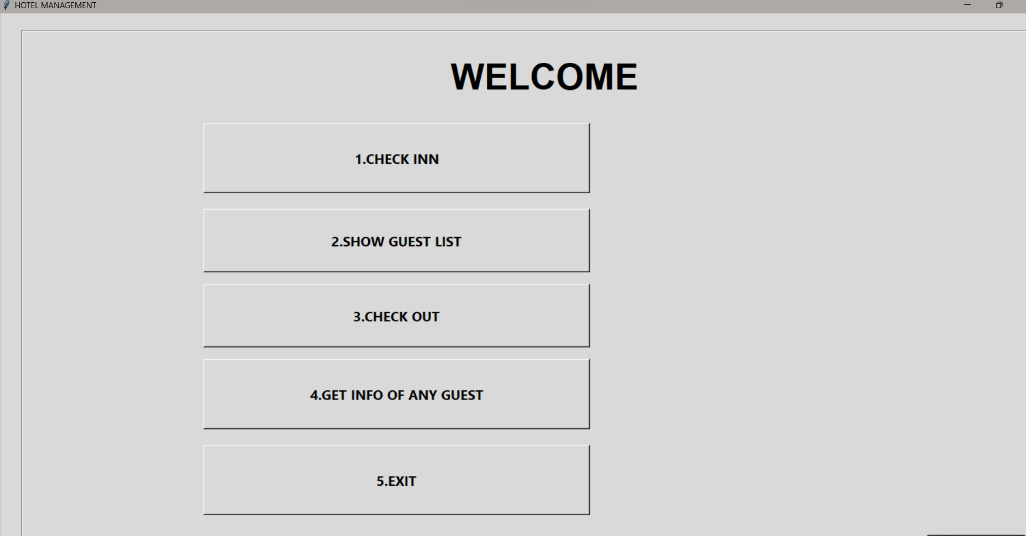

CHECK INN
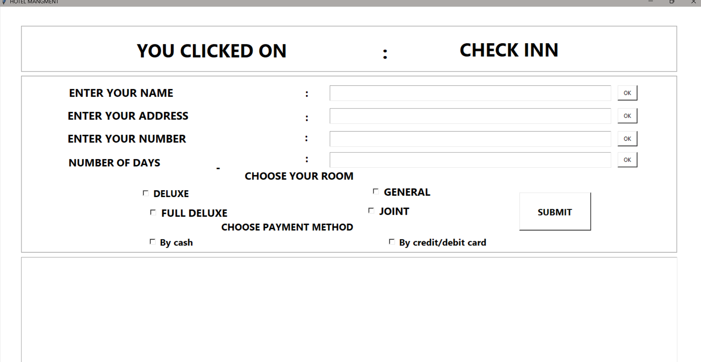

CHECK OUT
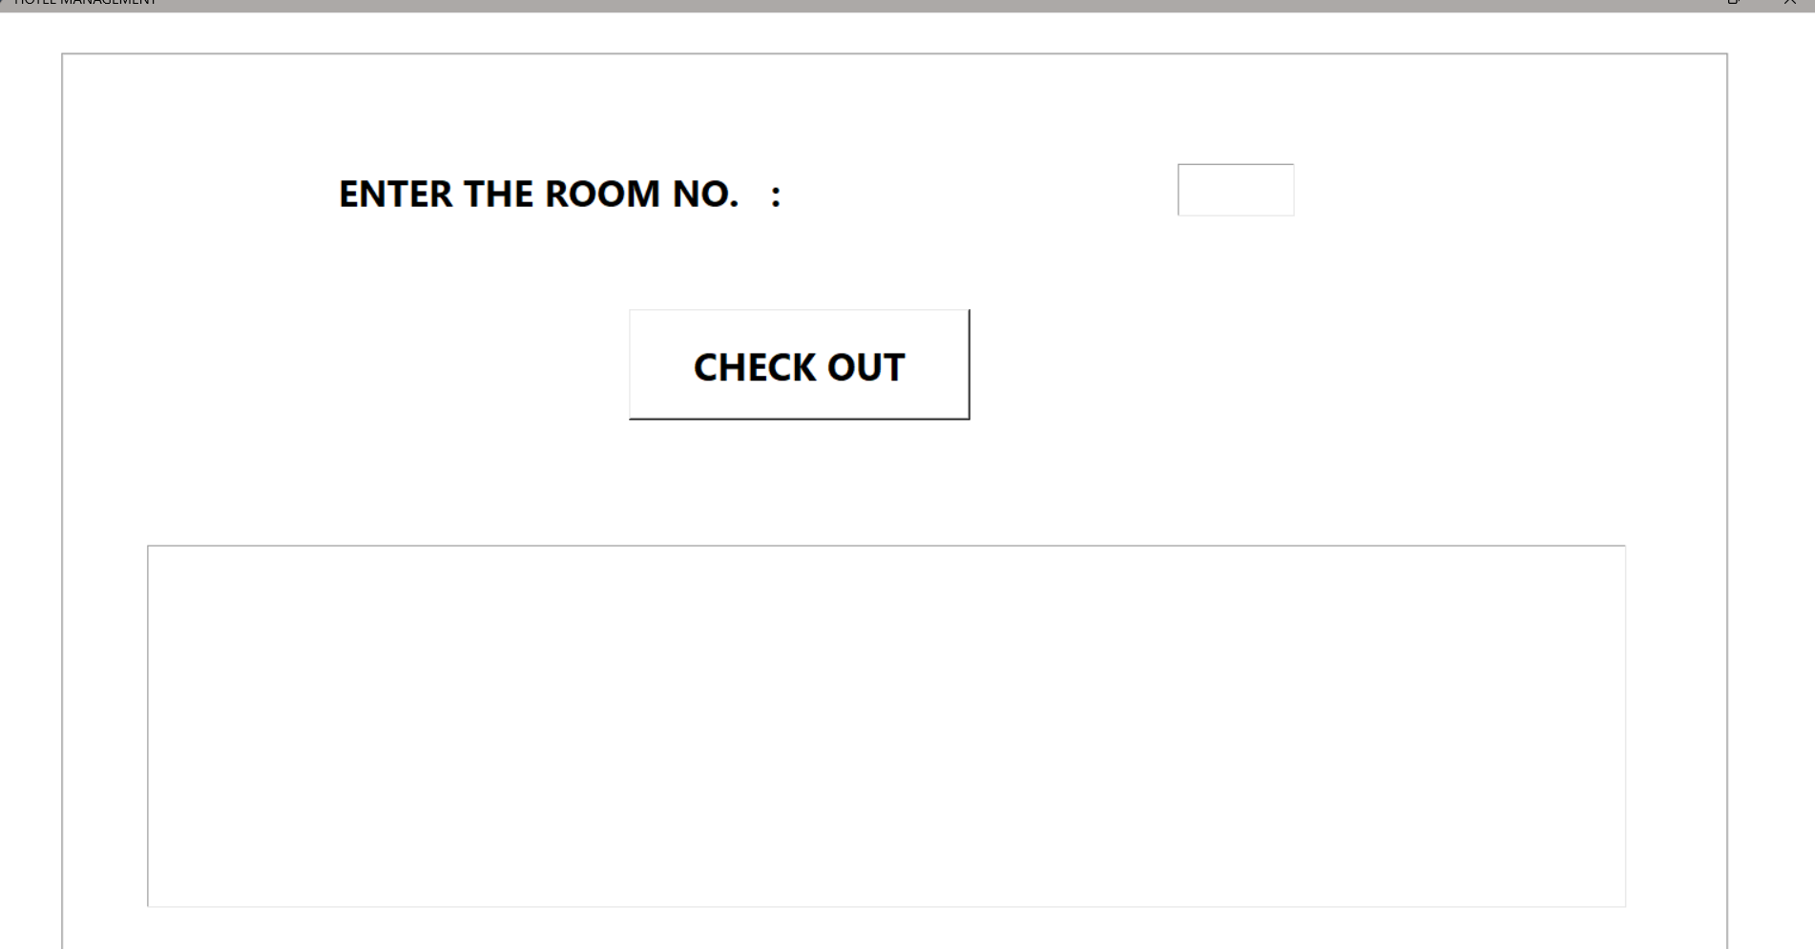

HOTEL DATA

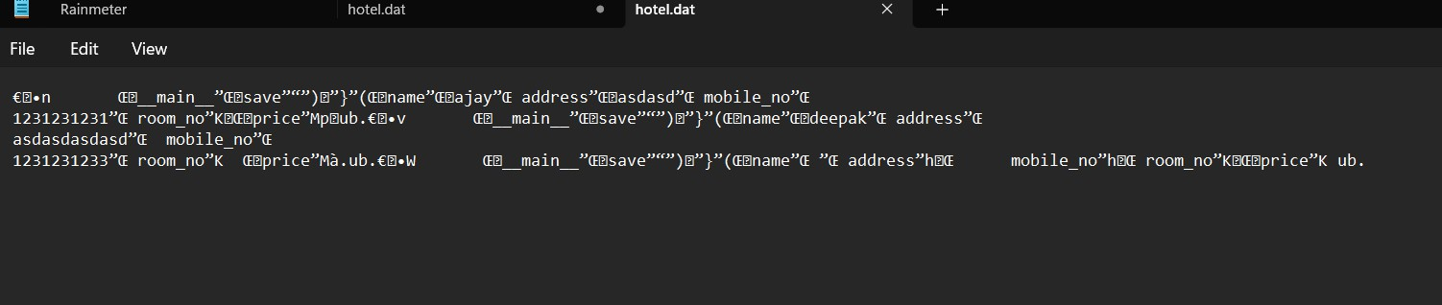

LIST OF GUESTS
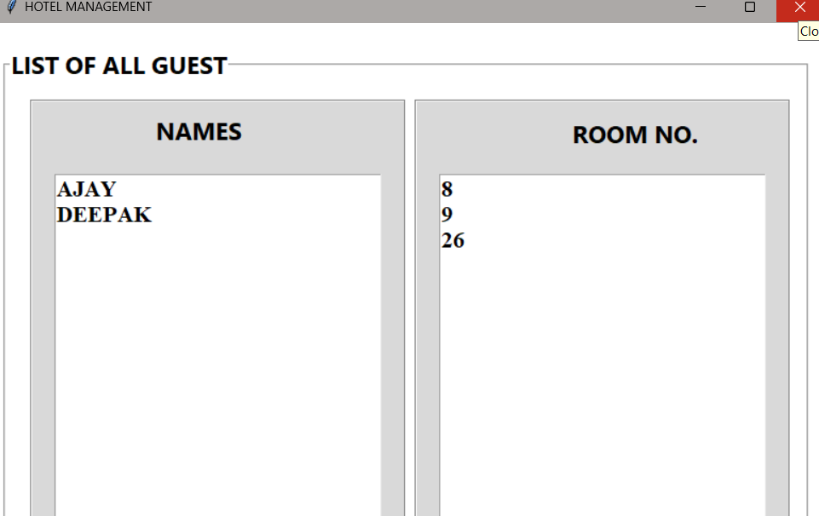

RECEIPT
