DESIGN

Overall architect
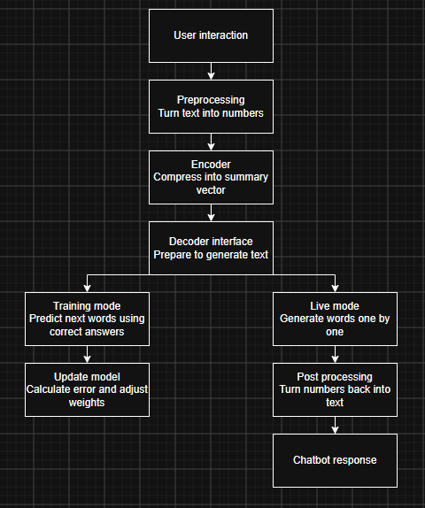
This shows the overall architectural design of the chat bot.
The aim of this is to pass a user’s input into a response or to train the model to know the correct answers using predictive text.
The users string must be processed into numbers through a tokenizer as it’s impossible to put characters into a vector diagram hence forcing a tokenizer to be made.
After the tokens have been generated the Encoder then places these numbers allocated to the tokens into a vector chart to be then read from later (this vector chart is an array of numbers displaying how closely related one token is to another)
After the decoder has logged and found all the Token ids it will then look at the neighbouring token ids to prepare to generate text
If the chatbot is in the training mode it will begin to guess the next token and looking at the correct answer to adjust the embeddings weights and bias, then repeating until accurate
If the model is in live mode the chatbot will see how accurate the guess may bee (how different the confidence between the highest words are) and will decide on that data to answer the question or phrase, if confidence is low requests the user to state the answer and then it goes into the training mode. If the chatbot is confident in its answer, it will post the numbers back through the tokenizer to turn it into text and print it to the user.

2. Tokenization
This program will use two tokenization’s one to encode the text and one to decode the token IDs back to text for the user
The first tokenizer will be used to encode; this will use the sub word tokenization to divide words into smaller meaningful units to handle rare or compound words efficiently.
The encoder will use the Byte pair encoding (BPE) to form these sub words, how this works is shown in this diagram

