Interactive Multimedia Programming

Lab 2

1.RWD:

2.

The main purpose of responsive web design is to make a good looking and functional website on all platforms.

It is used to show roughly the same things on a phone device and on a typical computer.

Well, before there wasn´t as much need for it because the mobile internet technologies wasn´t here yet, also most website were kind of unidirectional about the way they are supposed to be read.

Now stuffs look better in theory and mostly work independently of the screen size or used resolution.

The media query allow you to determine which CSS to use given information such as screen size and in some case which web browser is being use.

But it´s mostly different CSS codes used in response of certain parameters.

The advantages of using font based margin and percentages is because it´s impossible to do responsive stuff with static pixel values.

2.RWD Examples:

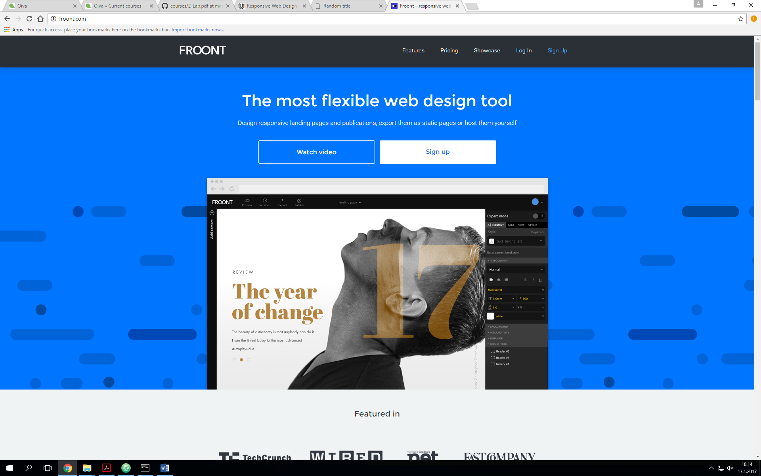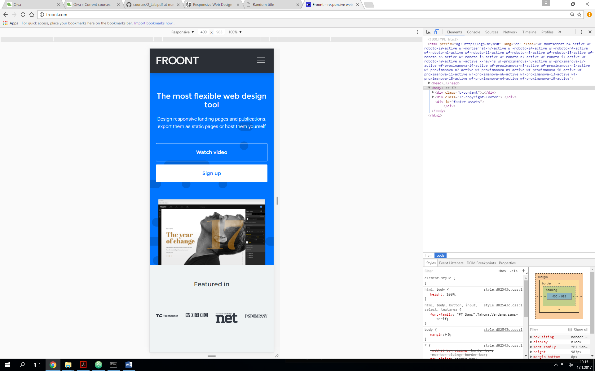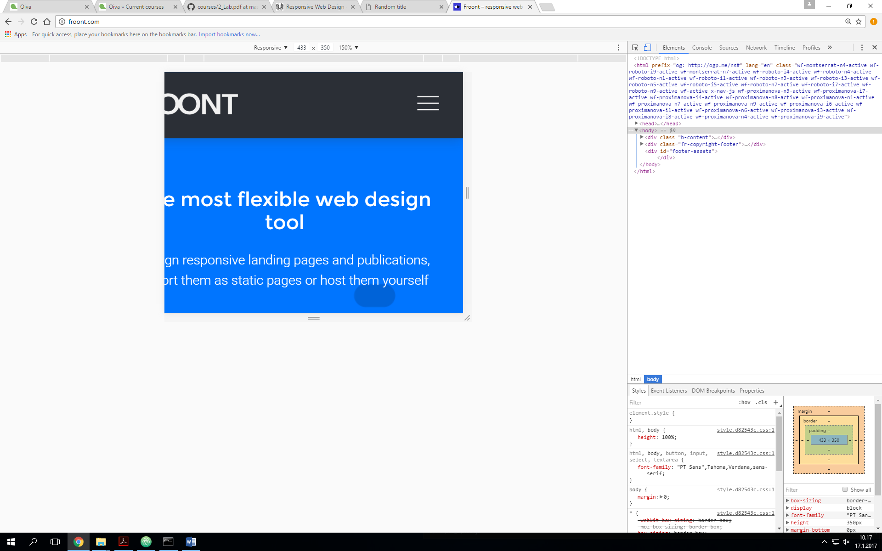

There limit though…