Exhibit 99 1 Intel Corporation 2200 Mission College Blvd Santa Clara CA 95054 1549 News Release Intel Reports Second Quarter 2024 Financial Results Announces 10 Billion Cost Reduction Plan to Increase Efficiency and Market Competitiveness NEWS SUMMARY Second quarter revenue of 12 8 billion down 1 year over year YoY Second quarter GAAP earnings loss per share EPS attributable to Intel was 0 38 non GAAP EPS attributable to Intel was 0 02 Forecasting third quarter 2024 revenue of 12 5 billion to 13 5 billion expecting third quarter GAAP EPS attributable to Intel of 0 24 non GAAP EPS attributable to Intel of 0 03 Implementing comprehensive reduction in spending including a more than 15 headcount reduction to resize and refocus Suspending dividend starting in the fourth quarter of 2024 The company reiterates its long term commitment to a competitive dividend as cash flows improve to sustainably higher levels Achieved key milestones on Intel 18A with the 1 0 Process Design Kit PDK released and key power on of first client and server products on Intel 18A Panther Lake and Clearwater Forest SANTA CLARA Calif Aug 1 2024 Intel Corporation today reported second quarter 2024 financial results Our Q2 financial performance was disappointing even as we hit key product and process technology milestones Second half trends are more challenging than we previously expected and we are leveraging our new operating model to take decisive actions that will improve operating and capital efficiencies while accelerating our IDM 2 0 transformation said Pat Gelsinger Intel CEO These actions combined with the launch of Intel 18A next year to regain process technology leadership will strengthen our position in the market improve our profitability an d create shareholder value Second quarter results were impacted by gross margin headwinds from the accelerated ramp of our AI PC product higher than typical charges related to non core businesses and the impact from unused capacity said David Zinsner Intel CFO By implementing our spending reductions we are taking proactive steps to improve our profits and strengthen our balance sheet We expect these actions to meaningfully improve liquidity and reduce our debt balance while enabling us to make the right investments to drive long term value for shareholders Cost Reduction Plan As Intel nears the completion of rebuilding a sustainable engine of process technology leadership it announced a series of initiatives to create a sustainable financial engine that accelerates profitable growth enables further operational efficiency and agility and creates capacity for ongoing strategic investment in technology and manufacturing leadership These initiatives follow the establishment of separate financial reporting for Intel Products and Intel Foundry which provides a clean sheet view of the business and has uncovered significant opportunities

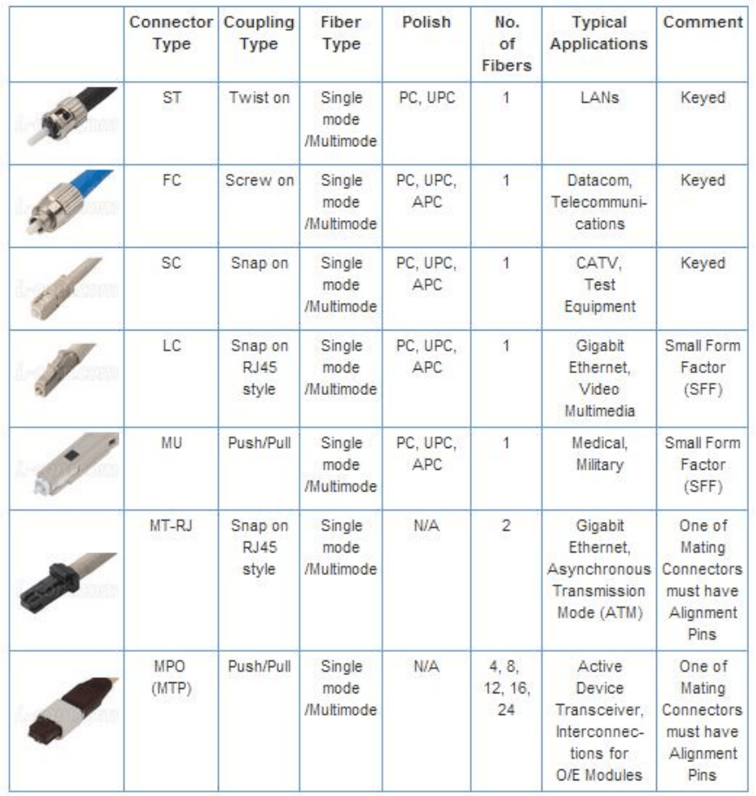

Intel Page 3 Business Unit Summary Intel previously announced the implementation of an internal foundry operating model which took effect in the first quarter of 2024 and created a foundry relationship between its Intel Products business collectively CCG DCAI and NEX and its Intel Foundry business including Foundry Technology Development Foundry Manufacturing and Supply Chain and Foundry Services formerly IFS The foundry operating model is a key component of the company s strategy and is designed to reshape operational dynamics and drive greater transparency a ccountability and focus on costs and efficiency The company also previously announced its intent to operate Altera as a standalone business beginning in the first quarter of 2024 Altera was previously included in DCAI s segment results As a result of these changes the company modified its segment reporting in the first quarter of 2024 to align to this new operating model All prior period segment data has been retrospectively adjusted to reflect the way the company internally receives information and manages and monitors its operating segment performance starting in fiscal year 2024 There are no changes to Intel s consolidated financial statements for any prior periods Business Unit Revenue and Trends Q2 2024 vs Q2 2023 Intel Products Client Computing Group CCG 7 4 billion up 9 Data Center and AI DCAI 3 0 billion down 3 Network and Edge NEX 1 3 billion down 1 Total Intel Products revenue 11 8 billion up 4 Intel Foundry 4 3 billion up 4 All other Altera 361 million down 57 Mobileye 440 million down 3 Other 167 million up 43 Total all other revenue 968 million down 32 Intersegment eliminations 4 3 billion Total net revenue 12 8 billion down 1 Intel Products Highlights CCG Intel continues to define and drive the AI PC category shipping more than 15 million AI PCs since December 2023 far more than all of Intel s competitors combined and on track to ship more than 40 million AI PCs by year end Lunar Lake the company s next generation AI CPU achieved production release in July 2024 ahead of schedule with shipments starting in the third quarter Lunar Lake will power over 80 new Copilot PCs across more than 20 OEMs DCAI More than 130 million Intel Xeon processors power data centers around the world today and at Computex Intel introduced its next generation Intel Xeon 6 processor with Efficient cores E cores code named Sierra Forest marking the company s first Intel 3 server product architected for high density scale out workloads Intel expects Intel Xeon 6 processors with Performance cores P cores code named Granite Rapids to begin shipping in the third quarter of 2024 The Intel Gaudi 3 AI acceler ator is also on track to launch in the third quarter and is expected to deliver roughly two times the performance per dollar on both inference and training versus the leading competitor NEX Intel announced an array of AI optimized scale out Ethernet solutions including the Intel AI n etwork interface card and foundry chiplets that will launch next year New infrastructure processing unit IPU adaptors for the enterprise are now broadly available and supported by Dell Technologies Red Hat and others IPUs will play an increasingly important role in Intel s accelerator portfolio which the company expects will help drive AI data center growth and profitability in 2025 and beyond Addition ally Intel and others announced the creation of the Ultra Accelerator Link a new industry standard dedicated to advancing high speed low latency communication for scale up AI systems communication in data centers

