Small Form-Factor Pluggable (SFP) Transceiver
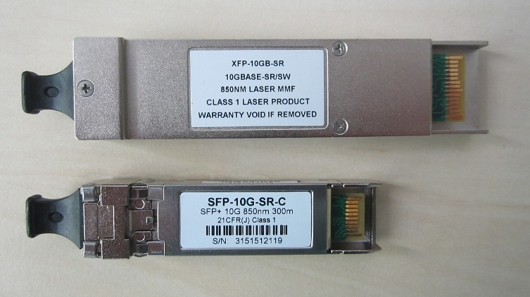
A small form-factor pluggable (SFP) transceiver is a compact, hot-swappable, input/output transceiver used in data communication and telecommunications networks. SFP interfaces between communication devices like switches, routers (NOT workstations!) and fiber optic cables, and performs conversions between optical and electrical signals.
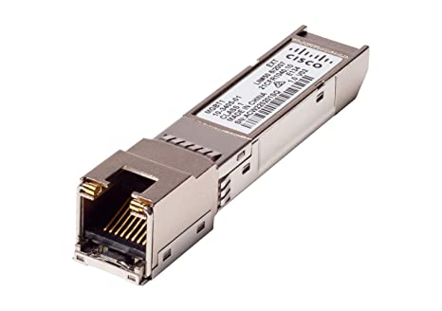
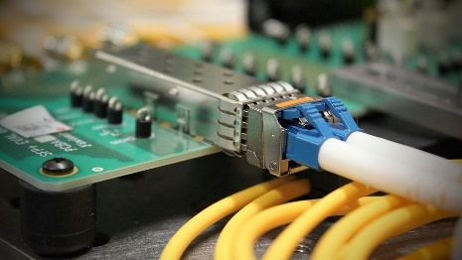

Antennas
A Patch Antenna is a type of radio antenna with a low profile, which can be mounted on a flat surface. A patch antenna is typically mounted to a wall or a mast and provides coverage in a limited angle pattern. Patch antennas can be directional or omnidirectional, but a directional antenna should be used for a connection between two buildings within line of sight of each other.
A Yagi or Directional Antenna could also be used, but if the distance is smaller than about 300 feet between the buildings, a patch antenna would be sufficient. A Yagi would be utilized for longer distances instead, but these do weigh more and have a larger footprint. Think of a meditating Yogi: focused and directed in his meditation on some far-off land.
A Whip Antenna is a vertical omnidirectional antenna that is usually utilized in indoor environments. A whip antenna is omnidirectional and cannot be used for directional use cases. Think of the “cantenna” antenna made from Pringles cans, and of whipped-cream dip for the ultimate chips & dip!
Omni-Directional Antennas broadcast radio frequencies in all directions creating a large sphere of coverage. The antenna has the capability to send and receive signals in a circumference around the antenna.
Directional Antennas broadcast radio frequencies in a single direction (unidirectional) or two directions (bidirectional) to create a zone or area of coverage.
High-Gain Antennas put out increase signal strengths and can reach further distances with fewer wireless access points (WAPs) than low gain antennas.
Low-Gain Antennas spread the power out across a wider volume in space, but the signal reaching the receivers is weaker and harder to process.

Wi-Fi Generations

Generation | IEEE  Standard | Maximum  Linkrate  (Mbit/s) | Adopted | Radio  Frequency  (GHz)
Wi-Fi 7 | 802.11be | 1376 to 46120 | (2024) | 2.4/5/6
Wi-Fi 6E | 802.11ax | 574 to 9608 | 2020 | 6
Wi-Fi 6 |  |  | 2019 | 2.4/5
Wi-Fi 5 | 802.11ac | 433 to 6933  (theoretical 3.5 Gbps as per the exam!) | 2014 | 5
Wi-Fi 4 | 802.11n | 72 to 600 | 2008 | 2.4/5
(Wi-Fi 3)* | 802.11g | 6 to 54 | 2003 | 2.4
(Wi-Fi 2)* | 802.11a | 6 to 54 | 1999 | 5
(Wi-Fi 1)* | 802.11b | 1 to 11 | 1999 | 2.4
(Wi-Fi 0)* | 802.11 | 1 to 2 | 1997 | 2.4

One way 802.11n and 802.11ac networks achieve superior throughput and speeds by using multiple-input multiple-output (MIMO) and multi-user MIMO (MU-MIMO), respectively. MIMO uses multiple antennas for transmission and reception, which results in higher speeds than 802.11a and 802.11g networks.
Wireless N and Wireless AC networks also utilize the 5 GHz frequency band, allowing them to achieve speeds greater than 54 Mbps, and AC uses Orthogonal Frequency-Division Multiple Access (OFDMA) to conduct multiplexing of the frequencies transmitted to and received at each client to provide additional bandwidth.
WPA2 is a wireless encryption standard and can be used with Wireless G, N, AC, or AX.
LightWeight Access-Point Protocol (LWAPP) is the name of a protocol that can control multiple Wi-Fi Wireless Access Points (WAPs) at once. This can reduce the amount of time spent on configuring, monitoring, or troubleshooting a large network. LWAPP does not affect the speed of a wireless network.

Received Signal Strength Indication (RSSI)
The Received Signal Strength Indication (RSSI) is an estimated measure of the power level that a radio frequency client device receives from a WAP. If the RSSI is -90dB to -100dB, it indicates an extremely weak connection and insufficient wireless coverage in the area where the device is operating.
REMEMBER THAT A HIGH SIGNAL-TO-NOISE (SNR) RATIO IS A GOOD THING!

