Abhigjna Goru
IMT2024081
Report
Different polynomial degrees were compared using 5 fold cross validation. For every polynomial degree, regression methods such as Ordinary Least Squares, Ridge Regression, and Lasso Regression were used. For Ridge and Lasso, different values of the parameter alpha, were also tested to help find the most approprite degree of the polynomial that is to be used .
For Ordinary Least Squares, the polynomial features are fitted directly using linear regression.
For Ridge and Lasso regression, different values of the regularization parameter of alpha that were considered were 10⁻⁵, 10⁻⁴ , 10⁻³ , 0.01, 0.1, 1, 10. Ridge and Lasso regression were used to prevent over fitting.
Ridge regression uses L2 regularization, while Lasso uses L1.
The training data was shuffled before creating the 5 folds so that the cross validation folds did not always consist of consecutive samples. A fixed random state was used to make the comparison.
Also since polynomial expansion creates several new value (x, x², x³, and so on). These terms can have different numerical scales, especially for higher polynomial degrees. Therefore, StandardScaler was applied to the polynomial features before fitting the regression models.
Standardization transforms each feature to have approximately zero mean and unit standard deviation:
z = (x-u)/ standard deviation
This is particularly important for Ridge and Lasso regression because their regularization penalties depend on the magnitude of the model coefficients. If the features have very different scales, the regularization may affect the coefficients unevenly. Standardization puts the polynomial features on a comparable scale.
5 folds cross validation was chosen for the sake of simplicity, and that way 800 samples could be used for training and 200 samples could be used for validation in each iteration.
Using fewer folds would leave less data available for training in each iteration, while using many more folds would make the validation sets smaller.
Polynomial expansion significantly increases the number of features as the degree increases. For Var1 with 6 inputs, Degree 1 has 6 features, Degree 2 has 27, Degree 3 has 83 and so on. Similar is the case for Var2 with 3 inputs also. . Therefore, higher polynomial degrees substantially increase model complexity and can increase the risk of overfitting. This was one reason cross-validation and regularization were used when selecting the final model.
For Var1, polynomial degrees from 1 to 10 were tested, while for Var2, degrees from 1 to 20 were tested.
Mean Squared Error(MSE) = (1/n) * Σ(i=1 to n) (yᵢ - ŷᵢ)²
ŷᵢ is the predicted value for the i-th observation, yᵢ is the Actual value, n is the number of data points.
A lower MSE indicates smaller prediction errors, so MSE was used as the criterion for comparing the models, though R² was also calculated. For each model, the average validation MSE across the five folds was calculated. The polynomial degree and regularization parameter that gave the lowest cross validation MSE was selected.
This model was then used to predict the values of y for the test dataset.

Var1
From the results, the lowest cross-validation MSE was obtained using Lasso regression with a degree 5 polynomial and alpha = 0.01 . The corresponding MSE was approximately 0.323. Therefore, a degree 5 polynomial with Lasso regularization was selected for Var1.
The below plots show the MSE values for OLS, Ridge regression and Lasso Regression.
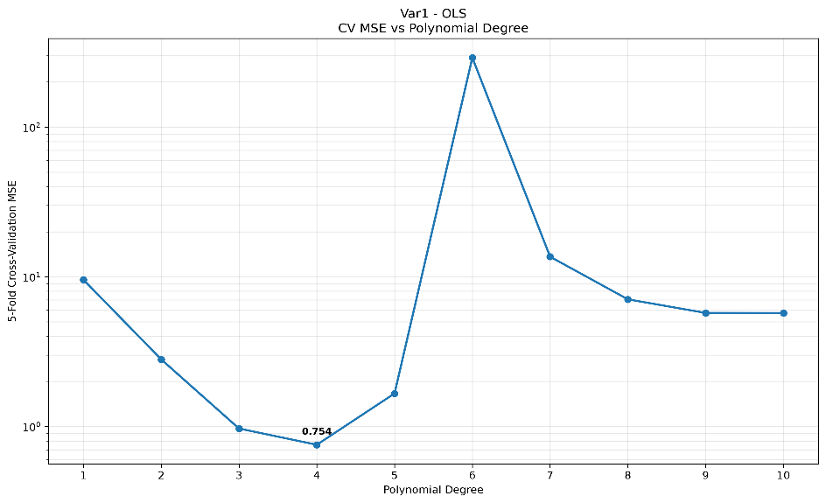
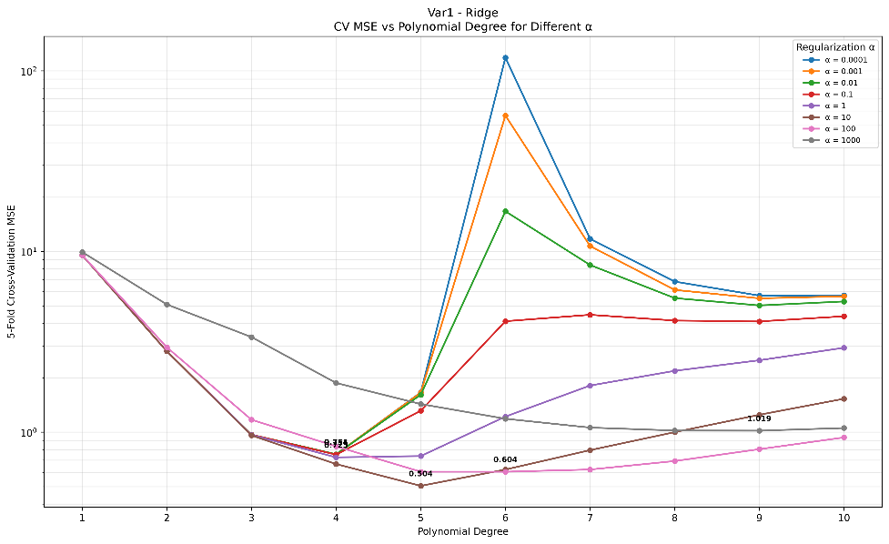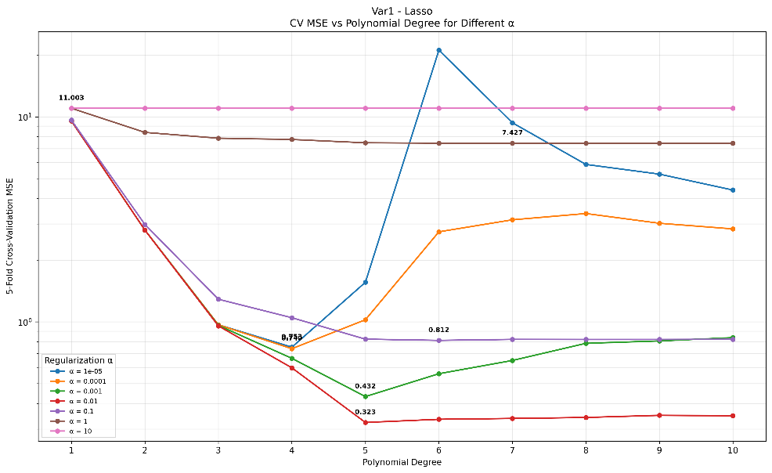

The plain OLS model gets worse very sharply at degree 6. This happens because the number of terms grows very fast. At degree 5 the model has 461 terms, but at degree 6 it has 923 terms, which is more than the 800 training samples used in each fold.
Lasso avoids this because it penalises large coefficients and sets the coefficients of unhelpful terms to zero, so only the useful terms are kept. This is why Lasso gave a much lower error.
Var2
The lowest cross-validation MSE was obtained using Ridge regression with a degree 12 polynomial and alpha 1 The corresponding MSE was approximately 0.257. Therefore, a degree-12 polynomial with Ridge regularization was selected for Var2
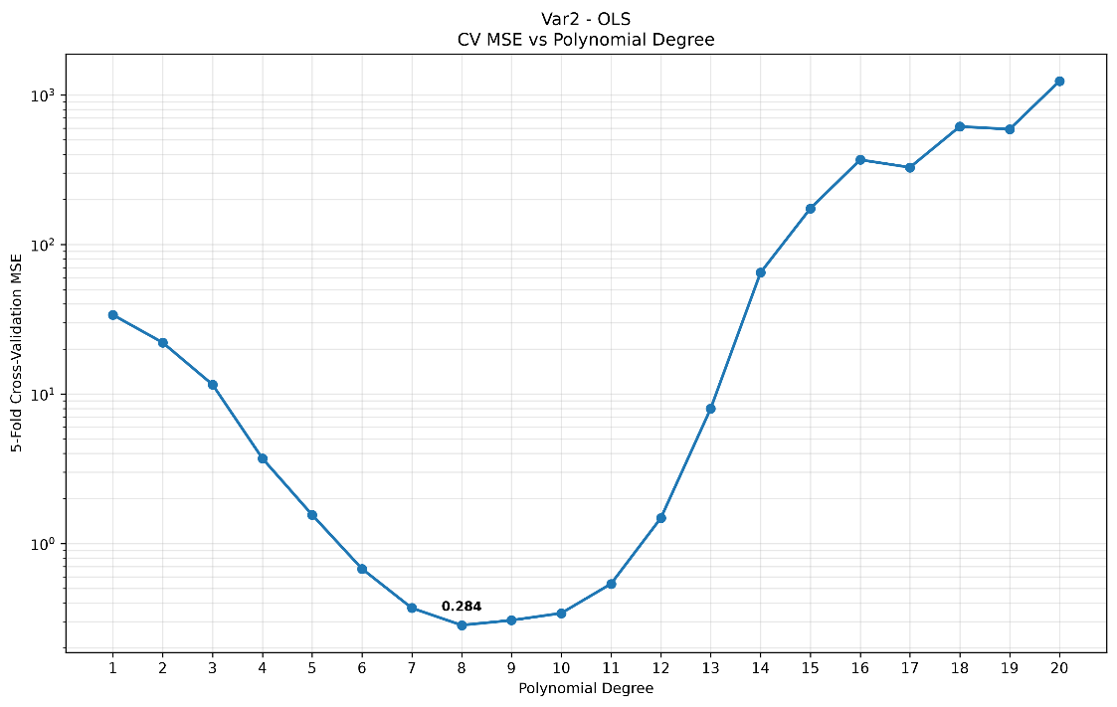
A degree-20 polynomial in 3 variables has 1,770 terms. When a model has this many terms, it starts fitting noise instead of the real pattern, which increases the error on new data. The OLS results show this: the error is lowest at degree 8 and then rises quickly.
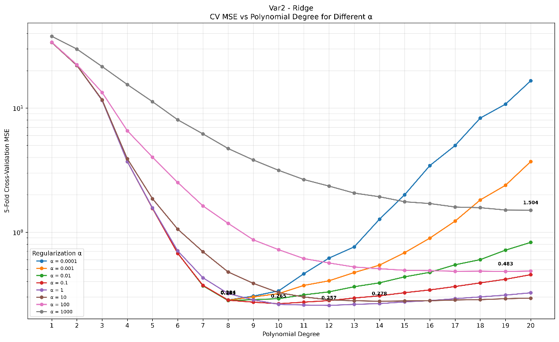
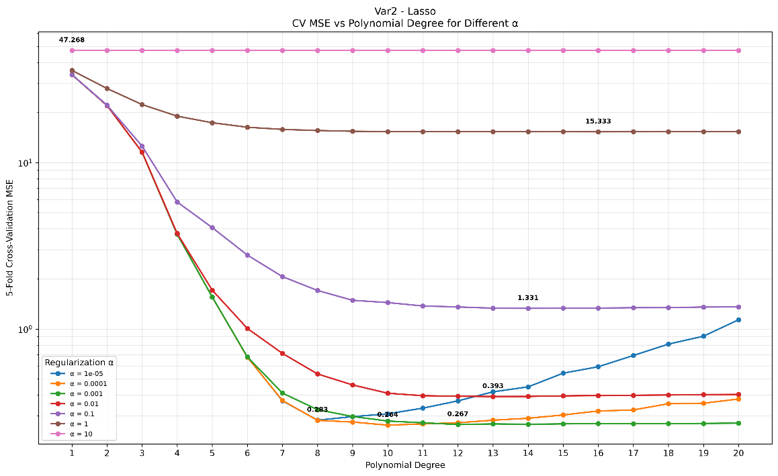

Github: https://github.com/abh1gjna/ML_Assignment_1

