
SCHOOL OF COMPUTER SCIENCE ENGINEERING AND INFORMATION SYSTEMS
B.Tech – Information Technology
BITE305L - Computer Networks
Course Project Report
Slot D1+TD1

DDoS Detection and Mitigation System

TEAM MEMBERS:
1. Abhishek Yennam
2. Aarav Gupta

Faculty Name: Dr. Ramesh P S

CONTENTS

Chapter No | Title | Page No
1. | Abstract | 4
2. | Introduction | 5
3. | Objective | 7
4. | Problem statement | 7
5. | Literature Review 15 Papers  (Recent 3 Years) | 8
6. | Architecture Diagram | 10
7. | Proposed Methodologies | 11
8. | Coding and Implementation | 16
9. | Screenshots and Results | 19
10. | Conclusion and Future Development | 28
11. | References | 29

DECLARATION

We hereby declare that the report entitled “DDoS Detection and Mitigation System” submitted by us, for BITE305L – Computer Networks to Vellore Institute of Technology is a record of bonafide work carried out by us under the supervision of Dr. Ramesh P S.

We further declare that the work reported in this report has not been submitted and will not be submitted, either in part or in full, for any other courses in this institute or any other institute or university.

Place : Vellore
Date : 25 October 2026

Signature of Candidate 1 – Abhishek Yennam
Signature omitted from repository copy
Signature of Candidate 2 – Aarav Gupta
Signature omitted from repository copy

1 Abstract
Distributed Denial of Service (DDoS) attacks affect network availability by overwhelming communication links or service resources. High traffic volume alone, however, does not explain whether a service is under attack. We developed SentinelShield to examine packet metadata, identify unusual traffic patterns and show the measurements behind each alert.
The system accepts PCAP and PCAPNG files, bounded live captures and locally generated demonstrations. Scapy extracts IP addresses, ports, protocols, timestamps, packet lengths and TCP flags. These records are grouped into fixed, epoch-aligned windows. A rule-based detector compares packet rate with a rolling median and median absolute deviation baseline. A second rule checks the proportion and rate of initial TCP SYN packets. Their combination produces four labels: Normal, Unusual Traffic, Suspicious TCP SYN Pattern and Potential DDoS Activity.
A Streamlit dashboard displays packet rates, thresholds, decisions and detection reasons. SQLite stores aggregate windows, alerts and temporary block simulations selected by the operator. Tests and demonstrations covered normal and mixed traffic, recorded SYN-flood traffic, alert history and a ten-second loopback capture. The live capture returned 21 packet records in two windows with no alerts. Separate Random Forest experiments examined synthetic classification and transfer between flow datasets. The project brings packet capture, transport-header analysis, traffic measurement and response simulation into one application. Its results show how the implemented rules behave on the selected inputs, while the stored explanations make individual decisions easy to examine.

2 Introduction

2.1 Network Availability and DDoS
Network services share finite bandwidth, processing time and memory. A Denial of Service (DoS) attack attempts to exhaust these resources or interrupt communication. A DDoS attack involves traffic from distributed sources. Detection is difficult because ordinary demand can also produce high packet rates, and source addresses may be spoofed. Recent work on changing DDoS profiles therefore considers response time and service to legitimate users alongside detection [1].
SentinelShield analyses traffic visible at a selected interface or recorded in a capture file. It identifies rate and TCP SYN patterns and explains why a window was flagged. The label Potential DDoS Activity means that both configured rules fired. It is an indication for investigation rather than a claim that the system has verified an attacker's identity or distributed origin.

2.2 Packets Protocols and Flows
An IP packet carries source and destination addresses. TCP and UDP headers also contain ports that identify communication endpoints within hosts. The project recognises IPv4 and IPv6 and counts TCP, UDP, recognised ICMP/ICMPv6 and other IP traffic. It uses header metadata without retaining application payloads in the analysis records.
A directional flow is represented by source IP, destination IP, source port, destination port and protocol. Reversing these values creates a different flow. The unique_flows feature counts distinct five-tuples within a window; it does not reconstruct long-lived bidirectional sessions. Address diversity provides traffic context, but an observed source IP alone does not identify an attacker.

2.3 TCP Handshake and SYN Behaviour
A normal TCP connection begins with SYN from the client, SYN-ACK from the server and ACK from the client [2]. Repeated connection attempts can place pressure on server connection state, which is relevant to SYN flooding [3]. Figure 2.1 shows the normal exchange and the SYN-heavy pattern examined by the project.
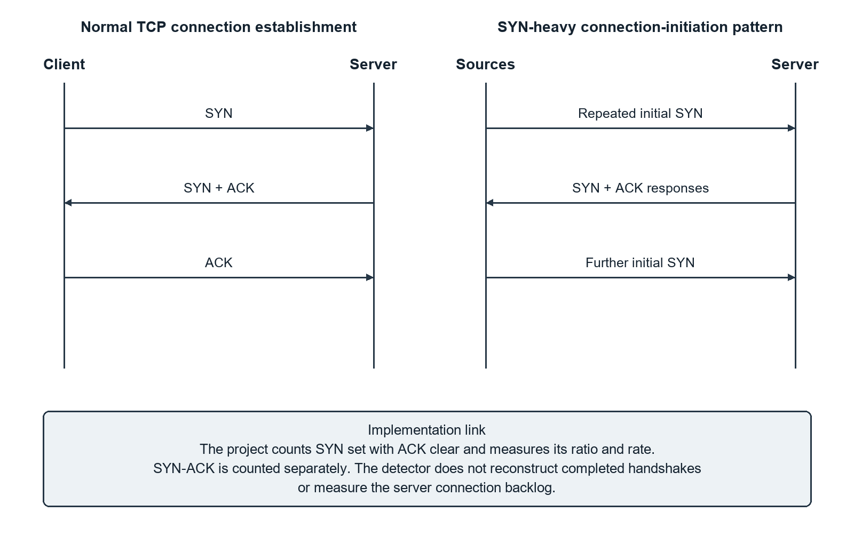
Figure 2.1: Normal TCP Handshake and SYN Heavy Connection Attempts
SentinelShield counts an initial SYN when the SYN bit is set and ACK is clear. SYN-ACK is counted separately. ACK, FIN and RST use independent bit tests, so their counts may overlap. The detector measures initial-SYN proportion and rate; it does not track handshake completion or measure a server's half-open connection backlog.

2.4 Project Overview
Scapy provides capture-file reading and live collection [4]. The dashboard offers three sources: generated demonstrations, uploaded PCAP/PCAPNG files and a selected live interface. Live collection runs for a chosen interval and displays its analysis after capture ends. A laptop interface only reveals traffic visible at that observation point; the live demonstration in this report uses loopback traffic.
The dashboard presents window measurements, rate plots and alert reasons. SQLite preserves the results and records operator-selected temporary block simulations with expiry times. These simulations document response decisions without changing firewall rules or packet forwarding. Random Forest experiments provide a separate comparison with the dashboard's rules.

3 Objective
The main objective is to build a DDoS monitoring application that turns packet metadata into understandable traffic measurements, rule decisions and recorded response simulations.
The specific objectives are to:
• Accept authorised capture files, bounded live captures and repeatable demonstration inputs.
• Extract addressing, protocol, port, packet-length and TCP-flag information from supported IP packets.
• Aggregate records into fixed windows and calculate packet rates, protocol counts, flag counts and communication diversity.
• Detect unusual packet rates and SYN-heavy patterns using explicit conditions and an adaptive baseline.
• Display the four traffic labels, their measured reasons and historical alerts.
• Record temporary block simulations with a validated address, reason and expiry.
• Check the implementation through unit tests, application demonstrations and separate model experiments.

4 Problem Statement
A network administrator needs more than a packet count to understand an unusual traffic event. High volume can result from legitimate demand, while a high SYN proportion may have different meanings at different rates. Manual packet inspection also becomes difficult as the number of observations grows.
The problem is to summarise traffic in a form that preserves useful networking information and makes each detection decision reproducible. The observation interval, packet-rate denominator and SYN conditions must be defined precisely. Alerts should retain the measurements that caused them so that an operator can inspect the result later.
SentinelShield addresses this through fixed-window aggregation and two rules: an adaptive packet-rate comparison and an initial-SYN ratio-and-rate condition. The dashboard links their decisions to plots and explanations. It also provides a controlled response simulation, allowing a selected address, reason and lifetime to be recorded without making an automatic enforcement decision.
Evaluation must distinguish demonstrations from independent attack-detection benchmarks. Generated examples test the processing path, recorded captures show the rules on sampled traffic, and separate flow experiments examine how a trained model transfers between datasets.

5 Literature Review 15 Papers Recent 3 Years
The review covers fifteen papers published during 2024–2026. Table 5.1 compares their methods and datasets and identifies the part relevant to SentinelShield. The abbreviations used are software-defined networking (SDN), Random Forest (RF), decision tree (DT), support vector machine (SVM), principal component analysis (PCA), convolutional neural network (CNN) and deep reinforcement learning (DRL).
Table 5.1: Comparison of Fifteen Recent Research Papers
Ref. | Authors and year | Method and data | Finding and relevance
[5] | Garba et al., 2024 | Supervised classifiers in an SDN controller; SNORT protects the controller.  Captured smart-home traffic | Connects traffic classification with controller protection. Distinguishes detection from an actual enforcement mechanism.
[6] | Wang et al., 2024 | Coarse traffic screening, wavelets/CNN and graph-based isolation.  Simulated and public SDN traffic | Separates inexpensive screening from detailed classification and isolation. Supports a clear acquisition–decision–response architecture.
[7] | Hassan et al., 2024 | Entropy-based screening combined with k-means clustering.  CIC-IDS2017; CSE-CIC-2018; CICIDS2019 as named by authors | Combines aggregate statistics with behavioural clustering. Provides an alternative statistical approach to the project's rate baseline.
[8] | Han et al., 2024 | XRDI feature selection with DT, RF, SVM and logistic regression.  InSDN; CICIDS2017; CICIDS2018 | Studies feature reduction and classification cost across datasets. Motivates explicit feature definitions and schema alignment.
[9] | Abiramasundari and Ramaswamy, 2025 | PCA-based feature reduction and comparison of supervised classifiers.  CICIDS2017; CICIDS2018; CICDDoS2019 | Compares several models under a common feature-reduction framework. Places the separate Random Forest experiments in context.
[10] | Sawah et al., 2025 | Feature elimination and grid-search optimisation of Random Forest.  DDoS-SDN | Examines the effect of feature and parameter selection. Shows why classifier choice and evaluation protocol both matter.
[11] | Nawaz et al., 2025 | Extra Trees feature selection; RF, logistic regression and Naïve Bayes.  NSL-KDD | Explores reduced feature sets for constrained deployments. Encourages separating dataset performance from deployment capability.
[12] | Hernandez et al., 2025 | Multivariate traffic time series with temporal deep-learning models.  CICDDoS2019 | Examines temporal representation and inference behaviour. Relates observation-window duration to the scope of a decision.
[13] | Zaman et al., 2025 | Decision-tree variants including a greedy decision-tree enhancement.  InSDN and Ahuja et al.'s SDN dataset | Studies interpretable classification on two SDN-specific datasets. Supports explainability while highlighting dataset dependence.
[1] | Orosz et al., 2025 | Data-centre attack-profile analysis and mitigation-method comparison.  Observed data-centre samples and reviewed studies | Relates response speed, false detection and legitimate-user service. Justifies cautious labels and separately describing mitigation effects.
[14] | Satpathy et al., 2025 | Actor–critic DRL with Boruta, SHAP and feature-stability analysis.  CICDDoS2019; UNSW-NB15 | Links feature selection, explainability and cross-dataset experiments. Provides context for transfer evaluation and optional learned extensions.
[15] | Ge et al., 2026 | Class-specific autoencoders, discovery by clustering and incremental learning.  NSL-KDD DoS classes | Integrates discovery and learning while retaining earlier classes. Suggests an optional research path beyond fixed signatures.
[16] | Eren et al., 2026 | MLP/CNN/GRU comparison with ONNX conversion and quantisation.  CIC-DDoS2019 reflection and benign traffic | Examines deployment-dependent inference and model-size trade-offs. Shows why model inference time is distinct from full pipeline latency.
[17] | Fatiyah et al., 2026 | sFlow telemetry, OpenFlow and C5.0, bagged CART or Random Forest.  SDN-based 5G experimental traffic | Integrates classifier output with network control and response. A concrete comparison for optional SDN enforcement extensions.
[18] | Kara and Sarısaray Bölük, 2026 | Analytical review of model, dataset and deployment evidence.  Published empirical DDoS studies | Separates classification scores from timing/resource evidence. Supports reporting measured scope and avoiding unsupported speed claims.

The papers show why traffic representation and evaluation conditions matter. Feature-selection studies [8]–[11] and temporal models [12] use different measurements from a packet-window detector. Decision-tree work [13] supports interpretable decisions, while SDN systems [5], [6], [17] combine detection with network control. Orosz et al. [1] also examine the effect of mitigation on service.
We used explicit rules so that each dashboard label can be checked against packet rate, SYN ratio and SYN rate. The literature also informed the separation between detection, simulated response and offline model evaluation. The reported performance of another method cannot be treated as the accuracy of this project.

6 Architecture Diagram
Figure 6.1 shows how the three input sources feed the same analysis path. Python modules called by the Streamlit application perform collection, processing and detection.
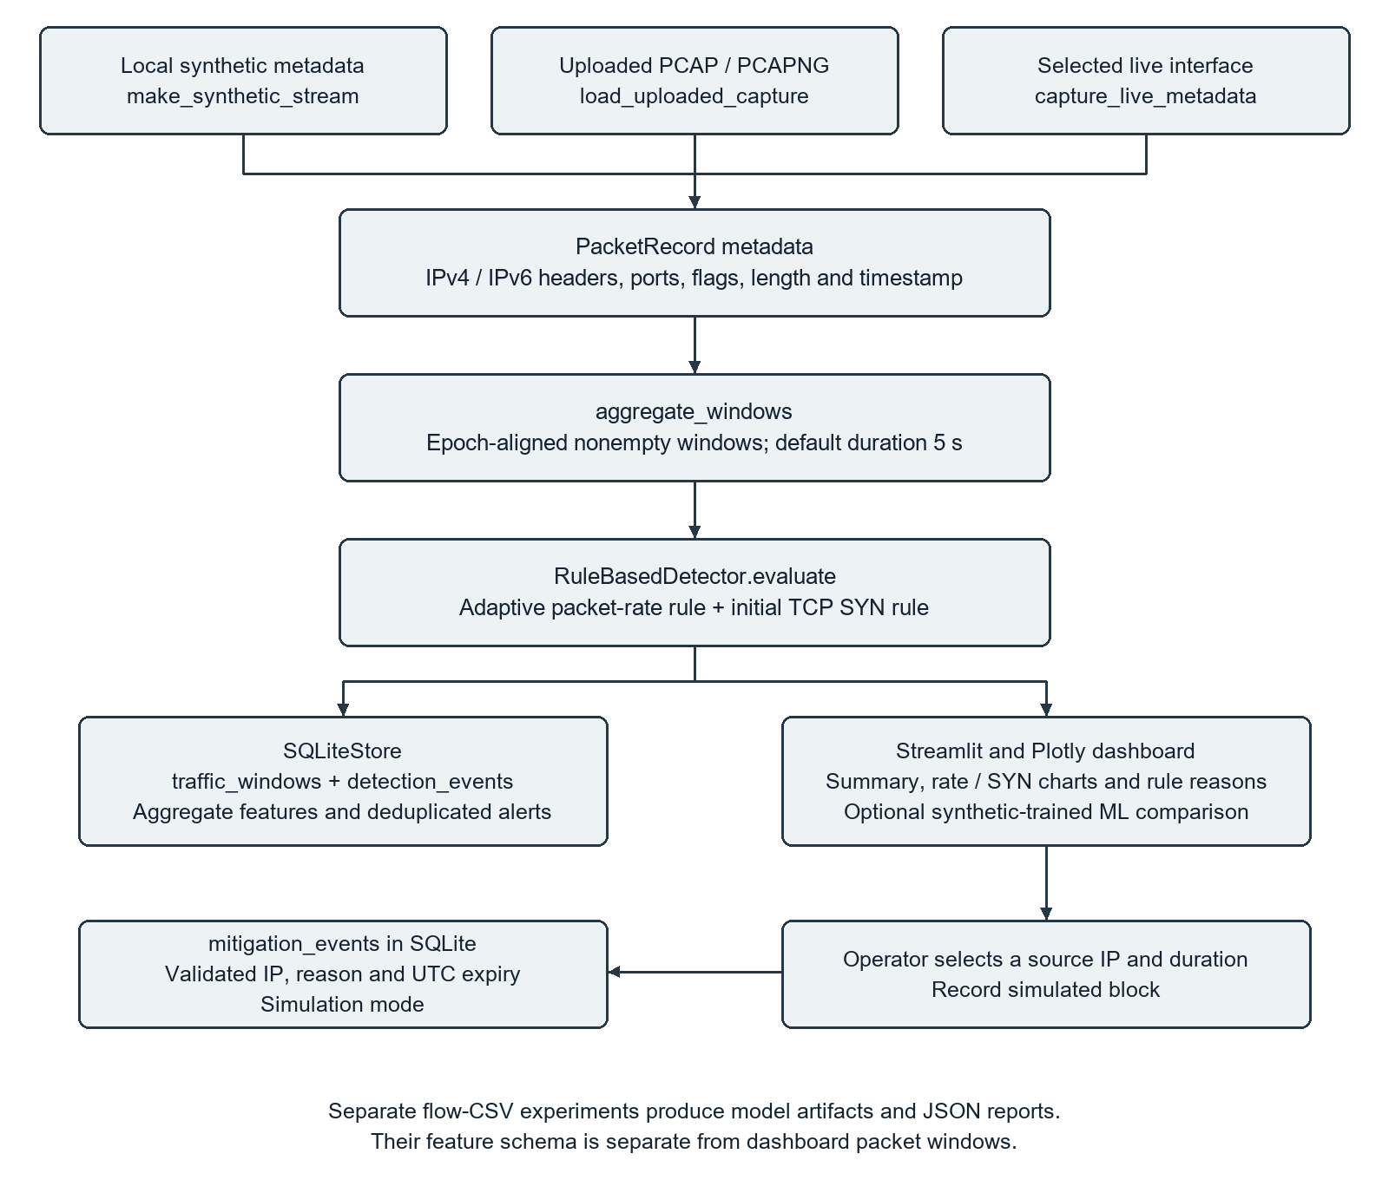
Figure 6.1: System Architecture of the DDoS Detection and Mitigation System
Each input becomes a list of PacketRecord objects. The aggregator forms occupied time windows and calculates their features. RuleBasedDetector evaluates these windows in chronological order. The dashboard displays the labels, charts and reasons, while SQLiteStore saves aggregate windows and non-Normal alerts.
The response branch begins with an operator action. A selected source address and duration are passed to the storage module as a temporary block simulation. Separate CSV-based flow experiments produce model files and evaluation reports; they do not supply the dashboard's operational rule decisions.

7 Proposed Methodologies

7.1 Traffic Acquisition and Packet Processing
Demo mode generates metadata for 30 windows. Upload mode reads authorised PCAP or PCAPNG files within the configured 50 MB limit, selecting the reader from the file's magic bytes. Live mode requires interface authorisation and a Start bounded capture action. The dashboard offers 5, 10, 20, 30 or 60 seconds; the collector accepts durations from 1 to 60 seconds.
Figure 7.1 shows the processing sequence. Unsupported non-IP packets are skipped. For supported packets, the extractor reads timestamp, source/destination IP, protocol and len(packet), then decodes TCP/UDP ports and TCP flags. Recognised ICMPv6 messages join the ICMP count.
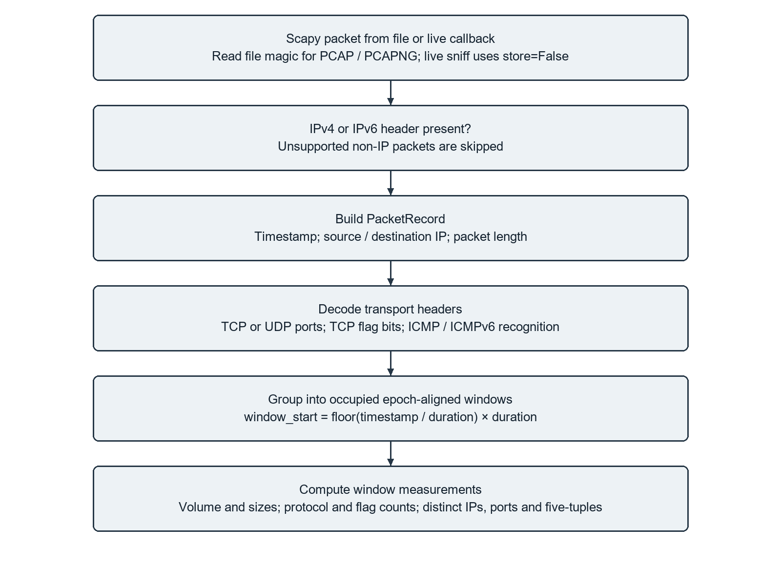
Figure 7.1: Packet Metadata Extraction and Window Processing
The live callback converts packets to metadata while Scapy runs with store=False. Analysis begins when the bounded capture ends. Uploaded captures and live records then use the same aggregation and detection functions.

7.2 Window Aggregation
For timestamp t and window duration Δ, window_start = floor(t/Δ) × Δ. The default duration is five seconds; the dashboard also offers one, two and ten seconds. Only windows containing supported records are emitted. Rates divide by the configured duration, including partially occupied first and last windows.

7.3 Feature Definitions
Table 7.1 groups the 21 numeric model features. Window start, duration and source_kind accompany them as metadata.
Table 7.1: Packet Window Features and Definitions
Feature group | Exact feature names | Definition
Volume and rates | packet_count; total_bytes; packets_per_second; bytes_per_second | Record count, sum of captured lengths, and each total divided by Δ
Packet sizes | average_packet_bytes; minimum_packet_bytes; maximum_packet_bytes | Mean, minimum and maximum captured packet length
Protocol composition | tcp_packets; udp_packets; icmp_packets; other_packets | Number of records in each decoded protocol group
TCP behaviour | syn_count; syn_ack_count; ack_count; fin_count; rst_count; syn_ratio | Initial SYN, SYN-ACK and independent flag counts; initial SYN divided by TCP count
Communication diversity | unique_sources; unique_destinations; unique_destination_ports; unique_flows | Distinct addresses, non-null destination ports and directional five-tuples

Let N be packet count, L total captured bytes, S initial SYN count and C TCP packet count. Packet rate R = N/Δ, byte rate = L/Δ and initial SYN rate I = S/Δ. SYN ratio Q = S/C when C > 0, otherwise zero. Its denominator is TCP packets, not all IP packets.

7.4 Adaptive Baseline and Detection Rules
The baseline contains up to 60 rates from earlier windows labelled Normal. Before five such samples exist, the threshold is 100 packets/s. It then uses the median m and median absolute deviation MAD:
m = median(normal_rates)
MAD = median(abs(rate - m) for rate in normal_rates)
spread = max(1.4826 * MAD, 1 packet/s)
T = max(100 packets/s, m + 3 * spread)
The default MAD multiplier is 3.0 and the minimum scaled spread is 1.0 packets/s. A fresh detector is created for each analysis pass, so the baseline develops within that pass and is not restored from SQLite. Only Normal windows update it.
The rate condition U is R > T. The SYN condition V requires C > 0, Q ≥ 0.70 and I ≥ 20 packets/s. Table 7.2 gives the resulting labels, and Figure 7.2 shows the branches and baseline updates.
Table 7.2: Rule Decisions and Actions
Rate U | SYN V | Traffic label and action
True | True | Potential DDoS Activity; alert; exclude from baseline
False | True | Suspicious TCP SYN Pattern; alert; exclude from baseline
True | False | Unusual Traffic; alert; exclude from baseline
False | False | Normal; append rate to baseline; no alert event

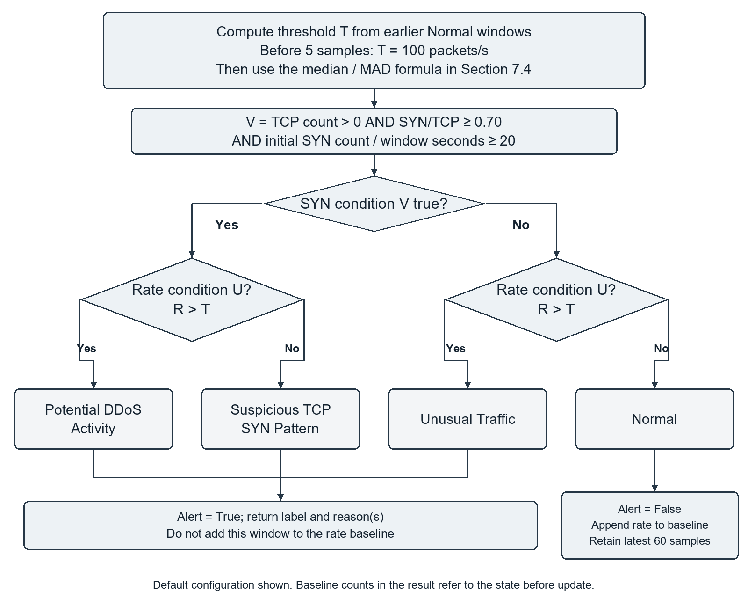
Figure 7.2: Detection Decisions and Baseline Updates
Rate comparison is strict, while both SYN floors are inclusive. With a threshold of 100, a rate of exactly 100 packets/s does not satisfy U. A SYN ratio of 0.70 and SYN rate of 20 satisfy V when TCP packets exist. The combined label requires both U and V.

7.5 Alerts Storage and Dashboard Workflow
Figure 7.3 follows an analysis from source selection to review. Every non-Normal result creates an alert decision with its observed values and reasons. The dashboard plots packet rate against the threshold and separately shows the initial SYN ratio. Decision tables also expose SYN rate and baseline readiness.
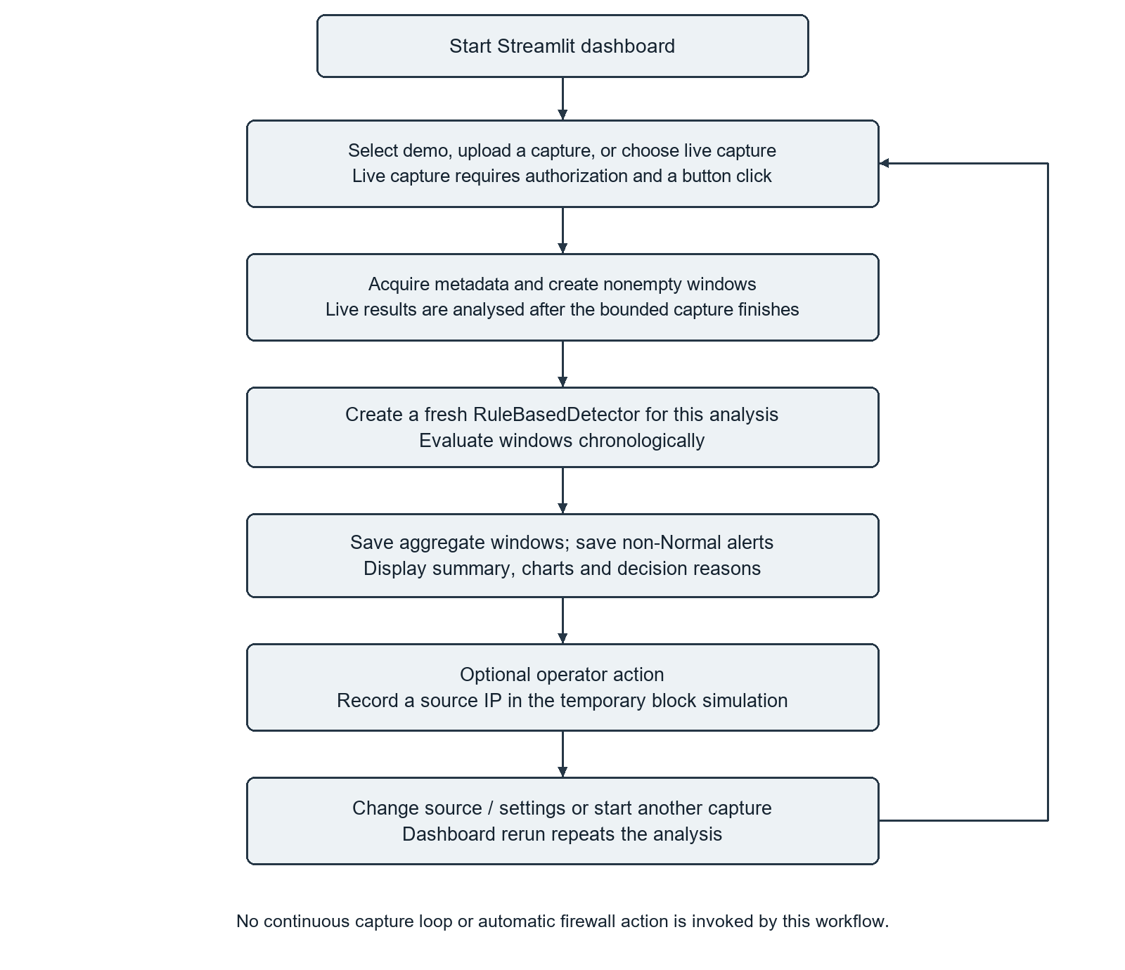
Figure 7.3: Project Workflow from Source Selection to Review
SQLite stores windows under a unique combination of window_start, window_seconds and source_kind. Alert identities include window information, label and reasons, preventing duplicate events from identical reruns. Historical alerts may belong to earlier inputs and are displayed separately from the current analysis.

7.6 Temporary Block Simulation
Figure 7.4 shows the response process. The operator selects an observed source IP and a duration of 1, 5, 15 or 60 minutes. The storage method validates the IP, requires a nonempty reason and a positive finite lifetime, and records temporary_block in simulation mode with UTC creation and expiry times.
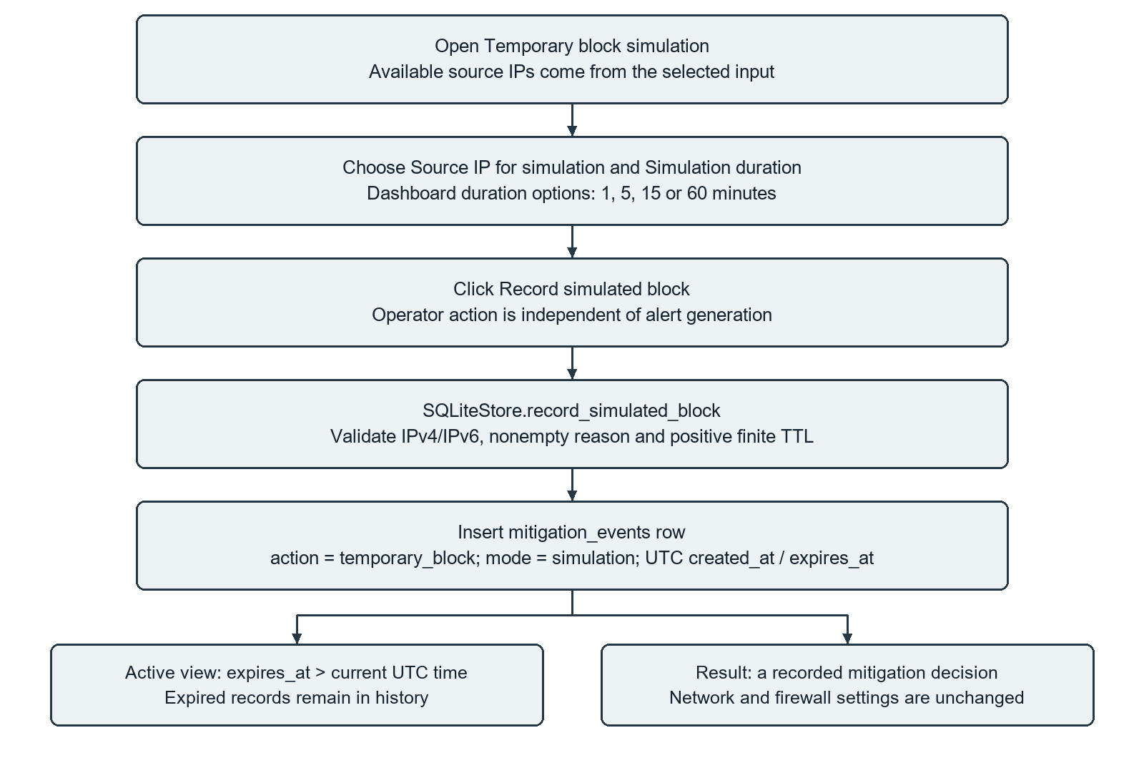
Figure 7.4: Temporary Block Simulation and Expiry
An entry is active while expires_at is later than the comparison time. It leaves the active view at expiry but remains in history. Recording a simulation is a separate operator action; alert generation does not invoke it automatically.

8 Coding and Implementation

8.1 Environment and Source Files
The application is packaged as sentinelshield. The recorded Windows environment used Python 3.14.3, Scapy 2.7.0, pandas 3.0.5, NumPy 2.5.2, scikit-learn 1.9.0, Joblib 1.6.0, Streamlit 1.65.0 and Plotly 6.9.0. SQLite is accessed through Python's sqlite3 module.
The dashboard starts from the repository root:
.\.venv\Scripts\python.exe -m streamlit run sentinelshield/dashboard/app.py
The demonstration used localhost port 8501. Table 8.1 lists the main modules; Figure 8.1 shows their relationships.
Table 8.1: Main Source Files and Their Roles
Module within sentinelshield | Purpose
dashboard/app.py | Source controls, analysis, charts, tables and simulation actions
collection/live.py and synthetic.py | Bounded live capture and generated PacketRecord inputs
processing/traffic.py | Capture-file readers, metadata extraction and window aggregation
detection/rules.py | Configuration, adaptive baseline and four-way rule decisions
storage/sqlite_store.py | Window/alert persistence and simulation expiry
evaluation/dataset.py and model.py | Synthetic feature rows and versioned packet-window models
evaluation/capture_evaluation.py | Whole-capture holdout checks and evaluation
evaluation/prepare_pcap_windows.py and prepare_pcap_interval.py | Sample conversion and bounded interval extraction
evaluation/flow_baseline.py and flow_multisource.py | Separate CSV-based cross-dataset flow experiments

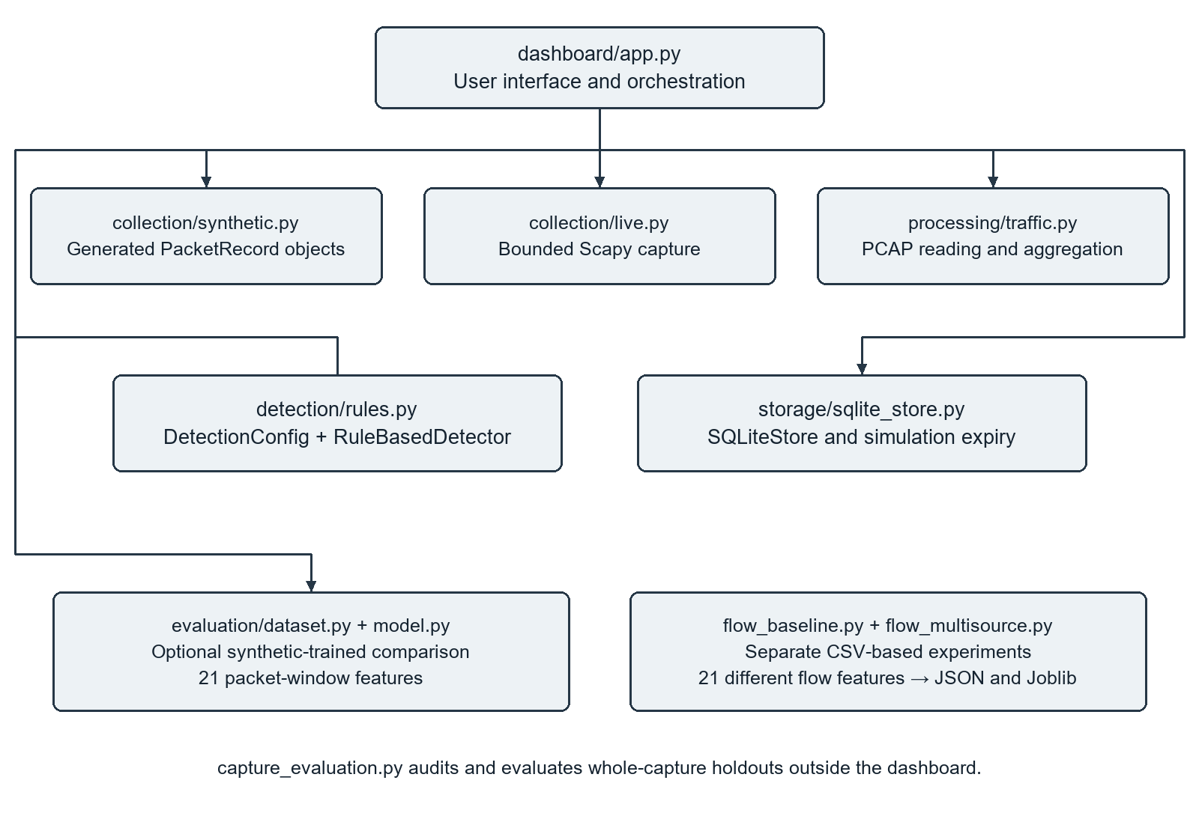
Figure 8.1: Software Components and Separate Evaluation Paths
The earlier sniffer.py and traffice_counter.py are separate console demonstrations. The latter uses a per-source count > 500 and SYN percentage > 70 after at least five wall-clock seconds, with exact flag equality to S. Those conditions differ from the main detector's aggregate-stream rules and TCP denominator.

8.2 Capture and Detection Code
The live collector calls Scapy with a selected interface, a timeout and a callback:
sniff(iface=interface, timeout=duration_seconds,
prn=collect, store=False)
The callback appends supported PacketRecord objects. store=False avoids retaining Scapy's list of full packets; the application keeps the extracted metadata in session memory. The detector calculates its threshold before testing the current window:
threshold = self.threshold_pps()
unusual_rate = features.packets_per_second > threshold
syn_pps = features.syn_count / features.window_seconds
suspicious_syn = (
features.tcp_packets > 0
and features.syn_ratio >= self.config.suspicious_syn_ratio
and syn_pps >= self.config.minimum_syn_pps
)
The following branch assigns the label from Table 7.2 and constructs its reasons. The result carries the threshold and baseline state used for that decision. A Normal rate is then appended to the baseline.

8.3 Storage and User Interface
The database has traffic_windows, detection_events and mitigation_events tables. Window features are stored as JSON; detection events reference their window and include label, reasons and creation time. The mitigation table records simulation mode, target address and expiry.
Streamlit controls the three input paths and displays Windows analyzed, Windows flagged and Packets processed. Plotly supplies the rate and SYN-ratio charts. Expandable sections contain measurements, reasons, simulations and recent alerts. After Record simulated block is clicked, the dashboard calls record_simulated_block with the selected IP, a reason and ttl_minutes × 60.

8.4 Model Experiments and Dataset Preparation
The optional dashboard comparison trains a Random Forest on 80 generated rows per class, using 21 packet-window features. It uses 200 trees, seed 42, balanced_subsample class weighting and a stratified 25% holdout [19]. Model files include ordered feature names, a schema version and provenance fields. This synthetic model is separate from the saved CIC flow models.
The five local PCAP samples are LUCID excerpts associated with CIC-DDoS2019 [20]–[22]. Their conversion produced 567 occupied five-second windows. File-level labels are coarse annotations; one benign capture cannot provide independent benign groups on both sides of a whole-capture holdout. A separate interval extractor processed 43,910 IP packets into 56 windows from an early five-minute Thursday CIC-IDS2017 interval. Its benign annotation is provisional and based on the published schedule [23], [24].
The flow experiments use 21 shared numeric CSV fields, rather than the dashboard's 21 packet-window measurements. One trains on supplied 2019 flows and evaluates Friday 2017; another combines earlier sources and evaluates a separate 2018 copy [25]. Both use 80 trees, maximum depth 16, minimum leaf size 5, seed 42 and balanced_subsample weighting. Non-finite selected features are excluded, and JSON reports retain class counts and confusion matrices.

8.5 Verification
The recorded test run passed 36 non-UI unit tests with no failures or errors. These covered packet extraction, capture-file readers, window aggregation, rule boundaries, baseline behaviour, mocked bounded capture, SQLite deduplication/expiry and model serialization. Application demonstrations also covered source selection, uploaded captures, live acquisition, alert history and the simulation action. Their outputs appear in Chapter 9.

9 Screenshots and Results

9.1 Normal Traffic Demonstration
The Normal only demo produced 30 windows and 3,770 packet records, all labelled Normal. Figure 9.1 shows the selected source and counters. Figure 9.2 shows packet rates below the initial 100 PPS threshold. These generated examples check the application's normal processing path.
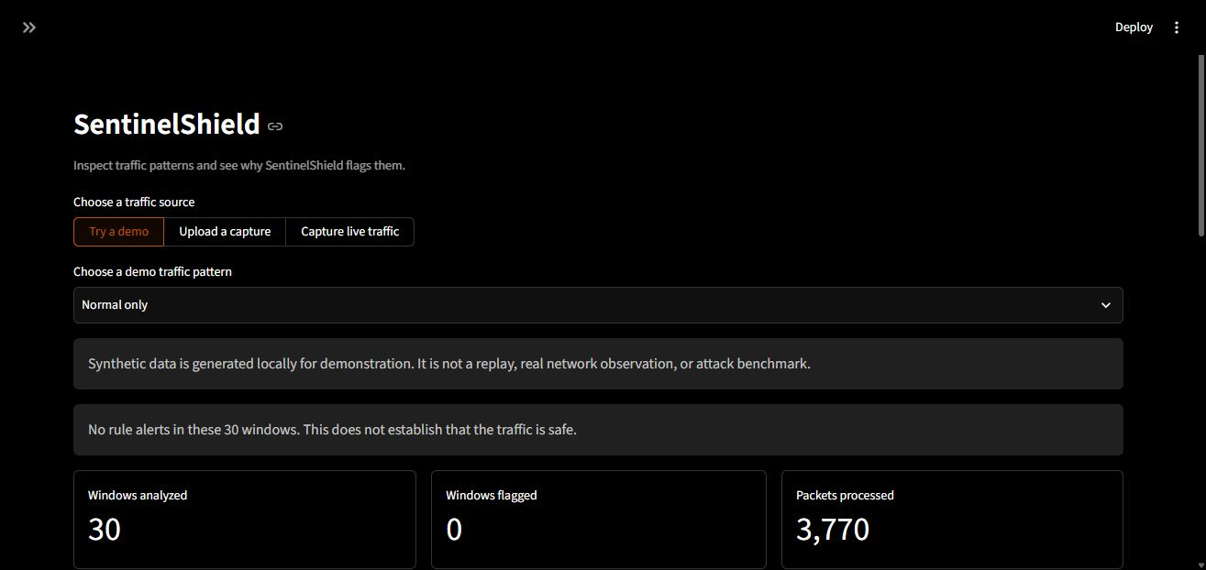
Figure 9.1: Normal Traffic Demonstration and Summary Counters
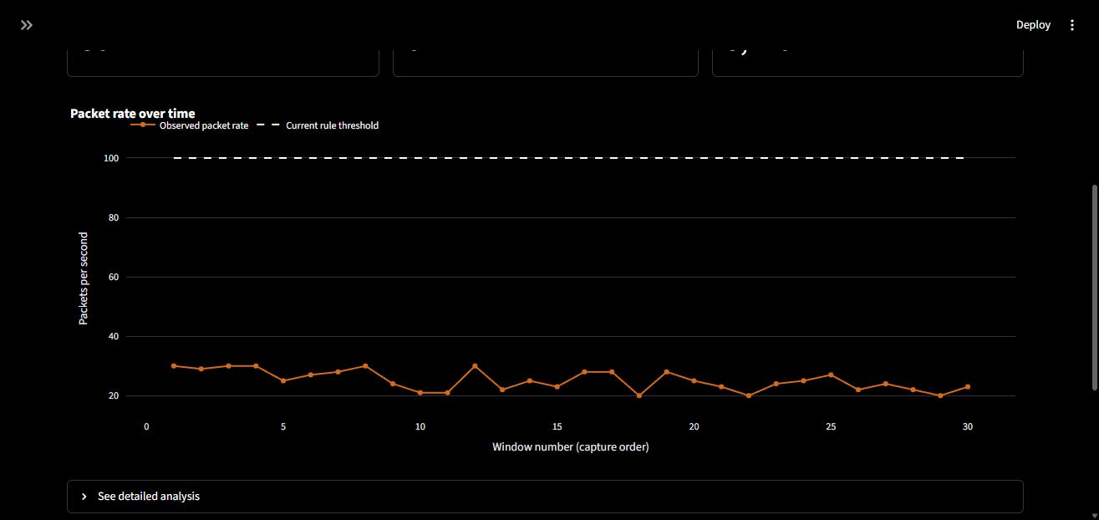
Figure 9.2: Normal Packet Rates and Rule Threshold

9.2 Mixed Traffic Demonstration
The Mixed demonstration produced 30 windows, 11,060 records and 16 alerts: 6 Unusual Traffic, 6 Suspicious TCP SYN Pattern and 4 Potential DDoS Activity. The other 14 windows were Normal. Figures 9.3 and 9.4 show the summary and rate phases. Only windows meeting both rules receive the combined label.
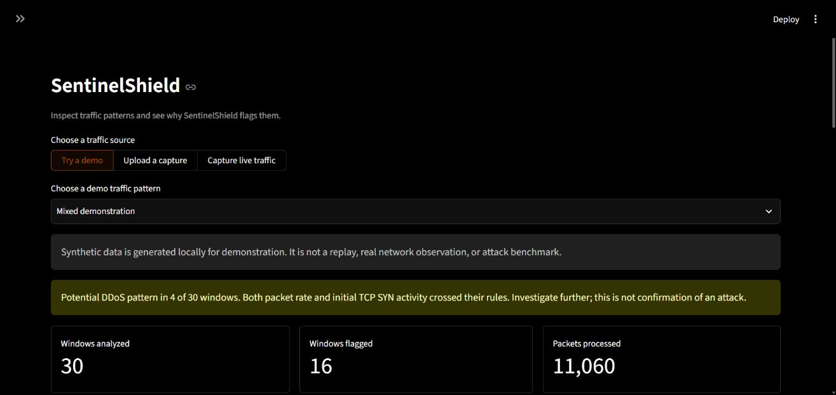
Figure 9.3: Mixed Traffic Summary and Combined Rule Warning
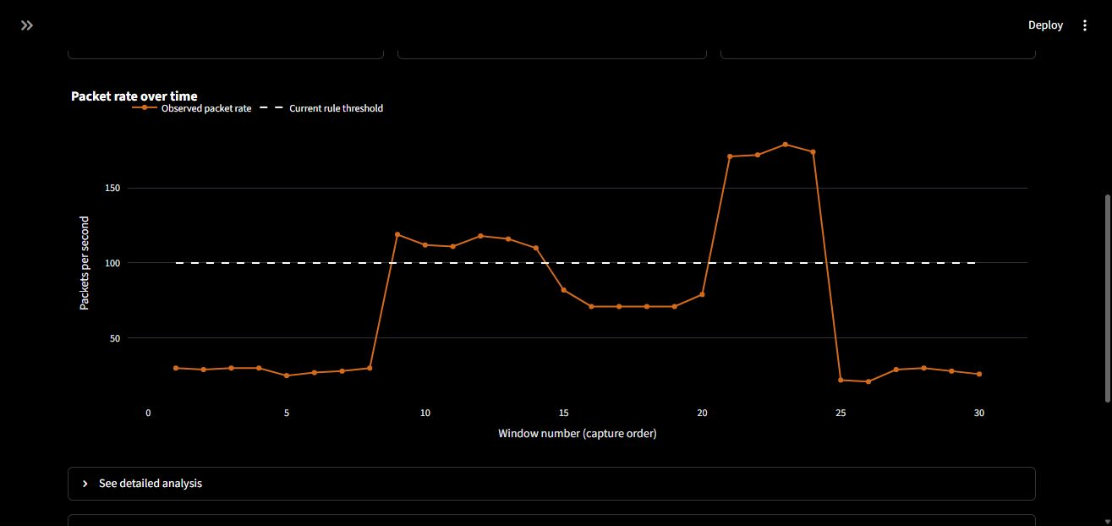
Figure 9.4: Packet Rates and Threshold during the Mixed Demonstration

9.3 SYN Heavy Traffic Decisions
The SYN-heavy demo returned 30 Suspicious TCP SYN Pattern labels across 12,085 records. In the first window, packet rate was 90 PPS, initial-SYN/TCP ratio about 0.9396 and SYN rate 77.8 PPS. The SYN condition passed while overall rate stayed below 100 PPS. Figures 9.5 and 9.6 show these measurements and reasons. No Normal windows entered the baseline in this run.
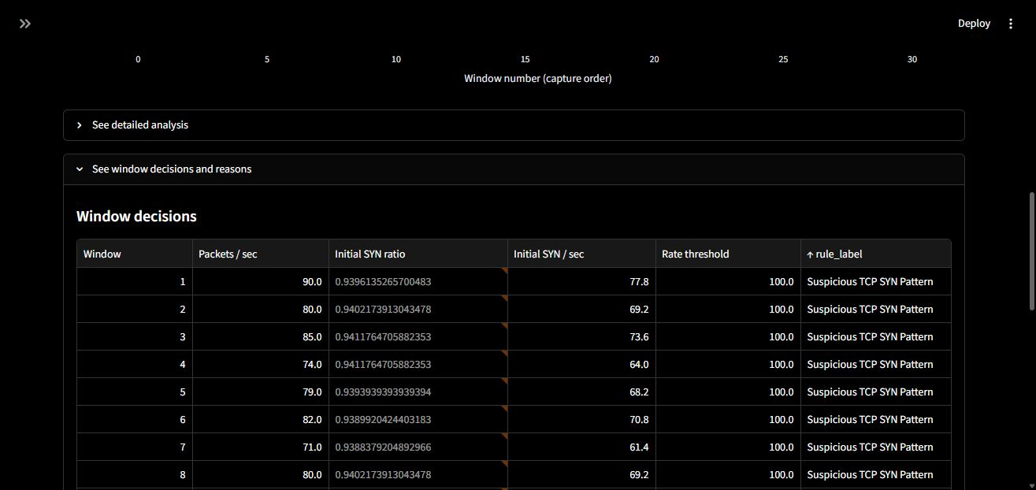
Figure 9.5: Window Measurements for the SYN Heavy Demonstration
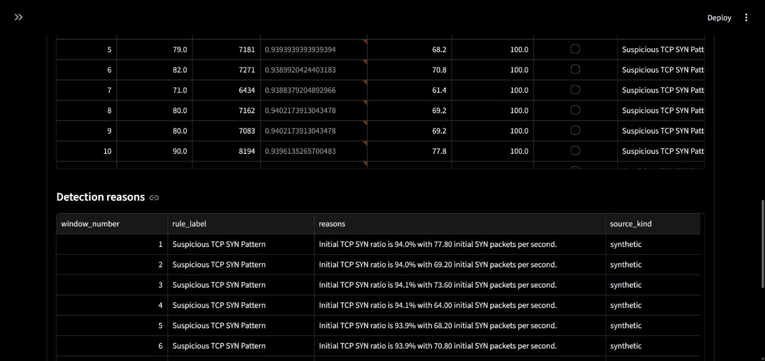
Figure 9.6: Detection Reasons for Suspicious TCP SYN Patterns

9.4 Uploaded Capture Results
The CIC-DDoS-2019-SynFlood.pcap excerpt produced one occupied window with 26,316 TCP records. Figure 9.7 shows the upload result; Figure 9.8 shows 5,263.2 PPS, 18,778 initial SYN packets, ratio about 0.713558 and SYN rate 3,755.6 PPS. Both rules passed against the cold-start threshold of 100 PPS. The five-second divisor is the configured window duration, not a measured attack duration.
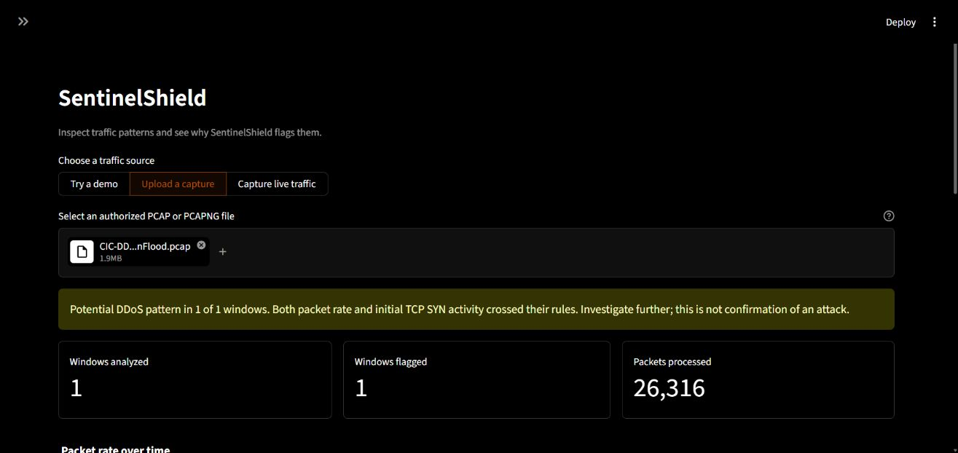
Figure 9.7: Uploaded SYN Flood Excerpt and Analysis Summary
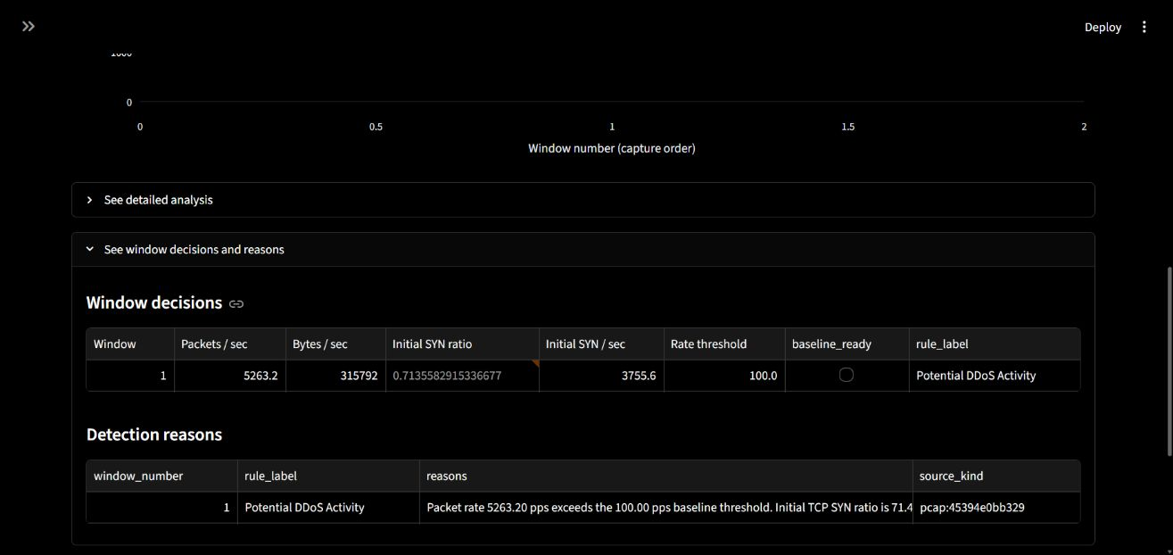
Figure 9.8: Measurements and Combined Rule Decision for the SYN Flood Excerpt
The benign-labelled excerpt produced 247 windows and 27,725 IP records: 235 Normal and 12 Unusual Traffic. Figure 9.9 shows that result. A file label does not provide independent ground truth for every window, so these alerts indicate threshold sensitivity rather than a validated false-positive rate. Table 9.1 also includes the other sampled captures.
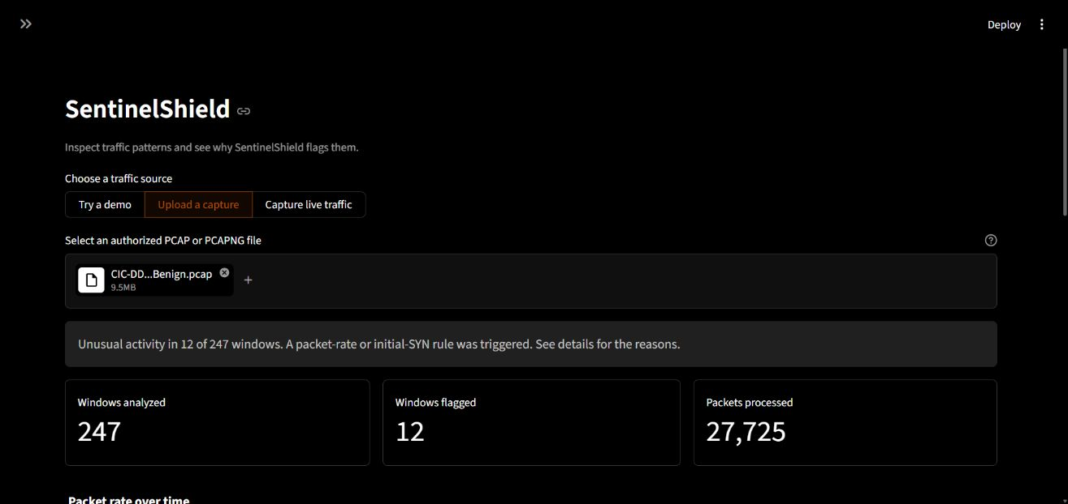
Figure 9.9: Rate Alerts in the Benign Labelled Capture

9.5 Live Capture
The live demonstration used an authorised ten-second capture on the Windows Npcap loopback interface. Opening another local dashboard session supplied ordinary host traffic. Figures 9.10 and 9.11 show the selected interface, duration and completed result: 21 supported records, two occupied windows and no alerts. Figure 9.12 shows their packet rates. Results were displayed after collection ended.
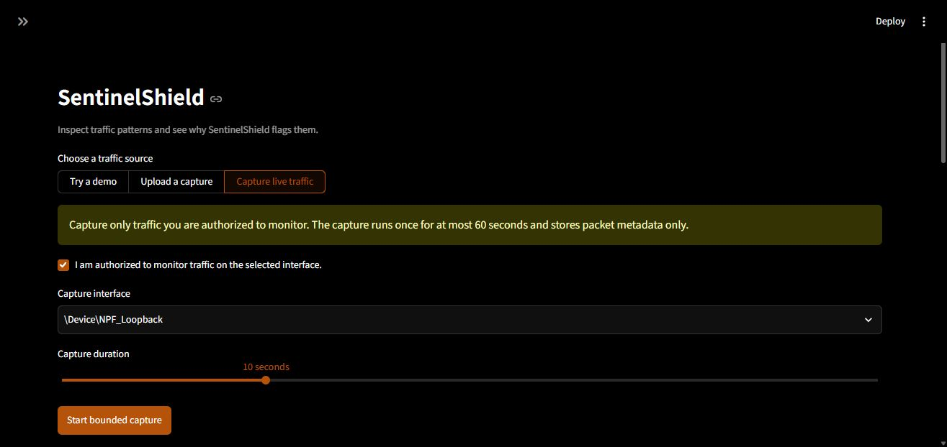
Figure 9.10: Live Capture Interface and Ten Second Duration
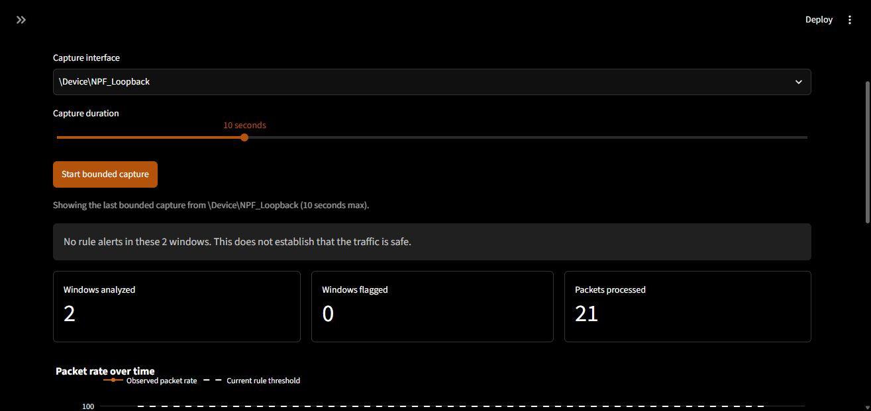
Figure 9.11: Completed Loopback Capture and Summary Counters
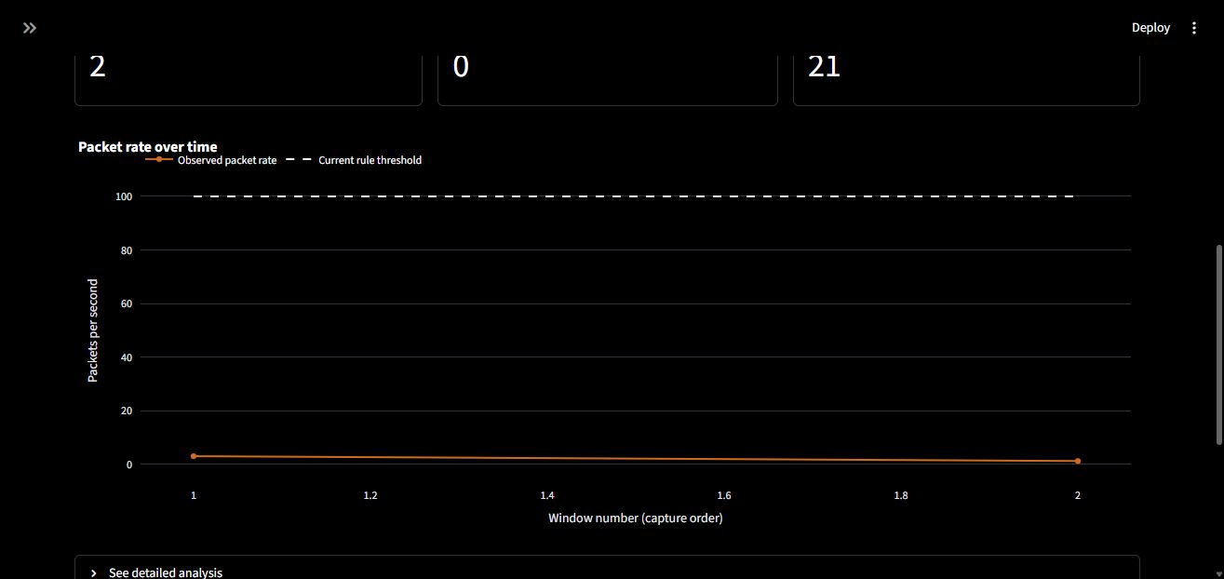
Figure 9.12: Packet Rates from the Loopback Capture

9.6 Response Simulation and Alert History
For the simulation, source 192.0.2.1 was selected from the generated mixed input for five minutes. Figure 9.13 shows the recorded target, reason and UTC timestamps five minutes apart. The address belongs to the demonstration input. The record was created manually and appears in the active list until expiry.
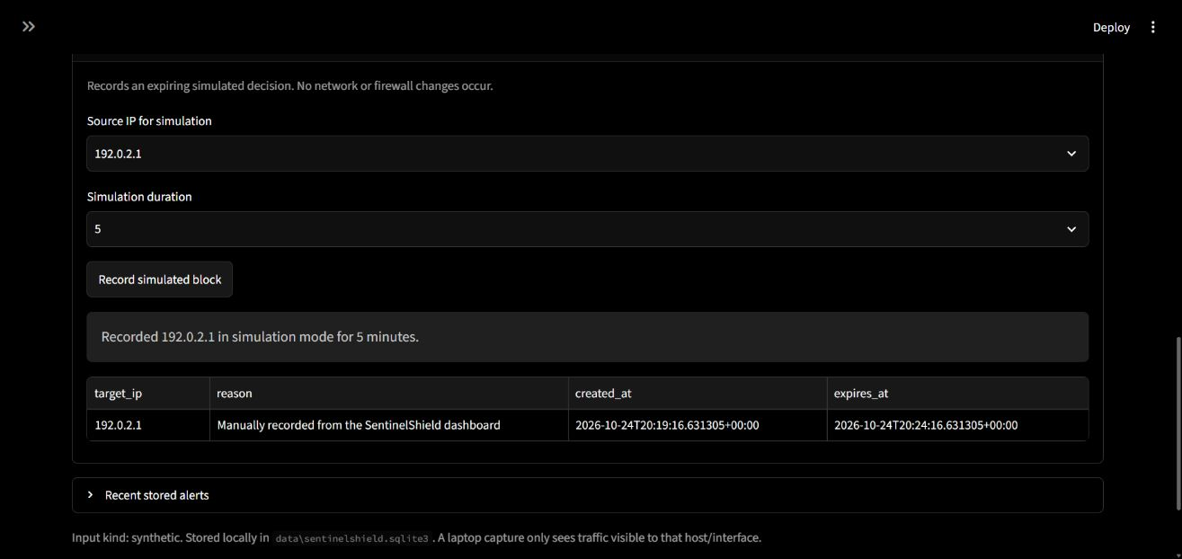
Figure 9.13: Temporary Block Simulation with UTC Expiry
Figure 9.14 shows the uploaded SYN capture's Potential DDoS Activity event retrieved from SQLite, with its reasons and timestamp alongside earlier alerts.
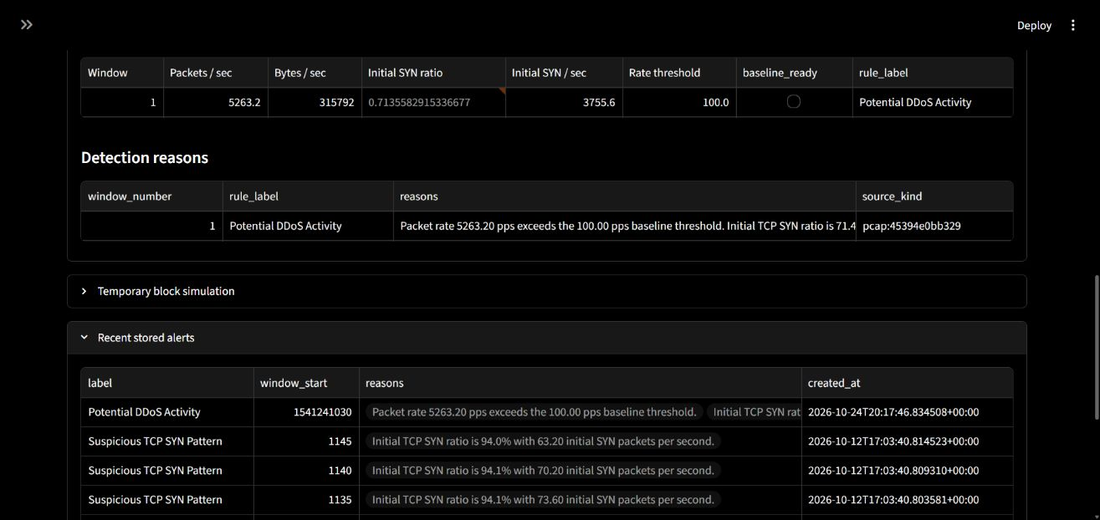
Figure 9.14: Detection Events Retrieved from SQLite

9.7 Machine Learning Results
Figure 9.15 shows 100.0% accuracy, weighted precision, weighted recall and weighted F1 on 80 generated holdout rows. The interface identifies these as synthetic results. They demonstrate training and inference on separable generated examples and do not measure generalisation to real network traffic.
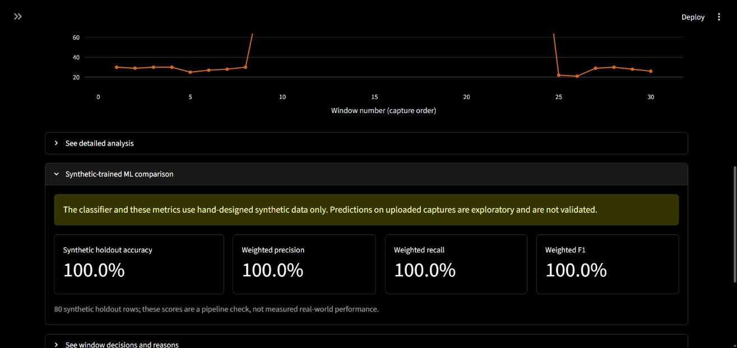
Figure 9.15: Random Forest Results on Synthetic Holdout Data

9.8 Discussion
Table 9.1 summarises the functional runs. Table 9.2 reports the separate flow-model experiments. Confusion-matrix rows are actual Benign/DDoS and columns are predicted Benign/DDoS. These models do not drive the dashboard's rules.
Table 9.1: Results with Five Second Windows
Input | Windows | Records | Detector output
Normal demo | 30 | 3,770 | 30 Normal
Mixed demo | 30 | 11,060 | 14 Normal; 6 rate-only; 6 SYN-only; 4 combined
SYN-heavy demo | 30 | 12,085 | 30 SYN-only
Benign PCAP | 247 | 27,725 | 235 Normal; 12 rate-only
DNS PCAP | 1 | 5,268 | 1 rate-only
SynFlood PCAP | 1 | 26,316 | 1 combined
UDPLag PCAP | 159 | 22,501 | 158 Normal; 1 rate-only
WebDDoS PCAP | 159 | 3,104 | 159 Normal
Loopback live capture | 2 | 21 | 2 Normal

Rate-only denotes Unusual Traffic, SYN-only denotes Suspicious TCP SYN Pattern, and combined denotes Potential DDoS Activity. Counts refer to occupied windows and supported IP records.
Table 9.2: Cross Dataset Flow Model Results
Training and test | Test flows | Confusion matrix | DDoS recall | Benign false alarms
2019 → Friday 2017 | 225,711 valid flows | [[73445, 24241], [81433, 46592]] | 36.3929% | 24.8152%
2019 + 2017 → 2018 copy | 1,048,575 flows | [[360521, 312], [687716, 26]] | 0.00378049% | 0.0864666%

The low DDoS recall shows poor transfer between these datasets. The local 2019 file has unverified original provenance, the 2018 copy has unverified completeness, and duplicate rows reduce sample independence. The recorded feature-shift analysis found distribution differences but did not establish one cause for the errors.
The demonstrations show that acquisition, aggregation, rule evaluation, alert storage and response simulation operate together. Capture names such as DNS, UDPLag and WebDDoS are dataset labels; the detector still applies its two generic conditions. An attack-labelled capture can therefore produce rate-only alerts or no alerts. A Normal label means that neither configured condition fired. The samples and loopback run provide functional evidence, while an independent labelled evaluation would be needed to estimate attack-detection accuracy for a deployment.

10 Conclusion and Future Development

10.1 Conclusion
SentinelShield brings capture-file analysis, bounded live acquisition and generated demonstrations into one DDoS monitoring application. It extracts network and transport metadata, forms fixed windows and applies an adaptive packet-rate rule together with an initial-SYN ratio-and-rate rule. The four labels, plots and textual reasons allow each result to be checked against its measurements.
The demonstrations covered normal and mixed patterns, SYN-heavy traffic, recorded captures and a ten-second loopback capture. SQLite retained the alerts and the operator's expiring simulation record. The separate Random Forest results also showed the difference between success on synthetic examples and transfer to another flow dataset.
The project applies addressing, protocols, TCP flags, time-window measurement and network monitoring in a working system. Its response component records temporary block simulations, and its detection output remains tied to the conditions actually measured.

10.2 Future Development
Further evaluation could calibrate the thresholds with independently collected benign and controlled attack captures, using time-separated or whole-capture holdouts. Multiple authorised observation points could extend visibility, provided their clocks and source identities are handled consistently.
An isolated laboratory deployment could add an enforcement adapter or SDN controller and measure both attack suppression and effects on legitimate traffic [5], [17]. Other extensions include incremental learning for new traffic classes [15], more efficient inference [16] and longer-term traffic analysis. These would build on the existing acquisition, storage and explanation modules.

11 References
[1] P. Orosz, B. Nagy, and P. Varga, “Real-Time Detection and Mitigation Strategies Newly Appearing for DDoS Profiles,” Future Internet, vol. 17, no. 9, Art. no. 400, 2025, doi: 10.3390/fi17090400. Available: https://doi.org/10.3390/fi17090400
[2] RFC Editor, “Transmission Control Protocol (TCP),” RFC 9293, Aug. 2022. [Online]. Available: https://www.rfc-editor.org/rfc/rfc9293
[3] W. Eddy, “TCP SYN Flooding Attacks and Common Mitigations,” RFC 4987, Aug. 2007. [Online]. Available: https://www.rfc-editor.org/rfc/rfc4987
[4] Scapy project, “Usage,” Scapy documentation. [Online]. Available: https://scapy.readthedocs.io/en/latest/usage.html. Accessed: Oct. 25, 2026.
[5] U. H. Garba, A. N. Toosi, M. F. Pasha, and S. Khan, “SDN-based detection and mitigation of DDoS attacks on smart homes,” Computer Communications, vol. 221, pp. 29–41, 2024, doi: 10.1016/j.comcom.2024.04.001. Available: https://doi.org/10.1016/j.comcom.2024.04.001
[6] K. Wang, Y. Fu, X. Duan, et al., “Detection and mitigation of DDoS attacks based on multi-dimensional characteristics in SDN,” Scientific Reports, vol. 14, Art. no. 16421, 2024, doi: 10.1038/s41598-024-66907-z. Available: https://doi.org/10.1038/s41598-024-66907-z
[7] A. I. Hassan, E. Abd El Reheem, and S. K. Guirguis, “An entropy and machine learning based approach for DDoS attacks detection in software defined networks,” Scientific Reports, vol. 14, Art. no. 18159, 2024, doi: 10.1038/s41598-024-67984-w. Available: https://doi.org/10.1038/s41598-024-67984-w
[8] D. Han, H. Li, X. Fu, and S. Zhou, “Traffic Feature Selection and Distributed Denial of Service Attack Detection in Software-Defined Networks Based on Machine Learning,” Sensors, vol. 24, no. 13, Art. no. 4344, 2024, doi: 10.3390/s24134344. Available: https://doi.org/10.3390/s24134344
[9] S. Abiramasundari and V. Ramaswamy, “Distributed denial-of-service (DDOS) attack detection using supervised machine learning algorithms,” Scientific Reports, vol. 15, Art. no. 13098, 2025, doi: 10.1038/s41598-024-84879-y. Available: https://doi.org/10.1038/s41598-024-84879-y
[10] M. S. Sawah, H. Elmannai, A. A. El-Bary, et al., “Distributed denial of service (DDoS) classification based on random forest model with backward elimination algorithm and grid search algorithm,” Scientific Reports, vol. 15, Art. no. 19063, 2025, doi: 10.1038/s41598-025-03868-x. Available: https://doi.org/10.1038/s41598-025-03868-x
[11] M. Nawaz, S. Tahira, D. Shah, et al., “Lightweight machine learning framework for efficient DDoS attack detection in IoT networks,” Scientific Reports, vol. 15, Art. no. 24961, 2025, doi: 10.1038/s41598-025-10092-0. Available: https://doi.org/10.1038/s41598-025-10092-0
[12] D. V. Hernandez, Y.-K. Lai, and H. T. N. Ignatius, “Real-Time DDoS Detection in High-Speed Networks: A Deep Learning Approach with Multivariate Time Series,” Electronics, vol. 14, no. 13, Art. no. 2673, 2025, doi: 10.3390/electronics14132673. Available: https://doi.org/10.3390/electronics14132673
[13] A. Zaman, S. A. Khan, N. Mohammad, A. A. Ateya, S. Ahmad, and M. A. ElAffendi, “Distributed Denial of Service Attack Detection in Software-Defined Networks Using Decision Tree Algorithms,” Future Internet, vol. 17, no. 4, Art. no. 136, 2025, doi: 10.3390/fi17040136. Available: https://doi.org/10.3390/fi17040136
[14] S. Satpathy, U. Tripathy, and P. K. Swain, “Cloud-based DDoS detection using hybrid feature selection with deep reinforcement learning (DRL),” Scientific Reports, vol. 15, Art. no. 36546, 2025, doi: 10.1038/s41598-025-18857-3. Available: https://doi.org/10.1038/s41598-025-18857-3
[15] J. Ge, Y. Feng, and K. Sakurai, “A Stage-Wise Framework Using Class-Incremental Learning for Unknown DoS Attack Detection,” Future Internet, vol. 18, no. 3, Art. no. 145, 2026, doi: 10.3390/fi18030145. Available: https://doi.org/10.3390/fi18030145
[16] S. Eren, A. Gültekin, Ö. Özkan, and İ. Özçelik, “High-Throughput and Low-Latency DrDoS Detection Using Quantized ONNX Models,” Symmetry, vol. 18, no. 7, Art. no. 1187, 2026, doi: 10.3390/sym18071187. Available: https://doi.org/10.3390/sym18071187
[17] A. C. Fatiyah, A. Abbas, P. E. Setiasabda, W.-B. Hsieh, J.-S. Leu, and S.-J. Chen, “Machine Learning-Based Real-Time Detection and Mitigation of DoS Attacks in SDN-Based 5G Network,” Electronics, vol. 15, no. 5, Art. no. 1005, 2026, doi: 10.3390/electronics15051005. Available: https://doi.org/10.3390/electronics15051005
[18] A. H. Kara and P. Sarısaray Bölük, “Deep Learning Approaches for Real-Time DDoS Detection in Network-Based Systems: A Comprehensive and Analytical Review,” Electronics, vol. 15, no. 18, Art. no. 4132, 2026, doi: 10.3390/electronics15184132. Available: https://doi.org/10.3390/electronics15184132
[19] Scikit-learn developers, “RandomForestClassifier,” API reference. [Online]. Available: https://scikit-learn.org/stable/modules/generated/sklearn.ensemble.RandomForestClassifier. Accessed: Oct. 25, 2026.
[20] I. Sharafaldin, A. H. Lashkari, S. Hakak, and A. A. Ghorbani, “Developing Realistic Distributed Denial of Service (DDoS) Attack Dataset and Taxonomy,” in Proc. IEEE 53rd International Carnahan Conference on Security Technology, Chennai, India, 2019. Dataset and paper record: https://www.unb.ca/cic/datasets/ddos-2019.html
[21] Canadian Institute for Cybersecurity, University of New Brunswick, “DDoS evaluation dataset (CIC-DDoS2019).” [Online]. Available: https://www.unb.ca/cic/datasets/ddos-2019.html. Accessed: Oct. 25, 2026.
[22] LUCID project, “Sample dataset,” lucid-ddos research repository. [Online]. Available: https://github.com/doriguzzi/lucid-ddos/tree/master/sample-dataset. Accessed: Oct. 25, 2026.
[23] I. Sharafaldin, A. H. Lashkari, and A. A. Ghorbani, “Toward Generating a New Intrusion Detection Dataset and Intrusion Traffic Characterization,” in Proc. 4th International Conference on Information Systems Security and Privacy, Portugal, Jan. 2018. Dataset and paper record: https://www.unb.ca/cic/datasets/ids-2017.html
[24] Canadian Institute for Cybersecurity, University of New Brunswick, “Intrusion detection evaluation dataset (CIC-IDS2017).” [Online]. Available: https://www.unb.ca/cic/datasets/ids-2017.html. Accessed: Oct. 25, 2026.
[25] Communications Security Establishment and Canadian Institute for Cybersecurity, “CSE-CIC-IDS2018 on AWS.” [Online]. Available: https://www.unb.ca/cic/datasets/ids-2018.html. Accessed: Oct. 25, 2026.

