Revision History
Rev. No. | Date | Changes
1.0 | 15Feb2016 | Initial Release

BPL Lifephone Plus WL – Build Note
This document details the specifics of the BPL Lifephone Plus white labelled application.

Application Details

APK Name | TricogConsumerApp.TG.1.00.apk
Package Name | com.LpppBplWL.android.userapp

Output File Details
Type : XML
Example File Name: LppMeasurement 15-02-2016 18:54:42.xml

Sample Example for ECG
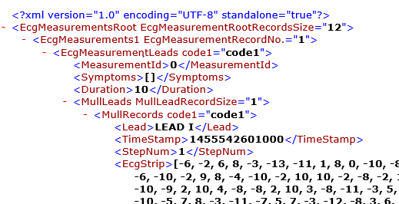

Integration Procedure Call
public void openApplication(Context context,String packagename)
{
Intent intent = context.getPackageManager().getLaunchIntentForPackage(packagename);
if(intent!=null)
{
context.startActivity(intent);
}
Else
{
Display any message (i.e app not found)
}}

