Problem statement:

Configure the vision sensor and make it detect colors.

Arena:

The arena for this task consists of a vision sensor and a color changing cube.

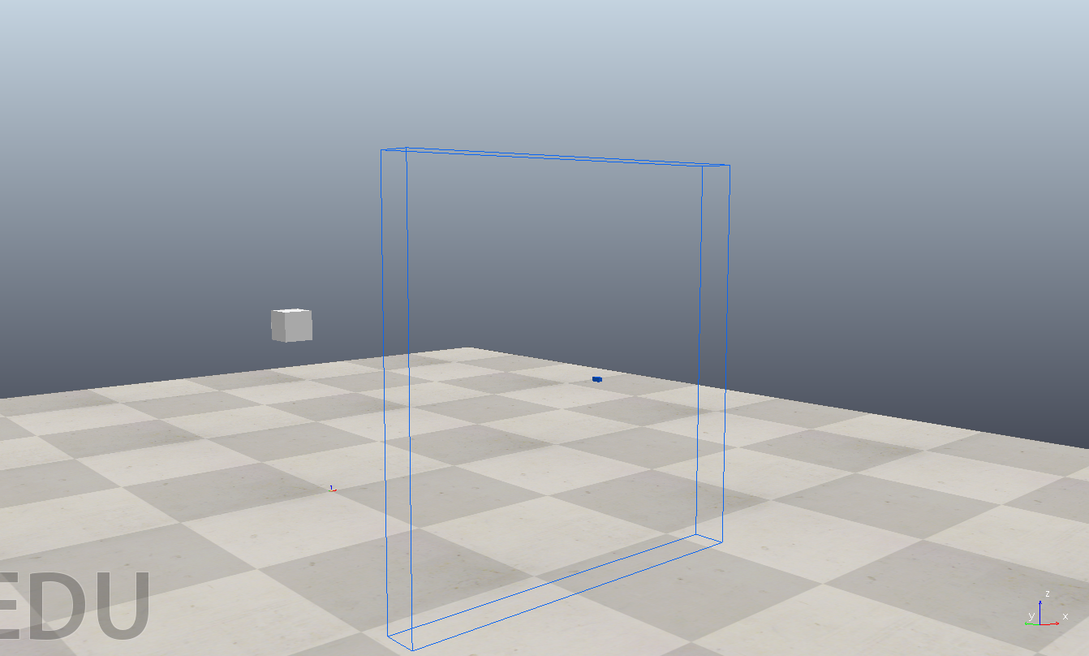

Theme rules:

* Neither the cube nor the vision sensor can be moved from their positions.
* The arena cannot be changed in any way.
* The color of the cube will change randomly during the simulation.
* Your job is to use the vision sensor to identify the color of the cube.
* Once identified, use the function sim.setStringSignal('colorDetected','<color name>') , where color name can be orange, green or unknown. Eg. If green color is detected then use the command sim.setStringSignal(‘colorDetected’,’green’)
* Once the simulation starts, human intervention will not be allowed.
* The user is not required to write the code to either start or stop the simulation.

Scoring:

* Score= 10*(correctly_identified_colors)-10*(wrongly_identified_colors or ignored_colors)
* There will be a total of 15 color changes.