Problem statement:

Use the robotic arm created in the previous task to pluck and deposit ripe fruits correctly.

Arena:

The arena for this task consists of a wall with ripe and unripe fruits, a differential drive bot and a deposition box.

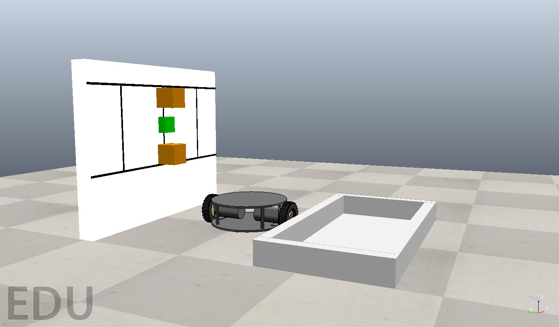

Theme rules:

* None of the above mentioned objects can be moved or tampered with.
* The arena cannot be changed in any way.
* Your job is to:
  + Mount the arm and collection basket designed in the previous task on the differential drive bot.
  + Scan and identify ripe and unripe fruits (however, setting string signal will not be necessary for evaluation in this task)
  + Pluck the ripe fruits without disturbing the unripe ones.
  + Drop them into your collection basket.
  + Empty all the fruits in the collection basket into the deposition box.
  + Use sim.setStringSignal('end simulation', 'true') to end the run.
* Once the simulation starts, human intervention will not be allowed.
* The user is not required to write the code to either start or stop the simulation.

Scoring:

* Score = 100-(number of untouched or un-deposited ripe fruits)\*50-(number of displaced unripe fruits)\*50
* There will be a total of 2 ripe and 1 unripe berries.