📘 StudyMate App — 10-Minute AI Studio Quick-Build Guide
Goal: Help college students create StudyMate, an AI-powered study and interview prep assistant using Google AI Studio, ChatGPT, or Hugging Face.

🕒 Total Time: 10 Minutes
🧰 You’ll Need:
- A Google account
- Internet connection
- Access to https://aistudio.google.com
- Optional: ChatGPT or Hugging Face account

Step 1: Login to Google AI Studio (1 min)
- Go to aistudio.google.com.
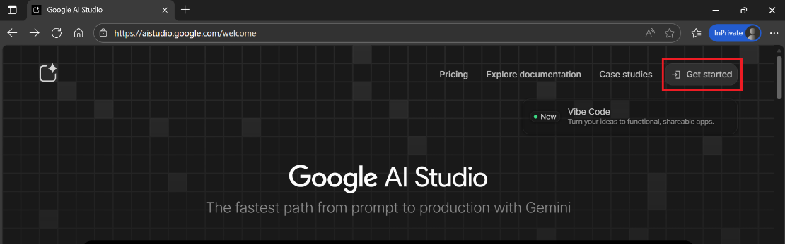
- Click “Sign in with Google”
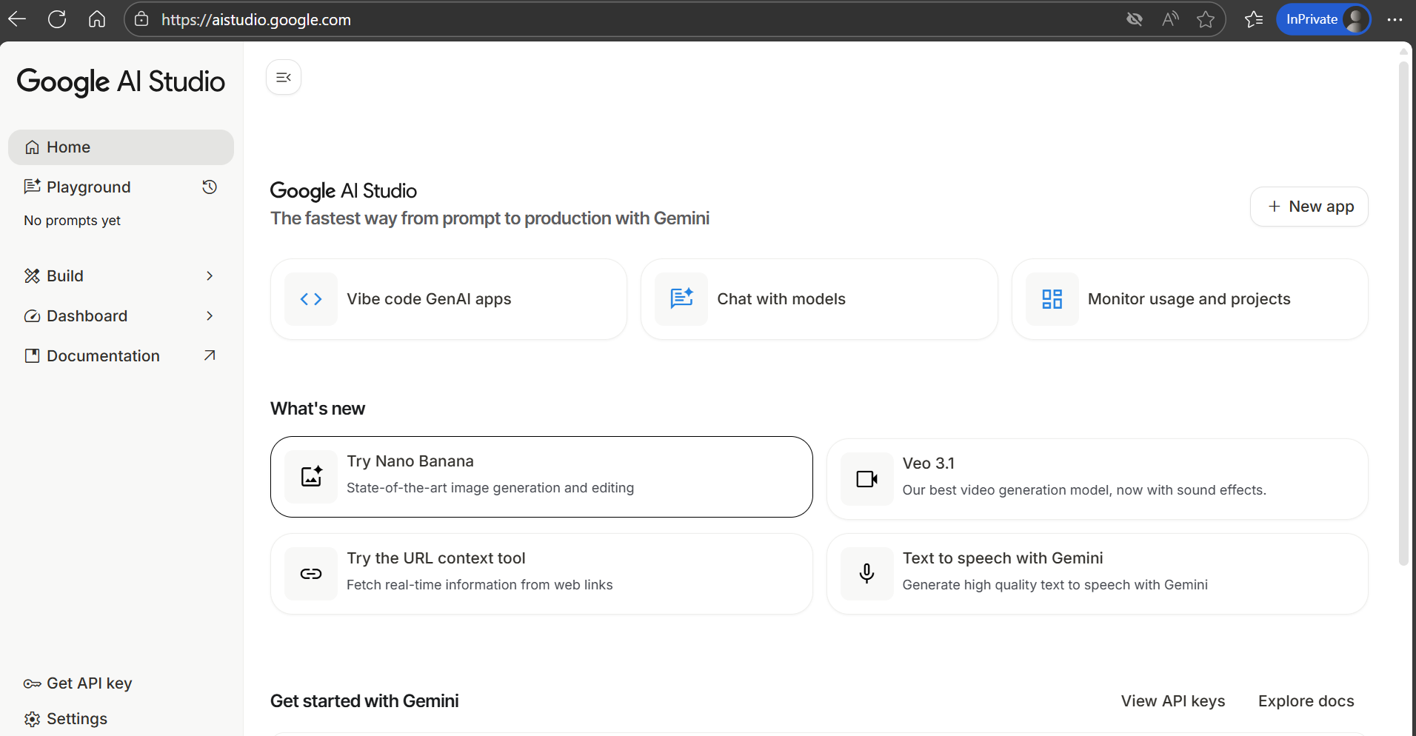
- Once logged in, click “Create New Project” → name it “StudyMate”.
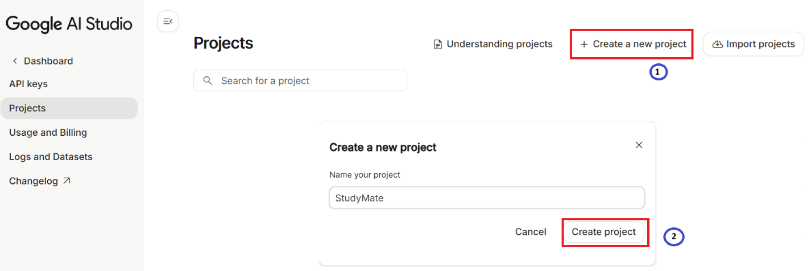

Step 2: Create a Raw Prompt (2 min)
Write a short description of what you want the AI to build:
Raw Prompt Example:
“Create a single-page app called StudyMate for college students.
It should help students generate quizzes, flashcards, and interview questions from uploaded notes using AI.
Use a modern UI and keep it beginner-friendly.”
📸 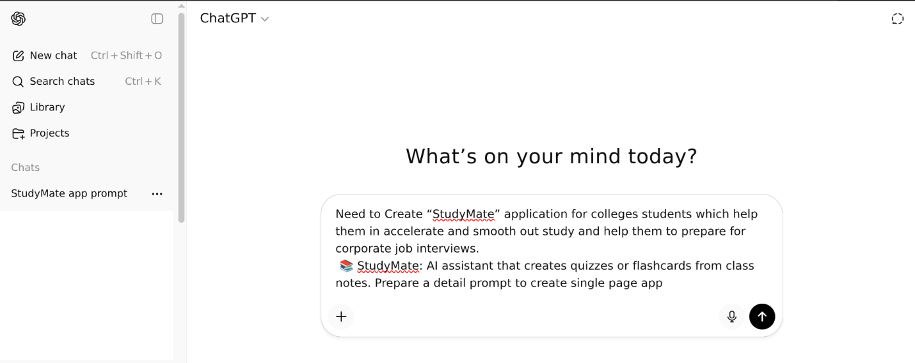

Step 3: Expand Prompt Using ChatGPT or Hugging Face (2 min)
Copy your raw prompt → paste it into ChatGPT or Hugging Face Chat → ask:
“Make this prompt more detailed and structured for AI Studio app generation.”
You’ll get a detailed version with:
- Clear feature list
- UI layout (Upload Notes → Flashcards → Interview Prep → Analytics → Chat)
- Tech stack suggestions (React.js or Web-based builder)
📸 [Screenshot: Detailed prompt output]
Here’s the extracted text from the image:

Goal
Create a single-page web app called StudyMate that helps college students accelerate their studies and prepare for corporate interviews using AI-generated quizzes, flashcards, and personalized learning insights.

Detailed Prompt for AI App Generator
Prompt Title:
📚 StudyMate – AI Study & Interview Assistant for College Students

App Description
Build a modern, responsive single-page web app named StudyMate, designed to help college students study smarter and prepare for corporate job interviews.
The app should use AI to convert class notes, PDFs, or text input into quizzes, flashcards, summaries, and provide interview prep assistance (common HR, technical, and aptitude questions).

Core Features
- Upload or Paste Notes
  - Allow students to upload PDFs / Word / Text files or paste text directly.
  - AI should parse the content and generate study materials.
- AI Quiz & Flashcard Generator
  - Automatically create quizzes (MCQs, short answers, or true/false) from uploaded notes.
  - Create AI flashcards (Question on front, Answer on back).
  - Allow export of flashcards as .csv or .pdf.
- Smart Summaries
  - Generate concise, AI-driven summaries of uploaded material.
  - Allow students to select “Quick Recap” or “Detailed Review.”
- Interview Preparation Mode
  - Preloaded corporate interview question banks:
    - General HR questions
    - Technical (by domain: IT, Finance, Marketing, etc.)
    - Aptitude & reasoning
  - AI should analyze uploaded resume (optional) and suggest personalized interview questions.
- Progress Tracker
  - Simple visual analytics dashboard:
    - Number of quizzes attempted
    - Accuracy %
    - Weak topic areas (based on quiz performance)
    - Suggested improvement areas.
- AI Chat Assistant
  - Integrated chatbot: “Ask StudyMate” for any question based on uploaded content.
  - Supports follow-up questions and rephrased explanations.
- UI & UX Requirements
  - Modern single-page layout using React.js (or Next.js) + Tailwind CSS.
  - Soft pastel theme (blue/white/green focus-friendly colors).
  - Sections in scrollable format:
    - Header → Upload Notes → Flashcards/Quiz → Interview Prep → Analytics → Chat.
  - Include icons & light animations (Fluent UI preferred).
- Tech Stack (suggested)
  - Frontend: React.js + Tailwind CSS
  - AI Backend: OpenAI API (or local LLM API placeholder)
  - Storage: LocalStorage / Firebase for user progress
  - Optional: Audio-based notes

Step 4: Paste Detailed Prompt into AI Studio (2 min)
- Go back to AI Studio.
- Paste the detailed prompt into the project prompt editor.
- Click “Run” or “Generate App”.
- AI Studio will automatically create app layout, sample UI code, or a working prototype.
📸 [Screenshot: App generation screen in AI Studio]

Step 5: Review & Test (2 min)
- Click Preview to see your working StudyMate app.
- Try uploading text or typing a paragraph — AI should generate:
  - Flashcards
  - Quiz questions
  - Quick summaries
  - Interview prep questions
📸 [Screenshot: StudyMate working app preview]

Step 6: Save & Share (1 min)
- Click Export → choose Shareable Link or Download HTML/JS.
- Share it with your classmates or upload to GitHub/Vercel.

💬 Talking Points for Presentation / Report
- Problem Solved: Students struggle to organize notes and prepare for interviews.
- AI Used: Google Gemini (via AI Studio) to generate and summarize learning material.
- Key Features: Quiz generation, flashcards, summaries, interview practice.
- Outcome: 1-page app created in <10 minutes using AI tools — no coding required.

Would you like me to now generate this as a ready-to-download illustrated PDF (with screenshot placeholders) titled
👉 “StudyMate — 10-Minute AI Studio App Creation Guide for Students”?
I can include mock screenshots and icons for clarity.

