Vibe coding workshop- College Buddy App
Objective :
Help me to create application for student for study material sharing, peer study , question answers for classwork, home work etc
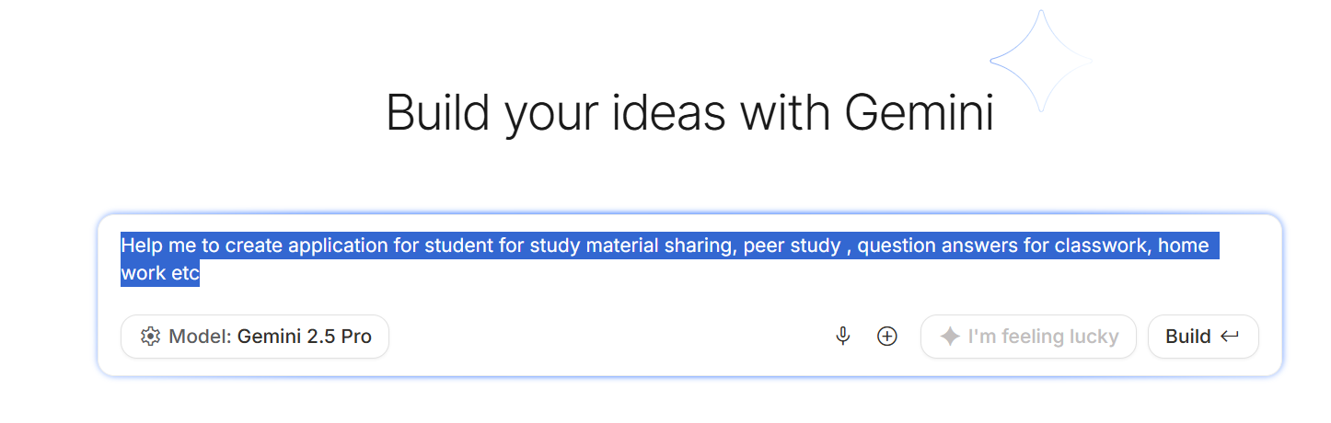
Prompt 1:
Help me to create application for student for study material sharing, peer study , question answers for classwork, home work etc.

You may face error :
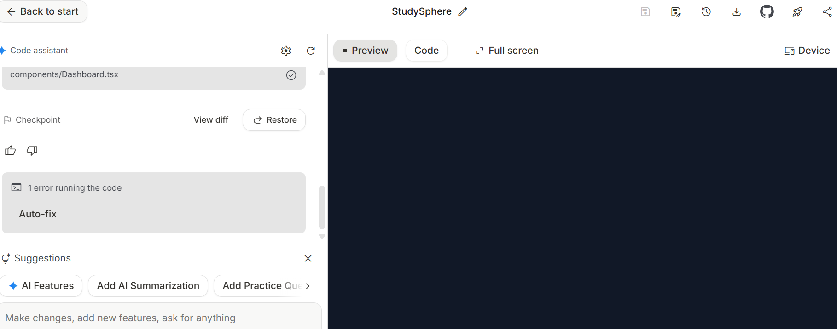

1 error running the code
Auto Fix the error Fix the error with help of AIstudio

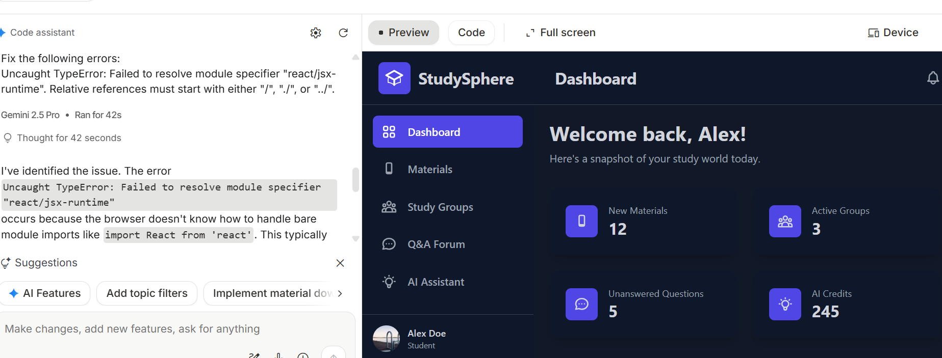
Application
https://ai.studio/apps/drive/1DT3rUMhwNvjnnJbEmD2czDmjpal-tf7Y

Creating Vibe Coding with Agile Development Way
✅ Presentation Flow
- Intro: Why Agile + AI for students?
- Vision & Use Case
- Raw Prompt → First Prototype
- Backlog & User Stories
- Sprint Execution (Demo)
- Retrospective & Key Learnings

✅ Step 1: Define the Goal & Use Case
Your app is for study material sharing , peer study, Q&A for classwork/homework (must-have) and chat box, party planning, trip planning (good-to-have).
This will be your vision statement in Agile terms.
✅ Step 2: Raw Prompt for Google AI Studio
Start with a basic prompt to generate the initial app skeleton.
Here’s an example you can show in your demo:
Prompt 2 :
"Create a web application “CollegeBuddy” for college students to share study materials, ask and answer questions, and collaborate on homework. The app should have user authentication, a dashboard for subjects, and a section for Q&A. Use a simple and clean UI suitable for students."
👉 This will give you a first working prototype.
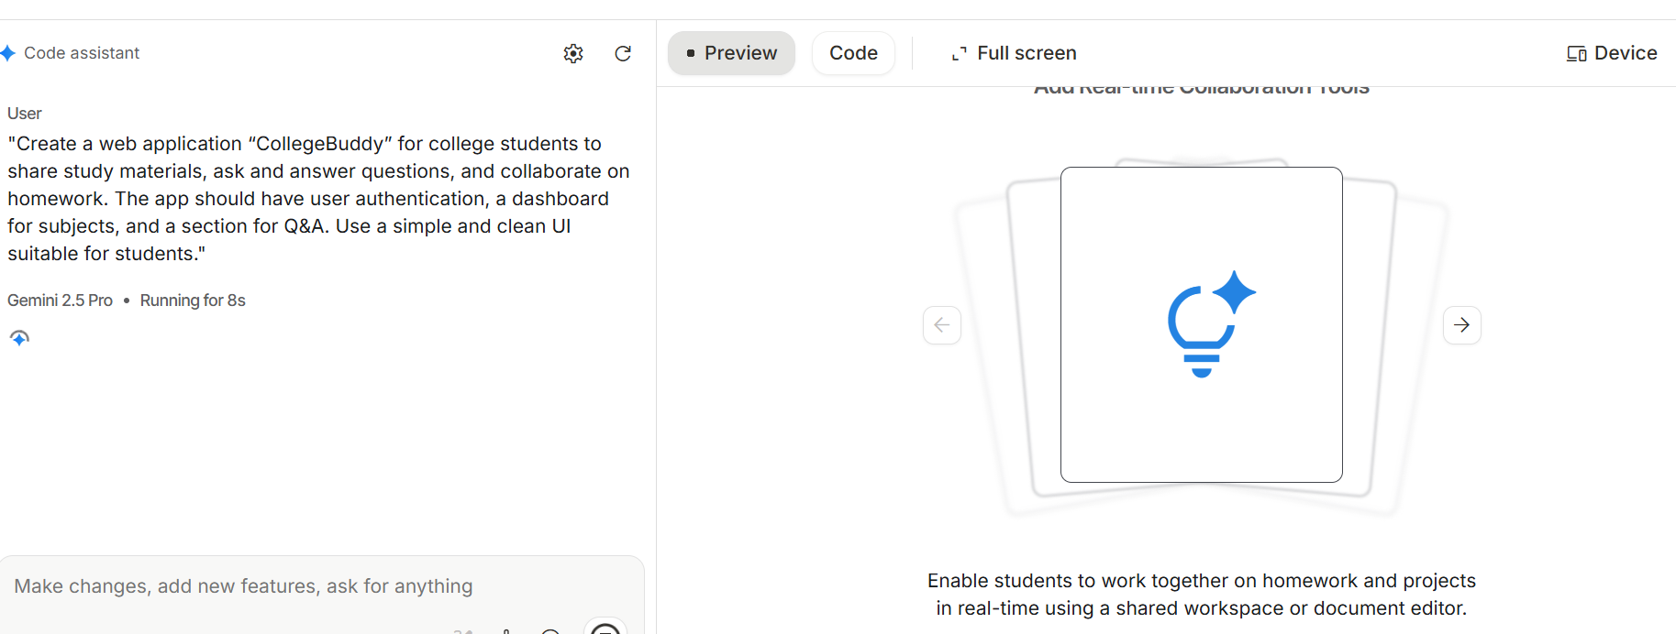

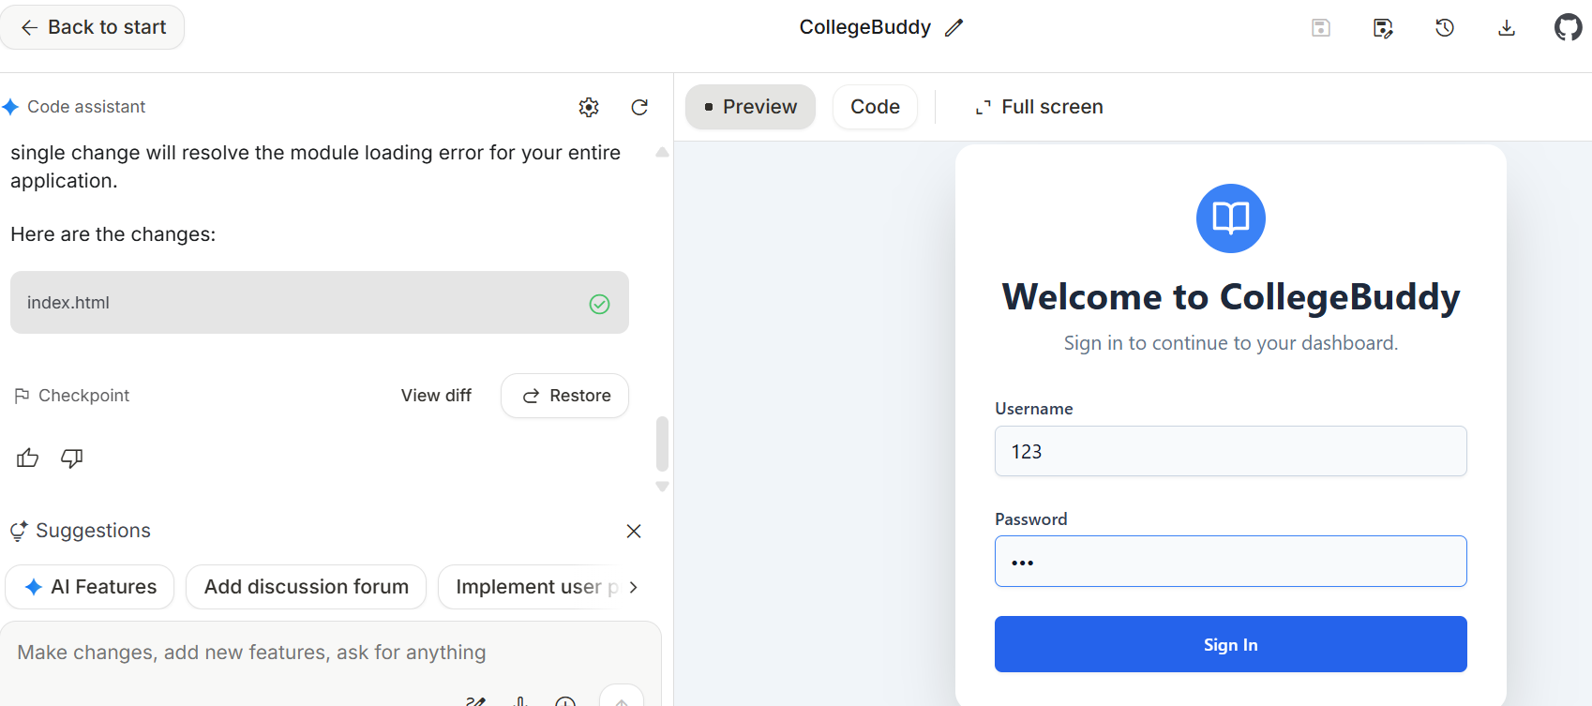

User id 123
Password 123

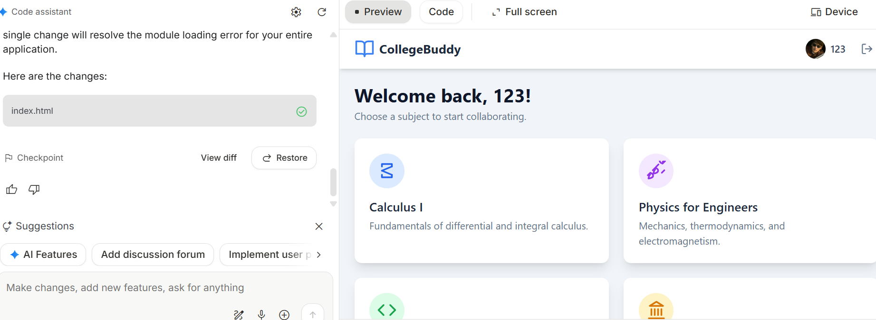
✅ Step 3: Refine into a High-Level Product Backlog
Explain that in Agile, we break down features into Epics and Stories.
Your Epics could be:
- Study Material Sharing
- Peer Study & Q&A
- Homework Collaboration
- Chat & Social Features
Then create high-level backlog items like:
- Upload and download study materials
- Create Q&A threads
- Homework submission and discussion
- Chat feature for peer interaction
- Event planning (party/trip)
✅ Step 4: Break Down into User Stories
Show how each Epic becomes user stories:
Example:
- As a student, I want to upload notes so others can access them. (Must have)
- As a student, I can set my weekly study goal and check progress (Good to Have)
- As a student, I want to ask questions and get answers from peers. (Good to have)
- As a student, I want to chat with classmates for quick discussions. (Good to Have)
👉 You can even prioritize using MoSCoW (Must-have vs Good-to-have).

✅ Step 5: Build Iteratively
Run Google AI Studio prompts for each user story.
Example for Q&A feature:
Prompt 3 :
"Add a Q&A section where students can post questions and answers. Include upvote/downvote functionality and tags for subjects."

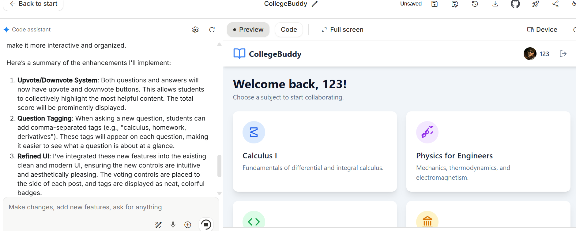

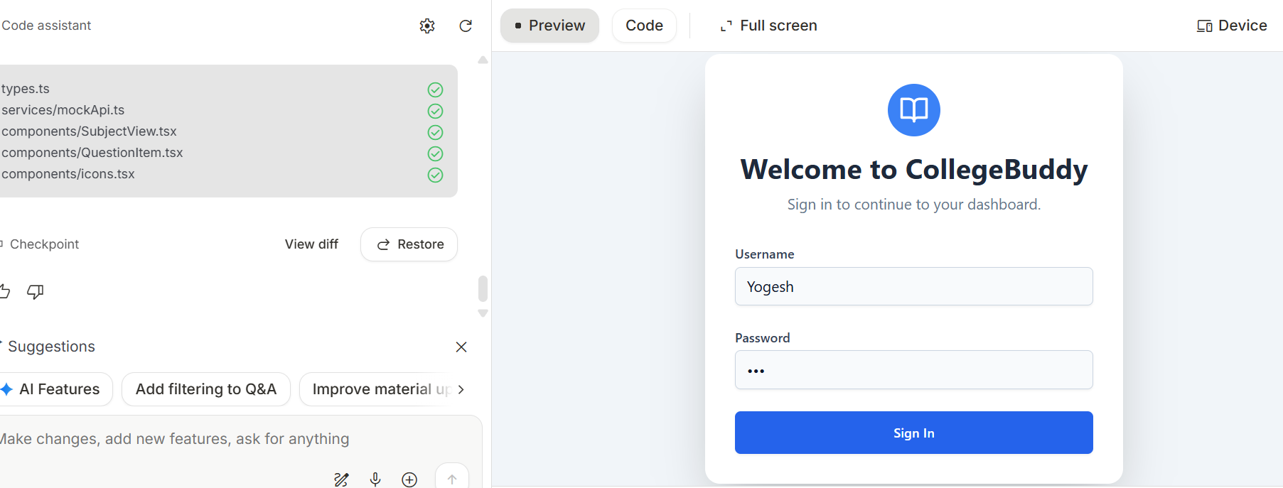

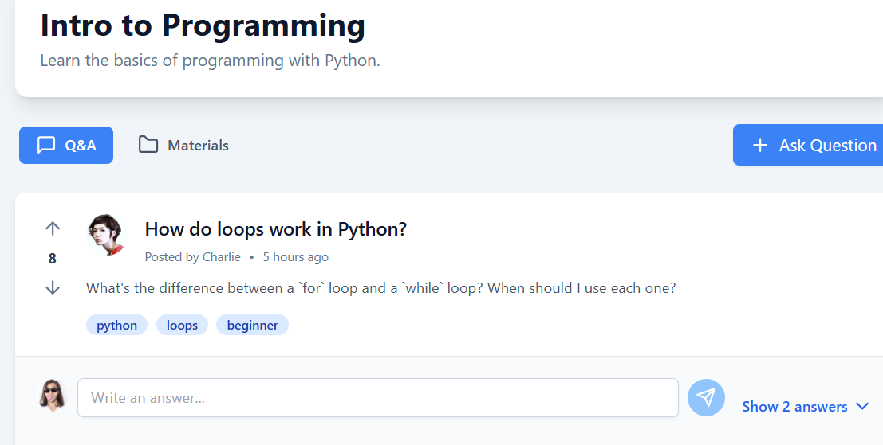

Repeat for other stories.
"Add a Q&A section As a student, I can set my weekly study goal and check progress on top of my it . Include progress bar for time spent on the app."

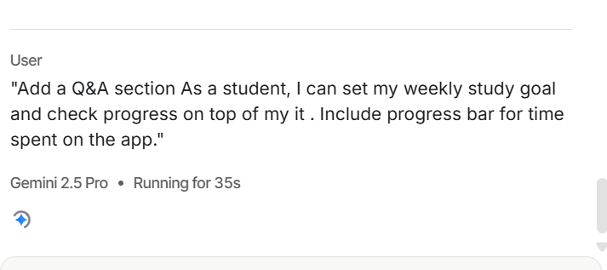

Of course! Adding a study goal tracker is a fantastic idea to help students stay motivated. I'll integrate a sleek and intuitive weekly study goal feature right onto the dashboard.
Here's what I've added:
- Weekly Study Goal Tracker: A new card will appear at the top of your dashboard. It prominently displays your progress toward your weekly study goal with a clean progress bar and text showing "X hours / Y hours studied."
- Set Your Goal: A "Set Goal" button on the tracker opens a simple modal, allowing you to easily input or update your desired number of study hours for the week.
- Automatic Time Tracking: To make it seamless, the app now simulates tracking your study time whenever you're logged in, so you can see your progress accumulate in real-time.
This new feature is designed to be a constant, gentle reminder of your commitment, helping you stay on track with your studies.
Here are the code updates to implement this feature:
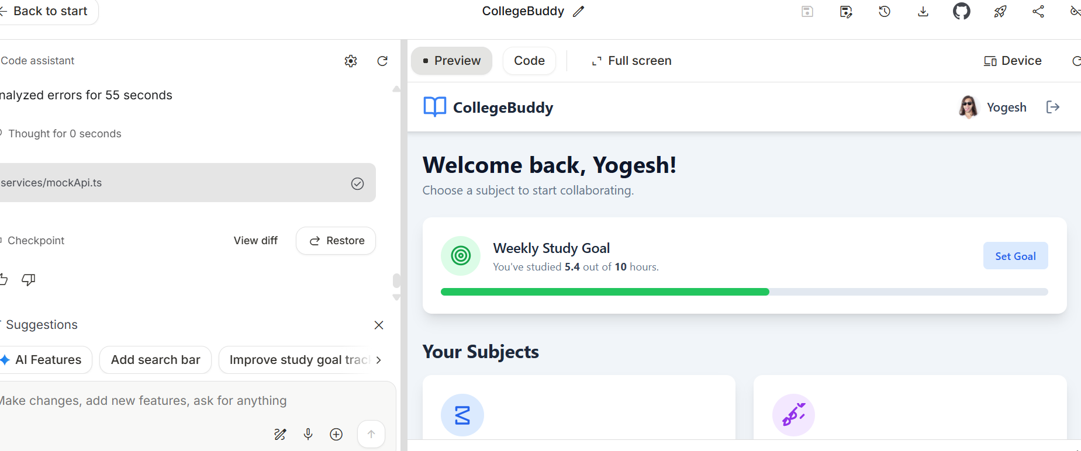

✅ Step 6: Demo the Working App
Show the incremental progress after each sprint.
Highlight how Agile allows continuous improvement.
Final version of app
https://ai.studio/apps/drive/1mIIsvFikPPYmMscC_eic6SflBr-2c_74

✅ Step 7: Sprint Retrospective
End with a slide summarizing:
- What went well (e.g., quick prototyping with AI)
- What can improve (e.g., better backlog refinement)
- What you learned (Agile + AI synergy)

Anchor – Yogesh Umbarkar

