**Project Review Report**

Project Topic: LAW FIRM MANAGEMENT WEBSITE

Team no:

Regno Name Split up of work

##### 1. 19BCE2632 Megha Shah Works on Module pages

##### 2.

##### 3.

##### 4.

##### 5.

Technology used:

Total number of modules: There are 19 modules in our website.

List of modules:

1. Index Page – The landing page of the website containing info and other details of the lawfirm and with an option to login which redirects to login page
2. Login page – Portal for clients/employees/admins to login
3. Signup page – Clients must fill a form and give details on their appointment request related to their case to sign up for an account.
4. Client portal – Clients can choose whether they want to see case details, their cases or hearings for their cases.
5. Employee portal – Employees(Lawyers) can choose whether they want to see their details, cases, clients or hearings
6. Admin portal - Administrators have access to all data and can choose to see or manipulate whatever they choose
7. Client Details – The client can see their personal information.
8. Client Cases – Clients can see information on their cases
9. Client Hearings – Clients can see information on hearings for their cases.
10. Employee details – Employees can see their personal information.
11. Employee Cases – Employees can see information on cases they are handling.
12. Employee Clients – Employees can see information on clients they are representing.
13. Employee Hearings – Employees can see information on hearings for cases they are representing.
14. Admin Clients – Administrators can see client data or choose to add/update/delete data from the table.
15. Admin Employees – Administrators can see employee data or choose to add/update/delete data from the table.
16. Admin Cases – Administrators can see case data or choose to add/update/delete data from the table
17. Admin Hearings – Administrators can see hearing data or choose to add/update/delete data from the table.
18. Admin Courts - Administrators can see court data or choose to add/update/delete data from the table
19. Admin Documents - Administrators can see document data or choose to add/update/delete data from the table

Total number of tables: The Law Firm Database consists of 7 tables each with multiple attributes

List of table names:

***1. Cases***

i.Case_id – The unique identifying id the case

ii.Client_id – The unique identifying id of the client represented.

iii.Lawyer_id – The unique identifying id of the employee(lawyer) handling the case.

iv. Case_notes – Notes on the happenings of the case

v. Status – Status of the case i.e., whether it is open or closed

vi. No_of_hearings – Total hearings taken place for the case

***2. Clients***

i. Client_id – The unique identifying id of the client

ii. Name – first_name, last_name – First and last name of the client

iii. Password – The login password of the client

iv. Contact - The phone number of the client

v. Address – door_no, street_name – The current address of the client.

***3. Employees***

i. Employee_id - The unique identifying id of the employee

ii. Name – first_name, last_name - First and last name of the employee

iii. Salary – The salary of the employee

iv. Since – The date on which the employee joined the firm

v. Contact – The phone number of the employee

vi. Password – The login password of the employee

vii. Address – door_no, street_name – The current address of the employee.

viii. No_of_cases – The total number of cases being handled by the employee.

***4. Courts***

i. c_no – The unique identifying id of a court

ii. Chief_judge – The name of the chief judge of the court.

***5. Documents***

i. Document_id – The unique name assigned to the document

ii. Case_id – The unique id assigned to the case referenced in the document

iii. Authenticity – Whether the document is an original or copy

***6. Hearings***

i. S_no – Unique identifying number of the hearing

ii. Case_id – Unique identifying id of the case being heard in court

iii.Lawyer_id – Unique identifying id of the lawyer representing the case

iv. Court - The unique identifying id of the court where the hearing is taking place.

***7. Client Requests***

i. Name – first_name, last_name – The first and last name of the potential client

ii. Contact – The phone number of the potential client

iii. Password – The chosen password by the potential client

iv. Address – Door_no, street_name – The current address of the potential client.

Total number of pages:-There are 5 pages on Law-Firm Management website.

Mapping the pages:

1. Home Page:-

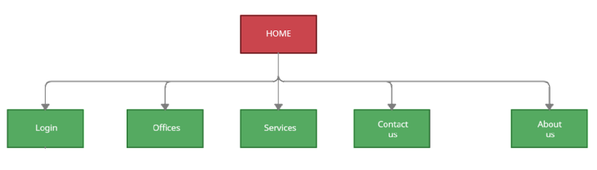

The home page of the website is structured such that the user may choose to be redirected to the login page or they may view information about the firm presented as 4 interchangeable

sections.

Offices: Information about the locations where the law firm has offices

Services: Information about the different legal services provided by the law firm.

Contact Us: Phone numbers and email addresses needed to contact the law firm directly.

About Us: General information about the history, motto and spirit of the law firm.

1. Login pages:-

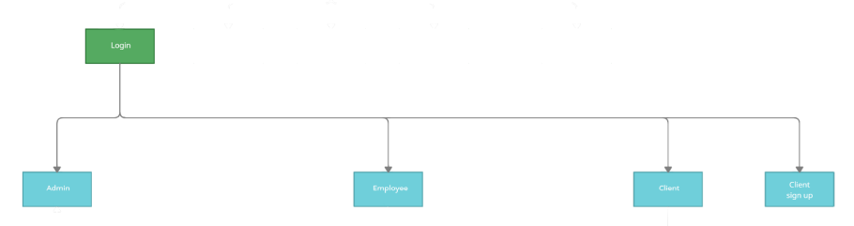

The login page redirects the user to one of three portals:

● Admin

● Employee

● Client

If the correct password is entered for the associated user id the user is redirected according to the user id. New clients can choose the sign-up option to get redirected to the sign-up page.

3.Admin Page:-

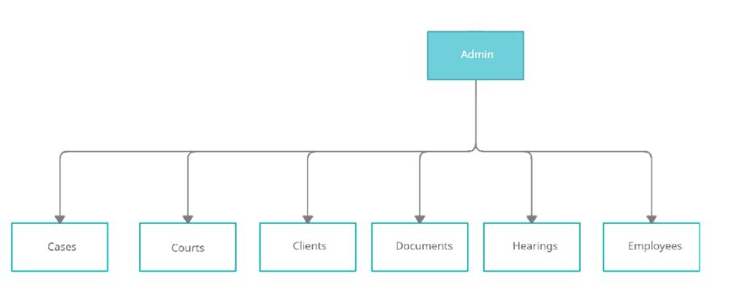

Administrators can access data for 6 different sections:

● Cases

● Courts

● Clients

● Documents

● Hearings

● Employees

They can view the data as a table and may add, remove and edit any of the data.

4.Employee Page:

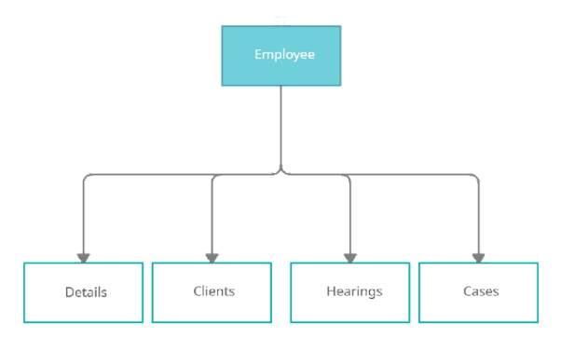

Employees can access data for 4 different sections:

● Details

● Clients

● Hearings

● Cases

Employees can only access their own details and details related to cases and clients they are

handling.5. Client Pages:-

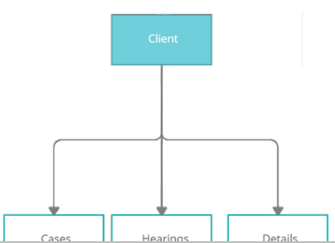

Clients can access data for 3 different sections:

● Cases

● Hearings

● Details

Clients can only view their own personal details along with data related to cases which are being represented by the firm.