DAY 09 — TASK: HOW WEB APPLICATIONS WORK
BreachForge Labs — Web Penetration Testing Internship
EXERCISE 01 — WEBSITE OR WEB APPLICATION?
Example 1
Name: Google
Type: Web Application
Reason: Google allows users to enter searches and interact with dynamically generated search results.
Example 2
Name: YouTube
Type: Web Application
Reason: YouTube allows users to search, watch videos, interact with content, and manage their accounts.
Example 3
Name: Amazon
Type: Both
Reason: Amazon contains informational/static pages as well as interactive features such as searching for products, adding items to a cart, and managing orders.
EXERCISE 02 — FOLLOW THE REQUEST JOURNEY
Website: Google
Simple request journey:
Browser → DNS → Web Server → Backend/Application → Database → Backend/Application → Web Server → Browser
Explanation:
When I enter a website address in my browser, the browser needs to locate the server associated with the domain. The request is then handled by the web server and application backend. If information is required from a database, the backend communicates with the database. The server then sends a response back to the browser, which displays the webpage to the user.
EXERCISE 03 — EXPLORE A URL
URL:
https://www.google.com/search?q=cybersecurity
Protocol: HTTPS
Domain: www.google.com
Path: /search
Query Parameter: q=cybersecurity
Observation:
The URL uses HTTPS for communication. The domain identifies Google, the /search path indicates the search resource, and the q=cybersecurity query parameter contains the search term submitted through the URL.
EXERCISE 04 — BROWSER DEVELOPER TOOLS EXPLORATION
Website Observed: Google
Browser: Google Chrome
- ELEMENTS / INSPECTOR
Observation:
The Elements tab displays the HTML structure of the webpage. I observed elements such as links, headings, buttons, div elements, and other HTML elements. Selecting an element highlights the corresponding part of the webpage.
Screenshot:
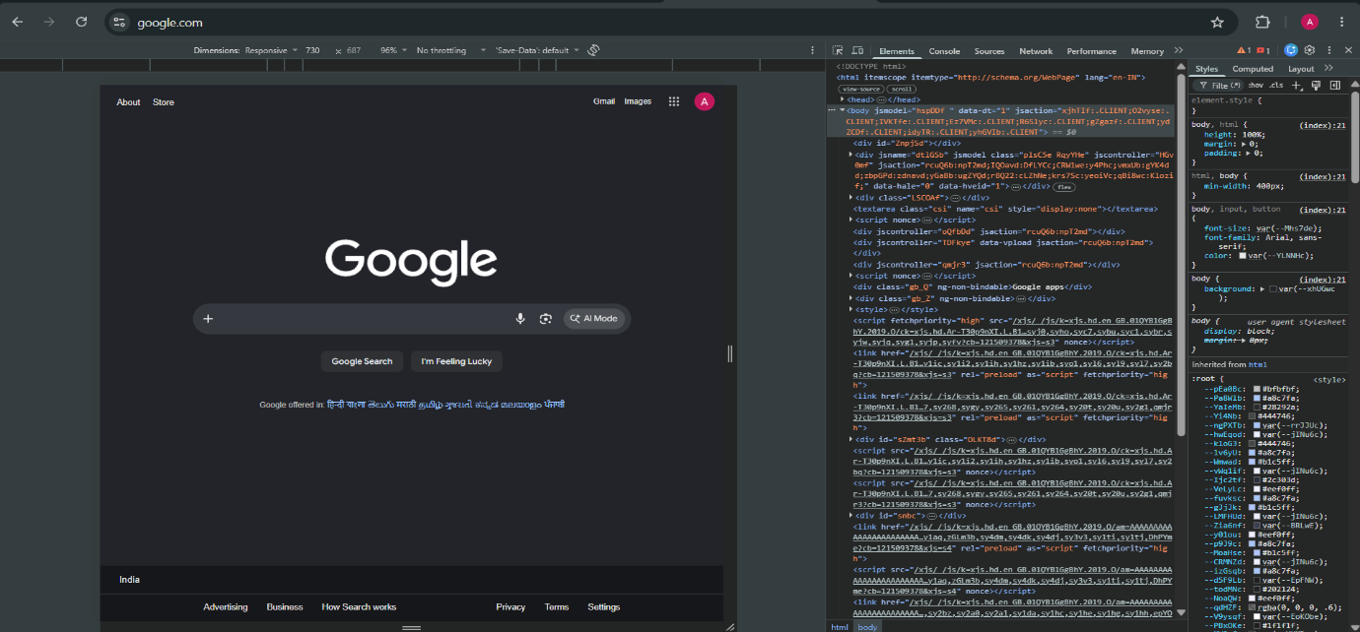
- NETWORK TAB
Observation:
The Network tab displays requests made by the browser while loading the webpage. I observed different resources such as HTML documents, JavaScript files, CSS files, images, and other resources. The requests also display information such as status and resource type.
Screenshot:
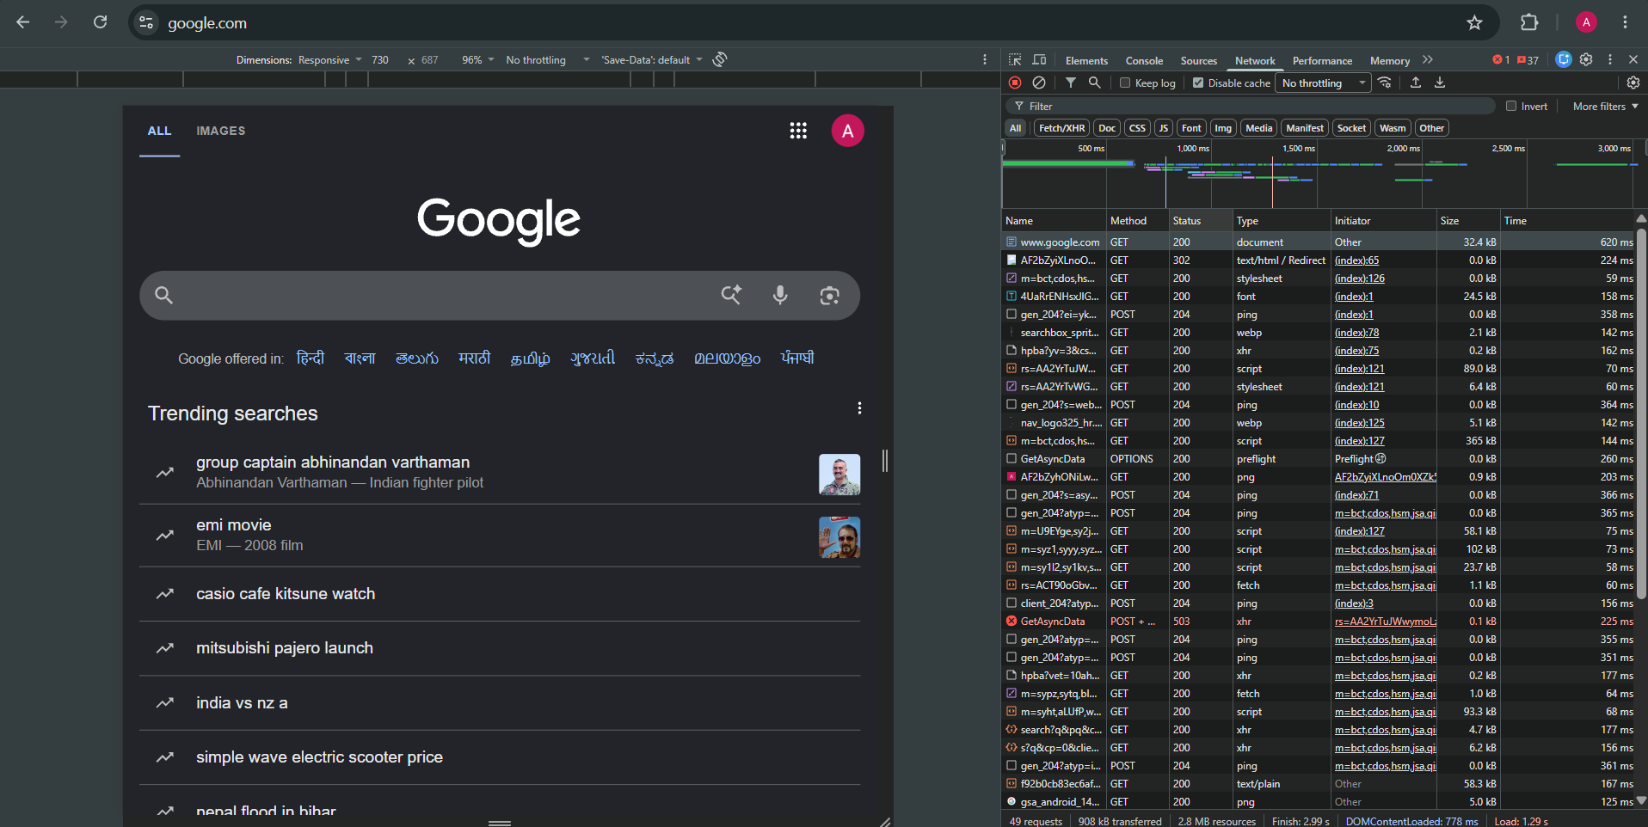

- APPLICATION / STORAGE
Observation:
The Application tab displays information about storage used by the webpage. I observed browser storage areas such as cookies and other storage options. These mechanisms can be used by web applications to store information needed by the application.
Screenshot:
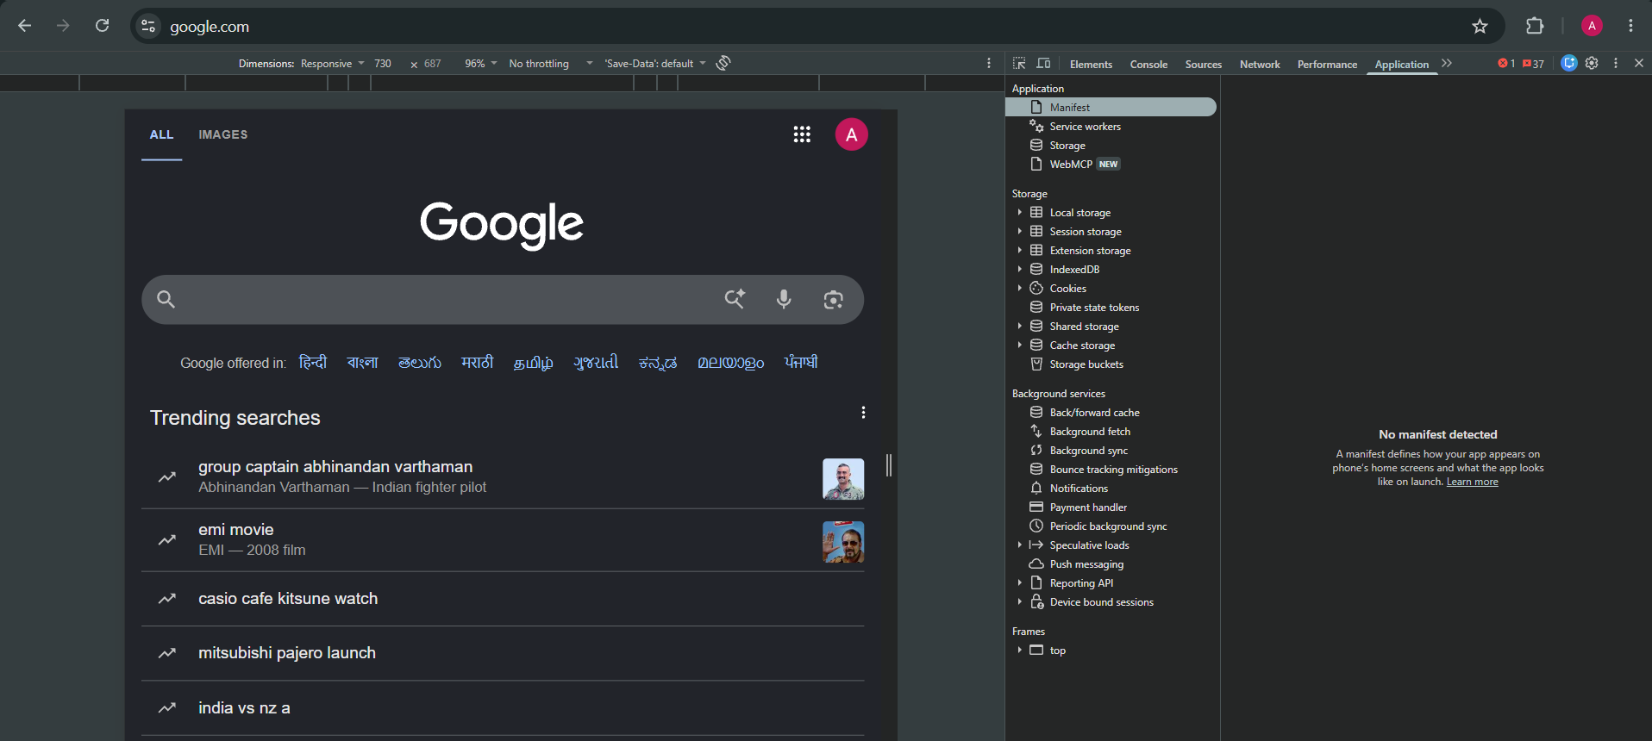
OVERALL OBSERVATION:
Developer Tools helped me understand how a webpage is structured and how the browser loads different resources. The Elements tab showed the webpage structure, the Network tab showed browser requests and resources, and the Application tab showed browser storage information. I performed only normal observation and did not modify or replay any requests.

EXERCISE 05 — FRONTEND DETECTIVE
Website: Google (https://google.com)
- HTML
Where observed:
I opened Developer Tools and selected the Elements tab. I observed HTML elements such as div, form, input, and other webpage elements.
What I understood:
HTML is used to define the structure and content of the webpage.
- CSS
Where observed:
I selected an HTML element in the Elements tab and observed the Styles section on the right side. I could see CSS properties such as font-size, margin, padding, and display.
What I understood:
CSS is used to control the appearance, layout, and styling of webpage elements.

- JavaScript
Where observed:
I opened the Sources tab in Developer Tools and observed JavaScript files with the .js extension.
What I understood:
JavaScript is used to provide functionality and interactive behavior to the webpage.
Overall Observation:
I learned that HTML provides the structure of a webpage, CSS controls its appearance, and JavaScript provides functionality and interaction.
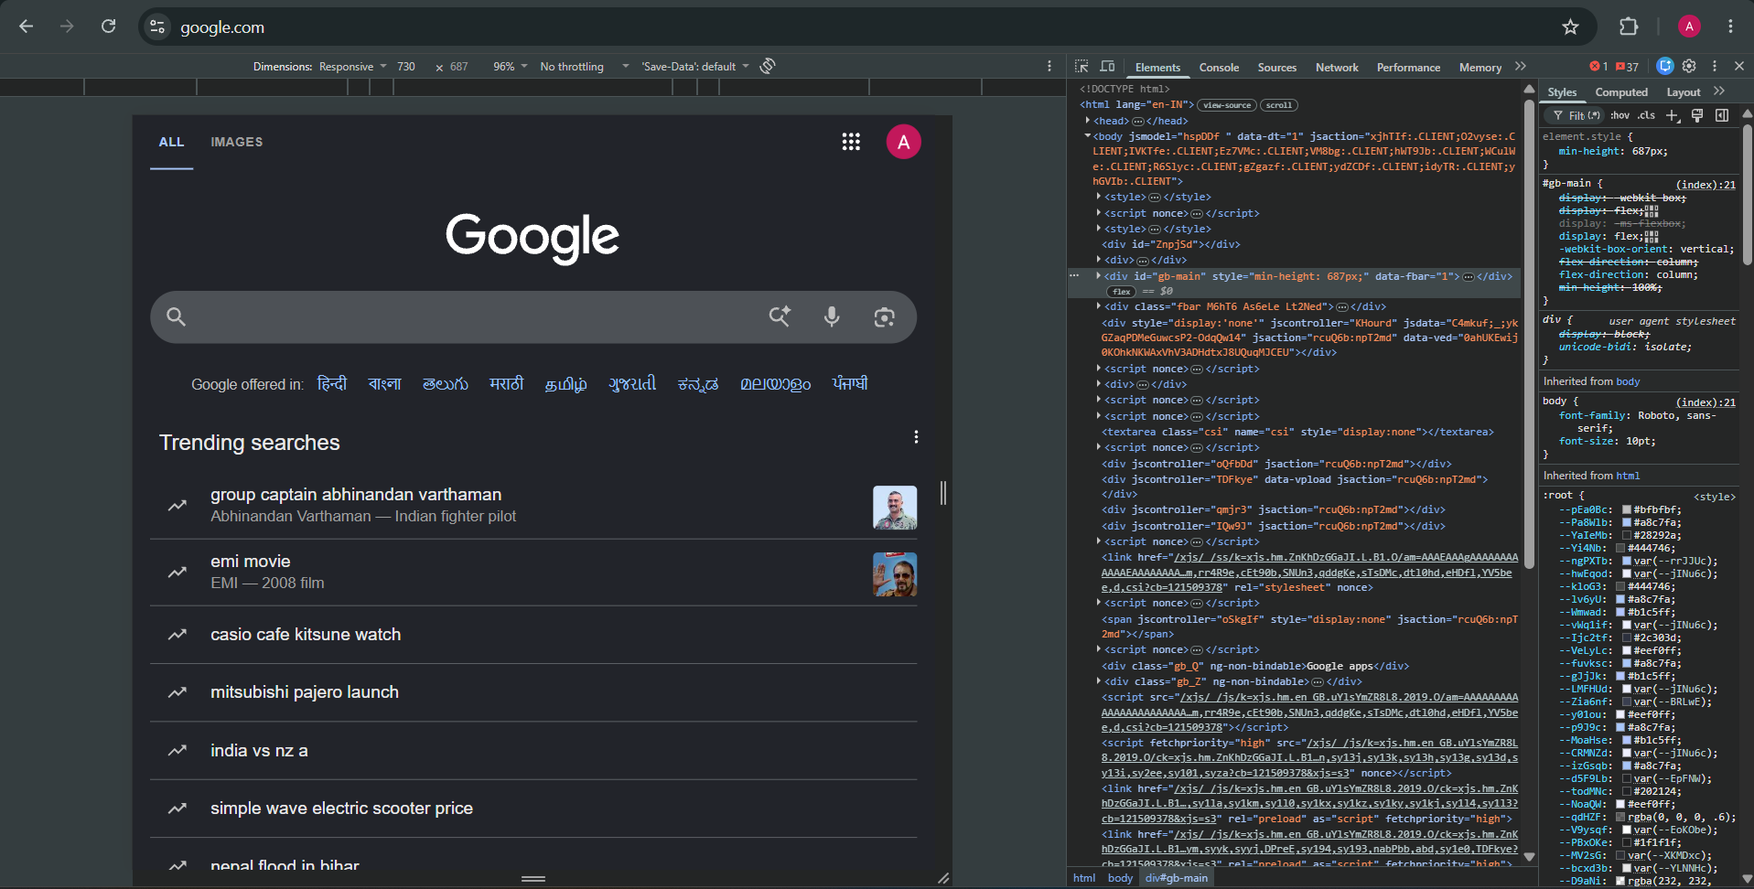
EXERCISE 06 — OBSERVE A NETWORK REQUEST
Website: https://google.com
Request Name/Resource: https://www.google.com/
Request Method: GET
Status Code: 200
Type of Resource: document
Observation:
I opened Google in Chrome and used Developer Tools to observe the Network tab. After reloading the webpage, I selected one request and recorded its basic information. I observed that the browser used a GET request and received a successful response. I did not modify or replay the request.
EXERCISE 07 — STATIC OR DYNAMIC?
Website: Google
URL: https://google.com
- Static Content
Example: Google logo
Reason:
The Google logo is relatively static because its basic appearance generally remains the same when the webpage is loaded.
- Dynamic Content
Example: Google search results
Reason:
Search results are dynamic because they are generated based on the user's search query and can change when a different search is performed.
Observation:
I observed that a webpage can contain both static and dynamic content. Static content generally remains consistent, while dynamic content can change based on user actions or application data.
EXERCISE 08 — LOGIN FLOW THINKING
User enters credentials
↓
Browser sends login request
↓
Server / Backend validates the credentials
↓
Application returns a response
Explanation:
When a user logs in, the browser sends the entered credentials to the application's backend through a login request. The backend checks the credentials and determines whether authentication is successful. If the login succeeds, the application can provide session information, often through a session cookie.
Cookies or session information help the application remember that the user has already authenticated, so the user does not need to enter their credentials on every page.
EXERCISE 09 — DOMAIN AND SUBDOMAIN HUNT
Main domain: google.com
Subdomain: mail.google.com
Possible purpose:
The subdomain mail.google.com is used for Google's email service and provides a separate web application under the main domain.
EXERCISE 10 — API THINKING
Example: Online Shopping Application
Situation:
A user searches for a product such as a laptop.
Information requested:
The frontend needs product information such as product names, prices, images, and availability.
Backend provides:
The backend API can provide the requested product information to the frontend.
Why communication is needed:
The frontend needs to communicate with the backend because the backend may retrieve information from the database and return the appropriate results to the user.
Simple flow:
User → Frontend → API → Backend → Database → Backend → API → Frontend
EXERCISE 11 — WEB APPLICATION ARCHITECTURE
Architecture:
User
↓
Browser / Frontend
↓
Web Server
↓
Backend
↓
Database
Component Roles:
User:
The person interacting with the web application.
Browser / Frontend:
The browser displays the frontend and allows the user to interact with the application.
Web Server:
The web server receives HTTP/HTTPS requests and serves the appropriate web resources.
Backend:
The backend handles application logic, processes requests, and communicates with other components such as the database.
Database:
The database stores application information such as user accounts, products, orders, or other records.
EXERCISE 12 — SECURITY THINKING
- Where can user input enter a web application?
User input can enter through login forms, registration forms, search boxes, contact forms, URL parameters, file uploads, API requests, and other interactive features.
- Why should a backend validate user input?
The backend should validate user input because data received from users cannot automatically be trusted. Validation helps ensure that the application receives data in the expected format and reduces security and application risks.
- Why should databases be protected?
Databases can contain important information such as user accounts, application data, and other records. Protecting the database helps prevent unauthorized access, modification, or loss of information.
- Why is HTTPS important for web applications?
HTTPS encrypts communication between the browser and server. This helps protect information while it is being transmitted over the network.
Exercise 13 — Spot the Component
Item | Classification | Result
HTML page | Frontend | Provides the structure displayed to the user
Python application logic | Backend | Handles server-side application logic
MySQL database | Database | Stores application data
Nginx web server | Server | Receives and serves web requests
Google Chrome | Browser | Client software used to access web applications

EXERCISE 14 — DAY 09 SUMMARY
A web application works through communication between a Browser and a Server. The browser acts as a Client and displays the Frontend to the user. When the user performs an action, the browser sends a Request to the server. The Backend processes the request and may communicate with a Database or an API to obtain the required information. The server then sends a Response back to the browser. Cookies or Sessions can also help an application remember information about an authenticated user. I learned that the frontend, backend, database, server, and browser work together to provide the functionality of a web application.

