BREACHFORGE LABS
WEB PENETRATION TESTING INTERNSHIP

DAY 05 — LINUX BASICS

PART 1 — GET COMFORTABLE WITH THE TERMINAL
Command: pwd
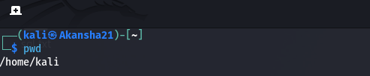
Purpose:
The pwd command displays the path of my current working directory.

Command: ls
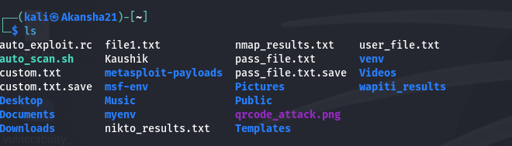
Purpose:
The ls command lists the files and directories in the current directory.

Command: clear
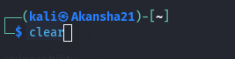
Purpose:
The clear command clears the previous output from the terminal screen.

PART 2 — CREATE A PRACTICE DIRECTORY
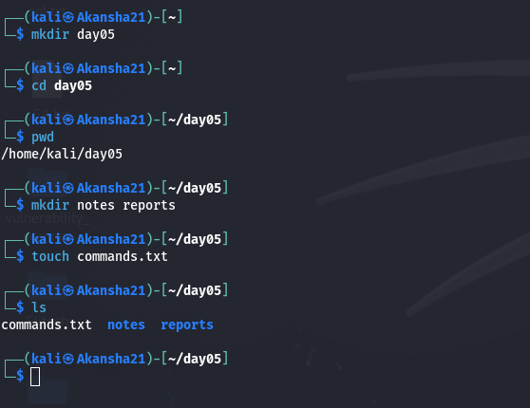
Commands Used:
mkdir day05
cd day05
mkdir notes reports
touch commands.txt
ls

Directory structure created:
day05/
├── commands.txt
├── notes/
└── reports/

Observation:
I created the day05 directory and then created the notes and reports
directories along with the commands.txt file.

PART 3 — WORK WITH A FILE
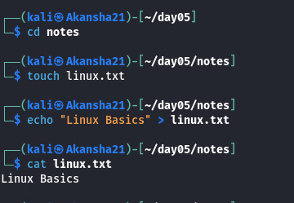
Commands Used:
cd notes
touch linux.txt
echo "Linux Basics" > linux.txt
cat linux.txt

Output:
Linux Basics
Command used to view the file contents:
cat linux.txt

Observation:
I created linux.txt inside the notes directory and added the text
"Linux Basics" to the file. I used the cat command to display its contents.

PART 4 — COPY AND MOVE
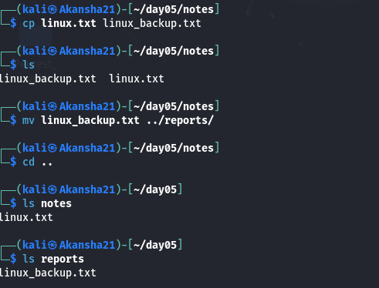
Commands Used:
cp linux.txt linux_backup.txt
mv linux_backup.txt ../reports/

Verification:
ls notes
ls reports

Result:
notes/
└── linux.txt
reports/
└── linux_backup.txt

Observation:
I created a copy of linux.txt and then moved the backup file into
the reports directory.

PART 5 — BASIC PERMISSIONS
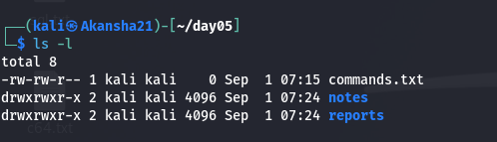
Command Used:
ls -l

Permissions:
r = Read
w = Write
x = Execute

Observation:
The ls -l command displays detailed information about files and
directories, including their permissions.

PART 6 —NOTES
What is Linux?
Linux is an open-source operating system used on computers, servers,
and many other devices. It is also commonly used in cybersecurity
and software development.

What is the terminal?
The terminal is a text-based interface used to interact with the
operating system by entering commands.

What does pwd do?
The pwd command displays the path of the current working directory.

What does ls do?
The ls command lists the files and directories in the current directory.

What does cd do?
The cd command is used to change the current directory.

What is the difference between a file and a directory?
A file stores information or data, while a directory is used to
organize and contain files and other directories.

What do r, w, and x mean?
r means Read, w means Write, and x means Execute. These permissions
define what actions can be performed on files and directories.

