BREACHFORGE LABS
WEB PENETRATION TESTING INTERNSHIP
DAY 07 — LINUX PERMISSIONS AND USER MANAGEMENT

EXERCISE 01 — CREATE A PRACTICE WORKSPACE
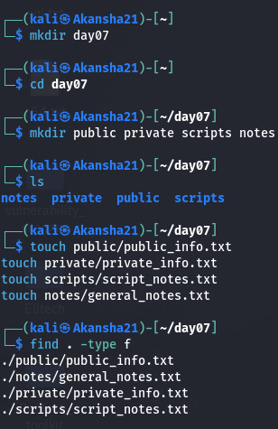
Commands Used:
mkdir day07
cd day07
mkdir public private scripts notes
touch public/public_info.txt
touch private/private_info.txt
touch scripts/script_notes.txt
touch notes/general_notes.txt
find . -type f

Observation:
I created a Day 07 workspace with separate directories for public files, private files, scripts, and notes. I also created at least one text file inside each directory and verified the structure.

EXERCISE 02 — CHECK USER INFORMATION
Commands Used:
whoami
id

Username: kali
Observation:
The whoami command displays the current username. The id command
shows information such as the user's UID, GID, and group memberships.

UID represents the user identification number, while GID represents
the group identification number.

EXERCISE 03 — UNDERSTAND FILE OWNERSHIP
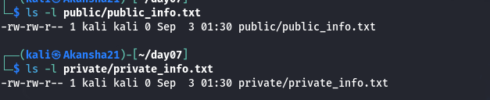
Commands Used:
ls -l public/public_info.txt
ls -l private/private_info.txt

Observation:
The ls -l command displays the permission string, file owner,group, file size, and other file information.
Each file has an owner and an associated group. The permission string shows the access rights for the owner, group, and other users.

EXERCISE 04 — PRACTICE WITH chmod
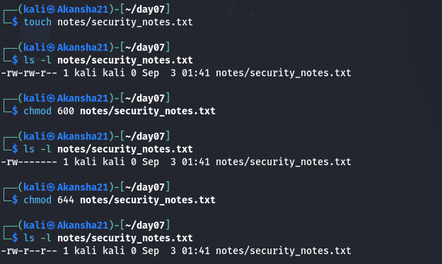
Commands Used:
touch notes/security_notes.txt
ls -l notes/security_notes.txt
chmod 600 notes/security_notes.txt
ls -l notes/security_notes.txt
chmod 644 notes/security_notes.txt
ls -l notes/security_notes.txt

Observation:
Permission 600 gives the owner read and write access while the group and other users have no permissions.
Permission 644 gives the owner read and write access, while the group and other users have read-only access.
Therefore, 600 is more restrictive than 644.

EXERCISE 05 — EXECUTE PERMISSION
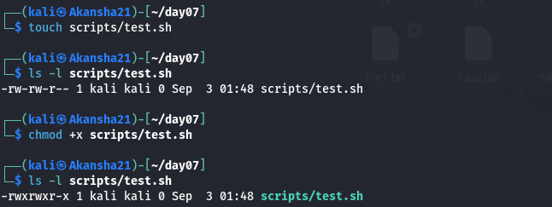
Commands Used:
touch scripts/test.sh
ls -l scripts/test.sh
chmod +x scripts/test.sh
ls -l scripts/test.sh

Observation:
After using chmod +x, execute permission was added to the file.
The permission string changed to include the x permission.

EXERCISE 06 — PERMISSION COMPARISON
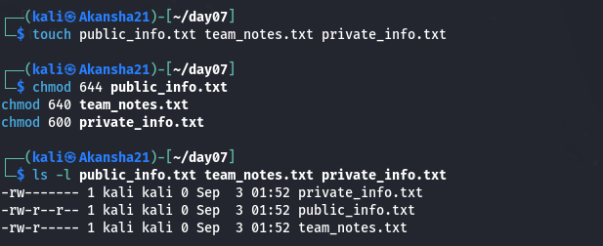
Commands Used:
touch public_info.txt team_notes.txt private_info.txt
chmod 644 public_info.txt
chmod 640 team_notes.txt
chmod 600 private_info.txt

ls -l public_info.txt team_notes.txt private_info.txt

Permission Comparison:
644:
Owner = Read + Write
Group = Read
Others = Read

640:
Owner = Read + Write
Group = Read
Others = No access

600:
Owner = Read + Write
Group = No access
Others = No access

Most Restricted File:
private_info.txt

Reason:
private_info.txt has 600 permissions, so only the owner can read
or modify the file. The group and other users have no access.

EXERCISE 07 — SYMBOLIC PERMISSIONS
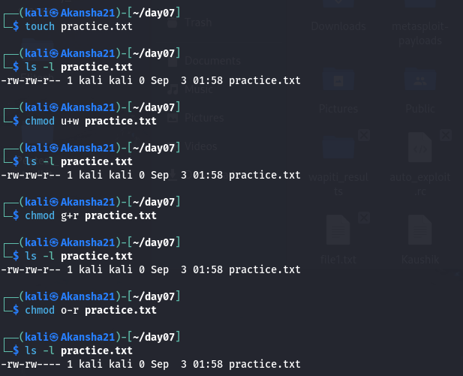
Commands Used:
touch practice.txt
chmod u+w practice.txt
ls -l practice.txt

chmod g+r practice.txt
ls -l practice.txt

chmod o-r practice.txt
ls -l practice.txt

Symbol Meanings:
u = User/Owner
g = Group
o = Others
r = Read
w = Write
x = Execute

Observation:
Symbolic permissions allow specific permissions to be added or
removed for the owner, group, or other users.

EXERCISE 08 — LEAST PRIVILEGE SCENARIO
File: Public information
Suggested permission: 644
Reason:
The owner can modify the file, while other users can read it without being able to modify it.

File: Internal team document
Suggested permission: 640
Reason:
The owner can read and modify the file, group members can read it, and other users have no access.

File: Private configuration file
Suggested permission: 600
Reason:
Only the owner can read and modify the file, which helps protect sensitive configuration information.

FINAL OBSERVATION:
This task helped me understand Linux users, groups, file ownership,and permissions. I learned how numeric permissions such as 600,640, and 644 control access to files. I also learned how symbolic
permissions can be used with u, g, and o.

The principle of least privilege means that users should receive only the permissions they need to perform their required tasks.
This reduces unnecessary access and helps protect files and data.

