BREACHFORGE LABS
WEB PENETRATION TESTING INTERNSHIP

DAY 04 — NETWORKING BASICS

PART 1 — IDENTIFY YOUR LOCAL IP
Command Used:
ipconfig

IPv4 Address: 192.168.31.47
Default Gateway: 192.168.31.1

PART 2 — DNS LOOKUP
Command Used:
nslookup demo.owasp-juice.shop

Domain Tested:
demo.owasp-juice.shop

IP Address Returned:
81.169.145.156

IPv6 Address Returned:
2a01:238:20a:202:1156::
Observation:
The DNS lookup resolved the domain name into an IP address. This shows how a domain name can be mapped to a server's network address.

PART 3 — PING
Command Used:
ping demo.owasp-juice.shop

Result:
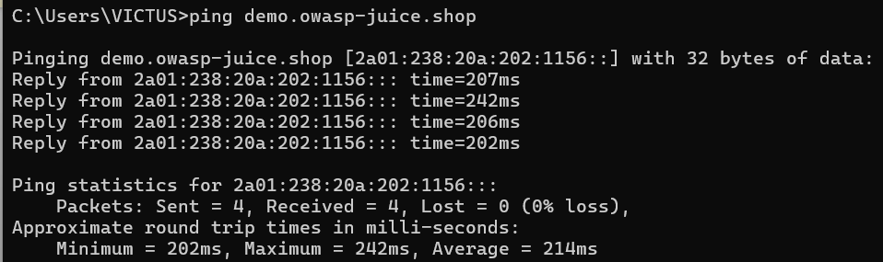
Observation:
The ping command helps determine whether a host is reachable and also provides information about the response time.
PART 4 — COMMON PORTS
Port 21 - FTP
Port 22 - SSH
Port 53 - DNS
Port 80 - HTTP
Port 443 - HTTPS

PART 5 — MY OWN NOTES
Basic networking knowledge is important for a web penetration tester
because web applications communicate through networks. Understanding
IP addresses, DNS, ports, HTTP, and HTTPS helps a tester understand
how applications communicate with servers and interpret basic network
information during security testing.

