DAY 08 — PROCESSES, SERVICES AND PORTS
BreachForge Labs — Web Penetration Testing Internship
PART A — LINUX PRACTICAL

EXERCISE 01 — CHECK RUNNING PROCESSES
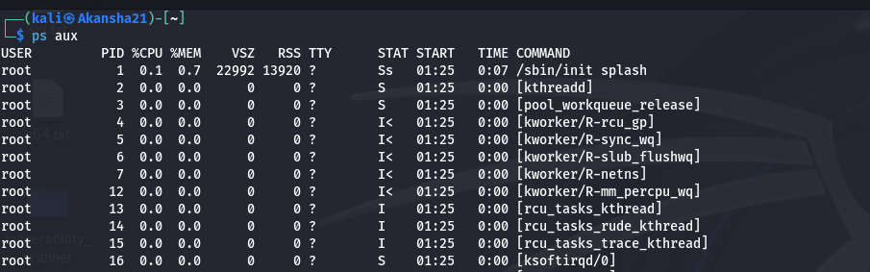
Command used:
ps aux
Three processes observed:
- Process Name: init
PID: 1
User: root
- Process Name: kthreadd
PID: 2
User: root
- Process Name: pool_workqueue_release
PID: 3
User: root
Observation:
The ps aux command displays currently running processes along with information such as the user, PID, CPU usage, memory usage, and command.
EXERCISE 02 — FIND A PROCESS

Command used:
ps aux | grep init
Observation:
The command searches the output of ps aux for entries containing the specified process name. This makes it easier to locate a particular process.

EXERCISE 03 — OBSERVE SYSTEM ACTIVITY
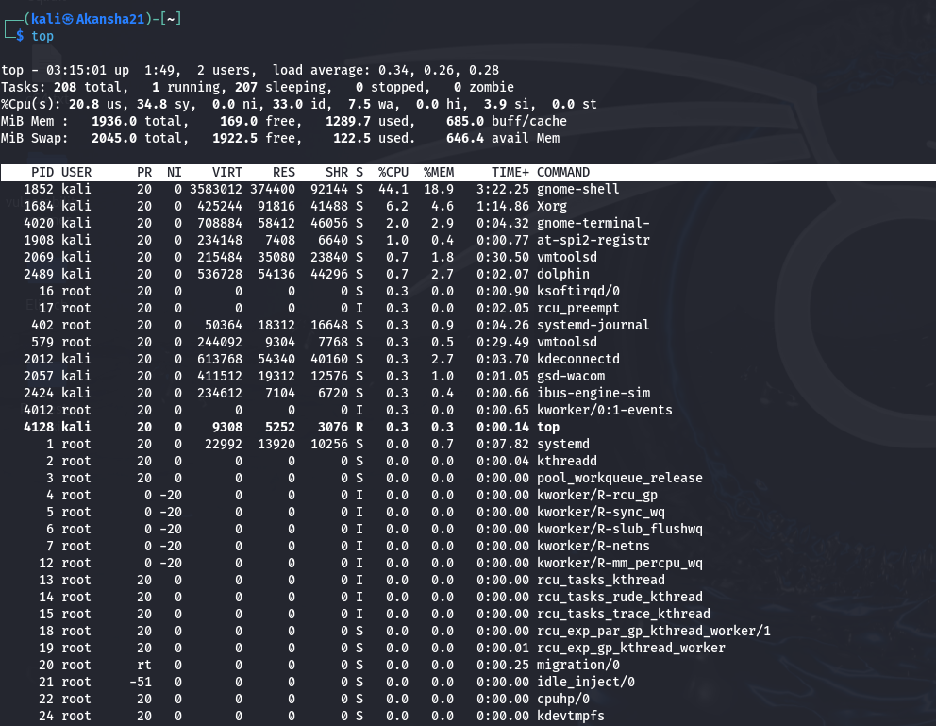
Command used:
top
Observation:
I used the top command to observe running processes and system activity in real time. I observed CPU usage, memory usage, process IDs, and changes in resource usage while applications were running.
EXERCISE 04 — CHECK LISTENING PORTS
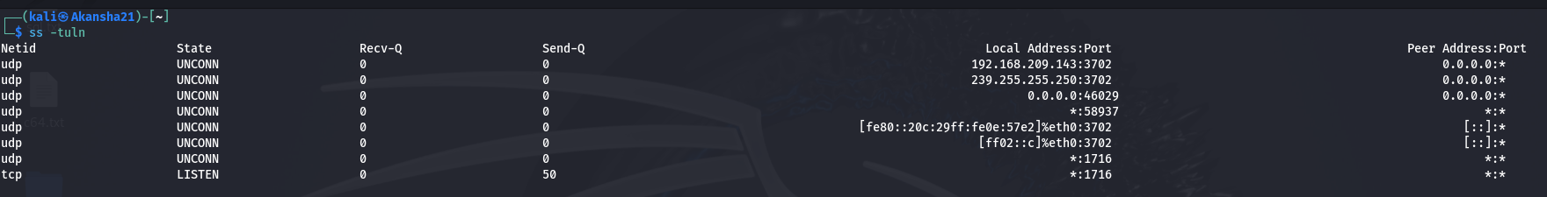
Command used:
ss -tuln
Ports observed:
- Protocol: UDP
Local Address: 192.168.209.143
Port: 3702
- Protocol: TCP
Local Address: *
Port: 1716
Observation:
The ss -tuln command displays listening TCP and UDP sockets without resolving service names. It helped me identify local addresses and listening port numbers.
EXERCISE 05 — CHECK RUNNING SERVICES
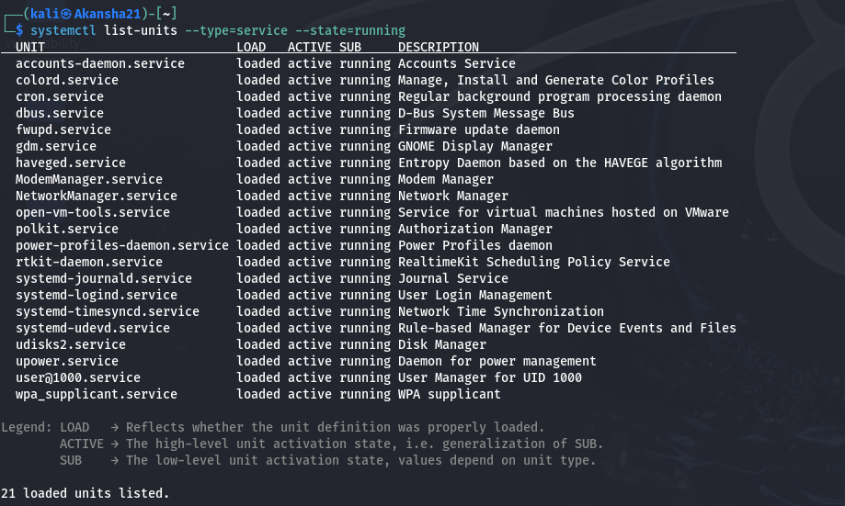
Command used:
systemctl list-units --type=service --state=running
Service 1:
Name: cron.service
Status: running
General Purpose: The cron service is used to run scheduled tasks and background jobs automatically at specified times or intervals.
Service 2:
Name: NetworkManager.service
Status: running
General Purpose: The NetworkManager service manages network connections on the Linux system, including wired, wireless, and other network interfaces.
Observation:
The command displays services that are currently running on the Linux system.
EXERCISE 06 — COMMON PORTS
Port 22 | SSH
Port 53 | DNS
Port 80 | HTTP
Port 443 | HTTPS
PART B — WINDOWS PRACTICAL
EXERCISE 07 — TASK MANAGER OBSERVATION
Tool used:
Windows Task Manager
Three processes observed:
- Process Name: Whatsapp
CPU Usage: 1%
Memory Usage:700 MB
- Process Name: Google Chrome
CPU Usage: 0.1%
Memory Usage: 450 MB
- Process Name: LinkedIn
CPU Usage: 0.1%
Memory Usage:590 MB
Observation:
I used Task Manager to observe applications and background processes. I also observed CPU and memory usage of running processes.
EXERCISE 08 — VIEW WINDOWS PROCESSES
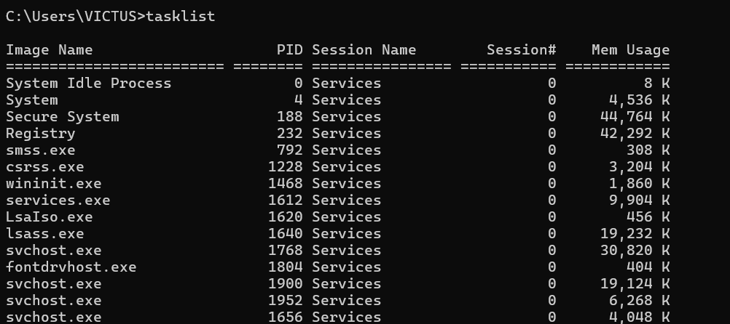
Command used:
tasklist
Three processes observed:
- Image Name: System Idle Process
PID: 0
Memory Usage: 8 K
- Image Name: csrss.exe
PID: 1228
Memory Usage: 3204 K
- Image Name: lsass.exe
PID: 1640
Memory Usage: 19232 K
Observation:
The tasklist command displays currently running processes and information such as image name, PID, and memory usage.
EXERCISE 09 — FIND A WINDOWS PROCESS
Command used:
tasklist | findstr csrss.exe
Observation:
The command searches the tasklist output for the specified process name. It helps identify a particular process and its PID and memory usage.
EXERCISE 10 — WINDOWS SERVICES
Tool used:
services.msc
Service 1:
Service Name: DHCP Client
Status: Running
Startup Type: Automatic
Service 2:
Service Name: Plug and Play
Status: Running
Startup Type: Manual
Observation:
The Services application allows me to view Windows services, their current status, and their startup type.
EXERCISE 11 — CHECK NETWORK CONNECTIONS
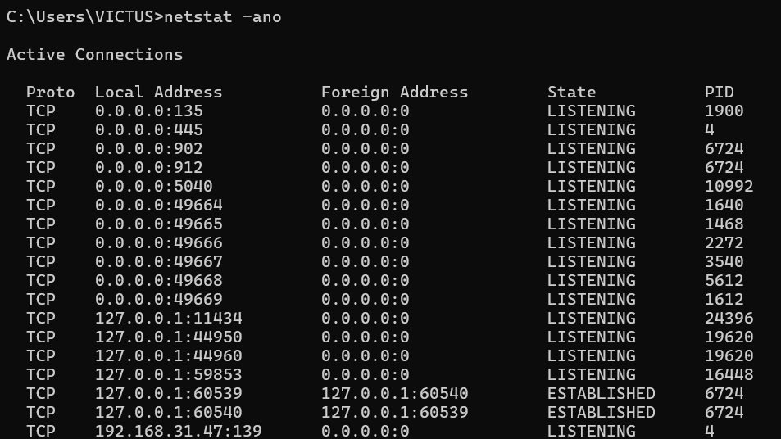
Command used:
netstat -ano
Observation:
Protocol: TCP
Local Address: 0.0.0.0:135
Foreign Address: 0.0.0.0.0
State:Listening
PID: 1900
The netstat -ano command displays network connections and listening ports along with the associated process ID.
EXERCISE 12 — MATCH A PID WITH A PROCESS
Command used:
tasklist | findstr 6724
Result:
vmware-authd.exe 6724 Services 0 3,892 K
Observation:
I used the PID obtained from netstat -ano and searched for it using tasklist. This helped me identify the process associated with the network connection.
PART C — CONCEPT AND SECURITY EXERCISES
EXERCISE 13 — PROCESS VS SERVICE
A process is a program or instance of a program that is currently running on a computer. A process normally has a PID.
A service is a background software component that performs a specific function and is generally managed by the operating system or service manager.
The main difference is that a process represents an executing program or program instance, while a service is a background component designed to provide a particular function.
A service can run through one or more processes depending on its implementation.
EXERCISE 14 — LOCALHOST
Localhost refers to the same computer on which an application or command is running.
127.0.0.1 is the standard IPv4 loopback address and points back to the local computer.
Localhost is useful when testing applications locally because developers and security testers can access and test applications without exposing them to other systems on the network.

EXERCISE 15 — SECURITY OBSERVATION
Unnecessary services can increase security risks because they may create additional entry points into a system. If an unnecessary service is vulnerable or incorrectly configured, it could potentially be abused.
An attack surface is the collection of possible points through which a system can be accessed or attacked, including services, ports, applications, and interfaces.
Exposed services should be reviewed to ensure they are necessary, properly configured, and appropriately secured. Reducing unnecessary exposure can reduce the attack surface.
EXERCISE 16 — COMPARE LINUX AND WINDOWS
Task | Linux Command | Windows Command
View running processes | ps aux | tasklist
View network connections | ss -tuln | netstat -ano
Find a process | ps aux | grep process_name | tasklist | findstr process_name
Check services | systemctl list-units --type=service --state=running | services.msc

EXERCISE 17 — YOUR SYSTEM OBSERVATION
Name: chrome.exe
Operating System: Windows
How I identified it:
PID or Status: tasklist
Why I think it is present:
The chrome.exe process is present because Google Chrome is running on my Windows system. I identified the process using the tasklist command and observed its PID.
Observation:
I identified the process or service on my own authorized system and observed its basic information without modifying or terminating it.
EXERCISE 18 — PORT AND SERVICE THINKING
A web application provides functionality to users and runs through one or more processes on a server. The process can listen for network communication through a specific port.
For example, HTTP commonly uses port 80 and HTTPS commonly uses port 443. When a client connects to the appropriate IP address and port, the web server or application process receives and handles the request.
Therefore, the relationship can be understood as:
Web Application
↓
Process
↓
Listening Port
↓
Network Request
↓
Client/Browser
FINAL OBSERVATION
In this task, I learned how to observe running processes, identify PIDs, check system activity, view listening ports, and inspect running services on Linux and Windows.
I also learned how network connections can be associated with processes using PIDs. The practical exercises helped me understand the relationship between processes, services, ports, and network communication.
From a security perspective, understanding running services and exposed ports is important because unnecessary or improperly configured services can increase the attack surface of a system.
All observations were performed only on my own authorized systems.

