BREACHFORGE LABS
WEB PENETRATION TESTING INTERNSHIP

DAY 06 — LINUX FILE SYSTEM, SEARCHING AND TEXT PROCESSING

PART 1 — CREATE YOUR WORKSPACE
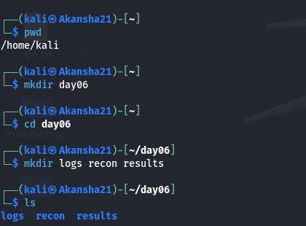
Commands Used:
cd ~
mkdir day06
cd day06
mkdir logs recon results
ls

Structure Created:
day06/
├── logs/
├── recon/
└── results/

Observation:
I created a day06 workspace and organized it into separate logs,
recon, and results directories.

PART 2 — CHECK SYSTEM INFORMATION
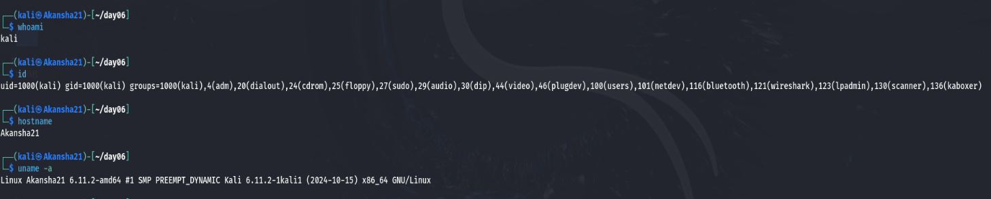
Command: whoami
Output:
kali
Explanation:
The whoami command displays the username of the current user.

Command: id
Output:
uid=1000(kali) gid=1000(kali) groups=1000(kali),4(adm),20(dialout),24(cdron),25(floppy),27(sudo),29(audio),30(dip),44(video),46(plugdev),100(users),101(netdev),116(Bluetooth),121(wireshark),123(lpadmin),130(scanner),136(kaboxer)
Explanation:
The id command displays the user's UID, GID, and group membership
information.

Command: hostname
Output:
Akansha21
Explanation:
The hostname command displays the name of the Linux system.

Command: uname -a
Output:
Linux Akansha21 6.11.2-amd #1 SMP PREEMPT_DYNAMIC Kali 6.11.2-1kali1 (2024-10-15) x86_64 GNU/Linux

Explanation:
The uname -a command displays detailed information about the Linux
kernel and system architecture.

PART 3 — CREATE AND ORGANIZE DATA
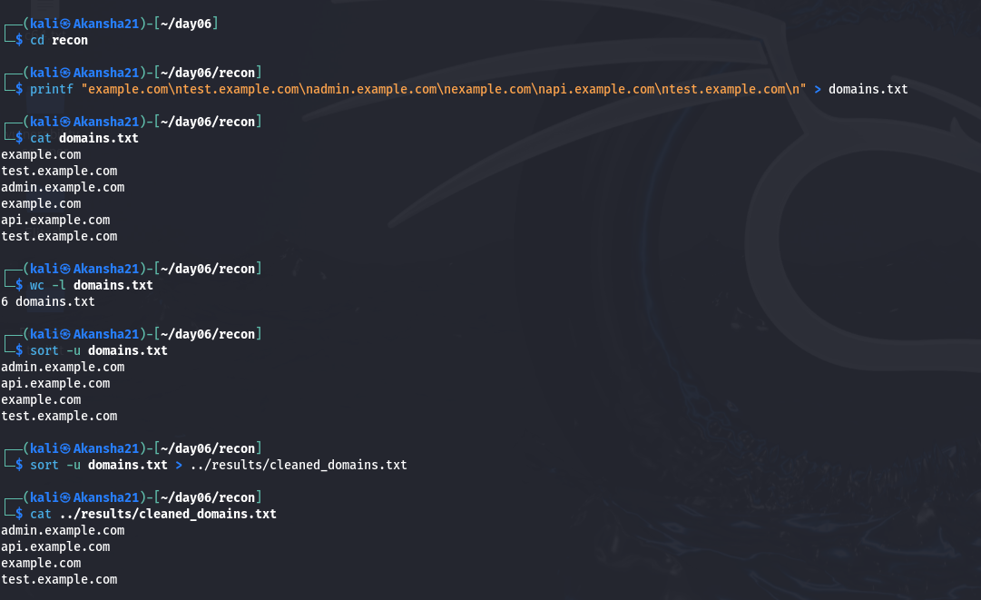
File Created:
recon/domains.txt

Commands Used:
cd recon
cat domains.txt
wc -l domains.txt
sort -u domains.txt
sort -u domains.txt > ../results/cleaned_domains.txt
cat ../results/cleaned_domains.txt

Original Data:
example.com
test.example.com
admin.example.com
example.com
api.example.com
test.example.com

Number of Lines:
6

Cleaned Output:
admin.example.com
api.example.com
example.com
test.example.com

Observation:
The original file contained duplicate domain entries. The sort -u
command sorted the entries alphabetically and removed duplicates.

PART 4 — SEARCH TEXT WITH GREP
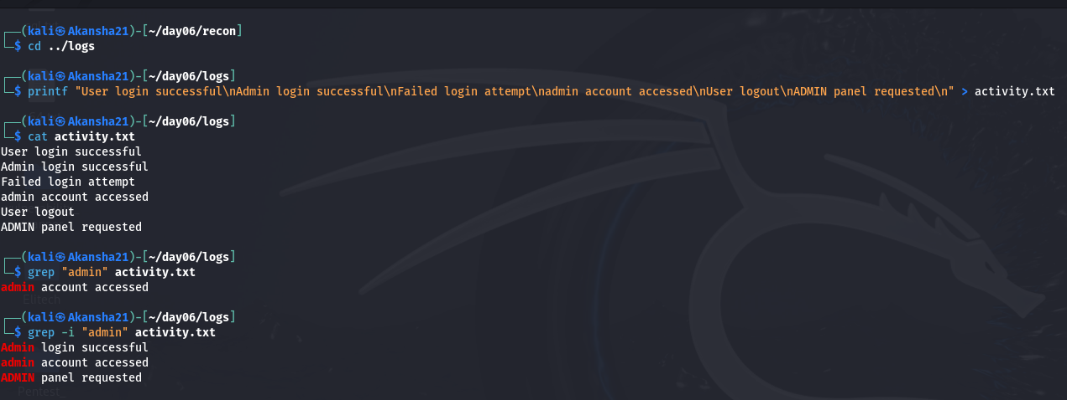
File Created:
logs/activity.txt

Command:
grep "admin" activity.txt

Observation:
The normal grep search found the lowercase "admin" entry.

Command:
grep -i "admin" activity.txt

Observation:
The -i option made the search case-insensitive, so it also found
"Admin" and "ADMIN".

PART 5 — FILE SEARCH CHALLENGE
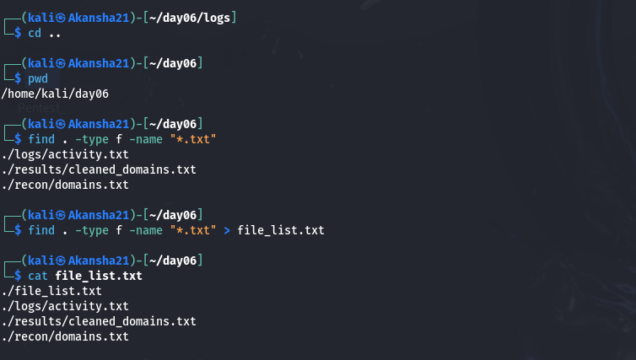
Commands Used:
cd ..
find . -type f -name "*.txt"
find . -type f -name "*.txt" > file_list.txt
cat file_list.txt

Observation:
The find command searched the day06 directory and its subdirectories
for files ending in .txt. I saved the results into file_list.txt.

PART 6 — READ PART OF A FILE
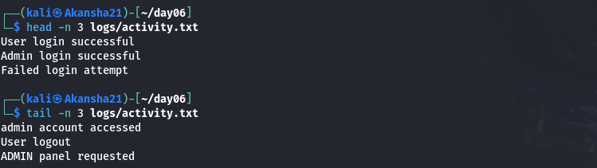
Command for first 3 lines:
head -n 3 logs/activity.txt
Output:
User login successful
Admin login successful
Failed login attempt

Command for last 3 lines:
tail -n 3 logs/activity.txt
Output:
admin account accessed
User logout
ADMIN panel requested

Observation:
The head command displays the beginning of a file, while the tail
command displays the end of a file.

