Error Warning Approval System

**User Guide Version 0.2**

17 Feb 2020

## Description

Error Warning Approval system is a tool which can capture Error and Warning messages from specified log files and bucketize (Group) them. It can detect groups based on either Synopsys Error and Warning Message Codes or User-specified regular expressions. The information about which logs to parse is given to the tool using .catalyzer.ini file which should be present in user’s home directory. A sample .catalyzer.ini file can be found in $TOOL_HOME/config/catalyzer.ini Information about User-defined buckets can also be passed to the tool using bucket_config_files variable in .catalyzer.ini file. The tool is capable of extracting the Errors/Warnings information and present it on the command window or dump the information in an excel file. The generated excel file can also be sent to users via e-mail.

## Setup

Please add following path to your PATH environment variable

**# CSH**

*% setenv PATH ${PATH}:/nfs/sc/disks/adl_media_par_02/amitvinx/releases/ErrorWarningApproval/bin*

**# BASH**

*% export PATH=/nfs/sc/disks/adl_media_par_02/amitvinx/releases/ErrorWarningApproval/bin:$PATH.*

## Catalyzer INI file (.catalyzer.ini)

**TBD**

## Buckets (Buckets .ini files)

The tool has the capability of grouping together similar error and warning messages found in the log files specified through the .catalyzer.ini filepresent in user’s home directory. Buckets are of two types. Synopsys Tools specific buckets and User-specified buckets. The tool specific buckets are identified by the tools specific Error or Warning code e.g. PSYN-001 etc. User can also specify their own buckets with the help of regular expressions. More information on this is available in the coming pages.

Sample bucket configuration file…

**TBD**

## Logfiles search paths (Configuration .ini file)

The tool uses search configuration files to identify which directories to search for the log files. Various include file patterns and exclude file patterns can be specified in these .ini files. You can also exclude hidden folders (Starting with .) Recursive search can be enabled or disabled in the .ini file.

Sample search path configuration file…

**TBD**

## Getting help

*% ErrorWarningApproval.py -h*

**TBD**

## Commands and options

ErrorWarningApproval has a predefined set of commands. The currently supported list of commands can be found in the command-line help. The commands work in association with the options which are specified while executing the command-line. All the information about the command-line arguments can be found in the command-line help printed by passing -h to the command-line.

The tool will execute the command passed to it using -cmd command-line argument. Currently ‘list_buckets’ and ‘report’ command are functional. New commands are being added at the time of writing this document.

### NOP

**TBD**

### List Buckets

List buckets command lists all the error and warning buckets which are found in the specified set of log files.

*% ErrorWarningApproval.py* ***-cmd list_buckets***

.catalyzer.ini file specifies which log files to be parsed for Error and Warnings. One such sample file sample_config.ini is provided in the tool installation directory.

This will list down all the Errors and Warning buckets found in the log files including Tool-specific and User-defined buckets as shown below.

**TBD**

### Report

Report command is used for doing various kinds of reporting related to Error and Warning buckets. The command can be supplied with various other arguments to modify the reports

*% ErrorWarningApproval.py* ***-cmd report***

***TBD***

### Report generation with various levels of reporting verbosity

The amount of information generated by report command can be controlled by the command-line argument --reporting_level or -rl. The levels can be specified as 1, 2, 3, 4, 5. The default level is 1.

1. *% ErrorWarningApproval.py -cmd report* ***-rl 2***

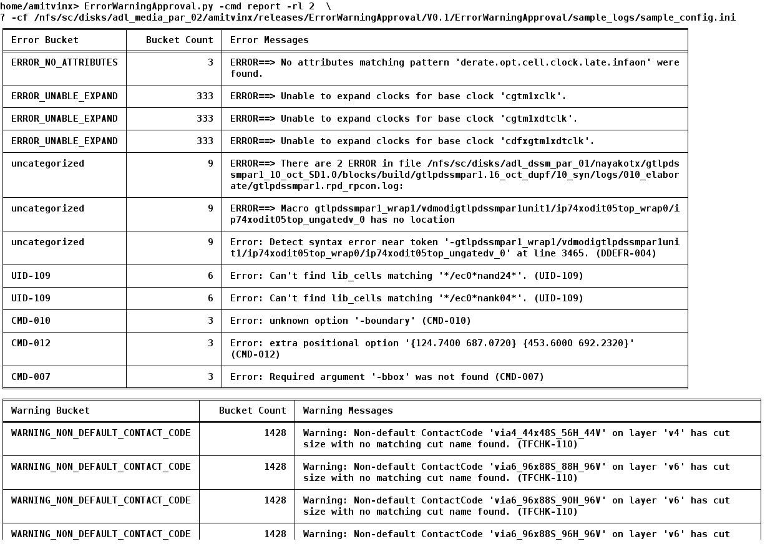

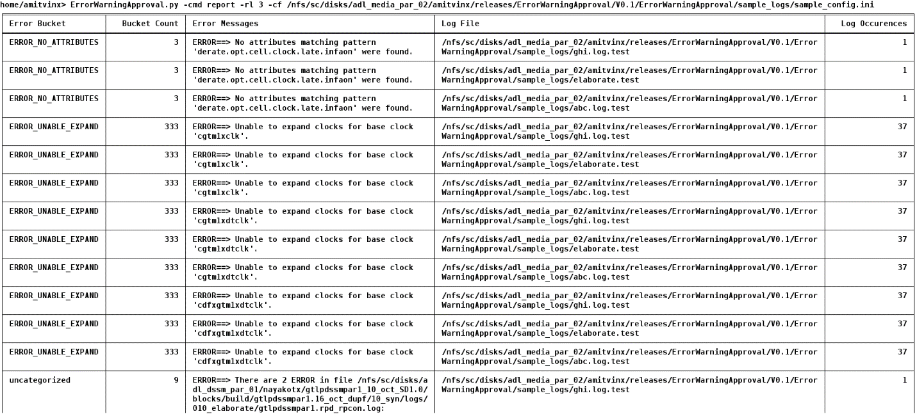

The above screenshot shows report with verbosity level 3. Here, we can also see which log files have the occurrence of the error or warning messages and their count.

### Report generation for specific buckets

The report can be generated for specific bucket e.g. bucket ‘CMD-007’ using command-line flag ‘-b’

*% ErrorWarningApproval.py -cmd report -cf /nfs/sc/disks/adl_media_par_02/amitvinx/releases/ErrorWarningApproval/V0.1/ErrorWarningApproval/sample_logs/sample_config.ini -rl 2* ***-b CMD-007***

***TBD: Explain how multiple buckets can be specified using -b <BUCKET 1> <BUCKET 2> <BUCKETS 3>***

### Report generation for specific bucket regular expression

You can also give regular expression for selecting buckets using the command-line flag ‘-bre’

*% ErrorWarningApproval.py -cmd report -cf /nfs/sc/disks/adl_media_par_02/amitvinx/releases/ErrorWarningApproval/V0.1/ErrorWarningApproval/sample_logs/sample_config.ini -rl* ***2 -bre ‘CMD.*’***

***TBD: Explain the need to use single quotes while using -bre***

### Report generation in XLSX format

The various reports generated can also be dumped in an excel sheet using the command-line argument ‘-xls’. You can provide the name of the output excel file as ‘ -xls xyz.xlsx’. If the name of the output file is not given, the report is dumped in a file called exadmin.xlsx. The generated files have autofilters for all the columns.

TBD: Explain that generated files will also have auto groups

*% ErrorWarningApproval.py -cmd repor -cf /nfs/sc/disks/adl_media_par_02/amitvinx/releases/ErrorWarningApproval/V0.1/ErrorWarningApproval/sample_logs/sample_config.ini* ***-xls***



**TBD: Change the picture. Explain about automatic addition of .xlsx extension if not specified by the user**

### Report generation in XLSX format and sending it by e-mail

The XLS report generated can be sent to one or more recipients via e-mail using the command-line flag ‘--mail ‘ or ‘-m’

*% ErrorWarningApproval.py -cmd repor -cf /nfs/sc/disks/adl_media_par_02/amitvinx/releases/ErrorWarningApproval/V0.1/ErrorWarningApproval/sample_logs/sample_config.ini -xls* ***-m ‘amitx.vinayak.bhalerao@intel.com’***

### SHELL

**TBD**