


Enhanced Software Solutions Pvt. Ltd

PII Data Detection Implementation



Document Information :

Document Name | PII Data Detection Platform
Document Type | .dox | Prepared by | Akash Bhandari
Document Number |  | Preparation Date
Document Version | 1.0 | Reviewed by
Document Version Date |  | Review Date

Version History

Ver. No. | Ver. Date | Revised By | Description
1.0

Contents

Document Objective..............................................................4
Prerequisites........................................................................5
Installation steps of PII data detection............................6

Document Objective :

This document provides step-by-step instructions for deploying the PII Data Detection Platform.

The solution enables organizations to identify Personally Identifiable Information (PII) in network traffic without requiring application code modifications. Traffic is intercepted at the network layer, analyzed for PII content, and exported as metrics for monitoring and alerting.

Solution Overview :
Business Objective -

Organizations often need visibility into sensitive information flowing through APIs and services.

This solution:

Detects PII in HTTP requests and responses
Requires no application code changes
Operates at the network layer
Generates metrics for observability
Integrates with Grafana Cloud for visualization and alerting

Components:
Component | Purpose
Envoy Proxy | Captures request and response payloads
Apache Kafka | Event transport layer
Kafka Strimzi Bridge | Kafka HTTP interface
Kafka Detector Forwarder | Consumes Kafka events and forwards them for analysis
PII Detection Envoy | Detects sensitive information
Grafana Alloy | Collects and exports metrics
Grafana | Visualization and alerting

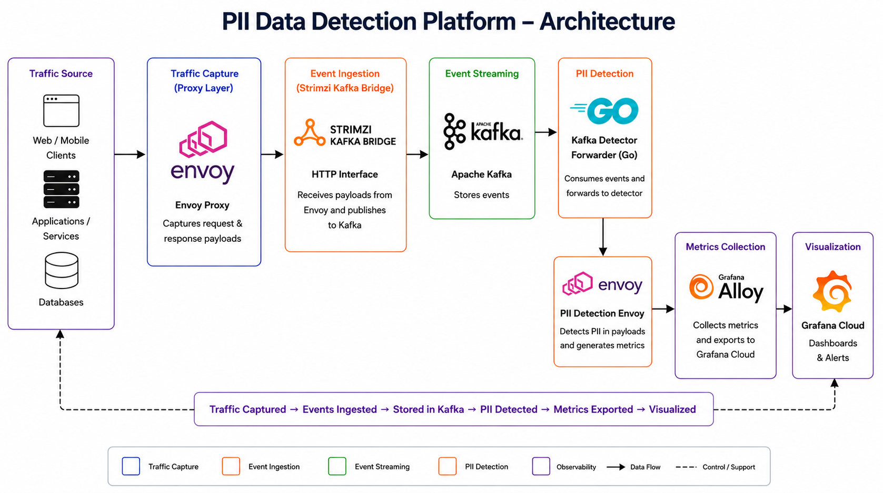

Prerequisites:

- Need access to configuration of any existing API gateway, Proxy or Firewall.
- Downloaded packages for Apache Kafka, Kafka Strimzi Bridge, Envoy, Grafana Alloy & Kafka Detector Forwarder.
- Java 21 installed for Demo App setup.
Installation steps -
Run the yum command, specifying the package you want to install:
sudo yum install java-21-openjdk
Check that the installation works:
java -version
- Maven installed
yum install maven -y
- NodeJS installed
yum install nodejs -y
- GO Runtime installed on the server.
Installion steps - https://go.dev/doc/install

Demo App repository link -
https://github.com/abhandari0510/PII_Data_Detection_Final_Setup.git

Download links -
- Apache Kafka - https://www.apache.org/dyn/closer.cgi?path=/kafka/4.2.0/kafka_2.13-4.2.0.tgz
- Envoy Proxy -
https://github.com/envoyproxy/envoy/releases
- Kafka Strimzi Bridge-
wget https://github.com/strimzi/strimzi-kafka-bridge/releases/download/1.0.0/kafka-bridge-1.0.0.tar.gz
- Grafana Alloy -
https://github.com/grafana/alloy/releases/tag/v1.16.1
- Kafka detector forwarder (Go) -
https://github.com/abhandari0510/kafka_detector_forwarder_go.git
- GO runtime -
wget https://go.dev/dl/go1.26.4.linux-amd64.tar.gz

PII Data Detection Set-up steps

Step 1: Configure the existing Firewall/API Gateway/Proxy in your application to capture and send request/response payloads and to Apache Kafka.
(The demo repository already contains an application routed via Envoy Proxy & this proxy is configured to send request response payloads to Kafka)

Clone the git repository to set up the demo app -
git clone https://github.com/abhandari0510/PII_Data_Detection_Proto.git

cd PII_Data_Detection_Proto
You can run the application using the helper script from the repository root:

./start-all.sh
Step 2: Configure Kafka in a separate directory:
- Create a kafka_files directory in /mnt/
- Move into the directory -
cd /mnt/kafka_files
- Download the Kafka package -
wget https://dlcdn.apache.org/kafka/4.2.0/kafka_2.13-4.2.0.tgz
- Unpack the tar file using -
tar -xvf kafka_2.13-4.2.0.tgz
- Move inside the Kafka directory -
cd kafka_2.13-4.2.0
- Generate a Cluster UUID
KAFKA_CLUSTER_ID="$(bin/kafka-storage.sh random-uuid)"
- Format Log Directories
bin/kafka-storage.sh format --standalone -t $KAFKA_CLUSTER_ID -c config/server.properties
- Start the Kafka Server
bin/kafka-server-start.sh config/server.properties
- Open a new terminal and create a topic to store your events
bin/kafka-topics.sh --create --topic envoy-body-events --bootstrap-server localhost:9092
- Check if topic is created successfully
bin/kafka-topics.sh --describe --topic envoy-body-events --bootstrap-server localhost:9092
The output of above command must look like -
Topic: envoy-body-events TopicId: 4YfoMzfKSn2TzluLwmxuVQ PartitionCount: 1 ReplicationFactor: 1 Configs: min.insync.replicas=1,segment.bytes=1073741824
Topic: envoy-body-events Partition: 0 Leader: 1 Replicas: 1 Isr: 1 Elr: LastKnownElr:

Step 3: Configure Kafka Strimzi Bridge:
- Download the kafka strimzi bridgepackage in /mnt/kafka_files-
wget https://github.com/strimzi/strimzi-kafka-bridge/releases/download/1.0.0/kafka-bridge-1.0.0.tar.gz
- Unpack the tar file using -
tar -xvf kafka-bridge-1.0.0.tar.gz
- Move to the kafka-rest directory and locate the kafka-rest.properties file -
cd kafka-bridge-1.0.0/config
- Edit the application.properties file and edit the following lines -
Change the existing -
http.port=8080
to
http.port=18082
http.management.port=8081
to
http.management.port=8080
- Start the kafka-strimzi-bridge after going back to kafka-bridge-1.0.0 directory-
bin/kafka_bridge_run.sh --config-file config/application.properties
Step 4: Configuring Envoy in-memory detection & envoy proxy -

- Download the Envoy package in demo_app directory in a new terminal and provide the executable permissions to the dowloaded binary -
wget https://github.com/envoyproxy/envoy/releases/download/v1.38.0/envoy-1.38.0-linux-x86_64
chmod 777 envoy-1.38.0-linux-x86_64
The demo app repository already has a envoy-pii-detection.yaml for Envoy in-memory detection and envoy.yaml for Envoy app proxy. Place the downloaded envoy binary file in the demo app root directory. A script ‘start-envoys.sh’ to enable both Envoys used for proxy and detection each. Use the same script to run the envoy.
./start-envoys.sh
Manual command to run envoy of not using the shell script-
./envoy-1.37.2-linux-x86_64 -c ‘config_file_name’.yaml

- Check if logs are being generated stating the pii data count at path - logs/envoy-pii-detection.log.

Step 5: Download and enable Kafka-detector-connector -
Make sure that you have Go installed on your server and the detector Envoy is up before starting the detector.

- The demo app repository already contains kafka-detector-connector source code, hence you can skip step 2.
- Download the source code from-
https://github.com/abhandari0510/kafka_detector_forwarder_go.git

- Start the kafka_detector_forwarder using the shell script in the same repo.
./start-detector-forwarder.sh

Step 6: Install and setup Grafana Alloy -

- Follow the installation steps from -
https://grafana.com/docs/alloy/latest/set-up/install/linux/

- The demo app already contains the required alloy configuration (File name: alloy-pii-metrics.alloy).
- Run Alloy agent by adding the Grafana credentials in the following command in the demo_app repository-
GRAFANA_CLOUD_PROMETHEUS_REMOTE_WRITE_URL="https://prometheus-prod-<region>.grafana.net/api/prom/push" \
GRAFANA_CLOUD_PROMETHEUS_USERNAME="<grafana-cloud-prometheus-user-id>" \
GRAFANA_CLOUD_PROMETHEUS_PASSWORD="<grafana-cloud-api-token>" \
alloy run --server.http.listen-addr=0.0.0.0:12345 alloy-pii-metrics.alloy

For ESSNFR GRAFANA CLOUD use -

GRAFANA_CLOUD_PROMETHEUS_REMOTE_WRITE_URL="https://prometheus-prod-26-prod-ap-south-0.grafana.net/api/prom/push" GRAFANA_CLOUD_PROMETHEUS_USERNAME="784926" GRAFANA_CLOUD_PROMETHEUS_PASSWORD="glc_eyJvIjoiNzk5NjI1IiwibiI6ImFrYXNoX2ZlX2RlbW8tYWthc2hfZmVfZGVtbyIsImsiOiJ2VXRDdjJUN3dDc2g0OTg0dzgxZDI5Zk4iLCJtIjp7InIiOiJ1cyJ9fQ==" alloy run --server.http.listen-addr=0.0.0.0:12345 alloy-pii-metrics.alloy
Now access application on port 8085 and the PII metrics will be generated and can be viewed in Grafana.

