**Bharath Kumar Avusherla**

**Summer Semester 2015 Submitted:  10thJune, 2015**

**1**   **SUMMARY** **1**

**2**   **BACKGROUND** **2**

**3**   **LOGICAL  ARCHITECTURE** **3**

**4**   **DATABASE  DESIGN** **4**

**5**   **REFERENCES** **6**

**1 S UM M ARY**

Any Hierarchical organization follows pyramid structure. Every employee is a superior to his subordinates. Similarly every Hierarchical organization divided into subunits or classes and each unit or class has its own designated employees.

Likewise, when it comes to the benefits that each employee can eligible is decided by the class he/she belongs. So if there are multiple classes in an organization, then the benefits vary from employee to employee and class to class.

The main objective of this project is to develop a database application to automate the services dynamically that each employee avails. It enables employees to know about their benefits, insurance and retirement plans that he can avail whenever an employee shifts from one class to another. Using this application we can provide better access to the employees and it makes the process so simple in a matter when generating pay slips.

.

**2 B AC K GR OUND**

In any organization, it’s inevitable that the employee designation or experience changes from time to time. If an employee has been working in the same organization for more than 5 years then his salary and designation wasn’t the same when he first started in the organization. Similarly the benefits he availed at the start of his career aren’t the same now. It has changed from time to time, so that the benefits under employee services should be provided to the employees without messing the things. This is very difficult manage if we take up the things whenever find out the change in the hierarchy. This should be done dynamically without any manual interruption. Hence I understand the importance this problem and has come up with a database application to provide best services to the employees.

Here, the employee services like provident fund deduction, health insurance, life insurance, retirement, education related plans. The employee should be well aware of all these products and plans; this is obviously the responsibility of an organization. So every organization needs to provide better employee services access to their employees. In this way the organization could be able to carefully watch the employee growth and ensure the security of their employees and give them 100% satisfaction.

**3 L OGI C AL   A RCH I TE CTURE**

This application am going to develop is build based on Oracle Application Express. As we know it is fully supported with all types of Oracle editions. But in this application I would like to choose Oracle 11g as my database. Well when it comes to the web pages design part, it is very user friendly to create pages with the Oracle Application Express. Even we can develop complex web pages with this tool that can be used in all kinds of web browsers. Here I would like to use Oracle Application Express 2.1 version in order to develop this application.

**4 D AT AB AS E   D ESI G N**

Below is the startup model for the Employee Benefits database data model. As of now I have identified 6 main tables and below shown is the data model for these tables. This was done using Oracle 11g and sql developer. By the end of the application no more than 12 tables necessary to do this. In addition to this am going to use triggers, procedures and functions to provide better access.

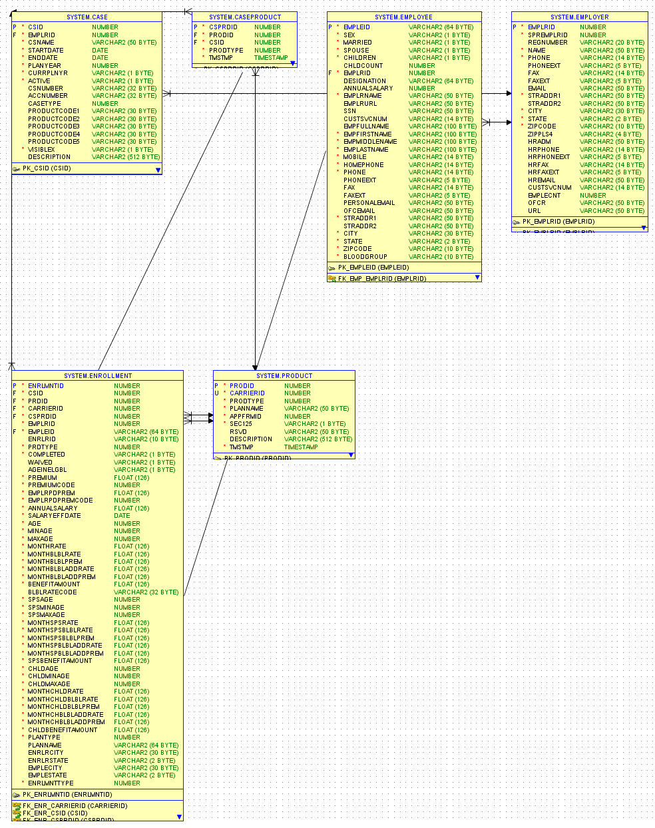

**5 REFERENCES**

Oracle Application Express Wikipedia:

<http://en.wikipedia.org/wiki/Oracle_Application_Express>

Oracle Application Express Documentation, Software and other information:

<http://www.oracle.com/technetwork/developer-tools/apex/overview/index-155186.html>