**1 Q Ans:**

Topological ordering defined as ordering of nodes so that all the edge points should be in forward direction i.e. if there is an edge (Vi, Vj) then “i” should be less than “j” i<j.

So one approach to solve this kind of problem is, find out the possible orderings. Here in this case we will get 6.5.4.3.2.1 = 720 combinations. Then we should be able to check the topological ordering for each combination, which usually eats huge amount of time.

As the above approach takes huge amount of time, we think about other possibilities. One other option is, as from the definition, the topological ordering starts with the edge that doesn’t have any edge coming into it and ends with the node which doesn’t have any edge leaving it. So in our case, the topological ordering starts with the node “a” and ends with the node “f”. In between these nodes, we have other 4 nodes (b, c, d, e) and these 4 nodes shouldn’t arranged randomly. There are two constraints with respect to these 4 nodes: the edge (b, c) enforces the requirement that b must come before c; similarly in case of edge (d, e) d must come before e and the nodes b, c, d, e can be placed anywhere but the above two constraints should be satisfied as a whole.

And the possible topological orderings are:

a ,b ,c ,d ,e ,f

a ,d ,e ,b ,c ,f

a ,d ,b ,e ,c ,f

a ,b ,d ,c ,e ,f

a ,d ,b ,c ,e ,f

a ,b ,d ,e ,c ,f

**2 Q Ans:**

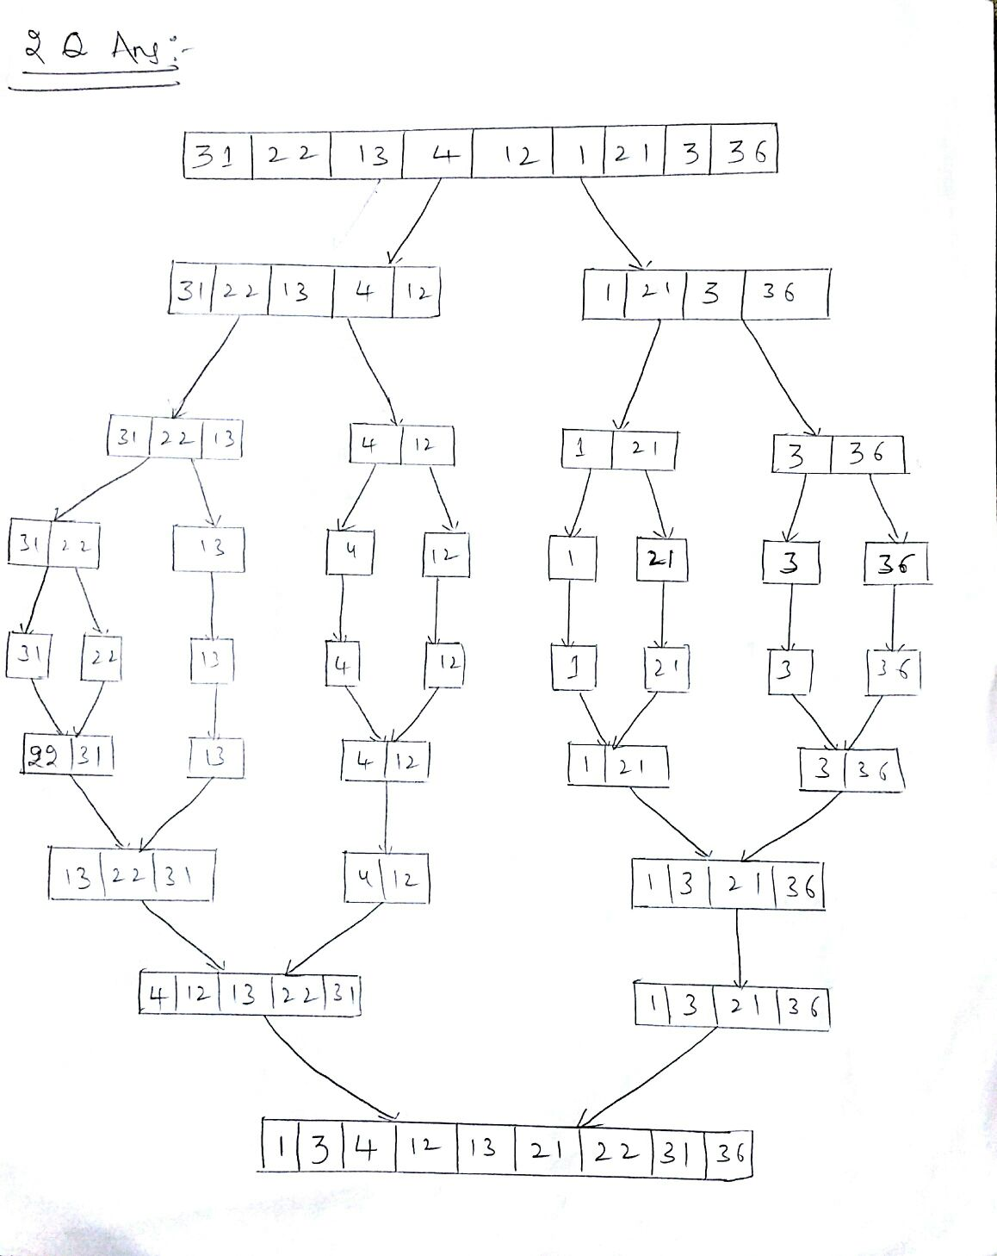

**3 Q Ans:**

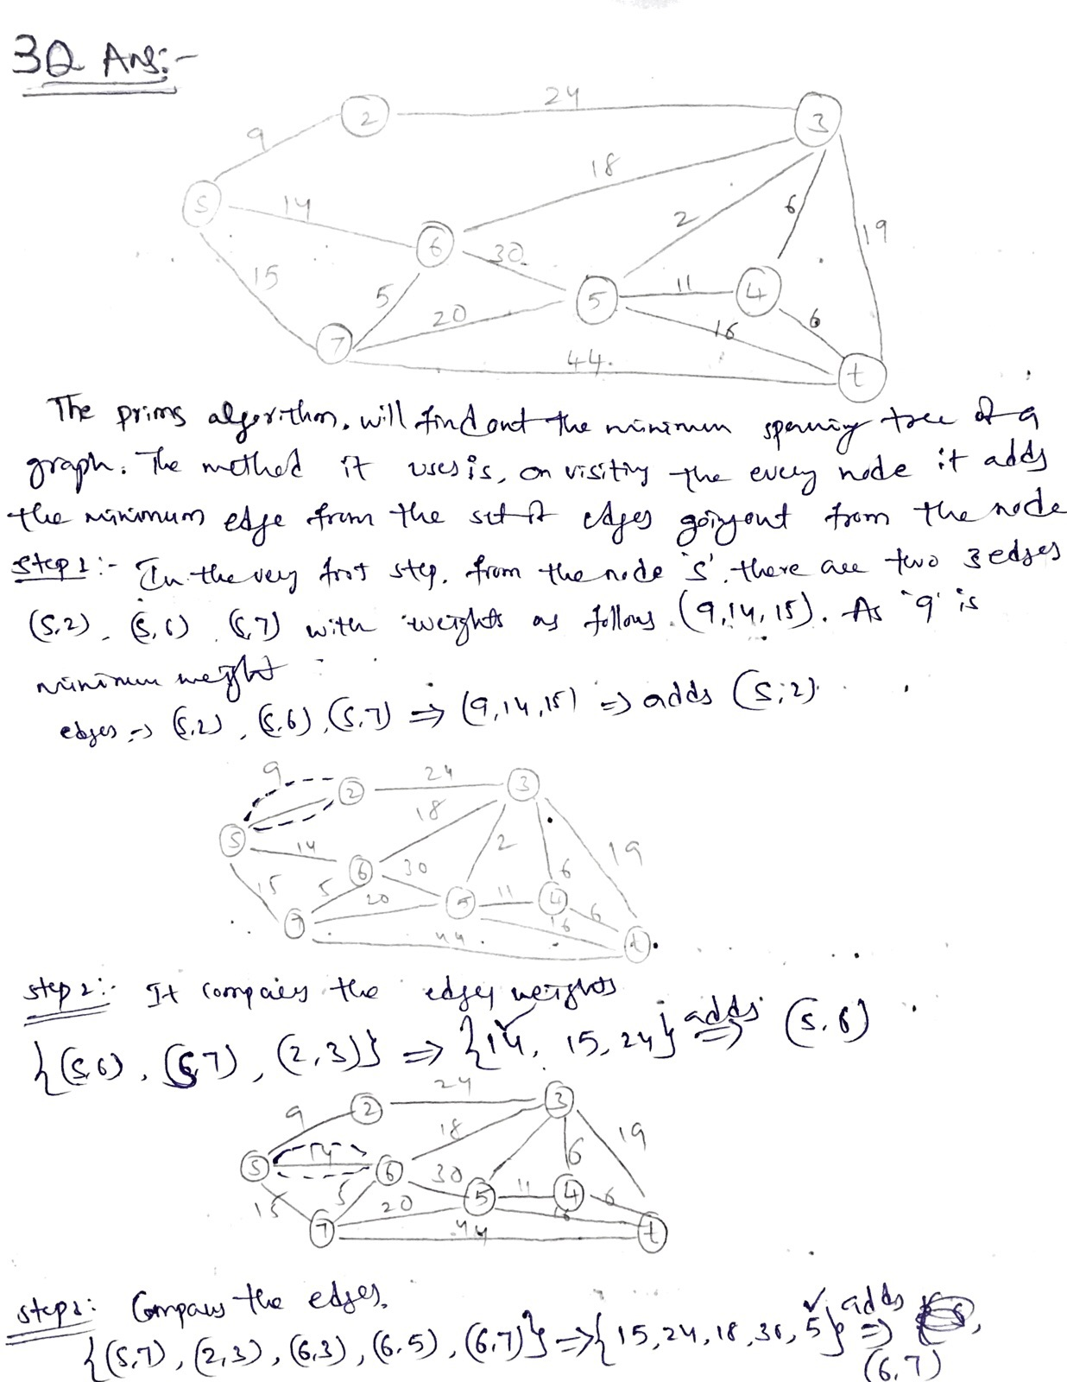

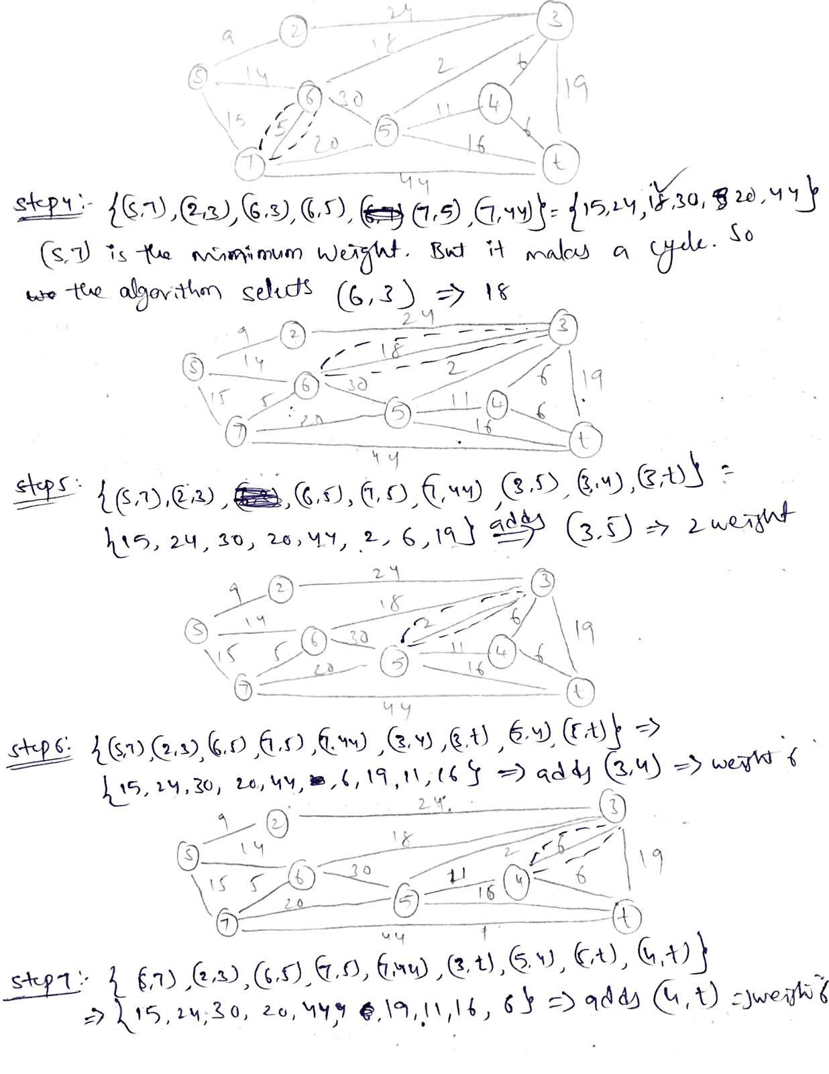

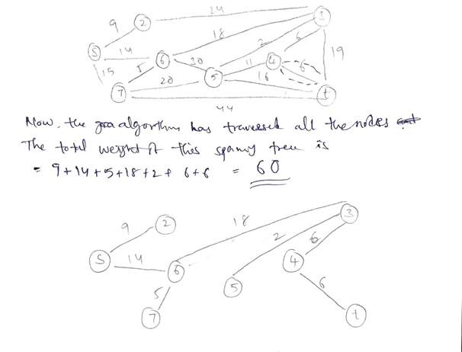

**4 Q Ans:**

