**1 Q Ans:**

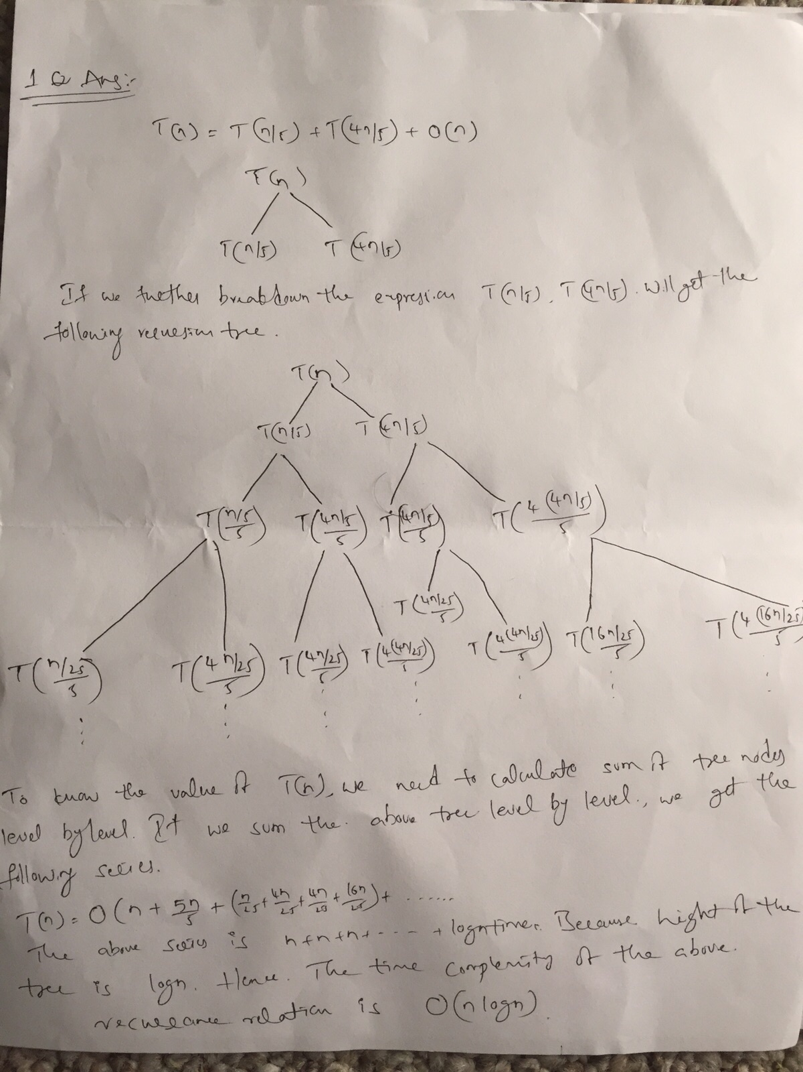

**2 Q Ans:**

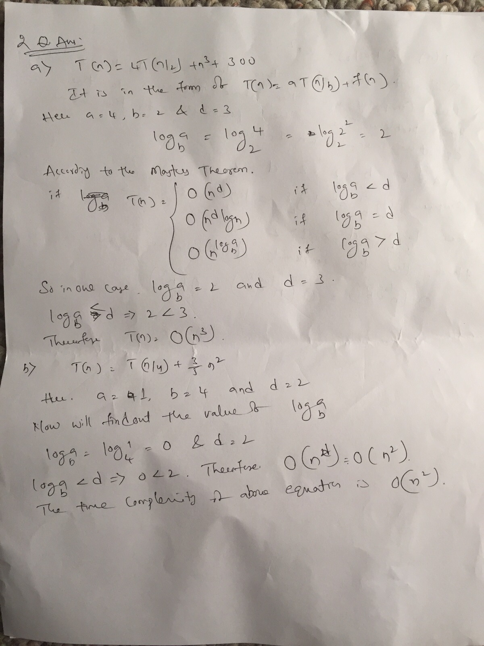

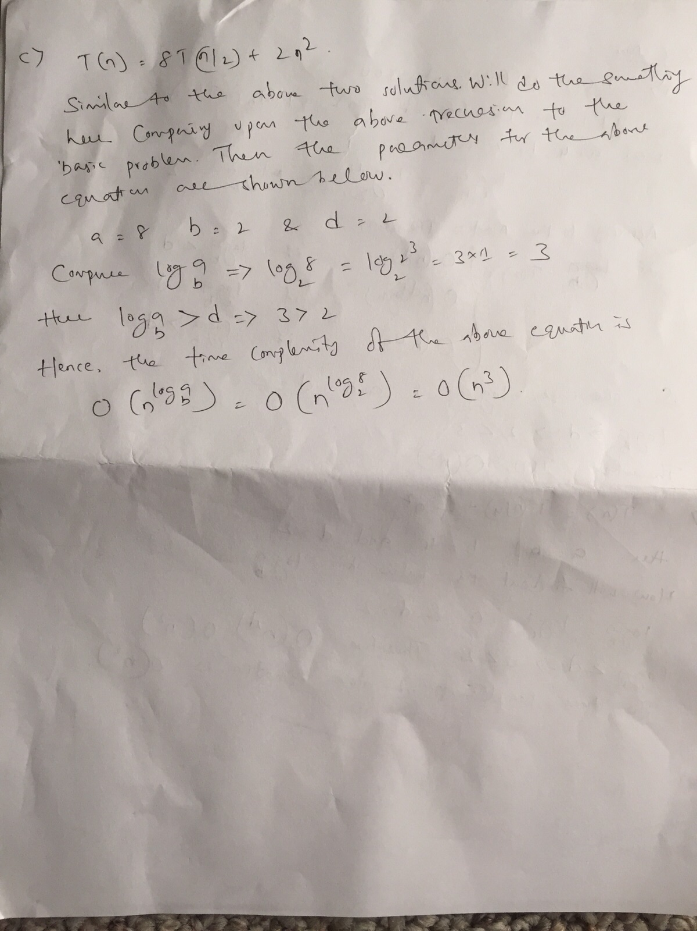

**3 Q Ans:**

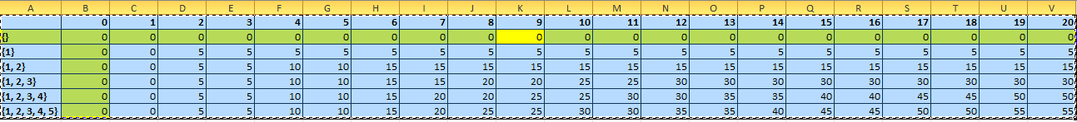

Optimum value = 55

Include {5, value 55-25=30

Include {30, 30} don’t add 4

Compare {30, 25} include {5, 3 value 30-15 =15

Compare {30, 15} include {5, 3,2 value 15-10=5

Compare {5, 0} include {5, 3, 2, 1}

Final items {5, 3, 2, 1}

**4 Q Ans:**

