* 1. **Answer:**

Data Mining on a whole is considered as the process which is designed to explore data from huge amounts called the Big data and extracting the knowledge out of it.

1. No it is not. When compared to todays internet which is accessible widely across the world , we see a lot of generation of data which happens In very less time. So it mainly depends on the way we extract and how much of it is usable , it is not easy . Finally one should separate it using some entities in the information technology field .
2. No, it is not simple. Transformation or application of methods which are developed from databases. It mainly involves on the integration phase.
3. Major things that one gets to know when Data mining is dealt is Machine learning, Artificial Intelligence, Statistics are some. Machine learning is the phase in which it deals with AI and Statistics where it informs the system of how to analyse the data, which usually involves a lot of mining and analysis.

* Data cleaning :-Emits the data which is basically noisy and which really inconsistent.
* Data integration:- Integration of multiple data sources.
* Data selection:- Useful data selected from the data store for analysis.
* Data transformation :- Forms of data seen after application of the business logics.
* Data mining:- Main part after the transformation which is the extraction of appropriate data from it.
* Pattern evaluation:- By using all the above methods which is interesting and intriguing for measures.
* Knowledge presentation :- Best way of representation of the mined knowledge.

**1.5 Answer:**

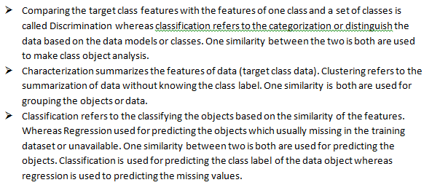

**1.8 Answer:**

* Knowledge types:- Data Mining where the extraction of data is of many types, the methodologies are different. Some of them are the Classification, Clustering, Discrimination and Analysis. All these types work on similar types of databases so only the technique which are based will show the difference.

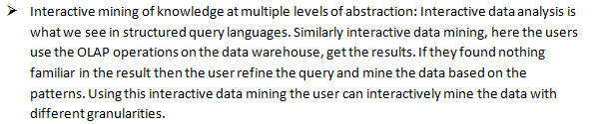

* Background Knowledge: Understanding of the system based on the datasets and divided clusters. This really helps the users to fasten the process of mining and give a whole idea of the data. Domain is one such challenge in this