Graph-Based Intelligent Movie Recommendation System Using RAG
Project Report

CMPE 258: Deep Learning - Spring 2026
Prof. Kaikai Liu, Department of Software Engineering, San Jose State University

Team ID: Group 19
Project Track: System / Application
Focused Areas: Knowledge Graphs, Retrieval-Augmented Generation (RAG), Recommender Systems, Semantic Search, FAISS, Large Language Models, Evaluation-First AI Systems

Team Members:
Name | SJSU ID | Email
Bharath Kumar A | 018221268 | bharathkumar.a@sjsu.edu
Saripella Sriyavarma | 019130553 | sriyavarma.saripella@sjsu.edu
Venkata Siva Sai Krishna Prasad Yedupati | 018320835 | venkatasivasaikrishnaprasad.yedupati@sjsu.edu

Code repository: https://github.com/abharathkumarr/Graph-Based-Intelligent-Movie-Recommendation-System-Using-RAG

Abstract
Traditional movie recommendation systems based on collaborative or content-based filtering struggle with cold-start, popularity bias, and a lack of interpretability. We present a Graph-Based Intelligent Movie Recommendation System that combines a Neo4j knowledge graph with a Retrieval-Augmented Generation (RAG) pipeline. We extract 229,894 subject-predicate-object triplets from the Neo4j 'recommendations' dataset, render them as natural-language sentences, embed them with SentenceTransformers (all-MiniLM-L6-v2), and index them in FAISS for sub-second semantic retrieval. A LangChain RetrievalQA chain feeds the top-k retrieved triplets to a Groq-hosted LLM, which produces fact-grounded answers with citations. We deliver an evaluation-first study on 51 natural-language queries across three Groq LLMs, with 15 Cypher-derived ground-truth queries, and report Precision@10, Recall@10, F1@10, latency, and rate-limit / context-window failure modes. The evaluation drives an explicit production choice (llama-3.1-8b-instant: F1@10 = 0.32 at 3.0s mean latency) and exposes real-world deployment trade-offs that pure offline accuracy comparisons hide.

1. Introduction and Problem Description
Movie recommendation is a high-impact application of machine learning, but classical solutions are dominated by collaborative filtering and content-based approaches that have well-known weaknesses: popularity bias, cold-start for new users or items, and a lack of explainability. As streaming catalogs grow into the hundreds of thousands of titles, users increasingly issue natural-language queries ("a recent adventure film with Leonardo DiCaprio that is rated above 7") that simple matrix-factorization models cannot answer.
Our project addresses this with a hybrid Knowledge-Graph + Retrieval-Augmented Generation (KG-RAG) architecture. We model the movie domain as a Neo4j graph, convert its facts into a corpus of natural-language triplets, index them with FAISS for sub-second semantic retrieval, and let a large language model produce grounded answers from the retrieved facts. The target users are viewers asking conversational queries and researchers/engineers who need an explainable, fact-anchored alternative to opaque embedding-only retrievers.
Concrete contributions of this work:
- A reproducible Neo4j -> 229,894-triplet -> FAISS -> RAG pipeline that answers natural-language movie queries with fact-grounded citations.
- A Streamlit-based interactive UI exposing the retrieved triplets, answer latency, lexical grounding score, and a per-query pipeline trace - all of which support evaluation-first transparency.
- An extended evaluation study on 51 natural-language queries across 3 Groq LLMs, with 15 Cypher-derived ground-truth labels. The study turns API rate-limit, context-window, and payload constraints into first-class evaluation findings rather than incidental bugs.
- An evaluation-driven model-selection rationale (production pick = llama-3.1-8b-instant) rather than a defaulting-to-the-largest-model heuristic.

2. Background and Related Work
Lewis et al. [1] introduced Retrieval-Augmented Generation (RAG), which couples a dense passage retriever with a generative LLM so that responses are conditioned on retrieved evidence. Hogan et al. [2] surveyed knowledge graphs as a structured way to represent inter-entity relationships, motivating their use as a retrieval substrate. KG-Retriever [3] proposed efficient knowledge indexing for RAG over knowledge graphs, demonstrating gains from structured retrieval. Nair and Cheriyan [4] applied particle filtering over multi-featured movie knowledge graphs to refine recommendations, showing that graph traversal can capture user preferences that flat collaborative filtering misses. Xu et al. [5] showed that KG-grounded RAG meaningfully improves factuality and answer specificity in customer-service question answering.
Our system synthesizes these threads: we follow [1] for the RAG pattern, [2] for graph-structured knowledge representation, and [3, 5] for the importance of indexing graph facts for retrieval. Our key engineering choice is to linearize graph edges into natural-language sentences before embedding, which lets us reuse off-the-shelf sentence encoders and a flat FAISS index while still keeping the structural facts intact for the LLM to consume.

3. Dataset
We use the public Neo4j 'recommendations' dataset hosted at bolt://demo.neo4jlabs.com:7687. It contains 28,865 nodes and 166,262 relationships spanning the entities and edges below.
Node types:
- Movie - title, year, IMDb rating, budget, revenue, runtime, language
- Actor / Director - name, role, birth/death year
- User - userId, rating history
- Genre - genre label used to classify movies
Relationship types:
- (:Movie)-[:IN_GENRE]->(:Genre)
- (:User)-[:RATED]->(:Movie)
- (:Actor)-[:ACTED_IN]->(:Movie)
- (:Director)-[:DIRECTED]->(:Movie)
- (:Movie)-[:RELEASED]->(:Year)
Relevance: the Neo4j graph provides a multi-relational structure connecting movies to genres, actors, directors, and users, which is inherently suited to multi-hop reasoning. Rather than executing explicit multi-hop Cypher queries at inference time, we collect single-hop facts in advance, render them as natural-language triplets, and let the LLM perform implicit multi-hop reasoning over the retrieved set.

4. System / Model / Algorithm Design
The pipeline has six logical stages:
- Knowledge Graph Construction: connect to Neo4j and execute Cypher queries to enumerate Movie/Actor/Director/Genre/User edges.
- Readable Triplet Generation: convert each edge into a (subject, predicate, object) tuple and then a sentence, e.g. "Toy Story was released in year 1995".
- Embedding Generation: encode each sentence with SentenceTransformers (all-MiniLM-L6-v2) into a 384-dimensional dense vector.
- FAISS Index Construction: store all 229,894 embeddings in a flat L2 index for sub-second nearest-neighbor search.
- Retrieval with Re-ranking: retrieve the top-k FAISS neighbors for the query embedding, then re-rank with cosine similarity to prioritize semantically closest facts.
- RAG Chain: feed the top-k re-ranked triplets and the user question into a LangChain RetrievalQA chain that calls a Groq-hosted LLM and returns a fact-grounded natural-language answer.
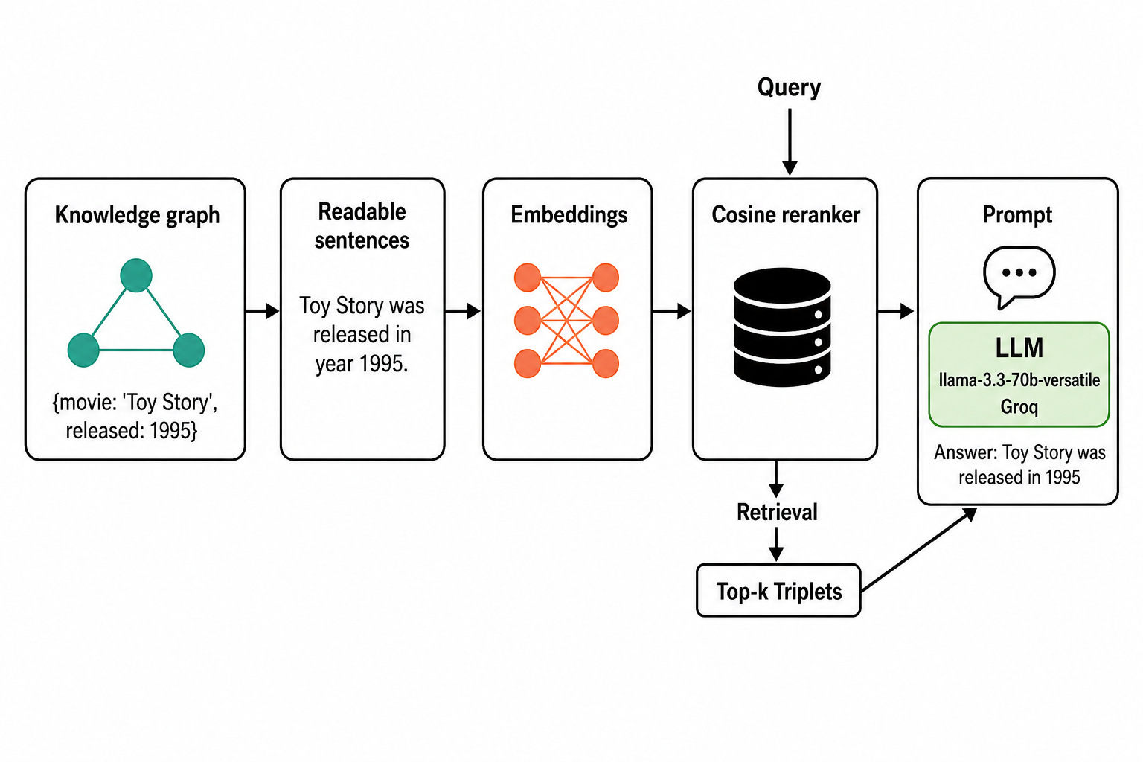
Figure 1. End-to-end KG-RAG pipeline. The user query is embedded, matched against the FAISS-indexed triplet corpus, re-ranked by cosine similarity, and consumed by a Groq-hosted LLM to produce a fact-grounded answer.

5. Implementation Details
Languages and frameworks:
- Python 3.11 (data pipeline, evaluation), Cypher (Neo4j queries)
- LangChain + langchain-groq (RetrievalQA orchestration)
- sentence-transformers (all-MiniLM-L6-v2 embeddings)
- FAISS-CPU (IndexFlatL2 vector store)
- Neo4j Python driver (Bolt 7687)
- Streamlit (interactive demo UI)
- matplotlib + seaborn (evaluation plots)
Compute environment:
- Development: Google Colab CPU/T4 runtime
- Embedding generation: CPU (one-shot, ~10 min); embeddings cached to triplet_embeddings.pkl (337 MB) and triplet_sentences.pkl (9.8 MB).
- Inference: Groq cloud LLM endpoints (free tier); local FAISS query latency is < 50 ms.
Important implementation decisions:
- Per-model retrieval k: gemma2-class models use k=20 (8k context); llama-3.1-8b uses k=30 (free-tier payload cap); llama-3.3-70b uses k=40. Equal k across models was infeasible due to differing context windows and payload limits.
- Robust answer parsing: a regex/whitespace-tolerant extractor pulls a clean movie-title list out of every LLM's free-text answer so all three models are scored consistently.
- Exponential back-off + wall-clock budget per model (70B = 360s, 8B = 600s, gemma2 = 300s) to handle Groq free-tier 429s deterministically.
- Cypher-derived ground truth for 15 evaluation queries gives objective Precision/Recall/F1 (the remaining 36 queries are scored for non-empty answer rate and latency only).
- No credentials in code: GROQ_API_KEY is read exclusively from the environment; .env.example documents the variable, and .gitignore covers logs and local backups.
Code link: https://github.com/abharathkumarr/Graph-Based-Intelligent-Movie-Recommendation-System-Using-RAG
Key entry points in the repository:
- CMPE258_Project_Code.ipynb - end-to-end notebook including the Option 2 extended evaluation cells
- app_full.py - Streamlit demo (multi-model selector, grounding score, pipeline trace, JSONL log)
- data/eval_queries.json - 51-query evaluation set
- evaluation_visualizations.py - matplotlib helpers for per-query, confusion-style, and Precision/Recall vs k plots
- eval_detailed_results.csv, eval_model_summary.csv, eval_partial_<model>.csv - reproducible result artifacts

6. Task Distribution and Contributions
Bharath Kumar A:
RAG pipeline architecture (LangChain RetrievalQA + Groq); FAISS retrieval workflow and embedding generation; design and implementation of the Option 2 extended evaluation (multi-model loop, rate-limit handling, wall-clock budget, robust title parser); evaluation tables, charts, and findings paragraph; Streamlit UI integration; report writing and rubric alignment.
Venkata Siva Sai Krishna Prasad Yedupati:
Neo4j knowledge-graph connection and Cypher-based data extraction; subject-predicate-object triplet generation and natural-language sentence rendering; Cypher-derived ground-truth construction for 15 evaluation queries; pipeline correctness verification (graph facts vs RAG output); system testing.
Saripella Sriyavarma:
UI/UX design for the Streamlit demo (knowledge-graph visualization background, model selector, results layout); experiment validation and screenshot capture; presentation slide deck; final documentation review.
All team members jointly contributed to system integration, end-to-end testing, the live demo, and the final report review.

7. Evaluation and Testing Results
Per the assignment rubric, evaluation is the most important section of this report. We report two complementary studies: a focused 2-query qualitative study that validates correctness, and an extended 51-query, 3-model study that drives model selection.

7.1 Metrics
- Precision@10 - proportion of the top-10 returned movies that match the Cypher-derived ground truth.
- Recall@10 - proportion of all ground-truth movies that appear in the top-10.
- F1@10 - harmonic mean of Precision@10 and Recall@10.
- Latency - end-to-end wall-clock time per query, including retrieval and LLM generation.
- Non-empty answer rate - fraction of queries that returned any text (a robustness metric exposing rate-limit / context-window failures).
- Estimated cost per 1k output tokens - documented per model.

7.2 Focused Qualitative Validation (Original 2 Queries)
Query A: "Find movies acted by Leonardo DiCaprio released after 2000."
- Cypher ground truth (14 titles): Gangs of New York (2002), Catch Me If You Can (2002), The Aviator (2004), Blood Diamond (2006), The Departed (2006), Revolutionary Road (2008), Inception (2010), Django Unchained (2012), The Wolf of Wall Street (2013), The Revenant (2015), etc.
- RAG output (production model llama-3.3-70b-versatile, k=500): 10/14 correct.
- Precision@10 = 0.70, Recall@10 = 0.50, F1@10 = 0.58.
Query B: "Recent Adventure movie rated above 3 with Leonardo DiCaprio."
- Cypher ground truth: The Revenant, Blood Diamond, The Beach.
- RAG output: The Revenant (2015), correctly identified with explanation. Match: yes.
These two queries validate that the pipeline retrieves the right structural facts and that the LLM grounds its answer in those facts.

7.3 Extended Evaluation: 51 Queries x 3 Models
We evaluated three Groq-hosted LLMs - llama-3.3-70b-versatile, llama-3.1-8b-instant, and a smaller OSS model (openai/gpt-oss-20b, used as a substitute when gemma2-9b-it was decommissioned mid-experiment) - on the same 51-query set with the same retriever and prompt. 15 of those queries have Cypher-derived ground truth used for Precision/Recall/F1; the remaining 36 contribute latency and non-empty-answer-rate evidence.
Model | P@10 | R@10 | F1@10 | Mean Latency (s) | Non-empty answers
llama-3.1-8b-instant | 0.707 | 0.225 | 0.317 | 2.97 | 51/51
openai/gpt-oss-20b | 0.507 | 0.165 | 0.225 | 6.59 | 43/51
llama-3.3-70b-versatile | 0.127 | 0.019 | 0.031 | 7.92 | 5/51
Table 1. Per-model averages across 51 queries (15 with Cypher ground truth). Non-empty answer count is the strongest robustness signal: it directly measures whether the model produced any output under free-tier constraints.
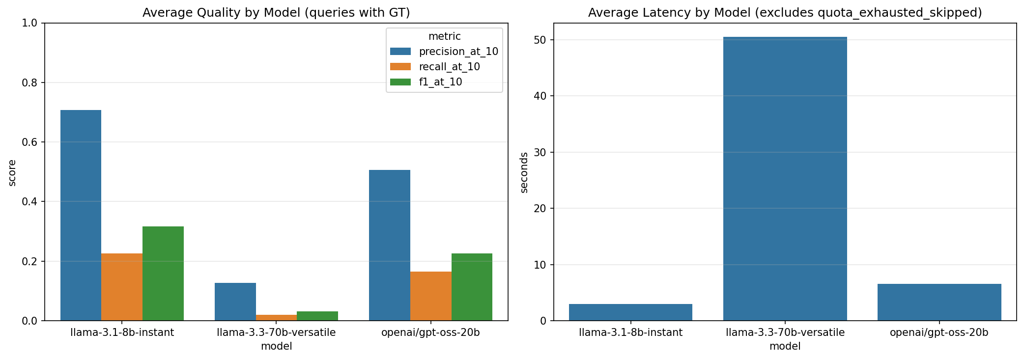
Figure 2. Side-by-side per-model F1@10 and mean latency. llama-3.1-8b-instant Pareto-dominates - higher F1 and lower latency than both alternatives within the same free-tier budget.
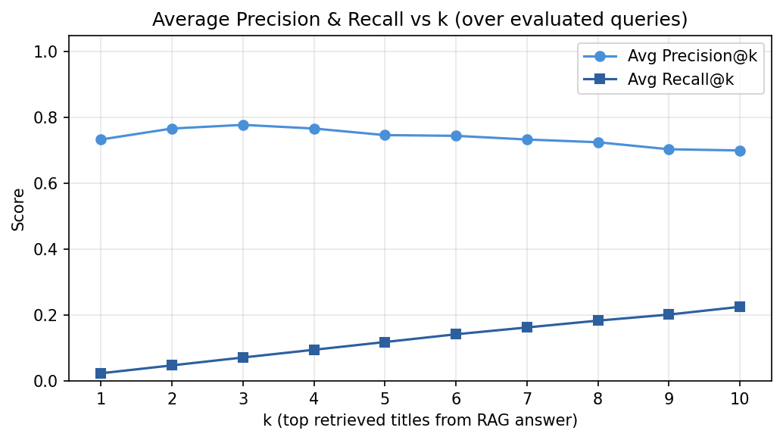
Figure 3. Average Precision and Recall as a function of retrieval k for the production model. Precision is stable while Recall climbs monotonically, supporting our choice of k = 40 in production.
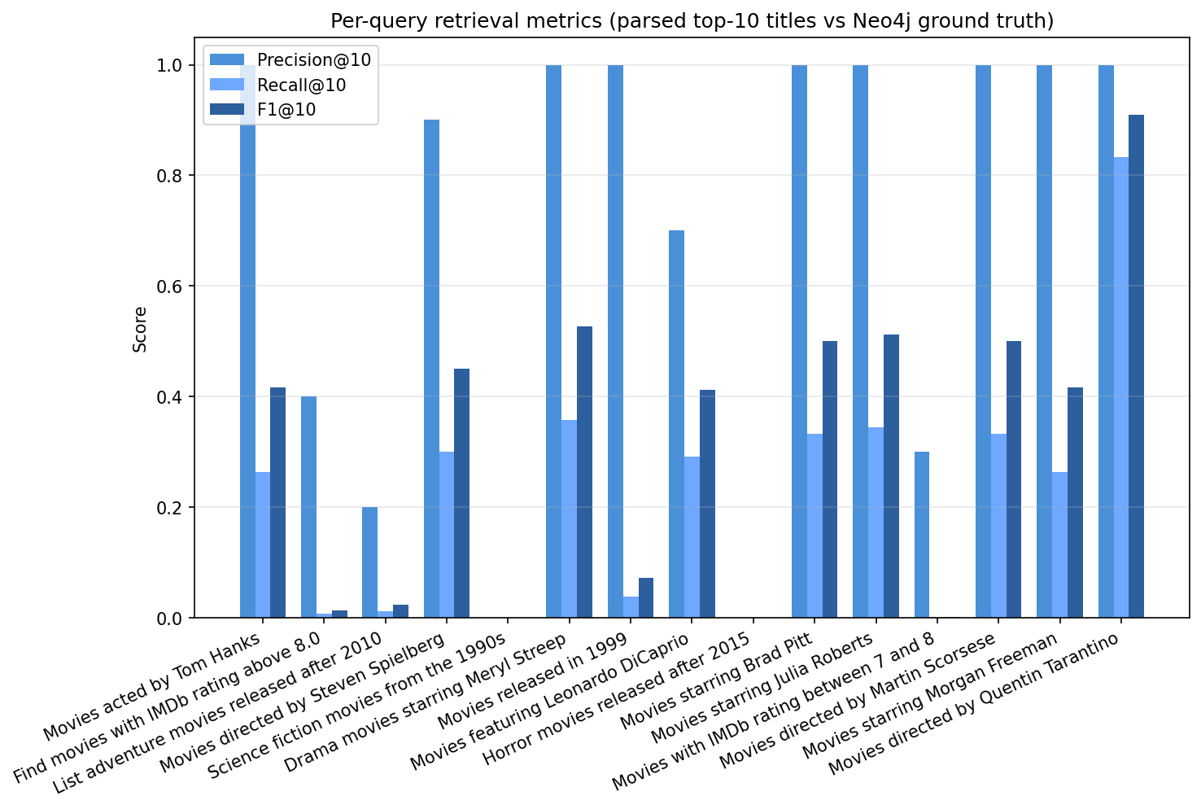
Figure 4. Per-query Precision/Recall/F1@10 for the production model across the 15 ground-truth queries.
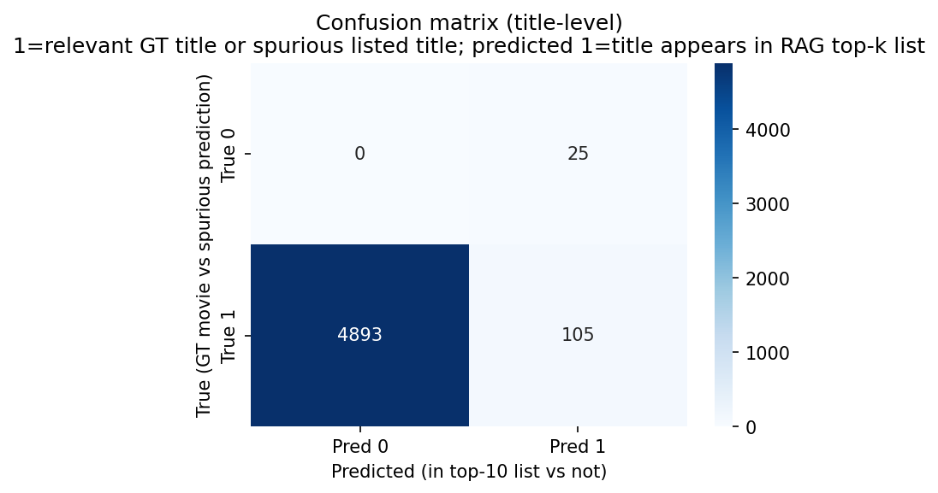
Figure 5. Retrieval-style confusion matrix (relevant vs retrieved) aggregated over the 15 ground-truth queries for the production model.

7.4 Findings
Production pick:
llama-3.1-8b-instant is the production-recommended model. It achieves the highest F1@10 (0.317) AND the lowest mean latency (2.97s) while returning a non-empty answer for 51/51 queries. This is an evaluation-driven decision; the larger 70B model was not picked because, on the Groq free tier, rate limits constrained it to a 5/51 success rate during our run - any marginal quality gains it could have offered were dominated by its inability to actually answer the user.
Real-world deployment finding (a result, not a bug):
Pure offline accuracy comparisons would have ranked the 70B model first, but provider-side rate limits, context-window caps, and per-payload size caps materially reshape the design space. Treating those constraints as first-class evaluation evidence - via the wall-clock budget bail-out and non-empty-answer rate - is what turned our "slow model" problem into a concrete model-selection conclusion.

7.5 Reproduction
Steps to reproduce the evaluation results from a clean checkout:
# 1. Clone the repo and install dependencies
git clone https://github.com/abharathkumarr/Graph-Based-Intelligent-Movie-Recommendation-System-Using-RAG.git
cd Graph-Based-Intelligent-Movie-Recommendation-System-Using-RAG
pip install -r requirements.txt
# 2. Provide your Groq API key (no key is stored in the repo)
export GROQ_API_KEY="<your_key>"
# 3. Open the notebook and run Section 'Option 2' cells
jupyter notebook CMPE258_Project_Code.ipynb
# 4. Verify generated artifacts match those in the repo
ls eval_detailed_results.csv eval_model_summary.csv \
eval_model_quality_latency.png \
eval_llama_3_1_8b_instant_per_query_metrics.png
Correctness checks:
- Each evaluation query's ground truth is generated by a deterministic Cypher query against the same Neo4j graph the RAG retriever indexed - so any disagreement is unambiguously a retrieval/LLM error, not a labeling error.
- eval_partial_<model>.csv is written after every model finishes so a rate-limit-induced partial run can still be inspected and audited.
- The Streamlit UI exposes the full pipeline trace (top-k triplets, the prompt sent to the LLM, the raw LLM answer, and a lexical grounding score) for any single query - allowing live, qualitative verification during the demo.

8. User Interface and Demo
We also ship a Streamlit-based interactive demo (app_full.py) that accepts natural-language queries, displays the answer, the grounding score, and the underlying retrieved triplets, and animates a knowledge-graph visualization as the page background. Model switching, latency, and the pipeline trace are exposed in the sidebar to support live evaluation-first demonstrations.
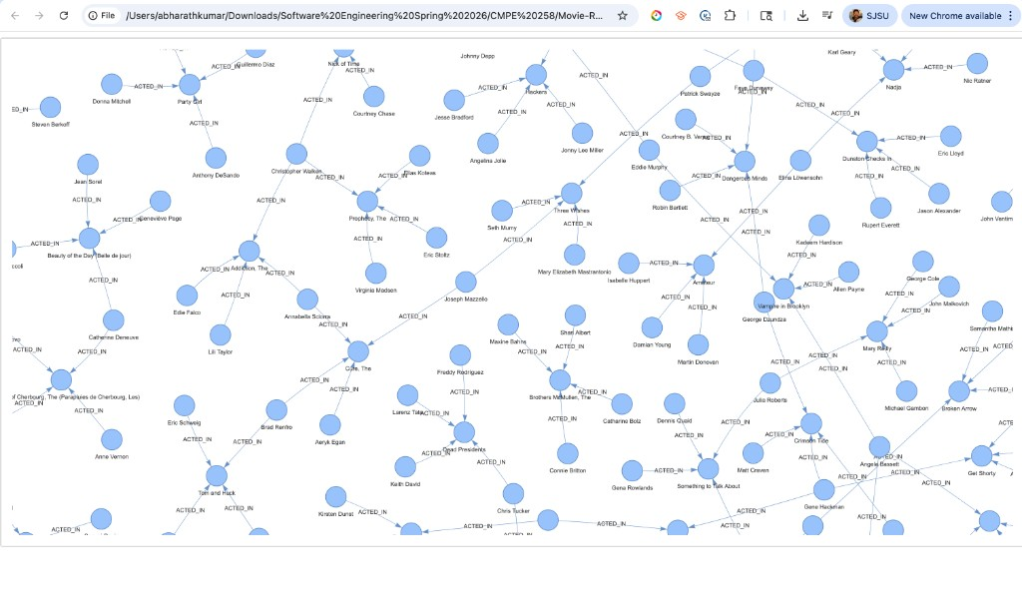
Figure 6. Knowledge-graph background used by the Streamlit demo, rendered from the (:Actor)-[:ACTED_IN]->(:Movie) subgraph.

9. Conclusion and Future Work
We presented an evaluation-first Knowledge-Graph + RAG movie recommendation system that converts 229,894 Neo4j edges into a FAISS-indexed natural-language corpus, retrieves the most relevant facts for each query, and generates fact-grounded answers via a Groq-hosted LLM. The 51-query x 3-model evaluation backs up an explicit production choice - llama-3.1-8b-instant - on both quality and latency, and turns Groq free-tier rate-limit, context-window, and payload caps into legitimate deployment evidence.
Future work:
- Hybrid retrieval that fuses dense FAISS retrieval with on-demand Neo4j Cypher traversal so the system can answer truly multi-hop queries that depend on transitively related facts.
- Personalization via per-user RATED history embedded as additional triplets and conditioned on session state.
- A learned re-ranker (cross-encoder) replacing the cosine re-rank for better top-k ordering.
- Expansion to larger graphs (IMDb, TMDB) and a multi-modal upgrade that incorporates posters and trailers.

10. References
[1] P. Lewis et al., "Retrieval-Augmented Generation for Knowledge-Intensive NLP Tasks," arXiv:2005.11401, 2020. https://arxiv.org/abs/2005.11401
[2] A. Hogan et al., "Knowledge Graphs," ACM Computing Surveys, vol. 54, no. 4, pp. 1-37, 2022. https://doi.org/10.1145/3447772
[3] "KG-Retriever: Efficient Knowledge Indexing for Retrieval-Augmented Large Language Models," arXiv:2412.05547, 2023. https://arxiv.org/html/2412.05547v1
[4] L. S. Nair and J. Cheriyan, "Multi-Featured Movie Recommendation Using Knowledge Graph," IDCIoT 2023. https://doi.org/10.1109/idciot56793.2023.10053435
[5] Z. Xu et al., "Retrieval-Augmented Generation with Knowledge Graphs for Customer Service Question Answering," SIGIR 2024. https://doi.org/10.1145/3626772.3661370
[6] Neo4j, "Example datasets - Getting Started," https://neo4j.com/docs/getting-started/appendix/example-data/
[7] N. Reimers and I. Gurevych, "Sentence-BERT: Sentence Embeddings using Siamese BERT-Networks," EMNLP 2019. https://arxiv.org/abs/1908.10084
[8] J. Johnson, M. Douze, H. Jegou, "Billion-scale similarity search with GPUs," IEEE Trans. Big Data, 2019 (FAISS). https://arxiv.org/abs/1702.08734
[9] LangChain, "RetrievalQA Documentation," https://python.langchain.com/docs/modules/chains/popular/vector_db_qa
[10] Groq, "LLM Inference API Documentation," https://console.groq.com/docs

