QuakeWatch
Revision-Aware Earthquake Intelligence Platform on ArangoDB

Review 2 Report
Database Implementation, Query Evaluation, Integrity Mechanisms and Backend-Database Connectivity with a Verified CRUD Demonstration

Item | Detail
Subject | Database Management Systems (NoSQL database project)
Database | ArangoDB 3.12.5 (multi-model: document, graph, key-value, search)
Backend / Frontend | Python 3.12, Django, Django REST Framework / HTML, CSS, JavaScript, Bootstrap, Leaflet, Chart.js
Data source | U.S. Geological Survey (USGS) earthquake feeds, live ingestion
Repository | https://github.com/abharathreddy751/quake_watch_v2
Report date | 11 October 2026

Safety statement: QuakeWatch does not predict earthquakes; its alerts are application notifications and not official emergency warnings. Earthquake data courtesy of the U.S. Geological Survey (USGS).

Contents
Abstract 4
Mapping of the Review 2 deliverables to the ArangoDB stack 4
1. Environment and Architecture 5
1.1 Runtime environment 5
2. Database Implementation 6
2.1 Database and collection creation 6
2.2 Document design 8
2.3 Graph model 9
2.4 Sample data and record count 10
2.5 Indexes 11
2.6 Views 13
2.7 Triggers and procedures: NoSQL equivalents 14
2.8 Database export (dump) 15
3. Complex AQL Queries with Output 16
3.1 Query 1: Event count and magnitude statistics per region 16
3.2 Query 2: Dashboard summary with subqueries 17
3.3 Query 3: Per-network statistics joined to network names 19
3.4 Query 4: Revisions with large magnitude changes (array index) 21
3.5 Query 5: Ingestion latency percentiles 23
3.6 Query 6: Significant events per ISO week 25
3.7 Query 7: A user's alert rules with match counts (edge traversal) 27
3.8 Query 8: Matched events through a two-hop graph traversal 29
3.9 Query 9: Event relationships (OUTBOUND and INBOUND traversal) 30
3.10 Query 10: Map viewport search (GEO_CONTAINS) 32
3.11 Query 11: Radius search (GEO_DISTANCE) 34
3.12 Query 12: Location text search (ArangoSearch view) 36
3.13 Query 13: Ingestion run statistics by kind 38
3.14 Query 14: Depth histogram (bucketed aggregation) 40
3.15 Query 15: Nearby events in space and time 41
3.16 Summary of the query execution 43
4. Backend and Database Connectivity: CRUD Demonstration 45
4.1 Authentication and session mechanism 45
4.2 Backend and database connectivity check 45
4.3 Request sequence and verified results 45
4.4 Findings and repairs made during the work 53
5. Test Cases and Results 54
5.1 Automated regression suite 55
6. Discussion and Limitations 55
References 56

Abstract
QuakeWatch ingests real earthquake observations from the USGS, validates and normalises them, keeps every revision of every event, and exposes search, map, analytics, alerting and research-snapshot functions through a Django REST API. ArangoDB is the only stateful service: it stores domain data, user accounts and sessions, the durable job queue, caches, metrics and audit records. This report documents the Review 2 scope for that stack: the implemented database (collections, 2,670 live earthquake documents, indexes, an ArangoSearch view and a named graph), the integrity mechanisms that play the role of triggers and stored procedures in a NoSQL setting, fifteen complex AQL queries executed against the live data with their outputs, the executed test cases, and a fifteen-request HTTP CRUD demonstration that proves backend-to-database connectivity. Every figure in the report was produced by running the real application; nothing is simulated or mocked.

Mapping of the Review 2 deliverables to the ArangoDB stack
The Review 2 checklist is written with relational terminology. Because QuakeWatch uses a NoSQL multi-model database, each item is satisfied by the closest equivalent construct, as listed below. Where ArangoDB has no direct counterpart (native triggers and stored procedures) this is stated explicitly and the alternative mechanism that actually enforces the behaviour is demonstrated.
Table 1: Review 2 checklist mapped to the implemented NoSQL stack
Review 2 item | ArangoDB / QuakeWatch equivalent | Section
DB dump (.sql) | Native arangodump export (structure + data per collection); JSON schema and index definitions via the repository's idempotent arango_migrate command | 2.8
Screenshots of 500+ records | events collection holds 2,670 real documents (2,655 at the time of Figure 6); event_revisions 2,767 | 2.4
Views | ArangoSearch view events_search (full-text, primary sort on occurred_at) and the named graph quakewatch_graph | 2.6
Triggers | Strict JSON-schema validation on write, unique-index constraints, TTL indexes, and ingestion-pipeline observers (no native triggers exist) | 2.7
Procedures | Atomic stream transactions (run_in_transaction), a catalogue of 53 named parameterised AQL queries, durable server-side job queue (no stored procedures exist) | 2.7
Indexes | 32 named secondary indexes (persistent, geo, TTL) plus primary and edge indexes | 2.5
15+ complex queries with output | 15 AQL queries (aggregation, graph traversal, geo, ArangoSearch, percentiles) with live output and GUI screenshots | 3
Test cases | 36 executed test cases plus the 936-test regression suite | 5
GitHub link + CRUD working, backend and DB connectivity | Repository link, health endpoint, 15 real HTTP requests with database read-back | 4

1. Environment and Architecture

1.1 Runtime environment
The application is deployed locally with Docker Compose as four containers that share one image: the ArangoDB 3.12.5 server, the Django web process (gunicorn), a background worker and a scheduler. The worker and scheduler replace Celery: jobs and schedules are documents in ArangoDB, claimed with atomic AQL updates. No relational database, Redis or Celery is used (the Django setting DATABASES is intentionally empty so that any accidental ORM query fails loudly).
Table 2: Runtime components
Component | Technology | Role
Database | ArangoDB 3.12.5 (container, port 8529) | Only stateful service: events, revisions, users, sessions, jobs, cache, metrics, audit
Web | Django + Django REST Framework, gunicorn (port 8000) | Pages and versioned JSON API under /api/v1/
Worker | apps.jobs worker | Executes queued ingestion, enrichment and alert-evaluation jobs
Scheduler | apps.jobs scheduler | Enqueues the USGS feed synchronisation every 300 seconds
Driver | python-arango | Used only inside repository modules and apps/core/arango (enforced by architecture tests)

Access to the ArangoDB web interface was made with the root account; the password field is masked in Figure 1 and no credential is reproduced in this report.
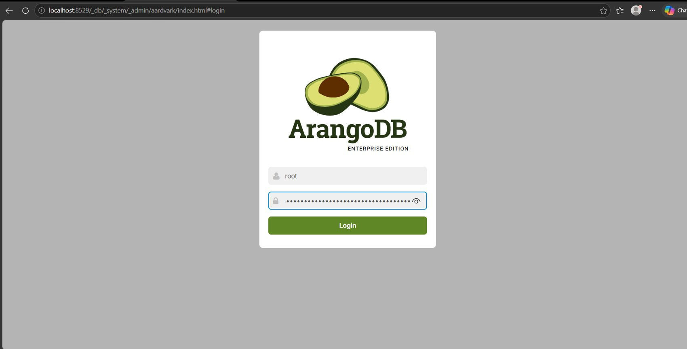
Figure 1: ArangoDB web interface login on localhost:8529 (password masked by the browser).
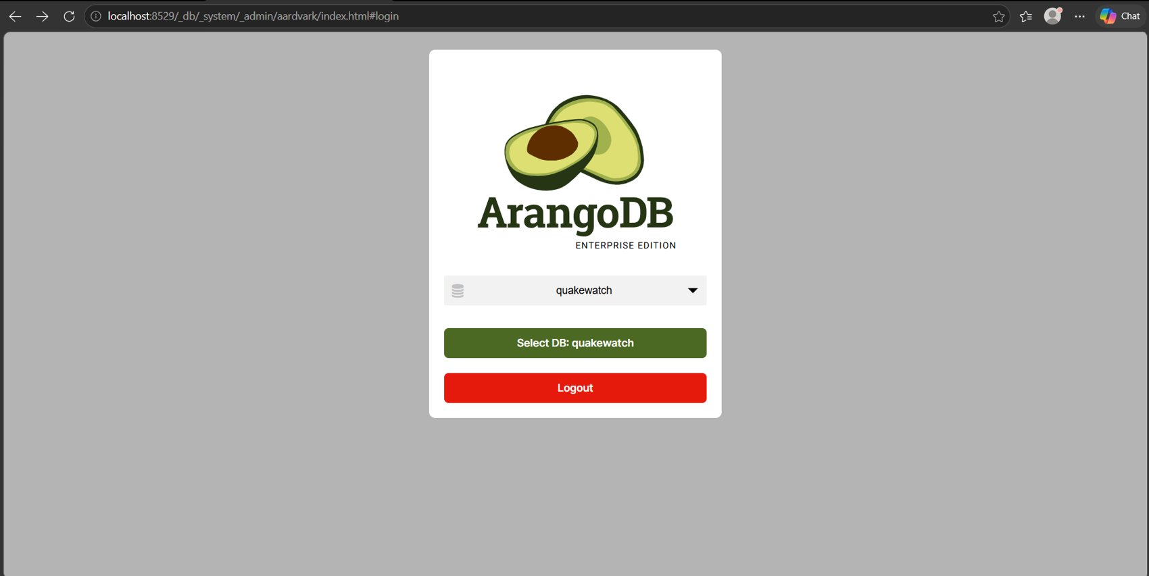
Figure 2: Database selection: the application database quakewatch is chosen after authentication.

2. Database Implementation

2.1 Database and collection creation
The database quakewatch and all of its structure are created by the idempotent management command arango_migrate, which applies schema version 6: collections with JSON-schema validators, persistent, geo and TTL indexes, the ArangoSearch view and the named graph. Re-running the command changes nothing, so the structure is reproducible on any machine. The interface lists 31 collections (Figure 3): 27 document collections and 4 edge collections.
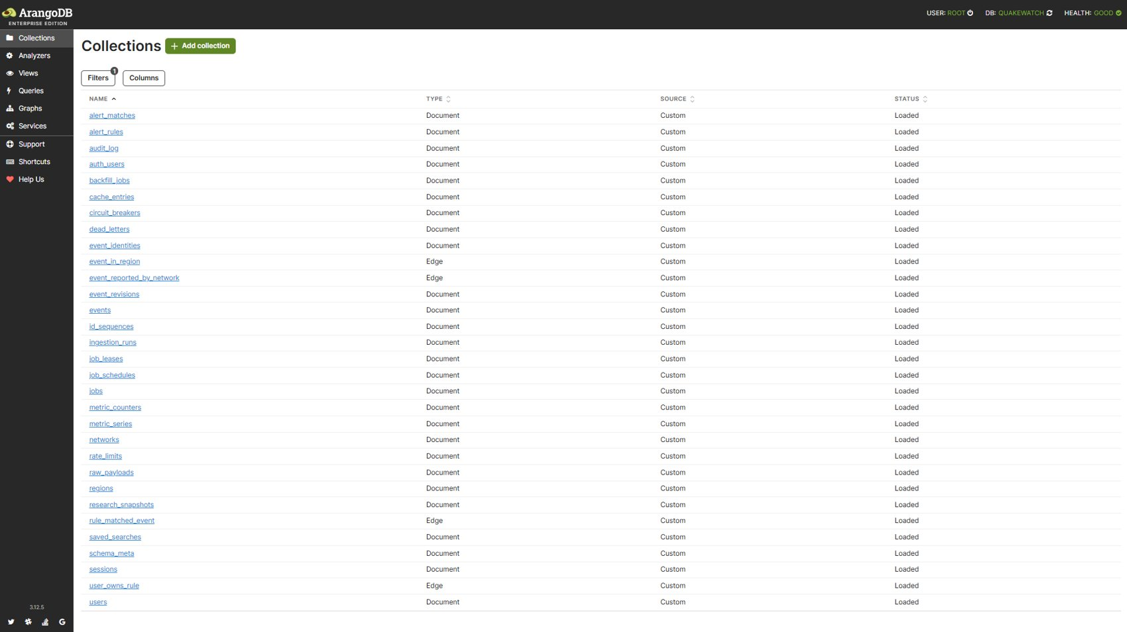
Figure 3: ArangoDB web interface listing the 31 QuakeWatch collections (document and edge types).
Table 3: Collections, live document counts and purpose (total 17,542 documents)
Collection | Type | Documents | Purpose
alert_matches | document | 0 | Notification records produced when a rule matches an event
alert_rules | document | 1 | User-defined alert rules (owner-scoped)
audit_log | document | 22 | Security and administrative audit trail
auth_users | document | 2 | Account records (password hashes, staff flags)
backfill_jobs | document | 2 | Historical backfill requests and progress
cache_entries | document | 3 | Query cache with TTL
circuit_breakers | document | 0 | Upstream circuit-breaker state
dead_letters | document | 0 | Records that failed validation, kept for retry
event_identities | document | 3,402 | Maps every USGS associated id to its canonical event (merge support)
event_in_region | edge | 2,670 | Edge: event to region
event_reported_by_network | edge | 2,670 | Edge: event to reporting network
event_revisions | document | 2,767 | Immutable per-change history of each event (before/after, changed fields)
events | document | 2,670 | Canonical earthquake documents, one per USGS event
id_sequences | document | 1 | Atomic integer sequences for ids
ingestion_runs | document | 148 | One document per feed sync, backfill or enrichment run
job_leases | document | 0 | Distributed leases with TTL
job_schedules | document | 2 | Periodic job definitions
jobs | document | 98 | Durable job queue
metric_counters | document | 11 | Operational counters
metric_series | document | 77 | Latency samples for percentile dashboards
networks | document | 15 | Reporting seismic networks (us, ak, nc, ...)
rate_limits | document | 2 | API throttle counters (TTL-expired)
raw_payloads | document | 2,843 | Original USGS payloads kept for provenance (TTL-expired)
regions | document | 126 | Normalised region dimension (US states, countries)
research_snapshots | document | 0 | Frozen, checksummed event selections for reproducible research
rule_matched_event | edge | 0 | Edge: rule to matched event
saved_searches | document | 0 | Per-user saved explorer filters (capped at 50)
schema_meta | document | 1 | Applied schema version marker
sessions | document | 7 | Django session store (TTL-expired)
user_owns_rule | edge | 1 | Edge: user to alert rule
users | document | 1 | Identity vertices for the graph

2.2 Document design
Documents are denormalised where reads dominate and referenced by key where relationships matter. An event is stored once under a deterministic key (usgs_<source id>); relationships to its region and network are edges, and every change is an immutable document in event_revisions. A real, unmodified event document read from the live database is shown below.
{
"_key": "usgs_nc75447861",
"source": "USGS",
"source_event_id": "nc75447861",
"associated_ids": [
"nc75447861"
],
"event_type": "earthquake",
"magnitude": 1.67,
"magnitude_type": "md",
"place": "9 km N of Hollister, CA",
"occurred_at": "2026-10-11T16:39:30.720Z",
"source_updated_at": "2026-10-11T16:43:51.390Z",
"longitude": -121.415832519531,
"latitude": 36.9268341064453,
"depth_km": 8.71000003814697,
"felt": null,
"cdi": null,
"mmi": null,
"alert": null,
"status": "automatic",
"tsunami": false,
"significance": 43,
"network": "nc",
"contributors": [
"nc"
],
"station_count": 29,
"min_station_distance_deg": 0.09661,
"rms_travel_time_residual": 0.07,
"azimuthal_gap_deg": 53,
"coordinates": [
-121.415832519531,
36.9268341064453
],
"derived": {
"first_seen_via": "feed",
"first_seen_latency_s": 330.897,
"region_key": "california",
"region_name": "California",
"region_kind": "us_state",
"region_method_version": 1
},
"first_seen_at": "2026-10-11T16:45:01.617Z",
"last_seen_at": "2026-10-11T16:45:01.617Z",
"last_ingested_at": "2026-10-11T16:45:01.617Z",
"revision_count": 1,
"payload_hash": "b51fddc4b333d0b0f12dcdefb178b86daf21db3aaf9a722e2c1b47ecfee315e5",
"schema_version": 1,
"revision_policy_version": 1,
"merged_into": null,
"last_ingestion_run_id": "431647c2a27341f39db5416a3cf5e89e"
}

The events collection carries a strict JSON-schema validator (validation level strict): magnitude is restricted to the range -2 to 11, latitude to -90..90, longitude to -180..180, status to automatic/reviewed/deleted, and timestamps must match an ISO-8601 pattern. The validator rejects non-conforming documents server-side regardless of which client wrote them (Figure 4, Section 2.7).
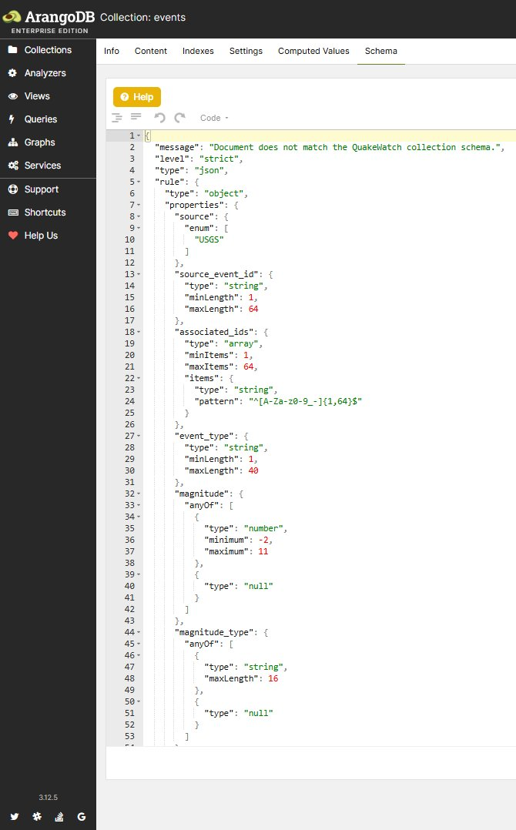
Figure 4: Schema tab of the events collection: server-side JSON-schema validation rules.

2.3 Graph model
The named graph quakewatch_graph connects users to alert rules (user_owns_rule), rules to matched events (rule_matched_event), events to regions (event_in_region) and events to networks (event_reported_by_network). Graph traversals answer questions such as which events matched a user's rules (Query 8) and which events share a region with a given event (Query 9).
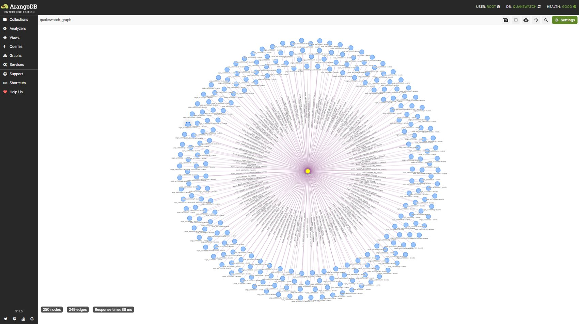
Figure 5: Graph viewer showing quakewatch_graph (250 nodes and 249 edges in the sampled view).

2.4 Sample data and record count
The data are real USGS observations, not generated test data. The events collection contains 2,670 documents covering 2026-08-26 to 2026-10-11 with magnitudes from -1.05 to 6.6; the revision history holds 2,767 documents and the database as a whole 17,542 documents, which satisfies the requirement of at least 500 records. The count grows as the scheduler ingests new feed data every five minutes, so the screenshot (2,655 documents) was taken slightly earlier than the figures in the tables.
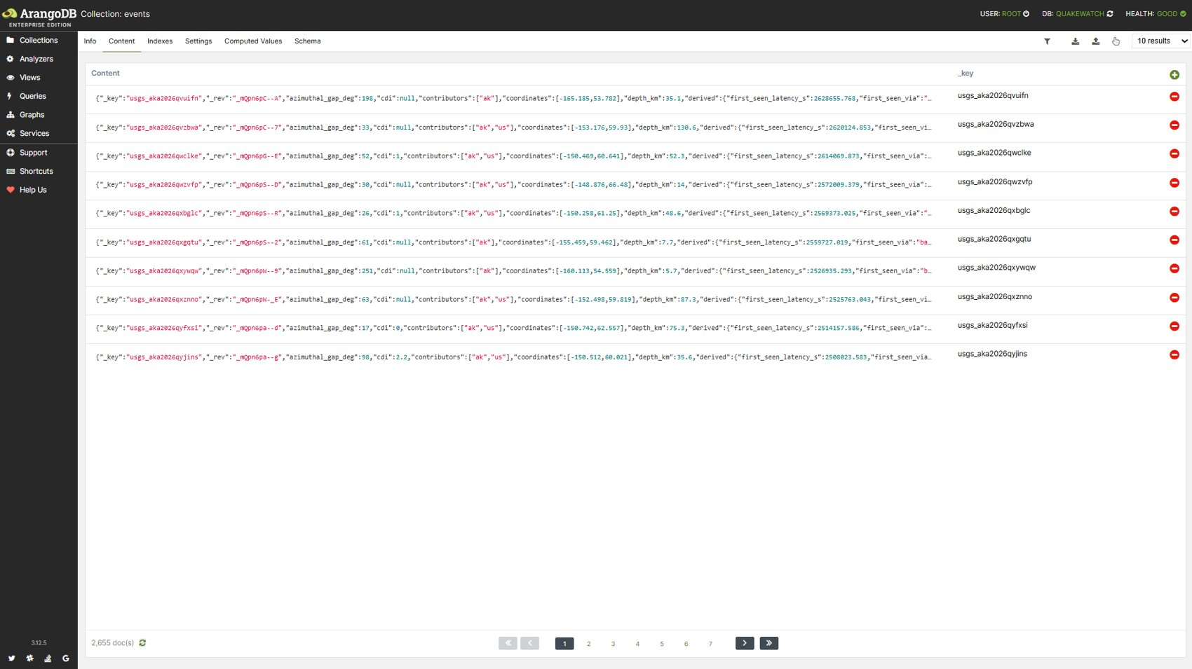
Figure 6: Content tab of the events collection showing 2,655 documents at the time of capture.
Table 4: Record counts of the principal entities (live database)
Entity | Count | Remark
events | 2,670 | Canonical earthquakes (2026-08-26 to 2026-10-11)
event_revisions | 2,767 | 97 revisions beyond the initial creation records (magnitude, status, location updates)
event_identities | 3,402 | USGS associated ids mapped to canonical events
raw_payloads | 2,843 | Provenance copies of source payloads
event_in_region + event_reported_by_network | 5,340 | 2,670 edges each
ingestion_runs | 148 | 138 feed syncs, 8 enrichments, 6 backfill windows
jobs | 98 | Durable queue entries (TTL-purged when finished)
regions / networks | 126 / 15 | Dimension collections

2.5 Indexes
Table 5: The 32 named secondary indexes defined by the schema
Index | Collection | Type | Fields | Unique | Purpose
qw_matches_rule_event | alert_matches | persistent | rule_key, event_key | yes | Unique match per (rule, event): no duplicate notifications
qw_matches_user_time | alert_matches | persistent | user_id, matched_at | no | Notification feed per user
qw_rules_user | alert_rules | persistent | user_id | no | Rules of one user
qw_rules_enabled | alert_rules | persistent | enabled | no | Select enabled rules during evaluation
qw_audit_at | audit_log | persistent | at | no | Audit trail by time
qw_auth_username | auth_users | persistent | username | yes | Unique username
qw_auth_username_ci | auth_users | persistent | username_ci | no | Case-insensitive username lookup
qw_backfill_status | backfill_jobs | persistent | status | no | Backfill jobs by status
qw_cache_ttl | cache_entries | ttl | expires_at | no | TTL: expire cache entries
qw_dead_last_failure | dead_letters | persistent | last_failure_at | no | Dead letters by last failure
qw_dead_source_event | dead_letters | persistent | source, source_event_id | no | Dead letters per source event
qw_identities_event_key | event_identities | persistent | event_key | no | Resolve all ids of an event
qw_revisions_event_rev | event_revisions | persistent | event_key, revision_number | yes | Unique (event, revision number); history of one event
qw_revisions_observed_at | event_revisions | persistent | observed_at | no | Time-bounded revision analytics
qw_revisions_changed_fields | event_revisions | persistent | changed_fields[*] | no | Array index: find revisions that changed a given field
qw_events_geo | events | geo | coordinates | no | Radius and viewport searches (GEO_DISTANCE, GEO_CONTAINS)
qw_events_source_identity | events | persistent | source, source_event_id, merged_into | yes | Uniqueness of (source, source_event_id, merged_into); idempotent upsert
qw_events_occurred_at | events | persistent | occurred_at, _key | no | Time-ordered explorer pages and analytics windows
qw_events_magnitude | events | persistent | magnitude, _key | no | Magnitude-sorted listings and filters
qw_runs_started_at | ingestion_runs | persistent | started_at | no | Chronological run listing
qw_runs_status | ingestion_runs | persistent | status | no | Filter runs by status
qw_runs_kind_started | ingestion_runs | persistent | kind, started_at | no | Latest runs per kind (operations dashboard)
qw_leases_ttl | job_leases | ttl | expires_at | no | TTL: release abandoned leases
qw_jobs_claim | jobs | persistent | status, run_at | no | Claim the next runnable job
qw_jobs_dedupe | jobs | persistent | dedupe_key | yes | Unique dedupe key: no duplicate jobs
qw_jobs_task_created | jobs | persistent | task, created_at | no | Job history per task
qw_jobs_purge | jobs | ttl | purge_at | no | TTL: remove finished jobs
qw_rate_limits_ttl | rate_limits | ttl | expires_at | no | TTL: expire throttle counters
qw_raw_ttl | raw_payloads | ttl | expires_at | no | TTL: expire raw payload copies
qw_snapshots_user | research_snapshots | persistent | user_id, created_at | no | Snapshots per user
qw_saved_user | saved_searches | persistent | user_id, created_at | no | Saved searches per user
qw_sessions_ttl | sessions | ttl | expire_at | no | TTL: expire sessions

Every named query in the catalogue declares the index it is expected to use, and the diagnostics endpoint runs EXPLAIN against the live optimizer to confirm it. The index actually chosen for each of the fifteen queries of Section 3 is reported with its output.
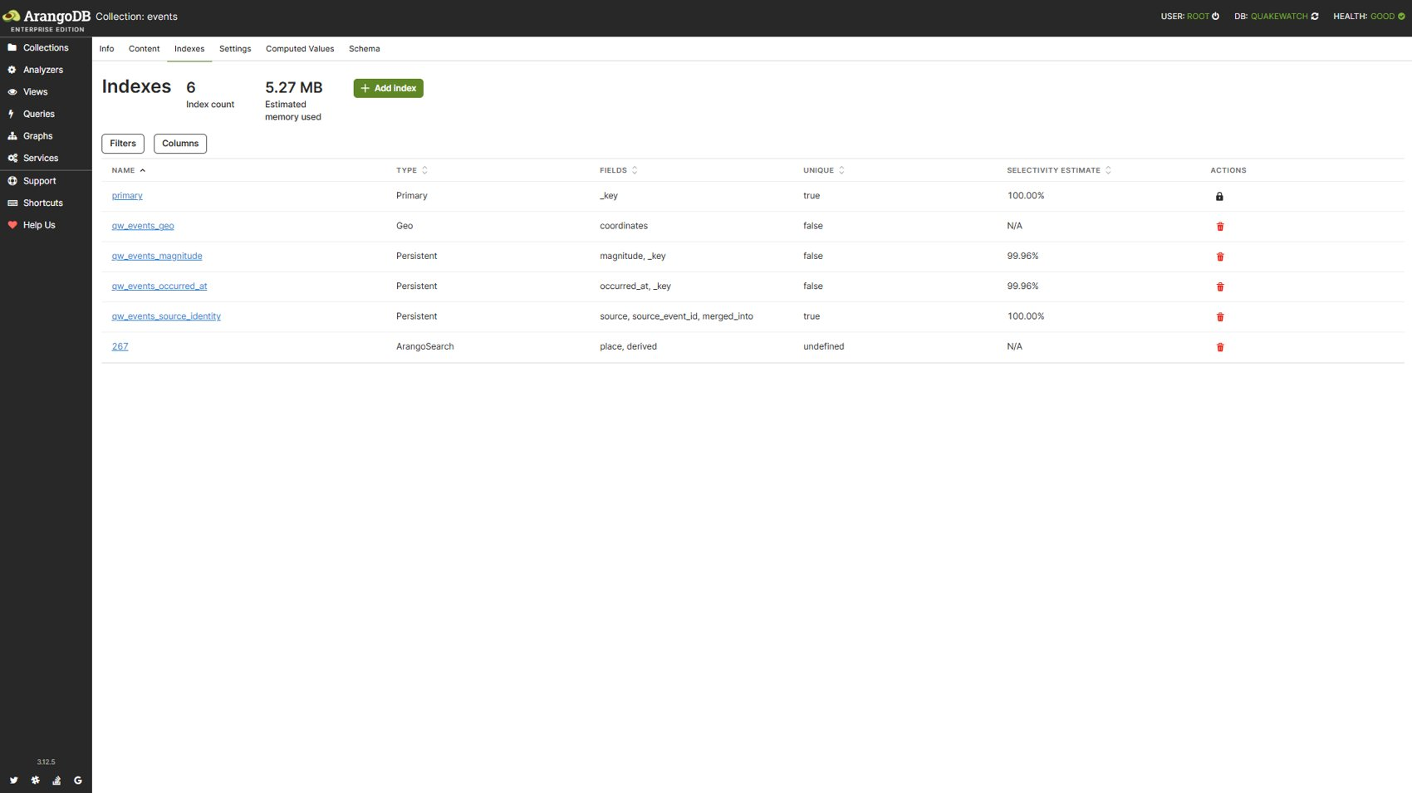
Figure 7: Indexes tab of the events collection: primary, geo, three persistent indexes and the ArangoSearch link.

2.6 Views
ArangoSearch view events_search links the events collection and indexes the place field with the text_en analyzer and derived.region_name with text_en and identity analyzers. Its primary sort is occurred_at descending, so the most recent matches are read first without a separate sort. Query 12 uses the view for tokenised location search.
{
"name": "events_search",
"type": "arangosearch",
"links": {
"events": {
"analyzers": [
"identity"
],
"fields": {
"place": {
"analyzers": [
"text_en"
]
},
"derived": {
"fields": {
"region_name": {
"analyzers": [
"text_en",
"identity"
]
}
}
}
},
"includeAllFields": false,
"storeValues": "none",
"trackListPositions": false
}
},
"primarySort": [
{
"field": "occurred_at",
"asc": false
}
],
"commitIntervalMsec": 1000
}

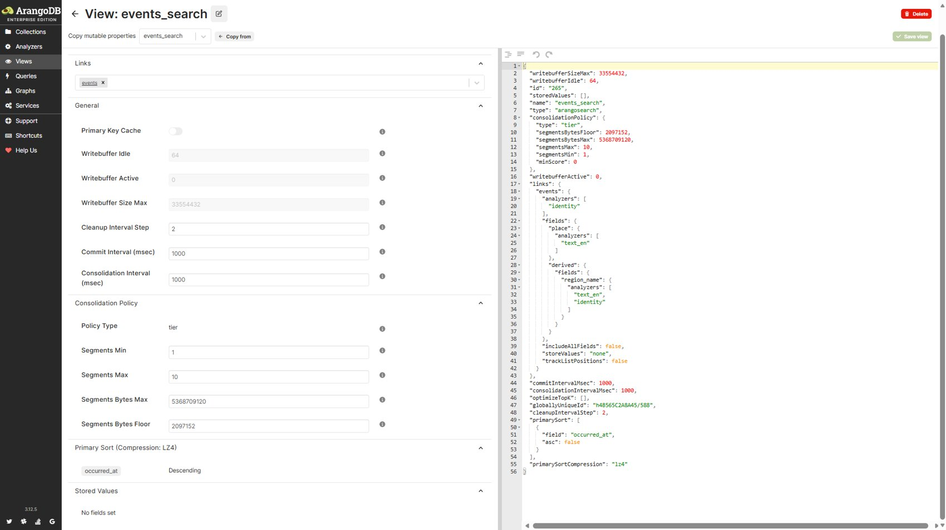
Figure 8: ArangoSearch view events_search: links, analyzers and primary sort.

2.7 Triggers and procedures: NoSQL equivalents
ArangoDB has no SQL-style triggers and no stored procedures; the AQL user-function registry of this database is empty (verified through the HTTP API). The behaviours that triggers and procedures provide in a relational system are obtained here from the following mechanisms, each of which was exercised against the live database.
Table 6: Relational constructs and their ArangoDB counterparts
Relational concept | Mechanism in QuakeWatch | Where
BEFORE INSERT trigger / CHECK constraint | Strict JSON-schema validation on events, alert_rules and other collections; rejected writes fail with error 1620 | ArangoDB server
UNIQUE constraint | Unique persistent indexes, e.g. qw_events_source_identity; violations fail with error 1210 | ArangoDB server
Scheduled clean-up (event / trigger) | TTL indexes on sessions, cache_entries, rate_limits, raw_payloads, job_leases, jobs | ArangoDB server
AFTER UPDATE trigger | Ingestion pipeline calls registered observers (for example the alert-rule observer) inside the same unit of work after an event changes | apps/ingestion, apps/alerts
Stored procedure | Named parameterised AQL queries (53, registered in apps/core/arango/catalog.py) executed with bind variables only | application
BEGIN / COMMIT / ROLLBACK | Stream transactions through run_in_transaction with automatic retry on write-write conflicts (error 1200) | apps/core/arango/transactions.py

The four mechanisms that can be demonstrated directly were executed on the live database with no residual change (document counts of events and audit_log were identical before and after).
Table 7: Integrity mechanisms exercised on the live database
Demonstration | Action | Observed result
Schema validation | Insert an event with source NOT_USGS and magnitude 99 | Rejected, error 1620: Document does not match the QuakeWatch collection schema.
Unique index | Insert a copy of an existing event under a new _key | Rejected, error 1210: unique constraint on index qw_events_source_identity
Transaction rollback | In one stream transaction insert a valid audit_log document, then an invalid event | Transaction aborted (error 1620); probe audit document present afterwards: False
Transaction commit | Insert a valid audit_log document in a stream transaction | Committed, document visible: True (removed afterwards)

2.8 Database export (dump)
The native export tool arangodump produces the structure and data of each collection (a structure.json and a gzip-compressed data.json.gz file per collection, a dump.json manifest and the view definition). A dump of an isolated test database was generated on 11 October 2026 and is stored under verification_evidence/review2_2026-10-11/native_arangodump_2026-10-11 (31 collections, 32.8 KB compressed, manifest and all 31 payloads verified readable). The live database can be exported on demand with the command below; no restore test was performed.
docker compose exec arangodb arangodump --server.endpoint tcp://127.0.0.1:8529 \
--server.database quakewatch --output-directory /tmp/qw_dump --overwrite true

3. Complex AQL Queries with Output
Fifteen queries were selected from the application's named-query catalogue because together they cover aggregation (COLLECT, AGGREGATE, PERCENTILE), subqueries, joins by DOCUMENT(), array-index lookups, multi-hop graph traversals in both directions, geospatial search, ArangoSearch full-text search and time-window analytics. Each query was executed against the live database with bind variables, and the first rows of the real result are reproduced. The screenshots were captured in the ArangoDB query editor with the same AQL; because the feed is live, counts in the screenshots and in the scripted run can differ by a few documents. For Queries 7 and 8 the screenshots were taken with user_id 1, who owned no rules at that moment (0 rows); the scripted run used a user with one enabled rule so that the traversal returned data.

3.1 Query 1: Event count and magnitude statistics per region
Catalogue name: analytics_avg_magnitude_by_region. Purpose: Event count and average/max magnitude by derived region (README Q3). Techniques: aggregation.
FOR e IN events
FILTER e.occurred_at >= @since FILTER e.merged_into == null
COLLECT region = e.derived.region_name
AGGREGATE n = LENGTH(1), avg_mag = AVERAGE(e.magnitude), max_mag = MAX(e.magnitude)
SORT n DESC
LIMIT @limit
RETURN {region: region, count: n, avg_magnitude: ROUND(avg_mag * 100) / 100,
max_magnitude: max_mag}

Bind variables: {"since": "2026-08-26T00:00:00.000Z", "limit": 20}
[
{
"region": "Alaska",
"count": 981,
"avg_magnitude": 2.82,
"max_magnitude": 6.5
},
{
"region": "California",
"count": 353,
"avg_magnitude": 1.41,
"max_magnitude": 4.74
},
{
"region": "Indonesia",
"count": 135,
"avg_magnitude": 4.6,
"max_magnitude": 6.5
}
]

Result: 20 row(s) returned in 6.98 ms. Index chosen by the optimizer: qw_events_occurred_at.
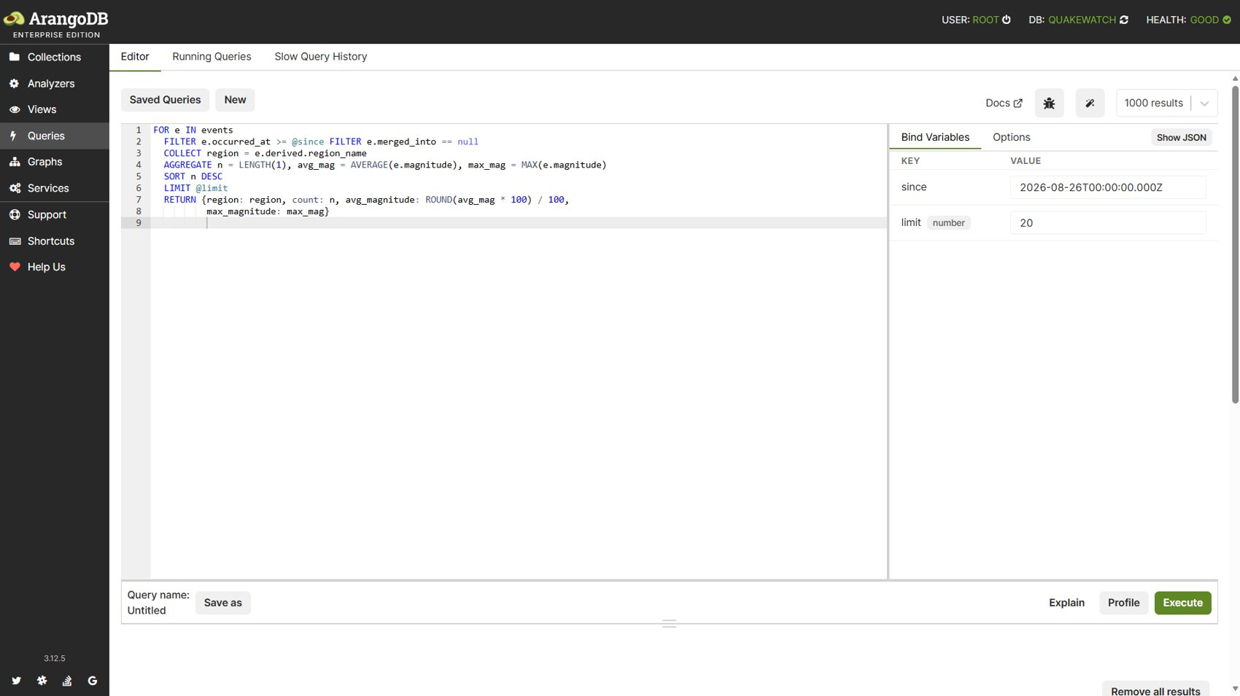
Figure 9: Query 1: Query editor with AQL and bind variables (since, limit).
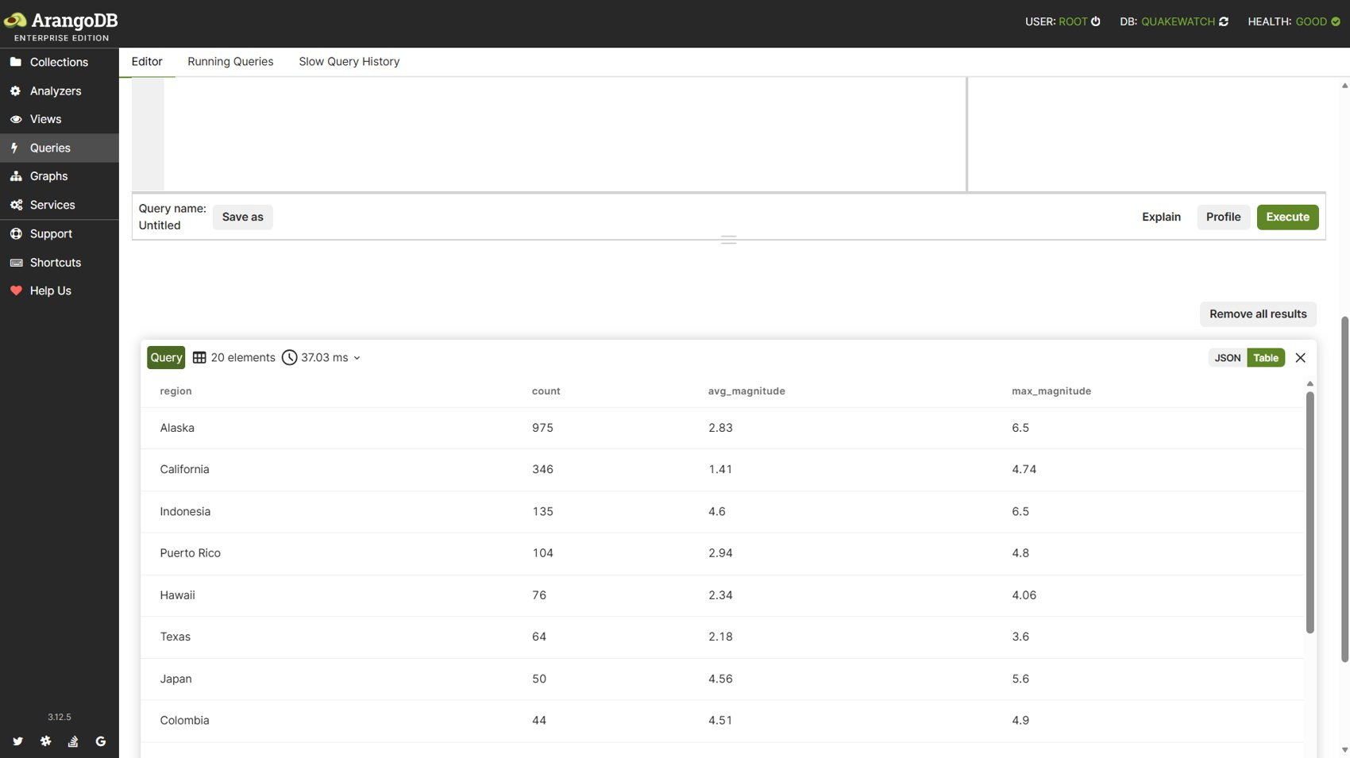
Figure 10: Query 1: Result table: 20 regions ranked by event count.

3.2 Query 2: Dashboard summary with subqueries
Catalogue name: analytics_dashboard_summary. Purpose: Situational summary: counts in the last 24 h / 7 d, strongest events, significant events. Techniques: aggregation, subqueries.
LET day = (FOR e IN events FILTER e.occurred_at >= @day FILTER e.merged_into == null
RETURN e)
LET week = (FOR e IN events FILTER e.occurred_at >= @week FILTER e.merged_into == null
RETURN KEEP(e, "_key", "magnitude", "place", "occurred_at", "alert",
"significance", "tsunami", "depth_km", "status"))
RETURN {
count_24h: LENGTH(day),
count_7d: LENGTH(week),
m45_plus_7d: LENGTH(FOR e IN week FILTER e.magnitude >= 4.5 RETURN 1),
strongest_24h: FIRST(FOR e IN day FILTER e.magnitude != null SORT e.magnitude DESC LIMIT 1
RETURN MERGE(KEEP(e, "magnitude", "place", "occurred_at", "depth_km"),
{key: e._key})),
strongest_7d: FIRST(FOR e IN week FILTER e.magnitude != null SORT e.magnitude DESC LIMIT 1
RETURN MERGE(UNSET(e, "_key"), {key: e._key})),
significant_7d: (FOR e IN week
FILTER e.significance >= 600 OR e.alert != null OR e.tsunami
SORT e.significance DESC LIMIT 10
RETURN MERGE(UNSET(e, "_key"), {key: e._key})),
reviewed_share_7d: LENGTH(week) == 0 ? null
: LENGTH(FOR e IN week FILTER e.status == "reviewed" RETURN 1) / LENGTH(week)
}

Bind variables: {"day": "2026-08-26T00:00:00.000Z", "week": "2026-08-26T00:00:00.000Z"}
[
{
"count_24h": 2671,
"count_7d": 2671,
"m45_plus_7d": 553,
"strongest_24h": {
"depth_km": 10,
"magnitude": 6.6,
"occurred_at": "2026-09-25T21:23:03.309Z",
"place": "80 km ENE of Tadine, New Caledonia",
"key": "usgs_us6000txpi"
},
"strongest_7d": {
"alert": "green",
"depth_km": 10,
"magnitude": 6.6,
"occurred_at": "2026-09-25T21:23:03.309Z",
"place": "80 km ENE of Tadine, New Caledonia",
"significance": 678,
"status": "reviewed",
"tsunami": false,
"key": "usgs_us6000txpi"
},
"significant_7d": [
{
"alert": "green",
"depth_km": 10,
"magnitude": 6.6,
"occurred_at": "2026-09-25T21:23:03.309Z",
"place": "80 km ENE of Tadine, New Caledonia",
"significance": 678,
"status": "reviewed",
"tsunami": false,
"key": "usgs_us6000txpi"
},
{
"alert": "green",
"depth_km": 372,
"magnitude": 6.5,
"occurred_at": "2026-09-11T21:23:55.907Z",
... (truncated for the report)

Result: 1 row(s) returned in 32.24 ms. Index chosen by the optimizer: qw_events_occurred_at.
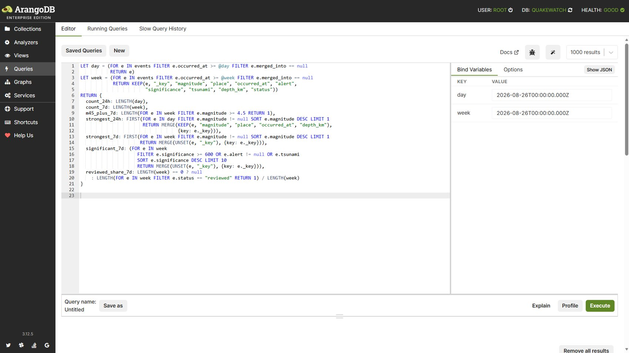
Figure 11: Query 2: Query editor with the dashboard summary AQL.
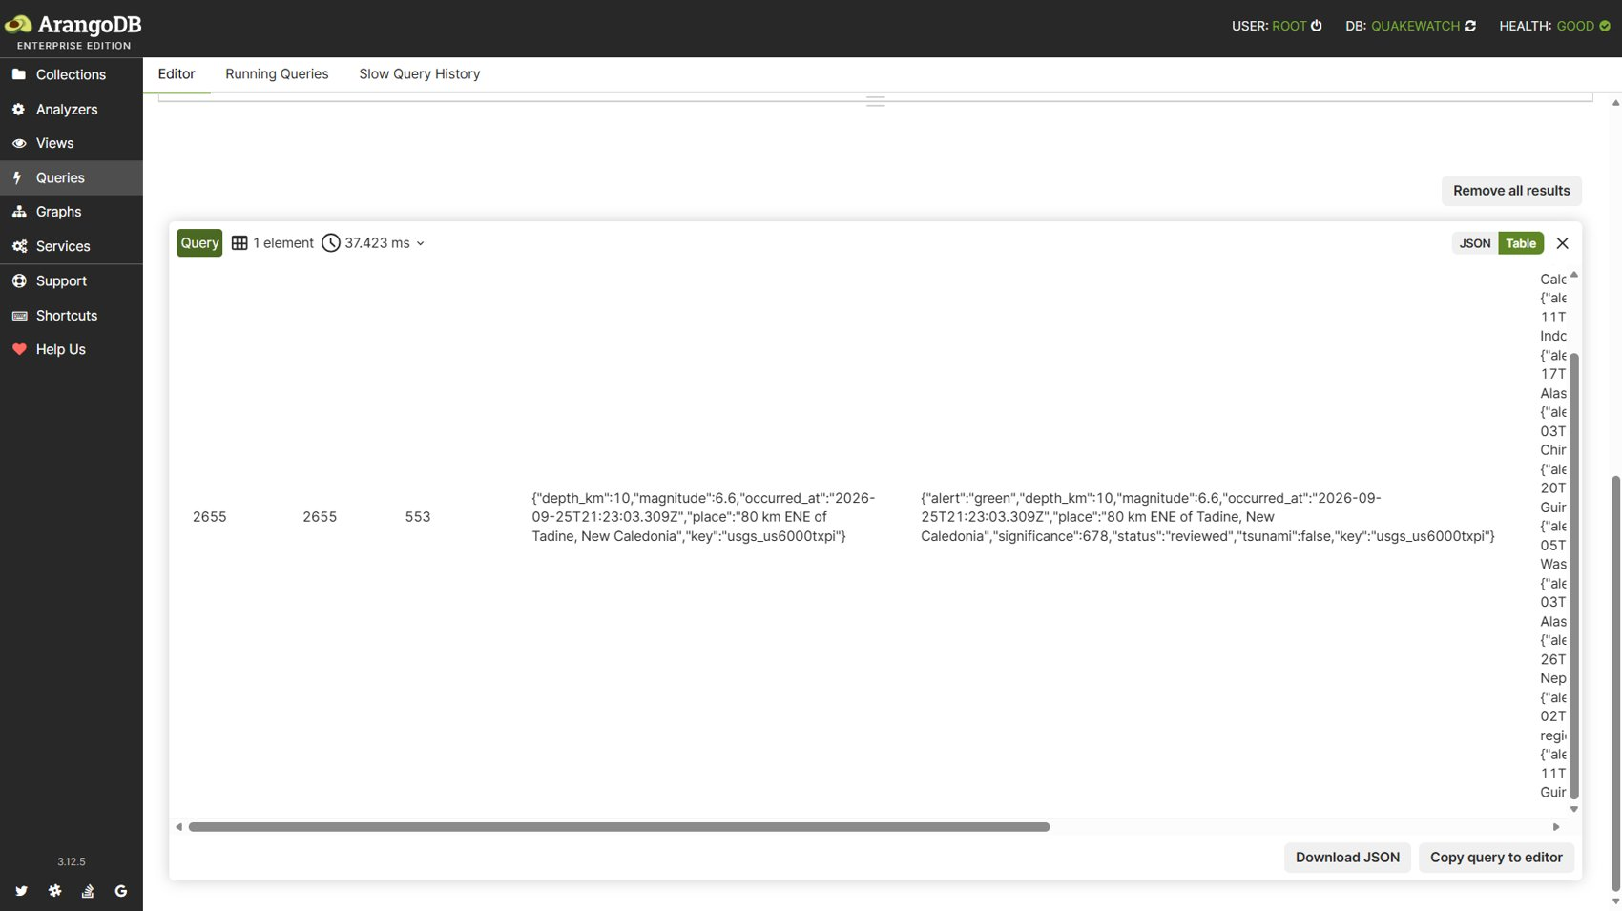
Figure 12: Query 2: Result: counts, strongest event and significant events.

3.3 Query 3: Per-network statistics joined to network names
Catalogue name: analytics_network_stats. Purpose: Per-network event statistics joined with network names via the graph (README Q11). Techniques: aggregation, join.
FOR e IN events
FILTER e.occurred_at >= @since FILTER e.merged_into == null
COLLECT code = e.network
AGGREGATE n = LENGTH(1), avg_mag = AVERAGE(e.magnitude), max_mag = MAX(e.magnitude),
reviewed = SUM(e.status == "reviewed" ? 1 : 0)
LET network = DOCUMENT("networks", code)
SORT n DESC
RETURN {network: code, name: network.name, count: n,
avg_magnitude: ROUND(avg_mag * 100) / 100, max_magnitude: max_mag,
reviewed_share: ROUND(reviewed / n * 1000) / 1000}

Bind variables: {"since": "2026-08-26T00:00:00.000Z"}
[
{
"network": "us",
"name": "USGS National Earthquake Information Center",
"count": 1295,
"avg_magnitude": 4.16,
"max_magnitude": 6.6,
"reviewed_share": 1
},
{
"network": "ak",
"name": "Alaska Earthquake Center",
"count": 617,
"avg_magnitude": 2.66,
"max_magnitude": 4.8,
"reviewed_share": 0.749
},
{
"network": "nc",
"name": "Northern California Seismic System",
"count": 191,
"avg_magnitude": 1.49,
"max_magnitude": 4.74,
"reviewed_share": 0.126
}
]

Result: 15 row(s) returned in 6.83 ms. Index chosen by the optimizer: qw_events_occurred_at.
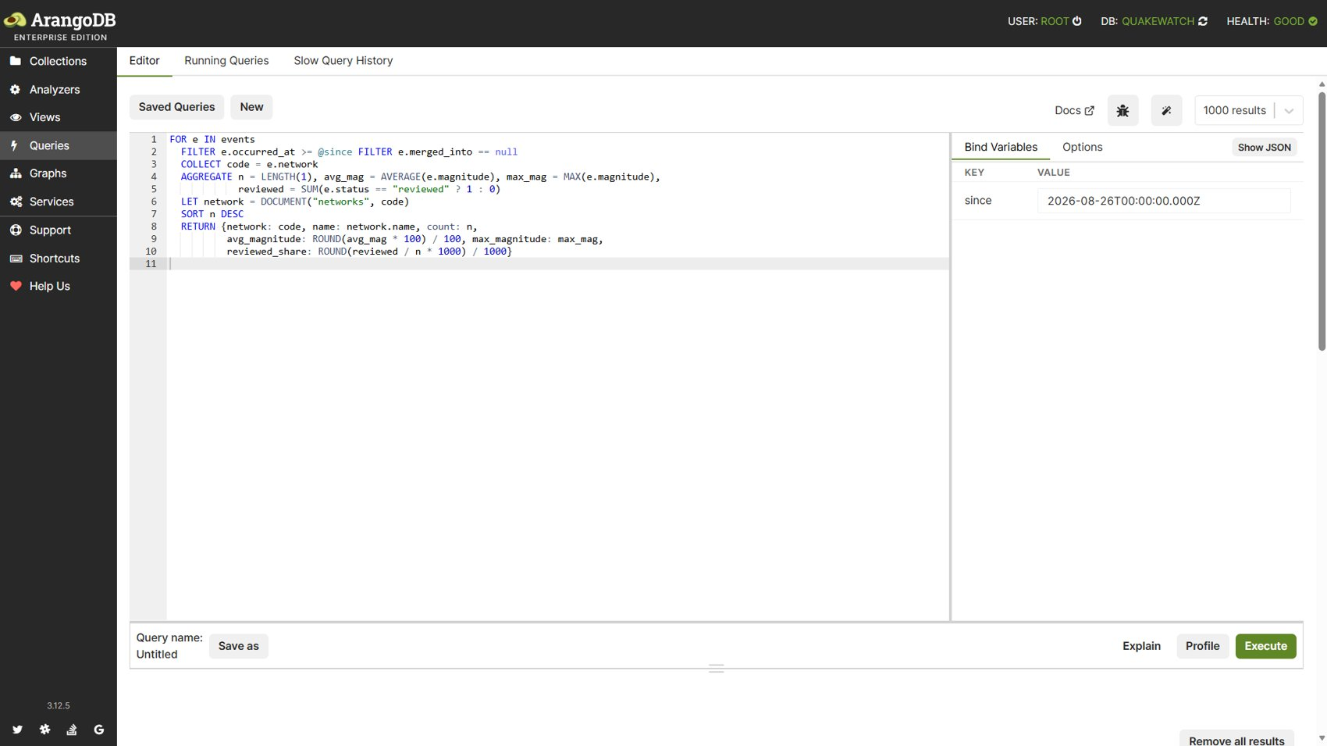
Figure 13: Query 3: Query editor with the network statistics AQL.
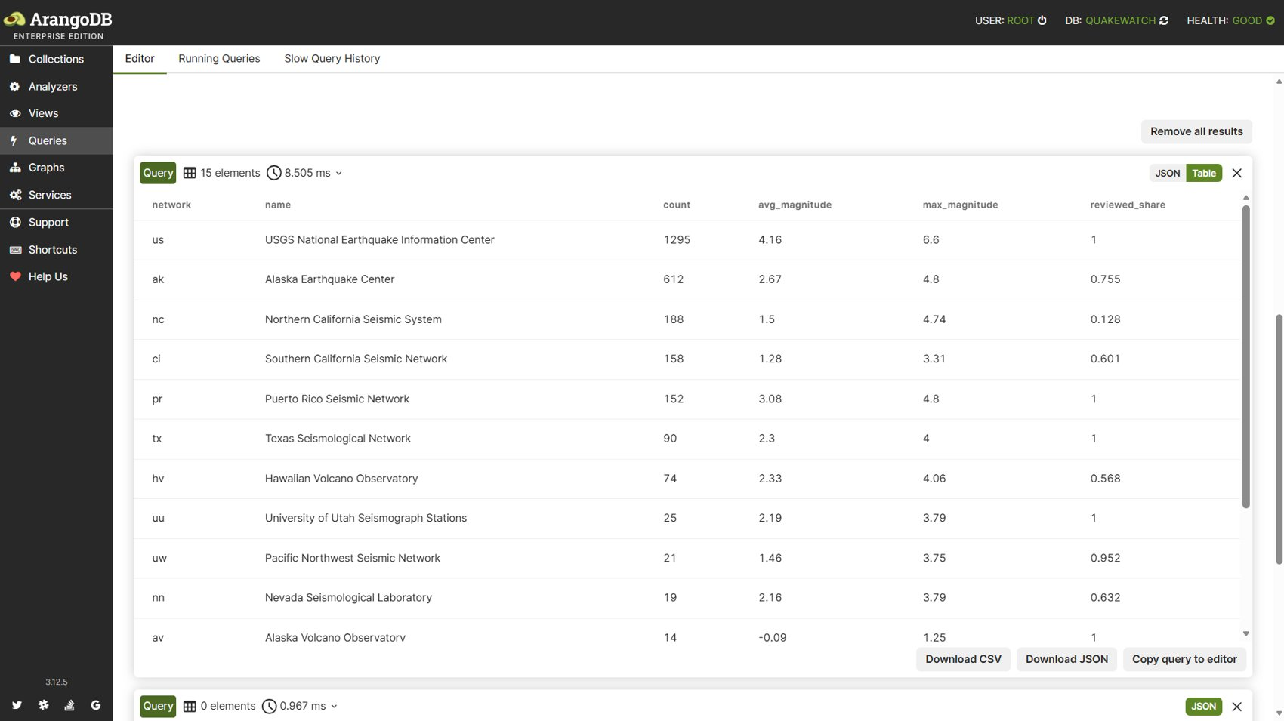
Figure 14: Query 3: Result table: 15 networks with names joined by DOCUMENT().

3.4 Query 4: Revisions with large magnitude changes (array index)
Catalogue name: analytics_magnitude_changes. Purpose: Revisions whose magnitude changed by at least a threshold (README Q14). Techniques: array index, join.
FOR r IN event_revisions
FILTER "magnitude" IN r.changed_fields[*]
FILTER r.before.magnitude != null AND r.after.magnitude != null
LET delta = r.after.magnitude - r.before.magnitude
FILTER ABS(delta) >= @threshold
SORT ABS(delta) DESC, r.observed_at DESC
LIMIT @limit
LET e = DOCUMENT("events", r.event_key)
RETURN {key: r.event_key, revision_number: r.revision_number, observed_at: r.observed_at,
before: r.before.magnitude, after: r.after.magnitude,
delta: ROUND(delta * 100) / 100, place: e.place}

Bind variables: {"threshold": 0.3, "limit": 20}
[
{
"key": "usgs_ci41339079",
"revision_number": 2,
"observed_at": "2026-09-26T11:25:00.784Z",
"before": 1.33521321207945,
"after": 0.26,
"delta": -1.08,
"place": "11 km SSW of Idyllwild, CA"
},
{
"key": "usgs_aka2026udvdhv",
"revision_number": 2,
"observed_at": "2026-10-11T14:35:01.152Z",
"before": 1.3,
"after": 2,
"delta": 0.7,
"place": "18 km N of Beluga, Alaska"
},
{
"key": "usgs_ci41338943",
"revision_number": 2,
"observed_at": "2026-09-25T17:22:14.930Z",
"before": 1.28,
"after": 0.64,
"delta": -0.64,
"place": "4 km WSW of Anza, CA"
}
]

Result: 10 row(s) returned in 3.15 ms. Index chosen by the optimizer: qw_revisions_changed_fields.
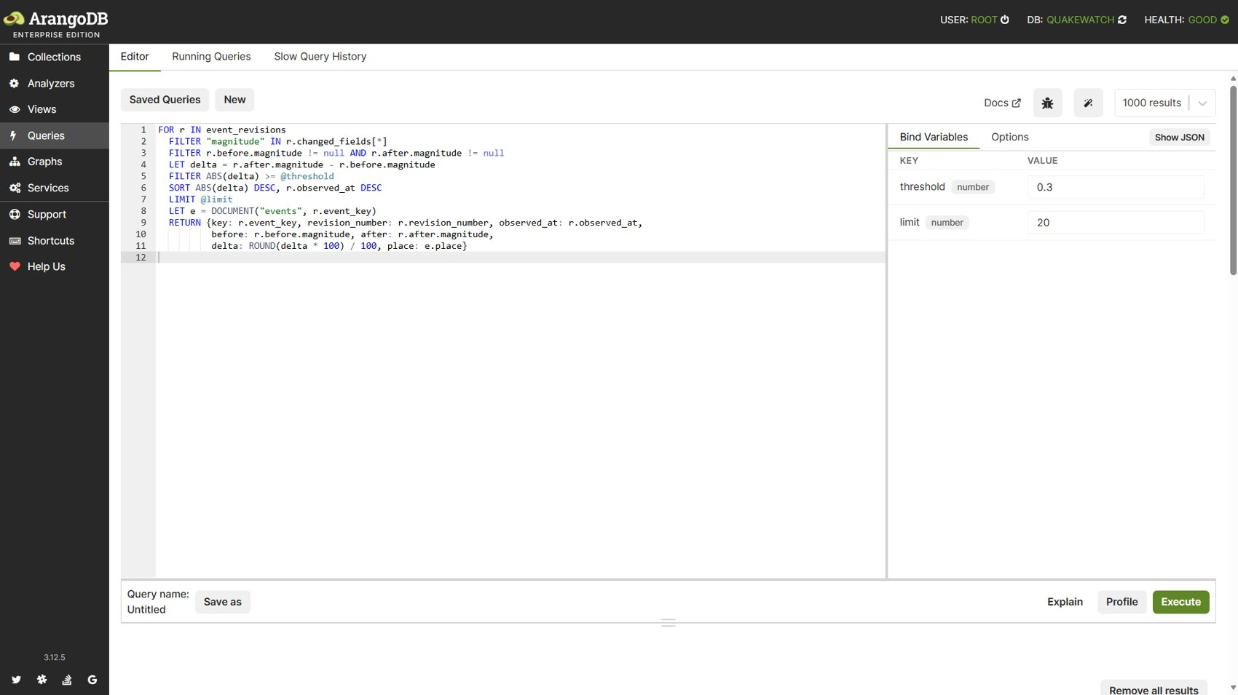
Figure 15: Query 4: Query editor with the revision-delta AQL (threshold 0.3).
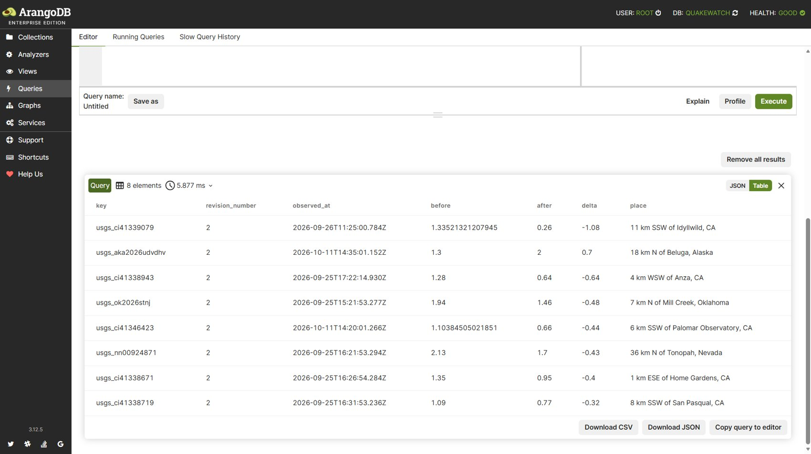
Figure 16: Query 4: Result: eight revisions whose magnitude changed by at least 0.3.

3.5 Query 5: Ingestion latency percentiles
Catalogue name: analytics_ingestion_latency. Purpose: Seconds from origin time to first observation by QuakeWatch, for events that occurred after live monitoring began (README Q15, derived value). Techniques: percentiles, subqueries.
LET monitoring_start = FIRST(
FOR r IN ingestion_runs OPTIONS {indexHint: "qw_runs_kind_started"}
FILTER r.kind == "feed_sync" AND r.status IN ["succeeded", "partial"]
SORT r.kind ASC, r.started_at ASC
LIMIT 1
RETURN r.started_at
)
LET since = monitoring_start == null ? @since : MAX([@since, monitoring_start])
LET latencies = (
FOR e IN events
FILTER e.occurred_at >= since FILTER e.merged_into == null
FILTER e.derived.first_seen_via == "feed" AND e.derived.first_seen_latency_s != null
RETURN e.derived.first_seen_latency_s
)
RETURN {
monitoring_start: monitoring_start,
count: LENGTH(latencies),
p50_s: LENGTH(latencies) == 0 ? null : PERCENTILE(latencies, 50),
p90_s: LENGTH(latencies) == 0 ? null : PERCENTILE(latencies, 90),
p99_s: LENGTH(latencies) == 0 ? null : PERCENTILE(latencies, 99),
min_s: MIN(latencies), max_s: MAX(latencies)
}

Bind variables: {"since": "2026-08-26T00:00:00.000Z"}
[
{
"monitoring_start": "2026-09-25T10:42:59.319Z",
"count": 442,
"p50_s": 26050.16,
"p90_s": 69140.77,
"p99_s": 84195.002,
"min_s": 120.047,
"max_s": 85659.403
}
]

Result: 1 row(s) returned in 3.29 ms. Index chosen by the optimizer: qw_events_occurred_at, qw_runs_kind_started.
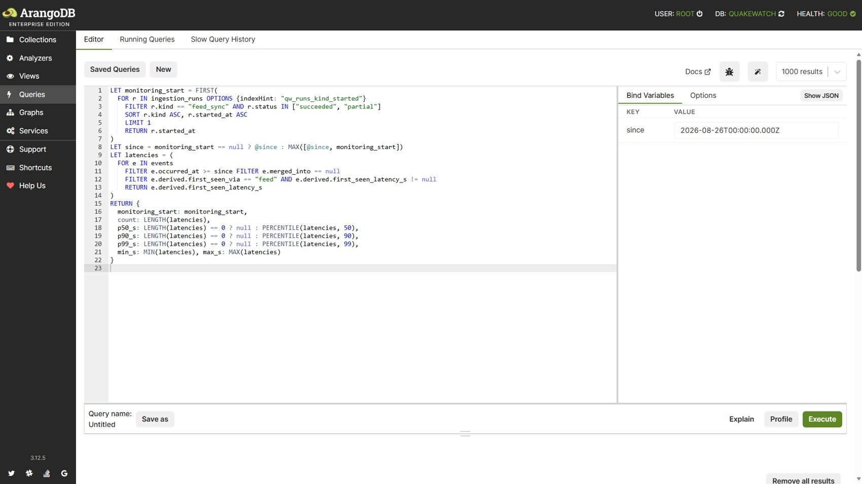
Figure 17: Query 5: Query editor with the latency percentile AQL.
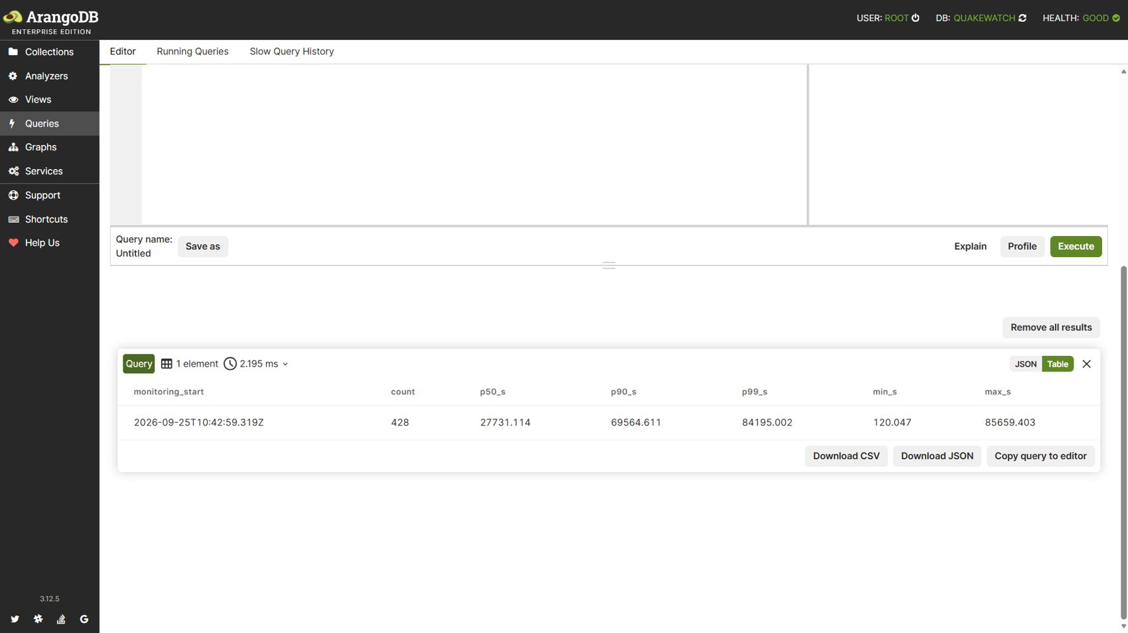
Figure 18: Query 5: Result: first-seen latency percentiles.

3.6 Query 6: Significant events per ISO week
Catalogue name: analytics_significant_by_week. Purpose: Significant events (significance ≥ 600, PAGER alert or tsunami flag) per ISO week (README Q12). Techniques: aggregation.
FOR e IN events
FILTER e.occurred_at >= @since FILTER e.merged_into == null
FILTER e.significance >= 600 OR e.alert != null OR e.tsunami
LET iso = DATE_ISOWEEKYEAR(e.occurred_at)
COLLECT week = CONCAT(iso.year, "-W", RIGHT(CONCAT("0", iso.week), 2)) INTO members = e
SORT week
RETURN {week: week, count: LENGTH(members),
strongest: MAX(members[*].magnitude)}

Bind variables: {"since": "2026-08-26T00:00:00.000Z"}
[
{
"week": "2026-W35",
"count": 5,
"strongest": 5.9
},
{
"week": "2026-W36",
"count": 24,
"strongest": 6.3
},
{
"week": "2026-W37",
"count": 8,
"strongest": 6.5
}
]

Result: 6 row(s) returned in 9.78 ms. Index chosen by the optimizer: qw_events_occurred_at.
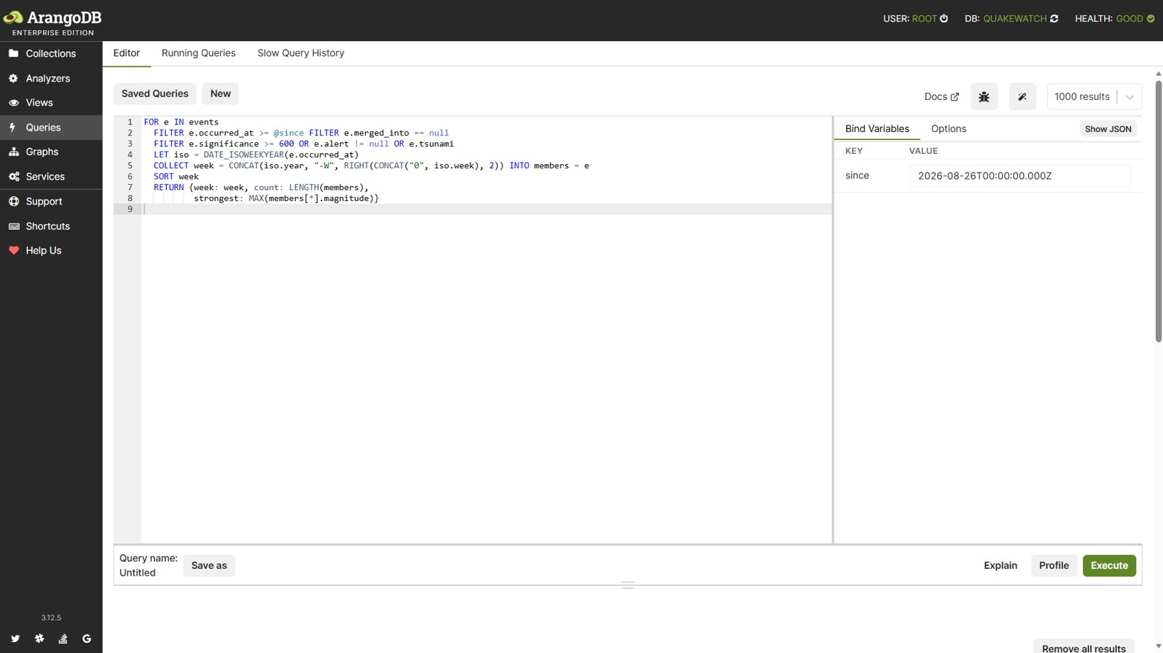
Figure 19: Query 6: Query editor with the ISO-week AQL.
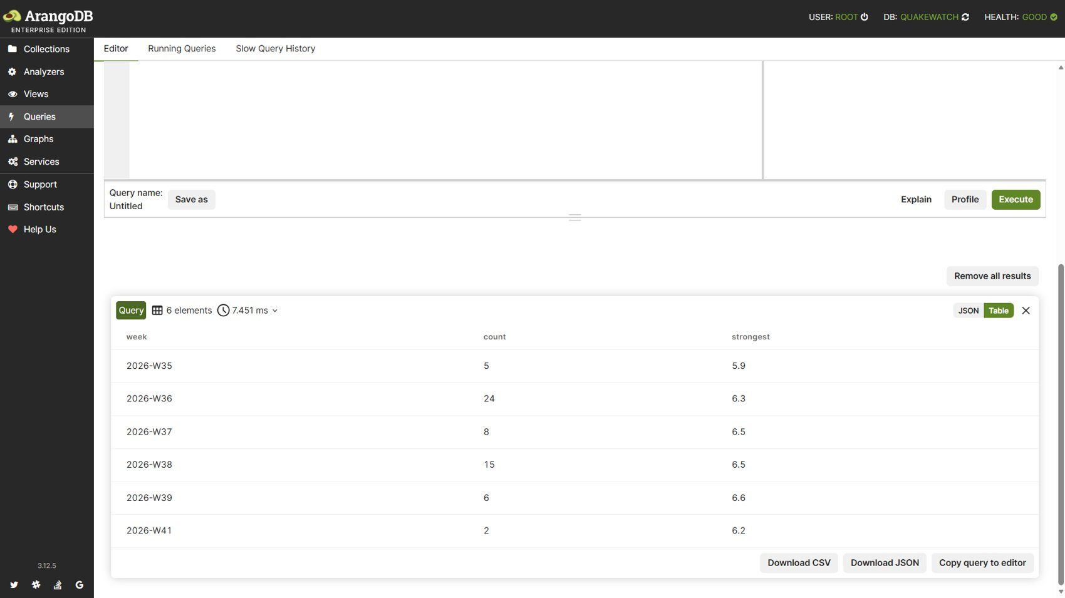
Figure 20: Query 6: Result: six weeks with counts and strongest magnitude.

3.7 Query 7: A user's alert rules with match counts (edge traversal)
Catalogue name: alerts_user_rules. Purpose: A user's alert rules with match counts (CRUD list). Techniques: persistent index, graph traversal.
FOR r IN alert_rules
FILTER r.user_id == @user_id
SORT r.created_at DESC
LET matches = LENGTH(FOR v IN 1..1 OUTBOUND r rule_matched_event RETURN 1)
RETURN MERGE(UNSET(r, "_id", "_rev", "_key"), {id: r._key, match_count: matches})

Bind variables: {"user_id": 2}
[
{
"conditions": {
"minimum_magnitude": 1,
"maximum_depth_km": null,
"minimum_depth_km": null,
"center": null,
"radius_km": null,
"alert_levels": [],
"tsunami_only": false,
"event_types": [
"earthquake"
]
},
"cooldown_minutes": 0,
"created_at": "2026-10-11T16:49:28.349Z",
"enabled": true,
"name": "Global M1.0+ evidence rule",
"updated_at": "2026-10-11T16:49:28.349Z",
"user_id": 2,
"match_count": 1,
"id": "baa80123a8d144709a4d91f1a3996973"
}
]

Result: 1 row(s) returned in 2.18 ms. Index chosen by the optimizer: edge, qw_rules_user.
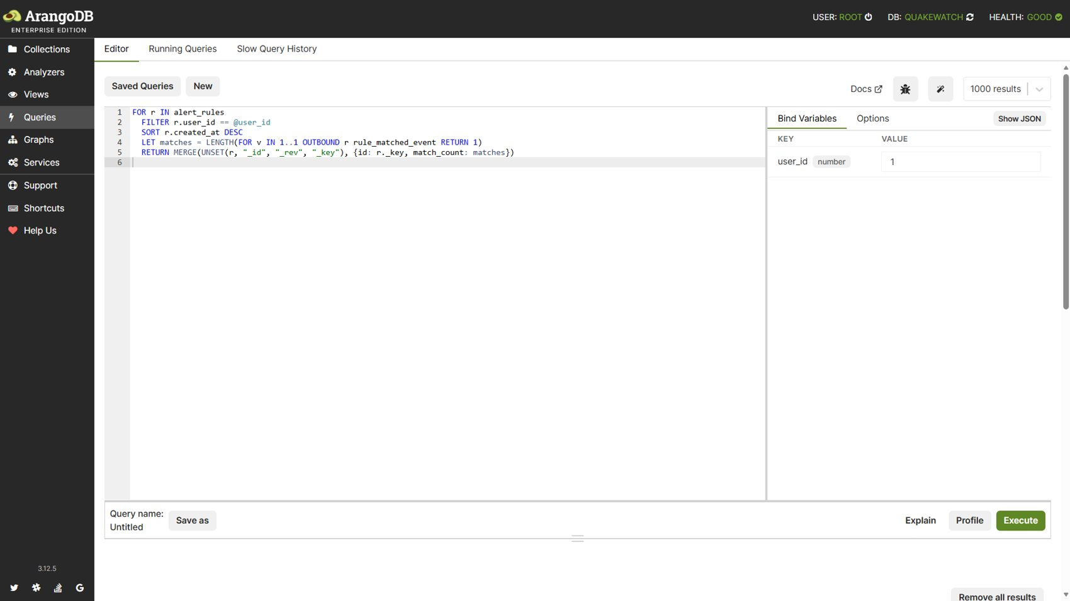
Figure 21: Query 7: Query editor with the user-rules AQL (user_id 1).
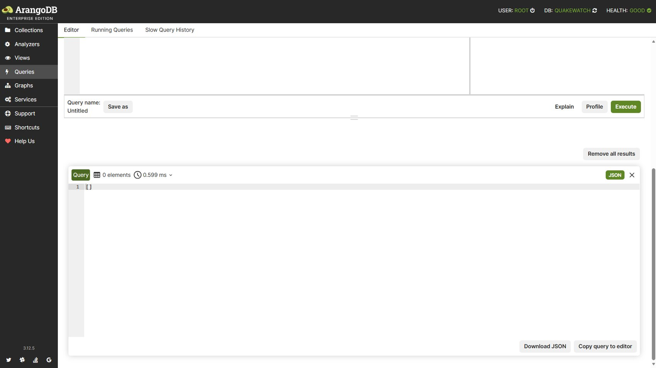
Figure 22: Query 7: Result: empty array, the user owned no rules at that moment.

3.8 Query 8: Matched events through a two-hop graph traversal
Catalogue name: alerts_matched_events_graph. Purpose: Events matched by any of a user's watch rules via 2-hop traversal users → rules → events (README Q13). Techniques: graph traversal, 2 hops.
FOR rule IN 1..1 OUTBOUND CONCAT("users/", @user_id) user_owns_rule
FOR ev, edge IN 1..1 OUTBOUND rule rule_matched_event
FILTER ev.merged_into == null
SORT edge.matched_at DESC
LIMIT @limit
RETURN {rule: rule.name, rule_id: rule._key, event_key: ev._key,
magnitude: ev.magnitude, place: ev.place, occurred_at: ev.occurred_at,
matched_at: edge.matched_at}

Bind variables: {"user_id": 2, "limit": 20}
[
{
"rule": "Global M1.0+ evidence rule",
"rule_id": "baa80123a8d144709a4d91f1a3996973",
"event_key": "usgs_aka2026udzskb",
"magnitude": 2.4,
"place": "22 km NNW of Nikiski, Alaska",
"occurred_at": "2026-10-11T16:45:11.678Z",
"matched_at": "2026-10-11T16:50:01.966Z"
}
]

Result: 1 row(s) returned in 1.22 ms. Index chosen by the optimizer: edge.
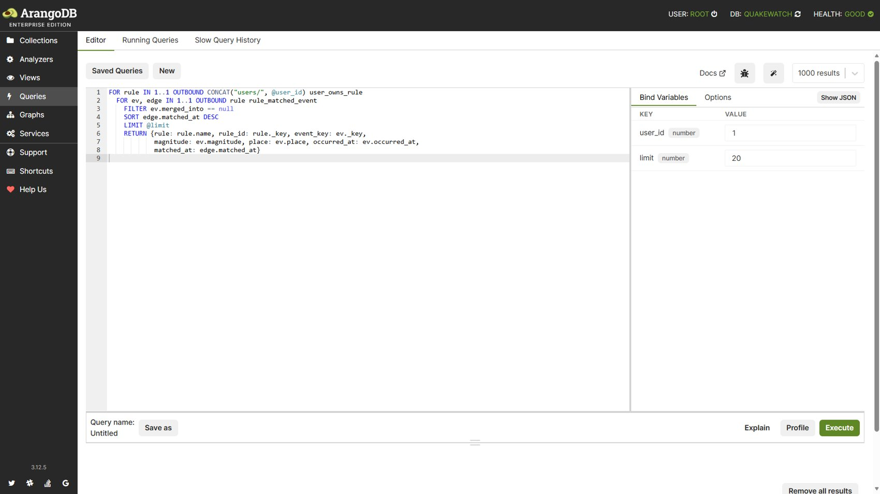
Figure 23: Query 8: Query editor with the two-hop traversal AQL.
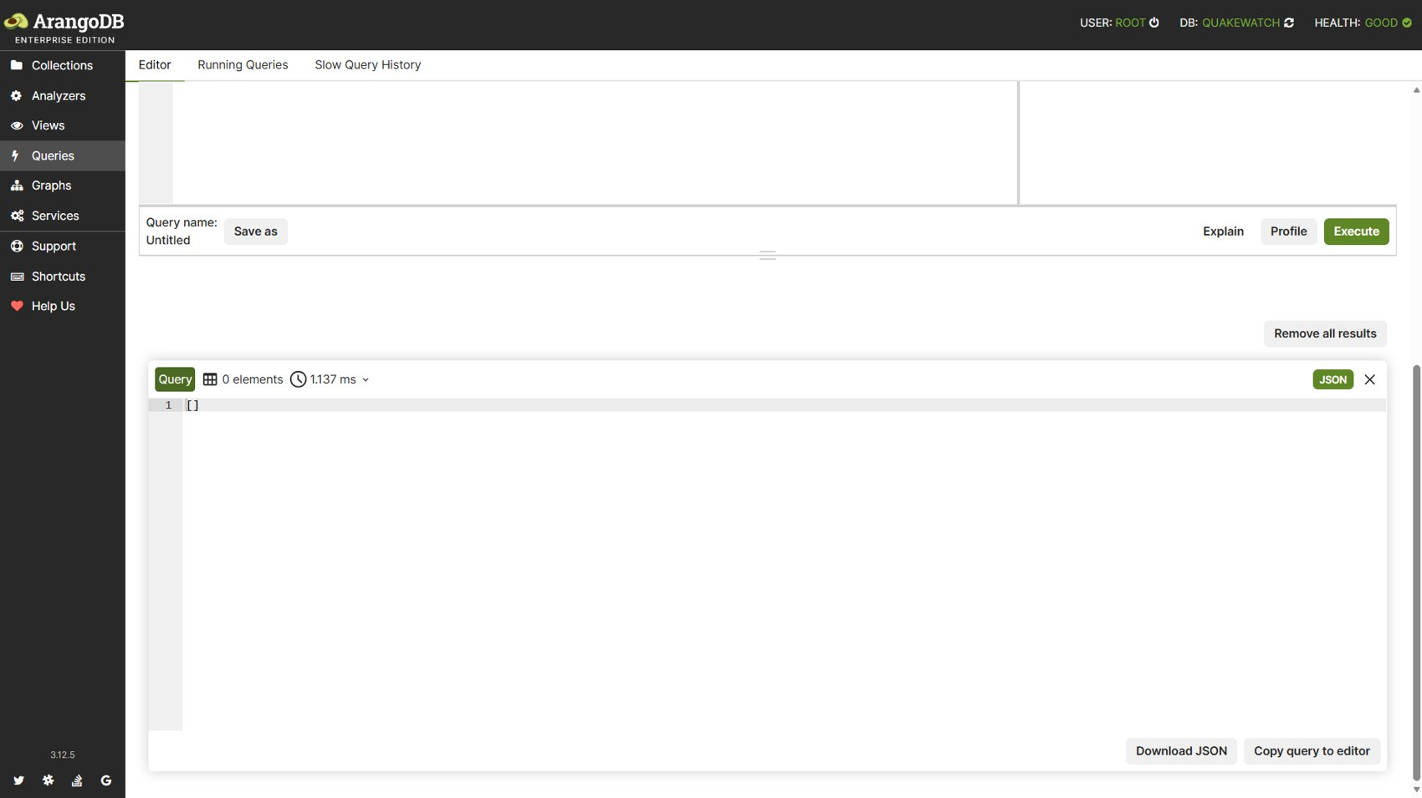
Figure 24: Query 8: Result: empty array for the same user.

3.9 Query 9: Event relationships (OUTBOUND and INBOUND traversal)
Catalogue name: event_graph_relationships. Purpose: Region and network of an event and other recent events in the same region (graph traversal event → region ← events; README Q10). Techniques: graph traversal, OUTBOUND, INBOUND.
LET start = DOCUMENT("events", @key)
LET region = FIRST(FOR v IN 1..1 OUTBOUND start event_in_region RETURN v)
LET network = FIRST(FOR v IN 1..1 OUTBOUND start event_reported_by_network RETURN v)
LET same_region = region == null ? [] : (
FOR other IN 1..1 INBOUND region event_in_region
FILTER other._key != @key AND other.merged_into == null
SORT other.occurred_at DESC
LIMIT @limit
RETURN MERGE(KEEP(other, "magnitude", "place", "occurred_at", "depth_km"),
{key: other._key})
)
LET region_total = region == null ? 0 : LENGTH(
FOR other IN 1..1 INBOUND region event_in_region
FILTER other.merged_into == null RETURN 1)
RETURN {region: region == null ? null : UNSET(region, "_id", "_rev"),
network: network == null ? null : UNSET(network, "_id", "_rev"),
same_region: same_region, region_event_count: region_total}

Bind variables: {"key": "usgs_aka2026szyrbl", "limit": 10}
[
{
"region": {
"_key": "alaska",
"kind": "us_state",
"method_version": 1,
"name": "Alaska"
},
"network": {
"_key": "ak",
"code": "ak",
"name": "Alaska Earthquake Center"
},
"same_region": [
{
"depth_km": 13.7,
"magnitude": 1.5,
"occurred_at": "2026-10-11T16:55:32.687Z",
"place": "4 km NNE of Susitna North, Alaska",
"key": "usgs_aka2026ueabjp"
},
{
"depth_km": 5,
"magnitude": 1.3,
"occurred_at": "2026-10-11T16:50:17.579Z",
"place": "22 km NE of Minto, Alaska",
"key": "usgs_aka2026udzwvf"
},
"..."
],
"region_event_count": 983
}
]

Result: 1 row(s) returned in 31.85 ms. Index chosen by the optimizer: edge.
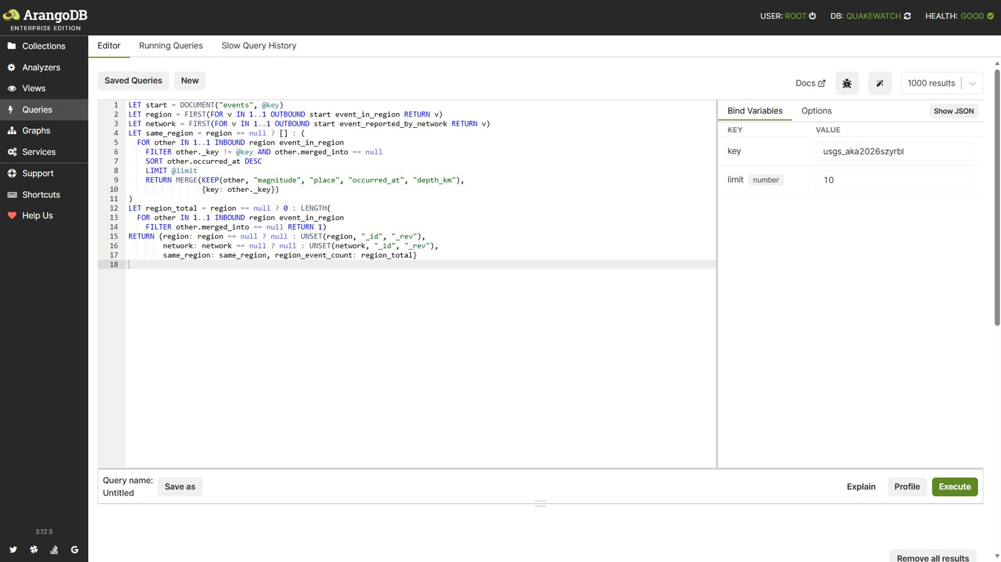
Figure 25: Query 9: Query editor with the relationship AQL (event usgs_aka2026szyrbl).
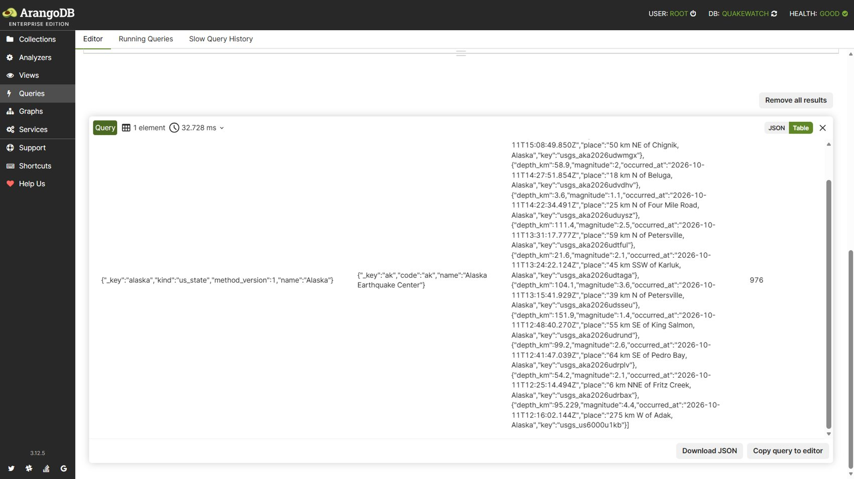
Figure 26: Query 9: Result: region, network and events in the same region.

3.10 Query 10: Map viewport search (GEO_CONTAINS)
Catalogue name: events_in_viewport. Purpose: Events inside a map viewport bounding box. Techniques: geo index, GEO_CONTAINS.
LET total = FIRST(
FOR e IN events
FILTER GEO_CONTAINS(@bbox0, e.coordinates)
FILTER e.merged_into == null
COLLECT WITH COUNT INTO n
RETURN n
)
LET rows = (
FOR e IN events
FILTER GEO_CONTAINS(@bbox0, e.coordinates)
FILTER e.merged_into == null
SORT e.occurred_at DESC, e._key DESC
LIMIT @offset, @limit
RETURN MERGE(KEEP(e, @fields), {key: e._key, region_name: e.derived.region_name})
)
RETURN {total: total, rows: rows}

Bind variables: {"bbox0": {"type": "Polygon", "coordinates": [[[-170.0, 50.0], [-130.0, 50.0], [-130.0, 72.0], [-170.0, 72.0], [-170.0, 50.0]]]}, "fields": ["source_event_id", "magnitude", "magnitude_type", "place", "occurred_at", "depth_km", "latitude", "longitude", "alert", "status", "tsunami", "network", "significance", "event_type", "felt", "revision_count", "source_updated_at"], "offset": 0, "limit": 25}
[
{
"total": 750,
"rows": [
{
"alert": null,
"depth_km": 72.7,
"event_type": "earthquake",
"felt": null,
"latitude": 60.87,
"longitude": -151.479,
"magnitude": 2.4,
"magnitude_type": "ml",
"network": "ak",
"occurred_at": "2026-10-11T16:45:11.678Z",
"place": "22 km NNW of Nikiski, Alaska",
"revision_count": 1,
"significance": 89,
"source_event_id": "aka2026udzskb",
"source_updated_at": "2026-10-11T16:48:40.440Z",
"status": "automatic",
"tsunami": false,
"region_name": "Alaska",
"key": "usgs_aka2026udzskb"
},
{
"alert": null,
"depth_km": 73.1,
"event_type": "earthquake",
"felt": null,
"latitude": 62.952,
"longitude": -149.616,
"magnitude": 2,
"magnitude_type": "ml",
"network": "ak",
"occurred_at": "2026-10-11T16:36:41.635Z",
"place": "59 km SW of Cantwell, Alaska",
"revision_count": 2,
"significance": 62,
... (truncated for the report)

Result: 1 row(s) returned in 9.77 ms. Index chosen by the optimizer: qw_events_geo.
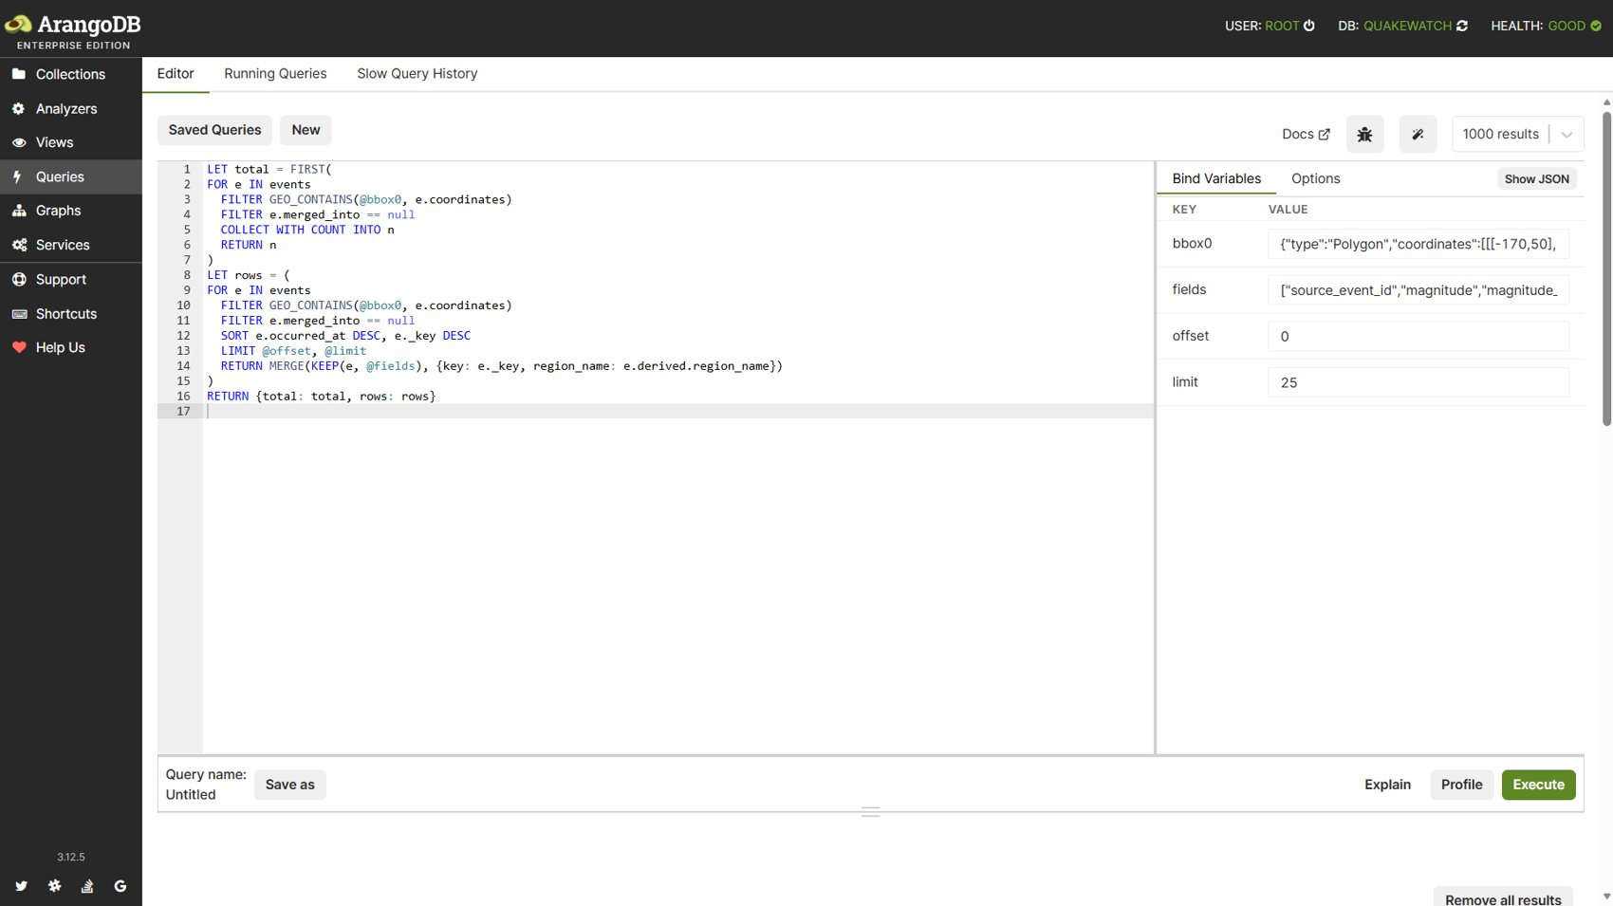
Figure 27: Query 10: Query editor with the GEO_CONTAINS viewport AQL.
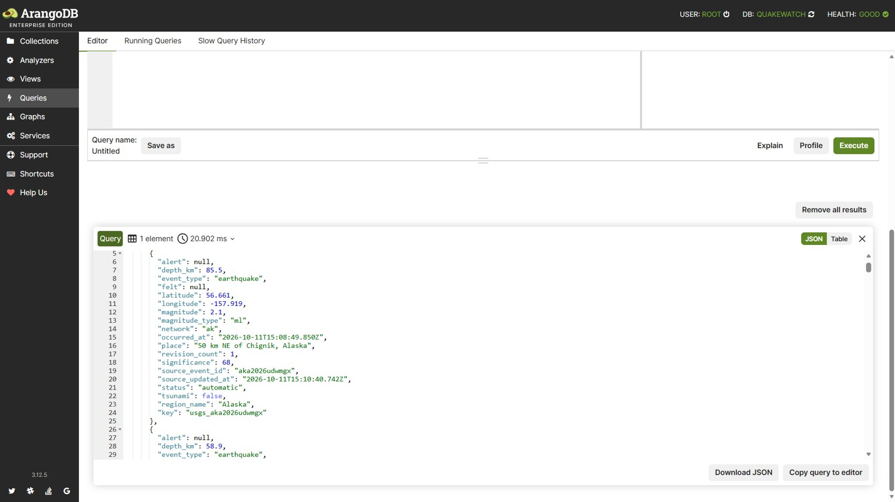
Figure 28: Query 10: Result: total and the first matching events.

3.11 Query 11: Radius search (GEO_DISTANCE)
Catalogue name: events_within_radius. Purpose: Events within a geographic radius of a point (README Q2). Techniques: geo index, GEO_DISTANCE.
LET total = FIRST(
FOR e IN events
FILTER GEO_DISTANCE(e.coordinates, [@lon, @lat]) <= @radius_m
FILTER e.magnitude >= @min_mag
FILTER e.merged_into == null
COLLECT WITH COUNT INTO n
RETURN n
)
LET rows = (
FOR e IN events
FILTER GEO_DISTANCE(e.coordinates, [@lon, @lat]) <= @radius_m
FILTER e.magnitude >= @min_mag
FILTER e.merged_into == null
SORT e.occurred_at DESC, e._key DESC
LIMIT @offset, @limit
RETURN MERGE(KEEP(e, @fields), {key: e._key, region_name: e.derived.region_name})
)
RETURN {total: total, rows: rows}

Bind variables: {"lon": -149.9, "lat": 61.2, "radius_m": 300000.0, "min_mag": 2.5, "fields": ["source_event_id", "magnitude", "magnitude_type", "place", "occurred_at", "depth_km", "latitude", "longitude", "alert", "status", "tsunami", "network", "significance", "event_type", "felt", "revision_count", "source_updated_at"], "offset": 0, "limit": 25}
[
{
"total": 93,
"rows": [
{
"alert": null,
"depth_km": 111.4,
"event_type": "earthquake",
"felt": null,
"latitude": 63.026,
"longitude": -150.653,
"magnitude": 2.5,
"magnitude_type": "ml",
"network": "ak",
"occurred_at": "2026-10-11T13:31:17.777Z",
"place": "59 km N of Petersville, Alaska",
"revision_count": 2,
"significance": 96,
"source_event_id": "aka2026udtful",
"source_updated_at": "2026-10-11T13:34:19.703Z",
"status": "automatic",
"tsunami": false,
"region_name": "Alaska",
"key": "usgs_aka2026udtful"
},
{
"alert": null,
"depth_km": 104.1,
"event_type": "earthquake",
"felt": null,
"latitude": 62.853,
"longitude": -150.688,
"magnitude": 3.6,
"magnitude_type": "ml",
"network": "ak",
"occurred_at": "2026-10-11T13:15:41.929Z",
"place": "39 km N of Petersville, Alaska",
"revision_count": 2,
... (truncated for the report)

Result: 1 row(s) returned in 3.52 ms. Index chosen by the optimizer: qw_events_geo.
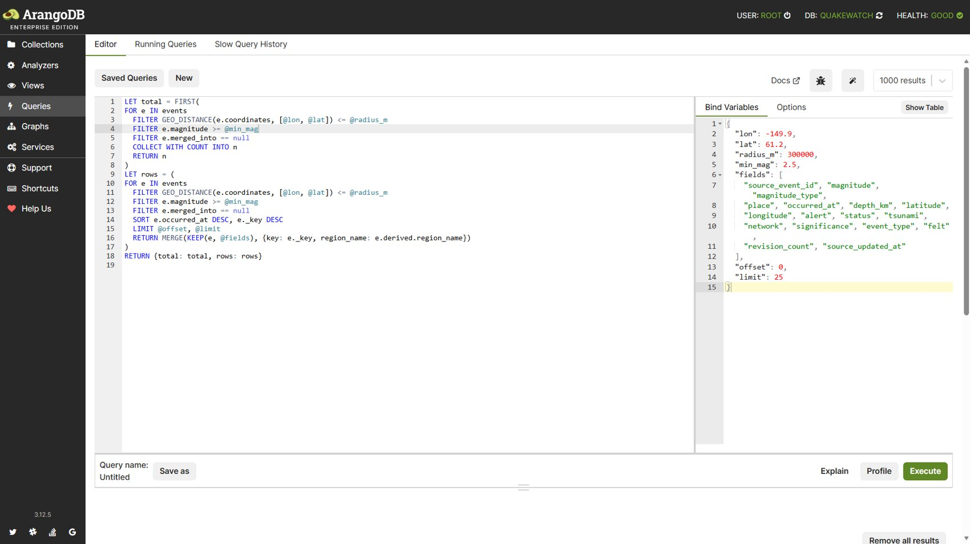
Figure 29: Query 11: Query editor with the GEO_DISTANCE radius AQL.
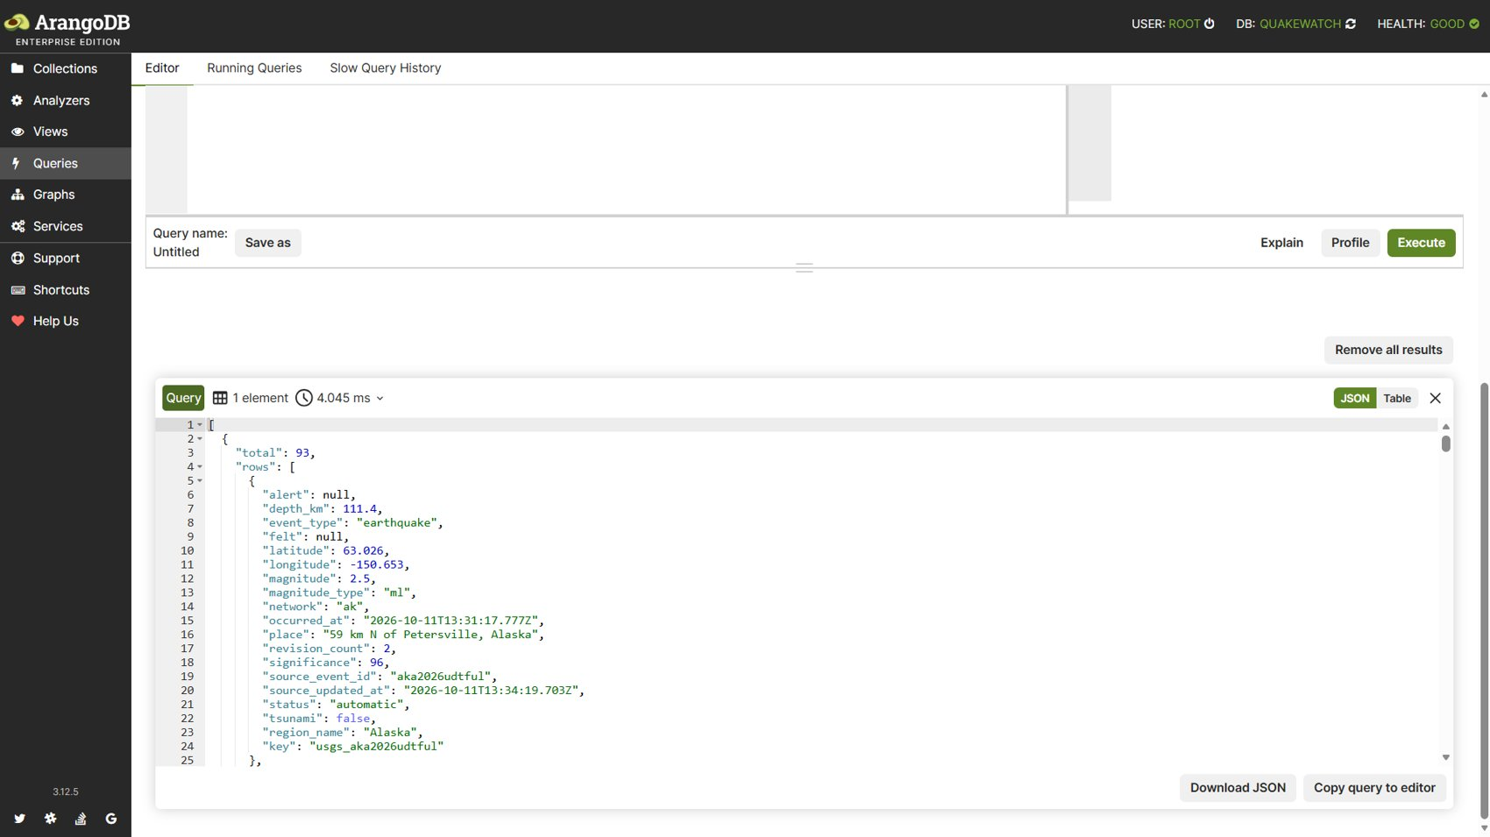
Figure 30: Query 11: Result: 93 events within 300 km of Anchorage with magnitude 2.5 or more.

3.12 Query 12: Location text search (ArangoSearch view)
Catalogue name: events_location_text. Purpose: Full-text location search over place and derived region (ArangoSearch view). Techniques: ArangoSearch view, text analyzer.
LET total = FIRST(
FOR e IN events_search SEARCH ANALYZER(TOKENS(@q, 'text_en') ALL == e.place, 'text_en') OR ANALYZER(TOKENS(@q, 'text_en') ALL == e.derived.region_name, 'text_en')
FILTER e.merged_into == null
COLLECT WITH COUNT INTO n
RETURN n
)
LET rows = (
FOR e IN events_search SEARCH ANALYZER(TOKENS(@q, 'text_en') ALL == e.place, 'text_en') OR ANALYZER(TOKENS(@q, 'text_en') ALL == e.derived.region_name, 'text_en')
FILTER e.merged_into == null
SORT e.occurred_at DESC, e._key DESC
LIMIT @offset, @limit
RETURN MERGE(KEEP(e, @fields), {key: e._key, region_name: e.derived.region_name})
)
RETURN {total: total, rows: rows}

Bind variables: {"q": "fiji islands", "fields": ["source_event_id", "magnitude", "magnitude_type", "place", "occurred_at", "depth_km", "latitude", "longitude", "alert", "status", "tsunami", "network", "significance", "event_type", "felt", "revision_count", "source_updated_at"], "offset": 0, "limit": 25}
[
{
"total": 20,
"rows": [
{
"alert": null,
"depth_km": 546.339,
"event_type": "earthquake",
"felt": null,
"latitude": -23.6919,
"longitude": 179.9648,
"magnitude": 4.5,
"magnitude_type": "mb",
"network": "us",
"occurred_at": "2026-10-11T07:28:52.878Z",
"place": "south of the Fiji Islands",
"revision_count": 1,
"significance": 312,
"source_event_id": "us6000u1j3",
"source_updated_at": "2026-10-11T07:46:37.040Z",
"status": "reviewed",
"tsunami": false,
"region_name": "south of the Fiji Islands",
"key": "usgs_us6000u1j3"
},
{
"alert": null,
"depth_km": 587.386,
"event_type": "earthquake",
"felt": null,
"latitude": -22.071,
"longitude": -179.5886,
"magnitude": 4.6,
"magnitude_type": "mb",
"network": "us",
"occurred_at": "2026-10-10T13:40:44.101Z",
"place": "south of the Fiji Islands",
"revision_count": 1,
... (truncated for the report)

Result: 1 row(s) returned in 4.11 ms. Index chosen by the optimizer: ArangoSearch view (no secondary index).
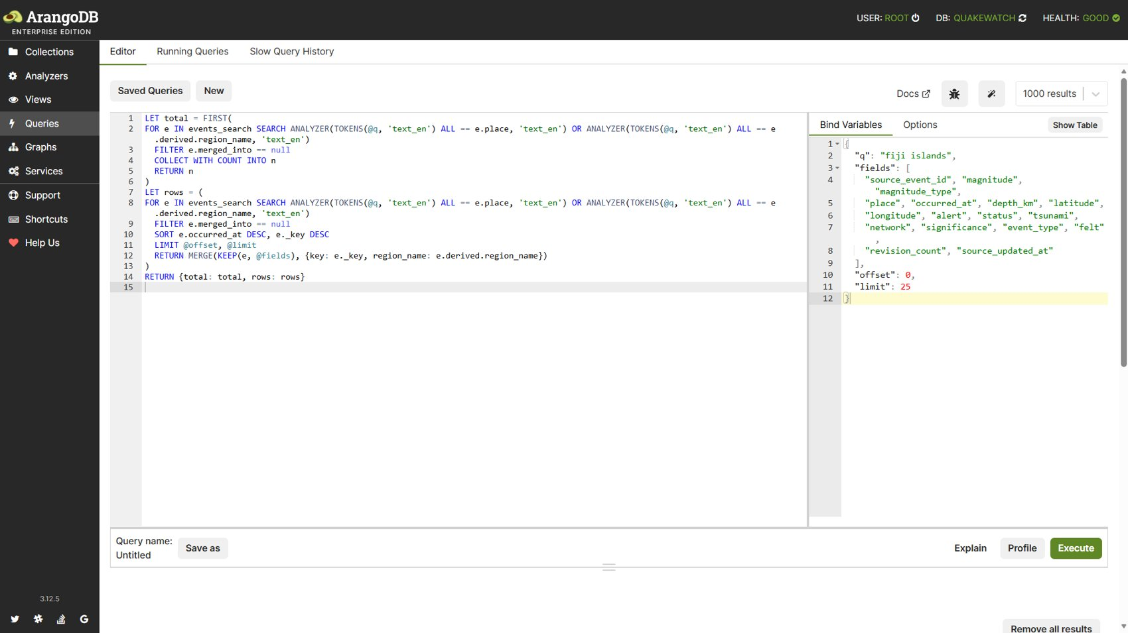
Figure 31: Query 12: Query editor with the ArangoSearch AQL (q = fiji islands).
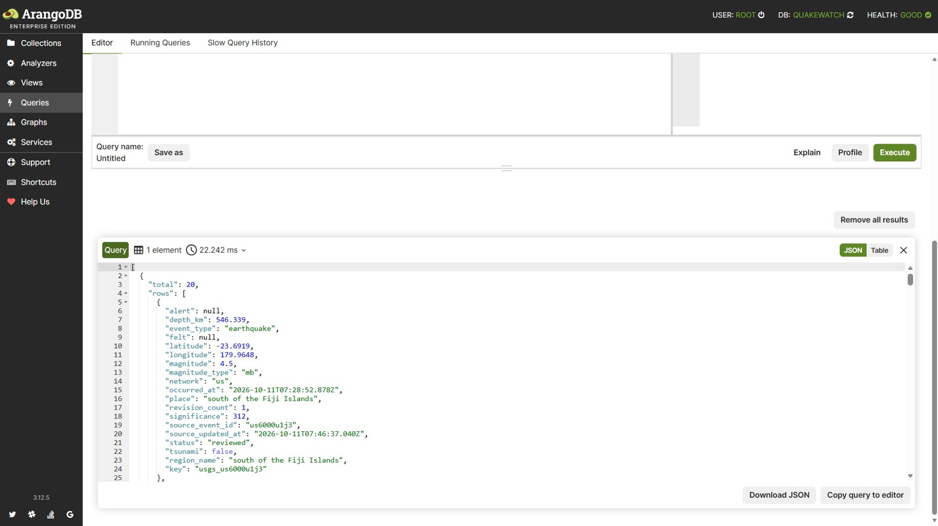
Figure 32: Query 12: Result: 20 matching events.

3.13 Query 13: Ingestion run statistics by kind
Catalogue name: ops_run_stats. Purpose: Run outcomes and durations per kind since a timestamp (success rate, p95). Techniques: aggregation, percentiles, array operators.
FOR r IN ingestion_runs
FILTER r.started_at >= @since
COLLECT kind = r.kind INTO runs = r
LET durations = runs[* FILTER CURRENT.duration_ms != null RETURN CURRENT.duration_ms]
RETURN {
kind: kind,
total: LENGTH(runs),
by_status: MERGE(FOR st IN UNIQUE(runs[*].status)
RETURN {[st]: LENGTH(runs[* FILTER CURRENT.status == st])}),
p50_ms: LENGTH(durations) == 0 ? null : PERCENTILE(durations, 50),
p95_ms: LENGTH(durations) == 0 ? null : PERCENTILE(durations, 95)
}

Bind variables: {"since": "2026-09-01T00:00:00.000Z"}
[
{
"kind": "backfill_window",
"total": 6,
"by_status": {
"failed": 1,
"succeeded": 5
},
"p50_ms": 14509.7,
"p95_ms": 25695.6
},
{
"kind": "detail_enrichment",
"total": 8,
"by_status": {
"succeeded": 8
},
"p50_ms": 561.9,
"p95_ms": 1335.3
},
{
"kind": "feed_sync",
"total": 135,
"by_status": {
"succeeded": 135
},
"p50_ms": 720.5,
"p95_ms": 1660.6
}
]

Result: 3 row(s) returned in 2.04 ms. Index chosen by the optimizer: qw_runs_kind_started.
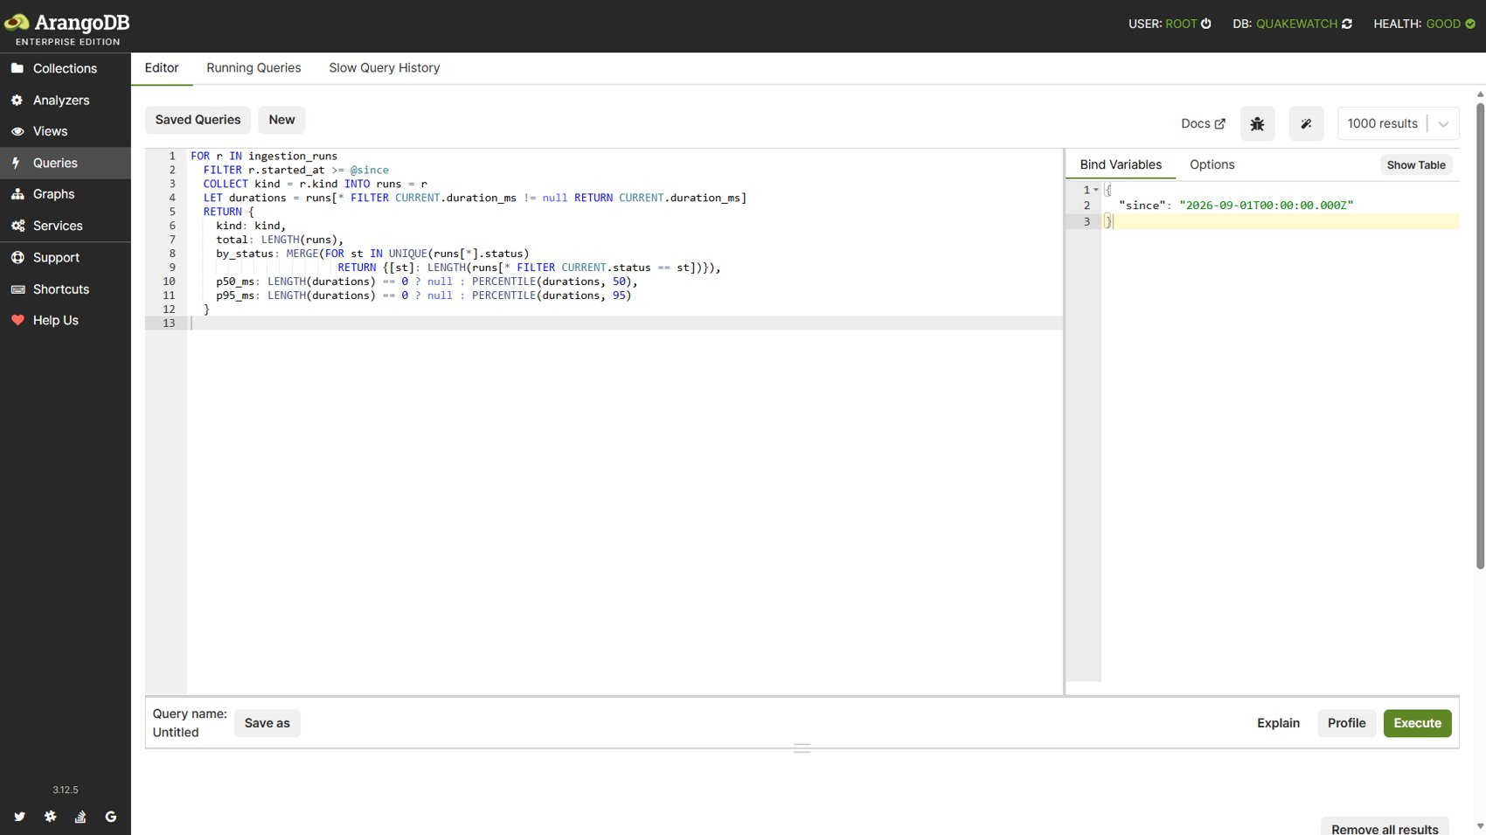
Figure 33: Query 13: Query editor with the run-statistics AQL.
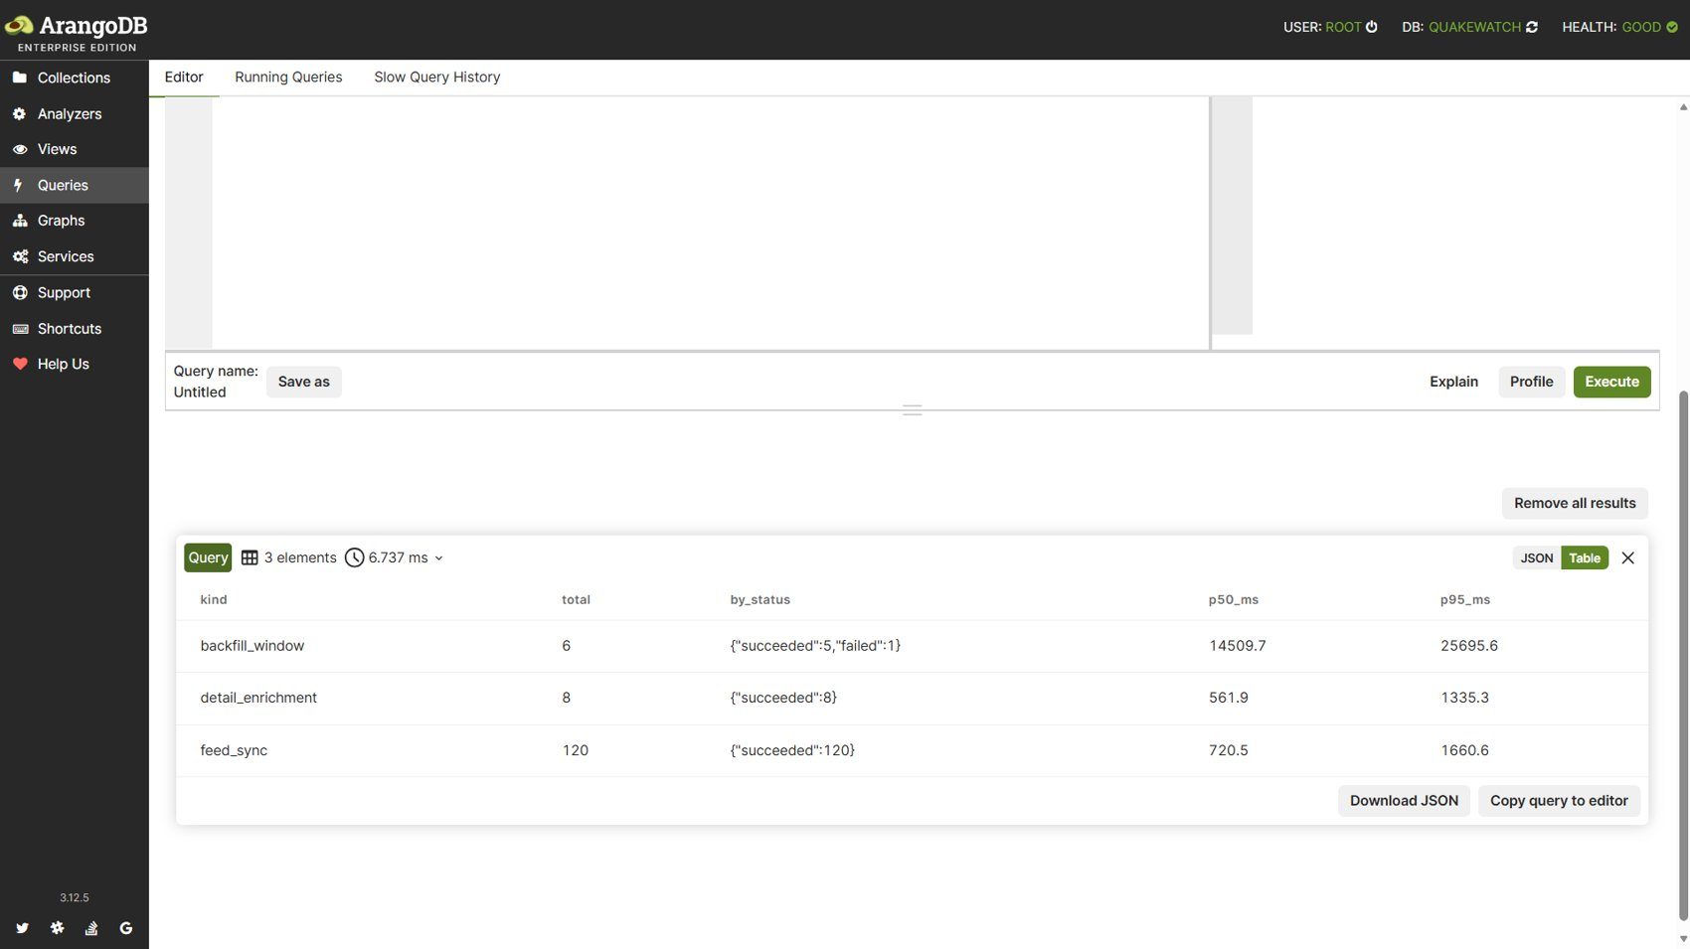
Figure 34: Query 13: Result: per-kind run counts, status mix and latency percentiles.

3.14 Query 14: Depth histogram (bucketed aggregation)
Catalogue name: analytics_depth_histogram. Purpose: Depth distribution (shallow < 70 km, intermediate 70 to 300 km, deep > 300 km, 10 km bins). Techniques: aggregation.
FOR e IN events
FILTER e.occurred_at >= @since FILTER e.merged_into == null FILTER e.depth_km != null
COLLECT bin = FLOOR(e.depth_km / 10) * 10 WITH COUNT INTO n
SORT bin
RETURN {bin: bin, count: n}

Bind variables: {"since": "2026-08-26T00:00:00.000Z"}
[
{
"bin": -10,
"count": 27
},
{
"bin": 0,
"count": 683
},
{
"bin": 10,
"count": 910
}
]

Result: 59 row(s) returned in 8.96 ms. Index chosen by the optimizer: qw_events_occurred_at.
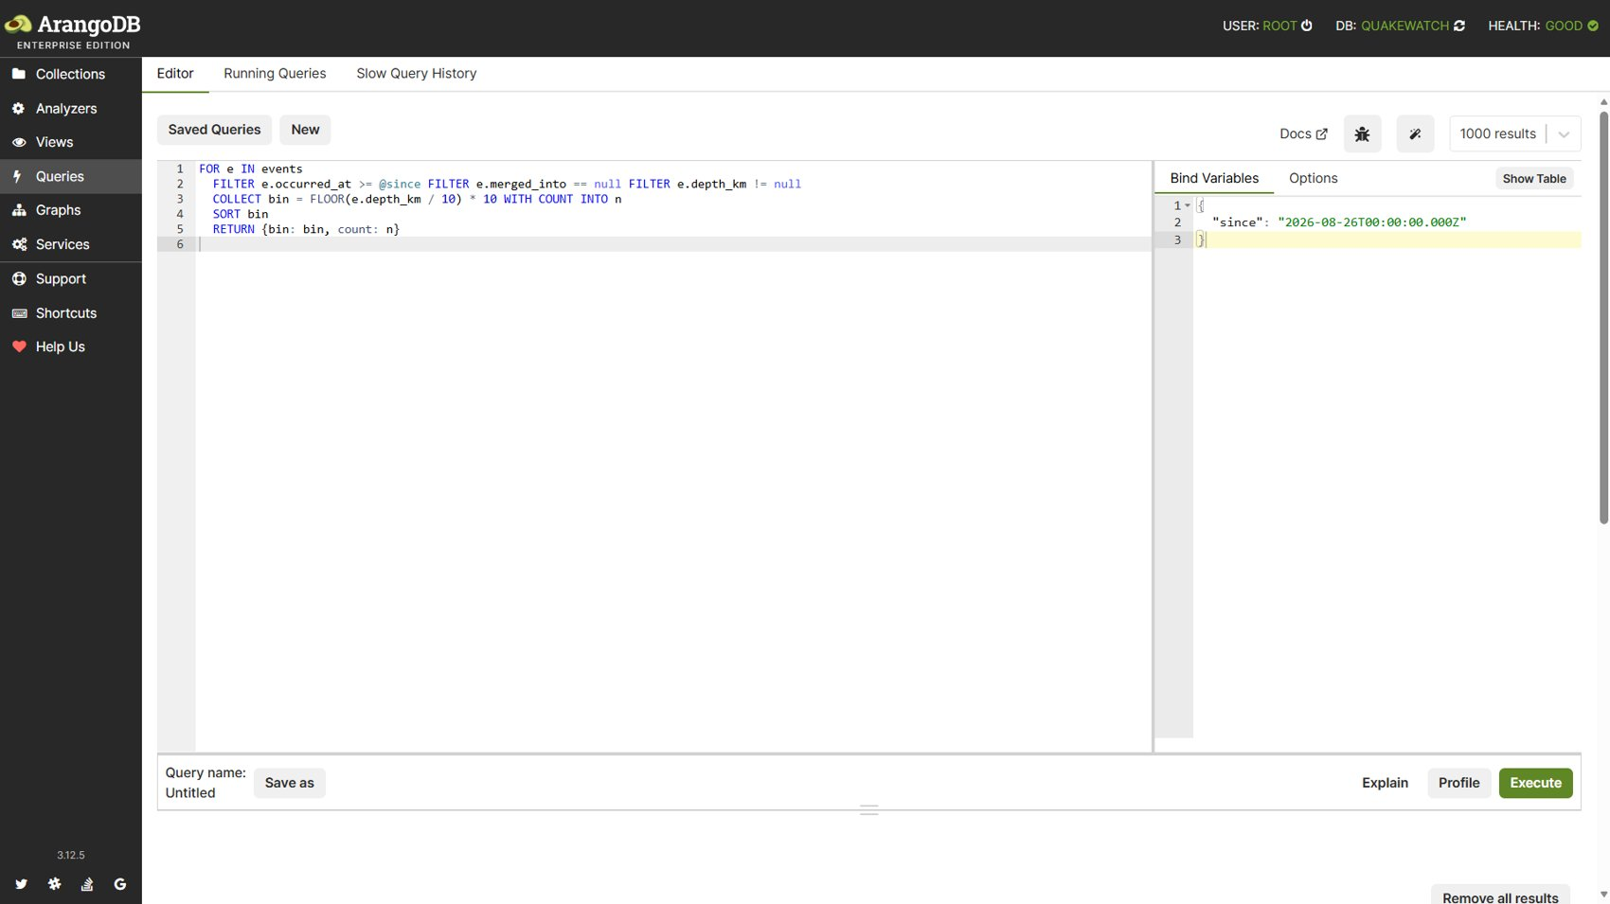
Figure 35: Query 14: Query editor with the depth histogram AQL.
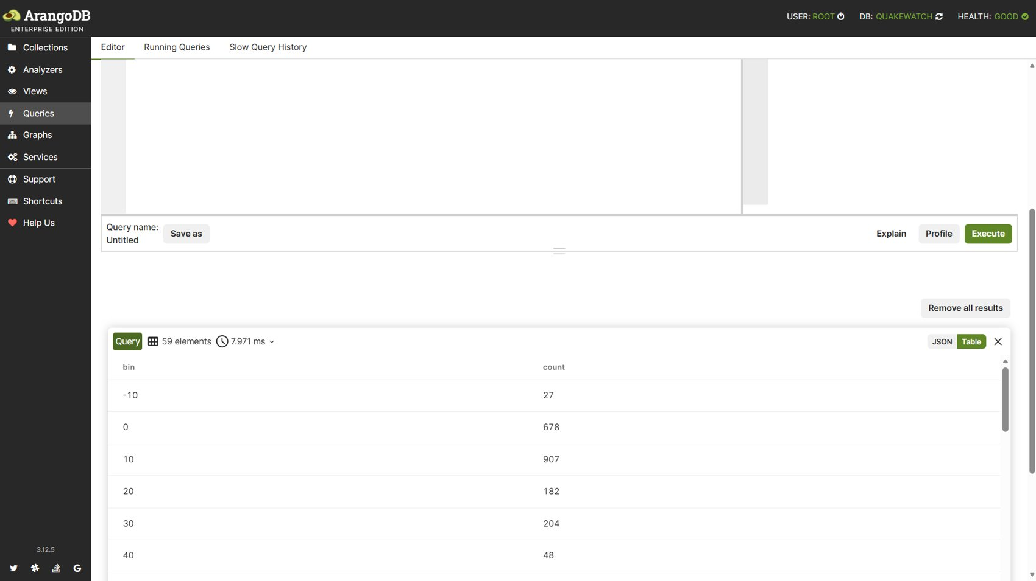
Figure 36: Query 14: Result: 59 depth bins of 10 km.

3.15 Query 15: Nearby events in space and time
Catalogue name: event_nearby_space_time. Purpose: Other events within a radius and a time window of an event (proximity only; not an aftershock classification — ESD §20C). Techniques: geo index, GEO_DISTANCE, time window.
FOR e IN events
FILTER GEO_DISTANCE(e.coordinates, @point) <= @radius_m
FILTER e.occurred_at >= @start AND e.occurred_at <= @end
FILTER e._key != @key AND e.merged_into == null
LET distance_km = GEO_DISTANCE(e.coordinates, @point) / 1000
SORT distance_km ASC
LIMIT @limit
RETURN {key: e._key, magnitude: e.magnitude, place: e.place,
occurred_at: e.occurred_at, distance_km: ROUND(distance_km * 10) / 10}

Bind variables: {"point": [-150.0, 61.0], "radius_m": 100000, "start": "2026-09-01T00:00:00.000Z", "end": "2026-09-15T00:00:00.000Z", "key": "usgs_x", "limit": 10}
[
{
"key": "usgs_aka2026rqamip",
"magnitude": 2.9,
"place": "3 km N of Anchorage, Alaska",
"occurred_at": "2026-09-05T23:31:38.296Z",
"distance_km": 28.4
},
{
"key": "usgs_aka2026sbenku",
"magnitude": 2.7,
"place": "21 km SSW of Sunrise, Alaska",
"occurred_at": "2026-09-12T00:28:57.062Z",
"distance_km": 37.1
},
{
"key": "usgs_aka2026rxarpv",
"magnitude": 2.9,
"place": "25 km ENE of Beluga, Alaska",
"occurred_at": "2026-09-09T18:35:05.415Z",
"distance_km": 44.8
}
]

Result: 7 row(s) returned in 1.56 ms. Index chosen by the optimizer: qw_events_geo.
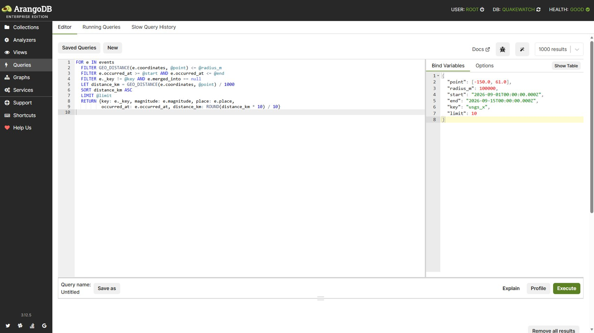
Figure 37: Query 15: Query editor with the space-time AQL.
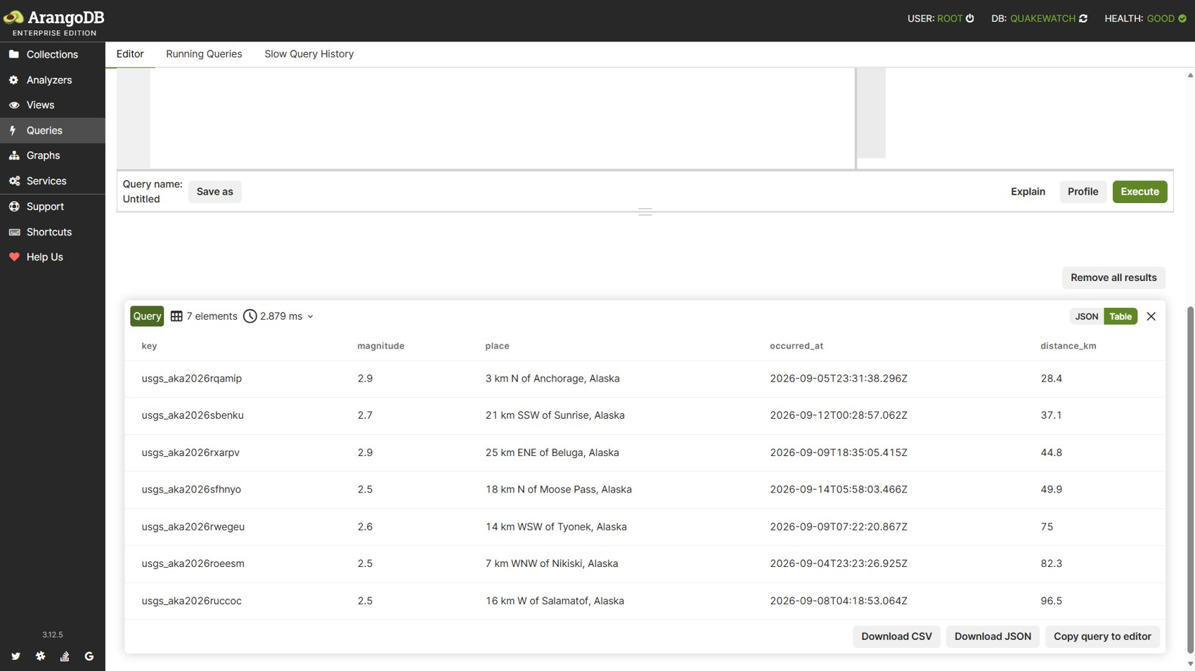
Figure 38: Query 15: Result: seven events within 100 km and the time window of the reference point.

3.16 Summary of the query execution
Table 8: Fifteen AQL queries executed against the live database
# | Query | Rows | Time (ms) | Index used
1 | analytics_avg_magnitude_by_region | 20 | 6.98 | qw_events_occurred_at
2 | analytics_dashboard_summary | 1 | 32.24 | qw_events_occurred_at
3 | analytics_network_stats | 15 | 6.83 | qw_events_occurred_at
4 | analytics_magnitude_changes | 10 | 3.15 | qw_revisions_changed_fields
5 | analytics_ingestion_latency | 1 | 3.29 | qw_events_occurred_at, qw_runs_kind_started
6 | analytics_significant_by_week | 6 | 9.78 | qw_events_occurred_at
7 | alerts_user_rules | 1 | 2.18 | edge, qw_rules_user
8 | alerts_matched_events_graph | 1 | 1.22 | edge
9 | event_graph_relationships | 1 | 31.85 | edge
10 | events_in_viewport | 1 | 9.77 | qw_events_geo
11 | events_within_radius | 1 | 3.52 | qw_events_geo
12 | events_location_text | 1 | 4.11 | ArangoSearch view (no secondary index)
13 | ops_run_stats | 3 | 2.04 | qw_runs_kind_started
14 | analytics_depth_histogram | 59 | 8.96 | qw_events_occurred_at
15 | event_nearby_space_time | 7 | 1.56 | qw_events_geo

4. Backend and Database Connectivity: CRUD Demonstration

4.1 Authentication and session mechanism
The code base was inspected before any request was written. The API uses Django REST Framework SessionAuthentication; there is no JWT and no bearer token. The mechanism is therefore:
- csrftoken cookie. Any page request (here GET /accounts/login/) sets the csrftoken cookie.
- Login. POST /accounts/login/ with the form fields username, password and csrfmiddlewaretoken. On success the server answers 302 to / and sets an HttpOnly sessionid cookie; the session document is stored in the ArangoDB sessions collection (a TTL index expires it after seven days). Django rotates the csrftoken at this moment.
- Unsafe methods. Every POST, PATCH and DELETE to /api/v1/ must carry the header X-CSRFToken equal to the current csrftoken cookie; otherwise DRF answers 403 'CSRF Failed'.
- Authorisation. Alert rules, saved searches and snapshots are owner-scoped: a user can only read or change documents carrying their own user_id. Operations endpoints additionally require staff status.
- Throttling. Request counters are kept in ArangoDB (600/min per user, snapshot creation 10/hour).
Cookies and tokens are handled by the Postman cookie jar and by scripts in the collection; their values are never printed in this report (shown as <hidden>).

4.2 Backend and database connectivity check
Request 03 calls the public health endpoint, which pings ArangoDB and the cache and reads the freshness of the last successful USGS synchronisation. A direct health probe of the database layer returned {"status":"ok","checks":{"arangodb":{"ok":true,"version":"3.12.5"},"schema":{"ok":true,"applied":6,"expected":6}}}.

4.3 Request sequence and verified results
Fifteen requests were executed in order against http://localhost:8000. After each write and each delete, the target document was read back from ArangoDB directly (HTTP cursor API with the database credentials, which are not shown) to prove that the API call changed the stored state. The requests span five resources: sessions/accounts, events, saved searches, alert rules and research snapshots. A disposable account with the same privileges as the demonstration account was used for the evidence run and removed afterwards.
Table 9: Fifteen HTTP requests and their verified status codes
# | Method | Path | Operation | Expected | Actual | Result
01 | GET | /accounts/login/ | AUTH | 200 | 200 | Pass
02 | POST | /accounts/login/ | AUTH / CREATE session | 302 | 302 | Pass
03 | GET | /api/v1/system/health | READ | 200 | 200 | Pass
04 | GET | /api/v1/events | READ (filter / sort / paginate) | 200 | 200 | Pass
05 | POST | /api/v1/saved-searches | CREATE | 201 | 201 | Pass
06 | GET | /api/v1/saved-searches/265750 | READ | 200 | 200 | Pass
07 | PATCH | /api/v1/saved-searches/265750 | UPDATE | 200 | 200 | Pass
08 | POST | /api/v1/alert-rules | CREATE | 201 | 201 | Pass
09 | PATCH | /api/v1/alert-rules/bdcd462b4b9443768aed4a8f0fea109e | UPDATE | 200 | 200 | Pass
10 | GET | /api/v1/alert-rules/bdcd462b4b9443768aed4a8f0fea109e/preview | READ | 200 | 200 | Pass
11 | POST | /api/v1/research/snapshots | CREATE | 201 | 201 | Pass
12 | DELETE | /api/v1/research/snapshots/e748993f062e4ae6b38171f43fba1e6b | DELETE | 204 | 204 | Pass
13 | DELETE | /api/v1/alert-rules/bdcd462b4b9443768aed4a8f0fea109e | DELETE | 204 | 204 | Pass
14 | DELETE | /api/v1/saved-searches/265750 | DELETE | 204 | 204 | Pass
15 | GET | /api/v1/saved-searches/265750 | READ (negative) | 404 | 404 | Pass

Outcome: 15 of 15 requests passed. The same sequence was then executed with the Newman runner of Postman (15 requests, 35 assertions, 0 failures).

4.3.1 Request 01: Open login page (obtain CSRF cookie)
GET http://localhost:8000/accounts/login/
Accept: application/json

HTTP 200 (expected 200), server time 2.18 ms
HTML login form (200 OK); the csrftoken cookie is set.

Database operation: Session middleware issues the csrftoken cookie; no DB write.

4.3.2 Request 02: Log in (create session)
POST http://localhost:8000/accounts/login/
Accept: application/json
Content-Type: application/x-www-form-urlencoded
Cookie: sessionid=<hidden>; csrftoken=<hidden>
Body (form): username=<demo account>&password=********&csrfmiddlewaretoken=<hidden>

HTTP 302 (expected 302), server time 288.79 ms
Empty body; Location: /; sessionid cookie set (HttpOnly).

Database operation: Credentials checked against `users`; session document written to `sessions`.
Direct read-back from ArangoDB (auth_users + sessions after login): {"user_exists": true, "live_sessions": 6}

4.3.3 Request 03: System health (backend + DB connectivity)
GET http://localhost:8000/api/v1/system/health
Accept: application/json
Cookie: sessionid=<hidden>; csrftoken=<hidden>

HTTP 200 (expected 200), server time 14.83 ms
{
"status": "ok",
"database": "up",
"cache": "up",
"freshness": "fresh",
"checked_at": "2026-10-11T16:48:27.241Z"
}

Database operation: Pings ArangoDB and cache; reads freshness from `ingestion_runs`.

4.3.4 Request 04: List and filter earthquake events
GET http://localhost:8000/api/v1/events?min_magnitude=4.5&sort=magnitude&direction=desc&page_size=3
Accept: application/json
Cookie: sessionid=<hidden>; csrftoken=<hidden>

HTTP 200 (expected 200), server time 9.07 ms
{
"results": [
{
"key": "usgs_us6000txpi",
"magnitude": 6.6,
"place": "80 km ENE of Tadine, New Caledonia",
"occurred_at": "2026-09-25T21:23:03.309Z"
},
{
"key": "usgs_us7000ti1p",
"magnitude": 6.5,
"place": "177 km W of Nikolski, Alaska",
"occurred_at": "2026-09-17T14:19:52.472Z"
},
"..."
],
"page": 1,
"page_size": 3,
"total": 553,
"total_pages": 185,
"query": {
"filters": {
"direction": "desc",
"min_magnitude": 4.5,
"sort": "magnitude"
},
"summary": "magnitude 4.5 to any — sorted by magnitude desc"
}
}

Database operation: AQL over `events` with bind variables; total = full match count.

4.3.5 Request 05: Create saved search
POST http://localhost:8000/api/v1/saved-searches
Accept: application/json
Content-Type: application/json
X-CSRFToken: <csrftoken cookie value, hidden>
Cookie: sessionid=<hidden>; csrftoken=<hidden>
Body (JSON):
{
"name": "Strong quakes M4.5+ (demo)",
"filters": {
"min_magnitude": 4.5,
"sort": "magnitude",
"direction": "desc"
}
}

HTTP 201 (expected 201), server time 16.78 ms
{
"created_at": "2026-10-11T16:48:31.398Z",
"filters": {
"direction": "desc",
"min_magnitude": 4.5,
"sort": "magnitude"
},
"name": "Strong quakes M4.5+ (demo)",
"summary": "magnitude 4.5 to any — sorted by magnitude desc",
"updated_at": "2026-10-11T16:48:31.398Z",
"user_id": 2,
"id": "265750"
}

Database operation: INSERT into `saved_searches` (per-user cap enforced atomically).
Direct read-back from ArangoDB (saved_searches document after POST): {"filters": {"direction": "desc", "min_magnitude": 4.5, "sort": "magnitude"}, "name": "Strong quakes M4.5+ (demo)", "user_id": 2}
Captured for later requests: saved_search_id = 265750

4.3.6 Request 06: Read saved search (persistence check)
GET http://localhost:8000/api/v1/saved-searches/265750
Accept: application/json
Cookie: sessionid=<hidden>; csrftoken=<hidden>

HTTP 200 (expected 200), server time 8.92 ms
{
"created_at": "2026-10-11T16:48:31.398Z",
"filters": {
"direction": "desc",
"min_magnitude": 4.5,
"sort": "magnitude"
},
"name": "Strong quakes M4.5+ (demo)",
"summary": "magnitude 4.5 to any — sorted by magnitude desc",
"updated_at": "2026-10-11T16:48:31.398Z",
"user_id": 2,
"id": "265750"
}

Database operation: Document fetched from `saved_searches` by key and owner.

4.3.7 Request 07: Rename saved search
PATCH http://localhost:8000/api/v1/saved-searches/265750
Accept: application/json
Content-Type: application/json
X-CSRFToken: <csrftoken cookie value, hidden>
Cookie: sessionid=<hidden>; csrftoken=<hidden>
Body (JSON):
{
"name": "Strong quakes M4.5+ (renamed)"
}

HTTP 200 (expected 200), server time 11.06 ms
{
"created_at": "2026-10-11T16:48:31.398Z",
"filters": {
"direction": "desc",
"min_magnitude": 4.5,
"sort": "magnitude"
},
"name": "Strong quakes M4.5+ (renamed)",
"summary": "magnitude 4.5 to any — sorted by magnitude desc",
"updated_at": "2026-10-11T16:48:35.524Z",
"user_id": 2,
"id": "265750"
}

Database operation: UPDATE of `name` and `updated_at` in `saved_searches`.
Direct read-back from ArangoDB (saved_searches document after PATCH): {"name": "Strong quakes M4.5+ (renamed)", "updated_at": "2026-10-11T16:48:35.524Z"}

4.3.8 Request 08: Create alert rule
POST http://localhost:8000/api/v1/alert-rules
Accept: application/json
Content-Type: application/json
X-CSRFToken: <csrftoken cookie value, hidden>
Cookie: sessionid=<hidden>; csrftoken=<hidden>
Body (JSON):
{
"name": "Alaska M2.5+ watch (demo)",
"enabled": true,
"cooldown_minutes": 30,
"conditions": {
"minimum_magnitude": 2.5,
"center": [
-149.9,
61.2
],
"radius_km": 500
}
}

HTTP 201 (expected 201), server time 9.99 ms
{
"id": "bdcd462b4b9443768aed4a8f0fea109e",
"user_id": 2,
"name": "Alaska M2.5+ watch (demo)",
"enabled": true,
"conditions": {
"minimum_magnitude": 2.5,
"maximum_depth_km": null,
"minimum_depth_km": null,
"center": [
-149.9,
61.2
],
"radius_km": 500,
"alert_levels": [],
"tsunami_only": false,
"event_types": [
"earthquake"
]
},
"cooldown_minutes": 30,
"created_at": "2026-10-11T16:48:37.611Z",
"updated_at": "2026-10-11T16:48:37.611Z"
}

Database operation: INSERT into `alert_rules` plus `user_owns_rule` graph edge.
Direct read-back from ArangoDB (alert_rules document and owner edge after POST): {"rule": {"cooldown_minutes": 30, "enabled": true, "name": "Alaska M2.5+ watch (demo)"}, "owner_edges": 1}
Captured for later requests: rule_id = bdcd462b4b9443768aed4a8f0fea109e

4.3.9 Request 09: Update alert rule
PATCH http://localhost:8000/api/v1/alert-rules/bdcd462b4b9443768aed4a8f0fea109e
Accept: application/json
Content-Type: application/json
X-CSRFToken: <csrftoken cookie value, hidden>
Cookie: sessionid=<hidden>; csrftoken=<hidden>
Body (JSON):
{
"name": "Alaska M3.0+ watch (updated)",
"cooldown_minutes": 15,
"conditions": {
"minimum_magnitude": 3.0,
"center": [
-149.9,
61.2
],
"radius_km": 500
}
}

HTTP 200 (expected 200), server time 23.15 ms
{
"id": "bdcd462b4b9443768aed4a8f0fea109e",
"user_id": 2,
"name": "Alaska M3.0+ watch (updated)",
"enabled": true,
"conditions": {
"minimum_magnitude": 3,
"maximum_depth_km": null,
"minimum_depth_km": null,
"center": [
-149.9,
61.2
],
"radius_km": 500,
"alert_levels": [],
"tsunami_only": false,
"event_types": [
"earthquake"
]
},
"cooldown_minutes": 15,
"created_at": "2026-10-11T16:48:37.611Z",
"updated_at": "2026-10-11T16:48:39.697Z"
}

Database operation: UPDATE of the rule document; validated against the pydantic schema first.
Direct read-back from ArangoDB (alert_rules document after PATCH): {"conditions": {"minimum_magnitude": 3, "maximum_depth_km": null, "minimum_depth_km": null, "center": [-149.9, 61.2], "radius_km": 500, "alert_levels": [], "tsunami_only": false, "event_types": ["earthquake"]}, "cooldown_minutes": 15, "name": "Alaska M3.0+ watch (updated)"}

4.3.10 Request 10: Preview alert rule against stored events
GET http://localhost:8000/api/v1/alert-rules/bdcd462b4b9443768aed4a8f0fea109e/preview
Accept: application/json
Cookie: sessionid=<hidden>; csrftoken=<hidden>

HTTP 200 (expected 200), server time 20.36 ms
{
"rule": {
"id": "bdcd462b4b9443768aed4a8f0fea109e",
"name": "Alaska M3.0+ watch (updated)",
"enabled": true
},
"window_days": 7,
"would_match": "4 event(s) (first omitted)"
}

Database operation: Geo/magnitude AQL over `events` using the stored rule conditions.

4.3.11 Request 11: Create research snapshot
POST http://localhost:8000/api/v1/research/snapshots
Accept: application/json
Content-Type: application/json
X-CSRFToken: <csrftoken cookie value, hidden>
Cookie: sessionid=<hidden>; csrftoken=<hidden>
Body (JSON):
{
"title": "M4.5+ research snapshot (demo)",
"notes": "Frozen selection created from the CRUD demonstration.",
"filters": {
"min_magnitude": 4.5,
"sort": "magnitude",
"direction": "desc"
}
}

HTTP 201 (expected 201), server time 38.65 ms
{
"id": "e748993f062e4ae6b38171f43fba1e6b",
"title": "M4.5+ research snapshot (demo)",
"created_at": "2026-10-11T16:48:43.897Z",
"row_count": 553,
"content_sha256": "bc516d5364ab0ecab59c975abd0df84b6610ac7637a7c97ee3356530b18de091",
"query_definition": {
"filters": {
"direction": "desc",
"min_magnitude": 4.5,
"sort": "magnitude"
},
"summary": "magnitude 4.5 to any — sorted by magnitude desc"
},
"application_version": "dev"
}

Database operation: Freezes matching event revisions into `research_snapshots` with a SHA-256 checksum.
Direct read-back from ArangoDB (research_snapshots document after POST): {"title": "M4.5+ research snapshot (demo)", "members": 553, "content_sha256": "bc516d5364ab0ecab59c975abd0df84b6610ac7637a7c97ee3356530b18de091"}
Captured for later requests: snapshot_id = e748993f062e4ae6b38171f43fba1e6b

4.3.12 Request 12: Delete research snapshot
DELETE http://localhost:8000/api/v1/research/snapshots/e748993f062e4ae6b38171f43fba1e6b
Accept: application/json
Content-Type: application/json
X-CSRFToken: <csrftoken cookie value, hidden>
Cookie: sessionid=<hidden>; csrftoken=<hidden>

HTTP 204 (expected 204), server time 11.98 ms
Empty body (no content).

Database operation: REMOVE from `research_snapshots`.
Direct read-back from ArangoDB (research_snapshots lookup after DELETE): null

4.3.13 Request 13: Delete alert rule
DELETE http://localhost:8000/api/v1/alert-rules/bdcd462b4b9443768aed4a8f0fea109e
Accept: application/json
Content-Type: application/json
X-CSRFToken: <csrftoken cookie value, hidden>
Cookie: sessionid=<hidden>; csrftoken=<hidden>

HTTP 204 (expected 204), server time 13.96 ms
Empty body (no content).

Database operation: REMOVE rule and its `user_owns_rule` edge.
Direct read-back from ArangoDB (alert_rules lookup and edge count after DELETE): {"rule": null, "owner_edges": 0}

4.3.14 Request 14: Delete saved search
DELETE http://localhost:8000/api/v1/saved-searches/265750
Accept: application/json
Content-Type: application/json
X-CSRFToken: <csrftoken cookie value, hidden>
Cookie: sessionid=<hidden>; csrftoken=<hidden>

HTTP 204 (expected 204), server time 6.64 ms
Empty body (no content).

Database operation: REMOVE from `saved_searches`.
Direct read-back from ArangoDB (saved_searches lookup after DELETE): null

4.3.15 Request 15: Verify deletion (expect 404)
GET http://localhost:8000/api/v1/saved-searches/265750
Accept: application/json
Cookie: sessionid=<hidden>; csrftoken=<hidden>

HTTP 404 (expected 404), server time 7.91 ms
{
"error": {
"code": "not_found",
"message": "Saved search not found.",
"details": {},
"correlation_id": "711f34eb1dd240b2ab66448089a1acbd"
}
}

Database operation: Lookup returns no document, proving the DELETE persisted.

4.4 Findings and repairs made during the work
Table 10: Defects and environment issues found and resolved
Finding | Root cause | Repair and verification
Sign-up returned HTTP 500 when the password resembled the username (AttributeError: '_Candidate' object has no attribute '_meta') | apps/accounts/forms.py passed a plain helper object to Django's UserAttributeSimilarityValidator, which reads user._meta | The form now builds an unsaved user from get_user_model(); the form returns a normal validation error. Image rebuilt and redeployed; the request now returns HTTP 400 with 'The password is too similar to the username'. Regression test tests/unit/test_accounts_forms.py added.
Postman login failed with 500 'URL doesn't end in a slash' | The generated collection dropped the trailing slash of /accounts/login/ | Path generation fixed; the collection now passes 15/15 under Newman.
Writes returned 403 'CSRF Failed' in the collection | The csrftoken cookie rotates at login and was read before rotation | The login test script stores the post-login token; all later requests send it in X-CSRFToken. Security protections were not weakened.
One regression test failed inside the container | The container inherits QW_DEBUG=true from the local .env, so a production-settings test hit the debug guard first | The test passes when QW_DEBUG is unset (environmental, not an application defect).

5. Test Cases and Results
The table lists the test cases executed for this review. Each was run against the live application and database; the Actual column states what was observed. The existing automated regression suite was run as well (Section 5.1).
Table 11: Executed test cases (36)
ID | Module | Scenario | Expected | Actual | Status
TC-01 | API / Auth | GET /accounts/login/ | HTTP 200 | HTTP 200 | Pass
TC-02 | API / Auth | POST /accounts/login/ | HTTP 302 | HTTP 302 | Pass
TC-03 | API / Read | GET /api/v1/system/health | HTTP 200 | HTTP 200 | Pass
TC-04 | API / Read | GET /api/v1/events | HTTP 200 | HTTP 200 | Pass
TC-05 | API / Create | POST /api/v1/saved-searches | HTTP 201 | HTTP 201 | Pass
TC-06 | API / Read | GET /api/v1/saved-searches/265750 | HTTP 200 | HTTP 200 | Pass
TC-07 | API / Update | PATCH /api/v1/saved-searches/265750 | HTTP 200 | HTTP 200 | Pass
TC-08 | API / Create | POST /api/v1/alert-rules | HTTP 201 | HTTP 201 | Pass
TC-09 | API / Update | PATCH /api/v1/alert-rules/bdcd462b4b9443768aed4a8f0fea109e | HTTP 200 | HTTP 200 | Pass
TC-10 | API / Read | GET /api/v1/alert-rules/bdcd462b4b9443768aed4a8f0fea109e/preview | HTTP 200 | HTTP 200 | Pass
TC-11 | API / Create | POST /api/v1/research/snapshots | HTTP 201 | HTTP 201 | Pass
TC-12 | API / Delete | DELETE /api/v1/research/snapshots/e748993f062e4ae6b38171f43fba1e6b | HTTP 204 | HTTP 204 | Pass
TC-13 | API / Delete | DELETE /api/v1/alert-rules/bdcd462b4b9443768aed4a8f0fea109e | HTTP 204 | HTTP 204 | Pass
TC-14 | API / Delete | DELETE /api/v1/saved-searches/265750 | HTTP 204 | HTTP 204 | Pass
TC-15 | API / Read | GET /api/v1/saved-searches/265750 | HTTP 404 | HTTP 404 | Pass
TC-16 | AQL | Run Q1 analytics_avg_magnitude_by_region | Executes, returns rows, uses an index where expected | 20 row(s) in 6.98 ms | Pass
TC-17 | AQL | Run Q2 analytics_dashboard_summary | Executes, returns rows, uses an index where expected | 1 row(s) in 32.24 ms | Pass
TC-18 | AQL | Run Q3 analytics_network_stats | Executes, returns rows, uses an index where expected | 15 row(s) in 6.83 ms | Pass
TC-19 | AQL | Run Q4 analytics_magnitude_changes | Executes, returns rows, uses an index where expected | 10 row(s) in 3.15 ms | Pass
TC-20 | AQL | Run Q5 analytics_ingestion_latency | Executes, returns rows, uses an index where expected | 1 row(s) in 3.29 ms | Pass
TC-21 | AQL | Run Q6 analytics_significant_by_week | Executes, returns rows, uses an index where expected | 6 row(s) in 9.78 ms | Pass
TC-22 | AQL | Run Q7 alerts_user_rules | Executes, returns rows, uses an index where expected | 1 row(s) in 2.18 ms | Pass
TC-23 | AQL | Run Q8 alerts_matched_events_graph | Executes, returns rows, uses an index where expected | 1 row(s) in 1.22 ms | Pass
TC-24 | AQL | Run Q9 event_graph_relationships | Executes, returns rows, uses an index where expected | 1 row(s) in 31.85 ms | Pass
TC-25 | AQL | Run Q10 events_in_viewport | Executes, returns rows, uses an index where expected | 1 row(s) in 9.77 ms | Pass
TC-26 | AQL | Run Q11 events_within_radius | Executes, returns rows, uses an index where expected | 1 row(s) in 3.52 ms | Pass
TC-27 | AQL | Run Q12 events_location_text | Executes, returns rows, uses an index where expected | 1 row(s) in 4.11 ms | Pass
TC-28 | AQL | Run Q13 ops_run_stats | Executes, returns rows, uses an index where expected | 3 row(s) in 2.04 ms | Pass
TC-29 | AQL | Run Q14 analytics_depth_histogram | Executes, returns rows, uses an index where expected | 59 row(s) in 8.96 ms | Pass
TC-30 | AQL | Run Q15 event_nearby_space_time | Executes, returns rows, uses an index where expected | 7 row(s) in 1.56 ms | Pass
TC-31 | Integrity | Insert schema-invalid event | Rejected by validator | Error 1620 | Pass
TC-32 | Integrity | Insert duplicate event identity | Unique constraint violation | Error 1210 | Pass
TC-33 | Transaction | Valid + invalid write in one transaction | Whole transaction rolled back | Aborted; probe document absent | Pass
TC-34 | Transaction | Valid write in a stream transaction | Committed and visible | Committed | Pass
TC-35 | Regression | Sign-up with password equal to username | HTTP 400 with validation message (was 500) | HTTP 400, message shown | Pass
TC-36 | Collection | Postman/Newman run of the 15-request collection | 0 failed assertions | 15 requests, 35 assertions, 0 failed | Pass

5.1 Automated regression suite
The project's pytest suite (unit, contract, integration against a real ArangoDB test database, resilience and architecture-boundary tests; browser, performance and live-network tests excluded) was run in a container on 11 October 2026: 935 passed, 1 failed, 61 deselected, line coverage 93 % over apps/. The single failure (test_production_requires_long_secret) is caused by the container inheriting QW_DEBUG=true from the local environment file; with that variable unset the test passes (1 passed). The suite was run after the sign-up repair and includes its new regression test.

6. Discussion and Limitations
- Trigger and procedure equivalence. ArangoDB offers no native triggers or stored procedures; equivalent guarantees are provided by server-side schema validation, unique and TTL indexes, stream transactions and application observers. This is a deliberate trade-off of the multi-model approach and is documented rather than hidden.
- Live data. Counts change every five minutes as the feed is ingested; tables report the values observed during the scripted run and screenshots may show slightly earlier values.
- Backup scope. The arangodump artifact was produced from an isolated test database; no restore test was carried out.
- Repository state. The sign-up repair and its test are present in the working tree and are included in the deployed image; they must be committed and pushed to appear on GitHub.
- Screenshots. Figures were captured by the project owner from the ArangoDB web interface; the textual results were produced independently by scripts, so the two sources corroborate each other.

References
ArangoDB Documentation, AQL, Indexing, ArangoSearch, Graphs and Transactions, version 3.12. https://docs.arangodb.com/3.12/
U.S. Geological Survey, Earthquake Hazards Program: GeoJSON Summary and Detail Feeds. https://earthquake.usgs.gov/earthquakes/feed/v1.0/geojson.php
Django Software Foundation, Django Documentation: Authentication, Sessions and CSRF protection. https://docs.djangoproject.com/
Django REST Framework, SessionAuthentication and Throttling. https://www.django-rest-framework.org/
Postman Learning Center, Collections, scripts and the Newman command-line runner. https://learning.postman.com/

