

Project Name: Project Evergreen: The Walmart Smart Retail Ecosystem
Version: 1.0
Date: July 6, 2025
Prepared By: AI Systems Analyst

Table of Contents
- Introduction
1.1. Purpose
1.2. Project Scope & Vision
1.3. Intended Audience
1.4. Problem Statement
1.5. Software Development Model
- Requirements Engineering
2.1. Stakeholders
2.2. Requirement Elicitation
2.3. Feasibility Study
2.4. Requirement Analysis
- Overall Description
3.1. Product Perspective
3.2. User Classes and Characteristics
3.3. Operating Environment
3.4. Assumptions and Constraints
- Specific Requirements
4.1. Business Requirements
4.2. Functional Requirements
4.2.1. Module 1: GreenScore - Sustainable Shopping
4.2.2. Module 2: Waste-Knot - Food Donation Logistics
4.2.3. Module 3: RoomScape AI - AR Room Designer
4.2.4. Common/System-Wide Requirements
4.3. Non-Functional Requirements
4.4. Technical Requirements
- System Models & Diagrams (SRD)
5.1. Context Diagram (DFD Level 0)
5.2. Data Flow Diagram (DFD Level 1)
5.3. Flow Chart (Example: GreenScore Purchase)
5.4. Use Case Diagram
5.5. Entity-Relationship (ER) Diagram
5.6. Class Diagram & Object Diagram
5.7. State-Chart Diagram (Donation Object)
5.8. Activity Diagram (Food Donation Process)
5.9. Sequence Diagram (AR Furniture Placement)
5.10. Collaboration Diagram (AR Furniture Placement)
5.11. Component Diagram
5.12. Deployment Diagram
- Business & Market Analysis
6.1. Project Uniqueness & Competitive Edge
6.2. Revenue Model & Monetization Strategy
- Future Scope & Evolution
7.1. Potential Enhancements
7.2. Adaptation to Market Changes

1. Introduction

1.1. Purpose
This Software Requirements Specification (SRS) document provides a comprehensive description of the features, behavior, and requirements for the Project Evergreen: The Walmart Smart Retail Ecosystem software suite. This document aims to serve as the single source of truth for all stakeholders, including developers, testers, project managers, and business executives, ensuring a common understanding of the system to be built.

1.2. Project Scope & Vision
Vision: To revolutionize the retail experience by integrating intelligent, value-driven technology that empowers customers to make sustainable choices, helps the business operate more efficiently and ethically, and allows consumers to visualize products in their own space, thereby bridging the gap between digital and physical shopping.
Scope: The project combines three core ideas into a unified platform, likely integrated within an existing retail mobile app and internal store management system (e.g., Walmart's).
- GreenScore: A gamified system that scores products based on sustainability criteria and rewards customers for making eco-friendly choices.
- Waste-Knot: An AI-driven logistics platform that identifies near-expiry food items and facilitates their donation to local charities, reducing waste and supporting communities.
- RoomScape AI: An Augmented Reality (AR) tool that allows customers to scan their rooms and place photorealistic 3D models of furniture and decor to see how they fit and look before buying.

1.3. Intended Audience
This document is intended for:
- Project Managers: For project planning, scheduling, and resource allocation.
- Software Developers: To understand the system's architecture, features, and constraints for implementation.
- QA & Testing Teams: To create test plans, test cases, and validation strategies.
- Business Analysts: To verify that all business needs are captured.
- Client/Stakeholders (e.g., Walmart Executives): To review and approve the project's scope and requirements.

1.4. Problem Statement
The modern retail landscape faces several disconnected challenges.
From the consumer's perspective:
There is a growing desire among consumers to shop sustainably, yet they often lack transparent, accessible information at the point of decision-making. Comparing the environmental impact of products is difficult, and there is little direct incentive to choose greener, sometimes more expensive, options. Furthermore, when purchasing large items like furniture online, customers face significant uncertainty. They cannot accurately visualize how a product will fit in their space or match their existing decor, leading to purchase hesitation, high return rates, and customer dissatisfaction.

From the business operations perspective:
Large retail stores generate a substantial amount of food waste. Perfectly edible food approaching its sell-by date is often discarded due to complex logistics, lack of real-time communication with potential recipients, and the overhead involved in managing donations. This results in direct financial loss and negative environmental and social impact.

Current System Analogy (Library Example):
Much like a traditional library where a student needs a specific card, follows a manual process to issue a book, and relies on staff for everything from finding a book to managing procurement, the current retail system is fragmented. The shopper (student) has limited tools. The store manager (librarian) performs many manual tasks for inventory and waste management. The connection between the store's surplus (unsorted books) and community needs (students needing those books) is inefficient.

Proposed Solution:
The Project Evergreen system aims to solve these problems by creating an intelligent, integrated digital layer over the existing retail infrastructure. It will provide shoppers with the "GreenScore" and "RoomScape AI" tools to make informed and confident purchasing decisions. Internally, it will provide store managers with the "Waste-Knot" platform to automate and streamline the food donation process, turning potential waste into a community benefit.

1.5. Software Development Model
The Prototype Model will be used for the development of Project Evergreen. Given the innovative and user-centric nature of the features (especially RoomScape AI and GreenScore gamification), this model is ideal.
- Rationale:
  - Early User Feedback: Prototypes of the AR interface and GreenScore dashboard can be shared with end-users early to gather feedback on usability and appeal.
  - Requirement Refinement: The AR and AI components are complex. Prototyping will help clarify technical feasibility and refine ambiguous requirements.
  - Risk Reduction: Building a small-scale, working model of the AI prediction for Waste-Knot or the room scanning for RoomScape AI can identify major technical hurdles before full-scale development.

2. Requirements Engineering

2.1. Stakeholders
- End-Users (Shoppers): Environmentally conscious consumers, home decorators, and general app users.
- Store Managers: Responsible for store inventory, P&L, and daily operations.
- Charity/Food Bank Representatives: The recipients of the donated food.
- Corporate Executives: Interested in sustainability goals, profitability, and brand image.
- Data Analysts: Who will manage and interpret product sustainability data.
- Development Team: The engineers, designers, and testers building the system.
- Legal & Compliance Team: Ensuring data privacy and donation regulations are met.

2.2. Requirement Elicitation
The following methods were used to gather requirements:
- Brainstorming Sessions: The initial three ideas were generated and refined through internal brainstorming.
- Stakeholder Interviews (Simulated):
  - Shopper Persona: "I want to do good, but I need it to be easy and rewarding."
  - Store Manager Persona: "I hate throwing food away, but my team has no time for the paperwork and phone calls to coordinate donations."
  - Charity Persona: "We need donations, but we never know what's available or when to pick it up. A reliable system would be a game-changer."
- Competitive Analysis: Reviewing existing AR furniture apps (e.g., IKEA Place), sustainability apps (e.g., Good On You), and food waste solutions (e.g., Too Good To Go) to identify gaps and opportunities.
- Prototyping: Wireframes and mockups of the app interfaces were created to visualize the user flow and gather initial feedback.

2.3. Feasibility Study
- Technical Feasibility: High but Complex. The project relies on mature technologies like React Native, PostgreSQL, and Node.js. The primary challenges are:
  - AR/3D: Requires expertise in ARKit/ARCore and 3D modeling. LiDAR integration offers high fidelity but limits the user base to newer devices. Photogrammetry is a viable alternative.
  - AI/ML: The Waste-Knot prediction model can start as a simple algorithm based on sales velocity and expiry dates, and evolve into a more complex ML model. Feasible.
  - Data: The GreenScore feature's success depends on a robust database of product sustainability metrics. This data may need to be sourced, purchased, or created, which is a significant effort. For the initial version, mocked or simplified data is feasible.
- Economic Feasibility: High. The initial investment in development, data acquisition, and 3D modeling will be substantial. However, the ROI is projected to be strong through:
  - Increased sales and reduced returns (RoomScape AI).
  - Reduced financial loss from waste (Waste-Knot).
  - Enhanced brand loyalty and appeal to ESG-focused investors.
- Operational Feasibility: Medium.
  - Customer-facing features (GreenScore, RoomScape): Easily integrated into the existing app. Minimal operational change.
  - Waste-Knot: Requires process changes for store staff. They will need training on the new dashboard and donation handling procedures. The system must be designed to be extremely simple to minimize operational disruption.
- Legal Feasibility: Medium. The primary concern is data privacy, especially with RoomScape AI scanning users' private homes. A clear privacy policy, opt-in consent, and anonymization of data are mandatory. Food donation requires adherence to local health and safety regulations (e.g., Good Samaritan laws).

2.4. Requirement Analysis
After elicitation, requirements were filtered and finalized.
- Filtered Out (For Version 1.0):
  - Generative AI for room design: Deemed too complex and costly for the initial release. A future enhancement.
  - Real-time carbon footprint tracking for delivery: Deferred due to complexities in logistics data integration.
  - Social network for GreenScore: Deferred to focus on the core gamification loop first.
- Prioritized & Finalized Requirements:
  - A simple, weighted-score algorithm for GreenScore based on 3-4 key criteria (e.g., packaging, sourcing, certifications).
  - A rule-based prediction engine for Waste-Knot.
  - AR functionality focusing on placing single items in a room, with high-quality rendering.
  - A two-sided platform for donation management (store dashboard and charity app).

3. Overall Description

3.1. Product Perspective
Project Evergreen is not a standalone application but a suite of features designed to be integrated into an existing large retailer's mobile application and internal systems. It will interact with the existing Product Catalog Database, User Account System, and Inventory Management System.

3.2. User Classes and Characteristics
(Refer to Section 2.1 Stakeholders for a detailed list).

3.3. Operating Environment
- Client-Side (Mobile App): iOS 15+ and Android 10+. Devices with LiDAR/ARCore Depth API support are required for the best RoomScape AI experience.
- Server-Side: The backend will be a cloud-native application running on a platform like AWS, Azure, or Google Cloud, utilizing containerization (Docker/Kubernetes) for scalability.
- Store-Side (Dashboard): A web-based application accessible on standard desktop or tablet browsers within the store's internal network.

3.4. Assumptions and Constraints
- Assumptions:
  - The retailer has an existing mobile app and user base.
  - Access to the retailer's Product, Inventory, and Sales databases will be granted via APIs.
  - Product sustainability data, even if simplified, can be acquired or created.
  - Local charities are willing to partner and use the companion app.
- Constraints:
  - The system must integrate with the retailer's existing security and authentication protocols.
  - The performance of the AR feature is dependent on the user's mobile device hardware.
  - The project must comply with all relevant data privacy laws (e.g., GDPR, CCPA).
  - The initial 3D model catalog will be limited to a select number of best-selling furniture items.

4. Specific Requirements

4.1. Business Requirements
- BR-01: Increase sales of home goods by at least 10% and reduce returns by 15% within one year of RoomScape AI launch.
- BR-02: Reduce in-store food waste by at least 50% in participating stores within six months of the Waste-Knot rollout.
- BR-03: Improve customer engagement metrics (e.g., daily active users, session duration) in the mobile app by 20%.
- BR-04: Enhance the company's public image as a leader in sustainability and corporate social responsibility.

4.2. Functional Requirements
- FR-GS-01: The system shall assign a "GreenScore" (from 1-100) to applicable products based on pre-defined criteria (e.g., packaging recyclability, sourcing distance, organic certification).
- FR-GS-02: Users shall be able to view a product's GreenScore on its product detail page.
- FR-GS-03: The system shall maintain a personal, cumulative GreenScore for each user based on their purchase history.
- FR-GS-04: Users shall have a dedicated "GreenScore" dashboard in their profile to view their score, impact statistics (e.g., "kg of plastic saved"), and earned badges.
- FR-GS-05: The system shall award users digital badges for reaching certain score milestones or completing challenges (e.g., "Plastic-Free Week").
- FR-GS-06: The system shall provide exclusive coupons for sustainable brands to users who reach high GreenScore tiers.
- FR-WK-01: The system shall scan store inventory data daily to identify food items approaching their "sell-by" date.
- FR-WK-02: The system shall generate a "Donation Manifest" listing available surplus items, quantities, and condition.
- FR-WK-03: Store managers shall be able to review, edit, and approve the generated manifest via a web dashboard.
- FR-WK-04: Upon approval, the system shall send push notifications to registered and verified local charities via a partner app.
- FR-WK-05: Charity representatives shall be able to view and "claim" available donations through their app on a first-come, first-served basis.
- FR-WK-06: Once a donation is claimed, the system shall schedule a pickup time and provide the charity with a unique confirmation code.
- FR-WK-07: The system shall log all completed donations for reporting and tax purposes.
- FR-RS-01: Users shall be able to initiate a room scan using their mobile device's camera.
- FR-RS-02: The system shall use ARKit/ARCore to create a 3D mesh of the user's room, detecting floors and walls.
- FR-RS-03: Users shall be able to browse a catalog of 3D models of furniture and decor.
- FR-RS-04: Users shall be able to select a 3D model and place it into the live AR view of their room.
- FR-RS-05: Users shall be able to move, rotate, and delete virtual objects in the scene.
- FR-RS-06: The system shall render objects to scale to give an accurate representation of size.
- FR-RS-07: Users shall be able to take screenshots of their designed room and save their design projects.
- FR-RS-08: Users shall be able to add an item to their shopping cart directly from the AR view.
- FR-SYS-01: Users must log in with their existing store account to access Project Evergreen features.
- FR-SYS-02: The system shall have an administrative backend to manage users, 3D models, sustainability data, and charity registrations.

4.3. Non-Functional Requirements
- NFR-01 (Performance):
  - API responses must be < 500ms under normal load.
  - AR scene should render at a minimum of 30 FPS on supported devices.
  - The Waste-Knot inventory scan must complete within 1 hour during off-peak times.
- NFR-02 (Security):
  - All communication between the client and server must be encrypted using TLS 1.2 or higher.
  - User passwords and sensitive data must be hashed and salted.
  - Room scan data must be anonymized and not permanently stored with user-identifiable information without explicit consent.
- NFR-03 (Usability):
  - The user interface shall be intuitive and consistent with the existing retailer's app design language.
  - The room scanning process must be completable in under 60 seconds for an average-sized room.
  - The donation claiming process for charities must be completable in 3 clicks or fewer from the notification.
- NFR-04 (Scalability):
  - The system must be able to support up to 1 million concurrent users for the GreenScore and RoomScape features.
  - The Waste-Knot system must be able to scale to handle 10,000+ stores.
- NFR-05 (Reliability):
  - The system shall have an uptime of 99.9%.
  - Data backups shall be performed daily.

4.4. Technical Requirements
- TCR-01: The mobile application shall be developed using React Native.
- TCR-02: The backend API shall be developed using Node.js with the Express.js framework.
- TCR-03: The primary database shall be PostgreSQL.
- TCR-04: The AI/ML model for Waste-Knot shall be developed in Python using libraries such as scikit-learn or Prophet.
- TCR-05: The AR functionality shall utilize native ARKit (iOS) and ARCore (Android) libraries, bridged to React Native.
- TCR-06: 3D models shall be provided in glTF or USDZ format for efficient loading on mobile devices.

5. System Models & Diagrams (SRD)

5.1. Context Diagram (DFD Level 0)
This diagram shows the entire system as a single process and its interaction with external entities.

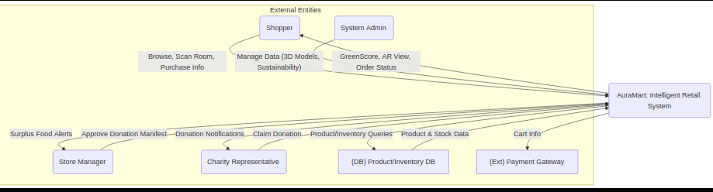

5.2. Flow Chart (Example: GreenScore Purchase)

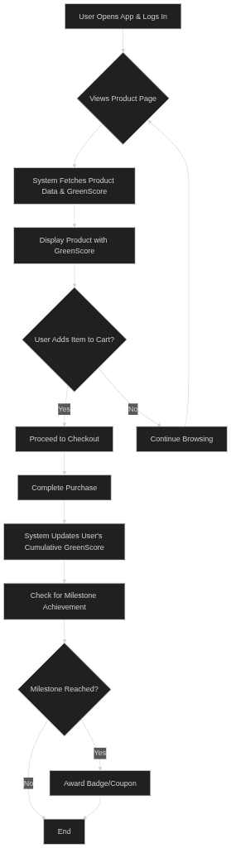

5.3. Entity-Relationship (ER) Diagram

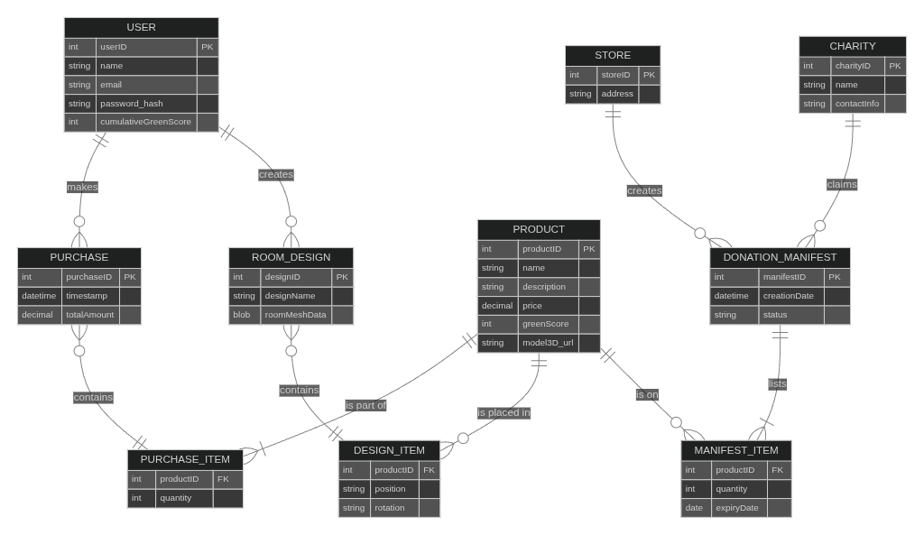

5.4. Class Diagram & Object Diagram

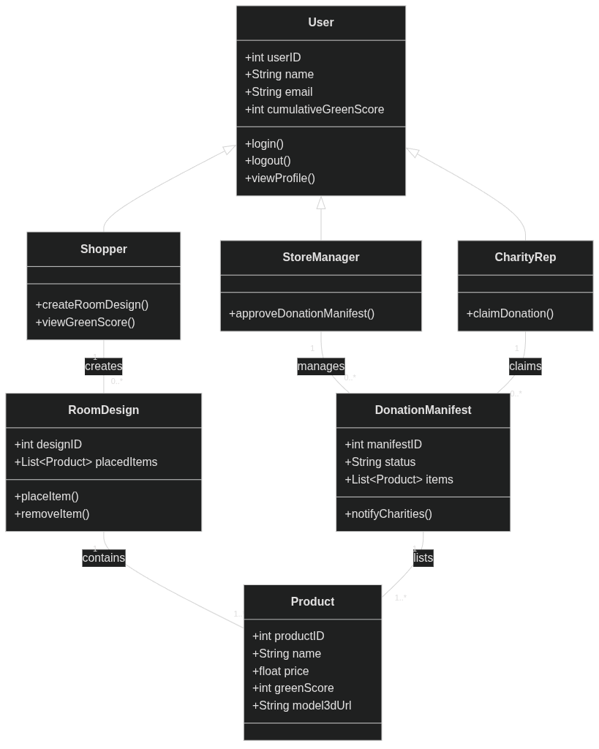

5.5. State-Chart Diagram (Donation Object)

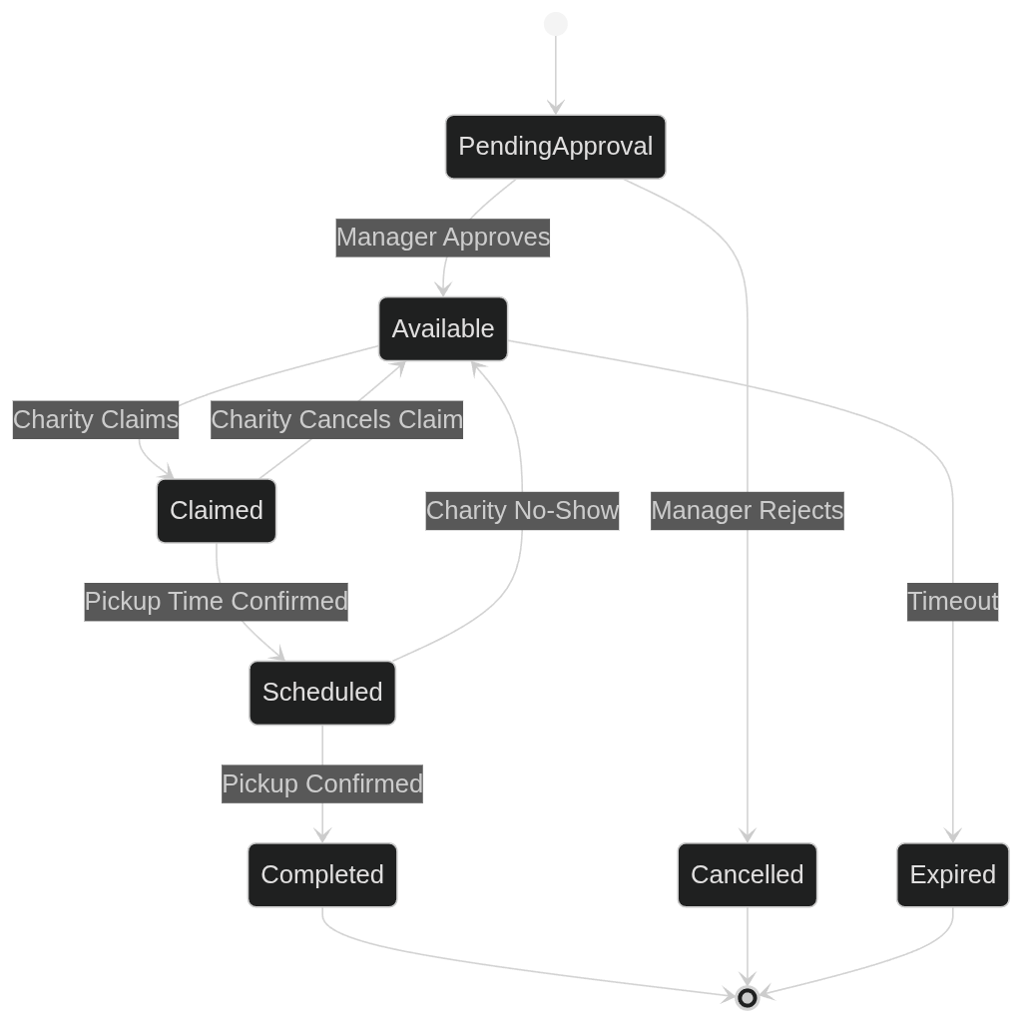

5.6. Activity Diagram (Food Donation Process)

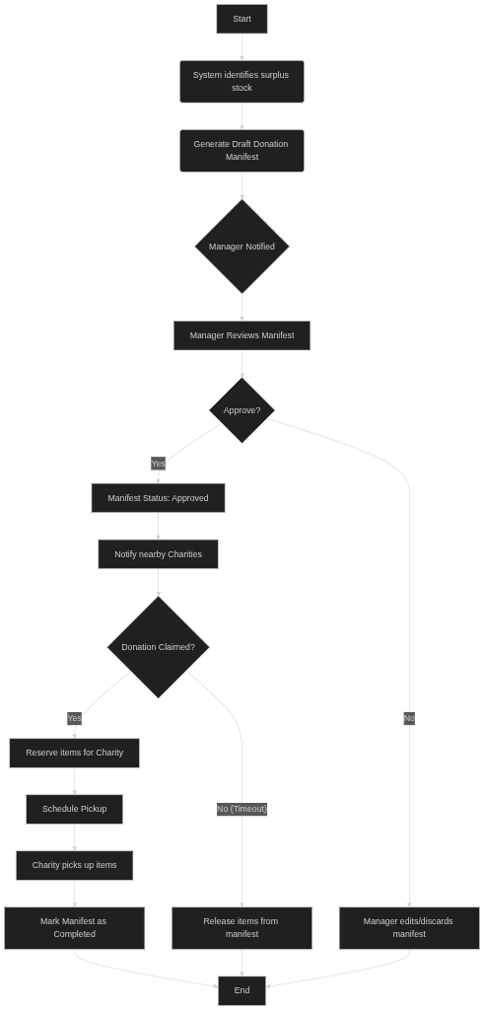

5.7. Sequence Diagram (AR Furniture Placement)

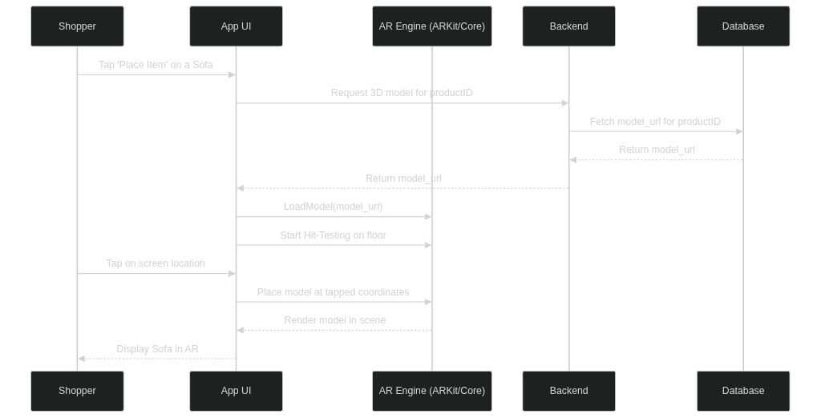

5.8. Collaboration Diagram (AR Furniture Placement)
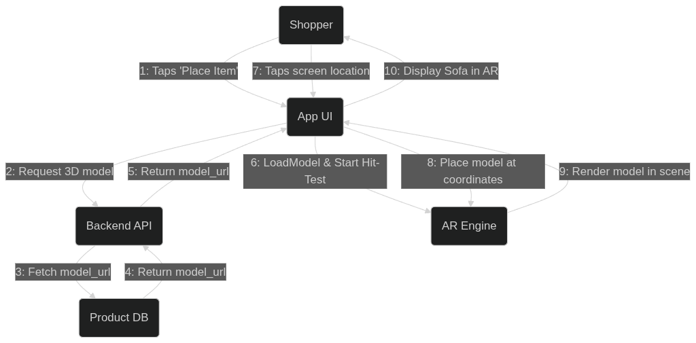

5.9. Component Diagram

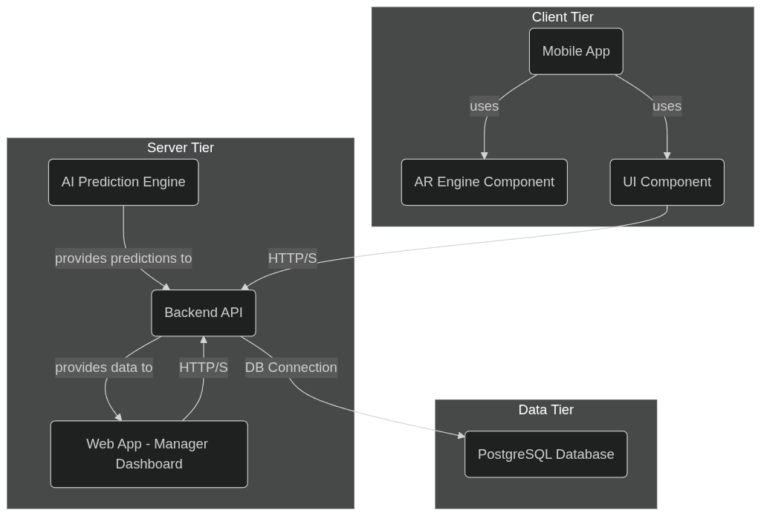

5.10. Deployment Diagram

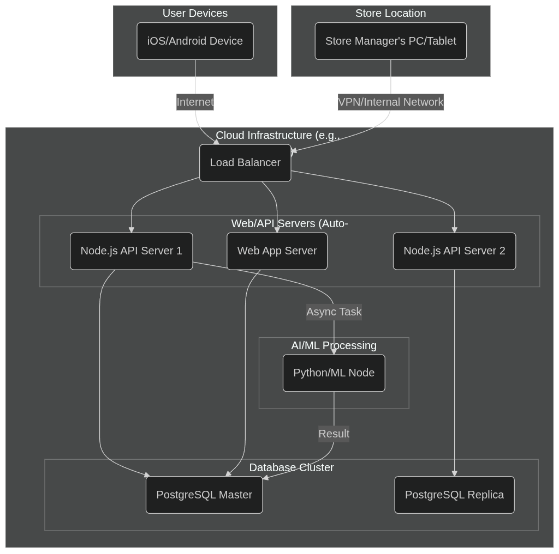

6. Business & Market Analysis

6.1. Project Uniqueness & Competitive Edge
Project Evergreen's defensible competitive advantage is not derived from a single feature but from the strategic, interlocking architecture of its three core modules. This creates a multi-layered moat that is exceptionally difficult for competitors to replicate.
- 1. Holistic Value Proposition: Beyond Siloed Solutions
While competitors focus on solving one problem at a time, Project Evergreen creates a unified ecosystem that addresses the customer journey from inspiration to post-purchase loyalty.
  - Full-Funnel Customer Engagement:
    - Top of Funnel (Attraction & Differentiation): The combination of GreenScore and the Waste-Knot initiative serves as a powerful brand differentiator. It answers the critical question, "Why should I shop here instead of on Amazon or at a specialty store?" The answer is: "Because we align with your values and help you live better." This ESG-forward narrative attracts new, value-driven demographics (Millennials, Gen Z) who are increasingly making purchasing decisions based on a company's ethical posture.
    - Mid-Funnel (Consideration & Conversion): This is where RoomScape AI becomes the decisive tool. Once a customer is attracted by the brand's values, RoomScape AI solves the tangible, high-friction problem of visualizing large items at home. It directly dismantles purchase anxiety, a primary reason for cart abandonment in the home goods sector.
    - Bottom of Funnel (Loyalty & Retention): The gamified rewards of GreenScore and the ongoing positive reinforcement from the company's social responsibility (Waste-Knot) create a "sticky" user experience. The relationship transcends a simple transaction, evolving into a partnership where the customer feels they are part of a positive movement. This builds loyalty that is far more resilient than price-based incentives.
  - Creation of a Lifestyle Brand: Competitors like IKEA have an AR app, and specialty grocers have sustainability programs. Project Evergreen's integration elevates the retailer from a mere seller of goods to an enabler of a desired lifestyle: one that is stylish, responsible, and efficient. This integrated approach is a a strategic move to embed the brand into the daily lives and value systems of its customers.
- 2. The Synergistic Data Flywheel: A Proprietary Intelligence Engine
The true long-term, unassailable advantage of Project Evergreen lies in the proprietary data ecosystem it creates. Each module feeds the others, creating a self-improving loop of business intelligence.
  - Pathway 1: GreenScore Purchase Data → RoomScape AI Content Strategy
By analyzing which "green" products are purchased most frequently, the business gains clear, data-driven insights on which product categories to prioritize for 3D modeling. This eliminates guesswork, optimizes the significant investment in creating high-quality 3D assets, and ensures that the most desired sustainable products are the first to be viewable in AR, creating a virtuous cycle.
  - Pathway 2: RoomScape AR Interaction Data → Predictive Merchandising
The system can track which items are most frequently placed in virtual rooms, even if they are not purchased immediately. This "digital window shopping" is an invaluable leading indicator of consumer desire. It allows marketing teams to create hyper-targeted campaigns ("Still thinking about that armchair? Here's a 10% coupon.") and informs inventory and merchandising teams about future trends before they even manifest in sales data. It also reveals product affinities (e.g., "Customers who view Sofa X often pair it with Rug Y"), enabling intelligent cross-selling.
  - Pathway 3: Sales & AR Data → Intelligent Waste Prediction (Waste-Knot)
The AI prediction model for Waste-Knot becomes exponentially smarter by incorporating more than just expiry dates. It can learn from sales trends (e.g., "Demand for organic bananas drops 30% after a GreenScore competitor goes on sale") and even AR data (e.g., "A spike in virtual placements of new outdoor furniture predicts an upcoming sales surge, so we should reduce our surplus prediction for related party-food items").
- 3. Authentic Technology Application: From Novelty to Utility
The market is saturated with "tech for tech's sake." Project Evergreen's success is predicated on applying cutting-edge technology to solve real, visceral human and business problems, building trust and utility.
  - Solving Real Anxiety: RoomScape AI is not a gimmick; it is a direct solution to the financial and emotional anxiety of making a large, uncertain purchase. It transforms the customer from a passive browser into an active, confident creator.
  - Solving Real Confusion: GreenScore demystifies the complex world of sustainability. It replaces confusion and "green-washing" fatigue with a simple, rewarding, and actionable framework.
  - Solving Real Inefficiency: Waste-Knot replaces a chaotic, manual, and wasteful internal process with a streamlined, automated, and value-creating system.
This focus on purpose-driven tech builds deep user trust. Customers perceive the technology not as a corporate tool for manipulation, but as a personal tool for empowerment.

6.2. Revenue Model & Monetization Strategy
Project Evergreen is an investment in the core business engine, not a standalone product for sale. Its financial return is measured through its profound, quantifiable impact on key business metrics.
- 1. Direct Revenue Growth via Enhanced Conversion & AOV
  - Confidence-Driven Conversion: RoomScape AI's primary financial contribution is de-risking the purchase. By allowing a customer to confirm fit, color, and style in their own space, it removes the #1 barrier to conversion for furniture and decor.
    - KPIs: AR-Influenced Conversion Rate, Reduction in Cart Abandonment Rate for Home Goods, Return Rate Reduction (specifically for "size/style mismatch" reasons).
  - Intelligent Cross-Sell & Up-Sell: The AR interface provides the perfect canvas for increasing Average Order Value (AOV). When a user places a sofa, the UI can seamlessly suggest and allow placement of matching end tables, lamps, or rugs. This is not an annoying pop-up but a helpful design suggestion, making the up-sell feel organic and value-additive.
    - KPIs: Average Order Value (AR vs. non-AR user sessions), Items Per Transaction.
- 2. Significant Cost Reduction & Value Recapture
  - Turning Spoilage into a Financial Asset: Waste-Knot is a cost-center transformation engine. It attacks financial loss on multiple fronts.
    - Direct Loss Mitigation: It prevents the 100% loss of Cost of Goods Sold (COGS) for products that would otherwise be discarded.
    - Tax Incentive Maximization: Food donations to registered charities are tax-deductible. The system's automated logging and reporting (FR-WK-07) provide the auditable documentation needed to maximize these tax benefits, turning a loss into a direct financial return.
    - Operational Expense Reduction: It slashes indirect costs associated with waste, including labor hours spent on manual inventory checks and disposal, and fees for waste hauling.
    - KPIs: Value of Tax-Deductible Donations Claimed, Percentage Reduction in Food Spoilage (by volume and value), Reduction in Labor Hours for Waste Management.
- 3. Margin Expansion through Strategic Nudging
  - Shifting the Sales Mix: The GreenScore algorithm is a powerful business lever. While based on objective criteria, the weighting can be strategically tuned to favor products with higher profit margins, such as the retailer's own private-label organic or sustainable brands. By rewarding customers for choosing these items, the system subtly shifts the overall sales mix towards more profitable products without any overt "hard sell."
    - KPIs: Sales Mix Shift (%) towards High-Margin Brands, Gross Profit Margin per Basket (GreenScore users vs. non-users).
- 4. Fortifying Long-Term Value through Brand Equity & Loyalty
This is the most strategic, albeit indirect, financial benefit. It builds an "Emotional Moat" around the brand.
  - Appeal to ESG Investors: In today's market, strong Environmental, Social, and Governance (ESG) performance is a key factor for institutional investors. Project Evergreen provides concrete, reportable metrics (tons of food donated, reduction in plastic use) that make the company more attractive to this massive and growing pool of capital, potentially increasing shareholder value.
  - Building a Values-Based Community: Modern customer loyalty is less about transactional points and more about shared identity and values. Project Evergreen makes customers feel like they are part of a community that cares. This emotional connection fosters a level of loyalty that price-slashing competitors cannot break.
  - Public Relations & Earned Media: Each component is a source of positive, authentic stories for PR and marketing. "How [Retailer] is Using AI to Fight Hunger" or "New AR Tool Lets You Redecorate Your Home From Your Couch" are compelling narratives that generate free, positive media coverage, reducing the need for paid advertising spend.
    - KPIs: Customer Lifetime Value (CLV), Net Promoter Score (NPS), Brand Perception Survey Scores (e.g., "is ethical," "is innovative"), Value of Earned Media.

7. Future Scope & Evolution

7.1. Potential Enhancements (Next Software Cycles)
- RoomScape AI 2.0:
  - Generative AI: Introduce a feature where users can select one item (e.g., a sofa) and the AI suggests a complete, stylistically coherent room layout with complementary products.
  - Multi-player Mode: Allow two users to design a room together in a shared AR space.
- GreenScore 2.0:
  - Social & Community Features: Allow users to form teams, compete on sustainability leaderboards with friends, and share their impact achievements on social media.
  - Hyper-personalization: Provide personalized sustainability challenges based on a user's past shopping habits.
- Waste-Knot 2.0:
  - Expansion: Expand the system beyond food to other categories like near-season-end apparel, returned-but-usable electronics, or discontinued items.
  - Dynamic Logistics: Integrate with routing and logistics APIs to optimize pickup schedules for charities, allowing them to collect from multiple stores in one trip.
- Platform Integration:
  - Integrate with smart home platforms (Google Home, Alexa) to allow voice commands for shopping and design.

7.2. Adaptation to Market Changes
- Evolving Tech: As AR/VR hardware becomes more ubiquitous (e.g., AR glasses), RoomScape can evolve from a phone-based tool to a fully immersive design experience.
- Changing Consumer Values: The weighting algorithm for GreenScore can be dynamically adjusted to reflect changing consumer priorities, such as a greater focus on water usage or labor ethics.
- Competitive Pressure: If a competitor launches a similar feature, Project Evergreen can leverage its integrated data advantage to offer a more personalized and seamless experience, solidifying its market position. The modular design allows for rapid development and deployment of new, competing features.

