PROJECT REPORT

AstroLake: An Airflow and Spark Data Engineering Pipeline
for Scoring Exoplanet Habitability

Submitted in partial fulfilment of the requirements of the degree
BACHELOR OF ENGINEERING IN
ARTIFICIAL INTELLIGENCE (AI) AND DATA SCIENCE
By
VARUN MURUGAN 124A8118
RANKIN PHILIP YANU 124A8125
ABHAY HANCHATE 225A8130
NAVIN NADAR 225A8134
Date of Submission: 16 October 2026
Supervisor
Prof. Akshay Jadhav

Department of
Artificial Intelligence (AI) and Data Science
SIES Graduate School of Technology, Nerul,
Navi Mumbai - 400 706
University of Mumbai (AY 2026-27)

1. Abstract
This report presents AstroLake, a data engineering project that ingests live data from three public space APIs and processes it through an Apache Airflow and Apache Spark pipeline organised as a Bronze, Silver and Gold medallion data lake. The project addresses a common limitation of student data pipelines, which usually stop at fetching, cleaning and charting data. AstroLake goes further and produces a decision output: a ranked shortlist of confirmed exoplanets scored for habitability using an Earth Similarity Index (ESI) style formula.
Data is collected from the NASA Exoplanet Archive, the NASA Astronomy Picture of the Day (APOD) service and Launch Library 2 (SpaceX launches). An Airflow DAG of 13 tasks orchestrates extraction, raw storage, Spark transformations, validation, loading into a SQLite serving layer, analytics quality checks, habitability alerting and metrics recording. A custom FastAPI and HTML/JavaScript dashboard presents the results, including a live record-lineage view measured directly from the Parquet files on disk.
A key engineering finding is that confirmed exoplanets are strongly biased towards hot Jupiters and close-in super-Earths, so raw ESI scores rarely exceed about 0.3. Fixed score thresholds therefore leave the top tier empty. The project instead assigns tiers from the score distribution observed in each run, and uses Kepler-22 b, which consistently ranks in the top three of the HIGH tier, as a sanity check of the ranking.

2. Introduction
Space agencies and research groups publish large and constantly growing catalogues of astronomical data. The NASA Exoplanet Archive alone lists more than 6,000 confirmed exoplanets. Follow-up observation time is limited and expensive, so a useful system must do more than display this data: it must narrow it down to a small set of candidates worth attention, and it must notify users when something new and promising appears.
Many data engineering projects end at visualisation. A chart summarises data but does not make a decision. AstroLake is designed around a decision output, namely an ESI-style habitability score for every confirmed exoplanet that has a measured radius, mass and orbital period. This is a published method from astrobiology (Schulze-Makuch et al., 2011) for comparing planets to Earth [1].
The primary objectives of AstroLake are therefore to (i) ingest data reliably from multiple public APIs, (ii) store raw data permanently and replayably in a Bronze layer, (iii) clean, deduplicate and type the data with Apache Spark into a Silver layer, (iv) compute aggregates and habitability scores in a Gold layer, (v) serve the results through a fast queryable store and an interactive dashboard, and (vi) validate the output and raise alerts when a newly discovered planet enters the top tier.
These objectives are achieved through a set of ingestion clients, an Airflow-orchestrated Spark pipeline over a Parquet data lake, a SQLite serving layer and a FastAPI dashboard, all running as plain local processes.

3. Methodology and Key Concepts
The project follows the medallion architecture, in which data moves through progressively refined layers while orchestration, storage and serving remain separate concerns. The major components are summarised below.
- Ingestion clients: Typed Python clients, with retrying and rate-limit awareness, for the NASA Exoplanet Archive (TAP/ADQL interface), the NASA APOD WordPress REST API and Launch Library 2.
- Bronze layer: Raw records exactly as received from each API, written once per run as Parquet under data_lake/bronze/<source>/batch_<run_id>/. This is the permanent, replayable record of what the source returned.
- Apache Airflow: Defines the pipeline as a Directed Acyclic Graph (DAG) of 13 tasks with explicit dependencies, retries and failure handling.
- Apache Spark (PySpark): Runs the Bronze to Silver to Gold transformations in local[*] mode, a real JVM-backed Spark session that uses all CPU cores.
- Silver layer: Cleaned, deduplicated, typed and string-normalised data, with incomplete records flagged.
- Gold layer: Aggregates (discoveries per year, method statistics, launches per year and rocket, APOD per month) and the habitability candidates table.
- SQLite serving layer: A fast, zero-setup queryable store that the dashboard reads from.
- FastAPI and dashboard: One lightweight Python process serves both the JSON analytics API and the HTML/CSS/JavaScript single-page dashboard.

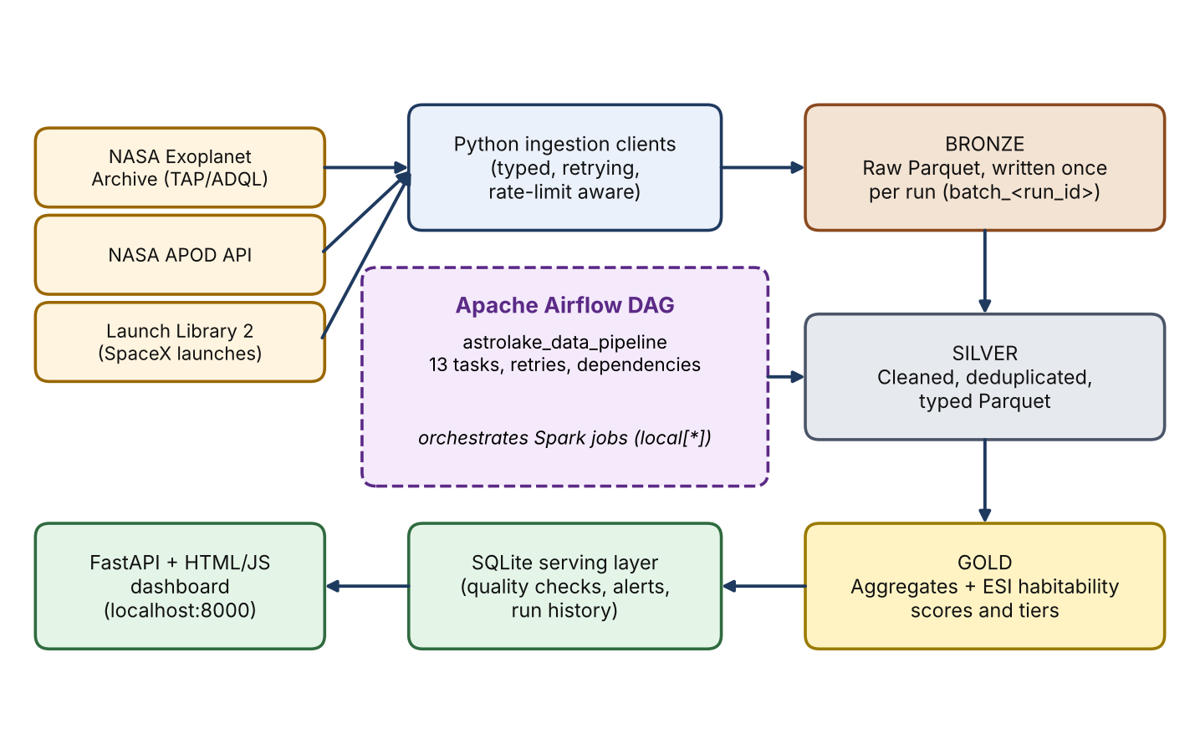
Fig. 1: AstroLake architecture

3.1 Habitability scoring
The habitability score compares three planetary properties with those of Earth: radius, mass and orbital period. For each property, the Spark job measures how close a planet's value is to Earth's corresponding value, with closer matches scoring higher. The three per-property scores are then combined into a single habitability_score for the planet.
A planet identical to Earth in radius, mass and orbital period would score a perfect 1.0. Only planets that have all three measurements recorded in the source data can be scored, which is why the Gold habitability table only ever covers a subset of the full catalogue.

3.2 Percentile-based tiers
Detection methods such as transit and radial velocity find large, close-in planets far more easily than Earth-sized planets in Earth-like orbits. As a result, even the best known candidates rarely score above about 0.3. An early implementation with a fixed cutoff (HIGH tier at a score of 0.80 or more) left the HIGH tier permanently empty, which was identified as a bug during development.
The fix is to compute tiers from the score distribution observed in each run: the top roughly 2% of scored planets are labelled HIGH, the next roughly 13% MODERATE, and the rest LOW. This keeps the shortlist meaningful even as the underlying data shifts.

3.3 Pipeline workflow
Each pipeline run executes the following Airflow tasks in order:
- check_source_availability pings all three source APIs and aborts only if all three are unreachable.
- The extract task group runs three extraction tasks in parallel, one per source.
- store_raw_data writes whatever was fetched to the Bronze layer as Parquet.
- run_spark_transformations submits three independent PySpark jobs that write Silver and Gold, including the habitability candidates.
- validate_transformed_data confirms that each source's Silver layer has Parquet output on disk.
- load_serving_layer loads every Gold table into the SQLite serving database.
- run_analytics_quality_checks runs 7 SQL assertions against SQLite and records pass or fail for each.
- raise_habitability_alerts compares this run's HIGH-tier planets with the previous run's and records new entrants as alerts.
- record_pipeline_metrics writes a run summary to the pipeline run history table.
The central design principle is separation of concerns: orchestration (Airflow), transformation (Spark), storage (Parquet), serving (SQLite) and presentation (FastAPI) are independent layers, so any one can be replaced without rewriting the others.

4. Data Engineering Analysis

4.1 Working
Each source follows the same path from raw data to dashboard. Raw records are preserved in Bronze, Spark refines them into Silver and then Gold, and the Gold tables are loaded into SQLite for fast querying. The exoplanet job additionally computes the ESI-style score for every scorable planet and writes the ranked candidates table.
Table 1: Tools and their roles in AstroLake
Tool | Role | Why it fits
Apache Airflow | Orchestration | Expresses the pipeline as a 13-task DAG with dependencies, retries and failure handling.
Apache Spark (PySpark) | Transformation | Performs cleaning, deduplication, aggregation and habitability scoring with the DataFrame API in local[*] mode.
Parquet | Storage format | Columnar, compressed and schema-aware; each layer is a set of inspectable files on disk.
SQLite | Serving layer | Zero-setup queryable store for the dashboard; replaceable with PostgreSQL.
FastAPI | API and UI host | Serves the JSON analytics API and the dashboard files from one process.

Table 2: Data sources
Source | Interface | Provides | Auth
NASA Exoplanet Archive | TAP / ADQL query interface | About 6,400+ confirmed exoplanets: name, host star, discovery year and method, radius, mass, orbital period, distance | None
NASA APOD | science.nasa.gov WordPress REST API | Daily astronomy image or video metadata: title, media URL, explanation, credit | None
Launch Library 2 | ll.thespacedevs.com, filtered to SpaceX (agency ID 121) | SpaceX launch history: mission, date, rocket, launchpad, outcome | None (free tier)
Archived r/SpaceX snapshot | Static JSON on GitHub | Historical launches, used only if the free quota (15 requests per hour) is exhausted | None

4.2 Advantages
- A decision, not just a dashboard: The pipeline produces a ranked shortlist of habitability candidates and raises alerts, rather than only charting data.
- Replayable raw data: The Bronze layer preserves exactly what each API returned, so downstream layers can be rebuilt at any time.
- Real, inspectable layers: Bronze, Silver and Gold are real Parquet files on disk with timestamps that match what the dashboard shows.
- Honest lineage: The dashboard's record-lineage view reads Parquet metadata directly, so every count shown is measured rather than hardcoded.
- Scalable processing code: The same PySpark code can run against a multi-node cluster by changing one configuration line, from .master("local[*]") to a cluster master URL.
- Portable serving layer: Data access is isolated in dashboard/db_local.py behind simple functions, so moving from SQLite to PostgreSQL means changing the connection logic in one file.
- Low setup cost: All components run as plain local processes, which makes the system easy to run and demonstrate on any machine.

4.3 Limitations and Design Trade-offs
- No containerisation: Docker was deliberately left out to avoid container, networking and volume complexity. The data engineering itself is unchanged, and the README documents how to containerise the project for production.
- Batch rather than streaming: Kafka was not used, because a continuously running broker is an awkward manual install without Docker and would not change what the pipeline computes.
- Local single-node execution: Spark runs in local[*] mode and SQLite is a single-file database, so the demonstrated deployment is not a multi-user production setup.
- Low absolute scores: Because of detection bias, absolute ESI values stay low (around 0.3 at best). Only the relative ranking is meaningful, which is why tiers are percentile-based.
- Scoring coverage: Only planets with measured radius, mass and period can be scored, so the Gold habitability table is much smaller than the full catalogue.
- Dependence on free public APIs: Rate limits and outages can interrupt ingestion. The pipeline mitigates this with fallbacks, but the data is only as fresh as the last successful run.

5. Data Quality, Resilience and Alerting
A pipeline is only useful if its output can be trusted and if it keeps working when parts of it fail. AstroLake addresses this at several points.
- Source availability gate: The first task checks all three APIs and aborts only if every one is unreachable, so a single failing source does not stop the run.
- Partial-success Bronze writes: The store_raw_data task uses the NONE_FAILED_MIN_ONE_SUCCESS trigger rule, so Bronze is written for whatever sources succeeded.
- Three-tier SpaceX fallback: The launch client tries the production API, then an official development mirror, then an archived static snapshot, merging results by launch ID so no duplicates appear. This protects against the free tier limit of 15 requests per hour.
- Silver validation gate: validate_transformed_data confirms that each source actually has Parquet output on disk before loading continues.
- Analytics quality checks: Seven SQL assertions run against SQLite, covering minimum row counts, absence of null keys, valid year ranges and valid outcome values, and each result is recorded as pass or fail.
- Habitability alerts: The raise_habitability_alerts task compares this run's HIGH-tier planets with the previous run's. Any planet newly promoted to HIGH is logged and stored in the habitability_alerts table, so the pipeline acts on what it computed.
- Audit trail: Per-source ingestion metrics (records fetched and written, duration, status) and a run history table are kept for every run and shown on the dashboard's Pipeline page.
If a source is down, the worst case is that the dashboard continues to serve data from the last successful run, which remains available in the data lake and in SQLite.

6. Results and Discussion
The project delivers a working end-to-end pipeline and dashboard. Its Overview page shows live indicators for confirmed exoplanets, launches, APOD records and mission success rate, together with the top habitability candidates, all read from the SQLite database that the pipeline populated. The Habitability page shows the HIGH, MODERATE and LOW tier breakdown and a ranked table of candidates.
The Pipeline page shows the architecture and a live record-lineage view, one funnel per source across the Bronze, Silver, Gold and SQLite stages, with row counts measured from disk through the GET /api/pipeline/lineage endpoint. For the exoplanet source, the count falls from 6,445 records in Bronze and Silver to 1,554 in Gold. This drop is expected and correct, because only planets with complete radius, mass and period measurements can be scored.
The model was validated by a sanity check. Kepler-22 b, a well-known potentially habitable-zone planet discovered by NASA's Kepler mission, consistently appears in the top three of the HIGH tier. This indicates that the relative ranking is scientifically sound even though absolute scores are low.
The full pipeline can be re-run from the dashboard, which runs airflow dags test astrolake_data_pipeline for the current date. This executes all 13 tasks end to end, from live API calls through Bronze, Spark, Gold and SQLite to quality checks and alerting, in roughly one to three minutes. When it finishes, the lineage bars and the DAG run history update with the new figures.
The scientific and practical value mirrors a real workflow: triaging a large catalogue of confirmed exoplanets into a short, ranked list worth follow-up observation, and notifying researchers only when something new and promising appears instead of making them rescan the archive by hand.
The main limitations are those described in Section 4.3: local single-node execution, batch-only processing and dependence on free public APIs. These were accepted deliberately to keep the project easy to run while preserving real DAGs, real Spark jobs and a real medallion data lake.

7. Conclusion
AstroLake demonstrates a complete, realistic data engineering pipeline built with Apache Airflow, Apache Spark and Parquet. It combines multi-source ingestion, a Bronze, Silver and Gold medallion architecture, validated serving, quality checks and automatic alerting, and it turns the processed data into a ranked, scientifically grounded list of habitability candidates.
Its major strengths are a real decision output, a replayable raw data layer, a resilient ingestion design with fallbacks, and a lineage view that is measured rather than mocked. The percentile-based tiering, adopted after a fixed threshold left the top tier empty, shows how engineering judgement can be matched to the real distribution of the data. Its main limitations are local single-node deployment, batch-only operation and reliance on rate-limited public APIs.
Future improvements include containerised deployment, a PostgreSQL serving layer, running Spark against a multi-node cluster and adding a streaming ingestion path. These would extend the project towards production use while keeping the same pipeline structure.

8. References
[1] D. Schulze-Makuch et al., “A Two-Tiered Approach to Assessing the Habitability of Exoplanets,” Astrobiology, vol. 11, no. 10, 2011.
[2] NASA Exoplanet Archive, Caltech/IPAC, TAP service. https://exoplanetarchive.ipac.caltech.edu
[3] NASA Astronomy Picture of the Day (APOD), science.nasa.gov.
[4] The Space Devs, Launch Library 2 API. https://ll.thespacedevs.com
[5] Apache Airflow documentation. https://airflow.apache.org
[6] Apache Spark (PySpark) documentation. https://spark.apache.org

